Full Website Sitemap / Menu Structure for Fencing Company
Below is a clean, SEO-friendly, user-friendly structure you can directly use for your website.

MAIN MENU

1. Home
Hero banner (best fencing images)
Quick links to main products
Project highlights
Why choose us
Get a quote button

2. Products
(Main category landing page with all product images)
creating this one first to add the prodcuts like this
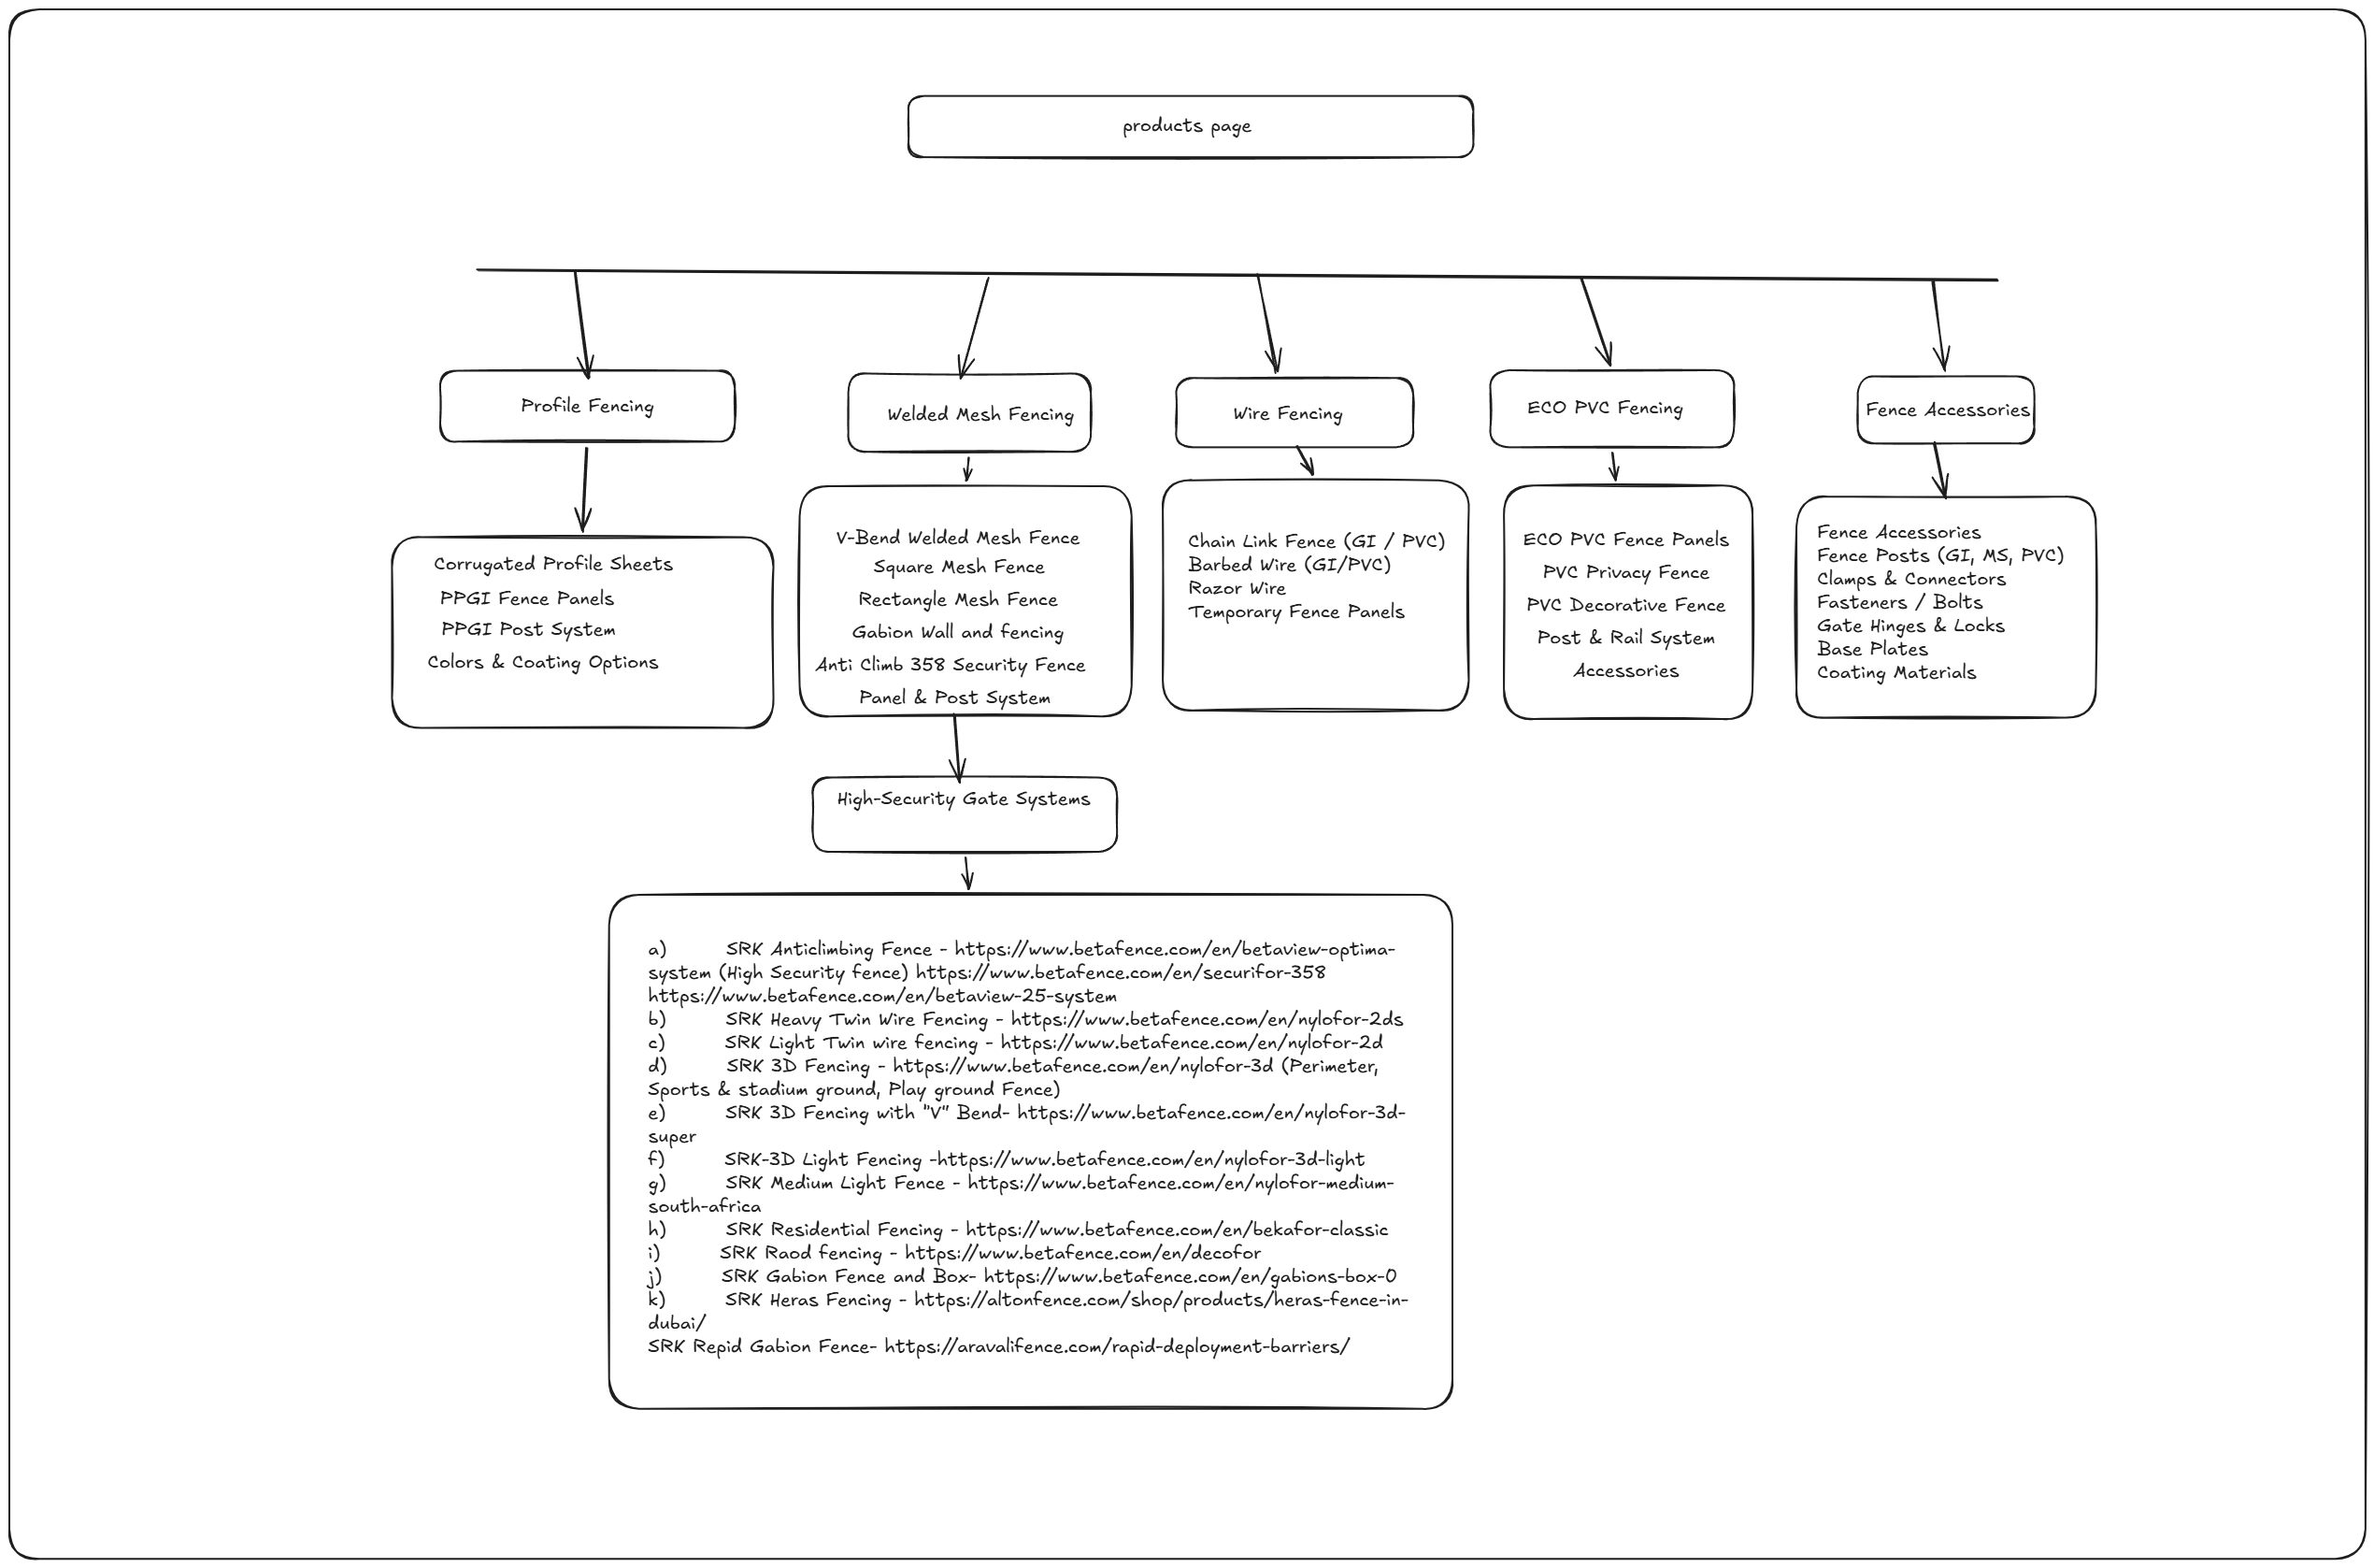

Profile Fencing

Corrugated Profile Sheets

PPGI Fence Panels

PPGI Post System

Colors & Coating Options

Welded Mesh Fencing

V-Bend Welded Mesh Fence

Square Mesh Fence

Rectangle Mesh Fence

Gabion Wall and fencing

Anti Climb 358 Security Fence

Panel & Post System

High-Security Gate Systems
  - SRK Anticlimbing Fence - https://www.betafence.com/en/betaview-optima-system (High Security fence) https://www.betafence.com/en/securifor-358 https://www.betafence.com/en/betaview-25-system
  - SRK Heavy Twin Wire Fencing - https://www.betafence.com/en/nylofor-2ds
  - SRK Light Twin wire fencing - https://www.betafence.com/en/nylofor-2d
  - SRK 3D Fencing - https://www.betafence.com/en/nylofor-3d (Perimeter, Sports & stadium ground, Play ground Fence)
  - SRK 3D Fencing with “V” Bend- https://www.betafence.com/en/nylofor-3d-super
  - SRK-3D Light Fencing -https://www.betafence.com/en/nylofor-3d-light
  - SRK Medium Light Fence - https://www.betafence.com/en/nylofor-medium-south-africa
  - SRK Residential Fencing - https://www.betafence.com/en/bekafor-classic
  - SRK Raod fencing - https://www.betafence.com/en/decofor
  - SRK Gabion Fence and Box- https://www.betafence.com/en/gabions-box-0
  - SRK Heras Fencing - https://altonfence.com/shop/products/heras-fence-in-dubai/
SRK Repid Gabion Fence- https://aravalifence.com/rapid-deployment-barriers/

2.3 Wire Fencing

Chain Link Fence (GI / PVC)

Barbed Wire (GI/PVC)

Razor Wire

Temporary Fence Panels

2.4. ECO / PVC Fencing
ECO PVC Fence Panels
PVC Privacy Fence
PVC Decorative Fence
Post & Rail System
Accessories

2.5 Fence Accessories
Fence Posts (GI, MS, PVC)
Clamps & Connectors
Fasteners / Bolts
Gate Hinges & Locks
Base Plates
Coating Materials

3. Applications
(SEO-focused pages)

Residential Fencing
Commercial & Industrial
Oil & Gas Sector
Data Centers
Schools & Public Parks
Farms & Animal Enclosures
Boundary & Security Fencing
Warehouses & Logistic Centers
Country Border fencing

4. Services
Supply & Installation
Site Measurement / Survey
Custom Fabrication
Powder Coating
Hot Dip Galvanizing
Delivery & Export Support
AMC (Annual Maintenance Contracts)

5. Projects
Completed Projects Gallery
Before/After Photos
Videos (if needed)
Client Testimonials

6. Resources
Good for SEO and customer trust.
Brochures / Catalogs
Technical Data Sheets
Mesh Size Chart
Fence Height Guide
Color Charts
Installation Manuals
Certifications (ISO, etc.)

7. About Us
Company Profile
Vision & Mission
Manufacturing Capacity
Quality Standards
Careers

8 Contact
Team (sales / Purchasse)
Contact Form (Quote Request)
WhatsApp Button
Location Map
Phone / Email

⭐ Other Sections

Blog / Knowledge Center
“How to choose the right fence?”
“PPGI vs PVC fencing — which is better?”
“Fence height rules in UAE”
“Best fencing for data centers”
“Difference between 358 and welded mesh”

