**Assignment 2.2**

**BlackBoard Instructions:**

* 1 tree map
* 1 area chart
* 1 stacked area chart
* 1 step chart

**_________________________ DONE IN R _______________________________**

**Tree Map - Expenditures**

In [3]:

library(ggplot2)

library(treemap)

*# Load the data*

expenditures **<-** read.table("C:/Users/mcken/Downloads/expenditures.txt", sep**=**"\t", header**=TRUE**)

*# Create the tree map*

treemap(

expenditures,

index **=** "category",

vSize **=** "expenditure",

vColor **=** "expenditure",

type **=** "value",

title **=** "Expenditures Tree Map"

)

Warning message:

"package 'treemap' was built under R version 4.3.3"

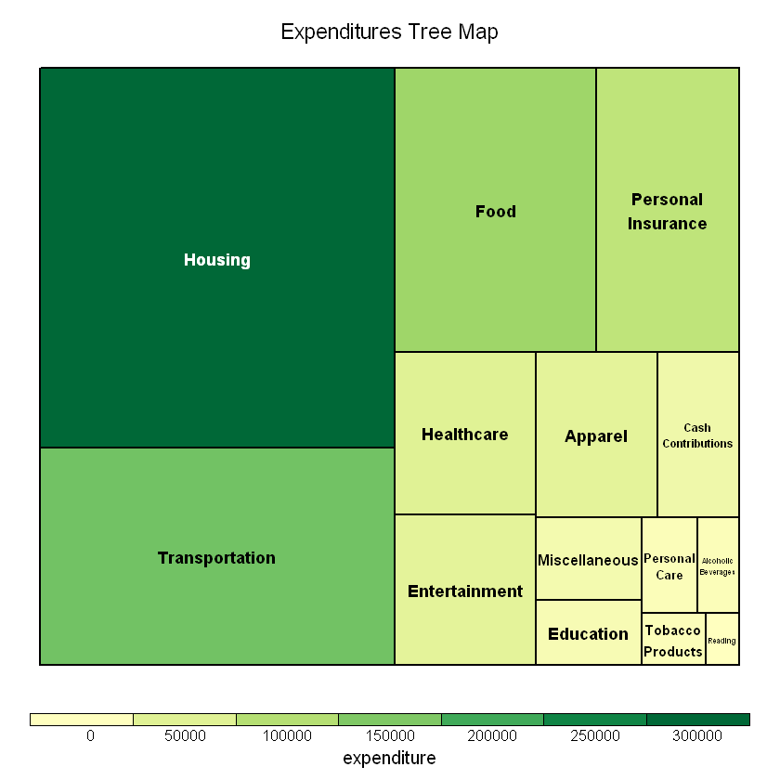

**Area Chart - World Population**

In [4]:

library(ggplot2)

library(readxl)

*# Load the data*

world_population **<-** read_excel("C:/Users/mcken/Downloads/world-population.xlsm")

*# Create the area chart*

ggplot(world_population, aes(x **=** Year, y **=** Population)) **+**

geom_area(fill **=** "skyblue", alpha **=** 0.4) **+**

geom_line(color **=** "Slateblue", alpha **=** 0.6) **+**

ggtitle("World Population Over Time") **+**

xlab("Year") **+**

ylab("Population")

Warning message:

"package 'readxl' was built under R version 4.3.1"

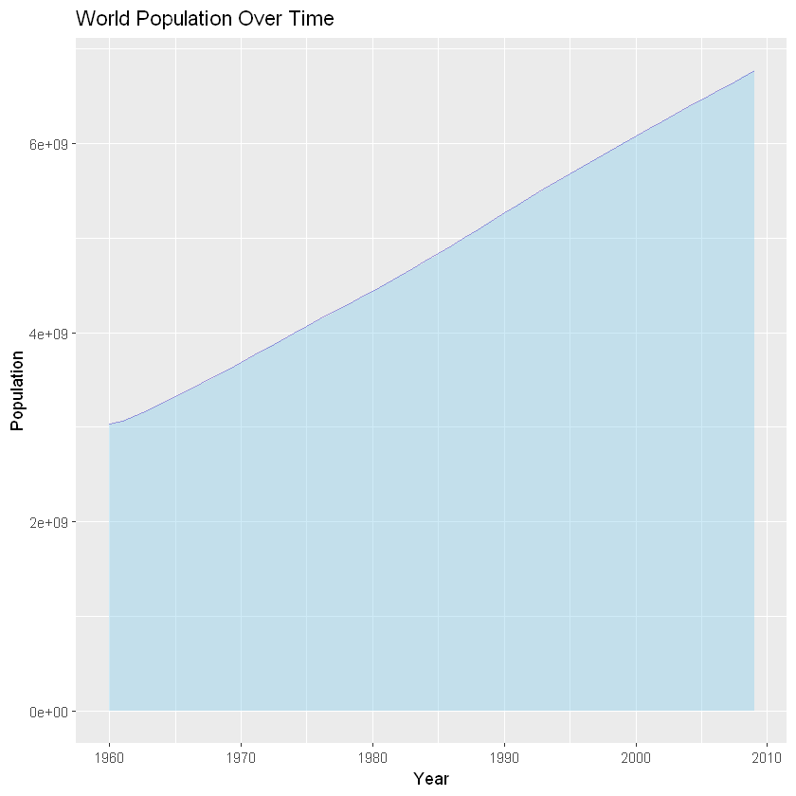

**Stacked Area Chart - US Postage Rates**

In [5]:

library(ggplot2)

library(readxl)

*# Load the data*

us_postage **<-** read_excel("C:/Users/mcken/Downloads/us-postage.xlsm")

*# Reshape the data for plotting*

us_postage_long **<-** reshape2**::**melt(us_postage, id.vars **=** "Year", variable.name **=** "Category", value.name **=** "Rate")

*# Create the stacked area chart*

ggplot(us_postage_long, aes(x **=** Year, y **=** Rate, fill **=** Category)) **+**

geom_area(alpha **=** 0.8) **+**

ggtitle("US Postage Rates Over Time") **+**

xlab("Year") **+**

ylab("Rates") **+**

scale_fill_brewer(palette **=** "Set3")

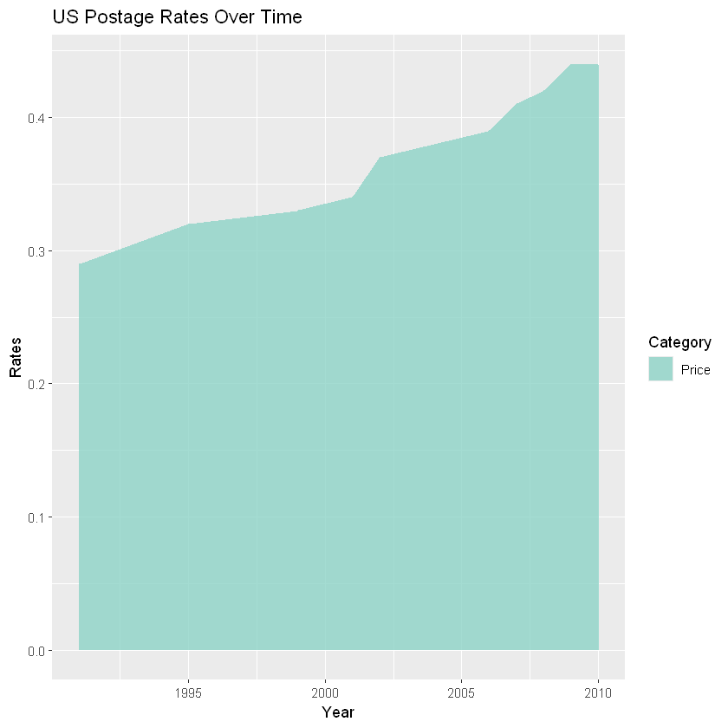

**Step Chart - Unemployment Rate**

In [6]:

library(ggplot2)

*# Load the data*

unemployment_rate **<-** read.csv("C:/Users/mcken/Downloads/unemployement-rate-1948-2010.csv")

*# Create the step chart*

ggplot(unemployment_rate, aes(x **=** Year, y **=** Value)) **+**

geom_step(color **=** "red", alpha **=** 0.8) **+**

ggtitle("Unemployment Rate (1948-2010)") **+**

xlab("Year") **+**

ylab("Unemployment Rate")

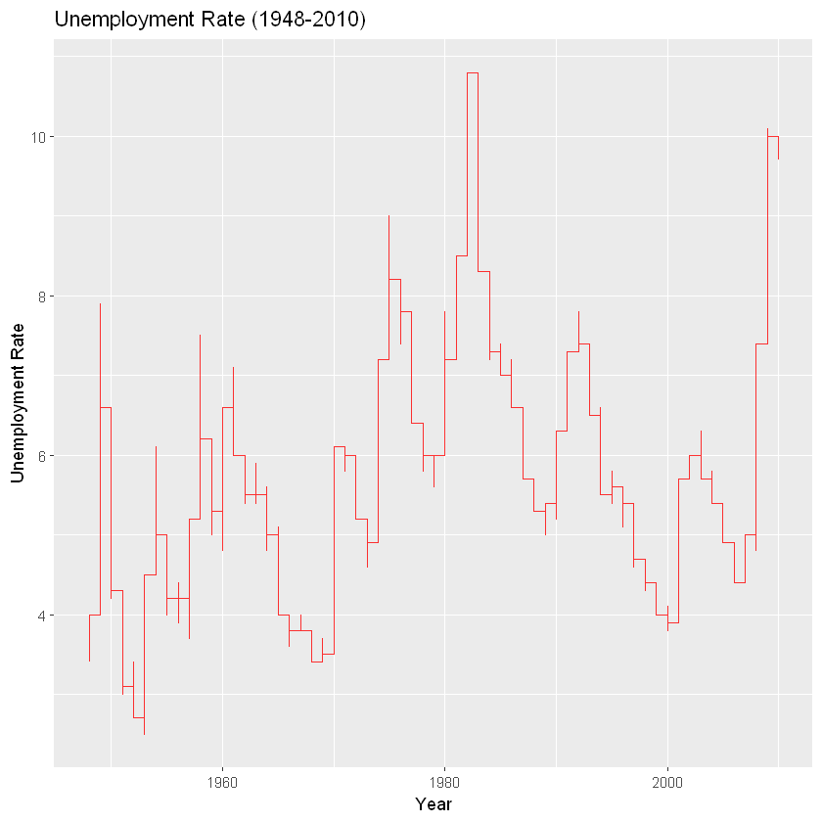

In [ ]:

**____________________ DONE IN PYTHON _____________________**

**BlackBoard Instructions:**

* 1 tree map
* 1 area chart
* 1 stacked area chart
* 1 step chart

**Tree Map**

**Data Source: expenditures.txt**

**Tree Map: Visualizes the proportions of different expenditure categories, offering a clear picture of relative spending.**

In [11]:

**import** pandas **as** pd

**import** matplotlib.pyplot **as** plt

**import** squarify

*# Load the data*

expenditures **=** pd**.**read_csv("C:/Users/mcken/Downloads/expenditures.txt", sep**=**"\t")

*# Check the first few rows to confirm the column names*

print(expenditures**.**head())

*# Prepare data for the tree map*

sizes **=** expenditures['expenditure']

labels **=** expenditures['category']

*# Create the tree map*

plt**.**figure(figsize**=**(10, 6))

squarify**.**plot(sizes**=**sizes, label**=**labels, alpha**=**.8)

plt**.**axis('off')

plt**.**title('Expenditures Tree Map')

plt**.**show()

year category expenditure sex

0 2008 Food 6443 1

1 2008 Alcoholic Beverages 444 1

2 2008 Housing 17109 1

3 2008 Apparel 1801 1

4 2008 Transportation 8604 1

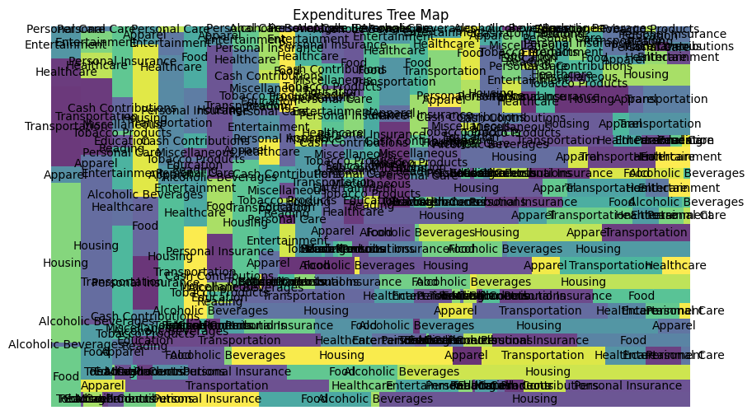

**Area Chart**

**Data Source: world-population.xlsm**

**Area Chart: Illustrates the growth of the world population over time, highlighting trends and changes.**

In [6]:

**import** pandas **as** pd

**import** matplotlib.pyplot **as** plt

*# Load the data*

world_population **=** pd**.**read_excel("C:/Users/mcken/Downloads/world-population.xlsm")

*# Prepare data*

years **=** world_population['Year']

population **=** world_population['Population']

*# Create the area chart*

plt**.**figure(figsize**=**(10, 6))

plt**.**fill_between(years, population, color**=**"skyblue", alpha**=**0.4)

plt**.**plot(years, population, color**=**"Slateblue", alpha**=**0.6)

plt**.**title('World Population Over Time')

plt**.**xlabel('Year')

plt**.**ylabel('Population')

plt**.**show()

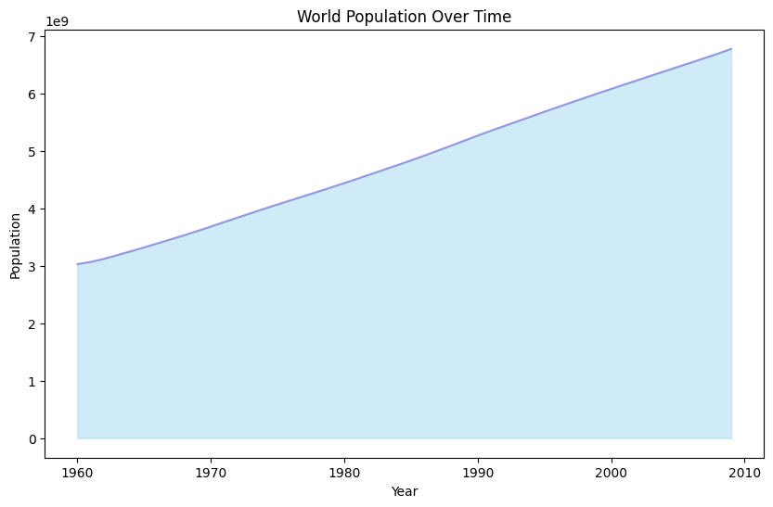

**Stacked Area Chart**

**Data Source: us-postage.xlsm**

**Stacked Area Chart: Shows how different postage rate categories have evolved over time, indicating trends and shifts.**

In [5]:

**import** pandas **as** pd

**import** matplotlib.pyplot **as** plt

*# Load the data*

us_postage **=** pd**.**read_excel("C:/Users/mcken/Downloads/us-postage.xlsm")

*# Prepare data*

years **=** us_postage['Year']

categories **=** us_postage**.**columns[1:]

*# Create the stacked area chart*

plt**.**figure(figsize**=**(10, 6))

plt**.**stackplot(years, us_postage[categories]**.**T, labels**=**categories, alpha**=**0.8)

plt**.**title('US Postage Rates Over Time')

plt**.**xlabel('Year')

plt**.**ylabel('Rates')

plt**.**legend(loc**=**'upper left')

plt**.**show()

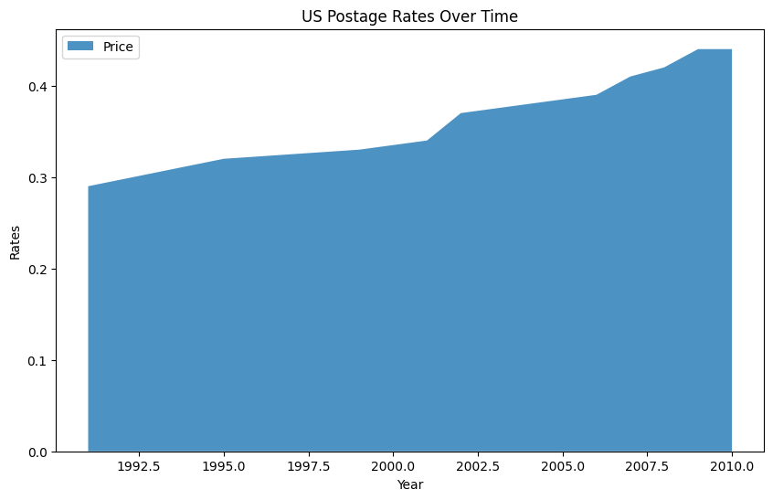

**Step Chart**

**Data Source: unemployement-rate-1948-2010.csv**

**Step Chart: Tracks the unemployment rate over a significant period, displaying the fluctuations and trends in employment.**

In [9]:

**import** pandas **as** pd

**import** matplotlib.pyplot **as** plt

*# Load the data*

unemployment_rate **=** pd**.**read_csv("C:/Users/mcken/Downloads/unemployement-rate-1948-2010.csv")

*# Check the first few rows to confirm the column names*

print(unemployment_rate**.**head())

*# Prepare data*

years **=** unemployment_rate['Year']

value **=** unemployment_rate['Value']

*# Create the step chart*

plt**.**figure(figsize**=**(10, 6))

plt**.**step(years, value, where**=**'mid', color**=**'red', alpha**=**0.8)

plt**.**title('Unemployment Rate (1948-2010)')

plt**.**xlabel('Year')

plt**.**ylabel('Unemployment Rate')

plt**.**show()

Series id Year Period Value

0 LNS14000000 1948 M01 3.4

1 LNS14000000 1948 M02 3.8

2 LNS14000000 1948 M03 4.0

3 LNS14000000 1948 M04 3.9

4 LNS14000000 1948 M05 3.5

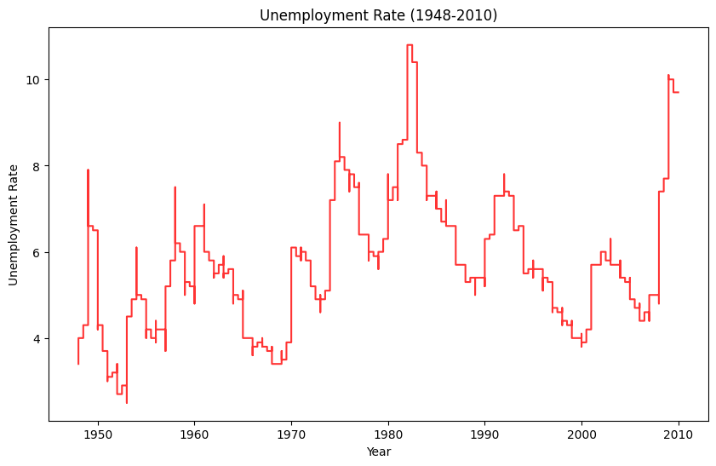

In [ ]:

**_______________ DONE IN POWERBI __________**

**TREE MAP:**

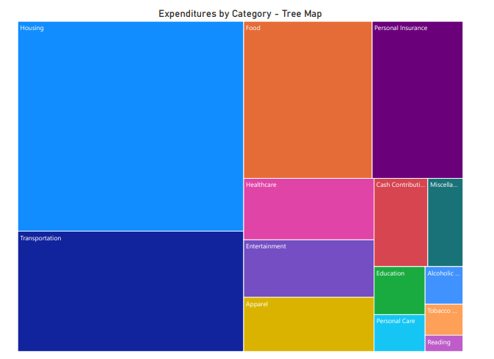

**STACKED AREA CHART:**

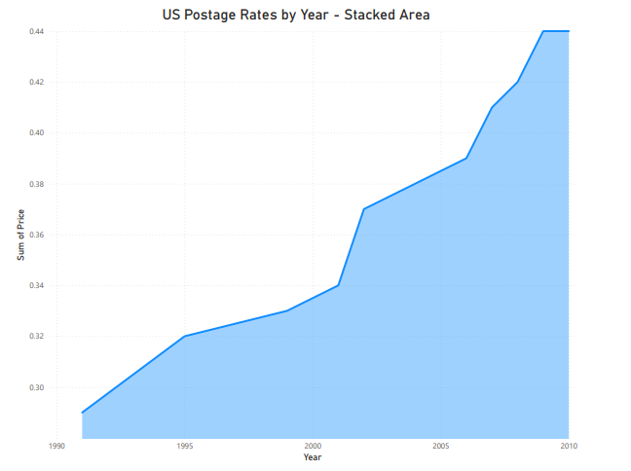

**STEP CHART:**

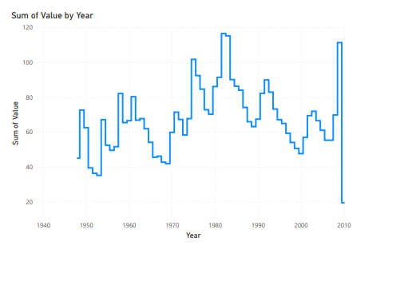

**AREA CHART:**

