UKM NEXUS: System Development (D6)
  - 1. INTRODUCTION

1.1Purpose
- The technical realization of the system based on the requirements and design specifications described in previous documentation is documented in this document, which covers the UKM NEXUS Q&A platform's implementation phase. It sheds light on important coding elements, implementation difficulties, and the development process.

1.2 Scope
- The scope of this document includes:
- Explanation of the system development process
- Analysis of critical code segments
- Description of key modules, components, and database structures
- Presentation of user interfaces
- Discussion of implementation challenges and solutions

1.3 Related Documents
• Requirements Analysis (D3): Defined functional and non-functional requirements
• Design Specification (D4): Established system architecture and component designs

2.1
The UKM NEXUS platform was developed using a PHP-based technology stack with MySQL for database management. The development environment was set up as follows:
- • XAMPP: Used as the local development server environment
- • Visual Studio Code: Employed as the code editor
- • MySQL : Utilized for database design and management
- • GitHub: Implemented for version control

Environment Configuration Code:

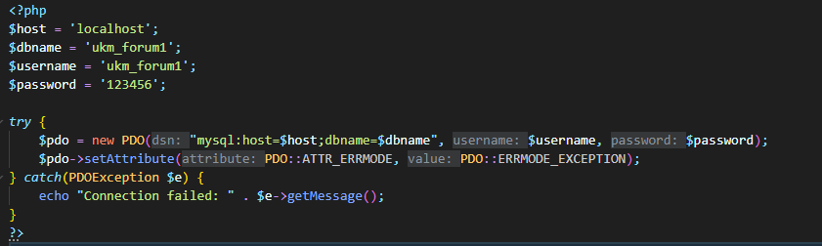
Figure 2.1 Configuration Code

2.2 Database Implementation
The database was implemented according to the entity-relationship diagram defined in the design specification. The database structure supports all core functionalities including user management, question-and-answer functionality, tagging, and notifications.
Database Structure Implementation:
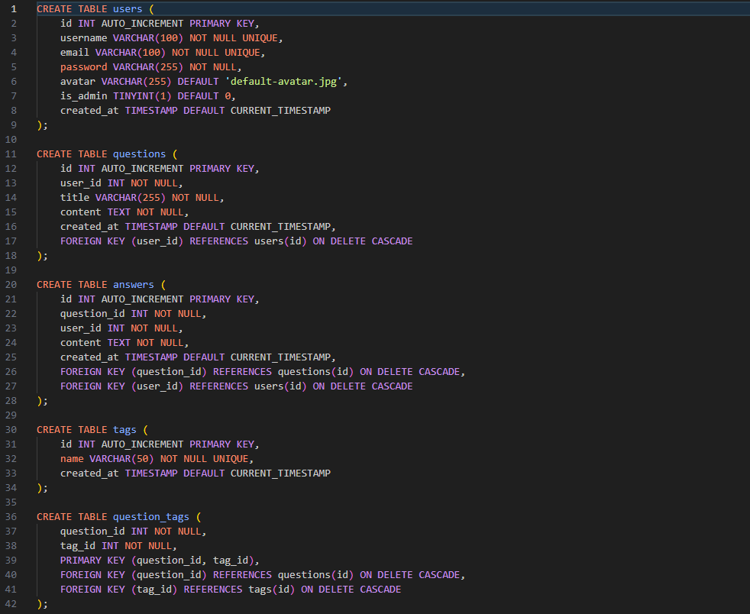
Figure 2.2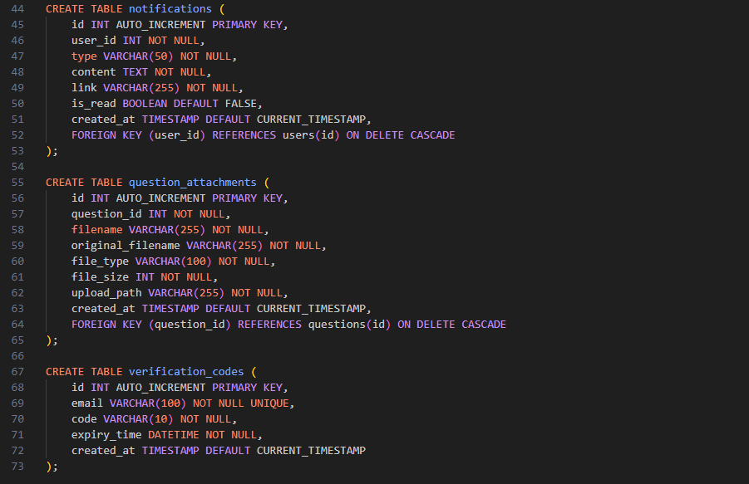
Figure 2.3

2.3 User Authentication Module
The user authentication module implements secure registration and login functionality with email verification using the UKM email domain. This was a critical security component to ensure only legitimate UKM community members can access the platform.

Email Verification System:
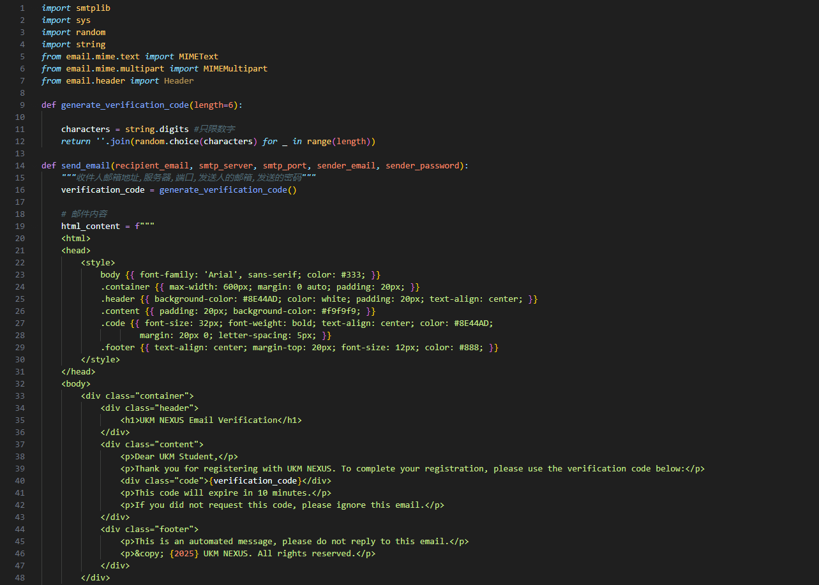
Figure 2.4
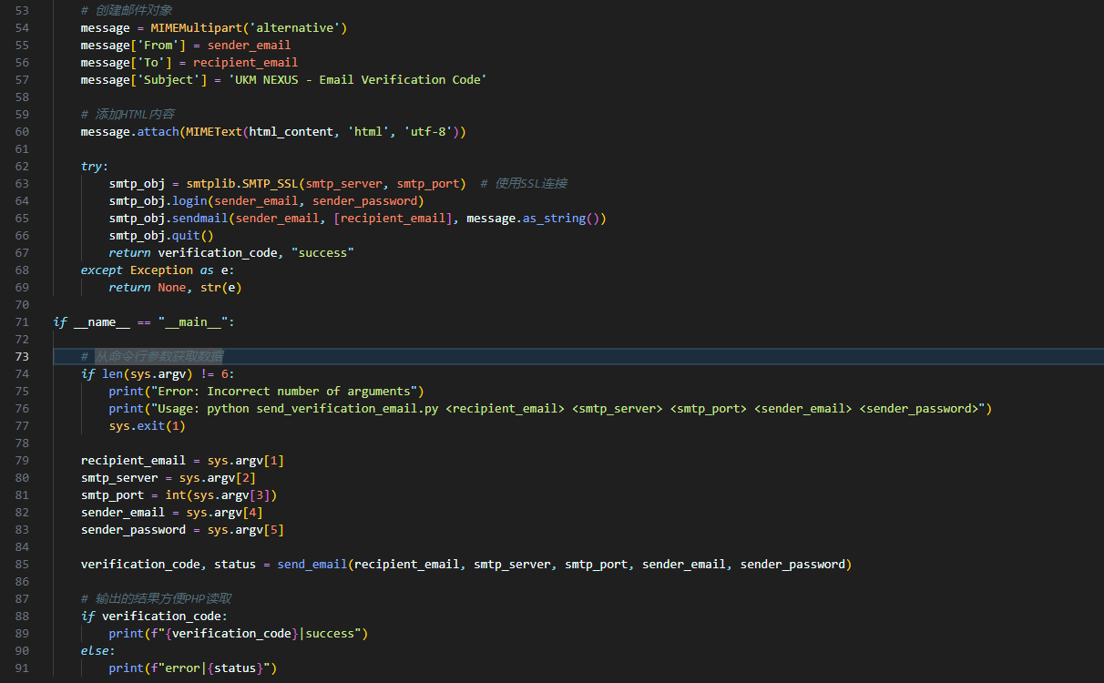
Figure 2.5

User Registration Implementation:
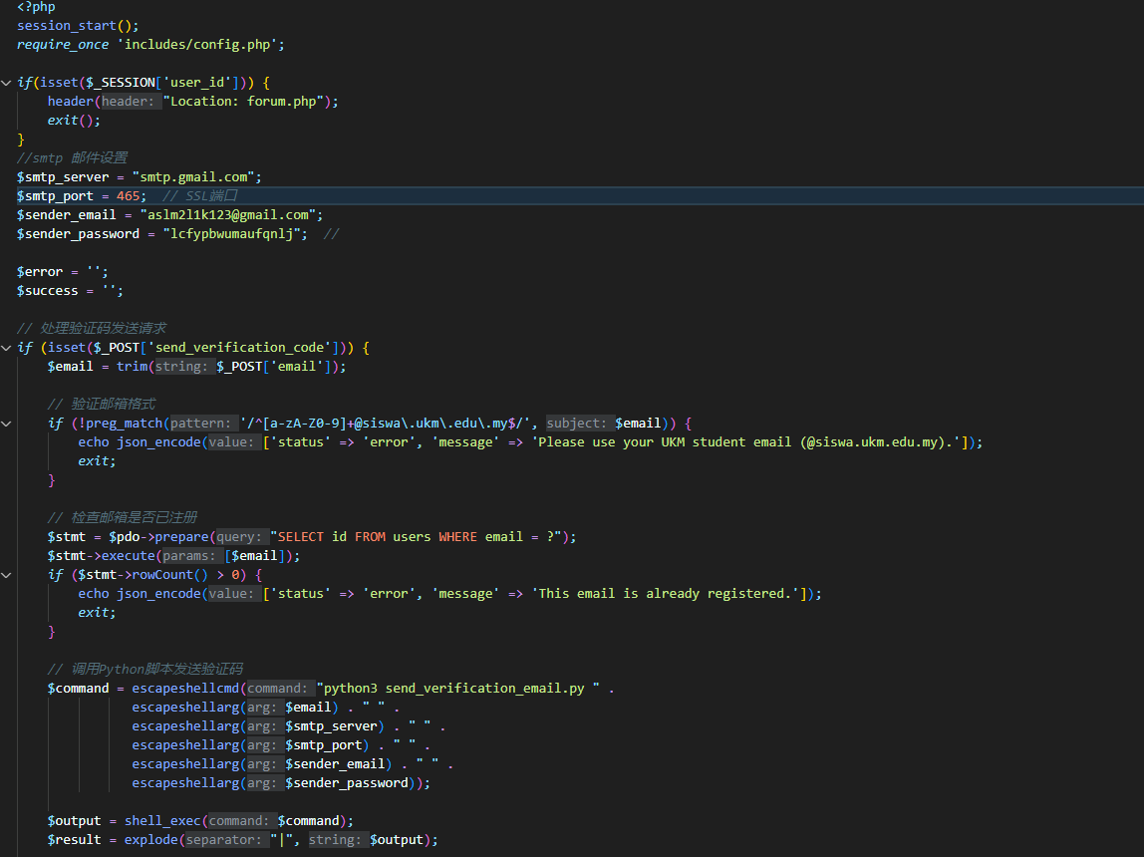Figure 2.6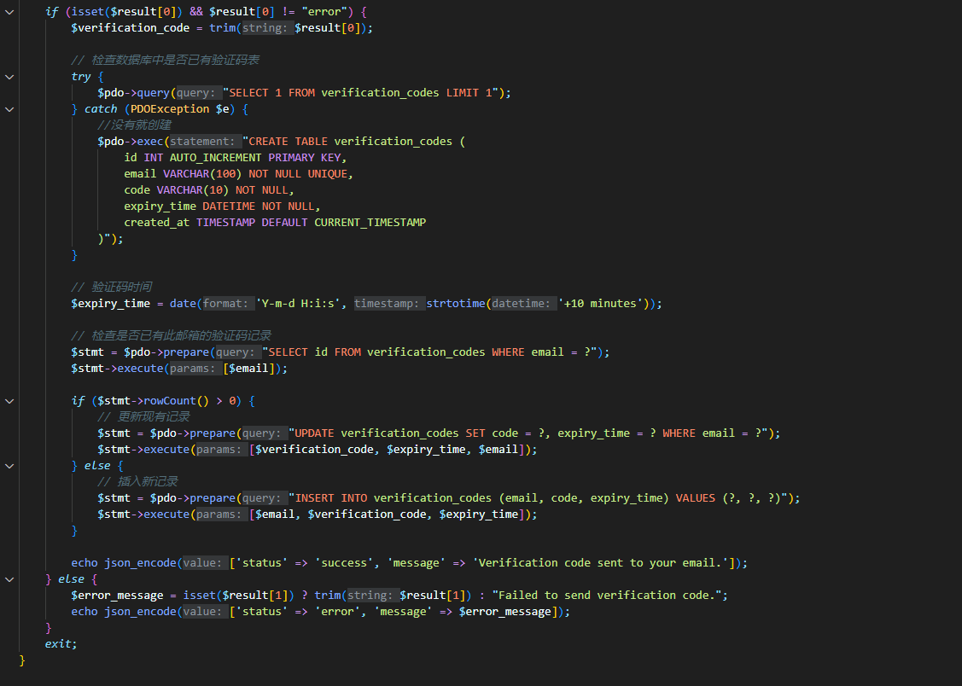Figure 2.7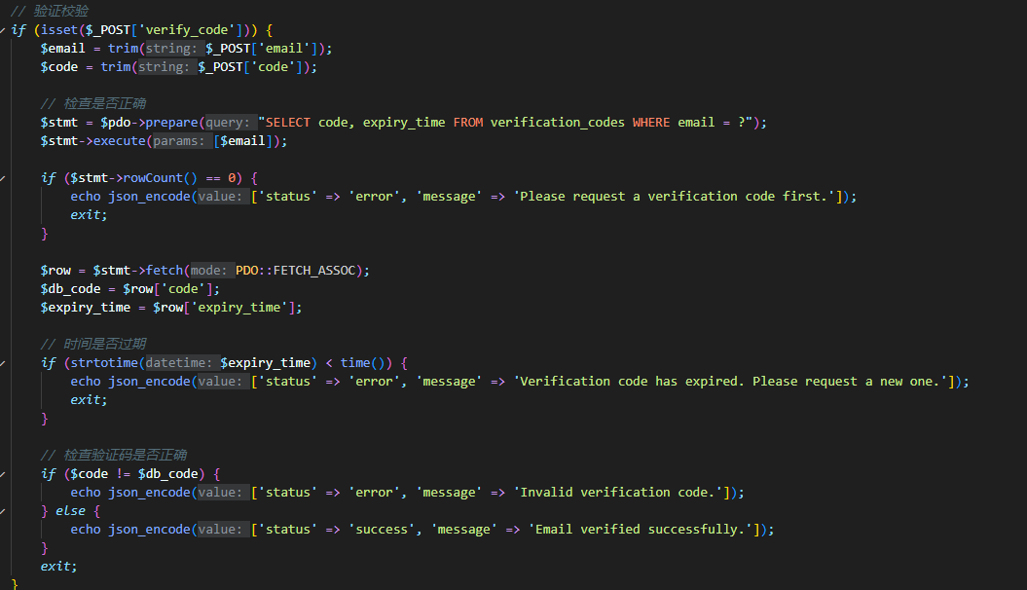Figure 2.8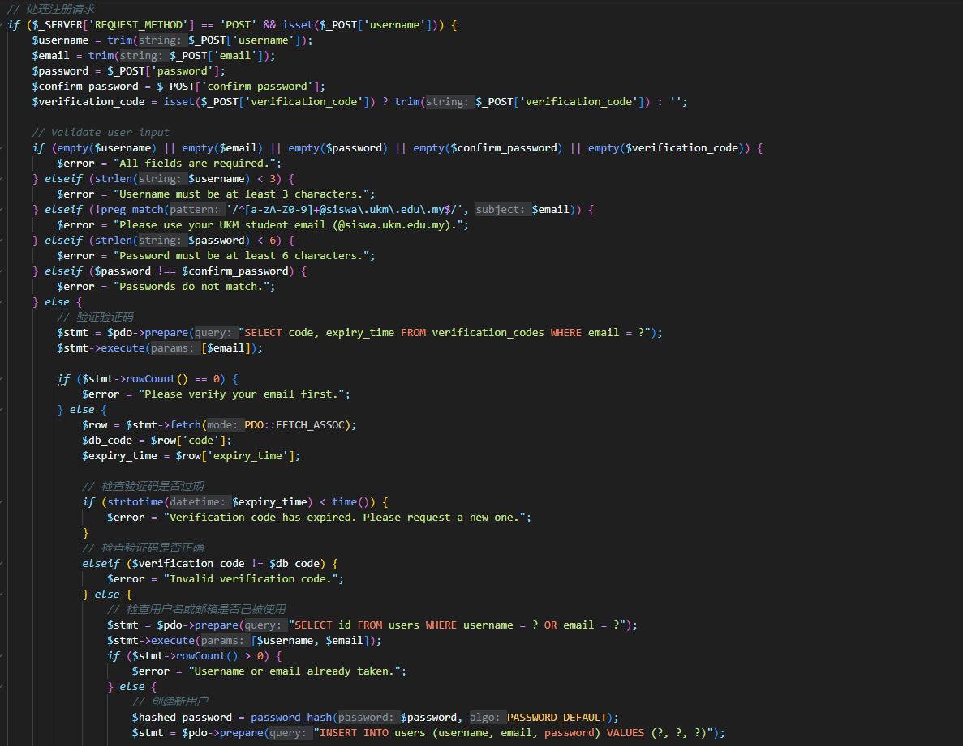Figure 2.9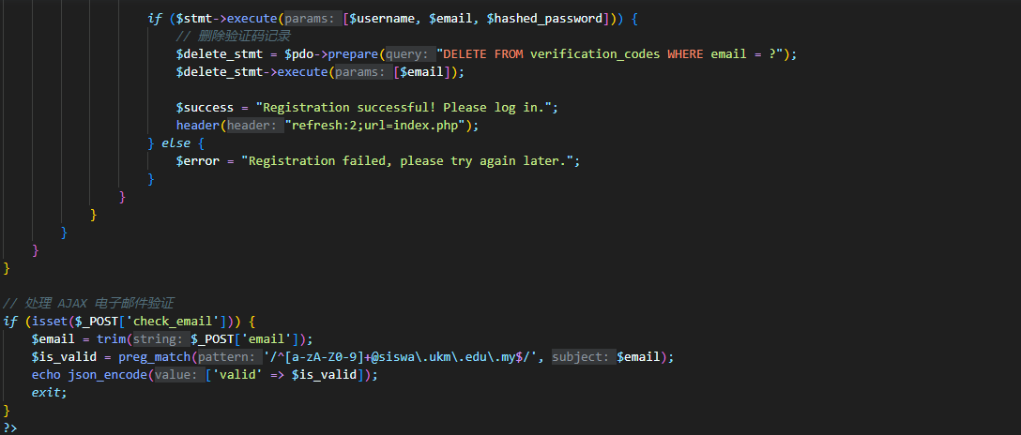Figure 2.10
The registration system combines PHP and Python to create a secure verification process. The most critical security aspect is the domain validation to ensure only UKM email addresses can register, implemented using a regular expression pattern matching system.

2.4 Content Filtering System
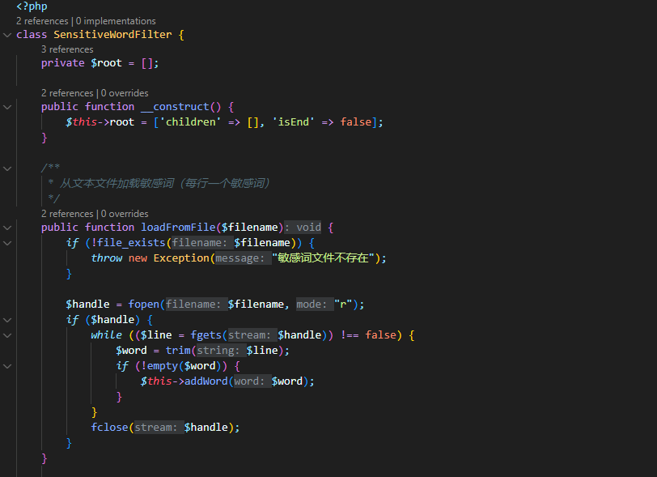
Figure 2.11
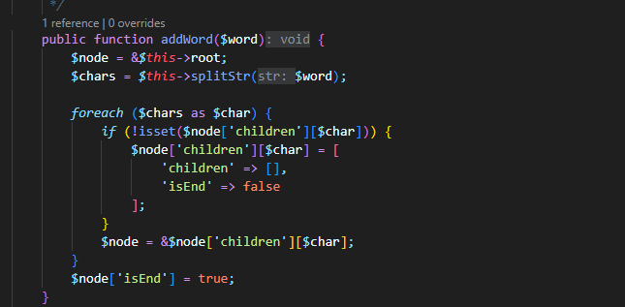
Figure 2.12
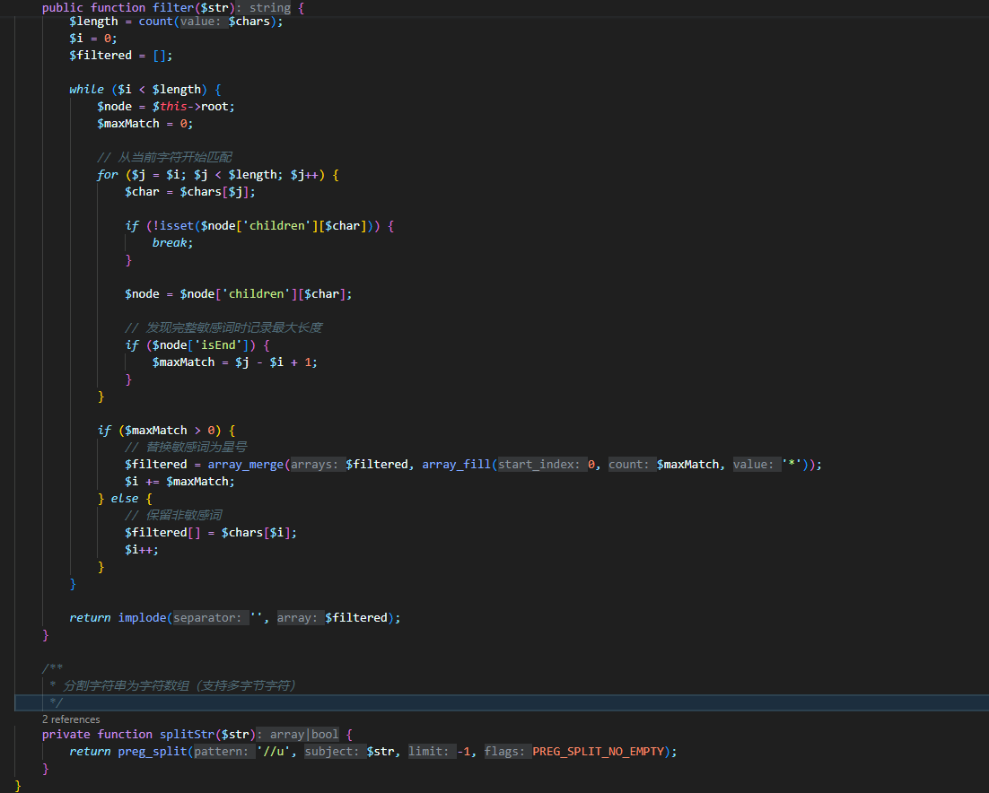
Figure 2.13
The sensitive word filter utilizes a Trie data structure to efficiently check content against a list of prohibited words. This approach offers fast pattern matching for content moderation with minimal performance impact.

Integration with Question Posting:
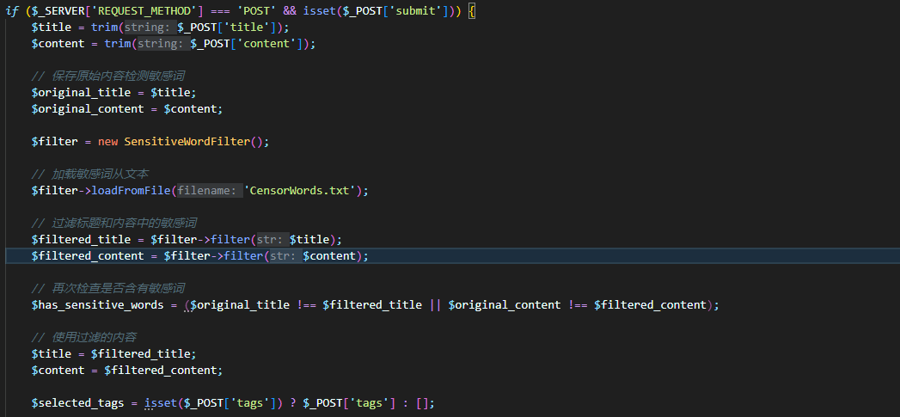
Figure 2.14
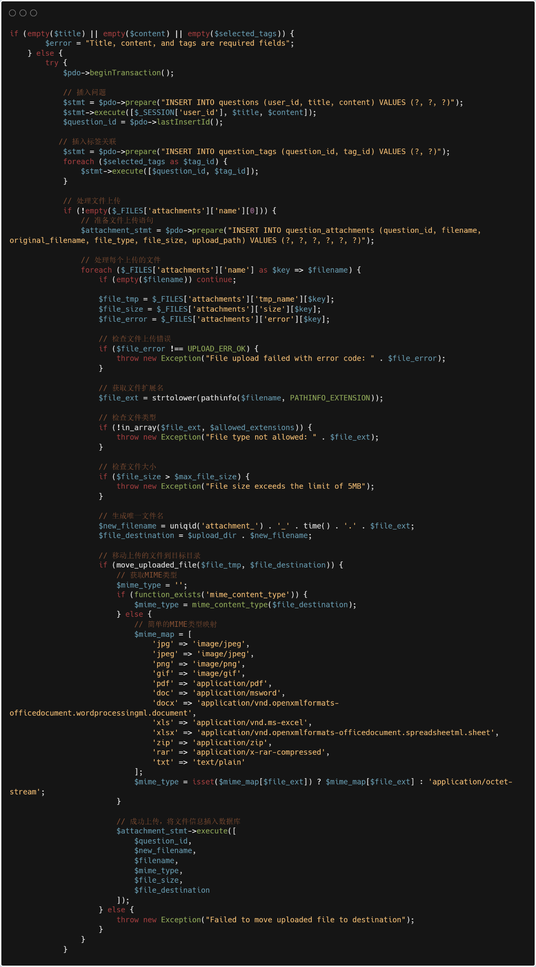
Figure 2.15
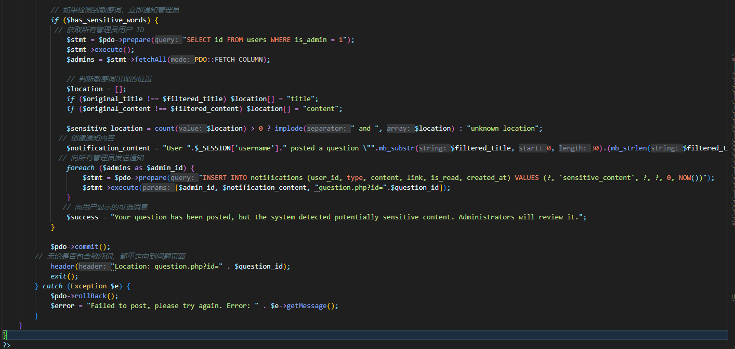
Figure 2.16
This integration ensures that all user-generated content is filtered in real-time. If sensitive content is detected, administrators are immediately notified, maintaining platform standards while still allowing content to be posted and reviewed.

2.5 Question and Answer Module
The question and answer module forms the core functionality of the platform, allowing users to post questions, view questions, and submit answers.
Question Viewing Implementation:
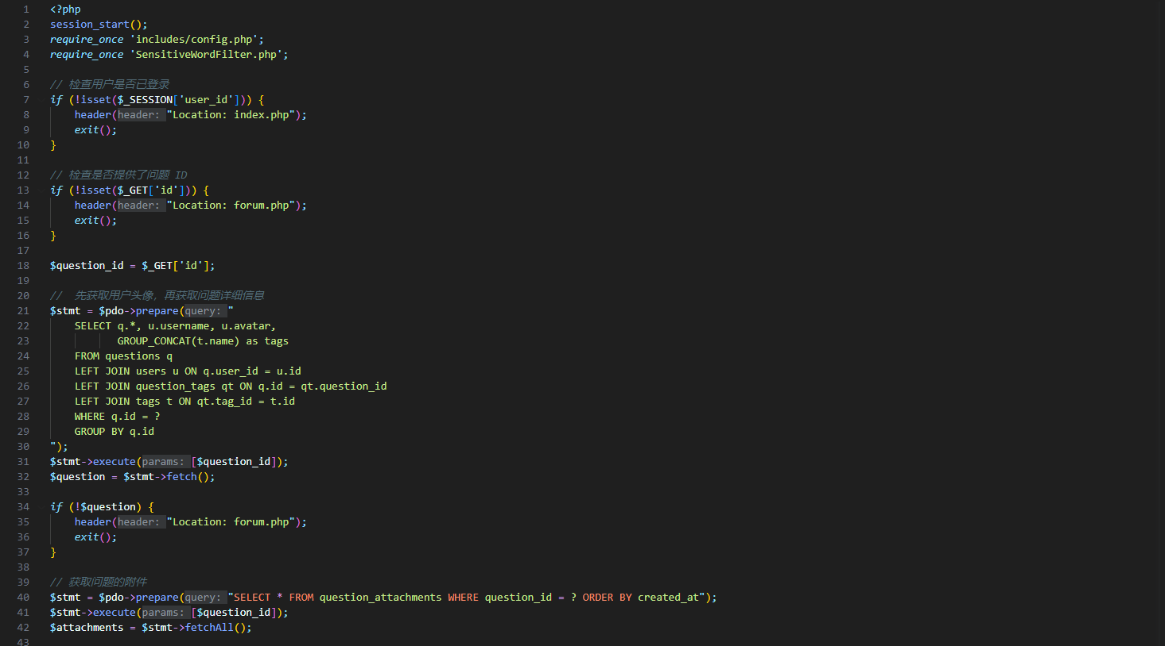
Figure 2.17
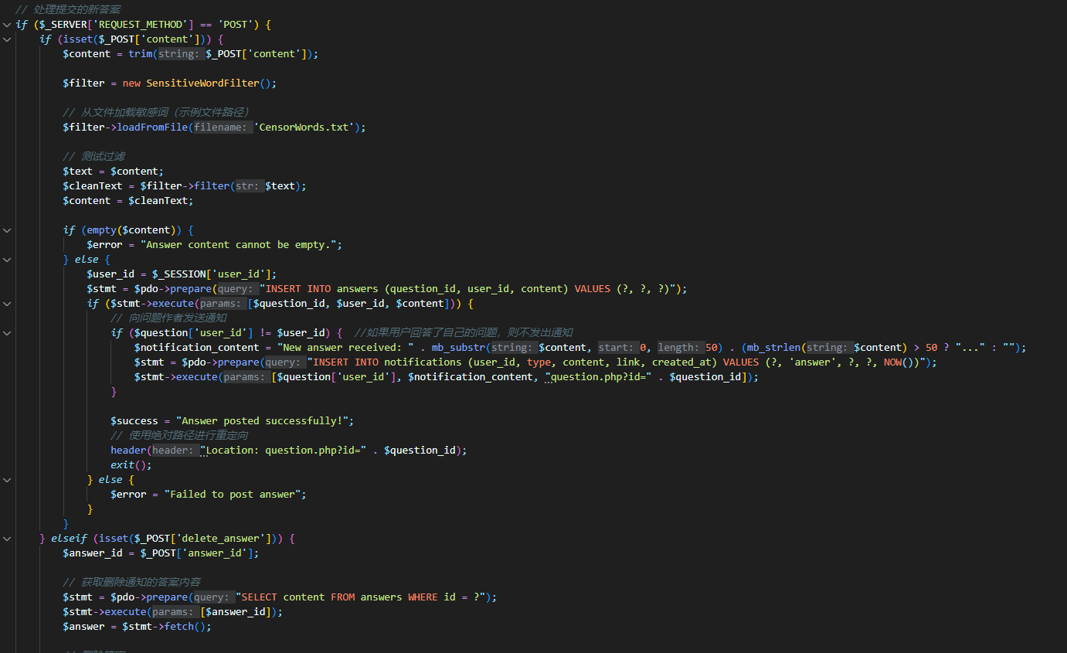
Figure 2.18
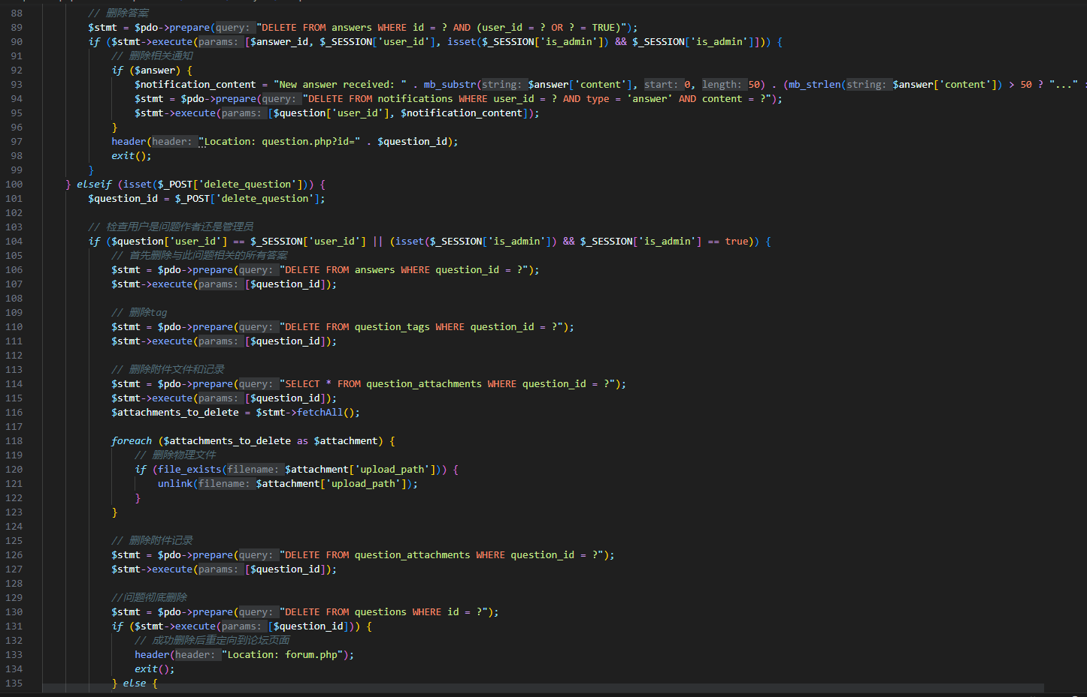
Figure 2.19
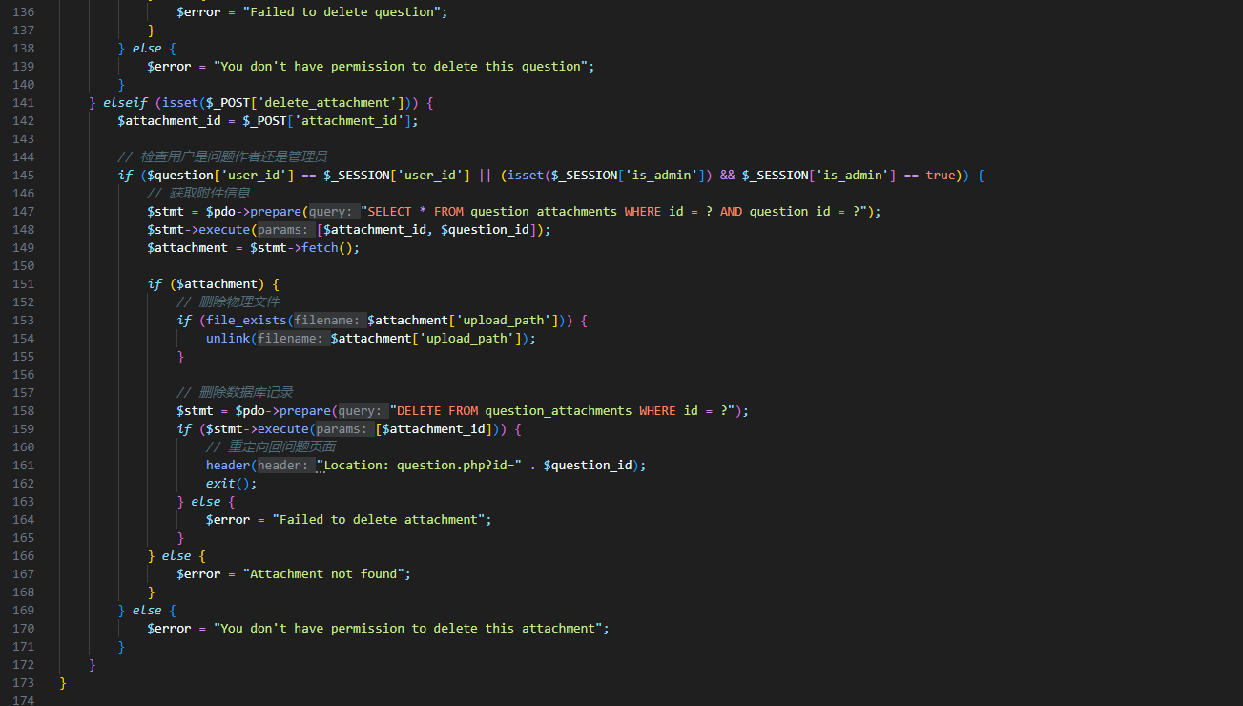
Figure 2.20
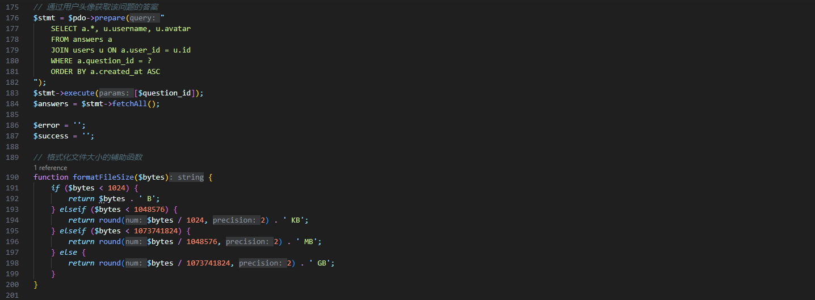
Figure 2.21
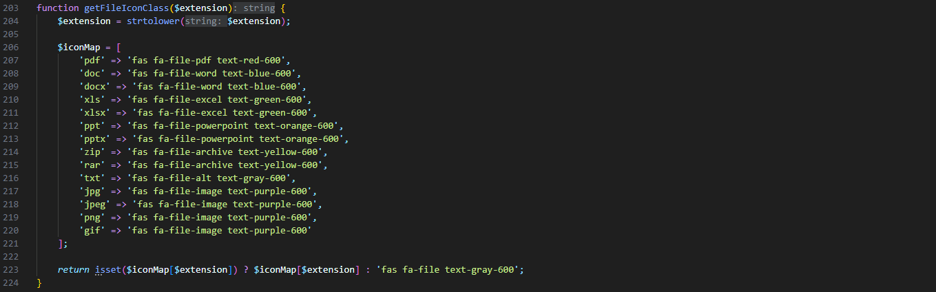
Figure 2.22

