WallE heading note
Physical rotation versus the heading the Teensy reports
Chat note, 7 October 2026. Written so a later search for physical rotation, fold, correction factor, L45, T command, catalog, or best depth finds this file on the PC. This is a copy of the settled conclusions, not a live link to the chat.

The result, in one page
The MPU6050, read through dmpGetYawPitchRoll, reports yaw from -180 degrees to +180 degrees. It does not keep climbing, and it does not report 0 to 360. Past due south the printed number flips from just under +180 to just under -180. That flip is the fold. It is the same direction.
The startup calibration does not fix heading scale. The six numbers it prints are offsets: how far the accelerometer and gyro read from zero while the robot is sitting still. They cancel drift. They do not change how many degrees the gyro counts for one real degree. A new chip gets its own offsets and then runs the same heading math. The same bad shape on two chips was the math, not a bad part.
Raw yaw runs about 1.27 times the physical rotation. Dividing by 1.27 is multiplying by 0.787. That factor is applied to the small step, after the fold has been undone. It is not applied to the already-folded +/-180 number.
Two different jobs got mixed together for a while. They are separate.
- The unfold keeps a stored heading on the side of the circle where the picture was taken. Without it, T can be aimed at the folded number, which is the other side of the room.
- The 0.787 factor makes seven L45 stops about 45 physical degrees apart, so together they cover about 315 degrees of floor and the camera sees the horizon. It does not change the catalog procedure, and it does not change how T returns to a stored heading.

What the chip reports
H prints the heading kept by UpdateIMUHdgValDeg. Before the correction, that was the chip yaw in degrees, optionally multiplied by a fudge factor. The fudge factor of 0.8 was an attempt to match a protractor. It made 0 to 120 degrees look right, because 0.8 times 1.28 is about 1.0. It also pulled the fold forward, so the chart dove at 160 degrees instead of 150. It never removed the fold.
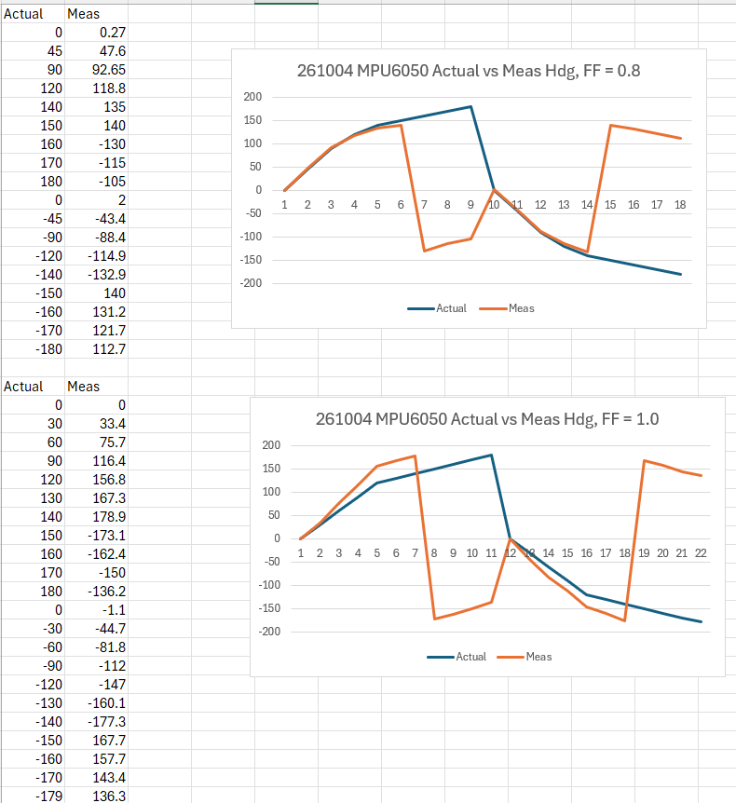
Figure 1. 4 October 2026. Top chart is the 0.8 fudge factor. Bottom chart is no fudge factor. The plunge is the fold, not a dead sensor.
Undo the 0.8 and the no-fudge column is a fairly steady 1.25 to 1.30 times the protractor, once the folded numbers are unfolded:
Robot | Printed | Same angle, unfolded | Ratio
90 | 116.4 | 116.4 | 1.29
140 | 178.9 | 178.9 | 1.28
150 | -173.1 | 186.9 | 1.25
180 | -136.2 | 223.8 | 1.24
-90 | -112 | -112 | 1.24
-150 | 167.7 | -192.3 | 1.28
-179 | 136.3 | -223.7 | 1.25

At the 150 degree mark the raw yaw is -173. That is 187 degrees if 360 is added. Scaling the folded value gives -173 times 0.787 = -136, a different direction. Unfolding first, then scaling, gives 187 times 0.787 = 147, which matches the protractor. From 0 to 120 the raw yaw has not folded, so both methods agree and the chart looks fine.

The fold, with numbers
Hand turn, no correction, protractor on the robot. At the stop where the physical orientation is +150 degrees (just east of due south), the chip says -173. With no unfold, -173 is what goes in the catalog next to the winning depth. The picture was taken facing +150. The stored heading says -173.
The Pi then sends T-173, because -173 is the only heading it has for that picture.
Both numbers in the command have to be chip numbers. An end-of-scan heading taken from a later corrected floor catalog does not belong in this example. Seven uncorrected L45 steps of 45 raw degrees, starting from 0, end near +45: -45, -90, -135, -180, then the fold, then +135, +90, +45.
So the Pi sends T-173 while the Teensy thinks the current heading is +45. The firmware subtracts in this order:
45 - (-173) = 218
218 is past 180, so 218 - 360 = -142
It calls SpinTurn with 142 degrees and a direction taken from the minus sign. The other order, -173 - 45 = -218, then +360 = 142, is the same turn with the sign flipped.
From +45 clockwise through 90, 150, and 180 to -173 is 135 degrees plus the last 7 degrees past the fold, which is 142. The path through 0 is 45 + 173 = 218. The firmware drops 218 because it is past 180, and takes the 142 degree path, clockwise through south. -173 on that path is 7 degrees past due south. That is the pose where the chip said -173, and that is the pose T aims at.

What the correction factor does
The factor scales the chip step before it is added to the running heading. A larger factor means the wheels stop after less physical rotation for the same commanded change. The unfold does not do that job.
L45 turns until the corrected heading has changed by 45 degrees, then H reports that corrected heading. The catalog can only ever show about 45 degrees, whichever factor is installed. Changing 0.787 to 0.753 does not move the catalog numbers. It changes how far the chassis turns to make the corrected heading move 45. The difference is on the floor, with a protractor or the tape marks, not in the catalog.
That is why these two catalogs matched after the factor was changed from 0.787 to 0.753:
-49.9, -96.4, -143.3, 170.6, 123.5, 77.3, 31.4
-50.1, -96.6, -143.5, 170.6, 124.4, 78.1, 30.9
Each step is about 46 degrees of corrected heading. The Excel delta on the first run was the leftover after that closed loop, not the raw 1.27 scale. Multiplying 0.787 by 315/328.6 gives 0.753. That only trims the leftover.
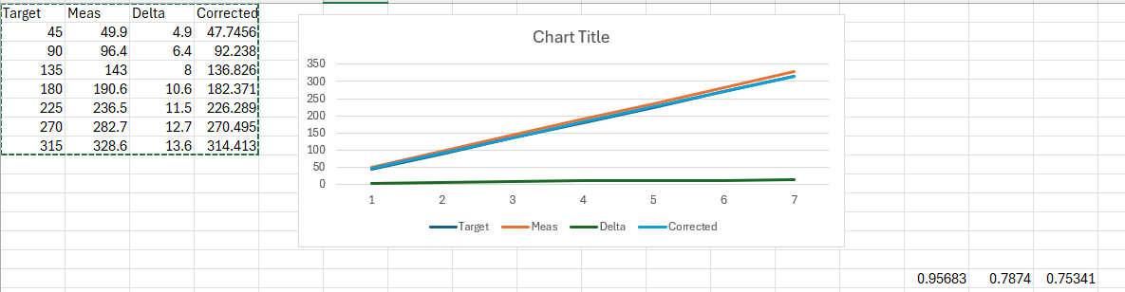
Figure 2. 7 October 2026. Commanded stop versus corrected heading after seven L45 steps, factor 0.787. The leftover is why 0.753 was tried. The catalog still showed about 45 degree steps.
Without the factor, L45 stops when raw yaw has moved 45. The chassis has then turned about 45 / 1.27, roughly 35 degrees. Seven of those cover about 245 degrees of floor, not 315. If the opening is in the arc never visited, the catalog has no sample for it, and T aims at the best sample it does have. Inside the arc that was scanned, the worst miss is half a step, about 17 degrees.
With the factor, the seven stops are about 45 physical degrees apart and cover the horizon. The catalog procedure is the same. The poses being photographed are not. T still returns to the pose that produced the winning depth, because the sample and the turn share the same corrected heading. A wrong but constant factor spaces the stops unevenly. It does not send T to a different pose than the one that took the picture.

What T actually does
T is not a separate compass. TurnToHdgDeg subtracts the current corrected heading from the catalog heading and hands that difference to SpinTurn. SpinTurn watches the corrected heading and stops when it has moved by that difference. Start plus that difference is the catalog heading, within the match tolerance.
The winning depth was stored with that same corrected heading. Stopping at that number puts the chassis back at the pose where the picture was taken. The factor never has to equal the protractor for this to hold. It only has to be the same factor during the scan and during T.
Wall-follow never asked this question. It steers from the side distance sensors. A heading that runs 25 percent long does not enter that loop, and a 10 degree correction never reaches the fold. The old run-to-daylight scan, which stored a heading and then called TurnToHdgDeg, is the same test as find_clear_direction. That is why it did not work well.

The code
The three static variables sit at the top of UpdateIMUHdgValDeg. Everything that reads ypr[0] replaces the fudge-factor line inside if (flag != 0), after dmpGetYawPitchRoll. ypr is only filled when flag is not 0. If flag is 0, leave IMUHdgValDeg as it was. setup already calls this function for the settle loop, so the first call seeds the running total. Do not keep a second copy in setup.
static float prevRawDeg = 0;
static float continuousDeg = 0;
static bool haveYaw = false;
float rawDeg = ypr[0] * 180.0f / M_PI;
if (!haveYaw) {
prevRawDeg = rawDeg;
continuousDeg = 0; // heading at power-up is 0
haveYaw = true;
} else {
float step = rawDeg - prevRawDeg;
if (step > 180.0f) step -= 360.0f;
if (step < -180.0f) step += 360.0f;
continuousDeg += step * IMU_HDG_CORRECTION_FACTOR;
prevRawDeg = rawDeg;
}
IMUHdgValDeg = continuousDeg;
while (IMUHdgValDeg > 180.0f) IMUHdgValDeg -= 360.0f;
while (IMUHdgValDeg < -180.0f) IMUHdgValDeg += 360.0f;
IMU_HDG_CORRECTION_FACTOR is 0.787, which is 1/1.27. The multiply is the divide. Putting 1.27 in that spot stretches the heading the wrong way. The two while lines only put the answer back into -180 to +180 for H and for T. They do not undo the unfolding. The first printed heading is 0, because the running total starts there. The settle test still works: it only cares that two readings in a row differ by less than 0.1 degree.
A few degrees is enough. The scan stores headings about 45 degrees apart and picks the one with the greatest depth. A 5 degree miss still lands in the same eighth of the circle. The old failure was a fold that pointed the robot at the opposite eighth.

Bench check after the correction
5 October 2026, robot turned by hand, no motors, factor 1/1.27. The plunge is gone. Measured heading runs a few degrees short: 180 reads 174.5, 90 reads 87.3, and back at the start it reads -2.8. So 1.27 is a little large. 1.24 would land nearer the marks. That is a trim.
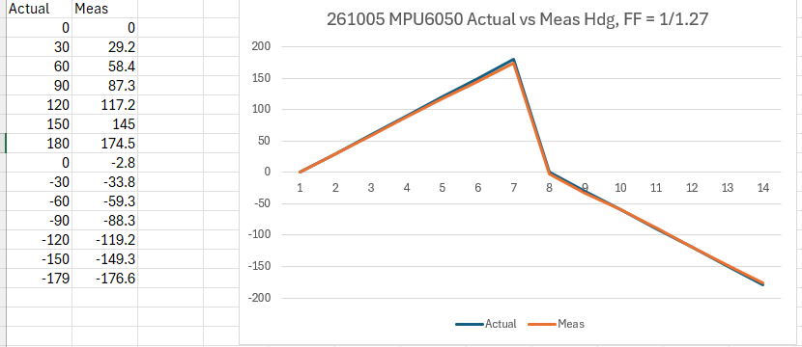
Figure 3. 5 October 2026 bench pass. Actual and measured stay together through 180 degrees and back through -179. No plunge.
The same day, T commands on the floor matched. T150 stopped at 153, T180 at 178.6, T-150 at -151.3. Return-to-zero stayed inside about 5 degrees. The full spin on the way back from 180 is the short-way rule. +180 and -180 are the same direction, and from there back to 0 is half a circle either way.

Floor scans, 7 October 2026
Both runs picked the same eighth, about -143 degrees, and T to that heading left the robot where later 4 and 6 tweaks only wandered by about 10 degrees. Frame ages were 0.001 to 0.033 seconds, which is a new picture, not the old stuck clock.
First run, factor 0.787. Best sample -143.3 degrees at 4834 mm.
(-49.9, 603), (-96.4, 979), (-143.3, 4834), (170.6, 1607),
(123.5, 1379), (77.3, 1173), (31.4, 460)
Second run, factor 0.753. Best sample -143.5 degrees at 2656 mm. Headings almost unchanged, as expected.
(-50.1, 987), (-96.6, 1692), (-143.5, 2656), (170.6, 2348),
(124.4, 1102), (78.1, 1123), (30.9, 1810)
The list has seven samples because the scan commands L45 seven times, labeled 45 through 315, and does not take an eighth sample back at the start. The first H of each run timed out with "no newer Teensy IMU timestamp." The H after the backup did return a heading, about -3 degrees, and the scan used that.

Search handles
- physical rotation, protractor, pose, horizon, 45 degree steps, 315 degrees
- fold, +/-180, -173 versus +150, T-173, 142 degree short way, 218 degree long way
- correction factor, 0.787, 1.27, 0.753, IMU_HDG_CORRECTION_FACTOR
- L45 closed loop, catalog cannot show the factor, SpinTurn, TurnToHdgDeg
- MPU6050, DMP, offsets versus scale, dmpGetYawPitchRoll, UpdateIMUHdgValDeg
- best depth, find_clear_direction, run to daylight

Files attached to the chat
Titles only. The files themselves stayed on the PC. Screenshots that carry the argument are embedded above.
- Screenshot 2026-10-04 145756.png — first actual-versus-measured chart, fudge factor 0.8
- Screenshot 2026-10-04 160919.png — fudge factor 0.8 and 1.0 together. Embedded as Figure 1.
- Screenshot 2026-10-05 145907.png — bench pass after unfold, factor 1/1.27. Embedded as Figure 3.
- Screenshot 2026-10-05 155145.png — floor T commands versus measured heading, same day
- Screenshot 2026-10-07 163330.png — commanded versus measured after 0.787. Embedded as Figure 2.
- 261005_Heading_Correction_Testing_Compressed.mp4 — floor T-command video
- nav.log — 16:37 run, factor 0.753
- 261007_1637_nav.log — 15:49 and 16:15 runs, factor 0.787
- VisionEnhanced4WheelRobot.ino — Teensy firmware reviewed for the yaw path

