Bangladesh University of
Business and Technology (BUBT)
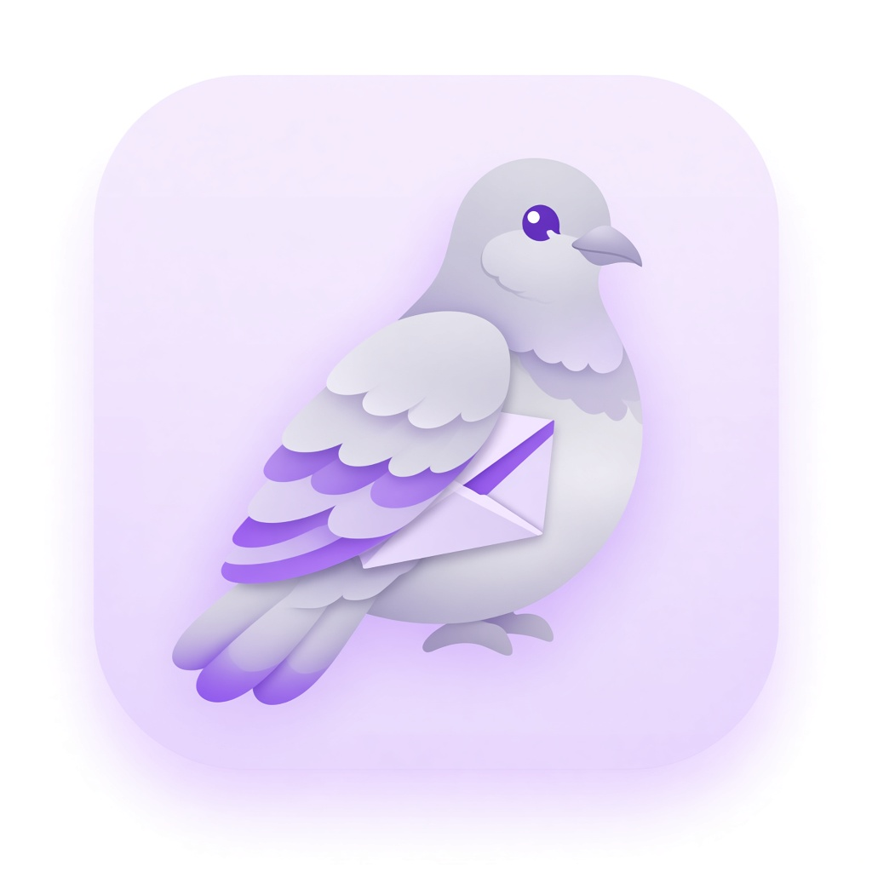
PROJECT PROPOSAL
On
Payra: A Real-Time Desktop Messaging Application
with Campus Chat and AI Assistant
Submission Date: 25th September, 2026
Submitted By:
ID | Name | Intake/Section

Submitted To
Meher Afroj
Assistant Professor, Dept. of CSE
BUBT

Payra: A Real-Time Desktop Messaging Application with Campus Chat and AI Assistant
1. Needs / Problems
Students and small campus groups rely heavily on messaging apps to coordinate classes, assignments, club activities, and project work. In practice, this creates several problems:
- Fragmented communication: conversations are scattered across WhatsApp, Facebook Messenger, email, and group SMS, which makes it hard to keep academic discussions organized.
- Mobile-first tools on desktop: most popular messengers are optimized for phones. On a laptop, students often use a browser wrapper or a heavy Electron app that feels slow and distracts from study-focused workflows.
- Weak project-team fit: general-purpose chat apps mix personal and academic chats, lack a clear campus/project identity, and do not provide a dedicated study assistant inside the same product.
- Limited learning opportunity: commercial apps are closed systems. For Software Development Project (SDP-2), the team needs a full-stack product they can design, implement, and demonstrate end-to-end — UI, authentication, realtime messaging, media, and an AI module.
Therefore, there is a clear need for a lightweight, native desktop chat application tailored to campus use: fast 1:1 and group messaging, image sharing, a clean study-friendly interface, and a separate AI assistant — without trying to replace every consumer messenger overnight.
2. Goals / Objectives
Payra (পায়রা) means pigeon in Bangla. The name is inspired by carrier pigeons — the old way humans sent messages across distance. The project aims to build a modern “carrier” for campus conversations: a realtime desktop messenger with a meaningful local identity.
Primary objectives:
1. Design and implement a native desktop chat client (Windows and macOS) using Python and PySide6.
2. Provide secure user authentication (register / login) and user profiles.
3. Support realtime text messaging for both one-to-one (direct) and group conversations.
4. Enable image sharing through cloud storage with messages.
5. Integrate a dedicated AI assistant as a separate module (not mixed into normal human chats).
6. Deliver a polished UI (login, register, chat list, conversation view, groups, profile) suitable for SDP-2 demonstration and evaluation.
3. Existing System Analysis
Before proposing Payra, we studied popular messaging applications that students already use. Below is a short analysis of three widely used systems and their shortcomings relative to our campus / SDP-2 goals.
3.1 WhatsApp Desktop
WhatsApp is the most common messaging tool among students in Bangladesh. The desktop client mirrors mobile chats and supports text, images, voice notes, and groups. Strengths include huge user adoption, reliable delivery, and end-to-end encryption for personal chat. Shortcomings for our context: (i) it is primarily a phone-linked product, not a campus-focused workspace; (ii) academic and personal chats are mixed; (iii) there is no built-in study / AI assistant; (iv) it is a closed commercial platform — we cannot extend it as a university software project [1].
3.2 Telegram Desktop
Telegram Desktop is a fast, multi-platform messenger with large groups, channels, bots, and cloud sync. Strengths include a capable desktop experience and extensibility through bots. Shortcomings: (i) the product is general-purpose social messaging, not tailored to a single campus or course team; (ii) bot-based “AI helpers” are external and fragmented; (iii) again, it is not a system our team can own, redesign, or submit as an SDP deliverable [2].
3.3 Discord
Discord is popular for communities, gaming, and student clubs. It offers servers, channels, voice, and rich permission models. Strengths include structured communities and a strong desktop client. Shortcomings: (i) the mental model (servers/channels) is heavier than simple campus DM + group chat; (ii) it can be distracting for academic focus; (iii) like WhatsApp and Telegram, it is proprietary and not suitable as the codebase for an SDP-2 implementation [3].
Summary of gaps: existing apps solve everyday messaging well, but none give our team a lightweight, ownable desktop product with campus branding, controlled feature scope, and a first-class AI assistant module. Payra addresses that gap as an educational product with a realistic MVP.
4. Features / Scopes
The scope is intentionally limited to features we can design, implement, and demonstrate within the SDP-2 timeline. Over-estimating features is avoided.
In-scope (MVP deliverables):
- User registration and login (MVP may use local auth first, then Supabase Auth).
- User profile display (name, username, about / status).
- Direct (1:1) chat with realtime text messages.
- Group chat with member list and group title / avatar.
- Image attachment / transfer via cloud storage (Supabase Storage).
- Desktop UI shell: navigation (Chats, Groups, Contacts, Starred, Payra AI), chat list, conversation pane, and detail / profile panels.
- Dedicated Payra AI assistant entry (separate from human conversations) — phase 3.
- Cross-platform desktop packaging target: Windows and macOS.
Out of scope for this proposal / MVP:
- Voice / video calling and voice notes.
- End-to-end encryption comparable to commercial messengers.
- Mobile native apps (iOS / Android).
- Public social feeds, stories, or marketplace features.
- Full enterprise admin console or multi-tenant SaaS billing.
5. Requirements
5.1 Hardware
- Development PCs / laptops (Windows 10/11 or macOS) with at least 8 GB RAM recommended.
- Stable internet connection for backend services (Supabase) and AI API calls.
5.2 Software & Tools
- Python 3.11+ virtual environment.
- PySide6 (Qt for Python) for the desktop UI.
- Supabase (Auth, PostgreSQL, Realtime, Storage) as backend-as-a-service.
- Git / GitHub for version control and team collaboration.
- Google Stitch (or equivalent) for UI mockups / design exploration.
- IDE: VS Code / Cursor; optional Qt Designer.
5.3 Technology Stack
Layer | Technology
Desktop Client | Python, PySide6 (Qt)
Backend / DB | Supabase (PostgreSQL, Auth, Realtime)
Media | Supabase Storage (chat images)
AI Assistant | Separate service module (e.g., Groq / Gemini API)
5.4 Personnel
An SDP-2 student team under the supervision of the course instructor. Roles will be divided across UI/UX implementation, backend/database, realtime messaging, media upload, and AI integration. (Team member details are listed on the cover page.)
6. Limitations & Future Works
Limitations (current / MVP):
- No voice/video calling in the first release.
- Email verification and advanced account recovery may be deferred in early auth.
- AI responses depend on third-party API availability and quota.
- Security features will follow standard HTTPS + Auth practices; full E2EE is not planned for MVP.
- Performance and scale will be demonstrated for a campus-sized user set, not millions of users.
Possible future works:
- Push notifications and better offline message sync.
- Voice messages and optional calls.
- Course / section-based groups and university SSO.
- Richer AI tools (summarize chat, quiz helper) still kept separate from human chats.
- Mobile companion app after the desktop MVP is stable.
7. References
References are listed below in a numbered style suitable for further reading (adapted from common academic citation practice).
[1]. WhatsApp LLC. “WhatsApp Features.” WhatsApp, https://www.whatsapp.com/. Accessed 24 Sept. 2026.
[2]. Telegram FZ-LLC. “Telegram Messenger.” Telegram, https://telegram.org/. Accessed 24 Sept. 2026.
[3]. Discord Inc. “Discord — Your Place to Talk and Hang Out.” Discord, https://discord.com/. Accessed 24 Sept. 2026.
[4]. The Qt Company. “Qt for Python (PySide6) Documentation.” Qt, https://doc.qt.io/qtforpython/. Accessed 24 Sept. 2026.
[5]. Supabase Inc. “Supabase Documentation — Auth, Database, Realtime, Storage.” Supabase, https://supabase.com/docs. Accessed 24 Sept. 2026.
[6]. Python Software Foundation. “The Python Language Reference.” Python.org, https://docs.python.org/3/. Accessed 24 Sept. 2026.

— End of Proposal —

