#install.packages("glmnet")  
#install.packages("ggcorrplot")  
#install.packages("MASS")  
#install.packages("car")  
#install.packages("lubridate")

library(tidyverse)

## ── Attaching packages ─────────────────────────────────────── tidyverse 1.3.0 ──

## ✓ ggplot2 3.3.2 ✓ purrr 0.3.4  
## ✓ tibble 3.0.4 ✓ dplyr 1.0.2  
## ✓ tidyr 1.1.2 ✓ stringr 1.4.0  
## ✓ readr 1.4.0 ✓ forcats 0.5.0

## ── Conflicts ────────────────────────────────────────── tidyverse_conflicts() ──  
## x dplyr::filter() masks stats::filter()  
## x dplyr::lag() masks stats::lag()

library(tidymodels)

## ── Attaching packages ────────────────────────────────────── tidymodels 0.1.2 ──

## ✓ broom 0.7.2 ✓ recipes 0.1.15  
## ✓ dials 0.0.9 ✓ rsample 0.0.8   
## ✓ infer 0.5.4 ✓ tune 0.1.2   
## ✓ modeldata 0.1.0 ✓ workflows 0.2.1   
## ✓ parsnip 0.1.5 ✓ yardstick 0.0.7

## ── Conflicts ───────────────────────────────────────── tidymodels_conflicts() ──  
## x scales::discard() masks purrr::discard()  
## x dplyr::filter() masks stats::filter()  
## x recipes::fixed() masks stringr::fixed()  
## x dplyr::lag() masks stats::lag()  
## x yardstick::spec() masks readr::spec()  
## x recipes::step() masks stats::step()

library(glmnet)

## Loading required package: Matrix

##   
## Attaching package: 'Matrix'

## The following objects are masked from 'package:tidyr':  
##   
## expand, pack, unpack

## Loaded glmnet 4.1

library(GGally)

## Registered S3 method overwritten by 'GGally':  
## method from   
## +.gg ggplot2

library(ggcorrplot)  
library(MASS)

##   
## Attaching package: 'MASS'

## The following object is masked from 'package:dplyr':  
##   
## select

library(car)

## Loading required package: carData

##   
## Attaching package: 'car'

## The following object is masked from 'package:dplyr':  
##   
## recode

## The following object is masked from 'package:purrr':  
##   
## some

library(lubridate)

##   
## Attaching package: 'lubridate'

## The following objects are masked from 'package:base':  
##   
## date, intersect, setdiff, union

library(lmtest)

## Loading required package: zoo

##   
## Attaching package: 'zoo'

## The following objects are masked from 'package:base':  
##   
## as.Date, as.Date.numeric

library(readr)  
bike = bike_cleaned <- read_csv("bike_cleaned.csv")

##   
## ── Column specification ────────────────────────────────────────────────────────  
## cols(  
## instant = col_double(),  
## dteday = col_character(),  
## season = col_character(),  
## mnth = col_character(),  
## hr = col_double(),  
## holiday = col_character(),  
## weekday = col_character(),  
## workingday = col_character(),  
## weathersit = col_character(),  
## temp = col_double(),  
## atemp = col_double(),  
## hum = col_double(),  
## windspeed = col_double(),  
## casual = col_double(),  
## registered = col_double(),  
## count = col_double()  
## )

bike = bike %>% mutate(dteday = mdy(dteday))  
bike = bike %>% mutate(season = as_factor(season))  
bike = bike %>% mutate(mnth = as_factor(mnth))  
bike = bike %>% mutate(holiday = as_factor(holiday))  
bike = bike %>% mutate(weekday = as_factor(weekday))  
bike = bike %>% mutate(workingday = as_factor(workingday))  
bike = bike %>% mutate(weathersit = as_factor(weathersit))  
bike = bike %>% mutate(hr = as_factor(hr))  
str(bike)

## tibble [17,379 × 16] (S3: spec_tbl_df/tbl_df/tbl/data.frame)  
## $ instant : num [1:17379] 1 2 3 4 5 6 7 8 9 10 ...  
## $ dteday : Date[1:17379], format: "2011-01-01" "2011-01-01" ...  
## $ season : Factor w/ 4 levels "Winter","Spring",..: 1 1 1 1 1 1 1 1 1 1 ...  
## $ mnth : Factor w/ 12 levels "Jan","Feb","Mar",..: 1 1 1 1 1 1 1 1 1 1 ...  
## $ hr : Factor w/ 24 levels "0","1","2","3",..: 1 2 3 4 5 6 7 8 9 10 ...  
## $ holiday : Factor w/ 2 levels "NotHoliday","Holiday": 1 1 1 1 1 1 1 1 1 1 ...  
## $ weekday : Factor w/ 7 levels "Saturday","Sunday",..: 1 1 1 1 1 1 1 1 1 1 ...  
## $ workingday: Factor w/ 2 levels "NotWorkingDay",..: 1 1 1 1 1 1 1 1 1 1 ...  
## $ weathersit: Factor w/ 4 levels "NoPrecip","Misty",..: 1 1 1 1 1 2 1 1 1 1 ...  
## $ temp : num [1:17379] 0.24 0.22 0.22 0.24 0.24 0.24 0.22 0.2 0.24 0.32 ...  
## $ atemp : num [1:17379] 0.288 0.273 0.273 0.288 0.288 ...  
## $ hum : num [1:17379] 0.81 0.8 0.8 0.75 0.75 0.75 0.8 0.86 0.75 0.76 ...  
## $ windspeed : num [1:17379] 0 0 0 0 0 0.0896 0 0 0 0 ...  
## $ casual : num [1:17379] 3 8 5 3 0 0 2 1 1 8 ...  
## $ registered: num [1:17379] 13 32 27 10 1 1 0 2 7 6 ...  
## $ count : num [1:17379] 16 40 32 13 1 1 2 3 8 14 ...  
## - attr(*, "spec")=  
## .. cols(  
## .. instant = col_double(),  
## .. dteday = col_character(),  
## .. season = col_character(),  
## .. mnth = col_character(),  
## .. hr = col_double(),  
## .. holiday = col_character(),  
## .. weekday = col_character(),  
## .. workingday = col_character(),  
## .. weathersit = col_character(),  
## .. temp = col_double(),  
## .. atemp = col_double(),  
## .. hum = col_double(),  
## .. windspeed = col_double(),  
## .. casual = col_double(),  
## .. registered = col_double(),  
## .. count = col_double()  
## .. )

We need to convert hr because it is technically not being used as a numerical value but rather a factor.

ggcorr(bike, label = TRUE)

## Warning in ggcorr(bike, label = TRUE): data in column(s) 'dteday', 'season',  
## 'mnth', 'hr', 'holiday', 'weekday', 'workingday', 'weathersit' are not numeric  
## and were ignored

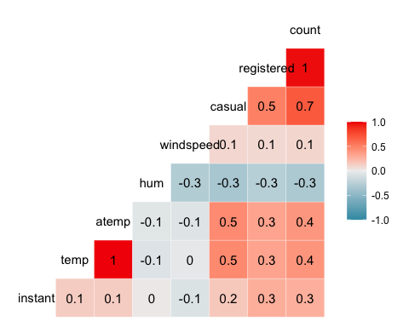 Temp and ATemp appear to be best correlated.

ggplot(bike, aes(x=hr, y=count)) + geom_boxplot() + theme_bw()

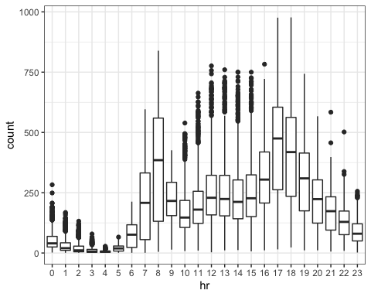

ggplot(bike, aes(x=season, y=count)) + geom_boxplot() + theme_bw()

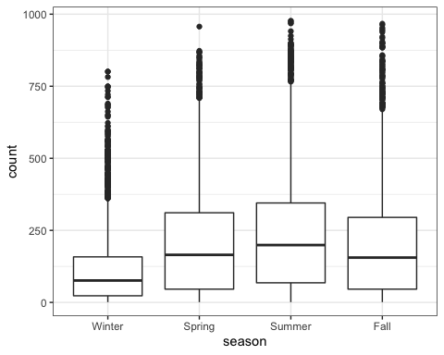

ggplot(bike, aes(x=mnth, y=count)) + geom_boxplot() + theme_bw()

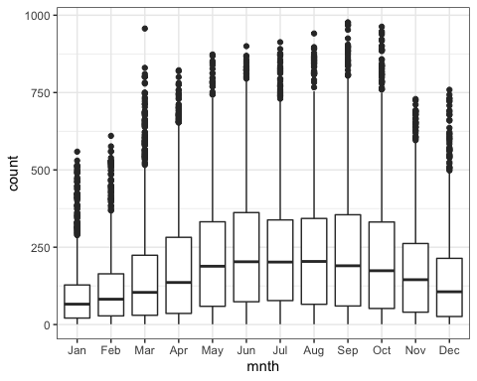

ggplot(bike, aes(x=holiday, y=count)) + geom_boxplot() + theme_bw()

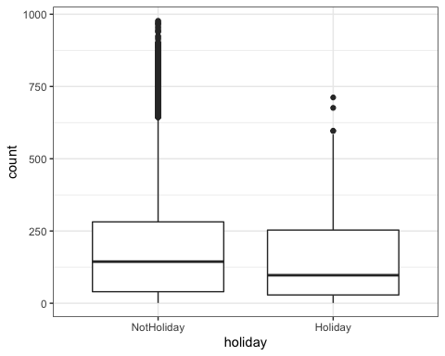

ggplot(bike, aes(x=weekday, y=count)) + geom_boxplot() + theme_bw()

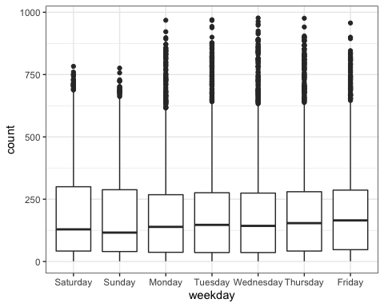

ggplot(bike, aes(x=workingday, y=count)) + geom_boxplot() + theme_bw()

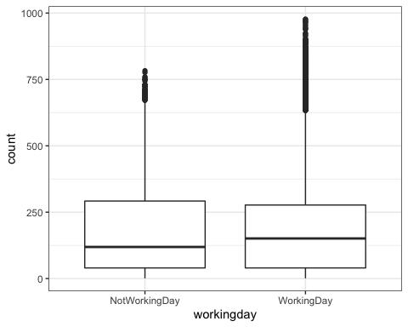

ggplot(bike, aes(x=weathersit, y=count)) + geom_boxplot() + theme_bw()

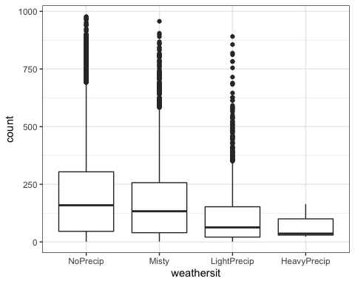 Hr, weathersit, etc.

bike_recipe = recipe(count ~ temp, bike)  
  
lm_model =  
 linear_reg() %>%  
 set_engine("lm")  
  
lm_wflow =  
 workflow() %>%  
 add_model(lm_model) %>%  
 add_recipe(bike_recipe)  
  
lm_fit = fit(lm_wflow, bike)

summary(lm_fit$fit$fit$fit)

##   
## Call:  
## stats::lm(formula = ..y ~ ., data = data)  
##   
## Residuals:  
## Min 1Q Median 3Q Max   
## -291.37 -110.23 -32.86 76.77 744.76   
##   
## Coefficients:  
## Estimate Std. Error t value Pr(>|t|)   
## (Intercept) -0.0356 3.4827 -0.01 0.992   
## temp 381.2949 6.5344 58.35 <2e-16 ***  
## ---  
## Signif. codes: 0 '***' 0.001 '**' 0.01 '*' 0.05 '.' 0.1 ' ' 1  
##   
## Residual standard error: 165.9 on 17377 degrees of freedom  
## Multiple R-squared: 0.1638, Adjusted R-squared: 0.1638   
## F-statistic: 3405 on 1 and 17377 DF, p-value: < 2.2e-16