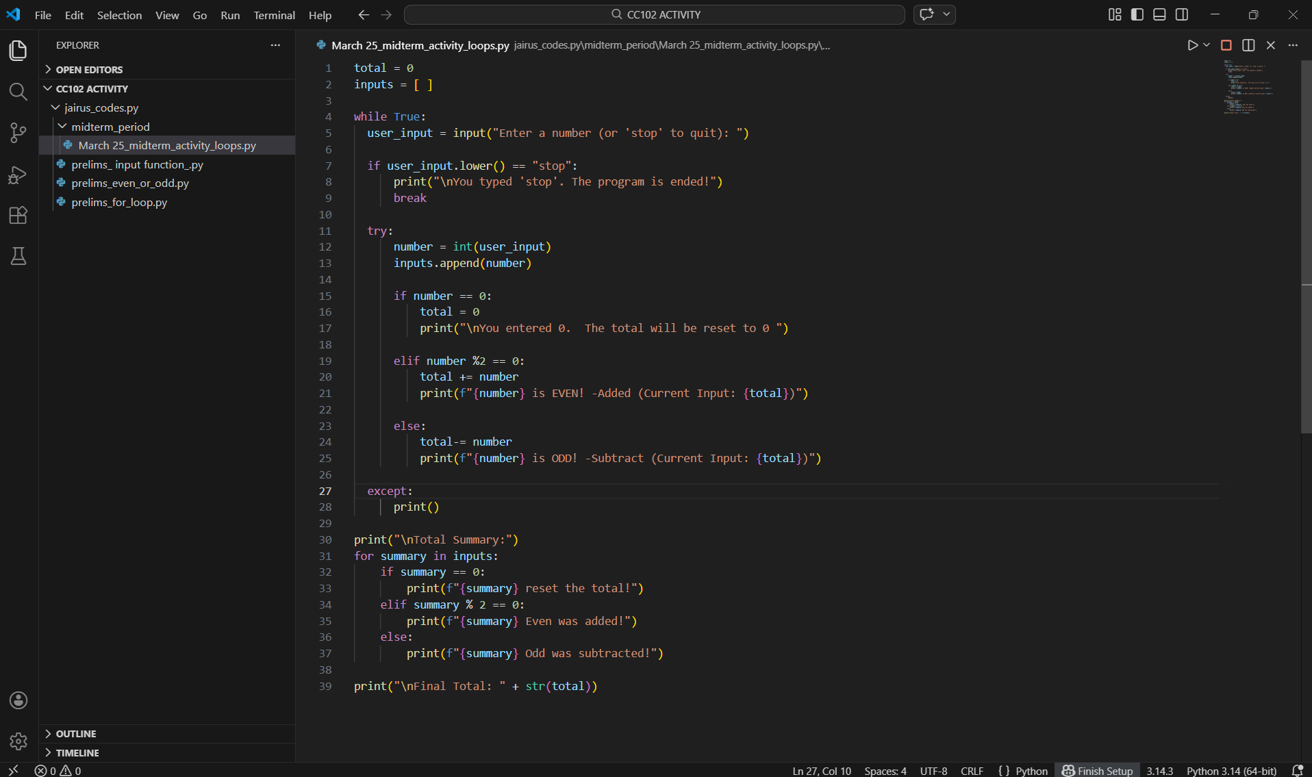
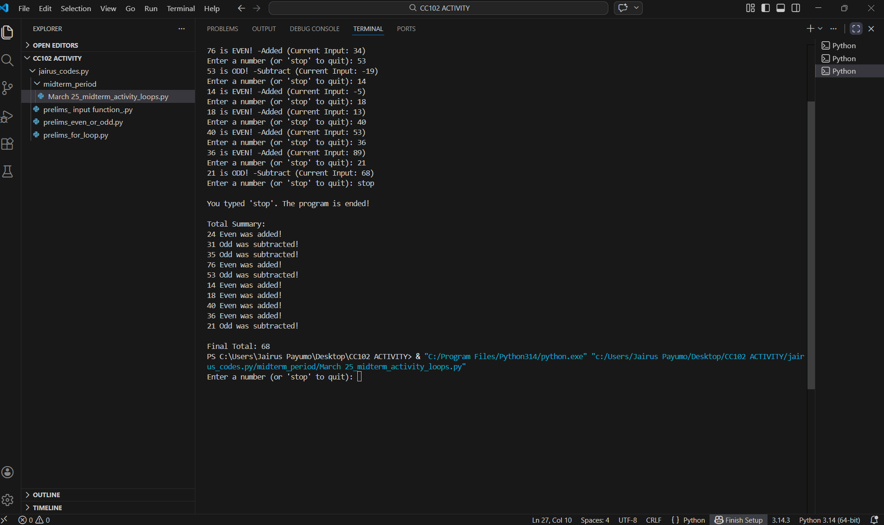
MIDTERM ACTIVITY 1: LOOPS

total = 0 - This code starts the total at 0.
inputs = [ ] - This code creates the list to store all numbers entered.
while True: - This code makes the program run repeatedly until stopped.
user_input = input("Enter a number (or 'stop' to quit): ") - This code asks the user to enter something.
if user_input.lower() == "stop": - This code will check if the user typed “stop”.
print("\nYou typed 'stop'. The program is ended!")
break - This code shows a message and ends the loop.
try: - This code tries to run the next lines.
number = int(user_input) - This code changes the input into a number.
inputs.append(number) - This code saves the number into the list.
if number == 0: - This code checks if the number is 0.
total = 0 - This code Resets the total to 0.
print("\nYou entered 0. The total will be reset to 0 ") - This code Shows reset message.
elif number % 2 == 0: - This code checks if the number is even.
total += number - This code adds the number to the total.
print(f"{number} is EVEN! -Added (Current Input: {total})") - This code shows that it was added.
else: - This code shows if not even, it is odd.
total -= number - This code subtracts the number from total.
print(f"{number} is ODD! -Subtract (Current Input: {total})") - This code Shows that it was subtracted.
except:
print() - This code shows that if the input is wrong, it avoids crashing (but prints nothing).
print("\nTotal Summary:") - This code prints the summary title.
for summary in inputs: - This code goes through all numbers entered.
if summary == 0: - This code checks if number is 0.
print(f"{summary} reset the total!") - This code shows reset message.
elif summary % 2 == 0: - This code checks if even.
print(f"{summary} Even was added!") - This code shows even message.
else: - This code shows if odd.
print(f"{summary} Odd was subtracted!") - This code shows odd message.
print("\nFinal Total: " + str(total)) - This code prints the final total.

