MIDTERM ACTIVITY 2: ANALYZE THE FLOWCHART ALGORITHM
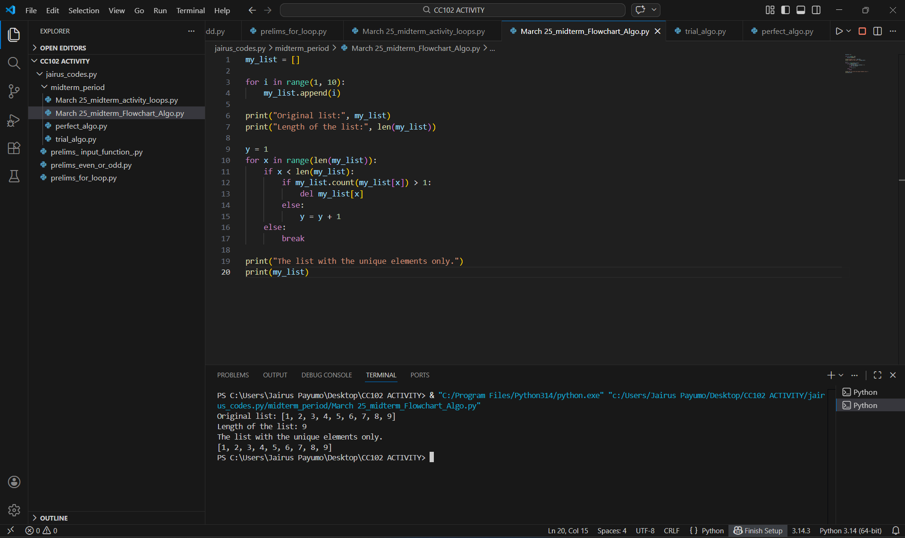

LINE BY LINE EXPLANATION:

L1. my_list = [] - This code creates an empty list.
L3. for i in range(1, 10): - This code starts a loop where the (i) variable goes from 1 to 9.
L4. my_list.append(i) - This code adds the current number (i) variable to my_list.
L6. print("Original list:", my_list) - This code shows the list before changing it.
L7. print("Length of the list:", len(my_list)) - This code shows how many items are in the list.
L9. y = 1 - This code makes a counter called y.
L10. for x in range(len(my_list)): - This code starts a loop using the index x to go through the list.
L11. if x < len(my_list): - This code checks if the index x is still inside the list.
L12. if my_list.count(my_list[x]) > 1: - This code checks if the current item appears more than once in the list.
L13. del my_list[x] - If it does appear more than once, delete it from the list.
L14-L15. else:
y = y + 1 – This code shows if it’s unique, add 1 to the counter y.
L16-L17. else:
break - Stops the loop if x goes past the list length.
L19. print("The list with the unique elements only.") – This code shows a message before printing the final list.
L20. print(my_list) print(my_list) - This code shows the list after removing duplicates.

