ISTANBUL TECHNICAL UNIVERSITY

COMPUTER ENGINEERING DEPARTMENT

BLG 335E

ANALYSIS OF ALGORITHMS I

PROJECT I REPORT

DATE: 08.12.2020

STUDENT NAME: ABDULKADİR PAZAR

STUDENT NO: 150180028

AUTUMN 2020

**Project I Report**

**a)**

Asymptotic upper bounds of Quicksort:

**Best Case: O(n*logn)**

Proof: T(N) = 2*T(N/2) + cN

Since a = bd, 1st part of the Master theorem applies

T(N) = n1 * logn = n * logn

**Worst Case: O(n2)**

Proof: T(N) = T(N – 1) + cN N > 1

T(N – 1) = T(N – 2) + c(N – 1)

T(N – 2) = T(N – 3) + c(N – 2)

: : : : :

: : : : :

T(2) = T(1) + c(2)

T(N) = T(1) + c(2+3+4….+(N – 1) + N)

T(N) = O(n2) worst-case bound for quicksort.

**Average Case: O(n*logn)**

Proof: T(N) = T(i) + T(N – i – 1) + cN where i = |S1|

For average case, each size of S1 is equally likely (P = 1/N)

Avg. value of T(i) and T(N – i – 1) = $\frac{2}{N}\sum_{k=0}^{N-1}{T(k)}$

T(N) = $\frac{2}{N}\sum_{k=0}^{N-1}{T(k)}$ + cN

N*T(N) =  + cN2 **(1)**

(N – 1)*T(N – 1) = + c(N – 1)2 **(2)**

Subtract (2) from (1)

N*T(N) - (N – 1)*T(N – 1) = 2T(N − 1) + 2cN − c

Drop insignificant constant and rearrange terms:

N*T(N) = (N + 1)*T(N − 1) + 2cN

Divide by N*(N + 1) and telescope:

T(N)/(N + 1)= T(N − 1)/N+ 2c/(N + 1)

T(N − 1)/N= T(N)/(N – 1)+ 2c/N

: : : :

: : : :

T(2)/3 = T(1)/2 + 2c/3

Add all equations:

T(N)/(N + 1) = T(1)/2 + $2c\sum_{k=3}^{N+1}{1/k}$

The sum evaluates to ln(*N* + 1) + *γ* – 3/2 where γ = 0.577

T(N)/(N + 1) = O(logN)

T(N) = O (N * logN)

**b)**

1. It will **not** give the desired output in all cases.

Example:

Sorting by profit is already done:

|  |  |
| --- | --- |
| Country | Profit |
| Zambia | 1000000 |
| United Kingdom | 750000 |
| New Zealand | 500000 |
| France | 250000 |
| Albania | 125000 |
| Albania | 62500 |
| Zambia | 31250 |

Last element is the pivot.

Result of sorting by country name:

|  |  |
| --- | --- |
| Country | Profit |
| Albania | 62500 |
| Albania | 125000 |
| France | 250000 |
| New Zealand | 500000 |
| United Kingdom | 750000 |
| Zambia | 31250 |
| Zambia | 1000000 |

Descending order of profits for Zambia is broken.

1. Insertion Sort, Bubble Sort, Merge Sort (Stable Sorts)

**c)**

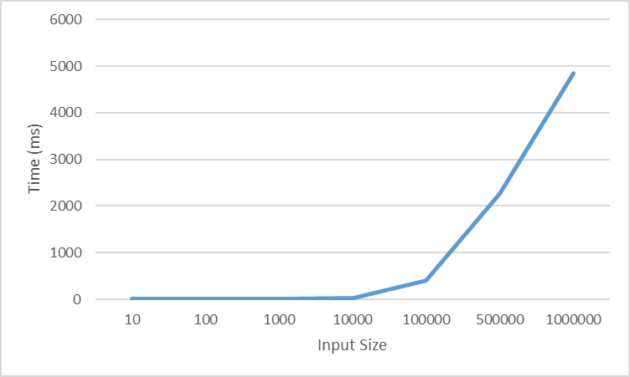

Input size – time (ms) chart

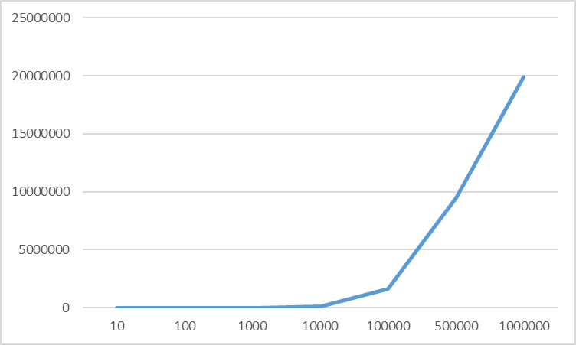

Chart of n * log2n for corresponding values

Quicksort’s average time complexity is O(n*logn). This is the best time complexity a comparison-based sorting algorithm can have. This relationship can also be observed by comparing two charts. And as we can see from the chart, it sorts large arrays within reasonable time (~5s for 1 million sized array).

**d)**

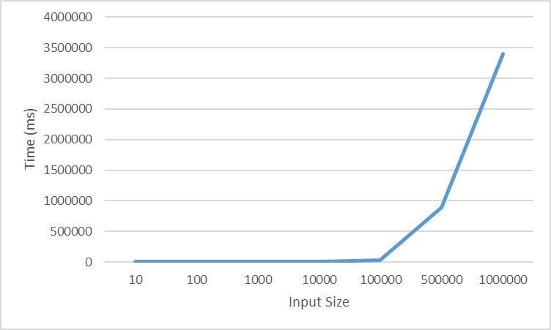

Input size – time (ms) chart

Chart of n2 for corresponding values

1. Computation times are significantly worse than (c) since Quicksort with pivot as rightmost element performs in O(n­­2). This is significantly worse than O(n*logn) and the computing times clearly reflect that fact. I had to increase the stack size for input size larger than 10000 as program would experience stack overflow because it made too many recursive function calls.
2. An almost sorted array, an array sorted in reverse, an array filled with same value elements perform in worst case when pivot is the rightmost element.
3. Choosing the pivot element with a random number generator will drastically reduce the probability of worst-case scenario occurring.