Database System

Assignment 3 report

Delivery Hanyang App

Student: Paz Jimenez

Student ID: 2017053772

**Objective**

The goal of this project was to build an application using the object-relational database management system named PostgreSQL and python language programming.

The PostgreSQL can be integrated with Python using psycopg2 module. Sycopg2 is a PostgreSQL database adapter for the Python programming language. Psycopg2 was written with the aim of being very small and fast, and stable as a rock.

**Approach**

* Connecting to PostgreSQL database server

Figure 1 shows how I accomplish the connection to an existing database named “deliveryhanyang”. If the database does not exist, then it will be created and finally a database object will be returned.

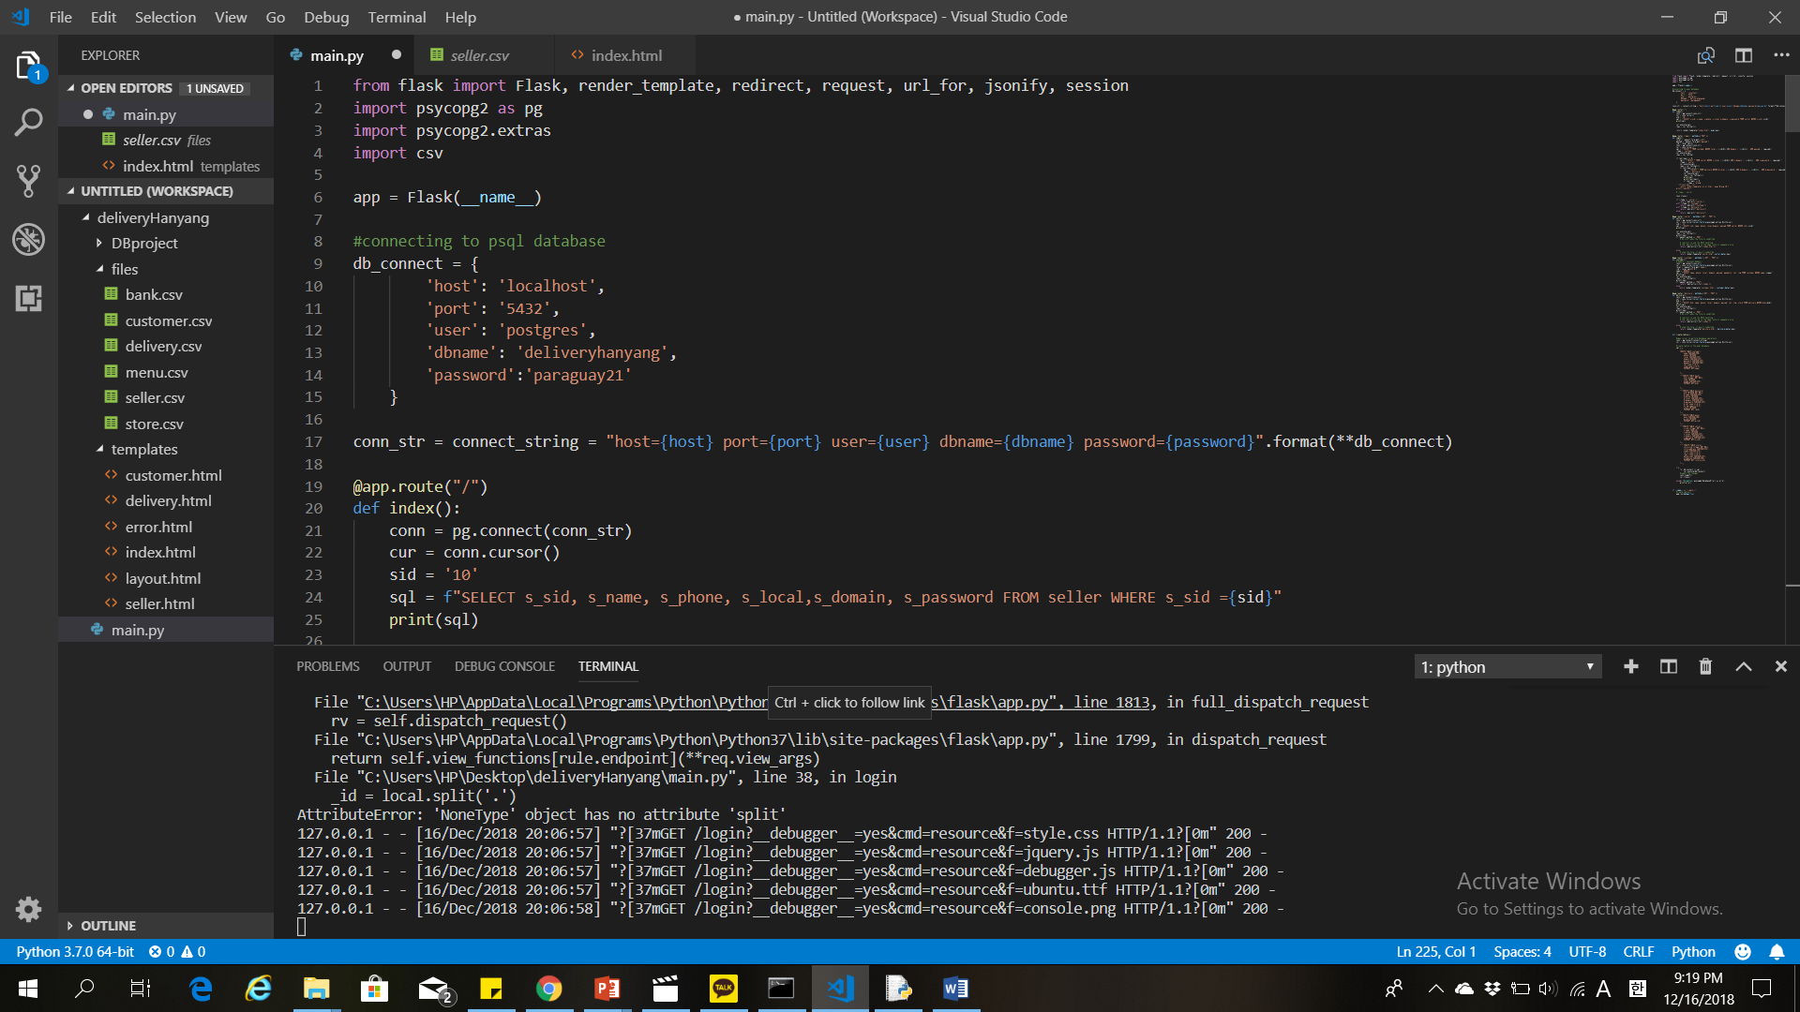

Figure 1

I handle my new database from the command prompt in windows 10 as it can be seen in figure 2. Moreover, I could control the progress of my database. I created the tables and respectively relations according to the csv files provided for this project. The data can be checked in pgadmin 4 and from there it could be manipulated as well as shown in figure 3.

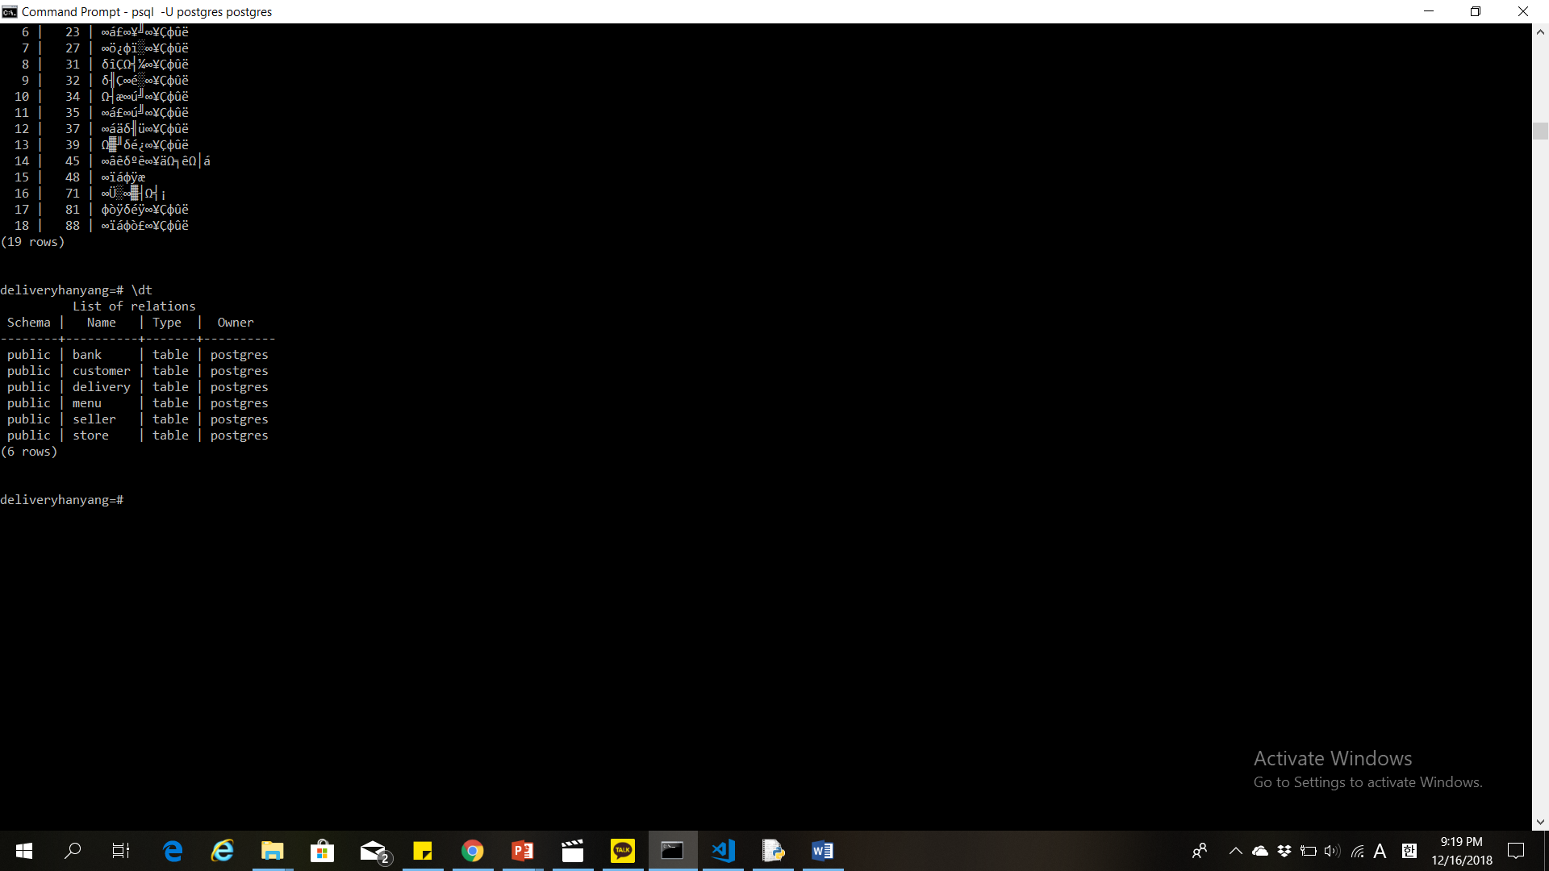

Figure 2

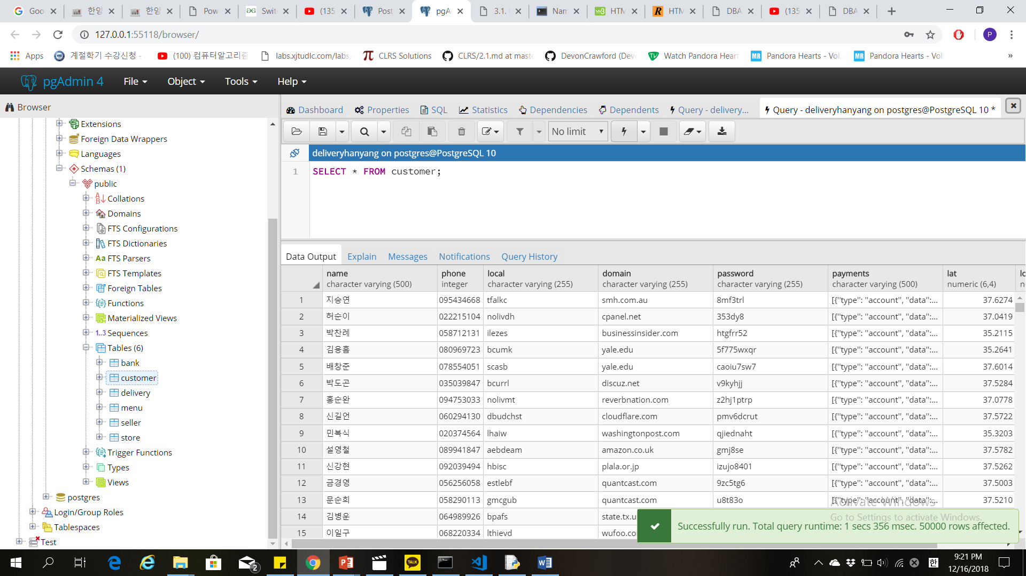

Figure 3

HTML and flask were also implemented for this assignment. I could return HTML pages through my Python script using the flask render_template. Figure 4 shows the final result of my website.

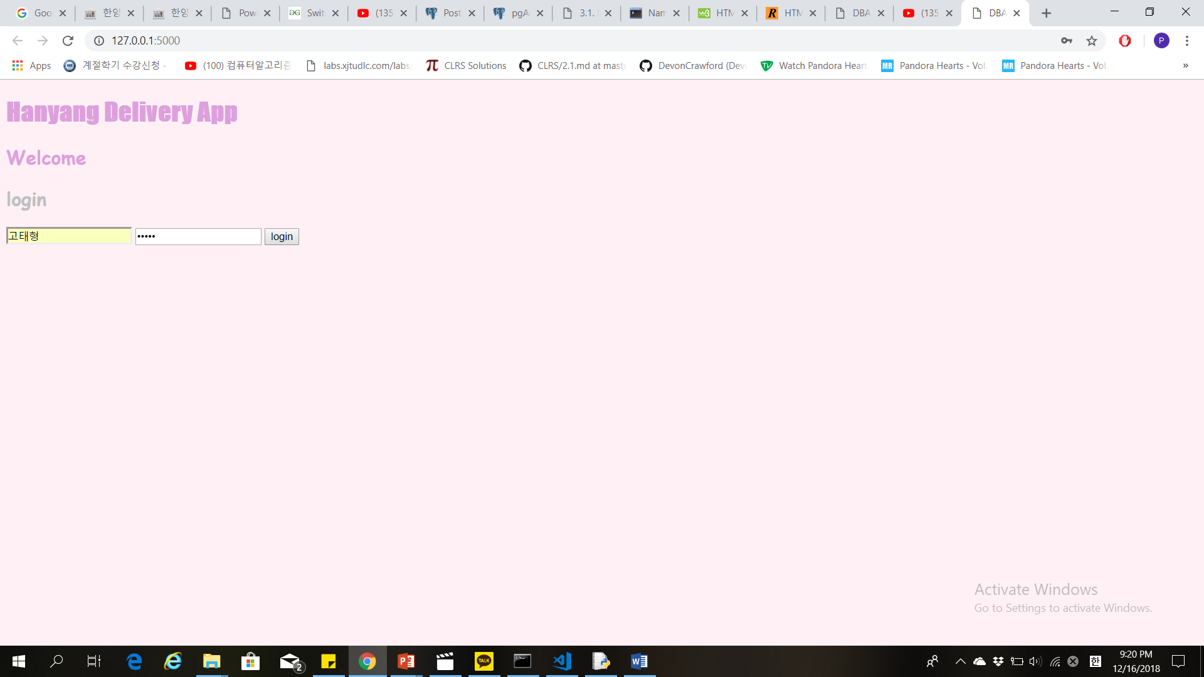

Figure 4

In this assignment, I learned how to create tables, insert, delete, update and querying data from the PostgreSQL tables. It was a good experience, but with more practice I think I could improve more my skills regarding the implementation of databases