Prisma Test: Kosmas Stamos

Requirement Analysis

The purpose of the project is to create an API that allows customers to fill custom forms with numeric values, which are then saved in a database for future inspection. The API should allow customers to read, create, update, and delete forms, and to add up to 10 fields in each form. Each form must have a title, a description, the date creation and the date of last updated.

The backend code for the API will be written in C#. The database could be Oracle or MSSQL, and the API should use the REST protocol.

Features and functionality: The API should allow customers to perform the following tasks:
- Create a form with a unique title and name for each field.
- Have a limit of 10 fields per form, with only numeric values accepted in each field.
- Perform all the fundamental CRUD operations.
- Retrieve a form with all it’s associated fields by its formId foreign key constraint.

The database schema for this API consists of 2 tables called “Forms” and “Fields” with a 1-M relationship (1: Forms – M:Fields). The class diagram is shown in the image below too.
Forms
Id(PK) | Title(UQ) | Description | DateOfCreation | LastUpdated

Fields
Id(PK) | NoteName(UQ) | Note | FormId(FK)

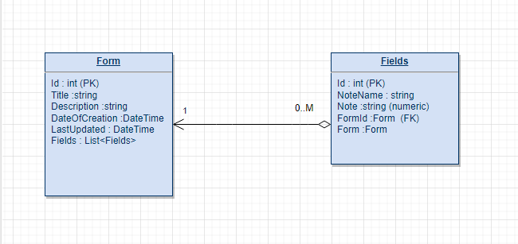

The API should be deployed to a cloud platform and made accessible through a web application.
Feasibility report

- Technical Feasibility
The proposed technology stack for the API is C# and the database platform is either Oracle or MSSQL. Both technologies are well-suited for this project as they provide robust support for handling numeric data and have good performance and scalability characteristics. There are no technical limitations, but there are challenges that would prevent the successful development and deployment of the API,mostly having to do with knowledge gaps, especially in the Migration/Publish of the API part.
- Operational Feasibility
The API will be deployed to a cloud platform and accessed through a web application. This deployment model offers several advantages such as scalability, accessibility, and flexibility. Most commercial cloud platforms could accommodate this project since it is simple and small in size.

- Schedule Feasibility
The project deadline is set for 31/10/2022, which should provide sufficient time to complete the project within the required time frame. However, the schedule may be impacted by factors such as unforeseen technical difficulties.
- Conclusion
Based on the analysis presented in this report, we believe that the Custom Form API project is technically feasible, operationally feasible, and schedule feasible. Therefore, we recommend proceeding with the development of the API as planned.

Parts Not Implemented & Difficulties

- Migration: I was not aware of a way to create a database migration without using EntityFramework and DbContext. I tried and did create a Schema through MSSQL (database→Security→ new schema..etc)
but I was still unable, without a DbContext file and its configuration files, to migrate the database.
- Publish: I didn’t find any free hosting options ( Azure free credits and charge after the end of the year is sketchy), so I tried hosting it with IIS but encountered problems that I couldn’t resolve even after extensive search. Photos of shame included below.
- No pages/ just endpoints: I realize and it’s an honest mistake that I should have used ASP.NET Web API so that the application opens in Swagger and not Web App that requires the programming of pages, but it was already quite late in the development and I was running out of time.

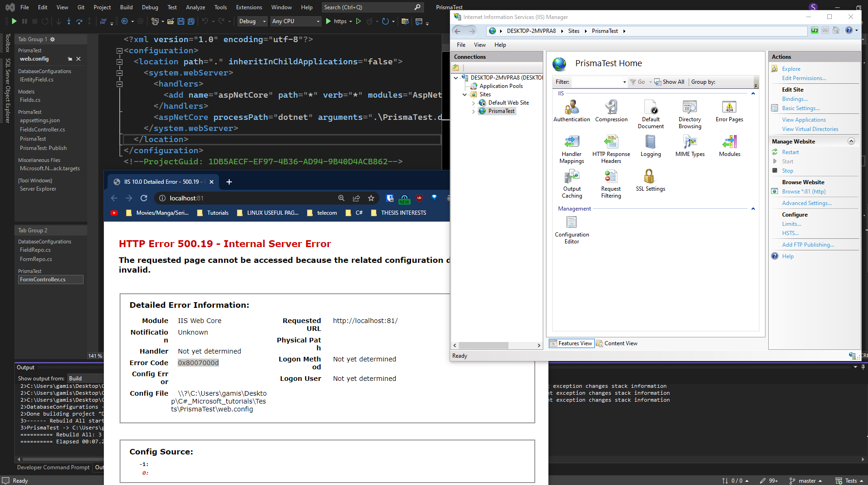
Code Manual

Models: Bellow I am going to exhibit the code for the 2 model class files Forms and Fields that have the properties that the API needs to work with.

ClassLibrary: Models
Forms: It has its own Id property but it also has a List of type Fields , that gets initialized every time a new Form object is instantiated. This is due to the requirement that each form must contain 10 fields at most. We have Constructors, one default and one that passes 2 properties ( Id needs not be passed)

public class Forms
{
public int Id { get; set; }
public string Title { get; set; }
public string Description { get; set; } // Limit 150 characters
public DateTime DateOfCreation { get; set; }
public DateTime LastUpdated { get; set; } //Can be null until form is updated--Everytime a new Field Line is created
//we need to update it

//relation
public List<Fields> Fields { get; set; } = new();

//constructors

public Forms()
{

}

public Forms(string title, string descr)
{
Title = title;
Description = descr;
DateOfCreation = DateTime.Now.Date;

}
}

Now the Fields Model, it follows the same logic, but it also has a Forms Form property is set to null! . What is different here is that we also declare a FormId of type int , and that is the element that is going to be taking the Forms.Id value of each field. As explained below, FormId is the Foreign Key in the database for that relationship. Again, we have 2 constructors, one empty and one instantiated with 2 properties just in case we needed to use it.

using System;
using System.Collections.Generic;
using System.Linq;
using System.Text;
using System.Threading.Tasks;

namespace Models
{
public class Fields
{
//has foreign key of FormId in this 1-M relationship
public int Id { get; set; }
public string NoteName { get; set; }
public int Note { get; set; } //Must only be numeric

//relationship
public int FormId { get; set; }
public Forms Form { get; set; } = null!;

//constructors

public Fields()
{

}

public Fields( int field, string noteName)
{
Note = field;
NoteName = noteName;
}

}
}

Repositories: That part of the code that handles the SQL Connections and CRUD actions. It also has 2 Interfaces that are there for Dependency Injection purposes and also show what methods need to be implemented by the Repo-class that implements it.

ClassLibrary:DatabaseConfigurations | Dependencies: Models

Most of the explanations require are on the . First off, IEntityRepo

namespace DatabaseConfigurations.Repositories
{
public interface IEntityRepo<TEntity>
{//We use Generics (TEntity ) since we need for the interface to apply to any type.
IList<TEntity> GetAll(); //self-explanatory, returns a list of all the Forms
TEntity? GetById(int ID); //Returns a single Form entity
void Add(TEntity entity); //Adds an Forms entity
void Update(int ID, TEntity entity); //Edits entity
void Delete(int ID); // Deletes entity
}
}

The comments do a decent job giving an basic outline of what those functions do. Now for the FormsRepo.

FormRepo is a class that implements the IEntityRepo interface for the Forms entity.
- The constructor initializes the FormRepo object by setting the _configuration field to the provided IConfiguration object.
- Add method adds a new entity to the database by creating a connection to the database, creating a SQL command to insert the entity's values, and executing the command.
- Delete method deletes an entity from the database by creating a connection to the database, creating a SQL command to delete the entity by its ID, and executing the command.
- GetAll method retrieves all entities from the database by creating a connection to the database, creating a SQL command to select all entities, and filling a DataTable with the returned values. Then, it iterates through the DataTable and creates a list of Forms objects to return.
- GetById method retrieves a single entity from the database by its ID by creating a connection to the database, creating a SQL command to select the entity by its ID, and filling a DataTable with the returned values. Then, it creates a Forms object with the first row of the DataTable and returns it.
- Update method updates an existing entity in the database by creating a connection to the database, creating a SQL command to update the entity by its ID, and executing the command with the new entity's values.

Controllers:

Dependency Injections:

