Картина, която съдържа символ, лого, черен, емблема

Генерираното от ИИ съдържание може да е неправилно.

**MASTERCODERS**

# **Contents**

Contents 1

Project Description 2

Team Information 2

Project Information 2

Technologies used 3

Ways of Realization 3

Static Libraries 5

UML Diagram 4

# **Project Description**

* *The project was build using C++.*

# **Team Information**

|  |  |  |
| --- | --- | --- |
| № | Name | Role |
| 1 | Ivelin Petkov Voynov 10V | Scrum Trainer |
| 2 | Daniel Krasimirov Kostadinov 10V | QA engineer |
| 3 | Aleksandar Ivailov Lalev 10V | Backend Developer |
| 4 | Luchezar Rumenov Rashkov 10V | Frontend Developer |

# **Project Information**

|  |  |
| --- | --- |
| № | Information |
| 1 | **Description**  The project is about event organization. |
| 2 | **Installation**  To install the project, you can open our GitHub repository and follow the instruction in the README.md file or via our website. |
| 3 | **Communication**  For communicate we used Teams. Which made it easy to share file and text messages. |

# **Technologies used**

|  |  |  |
| --- | --- | --- |
| № | Technologies | Usage |
| 1 | Visual Studio 2022 | As out IDE |
| 2 | GitHub and Git | For collaboration |
| 3 | C++ | As programming language |
| 5 | Word | For the documentation |
| 4 | Excel | For QA(Native Unit Tests) PASSED/FAILED |
| 6 | PowerPoint | For the presentation |

# **Ways of Realization**

|  |  |  |
| --- | --- | --- |
| № | Issue | Solution |
| 1 | **Task Distribution** | When we distributed the tasks, we took in consideration the skills of each member and where he could be most productive.  For each task we made a GitHub issue which helped us to stay in track and made it easy for each member to see his tasks. |
| 2 | **Task Completion** | There were team meetings almost every day where we discussed problem and the overall state of the project.  Each member worked in a convenient for him time. When he was ready with his part of the project, he committed it to GitHub and closed the respective issue. This made it easy to track the progress of the project. |

UML DIAGRAM: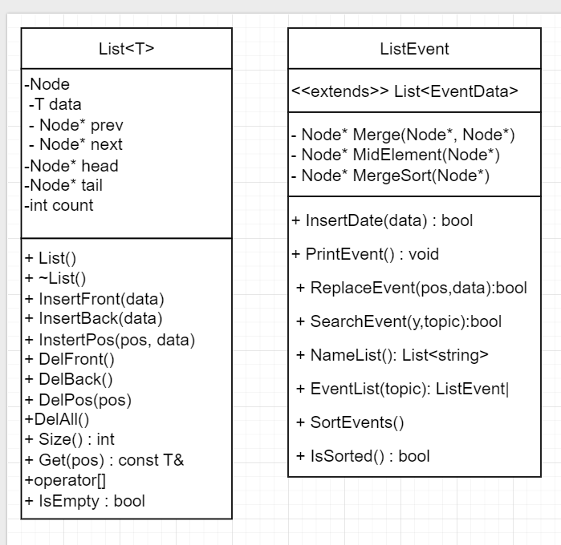

# **Static Libraries**

|  |  |  |
| --- | --- | --- |
| № | Name: | Description |
| 1 | **Core** | Core is the foundation library of this project. It provides doubly linked list implementation and general utilities. List implementation consists of two classes: List and ListEvent. List is a template for a doubly linked list. ListEvent is an extended List specialization with EventData as a template parameter type. The class has multiple functions to organize events. |
| 2 | **Access** | Access is a static library which represents the data access logic layer. It supplies models like user and event. Functionalities for essential CRUD operations are also included. |
| 3 | **Business** | A static library which holds the main logic behind the application. It works with the data access layer and implements the features of the app menu. Validation functions are also covered. |
| 4 | **Presentation** | Static library servers as the presentation layer. Menu layout and user input is mostly implemented here. |
| 5 | **TestAccess** | A testing module designed to verify the functionality of the Access library. It includes unit tests for models and operations, ensuring data handling is accurate and reliable. |
| 6 | **TestCore** | A testing module for the Core library. This project focuses on validating the behavior of utility classes such as List and ListEvent. |