**Website development information about idea and progression**

**P13202994**

Contents

Tools and items used 2

Initial subject idea 2

Initial design idea 2

Final design 3

Navigation 4

Pages 4

Development stages 7

# Tools and items used

* Github
* Bootstrap
* Adobe photoshop
* Brackets
* JavaScript
* HTML
* CSS

# Initial subject idea

From starting, I wanted to develop a single page website with lots of ideas in mind but at the end I concluded that I should do my website on this idea on my interest as it will be easy for me add the content and the development will be much easy and enjoyable for me.

# Initial design idea

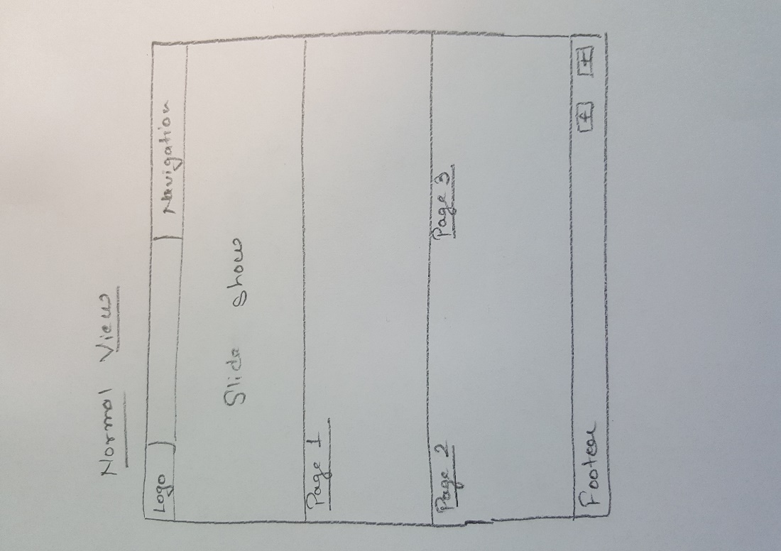I got the idea of single page website from various websites I came across while researching around the web and made my initial design on paper which I had to moderately change at later stages of development.

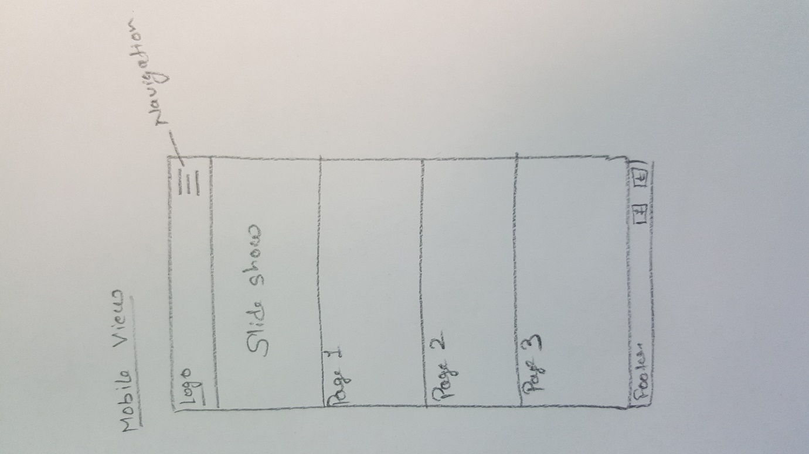

Figure 1- Desktop view of initial idea

Figure 2- Mobile view idea

# Final design

Before putting the idea into action, I again made my final design on a piece of paper and stick to that design till the end of development stage. I just needed to change some layout of the content in order to make it look good according to device size. The final design screenshots are given below:

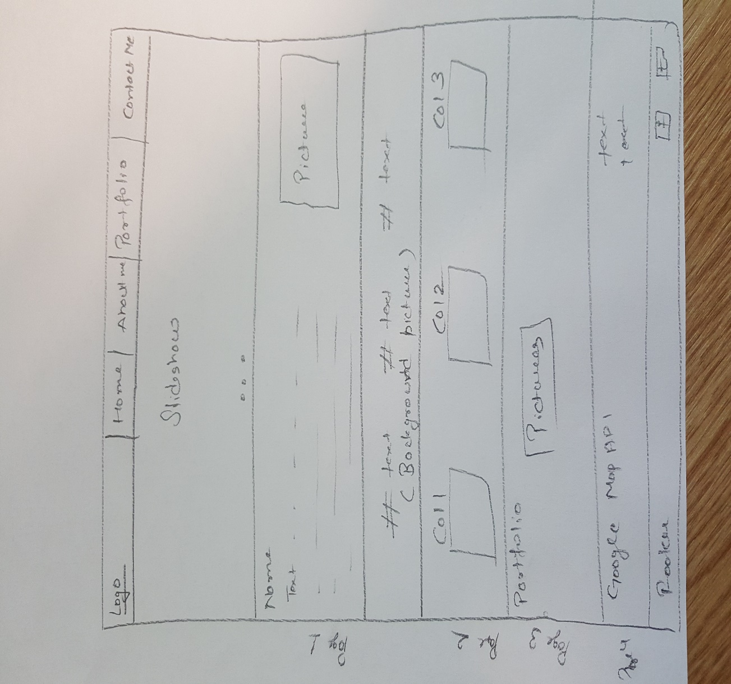

Figure 3- Desktop view

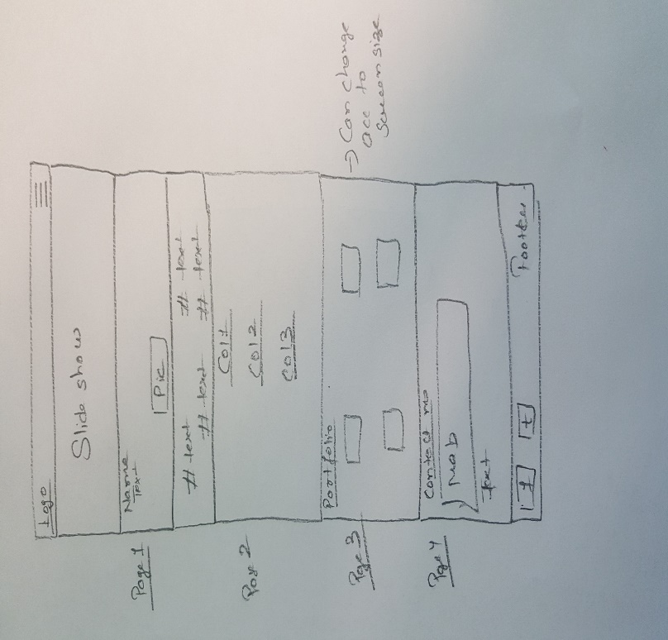

Figure 4- Mobile view

# Navigation

The navigation of the website is in two forms- normal view which is desktop view and other one is mobile view. The screenshots are given below:

C:\Users\RAJVIR SINGH\AppData\Local\Microsoft\Windows\INetCache\Content.Word\nav.jpg

Figure 5- Normal navigation view

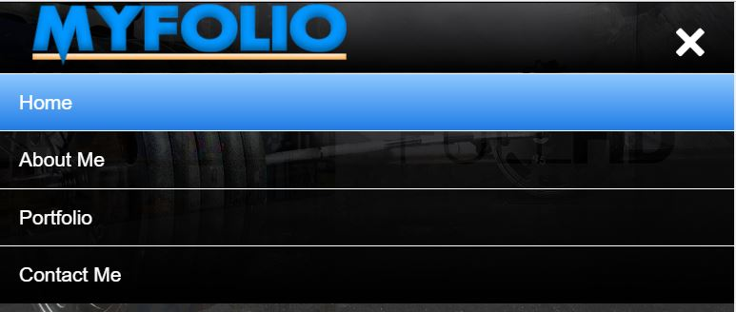

Figure 6- Mobile view navigation

## Pages

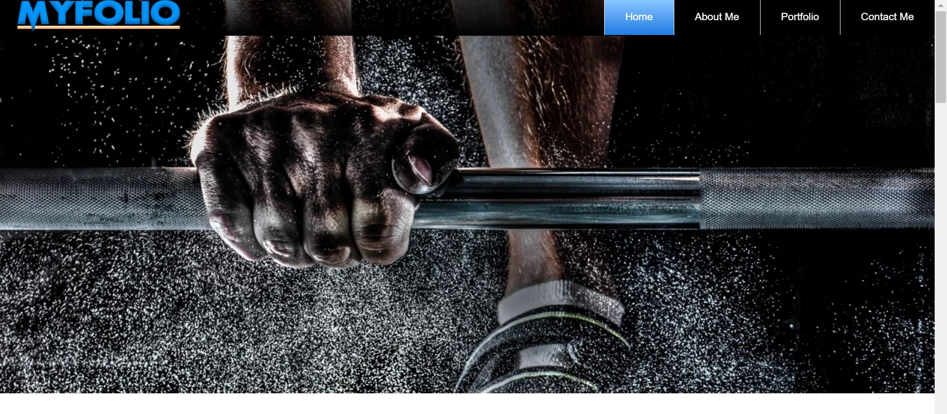**Home**

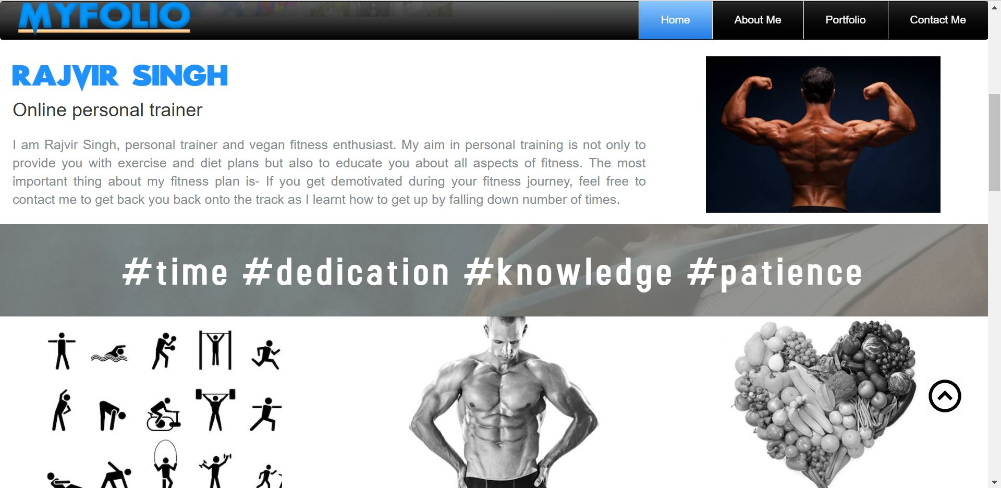**About me**

**Portfolio**

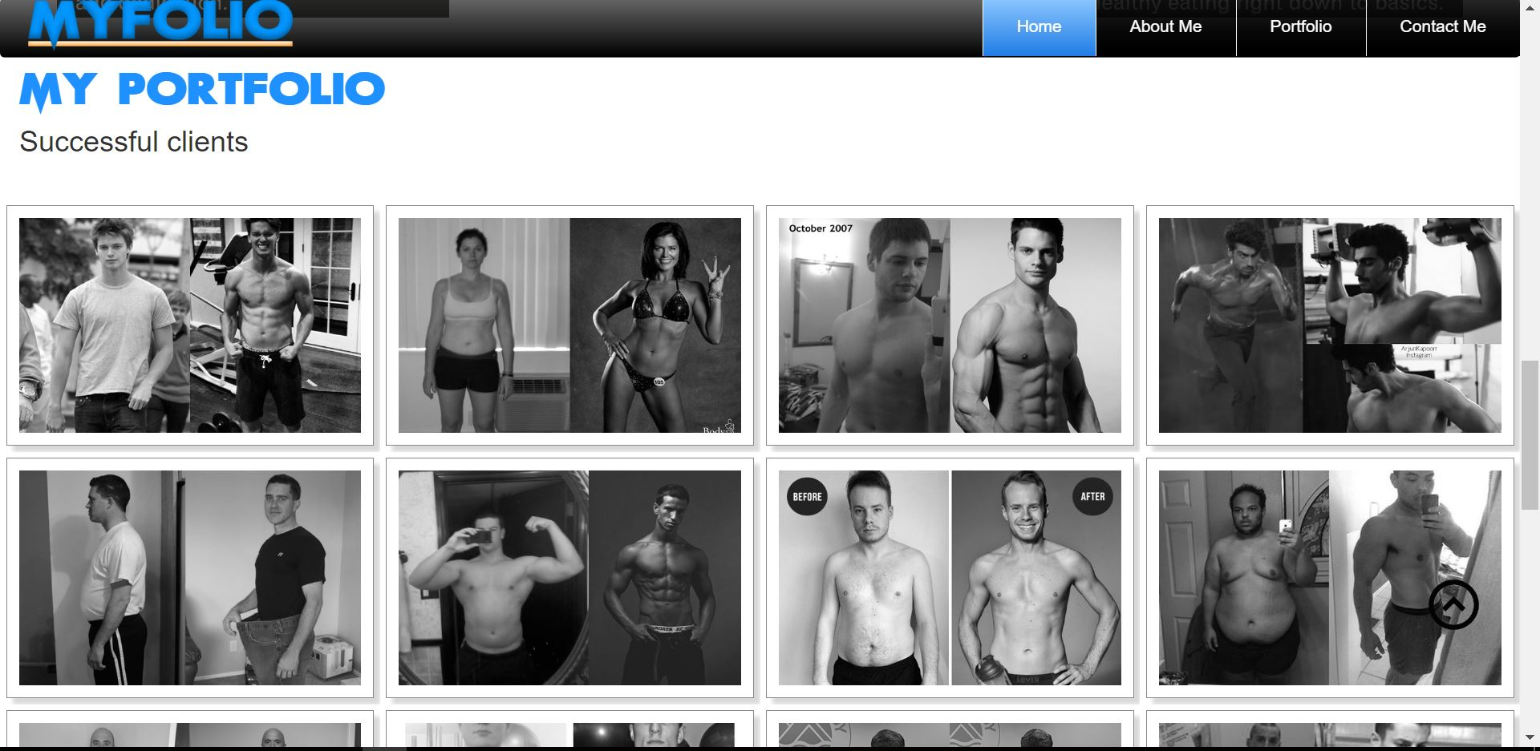

**Contact me**

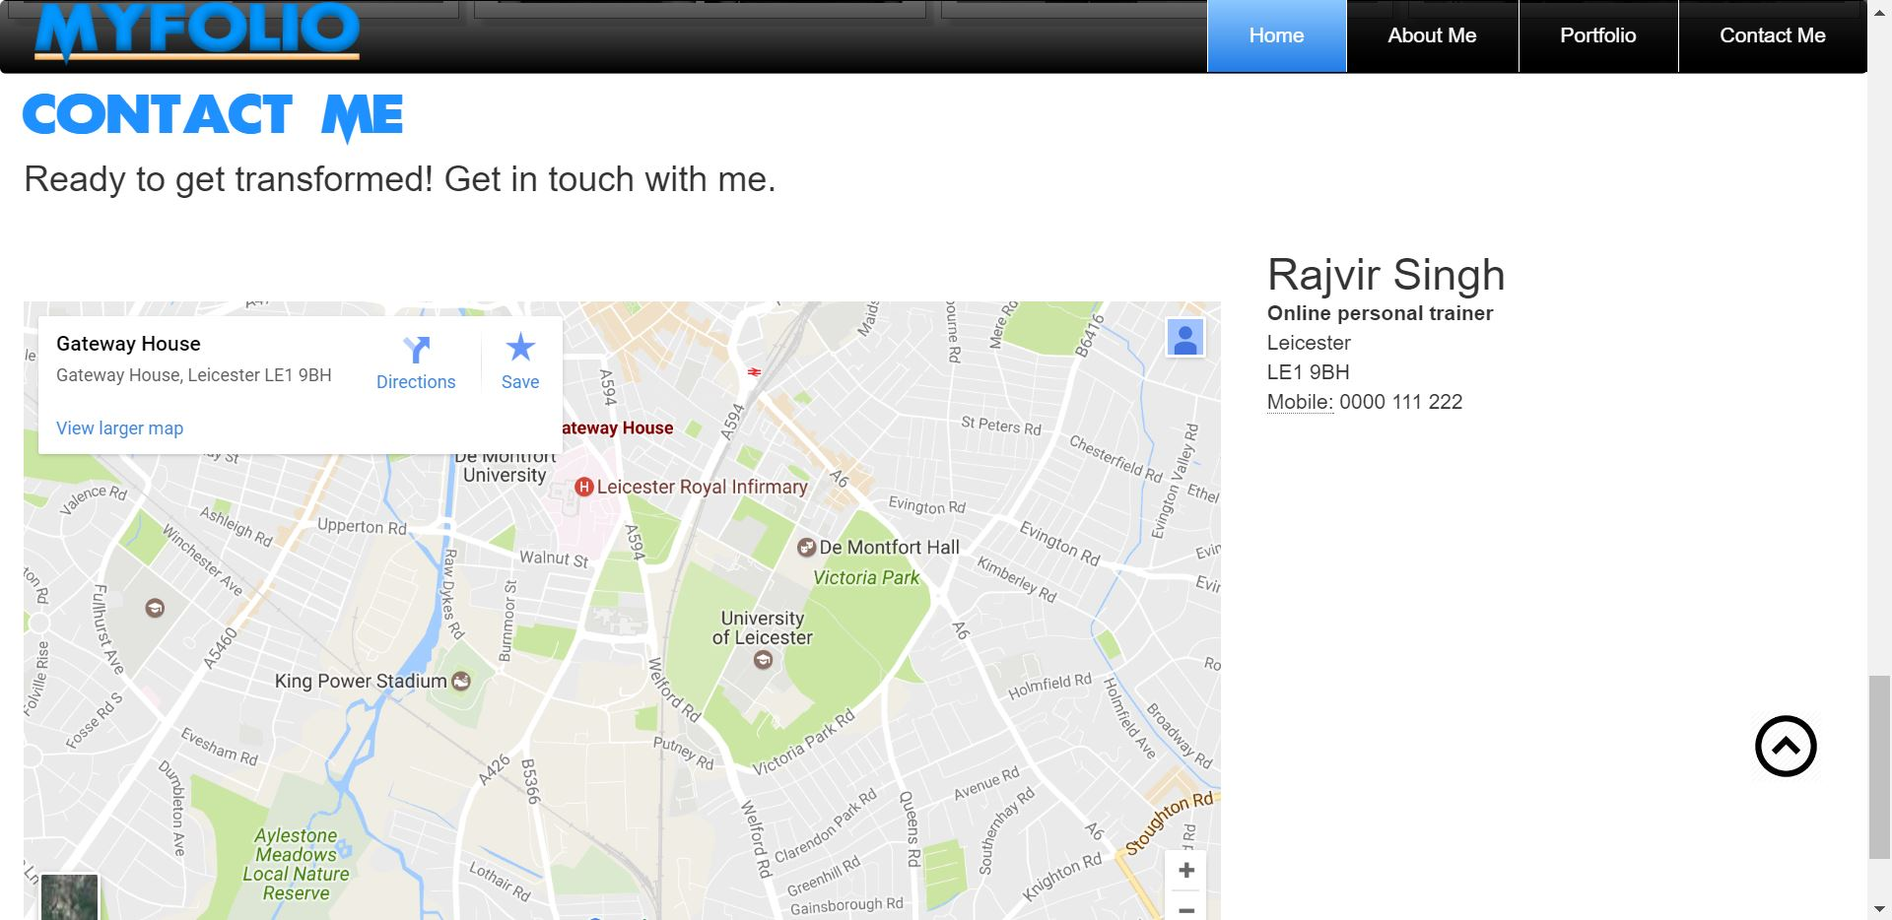

# Development stages

1. **Github setup:** The first step before starting anything was setting up Github with the repository containing all project files. This was not so easy task however after following lab session on Github and getting some help from Dave, I set it up.

Public account which I set up is – p13202994

Repository – CTEC3905_Assignement_2

I setup first repository in January and committed some initial data but got it deleted accidently. Then I made a new one in February and added all local files in initial commit and then committed regularly as I made changes.

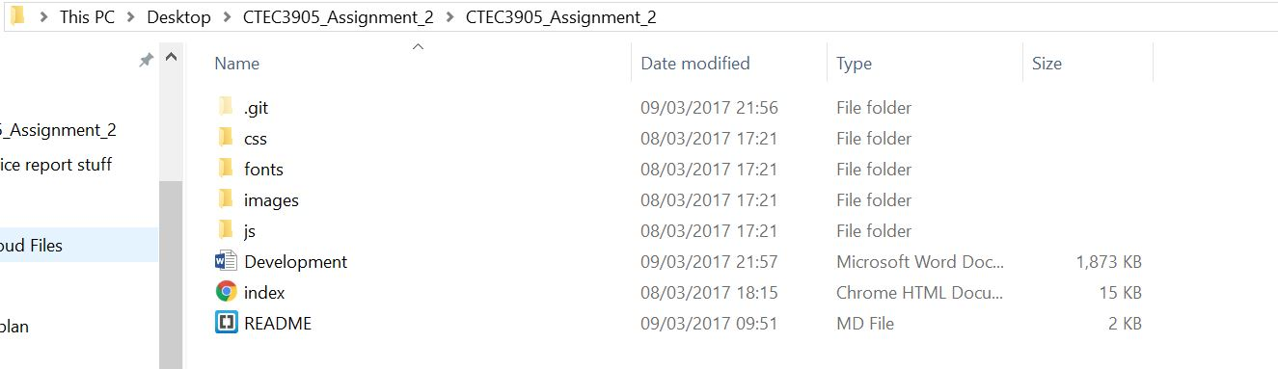

Figure 7- Local setup

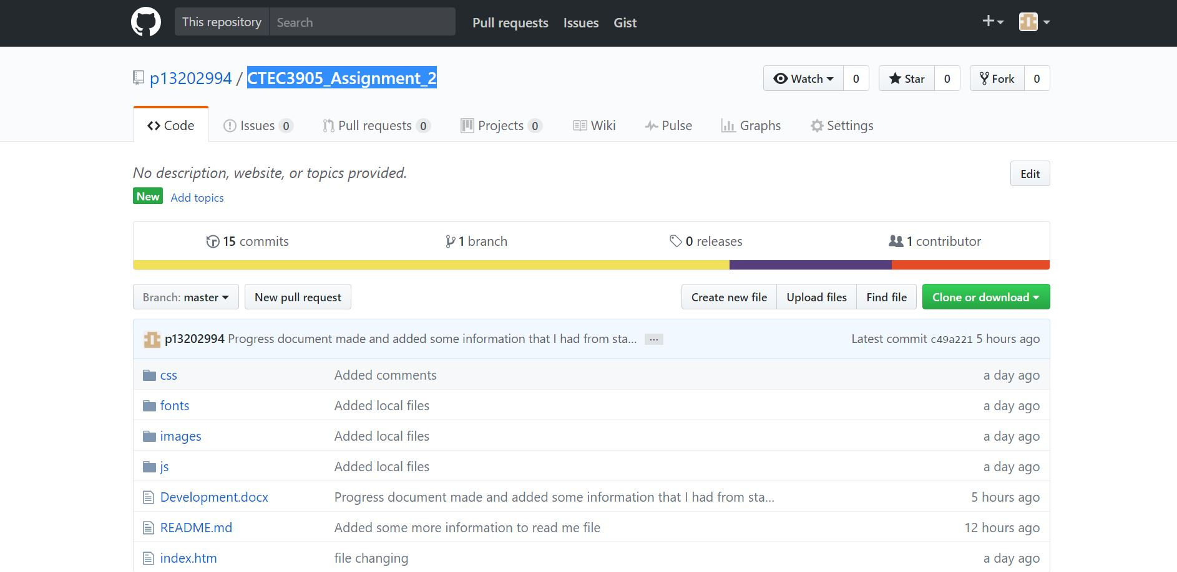

Figure 8- Github screenshot

1. Second step in development stage was to get some more knowledge about how to create responsive single page website. For this I watched youtube videos and inspected few sites with the help of Google chrome’s tool of viewing code.
2. After gaining knowledge (from external sources and lab sessions) and collecting content, I developed an initial design of the site.
3. The final design of the site took 7 days to finish which includes deciding all the colours and designs of the content. In these 7 days, I did all work related to responsiveness and looks of the site. It was challenging to complete in 7 days as I had very days left to submit.
   1. The js files that I have used are standard libraries which I have called in website coding to get their functionality.
   2. Fonts which I have used are saved in fonts folder.
4. After designing everything, images needed to change and edited which was done with the help of adobe photoshop and all images that are used in the site were available freely on the internet.

# Responsiveness

