Problem2

Extra Credit

for the threshold of 0.001



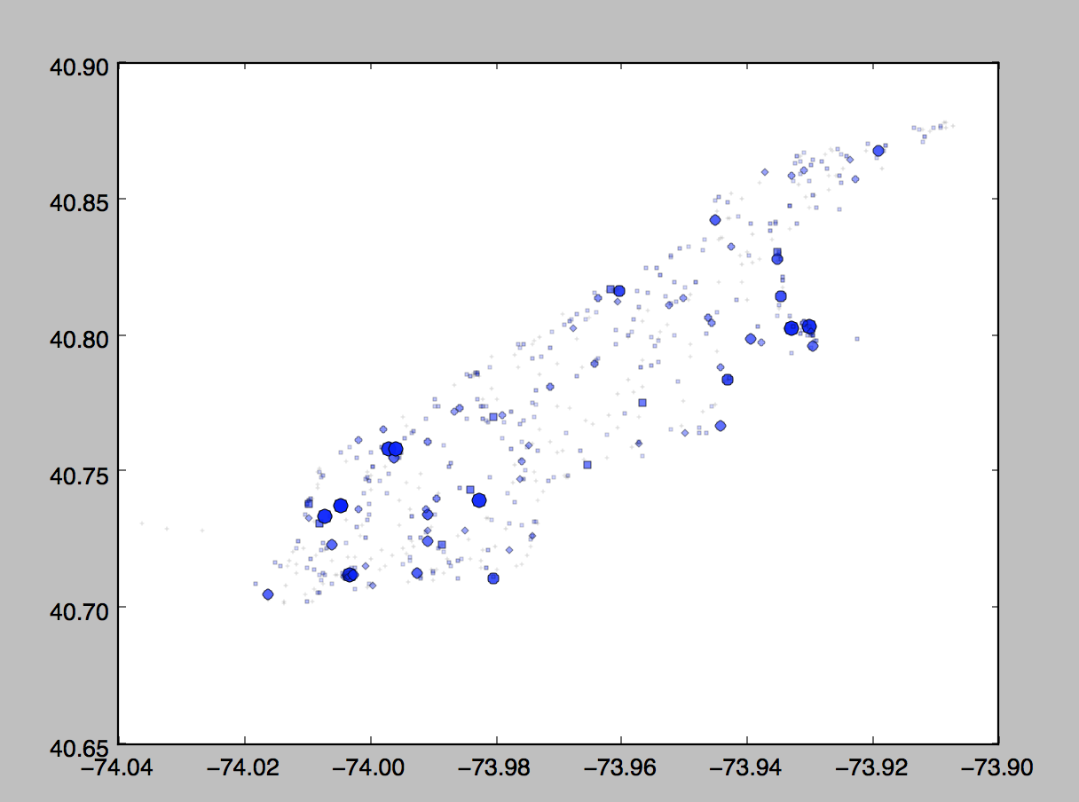

for the threshold of 0.005



