Game Design Document

Fill up the following document

1. Write the title of your project.

Power of **INDIAN ARMY**

1. What is the goal of the game?

To kill the terrorists

1. Write a brief story of your game.

The Indian soldiers have got the information that some terrorists are

Trying to enter our **BHARAT MATA .** Help them to kill the terrorists.

In order to save India

1. Which are the playing characters of this game?

* Playing characters are the ones who respond to the user based on the input from the user.
* Cars, monkeys, dinos, wizards, etc., are the playing characters in the game.

|  |  |  |
| --- | --- | --- |
| Number | Character Name | What can this character do? |
| 1 | INDIAN ARMY | THEY CAN KILL THE TERRORISTS ENTERING IN OUR CUNTRY |
| 2 |  |  |
| 3 |  |  |
| 4 |  |  |
| 5 |  |  |
| 6 |  |  |
| 7 |  |  |
| 8 |  |  |

1. Which are the Non-Playing Characters of this game?

* Non-Playing characters are the ones that don't have an action or behavior when the user interacts with the game.
* Hurdles, stones, bananas, coins, etc., are non-playing characters in the game.

|  |  |  |
| --- | --- | --- |
| Number | Character Name | What can this character do? |
| 1 | terroists | hurdles |
| 2 |  |  |
| 3 |  |  |
| 4 |  |  |
| 5 |  |  |
| 6 |  |  |
| 7 |  |  |
| 8 |  |  |

Draw your imagination of this game. What does this game look like?

* Draw the game either on your computer or on paper.
* Add images of the game scenes to show each of the playing and non-playing characters at least once.

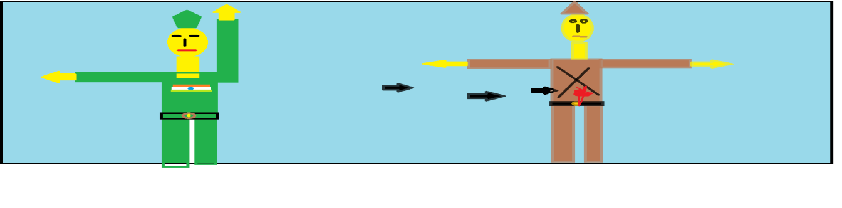

How do you plan to make your game engaging?

THE BACKGROUND IS DEDICATED TO INDIA AND THERE ARE NICELY DRESSED SOLDIERS WHO WILL KILL TERRORISTS