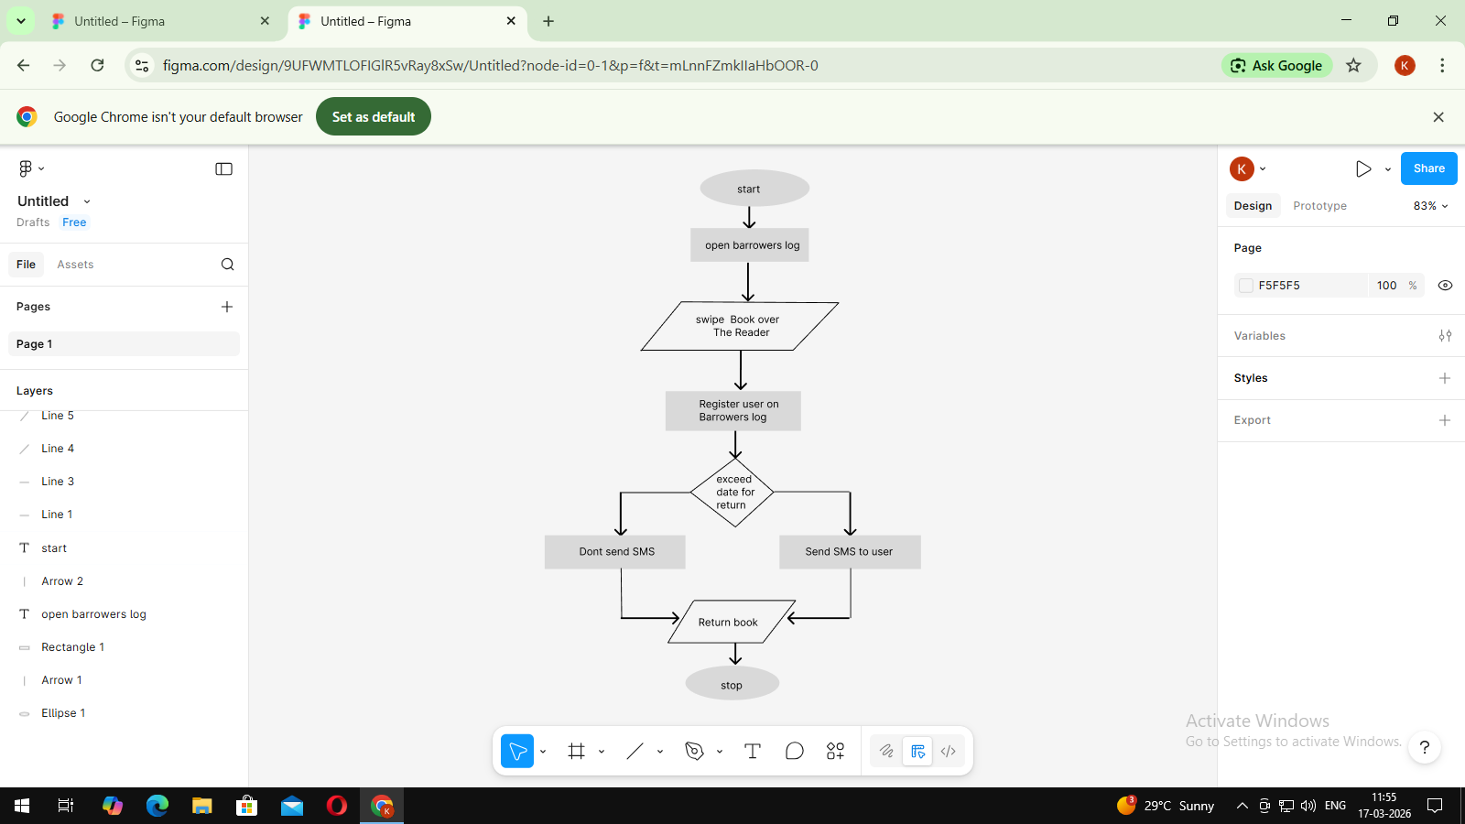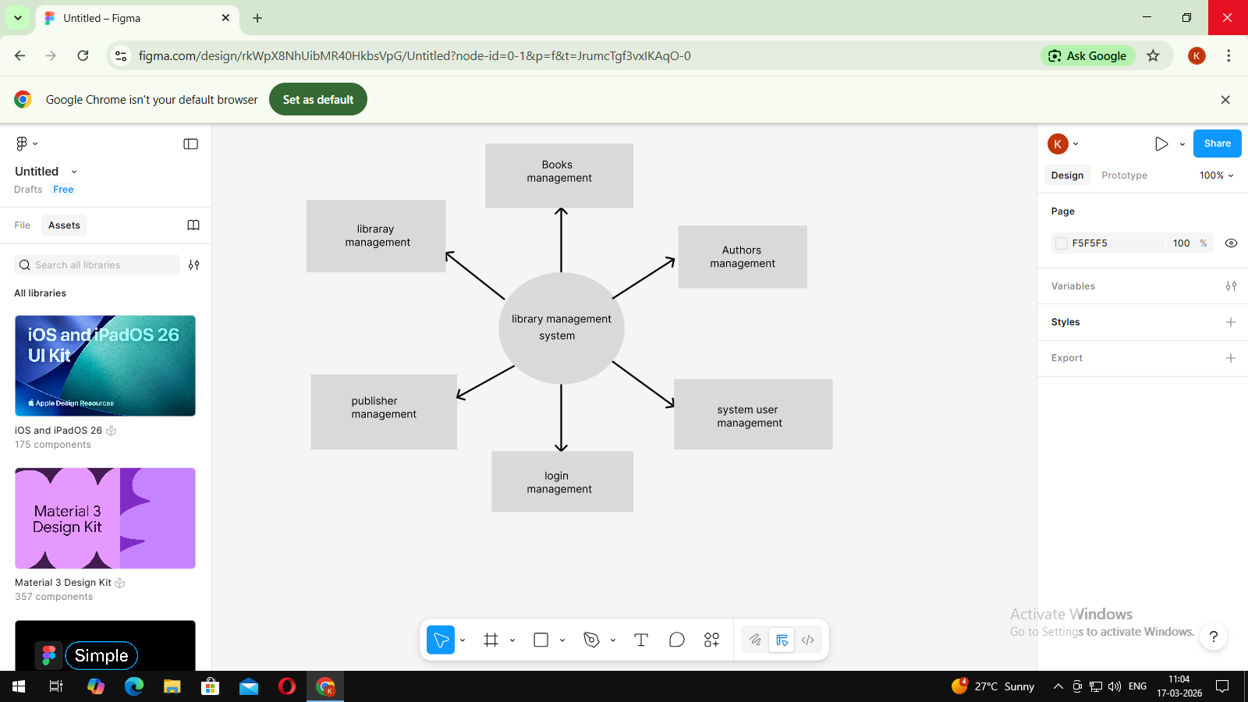

https://www.figma.com/design/rkWpX8NhUibMR40HkbsVpG/Untitled?node-id=0-1&t=JrumcTgf3vxIKAqO-1

