**The Temple Inn & Suites**

**Site plan**

**Site Purpose**

**Company Name:** The Temple Inn & Suite

**Locations:** A hotel chain headquartered in Bethesda, MD

**Overall Goal:**

Promote and provide information about the specialized services that The Temple Inn & Suite offers to meet the needs of temple patrons who come to serve in the temple or who participate in events such as sealing’s, weddings, receptions, and youth trips.

**Additional Insights:**

We want to engage with members of The Church of Jesus Christ of Latter-day Saints around the world who are planning to attend a temple, where The Temple Inn & Suite has hotels.

We will engagement them by using the following tactics

* Showcasing the Specialized Services offered byThe Temple Inn & Suite. Examples would be, but not limited to
  + A playroom and low-cost, short-term babysitting services for the children of patrons
  + A wedding reception hall that can be easily customized with a simple catering menu and kitchen access for food preparation and serving
  + A family search center that supports family search and ordinance work
* Offering range of free Amenities**.** Examples would be, but not limited to
  + Breakfast
  + Exercise/workout room
  + Family history consultation and family ordinance card service
* Added Extra’s to help engagement
  + A call to action to make a hotel reservation
  + Readily available navigation and contact information for the hotel chain
  + Information about different temples – give visitors the ability to choose the temple
  + Links to our additional Social media
  + Weather conditions (include a 3 day forecast)
  + Google maps links
* **Logo:** Still in development

**Target Audience**

Name: Mr Bishop

Age: 48

Married + 3 kids (Empty nester)

Profession: Lawyer

Service: Bishop

Trying to ensure his youth to have a great temple experience, looking for ways to make a completed trip easy.



Name: Molly Temp

Age: 34

Married + 2 kids

Profession: Wedding Planner

Service: Sunday school teacher

Looking for venues close to LDS temples that understand the standards and requires of Church Members. So it makes her job easier.

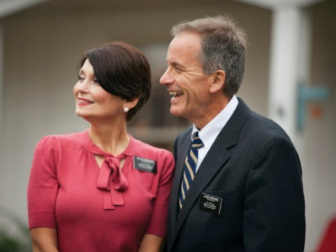Name: Mr. & Mrs. Bloem

Ages: 75 & 72

Married, 5 kids, 12 grand kids, 3 great grand kids

Profession: Retired

Service: Full time Missionaries

Looking for good accommodation close to the temple, pleasant environment, relevant amenities

**Site Map**

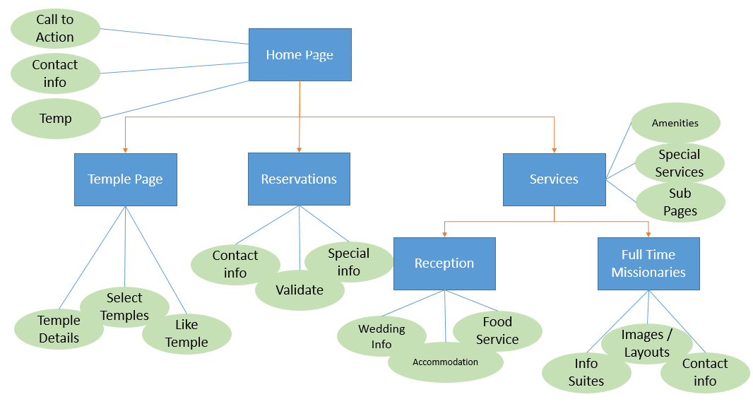

**Color Scheme**

Primary color: # d7f0e9 – Applied to all page background (main)

Secondary color: # eofbfc - Used for background on texted within the main sections

Primary blocks color: # 295982 – Applies to bottom part of header and top part of footer

Secondary blocks color: # 98c1d9- Applies to bottom part of header and top part of footer

Primary text color: #293241 – Applies to all headers

Secondary text color: #ee6c4d – Applies on navigate and footers

Text back ground color: #D6DBDB

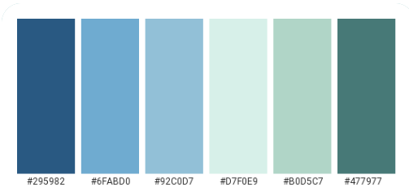

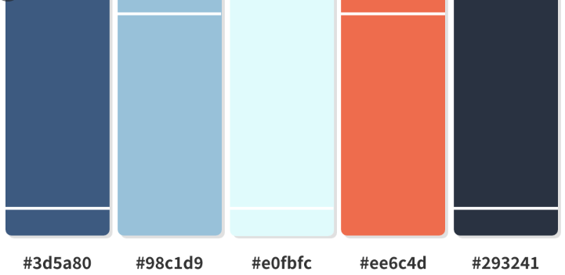

**Site Typography**

Fonts

**Heading font:** Merriweather, serif

**Paragraph font:** Georgia, Times;

**Link-font:** Verdana, Geneva, sans-serif

**Font Sizes**

**Header L1:** font-size: 34px

**Header L2:** font-size: 28px

**Header L3:** font-size: 24px

**Paragraphs:** font-size: 20px

**Wireframe Sketches**

