Motivation and research questions:

Our work with long-term, observational data sets shows strong intraspecific limitation and weak interspecific interactions, leading to very stable coexistence. The large differences in the strength of intra- and interspecific interactions seem surprising given that our plant species are competing for the same resources. A reason to be skeptical of these differences is our reliance on analysis of observational data, a weak form of inference. We would have more confidence in our results if they were confirmed by an experiment.

We conducted a field experiment to test whether models based on observational data could successfully predict (explain?) the population responses of perennial grasses to removal of sagebrush and sagebrush to removal of grasses.

Our first research question was qualitative: Are the survival, growth or recruitment of our target species significantly different in control vs. removal treatments?

Our second research question was quantitative: How does incorporating information from removal treatments impact simulated population dynamics?

Question 1 results: Significant differences?

Approach: Fit vital rate regression models with a categorical "removal treatment" effect. For ARTR, this is the effect of a grass removal, for HECO, POSE and PSSP this is the effect of an ARTR removal. A significant effect indicates that performance of the target species is significantly different from its performance in control plots. Positive coefficients mean higher performance in removal plots, negative coefficients mean lower performance in removal plots.

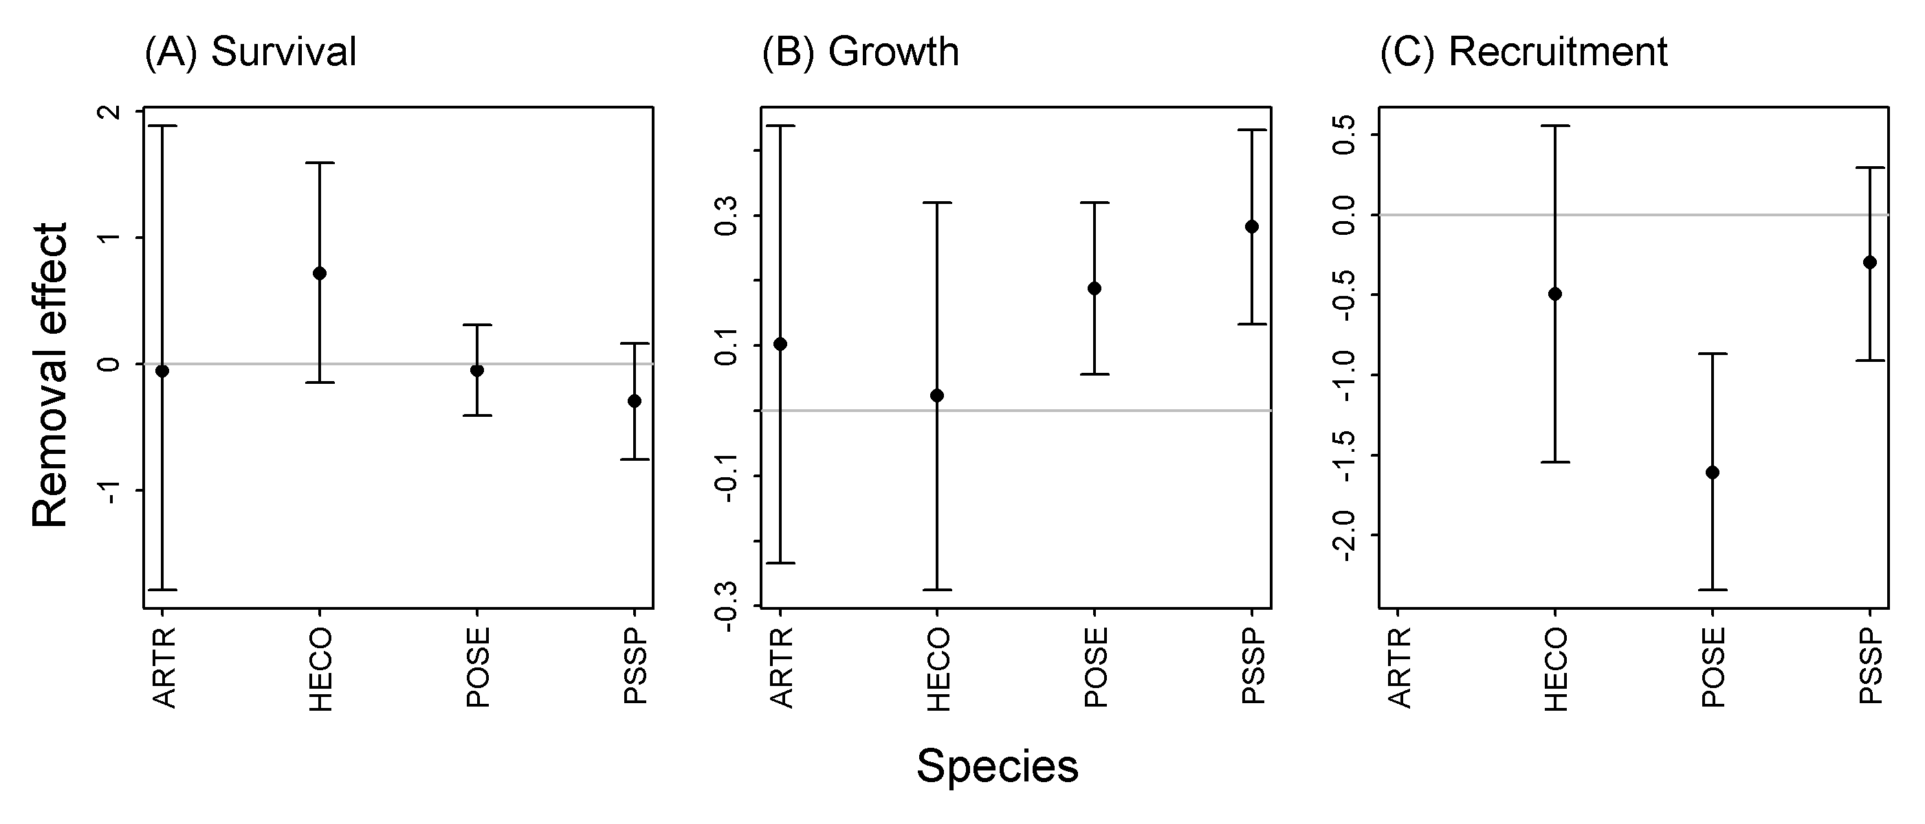
Fig. 1. Removal treatment coefficients and 95% confidence intervals for the four species and three vital rate models. (A) Removals had no significant effects on survival. (B) ARTR removal significantly increased POSE and PSSP individual growth (see supplementary info for more on these two). (C) Removals decreased ARTR and POSE recruitment. The full confidence interval for ARTR in recruitment is not shown because it is poorly estimated: we observed zero ARTR recruitment events in the grass removal plots.

Question 2 results: Differences in population dynamics?

First approach: Do one step-ahead predictions of quadrat-level cover and calculate population growth rates using an individual-based model. Compare predictions of a model fit to all data (no removal effects), and a model that includes removal treatment effects. (Question: I have included all estimated treatment effects, even those that are not statistically significant. Should I use a simpler model--no treatment effects--for species and vital rates for which the effects are not significant?)

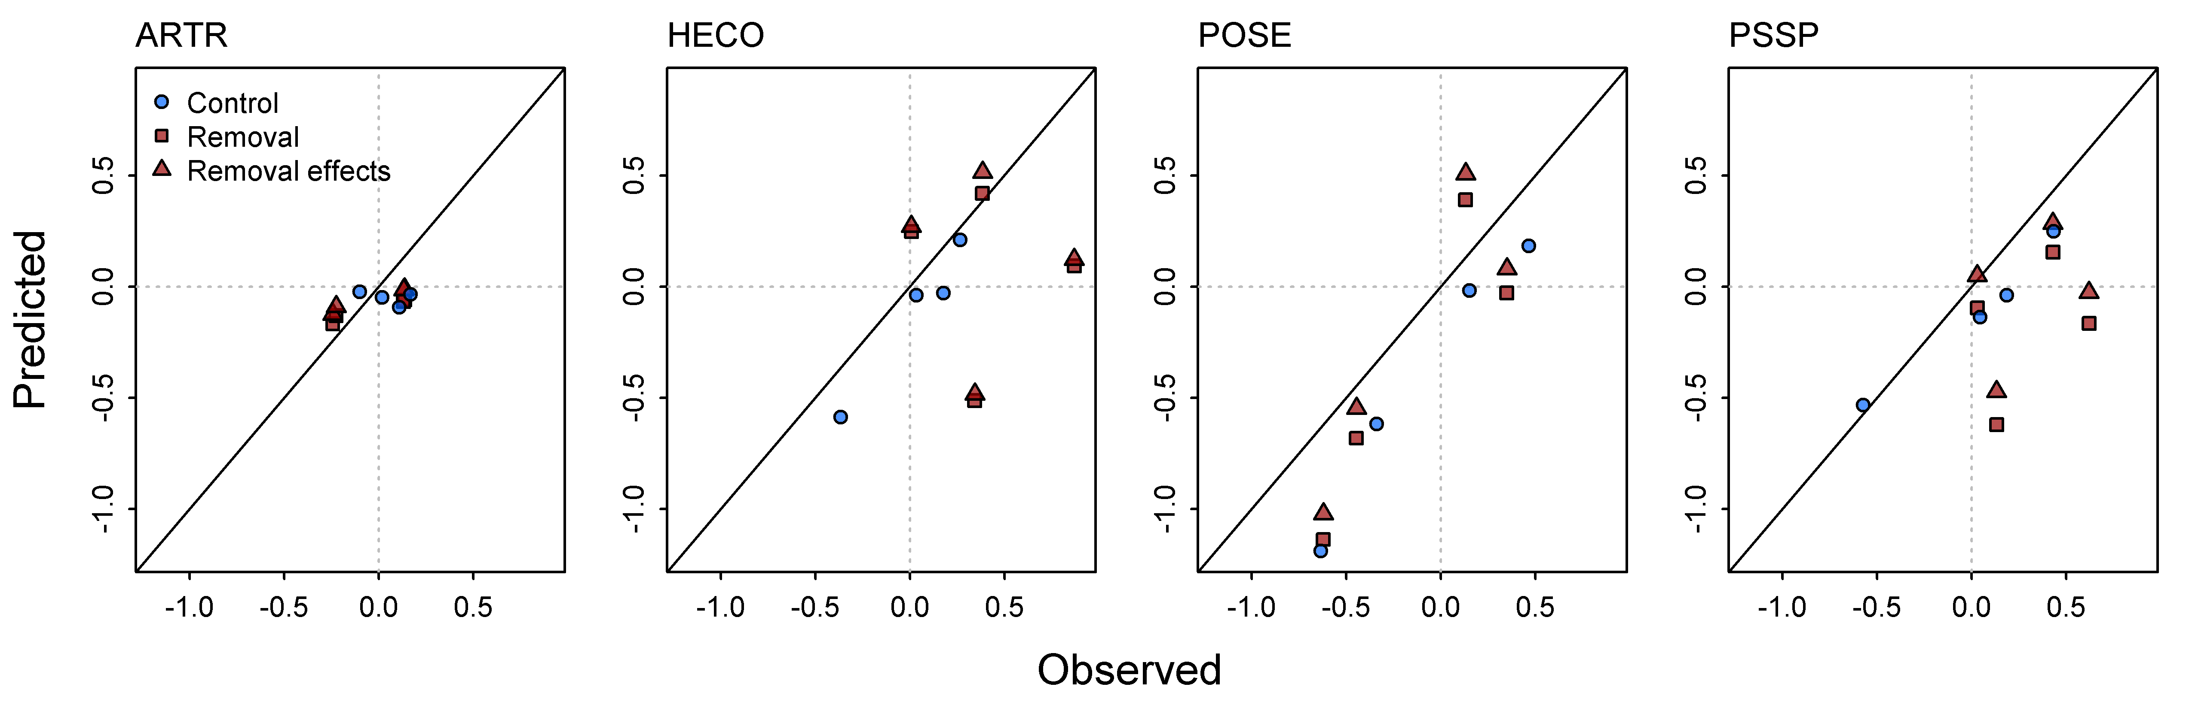
Fig. 2. Comparison of observed and predicted population growth rates (log (cover_t+1 / cover_t)). Blue circles: means for control plots based on a model with no removal treatment effects. Red squares: means for removal plots from predictions of a model with no removal treaetment effects. Red triangles: means for removal plots from predictions of a model with no removal treaetment effects.

The important comparison is between the red squares and red triangles. For ARTR and HECO, they are very similar, meaning very little effect of removal treatment. For POSE and PSSP, population growth is higher when we account for removal treatment effects.

(The comparison between blue and red is not as informative: The model works better for control plots, probably because we have much higher replication of control plots in space and time. Should I remove the blue dots from these figures?)

Second approach: The one-step ahead predictions in the previous figure tell us about short term differences in model predictions. To ask about long-term effects of ARTR removals on predicted equilibrium cover of the grasses, we use integral projections models.
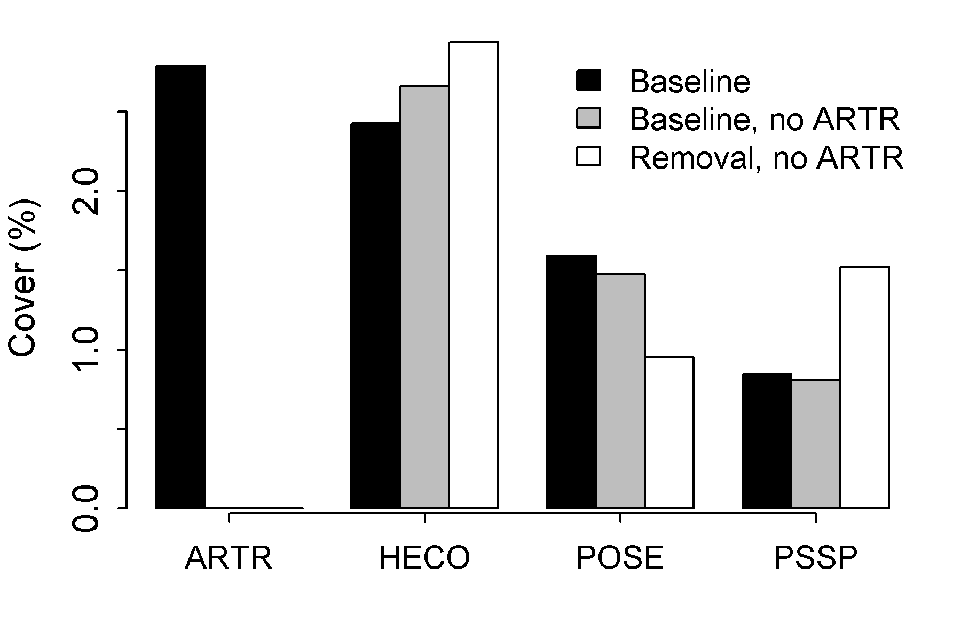
Fig. 3. Simulated equilibrium cover from 1) a model that includes all four species but no removal treatment effects (black bars), 2) a model with ARTR removed but no removal treatment effects (gray bars), and 3) ARTR removed and removal treatment effects.

My interpretation: including removal effects (compare gray and white bars) has little impact on HECO, actually decreases POSE cover (probably because of negative effect of ARTR removal on POSE), but almost doubles PSSP equilbrium cover.

Summary:

For three of the four species, vital rates and populations dynamics in removal plots were not significantly different from controls, suggesting that our analyses of observational data do not underestimate the strength of interspecific interactions. In fact, for POSE, our analysis of historical data may have underestimated the strength of facilitation.

For one species, PSSP, both individual and population growth are higher in the sagebrush removal treatments than in the control plots, suggesting that our analyses of observational data may underestimate the competitive effect of ARTR on PSSP. However, the mechanism by which ARTR removal promotes PSSP remains unclear, meaning we are not sure whether we are really seeing competitive release or not...(see supplement).

Supplement:

OK, so POSE and PSSP grow faster in ARTR removal plots. Can we learn anything more about this response? Here are some things I have tried:

- I classified POSE and PSSP individuals as located either inside or outside the limits of ARTR canopies present in 2011 (before removal). Including that indicator variable in the regressions had no effect.

- I looked for evidence that removal effects were transient by adding a year-by-treatment interaction. There are year-to-year differences but no sign of temporal trend.

- I explored preexisting differences in removal and control plots. In selecting removal plots, our criteria was that plots need to include a certain amount of our target removal species. In contrast, some of the control plots (which are the historical plots) might not contain a particular species. To quantify these differences, I characterized neighborhood crowding at the individual plant level (our "W's"). Here are the results for PSSP:

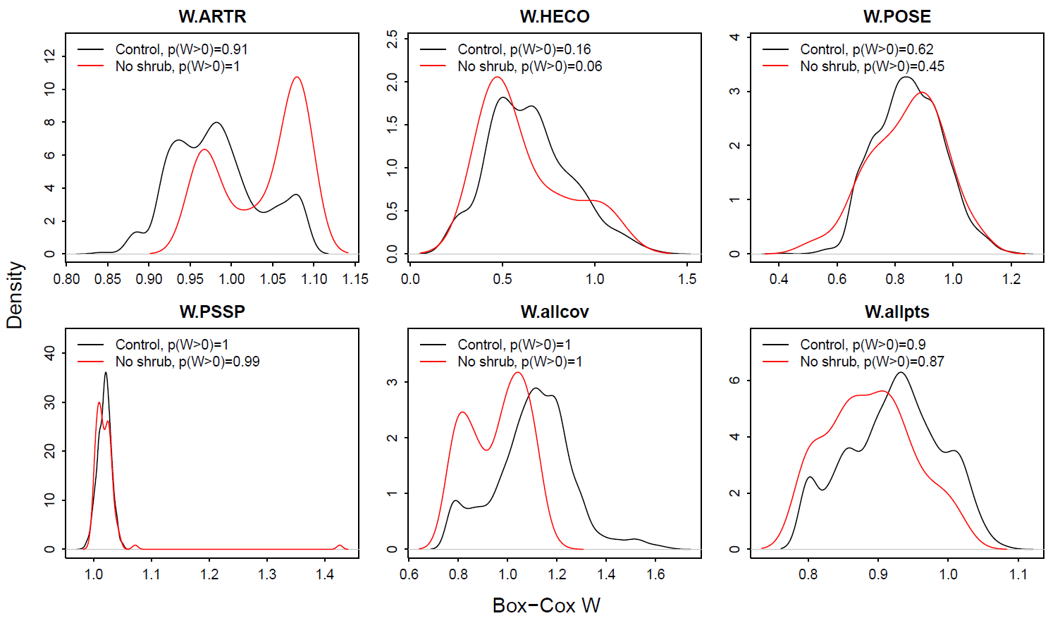
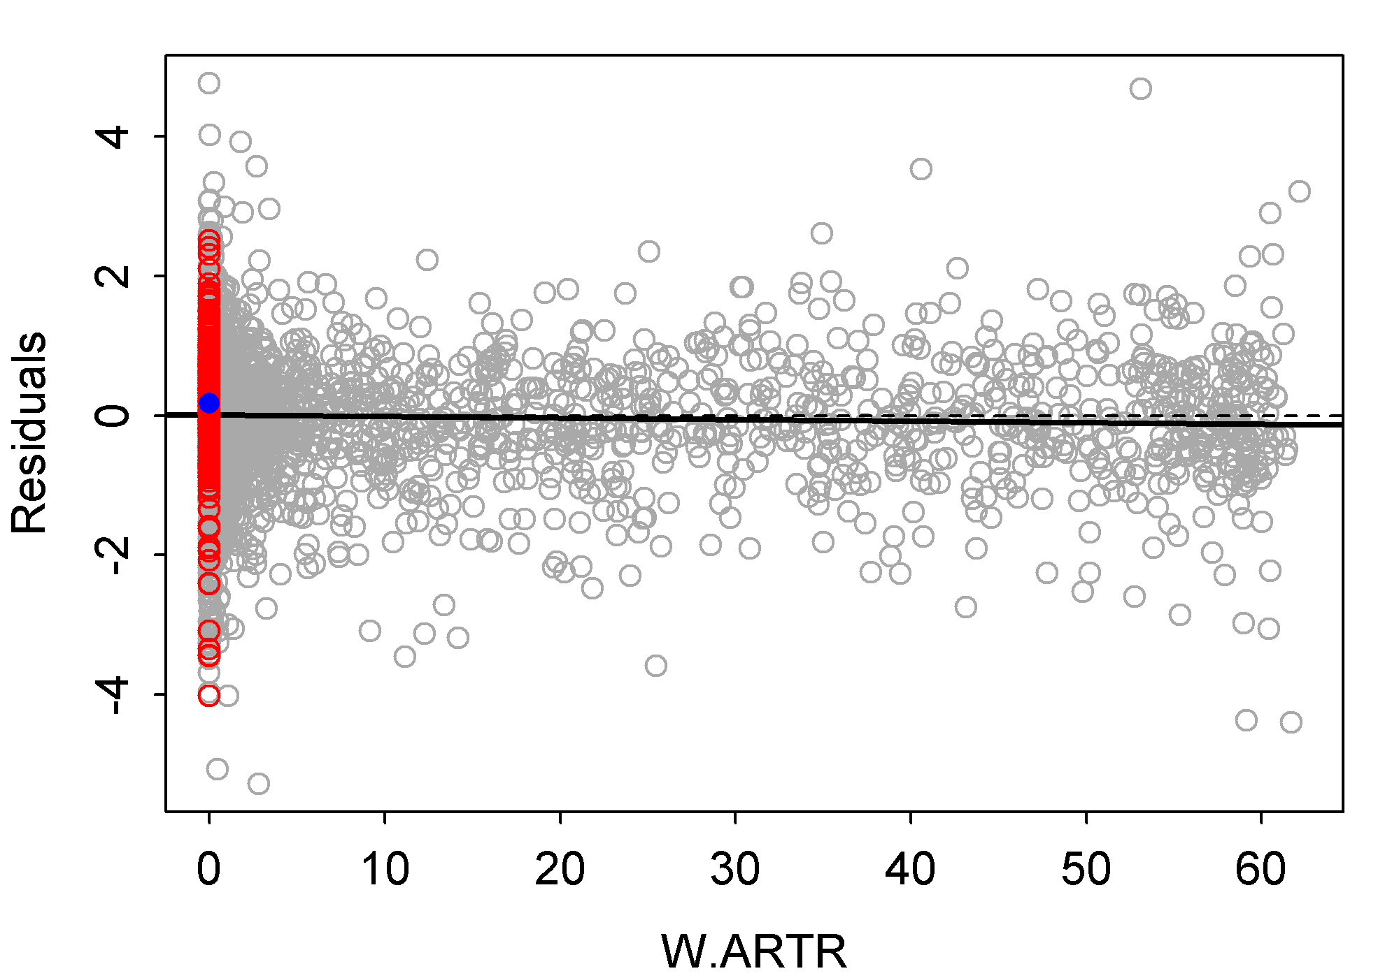
Fig. S1? This is a little complicated because the W distributions have two parts: 1) probability of W > 0, and 2) a Box-Cox transformed distribution of the continuous, non-zero values. This figure shows that PSSP plants in removal plots (red) are more likely to have non-zero values of W.ARTR, and higher values of W.ARTR. And they have lower values of W.allcov (cover of all other shrub and grass species not including the big 4) and W.allpts (cover of forbs).

Our regression models should take these differences into account, but if there is some underlying environmental factor that such differences reflect, our models would not capture that effect.

- Finally, I made a figure that folks in my lab suggested that illustrates the basic nature of the data we are working with, and might be a nice way to explain limitations on what we can say about interspecific interactions. This figure shows residuals of a model of PSSP growth that includes every covariate except W.ARTR. Grey points are residuals from control plots, the solid black line is the fit line, the dashed line is at zero. Red are residuals from ARTR removal plots, and the blue point is the mean of the residuals. It shows that the PSSP growth regression tells us: the intercept for removal plots is (a little) higher than the intercept for controls.

