SWITCHING PHASES OF BLDC MOTOR USING HALL SENSOR VALUES AS INPUTS

By

Prashant Bagal

SFID:105221

(Track S2)

TABLE OF CONTENTS

1.Introduction…………………………………3

2.Problem Statement………………………….4

3.System Analysis…………………………….4

4.System Objective……………………………6

5.System Requirements……………………….6

6.Simulation Diagrams………………………..7

7.Test Cases And Expected Outcomes………..8

1. INTRODUCTION

Brushless DC motors are very popular in a wide array of applications in industries such as appliances, automotive, aerospace, consumer, medical, industrial automation for its reliability, high efficiency, high power density, low maintenance requirements, lower weight and low cost. As the name implies, BLDC motor do not have brushes for commutation.

A BLDC motor finds numerous applications in motion control. A BLDC motor has windings on stator and alternate permanent magnets on rotor. Electronic commutation of stator windings is based on rotor position with respect to the stator winding. A new generation of microcontrollers and advanced electronics has overcome the challenge of implementing required control functions, making the BLDC motor more practical for a wide range of uses. Hall sensors are mounted on stationary part of motor so as to provide values based on the position of rotor magnets. The BLDC motor can also be driven with predefined commutation interval. But to achieve precise speed control and maximum generated torque, brushless commutation should be done with the knowledge of rotor position. In this project these hall sensor values are used and decoded with the help logic developed with C programming language to obtain which phase of motor and which switch of inverter is operated for particular position of rotor.

1. PROBLEM STATEMENT

For continuous rotation of BLDC motor at desired speed it is required to know rotor position. For Hall-effect sensors used in BLDC motors, whenever rotor magnetic poles North (N) or South (S) pass near the hall sensor, they generate a HIGH- or Low-level signal, which can be used to determine the position of the shaft. In order to keep the motor running, the magnetic field produced by the winding should shift position as the rotor moves to catch up with the stator field. So for continuous operation of rotor ,decoded commutation sequence obtained from Hall sensor decoder is used to switch phases accordingly and speed of motor is maintained.

1. SYSTEM ANALYSIS

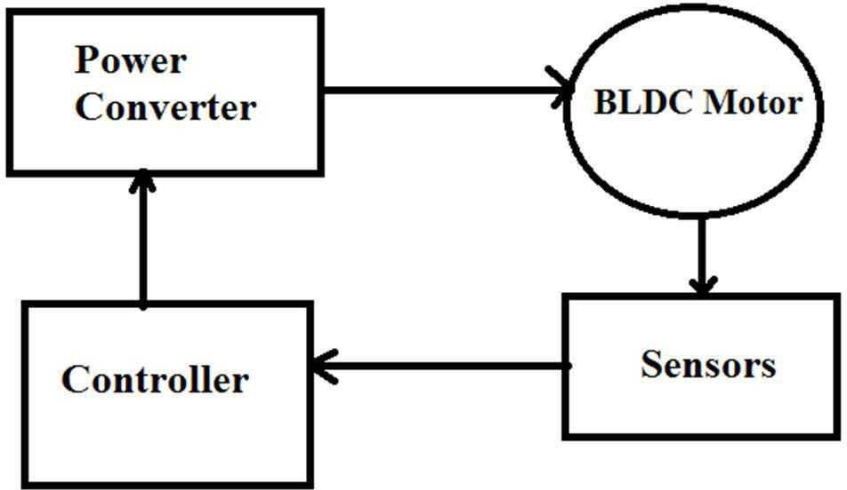

The block diagram of brushless dc motor with its speed controller is shown in above figure. It consist of four main parts they are BLDC motor, sensors, controller and power converters. The power is transformed from source to BLDC motor through converter. So the BLDC motor in turn converts electrical energy in to mechanical energy. To the power converter gate signal is applied on the basis of rotor position.

Hall sensors work on the hall-effect principle that when a current-carrying conductor is exposed to the magnetic field, charge carriers experience a force based on the voltage developed across the two sides of the conductor. If the direction of the magnetic field is reversed, the voltage developed will reverse as well. Most BLDC motor consists of three Hall Effect sensors and the combination of this sensor will produce the exact sequence of commutation. Figure represents a cross section of a BLDC motor with rotor that has alternate North and South permanent magnets. There are two output versions by referring the physical position of the Hall sensors either at 60˚ or 120˚ phase shift to each other.

Three windings on each commutation have different function. First windings will be energized to positive power (current inflow into the winding), the second winding for negative (current out flow the winding) and the last winding is in a non-energized condition. The interaction between the permanent magnet and magnetic field generated by the stator coils will produce the torque. Basically, the peak torque occurs when these two fields are at 90˚ to each other and falls off as the field move together. In order to keep the motor running, the magnetic field produced by the winding should shift position as the rotor moves to catch up with the stator field.

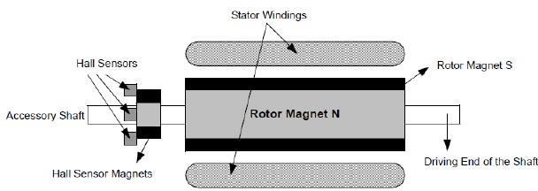

1. SYSTEM OBJECTIVE

To develop program that decodes the Hall sensor values to obtain commutation sequence to energize three windings. Based on this commutation sequence, system will decide to which switch of power converter gate pulse should be supplied.

1. SYSTEM REQUIREMENTS

* Software Requirements (Operating System Database):

Win-98, Win-XP, Win-7, Win-8, Win-10, Linux

* IDE used: Codeblocks
* Coding Language    : C
* Decoder equations

Va=(ha.!hb)-(!ha.hb)

Vb=(hb.!hc)-(!hb.hc)

Vc=(hc.!ha)-(!hc.ha)

1. 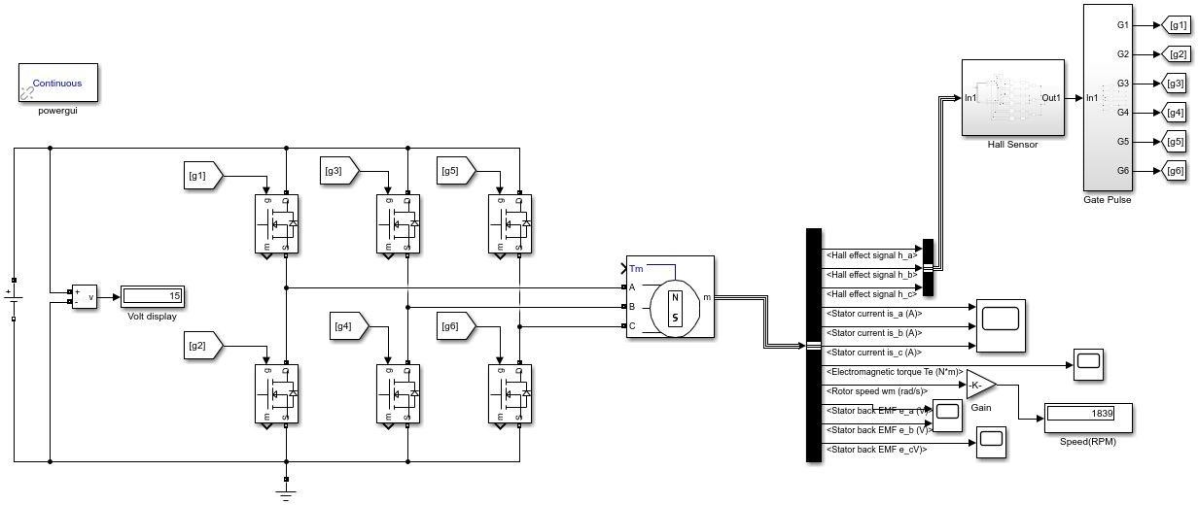SIMULATION DIAGRAMS

* 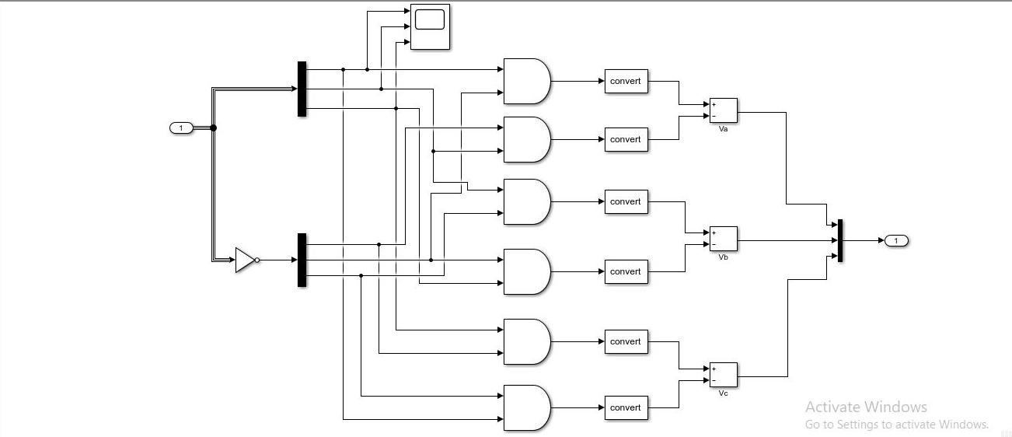Hall sensor decoder
* 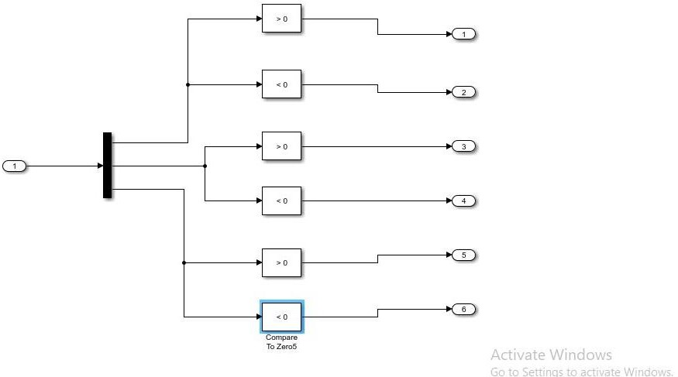Gate firing logic

1. TEST CASES AND EXPECTED OUTCOMES

Select value of 3 Hall sensor from following 8 cases

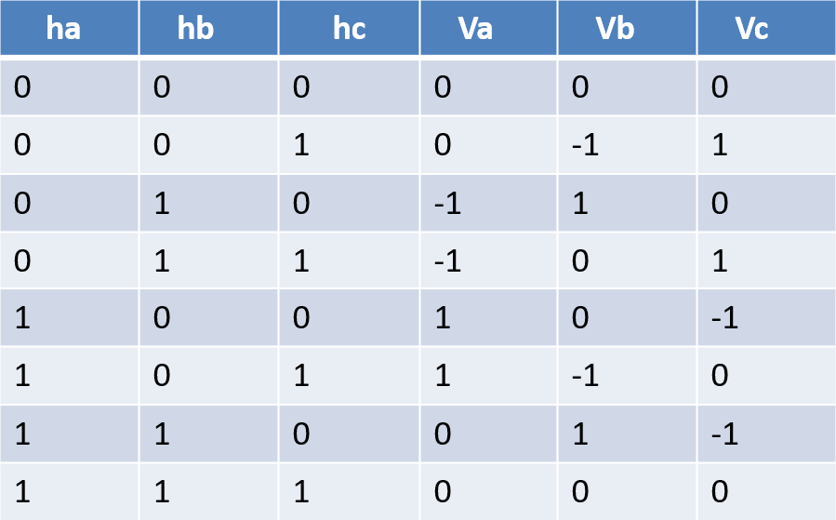

EXPECTED OUTCOME:

For selected case of input system will show following commutation sequence.

For corresponding commutation sequence system will show which switch should be ON and which should be OFF of six switches of power converter.

Here, 0 = OFF

 1 = ON

SYSTEM OUTPUT:

