**DAC-PHASE-3**

**Website Traffic Analysis with IBM Cognos**

**P.Bakkiyam**

**OBJECTIVE:**

Website traffic analysis aims to provide a comprehensive understanding of user interactions with a website, including the identification of traffic sources, demographics, and behavior patterns. The primary objective is to leverage these insights for strategic decision-making.In this phase, which appears to be related to data analysis and data cleaning, the primary activities involve analyzing the collected data to gain insights and ensuring data accuracy and consistency through cleaning. Additionally, loading the cleaned data in IBM COGNOS .Accurate and clean data is essential for making informed decisions and deriving meaningful insights from the data analysis phase.

**DATA INGESTION:**

Data ingestion into Python Jupyter is a critical first step for preprocessing and cleansing website traffic data, enabling you to leverage Python's data manipulation libraries to prepare the data for analysis. Subsequently, using IBM Cognos for data visualization, you can create interactive dashboards that provide a comprehensive overview of key website performance metrics, empowering stakeholders to make data-driven decisions and effectively track progress toward business objectives, all within a seamless and integrated workflow.

**DATA INGESTING INTO PYTHON JUPYTER:**

**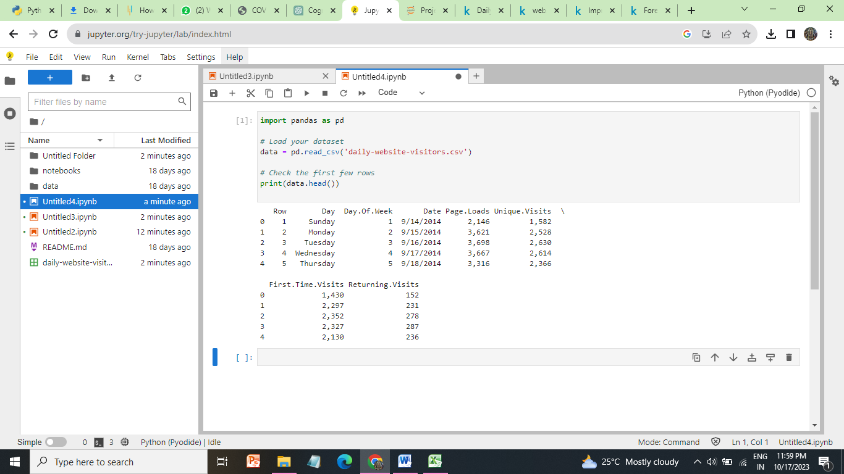**

**DATA PREPROCESSING**

Data preprocessing is a step in the data mining and data analysis process that takes raw data and transforms it into a format that can be understood and analyzed by computers and machine learning.

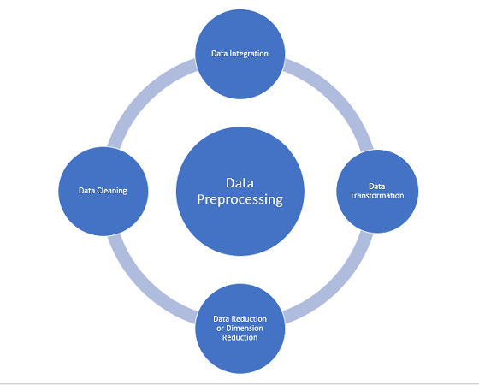

**DATA CLEANSING:**

[Data cleaning](https://monkeylearn.com/data-cleaning/" \t "_blank) is the process of adding missing data and correcting, repairing, or removing incorrect or irrelevant data from a data set. Dating cleaning [is the most important step](https://monkeylearn.com/blog/data-cleaning-steps/" \t "_blank) of preprocessing because it will ensure that your data is ready to go for your downstream needs.

**OUTLIERS IN PAGELOADS:**

**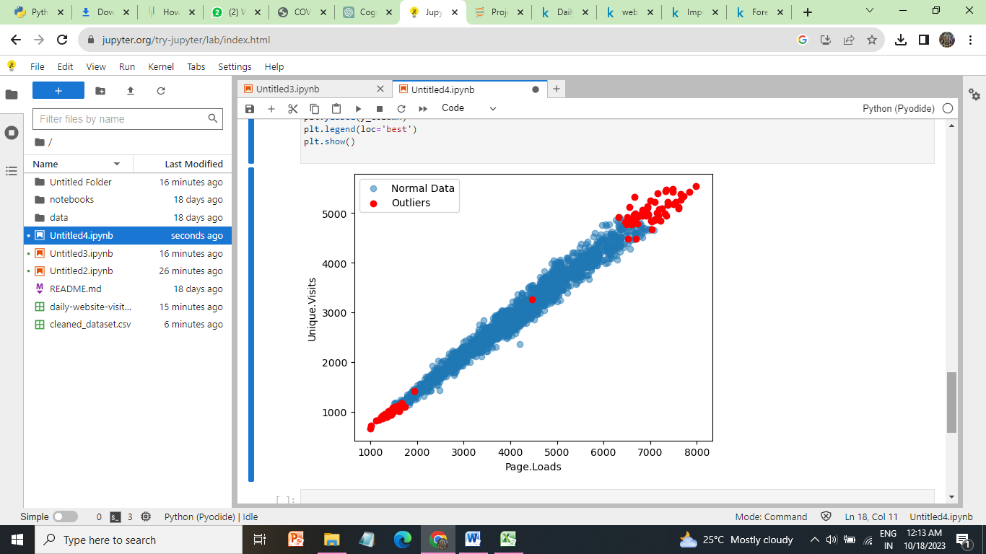**

**INCORRECT AND MISSING VALUE:**

**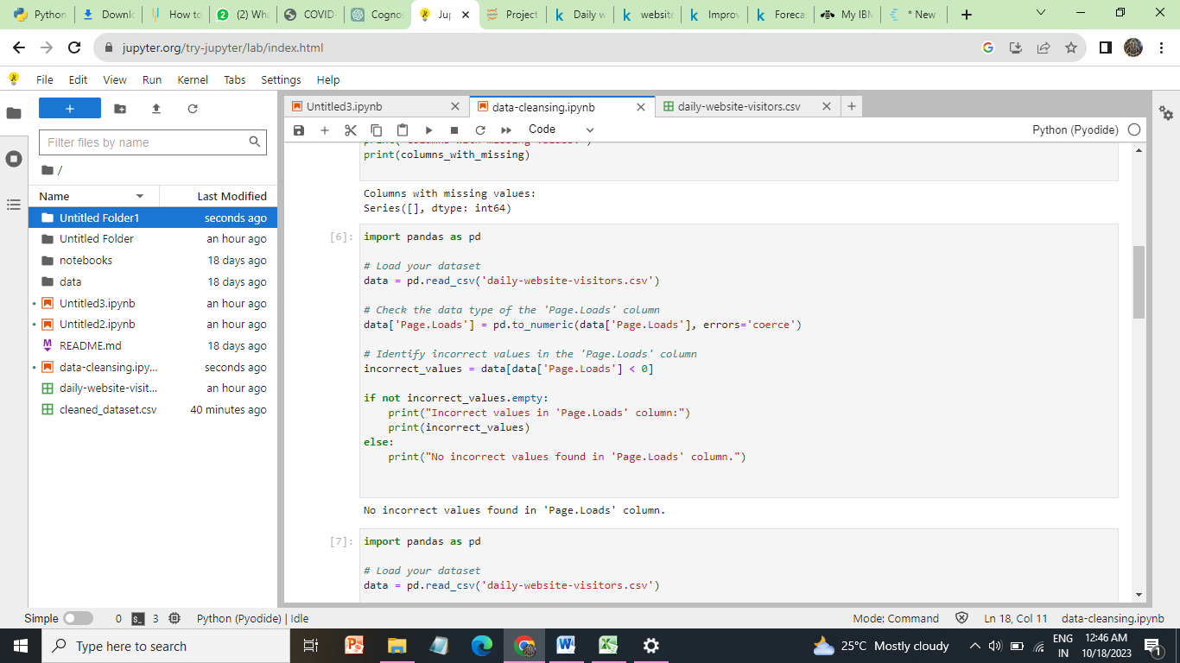**

**MISSING VALUES**

**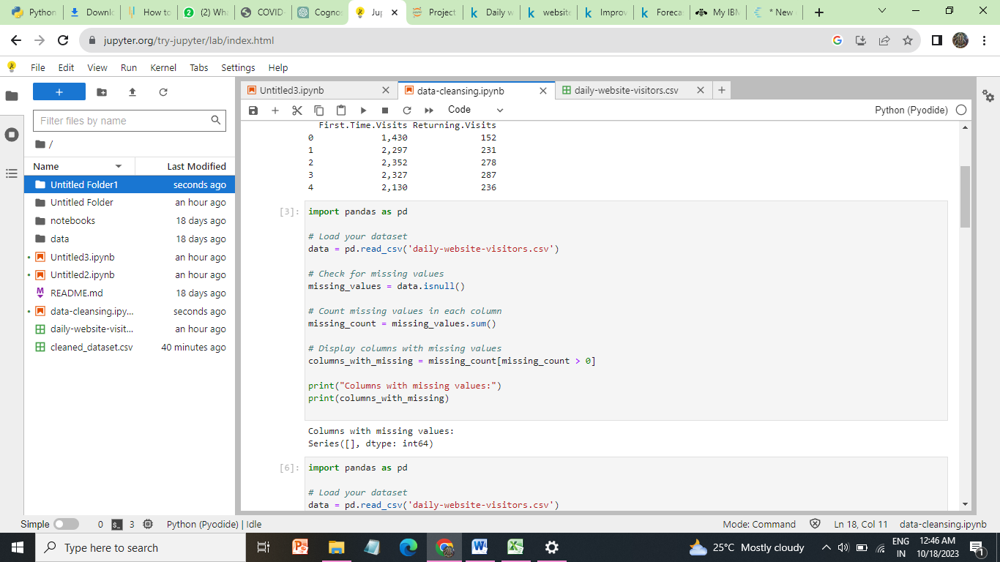**

**DUPLICATE VALUES:**

**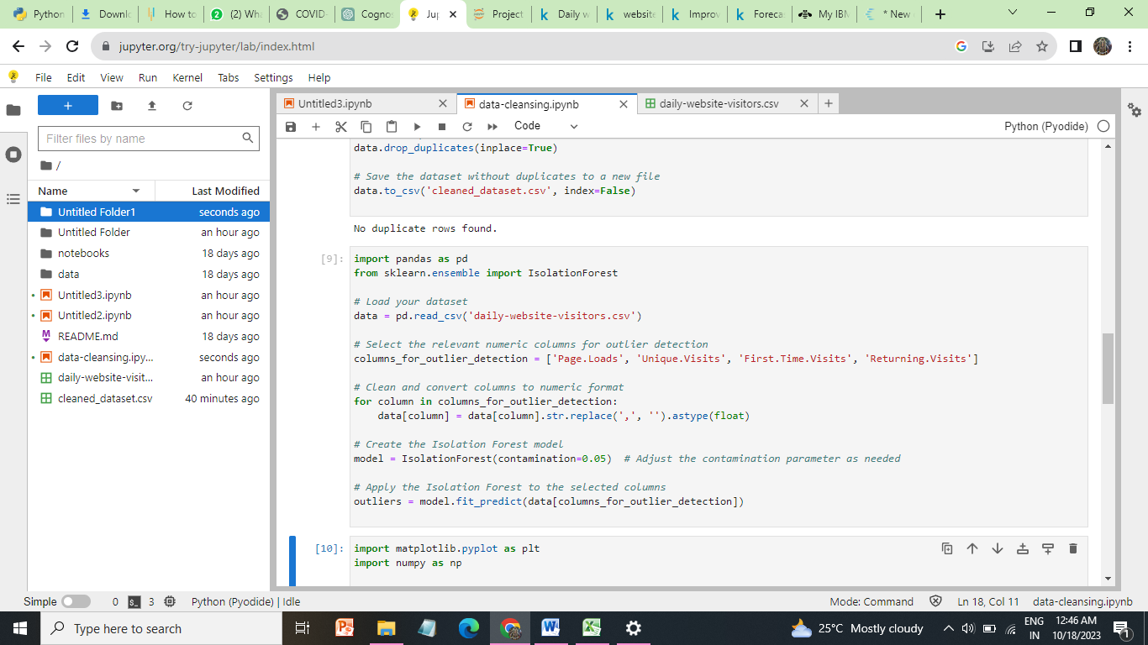**

**DATA INGESTION IN VISUALIZATION:**

**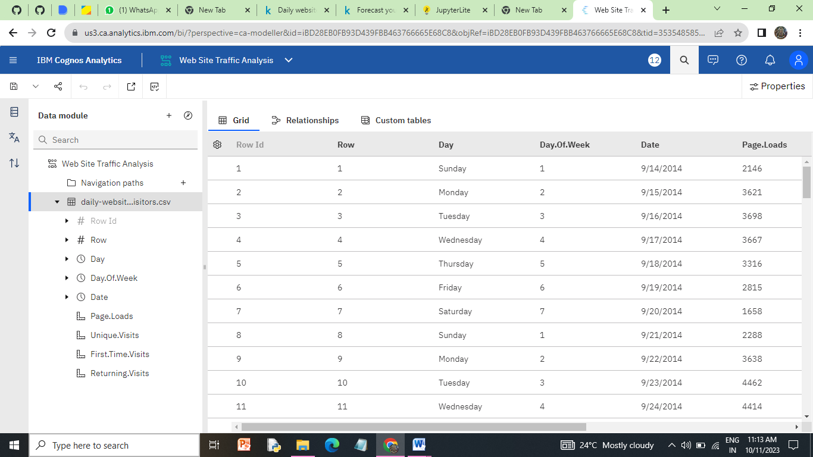**

**WE HAVE ALSO ADDED THE JUPYTER NOTBOOK OF DATA PREPROCESSING IN OUR REPOSITORY.**

**CONCLUSION:**

By ingesting and cleaning data in Python, we set the stage for robust analysis. In data preprocessing ,we have checking outliers, duplicate values, missing values, incorrect values and cleaned dataset loaded in python jupyter.Then, utilizing IBM Cognos to visualize the data empowers decision-makers with accessible, interactive dashboards, ultimately enabling data-driven insights and facilitating the tracking of key performance metrics for better-informed business strategies.