**WEBSITE TRAFFIC ANALYSIS**

# **P.Bakkiyam**

CK COLLEGE OF ENGINEERING & TECHNOLOGY

**OVERVIEW :**

Our website traffic analysis innovation is a comprehensive approach to understanding and optimizing user interactions with our digital platform. By leveraging advanced data collection techniques from tools like Google Analytics, we gather detailed insights into user behavior, popular content, and traffic sources. Through the integration of IBM Cognos for data visualization and Python for advanced analysis, we not only provide real-time data dashboards but also harness predictive modeling to forecast future trends in user engagement and traffic patterns. Additionally, we prioritize data privacy and ethical AI practices to ensure secure handling of user information. This innovation empowers website owners to make data-driven decisions, enhance user experiences, and continuously improve website performance for sustained success.

**TABLE OF CONTENTS:**

* Introduction
* Innovation Ideas
* Product Innovation
* Process Innovation
* Business Model Innovation
* The Innovation Process
* packages
* visualization
* Conclusion

**INTRODUCTION:**

The objective and purpose of website traffic analysis are to gain actionable insights into user behavior, popular content, and traffic sources. By understanding how users interact with the website, our aim is to optimize user experiences, improve website performance, and inform data-driven decision-making for sustained digital success.

**INNOVATION IDEAS:**

1. **Natural Language Processing (NLP) for User Feedback Analysis:**
   * **Product:** Implement an NLP-driven user feedback analysis feature within your analytics tool.
   * **Process:** Develop NLP algorithms to categorize sentiments and identify emerging trends in user opinions.
   * **Business:** Enhance user insights by understanding user sentiments and feedback, leading to product improvements and increased user satisfaction.
2. **Machine Learning-Powered Content Recommendations:**
   * **Product:** Integrate machine learning algorithms for content recommendation.
   * **Process:** Develop personalized content recommendation models.
   * **Business:** Increase user engagement and retention by providing tailored content experiences, ultimately boosting conversions and revenue.
3. **Blockchain for Data Transparency:**
   * **Product:** Incorporate blockchain technology to secure and ensure data integrity.
   * **Process:** Implement blockchain protocols for data validation and transparency.
   * **Business:** Enhance user trust by allowing them to verify the accuracy and authenticity of data, fostering confidence in your platform.
4. **Real-time Analytics and Alerts:**
   * **Product:** Integrate real-time analytics and alert features.
   * **Process:** Implement real-time monitoring and notification systems.
   * **Business:** Improve site performance and user experience by responding swiftly to issues and opportunities as they arise.
5. **A/B Testing Automation:**
   * **Product:** Automate A/B testing processes.
   * **Process:** Develop machine learning-driven test hypothesis generation.
   * **Business:** Optimize website elements efficiently, saving time and resources while maximizing improvements and conversions.
6. **Quantum Computing for Advanced Analysis:**
   * **Product:** Explore the potential of quantum computing for large-scale data analysis.
   * **Process:** Investigate quantum computing applications for complex data calculations.
   * **Business:** Revolutionize the depth and speed of data analysis, gaining a competitive edge in understanding user behavior.
7. **Predictive User Engagement Analysis:**
   * **Product:** Develop predictive models for user engagement.
   * **Process:** Utilize historical data and machine learning algorithms.
   * **Business:** Allocate resources effectively, ensuring the website is prepared for traffic peaks during specific times, optimizing user engagement, and revenue generation.
8. **Personalized Email Campaigns:**
   * **Product:** Implement machine learning-driven personalization for email marketing.
   * **Process:** Analyze user behavior, preferences, and browsing history.
   * **Business:** Increase email campaign effectiveness, leading to higher conversion rates and revenue growth.
9. **Behavioral Segmentation with Clustering Algorithms:**
   * **Product:** Apply clustering algorithms for user segmentation.
   * **Process:** Segment users based on behavior and preferences.
   * **Business:** Tailor marketing strategies for distinct user groups, optimizing content and engagement.
10. **Ethical AI and Data Privacy:**
    * **Product:** Prioritize ethical AI and data privacy within your analytics tool.
    * **Process:** Implement data privacy measures and transparent data handling.
    * **Business:** Build trust among users, comply with regulations, and uphold ethical standards, ensuring the long-term success of your business.

Process:

# Feature scaling

# Build and train machine learning or deep learning models

# Example of a machine learning model:

# Evaluate the model

# Other regression metrics if it's a regression task

# Implement other innovative techniques mentioned earlier, e.g., NLP analysis, blockchain integration, quantum computing (if applicable).

# Data privacy and ethics considerations (if applicable)

# Visualization of results and insights

# Create visualizations to present results and insights.

# Save or deploy the model for production (if needed)

# Additional steps for ongoing analysis and improvement based on results

# End of pseudocode

Packages:

# Import necessary libraries

import pandas as pd

import numpy as np

from sklearn.model_selection import train_test_split

from sklearn.preprocessing import StandardScaler

from sklearn.metrics import accuracy_score, regression_metrics

Visualization:

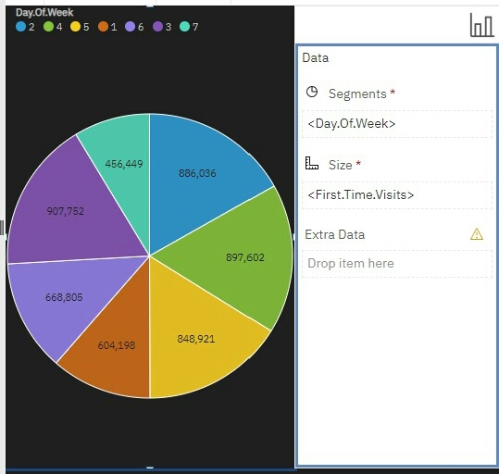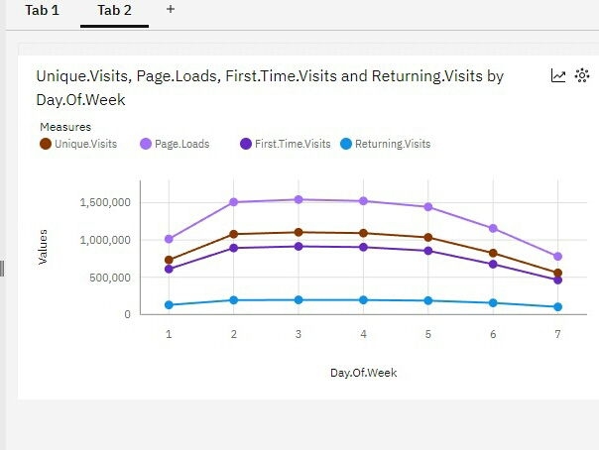

Conclusion:

In conclusion, this website traffic analysis project aims to uncover valuable insights into user behavior, popular website content, and effective traffic sources. By understanding how users interact with the site and tailoring content and experiences accordingly, we seek to enhance overall user satisfaction and engagement. Through data visualization, advanced analysis, and actionable recommendations, we aim to empower website owners to make informed decisions and continuously improve their digital platforms for the long term.