**Read Me Steps:**  
1) Import the QTREF project into Intellij or eclipse editor.  
2) Check for dependencies import as per the POM file attached in the project.  
3) Perform clean and install maven target executions , in the project  
4) Refer the target folder for IngTask-0.1.0.jar file  
5) Select the Jar file and execute Run command if supported by the editor or execute in the command line.  
6) Jar file execution deploys the web application in the embedded tomcat and the expected port is 8080  
 and no such server properties are configured in application.properties.  
7) Make sure that Spring Boot application is started.  
8) The end points can be tested either in CURL / Postman supported in Chrome Browser.  
9) This service simply uses basic authentications, no encryption algorithm is used.  
  
10) To fetch all transactions use the below specification,   
 **user : user   
 password : password  
 url :** [**http://localhost:8080/getTransactionList**](http://localhost:8080/getTransactionList)  
11) To fetch transaction amount for the given transaction type use the below specification,   
 **user : admin  
 password : password  
 url :** [**http://localhost:8080/getTransactionValueForType?transactionType=sandbox-payment**](http://localhost:8080/getTransactionValueForType?transactionType=sandbox-payment)  
13) To fetch all transaction list for the given transaction type use the below specification,   
 **user : admin  
 password : password  
 url :** [**http://localhost:8080/getTransactionListForType?transactionType=sandbox-payment**](http://localhost:8080/getTransactionListForType?transactionType=sandbox-payment)

***PostMan Test Screen shots, you may please refer the url for respective services,   
once you enter user credentials click update request button, then submit the request using Send button.***  
  
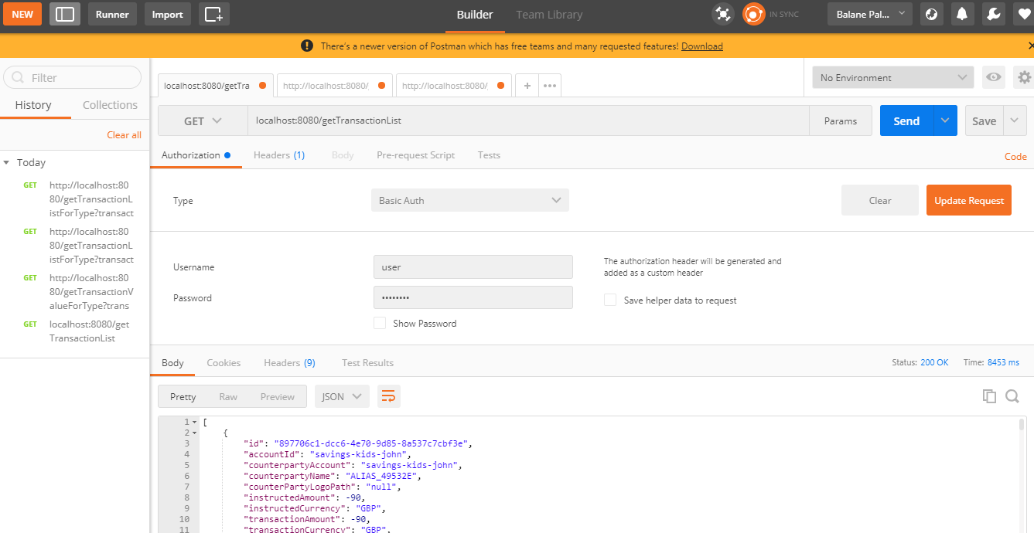  
  
  
  
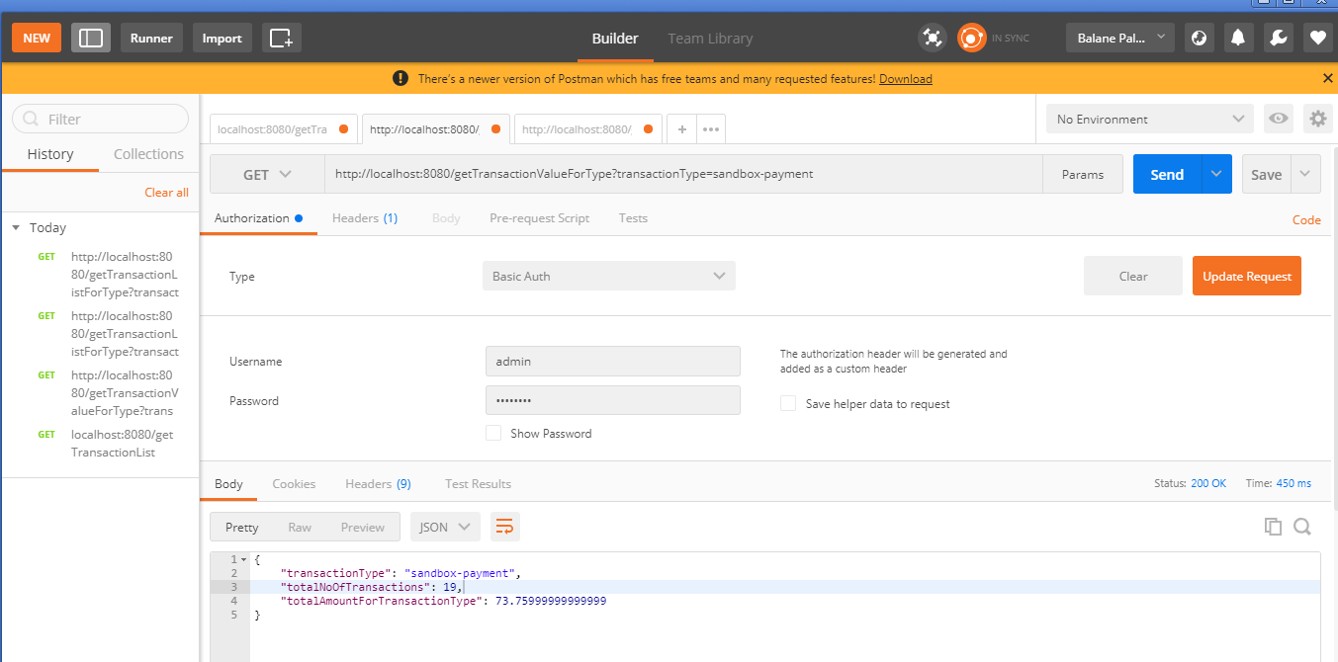

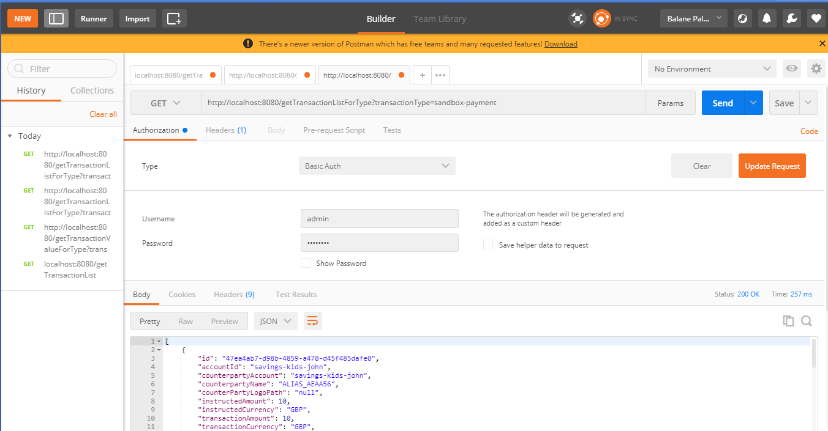

12) Apache camel is not used for routing URL requests, simple proxy service is used with RestTemplate APIs.  
13) EhCache is used as in memory database and cache values removed after exiting the processes automatically.   
  
**Additional tools testing performed**  
1) Get All Transactions List  
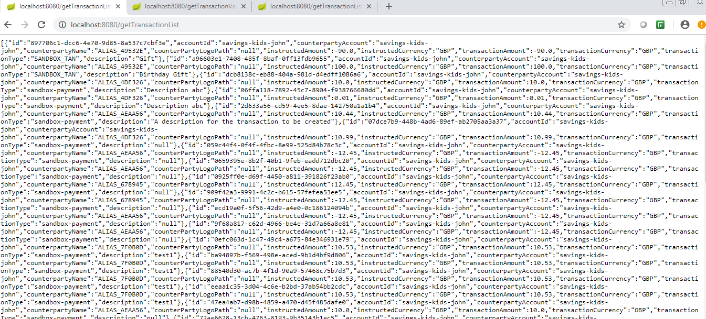

2) GetTransaction List for Type  
  
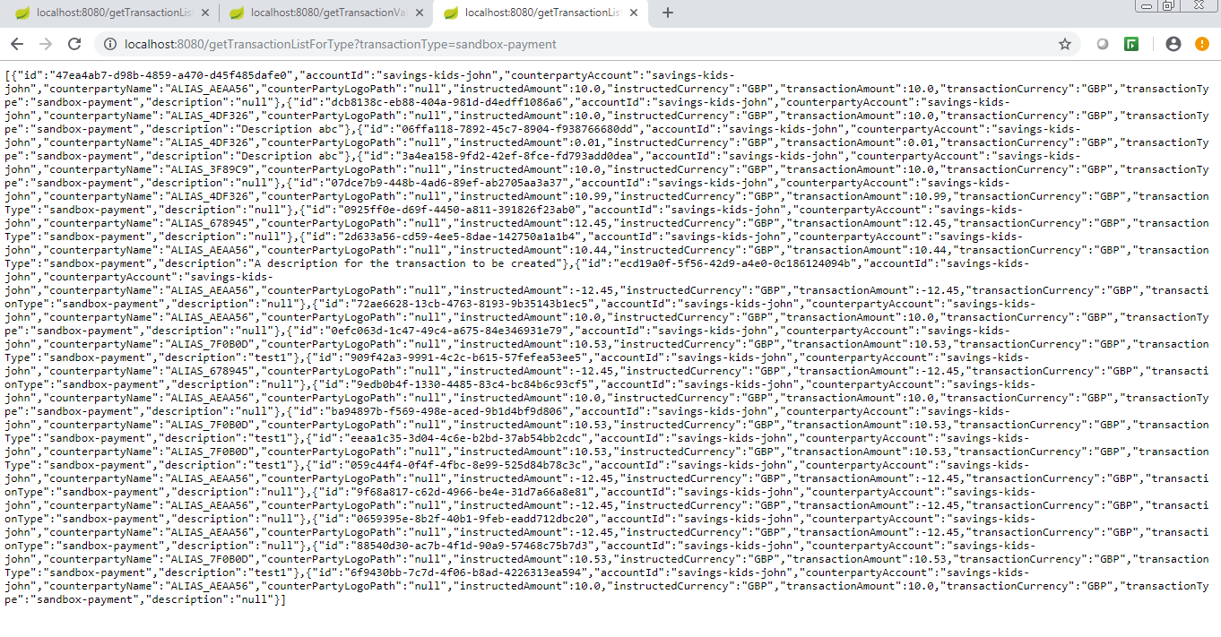  
  
3) Get Transaction amount value for Type  
  
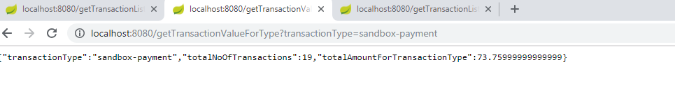

**CURL testing**



