**Homework 3**

GitHub: <https://github.com/pballou/ECGR_4105/tree/master/Homework/homework_3>

1. Naïve Bayes classifier on cancer dataset. Pretty accurate overall, especially for a model only based on probabilities.

1. Logistic regression with PCA (k=1:30) on cancer dataset. The optimal k is 9 in this situation.

Results with k=9:

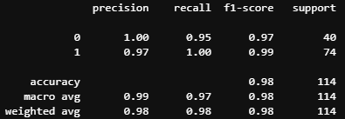

1. Naïve Bayes with PCA (k=1:30) on cancer dataset. The optimal k is 7 in this situation.

Results with k=7:



