**Load Runner Cloud – Git Integration**

Pre-Requisites:

LRC GitAgent

Github

* Download LRC Git Agent from LRC web page – Get Tools🡪Agents🡪Download Git Agent

Click [here](https://loadrunner-cloud.saas.microfocus.com) to download

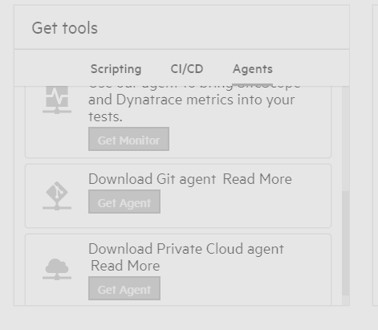

* Download Git – from [here](https://git-scm.com/download/win)
* [Login](https://git.autodesk.com/) Git Enterprise
* Create a Repository – click New🡪Provide required details and click Create Repository

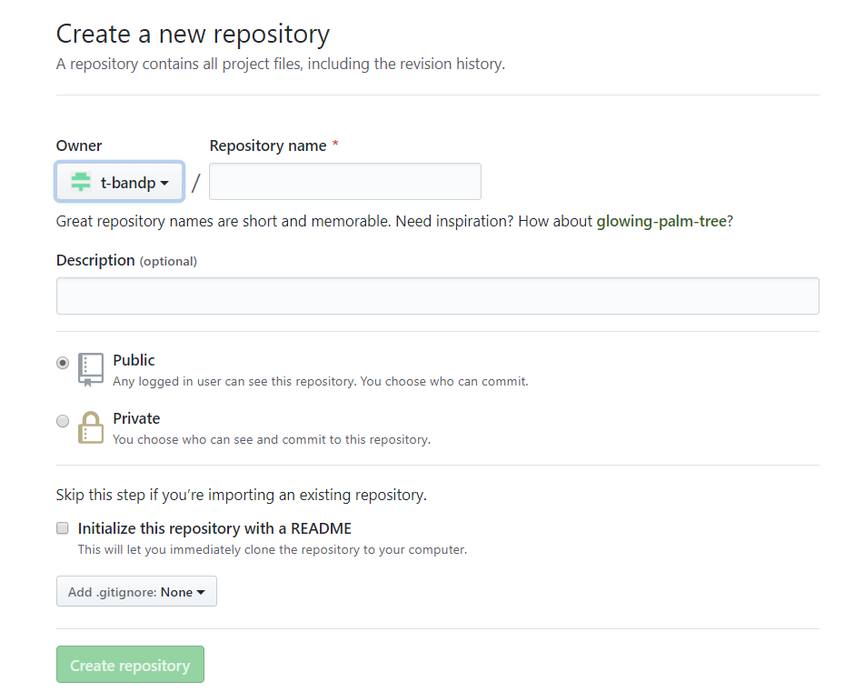

* Create PAT – Personal Access Token from Git Enterprise

Navigate Profile Setting🡪Developer Settings🡪Personal access tokens🡪Generate New Token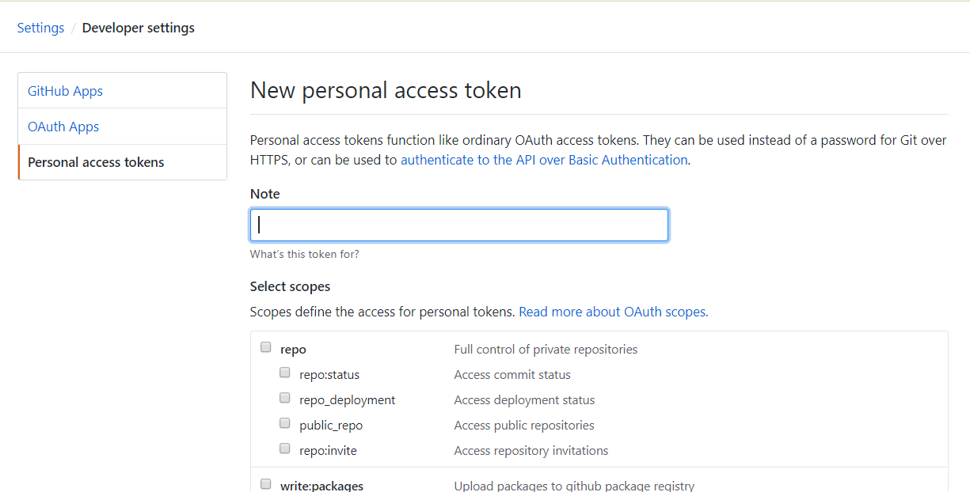

Once Token generated save it for future use case.

* Install Git on dedicated windows machine
* Open Git GUI/Bash and clone existing Repository – to get Repo URL follow below method

Open Repository from Git and copy repository URL

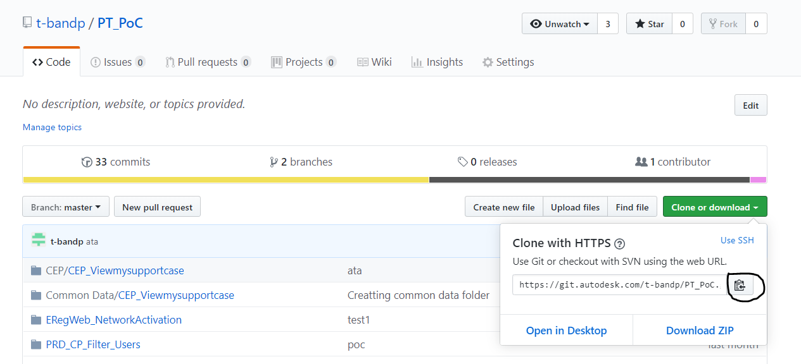

* Go back o respective windows machine and clone Repo using above URL.

Use username as same Autodesk and for password use Personal Access Token which is created

(When you are using SSO or Two Factor Authentication to login Git you should use PAT instead of password)

* Install LRC GitAgent which is already downloaded
* Create Environment Variables in windows machine

Variable Name - SRL_AGENT_USE_GIT_CMD

Variable Value - true

* Open Configure LRC Git Agent

Under General tab provide required details

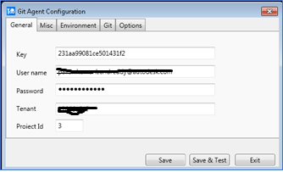

Under Git tab – Click Add repository🡪Provide Repository URL🡪click Advanced 🡪Provide Username and Password(PAT)

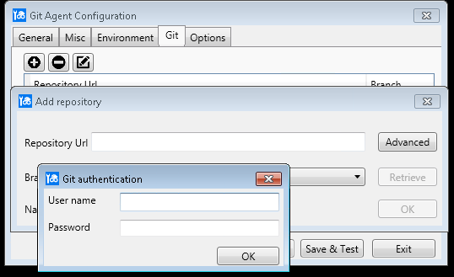

Save and Test – If any issue found provide Proxy details under Misc

* Once above steps are successful start LRC Git Agent

Agent status can be verified from LRC like below

Login [LRC](https://loadrunner-cloud.saas.microfocus.com/)🡪ASSETS🡪Agents – Check status

