Berkely - Project Findings and solutions:

**1. Installing Python and Flask on Amazon Linux 2023**

Update the system :

Sudo yum update -y ;

Install Python :

sudo yum install -y python3 ; python3 --version ;

sudo yum install -y python3-pip

pip3 --version

pip3 install Flask

1. **Setting Up the Flask Application**

mkdir /home/brklyusr/berkeley-project/app

cd /home/brklyusr/berkeley-project/app

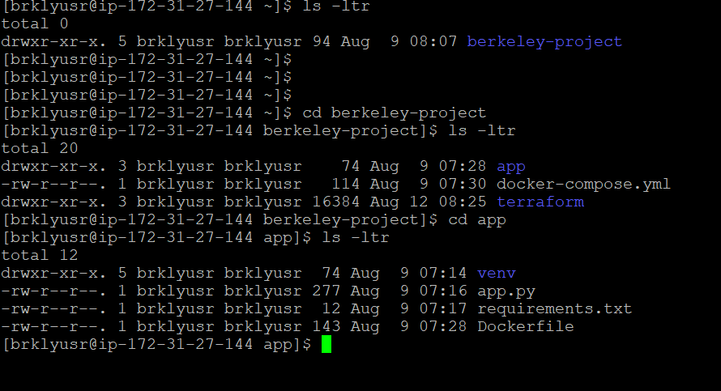

Added the following code

**from flask import Flask**

**import redis**

**app = Flask(__name__)**

**r = redis.Redis(host='redis', port=6379)**

**@app.route('/')**

**def index():**

**count = r.incr('counter')**

**return f"This is the {count} visitor"**

**if __name__ == "__main__":**

**app.run(host="0.0.0.0", port=5000)**

**Flask app connects to a Redis server, increments a counter each time the page is visited, and displays the count.**

1. Dockerizing the Flask Application

cd /home/brklyusr/berkeley-project/app

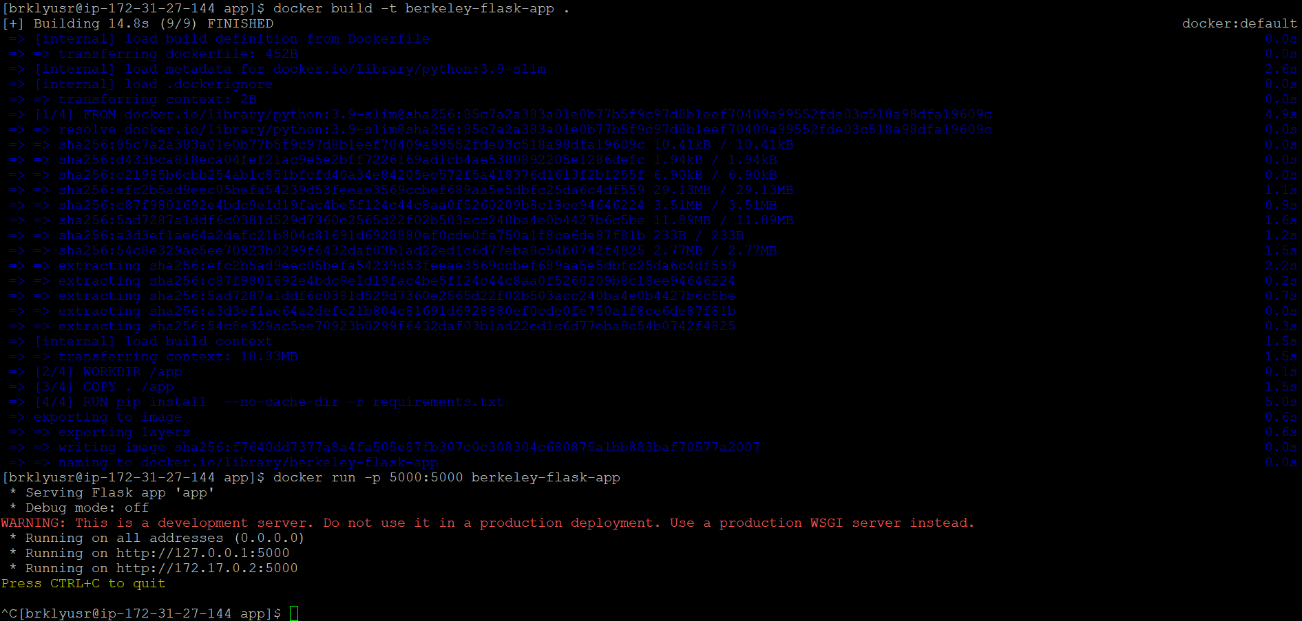

docker build -t berkeley-flask-app .

docker run -p 5000:5000 berkeley-flask-app

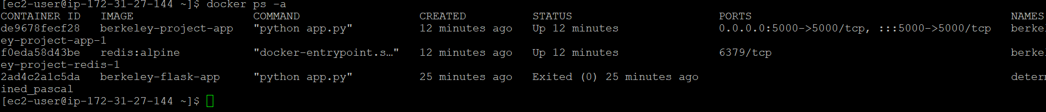

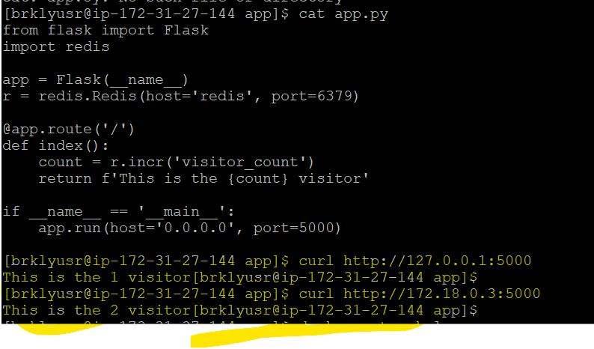

**OUTPUT :**



**Terraform EKS Cluster Setup Details and errors:**

1. **Error: Unsupported Kubernetes Version**

When initially attempted to apply the Terraform plan, encountered the following error:

**Error: creating EKS Cluster (berkeley-eks): operation error EKS: CreateCluster, https response error StatusCode: 400, RequestID: <request-id>, InvalidParameterException: unsupported Kubernetes version 1.21**

The error occurred because Kubernetes version 1.21 is no longer supported by AWS EKS.

**Resolution**: Updated the Kubernetes version in the main.tf file from 1.21 to a supported version, 1.24.

**module "eks" {**

**source = "terraform-aws-modules/eks/aws"**

**version = "20.0.0"**

**cluster_name = "berkeley-eks"**

**cluster_version = "1.24" # Updated Kubernetes version**

**...**

**}**

1. **Error: Unsupported Attribute in Node Group**

During the Terraform apply, encountered an error related to an unsupported attribute:

**Error: Unsupported attribute**

**on main.tf line 70, in output "eks_node_group_arn":**

**70: value = module.eks.eks_managed_node_groups["berkeley_ng"].arn**

The error was caused by referencing an attribute arn that doesn't exist in the context which am using.

**Resolution :** Identified that the correct attribute to use was node_group_arn, not arn. The output block was updated as follows

**output "eks_node_group_arn" {**

**description = "ARN of the EKS node group"**

**value = module.eks.eks_managed_node_groups["berkeley_ng"].node_group_arn**

**}**

**3. Error: Deprecated Arguments in VPC Module**

When using the VPC module, warnings appeared related to deprecated arguments:

**Warning: Argument is deprecated**

**with module.vpc.aws_eip.nat,**

**on .terraform/modules/vpc/main.tf line 1013, in resource "aws_eip" "nat":**

**1013: vpc = true**

The deprecated vpc argument was still being used in the older version of the VPC module.

**Resolution**: Reviewed the module documentation and removed or updated deprecated arguments to comply with the latest version of the Terraform AWS VPC module.

**4 Error: Unsupported Argument in the VPC Module .**

**Error: Unsupported argument**

**on .terraform/modules/vpc/main.tf line 35, in resource "aws_vpc" "this":**

**35: enable_classiclink = null**

The argument enable_classiclink is no longer supported in the Terraform AWS VPC module.

**Resolution:** Commented out the the deprecated enable_classiclink and enable_classiclink_dns_support arguments from the configuration to resolve the issue under .  
**/home/brklyusr/berkeley-project/terraform/.terraform/modules/vpc/main.tf**

1. **Error: Invalid Reference for Domain Attribute**

Attempted to resolve the deprecated vpc argument by updating it to domain, which led to a new error:

**Error: Invalid reference**

**on main.tf line 1013, in resource "aws_eip" "nat":**

**1013: domain = vpc**

**Resolution** : removed the invalid reference and ensured that the correct attribute is used

domain = “vpc”

6. **Lock File Management**

Initially, the .terraform.lock.hcl files were not excluded from version control, which could lead to issues when collaborating with others

**Resolution:** updated the .gitignore file to exclude .lock.hcl files: