**Report Data**

**Q1.** Given the provided data, what are three conclusions that we can draw about crowdfunding campaigns?

**Ans.** With the provided data, we can conclude the following:

1. The category “theatre” has the most crowdfunding and has most successful events. One thing to see is that although this category has most successful events, it also has most failed events.

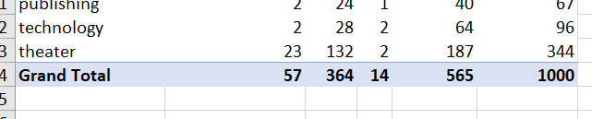

1. During a year, all months have some number of cancelled events that is below 10 but July month has most successful events although it has highest number of events happened.



1. From Goal dataset, we can see that for price more than 45000 the success rate is going down and failure rate is increasing. So, we should keep the target below 45000 for higher success rate.

**Q2.** What are some limitations of this dataset?

**Ans.** The dataset is incomplete because it only provides details of the amounts collected in the local currency. If you want to determine how crowdfunding campaigns are performing across the globe for different regions, the data is not very helpful. You not only need data in a common currency, but you also need to understand how significant or insignificant these amounts are about each region. Only then can analysts reach a consensus on how crowdfunding is performing in each geography**.**

Also, the data has around 1000 entries which is very small to predict the right analysis for crowdfunding type of big area, this is giving idea for a very small part of actual predictions as geographic area also effects the crowdfunding.

**Q3.** What are some other possible tables and/or graphs that we could create, and what additional value would they provide?

**Ans.** One other possible table and graph is finding out number of successful, failed, and canceled events in different countries. This helps finding out the country which does the most crowdfunding.

The other one is finding out difference in campaign outcomes based on categories and sub categories.