Frage PBU
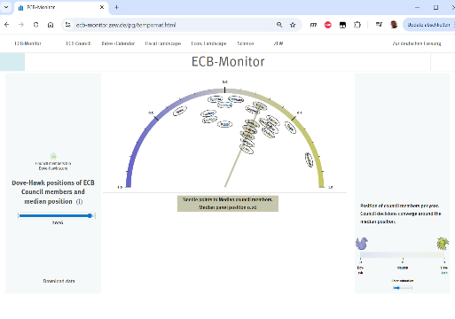 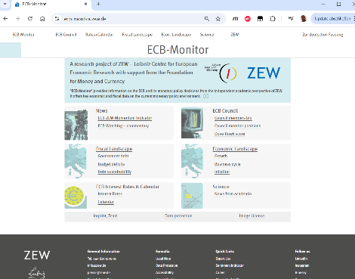 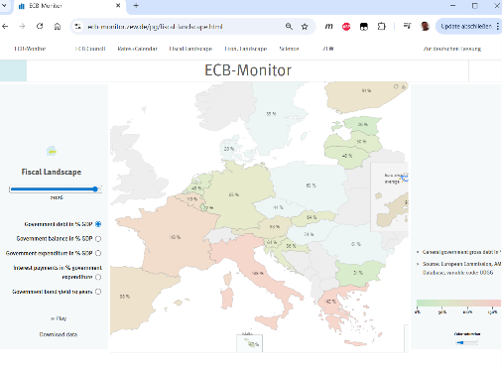
three screenshot of the website I am working on. Question about navigation design. various target groups have reported different ways of getting back to homepage. Top row - section navi - but also a link to home. Second main row - always name of the website - with link to home, reportedly not recognized by some users - left margin column - "home" icon - and links to sibling. this was requested and grasped by many users - but others did not grasp it - last requirement by ME - the total height of the screen layout should not increase too much - so that users dont have to scroll down vertically. Suggestions please.

Antwort “Nano Banana” – Googles leading Image AI
This is a classic UX dilemma: balancing multiple user mental models (how they expect navigation to work) while adhering to strict design constraints (vertical space).
Given your constraint that the total vertical height of the header area must not increase significantly, we need to optimize the existing elements rather than add new rows of navigation (like breadcrumbs).
Here is a prioritized analysis of your current setup and actionable suggestions to improve homepage navigation without increasing vertical height.

The Analysis: Why Users Are Confused
Based on your screenshots and description, here is where the current design fails different user groups:
1. The "Standard Web User" (Expects top-left logo to go home)
In your Top Row (Image 0, 1, 2), you have the text "ECB-Monitor" on the far left.
- The Problem: It looks like plain text, not an interactive logo or button. It lacks "affordance" (visual clues that it is clickable). Users glance at it, assume it's just a label, and keep looking.
2. The "Literal User" (Looks for a button labeled "Home")
You mentioned the left margin column has a home icon (the small house) that some users requested, but others missed.
- The Problem (Images 0 & 2): The house icon is too subtle. It is small, low-contrast (pale yellow/green), and floats ambiguously above the sibling links ("Council members bio"). Crucially, it lacks the text label "Home". An icon without a label is often invisible to users scanning quickly.
3. The "Big Heading User" (Expects main titles to be links)
You mentioned the large, centered "ECB-Monitor" heading is a link, but not recognized.
- The Problem: Like the top-left text, this big heading provides zero visual cues that it is a link. It looks like static title text.

Suggestions: Fixing Navigation Without Adding Height
We need to turn your existing elements into clear navigation anchors.
Priority 1: Solidify the "Brand Anchor" (Top Left)
This is the single most impactful change for the majority of users. The top-left corner is the standard location for "reset/home" functionality on the web.
- Current state: Plain text "ECB-Monitor".
- Suggestion: Turn this text into a clear interactive element.
  - Option A (Add an icon): Place a distinct icon next to the text in the top bar. A stylized version of the ZEW logo or a simple, bold "Home" house icon directly to the left of "ECB-Monitor".
  - Option B (Visual Weight): Make the "ECB-Monitor" text in that top bar significantly bolder or a different color (like the ZEW blue) so it stands out from the section links next to it.
- Height Impact: None.
Priority 2: Fix the Sidebar "Home" (Left Column)
For the user group that wants an explicit "back" mechanism in the sidebar area (visible in Images 0 and 2).
- Current state: A tiny, floating, low-contrast house icon.
- Suggestion: Make it explicit and integrated.
  - Add Text: Do not rely on the icon alone. Add the word "Home" next to it.
  - Improve Contrast: Change the icon color from pale yellow to a dark grey or blue so it matches the rest of the UI text.
  - Align it: In Images 0 and 2, do not let the icon float above the sibling links. Make "Home" the first item in that left-hand navigation list, clearly separate from the sibling links below it.
Visual Example for Image 0 Left Sidebar:
[House Icon] Home
--- (a subtle divider line) ---
Council members bio
Dove-Hawk score
- Height Impact: None in the header area. Negligible in the content area.
Priority 3: Add "Affordance" to the Main Heading
If you want to keep the large, centered "ECB-Monitor" heading as a homepage link, you must give it a clue that it is clickable on hover.
- Suggestion: When a user moves their mouse over the large "ECB-Monitor" heading, it should react. A subtle change in color (e.g., turning ZEW blue) or a slight underline appears. This tells the user, "I am interactable."
- Height Impact: None.
Summary of Recommended Changes
By implementing these three changes, you cater to different mental models without adding any vertical clutter:
- Top Bar: Make the top-left "ECB-Monitor" text look like a clickable brand/logo.
- Sidebar: Replace the floating house icon with a clear "[Icon] Home" link at the top of the sidebar list.
- Main Heading: Add a hover-state effect to the large heading to reveal it is a link.

