PureBasic Print

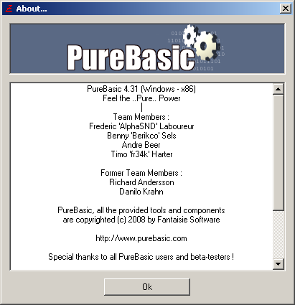
History

Version 1.0 (beta), 2009-08-01, First release.

Author

Flype, flype(at)gmail(dot)com

Homepage

http://forum.purebasic.com/


Purpose

A PureBasic IDE Tool to print code sources

Supported features

- IDE Tool (Command Line arguments)
- IDE Options (Options written by IDE at the bottom of .PB files)
- IDE Preferences (Editor Colors, Tab Length and more)
- IDE Markers as Page Breaks
- IDE Syntax Hilighting (using SyntaxHilighting.DLL)
- 3 x Color Modes (IDE, IDE on White Background, Black on White Background)
- Can print %FILE or %TEMPFILE
- Print Header (File Name, Build Count)
- Print Footer (File Size, Page, Date)
- Print only Selection (%SELECTION)
- Keyword Bolding
- Line Numbering (Gutter)
- Automatic Line Wrapping
- Define Margins of the document (Left x Right x Top x Bottom)
- Magnify the font to increase or decrease the zoom factor (for large layout printer)
- Show Current Line (%CURSOR)
- Show Print Requester

SCREENSHOT OF A OUTPUT PRINT

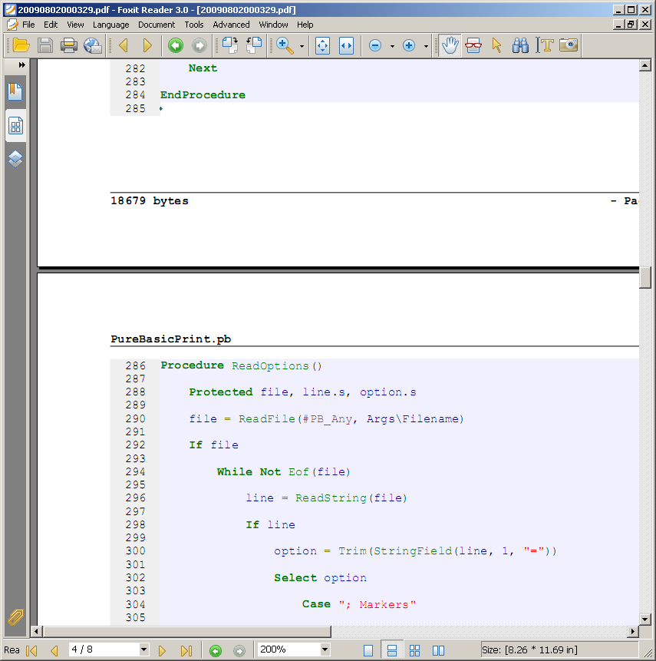

Screenshot of a PureBasicPrint printing
using a virtual printer (PDFCreator)

TODO

Add: Line Spacing

Add: Linux/MacOS Compatible
Should be but the Syntax Hilighting SDK is not available on Linux/MacOS at the moment

Add: Graphical User Interface (?)

Optimize: Some redundant calculations

Optimize: Read options from the end of the .PB file to increase the loading part

Known bug: Line wrapping do not works on large comments at the moment

Supported Command Line Arguments

Parameter → "%FILE"
Parameter → "%TEMPFILE"

Parameter → CURSOR=%CURSOR
Parameter → SELECTION=%SELECTION

Parameter → REQUESTER=0|1
Parameter → PAGEBREAKS=0|1
Parameter → MAGNIFICATION=3
Parameter → MARGINS=LEFTxRIGHTxTOPxBOTTOM
Parameter → COLORMODE=IDE|IDEONWHITE|BLACKONWHITE

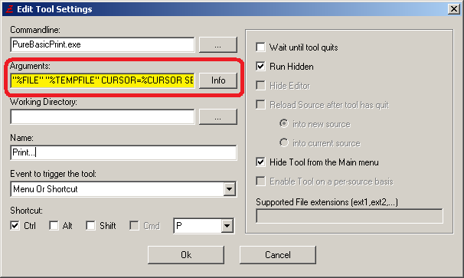

Supported Options from .PB files

Option → Markers
Option → EnableBuildCount

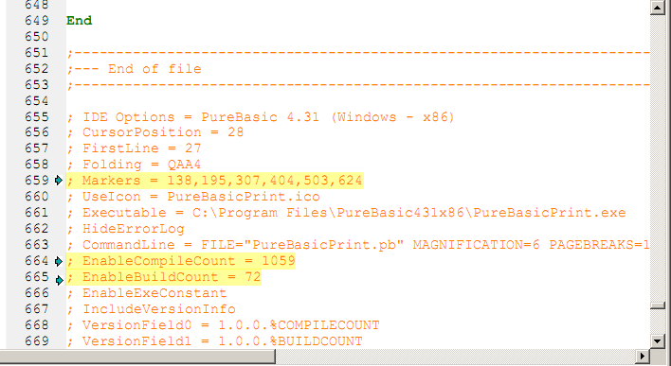

Markers

Markers of the PureBasic IDE ( Ctrl + F2 ) are used by PureBasicPrint for inserting PageBreaks in the document if PAGEBREAKS=1 in the command line arguments.

This is useful for clarify the printing of your code sources.

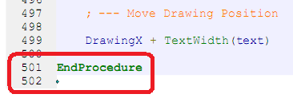

EnableBuildCount

If this option is specified in the .PB file then the Build counter is drawn on the top right of the header.

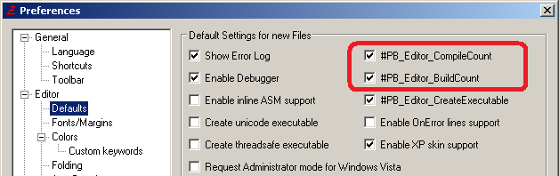
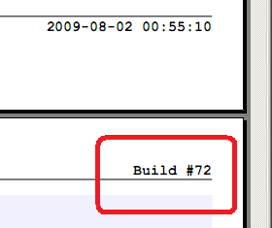

Supported PureBasic IDE Preferences File

PureBasic IDE → Menu → File → Preferences... →

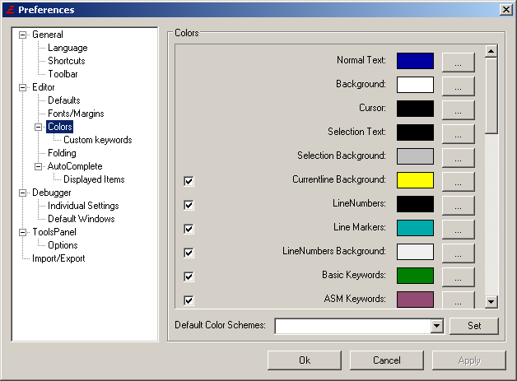

General → Display full Source Path
General → Language

Editor → Tab Length
Editor → Fonts/Margins → Enable Syntax coloring
Editor → Fonts/Margins → Enable bolding of Keywords
Editor → Fonts/Margins → Display Line numbers
Editor → Fonts/Margins → Select Font -> Name/Size/Style

Editor → Colors → BackgroundColor
Editor → Colors → ProcedureBackColor
Editor → Colors → LineNumberColor
Editor → Colors → LineNumberBackColor
Editor → Colors → CurrentLineColor
Editor → Colors → NormalTextColor
Editor → Colors → BasicKeywordColor
Editor → Colors → CommentColor
Editor → Colors → ConstantColor
Editor → Colors → StringColor
Editor → Colors → PureKeywordColor
Editor → Colors → ASMKeywordColor
Editor → Colors → OperatorColor
Editor → Colors → StructureColor
Editor → Colors → NumberColor
Editor → Colors → PointerColor
Editor → Colors → SeparatorColor
Editor → Colors → LabelColor

Installation – Step 1

Copy these files from the PureBasicPrint.zip archives:

- PureBasicPrint.exe
- SyntaxHilighting.dll

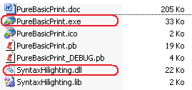

And paste them into the PureBasic installation folder.

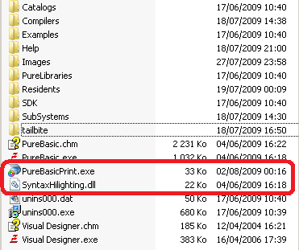

Installation – Step 2

From the PureBasic IDE, creates two new IDE tools.

PureBasic IDE → Menu → Tools → Configure Tools...

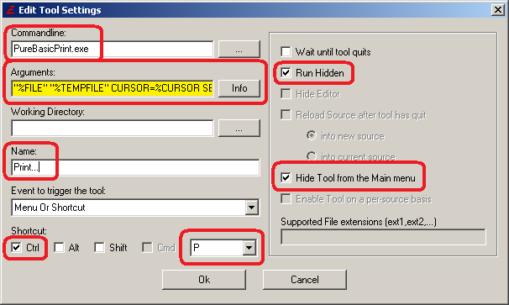

Command Line: PureBasicPrint.exe
Arguments: "%FILE" "%TEMPFILE" CURSOR=%CURSOR SELECTION=%SELECTION MAGNIFICATION=3 PAGEBREAKS=1 COLORMODE=IDE MARGINS=80x80x80x80
Name: Print
Shortcut: None
Hidden: True
Hide from menu: True

Command Line: PureBasicPrint.exe
Arguments: "%FILE" "%TEMPFILE" CURSOR=%CURSOR SELECTION=%SELECTION MAGNIFICATION=3 PAGEBREAKS=1 COLORMODE=IDE MARGINS=80x80x80x80 REQUESTER=1
Name: Print...
Shortcut: Ctrl + P
Hidden: True
Hide from menu: True

Installation – Step 3

From the PureBasic IDE, creates two new ToolBar items.

PureBasic IDE → Menu → File → Preferences... →
General → ToolBar → Add → Item Settings...

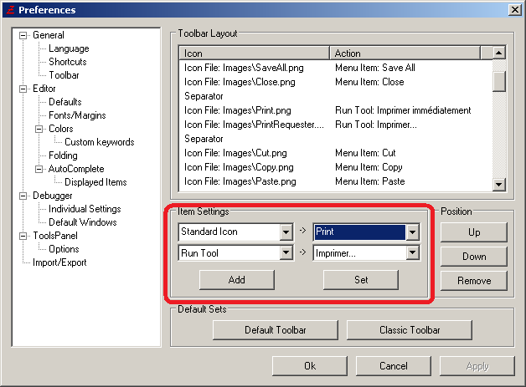

[Separator]
[Standard icon] + [Print] + [Run Tool] + [Print]
[Standard icon] + [Print] + [Run Tool] + [Print...]
[Separator]

