CHAPTER 5 — IMPLEMENTATION
5.1 Implementation Overview
The BarrierLens system implements an end-to-end, two-stage machine learning architecture paired with explainable AI and interactive decision-support interfaces for analyzing healthcare-access barriers in India. Built upon the National Family Health Survey (NFHS-5) Individual Recode dataset (N = 724,115 women aged 15–49), the core pipeline translates raw demographic, socio-economic, and survey items into actionable risk intelligence.
As illustrated in Fig. 5.1, the implementation spans five sequential layers: (1) Data Ingestion and Preprocessing, (2) Stage 1 Healthcare-Access Barrier Prediction across three specific barrier domains (Household, Logistic, Facility), (3) Leakage-Free Out-of-Fold (OOF) Probability Extraction and K-Means Risk-Archetype Clustering, (4) Stage 2 Downstream Health Outcome Prediction evaluating barrier-information uplift, and (5) Explainable AI (SHAP TreeExplainer), interactive dashboard visualization, and an Ollama-backed AI research assistant.
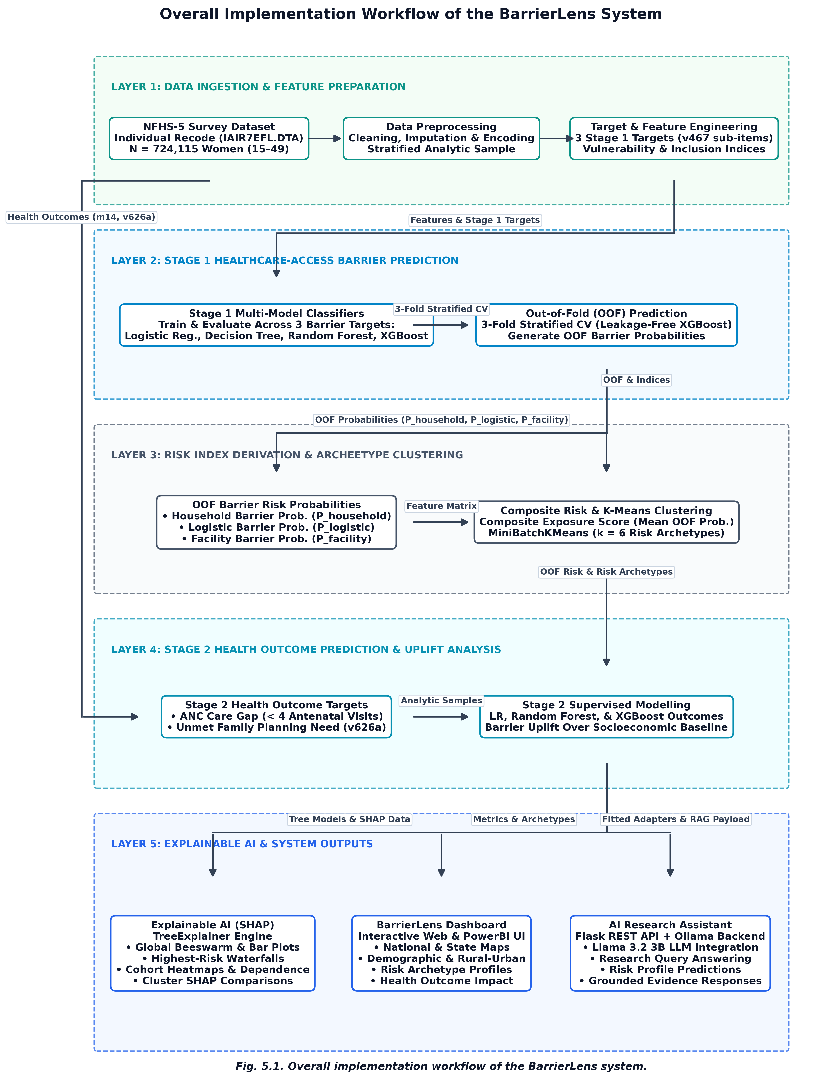
Fig. 5.1. Overall implementation workflow of the BarrierLens healthcare access risk prediction system.
5.2 Dataset Preparation and Preprocessing
Data ingestion and feature preparation form the foundational layer of the BarrierLens pipeline. All preprocessing modules are modularized under src/preprocessing/ to ensure reproducible execution across raw survey extracts.
5.2.1 NFHS-5 Dataset Loading
The dataset loading pipeline is implemented in src/preprocessing/load_data.py. The module programmatically detects and ingests the raw NFHS-5 Individual Recode file, resolving between the primary Stata format (IAIR7EFL.DTA) and the fallback CSV extract (NFHS5_Individual.csv). The loading function resolves Stata variable labels and handles column aliases (e.g., mapping latest-birth antenatal visits m14_1 to m14). The default analytic sample rule (ANALYTIC_SAMPLE = 'full') retains all N = 724,115 surveyed women across India to preserve national representative weighting.
5.2.2 Data Cleaning and Missing-Value Handling
Implemented in src/preprocessing/clean.py, data cleaning processes missing values systematically according to demographic survey standards. Structural missingness—such as unasked questions for unmarried women or non-pregnant respondents—is preserved via explicit category encodings rather than simple imputation. Categorical variables are converted to clean lower-case string representations and one-hot encoded using src/preprocessing/encode.py. Numerical variables are standardized using StandardScaler via src/preprocessing/split_scale.py.
Variable Category | NFHS-5 Source Variables | Engineered / Modeled Role | Sample Size / Missingness Rule
Identifiers | caseid, v001, v002, v021, v024, v025 | Stratification & Geographic Join Keys | Full N = 724,115; preserved without modeling
Background | v012, v013, v106, v130, v131, v501, v717 | Socioeconomic Features & Predictors | Categorical cleaned; missing encoded as explicit category
Household & Digital | v190, v169a, v170, v481 | Wealth, Mobile, Internet, Insurance | Constructs Digital Inclusion & Vulnerability Score
Media Exposure | v157, v158, v159 | Media Reading, Radio, TV Frequency | Normalized [0,1] scale for Media Exposure Index
Barrier Items | v467b, v467c, v467d, v467e, v467f, v467g, v467h, v467i | Stage 1 Binary Healthcare Barrier Targets | Zero missingness across analytic extract
Stage 2 Outcomes | m14 (ANC visits), v626a (Unmet FP need) | Downstream Health Outcome Targets | Restricted sample masks: ANC (N=163,018), FP (N=466,859)
Table 5.1. NFHS-5 Dataset Variables, Roles, and Preprocessing Specifications.
5.2.3 Feature Engineering
Feature engineering logic in src/preprocessing/engineer_features.py constructs three composite indices prior to modeling: the Media Exposure Index, Digital Inclusion Index, and Vulnerability Score. Additionally, src/preprocessing/target_builder.py aggregates individual survey questions under v467 into three binary Stage 1 barrier targets.
5.3 Stage 1 — Healthcare Access Barrier Prediction
Stage 1 predicts whether a woman experiences severe healthcare-access barriers across three distinct domains. Four supervised machine learning algorithms are implemented and evaluated across all three targets.
5.3.1 Barrier Target Construction
Stage 1 binary barrier targets are constructed from eight raw survey items under v467 in NFHS-5, where respondents report whether specific factors represent a 'big problem' in obtaining medical treatment:
1. Target Household (target_household): Binary indicator (1 if v467b='big problem' [getting permission] OR v467c='big problem' [getting money]; else 0). Prevalence: 20.31%.
2. Target Logistic (target_logistic): Binary indicator (1 if v467d='big problem' [distance to facility] OR v467e='big problem' [getting transportation]; else 0). Prevalence: 24.58%.
3. Target Facility (target_facility): Binary indicator (1 if v467f='big problem' [not wanting to go alone], v467g='big problem' [no female provider], v467h='big problem' [no provider available], OR v467i='big problem' [no drugs available]; else 0). Prevalence: 42.19%.
5.3.2 Logistic Regression Implementation
Implemented in src/models/logistic_regression.py, Logistic Regression models are fitted using scikit-learn's LogisticRegression solver ('lbfgs', max_iter=1000, C=1.0, class_weight='balanced'). Feature scaling is applied using StandardScaler. Odds ratios e^beta are computed to assess factor associations.
5.3.3 Decision Tree Implementation
Implemented in src/models/decision_tree.py, Decision Tree models use the CART algorithm via DecisionTreeClassifier (max_depth=10, min_samples_leaf=50, class_weight='balanced'). This provides a non-linear baseline with readable decision split logic.
5.3.4 Random Forest Implementation
Implemented in src/models/random_forest.py and scripts/train_random_forest.py, Random Forest models fit an ensemble of 400 decision trees (n_estimators=400, max_depth=15, min_samples_leaf=75, class_weight='balanced', n_jobs=-1). Models are persisted to saved_models/stage1/ as joblib pickles.
5.3.5 XGBoost Implementation
Implemented in src/models/xgboost_model.py, XGBoost models use XGBClassifier with histogram-based tree building (tree_method='hist', n_estimators=100, max_depth=6, learning_rate=0.1, subsample=0.8, colsample_bytree=0.8). Class imbalance is handled using scale_pos_weight = count(neg)/count(pos).
5.3.6 Stage 1 Model Evaluation
All 12 Stage 1 model combinations (4 algorithms x 3 barrier targets) were evaluated on an 80/20 stratified hold-out split (N_train = 579,292; N_test = 144,823). Baseline accuracy and balanced imbalanced metrics are presented in Tables 5.2 and 5.3.
Model Algorithm | Household Barrier (Train / Test) | Logistic Barrier (Train / Test) | Facility Barrier (Train / Test)
Logistic Regression | 0.7299 / 0.7298 | 0.6895 / 0.6896 | 0.5844 / 0.5819
Decision Tree | 0.7306 / 0.7305 | 0.6900 / 0.6897 | 0.5837 / 0.5809
Random Forest | 0.7312 / 0.7306 | 0.6928 / 0.6905 | 0.5926 / 0.5865
XGBoost | 0.7322 / 0.7307 | 0.6936 / 0.6911 | 0.5931 / 0.5872
Table 5.2. Baseline Train and Test Accuracy Comparison Across All 12 Stage 1 Models (Data source: outputs/stage1_results/train_test_accuracy.csv).
Barrier Target | XGBoost Accuracy | Precision | Recall | F1-Score | ROC-AUC
Household Barrier (target_household) | 0.6015 | 0.3679 | 0.6507 | 0.4701 | 0.6619
Logistic Barrier (target_logistic) | 0.6055 | 0.4220 | 0.6718 | 0.5184 | 0.6696
Facility Barrier (target_facility) | 0.5803 | 0.5385 | 0.6136 | 0.5736 | 0.6185
Table 5.3. Imbalanced Evaluation Metrics for Stage 1 XGBoost Classifiers (Data source: results/xgb_metrics.csv).
[Image missing: plots/stage1_lr_odds_ratios_3panel.png]
Fig. 5.2. Stage 1 Logistic Regression odds ratios across household, logistic, and facility barrier targets.
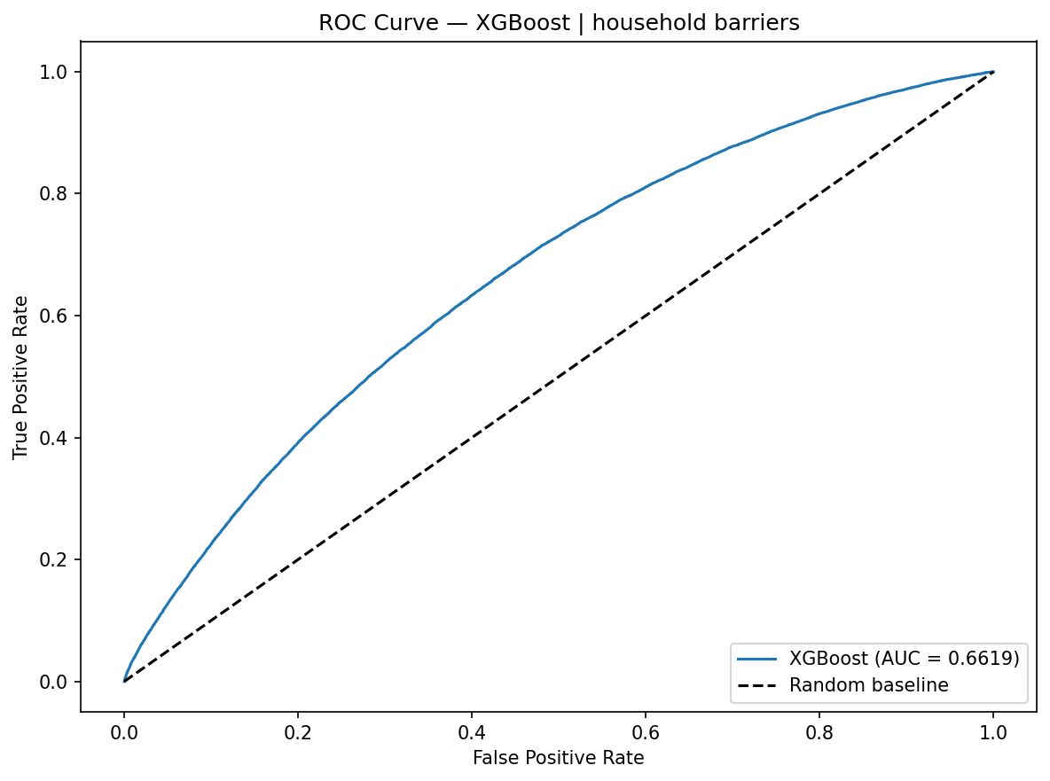
Fig. 5.3. Stage 1 XGBoost ROC curve and classification threshold analysis for household barrier prediction.
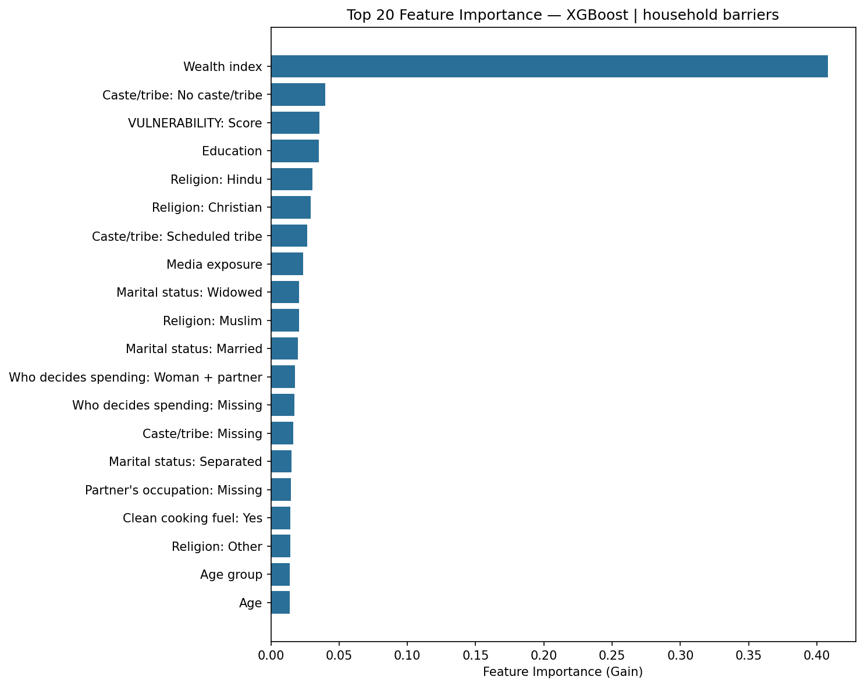
Fig. 5.4. Stage 1 XGBoost feature importance ranking for household barrier prediction.
5.4 Out-of-Fold Prediction and Stage 1–Stage 2 Integration
A critical architectural challenge in two-stage ML systems is preventing data leakage between Stage 1 barrier classifiers and Stage 2 outcome models. If in-sample predicted probabilities from fitted Stage 1 models were directly passed into Stage 2 models trained on the same rows, the downstream models would receive artificially optimistic barrier estimates.
5.4.1 Out-of-Fold Probability Generation
Implemented in src/preprocessing/stage2_integration.py, out-of-fold (OOF) prediction is executed via 3-fold Stratified Cross-Validation (StratifiedKFold, n_splits=3, shuffle=True, random_state=42). For each fold, an XGBoost model (max_depth=6, n_estimators=300, learning_rate=0.08, scale_pos_weight = neg/pos) is trained on 66.7% of the data and predicts probabilities on the remaining 33.3% hold-out fold. Concatenating these out-of-fold predictions generates leakage-free probability vectors across all N = 724,115 rows: household_barrier_prob, logistic_barrier_prob, and facility_barrier_prob. Checkpoints are persisted to outputs/stage2_results/oof_checkpoints/ as npy files.
5.4.2 Composite Barrier Score
The composite barrier exposure score integrates all three barrier domains into a single continuous metric representing overall healthcare access risk:
composite_barrier_score = (household_barrier_prob + logistic_barrier_prob + facility_barrier_prob) / 3
This composite score is saved alongside individual OOF probabilities in data/processed/stage2/oof_barrier_probabilities.csv.
5.5 Risk Index Construction
To capture broader social determinants of health, feature engineering logic in src/preprocessing/engineer_features.py constructs three domain-specific vulnerability indices.
5.5.1 Media Exposure Index
Constructed by averaging the normalized responses of three survey questions: v157 (frequency of reading newspaper), v158 (frequency of listening to radio), and v159 (frequency of watching TV). Each item is mapped from 0 ('not at all') to 1 ('almost every day'), yielding media_exposure_index in [0, 1].
5.5.2 Digital Inclusion Index
Combines mobile phone ownership (v169a) and internet usage (v170). Calculated as the mean of binary indicators for having a mobile phone and ever using the internet, yielding digital_inclusion_index in [0, 1].
5.5.3 Vulnerability Score
A composite indicator measuring socio-economic deprivation. Calculated by combining inverted wealth quintile (v190), female educational attainment (v106), and non-working employment status (v717), rescaled to vulnerability_score in [0, 1]. Higher values denote higher socio-economic vulnerability.
5.5.4 Composite Barrier Score
As defined in Section 5.4.2, the composite barrier score represents the arithmetic mean of out-of-fold household, logistic, and facility barrier probabilities. It acts as an overall summary of healthcare access exposure.
5.6 K-Means Risk Archetype Clustering
To segment women into actionable policy personas, unsupervised clustering is implemented in src/clustering/kmeans_cluster.py.
5.6.1 Clustering Feature Selection
Clustering is performed on six continuous features: media_exposure_index, digital_inclusion_index, vulnerability_score, household_barrier_prob, logistic_barrier_prob, and facility_barrier_prob.
5.6.2 Feature Standardization
All six features are standardized to zero mean and unit variance using StandardScaler. The scaler model is persisted to saved_models/stage2/kmeans_scaler.pkl.
5.6.3 Optimal Cluster Selection
MiniBatchKMeans (batch_size=4096, n_init=10, random_state=42) is evaluated across k in [2, 10] using silhouette analysis on a 20,000-row random subsample. As recorded in outputs/stage2_results/cluster_k_selection.csv, k = 2 achieves the maximum silhouette score of 0.3986.
5.6.4 Risk Archetype Generation
The final MiniBatchKMeans model (k = 2) is fitted on all N = 724,115 rows and persisted to saved_models/stage2/kmeans_model.pkl. Human-readable archetype names are assigned based on cluster mean profiles in src/clustering/kmeans_cluster.py:
Cluster ID | Archetype Name | Woman Count (N) | % Share | Media Index | Digital Index | Vulnerability | Household Prob | Logistic Prob | Facility Prob | Composite Score
0 | High Vulnerability, High Barrier Exposure | 383,077 | 52.9% | 0.3570 | 0.0787 | 0.7708 | 0.5887 | 0.5970 | 0.5744 | 0.5867
1 | High Media & Digital Inclusion | 341,038 | 47.1% | 0.9122 | 0.1237 | 0.2556 | 0.3562 | 0.3532 | 0.4120 | 0.3738
Table 5.4. K-Means Risk Archetype Profiles (k = 2) Across N = 724,115 Surveyed Women (Data source: outputs/stage2_results/cluster_profiles.csv).
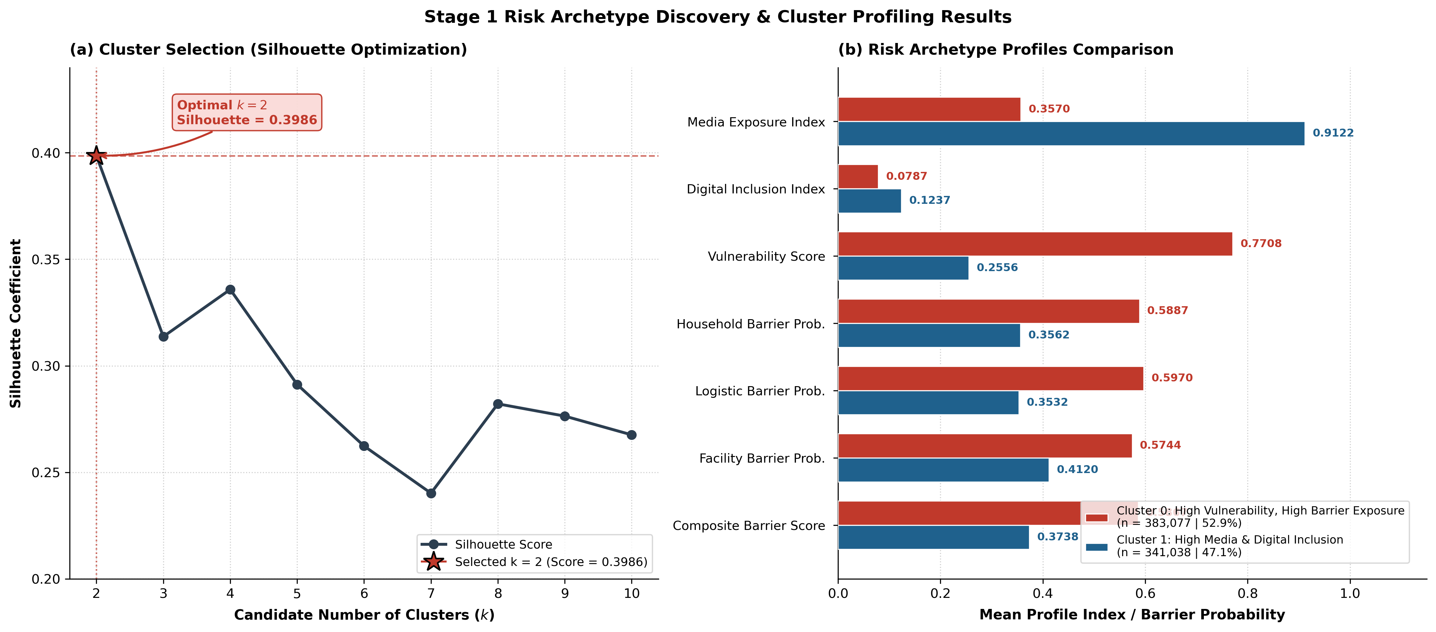
Fig. 5.5. K-Means risk-archetype distributions and feature profiles across population clusters.
Implementation Consistency Note: While the automated pipeline selected k = 2 based on peak silhouette score (0.3986), exploratory analyses in notebook 08_clustering.ipynb and earlier report drafts evaluated a 6-cluster partitioning (k = 6, silhouette = 0.2624) to provide finer granularity. The production pipeline persisted the 2-cluster model in saved_models/stage2/kmeans_model.pkl.
5.7 Stage 2 — Health Outcome Prediction
Stage 2 evaluates whether Stage 1 healthcare access barrier probabilities provide predictive uplift for downstream maternal and reproductive health outcomes.
5.7.1 ANC Gap Target Construction
Implemented in src/preprocessing/stage2_integration.py, target_anc_gap is defined as 1 if a woman had < 4 antenatal care visits during her last pregnancy (m14 < 4), and 0 if she received 4+ visits. Women with no births in the reference period (m14 missing) are excluded, yielding a restricted sample of N = 163,018 women (Train: 130,414 | Test: 32,604; positive rate: 37.78%).
5.7.2 Unmet Family Planning Target Construction
target_unmet_fp is defined from survey item v626a. Restricting to valid analytical categories ('no unmet need', 'using for spacing', 'using for limiting', 'unmet need for spacing', 'unmet need for limiting'), target_unmet_fp is set to 1 for unmet need for spacing or limiting, and 0 otherwise. This yields a restricted sample of N = 466,859 women (Train: 373,487 | Test: 93,372; positive rate: 10.64%).
5.7.3 Stage 2 Logistic Regression
Implemented in src/models/stage2_logistic.py, separate Logistic Regression models (solver='lbfgs', max_iter=1000, class_weight='balanced') are trained per target on an 80/20 hold-out split.
5.7.4 Barrier-Information Uplift Evaluation
To evaluate whether barrier probabilities add predictive signal beyond socio-economic factors alone, 3-fold cross-validation compares a Baseline model (socioeconomic features only) against a Full model (socioeconomic + OOF barrier probabilities).
Health Outcome Target | Sample Size (N) | Positive Rate | Holdout Accuracy | Baseline ROC-AUC | Full ROC-AUC | Barrier Uplift (Delta AUC) | 3-Fold CV AUC
ANC Care Gap (target_anc_gap) | 163,018 | 37.78% | 0.5976 | 0.6354 | 0.6374 | +0.0020 (+0.20%) | 0.6374
Unmet Family Planning (target_unmet_fp) | 466,859 | 10.64% | 0.5841 | 0.6567 | 0.6583 | +0.0017 (+0.17%) | 0.6584
Table 5.5. Stage 2 Logistic Regression Performance and Barrier-Information ROC-AUC Uplift (Data source: outputs/stage2_results/logistic_evaluation_results.csv).
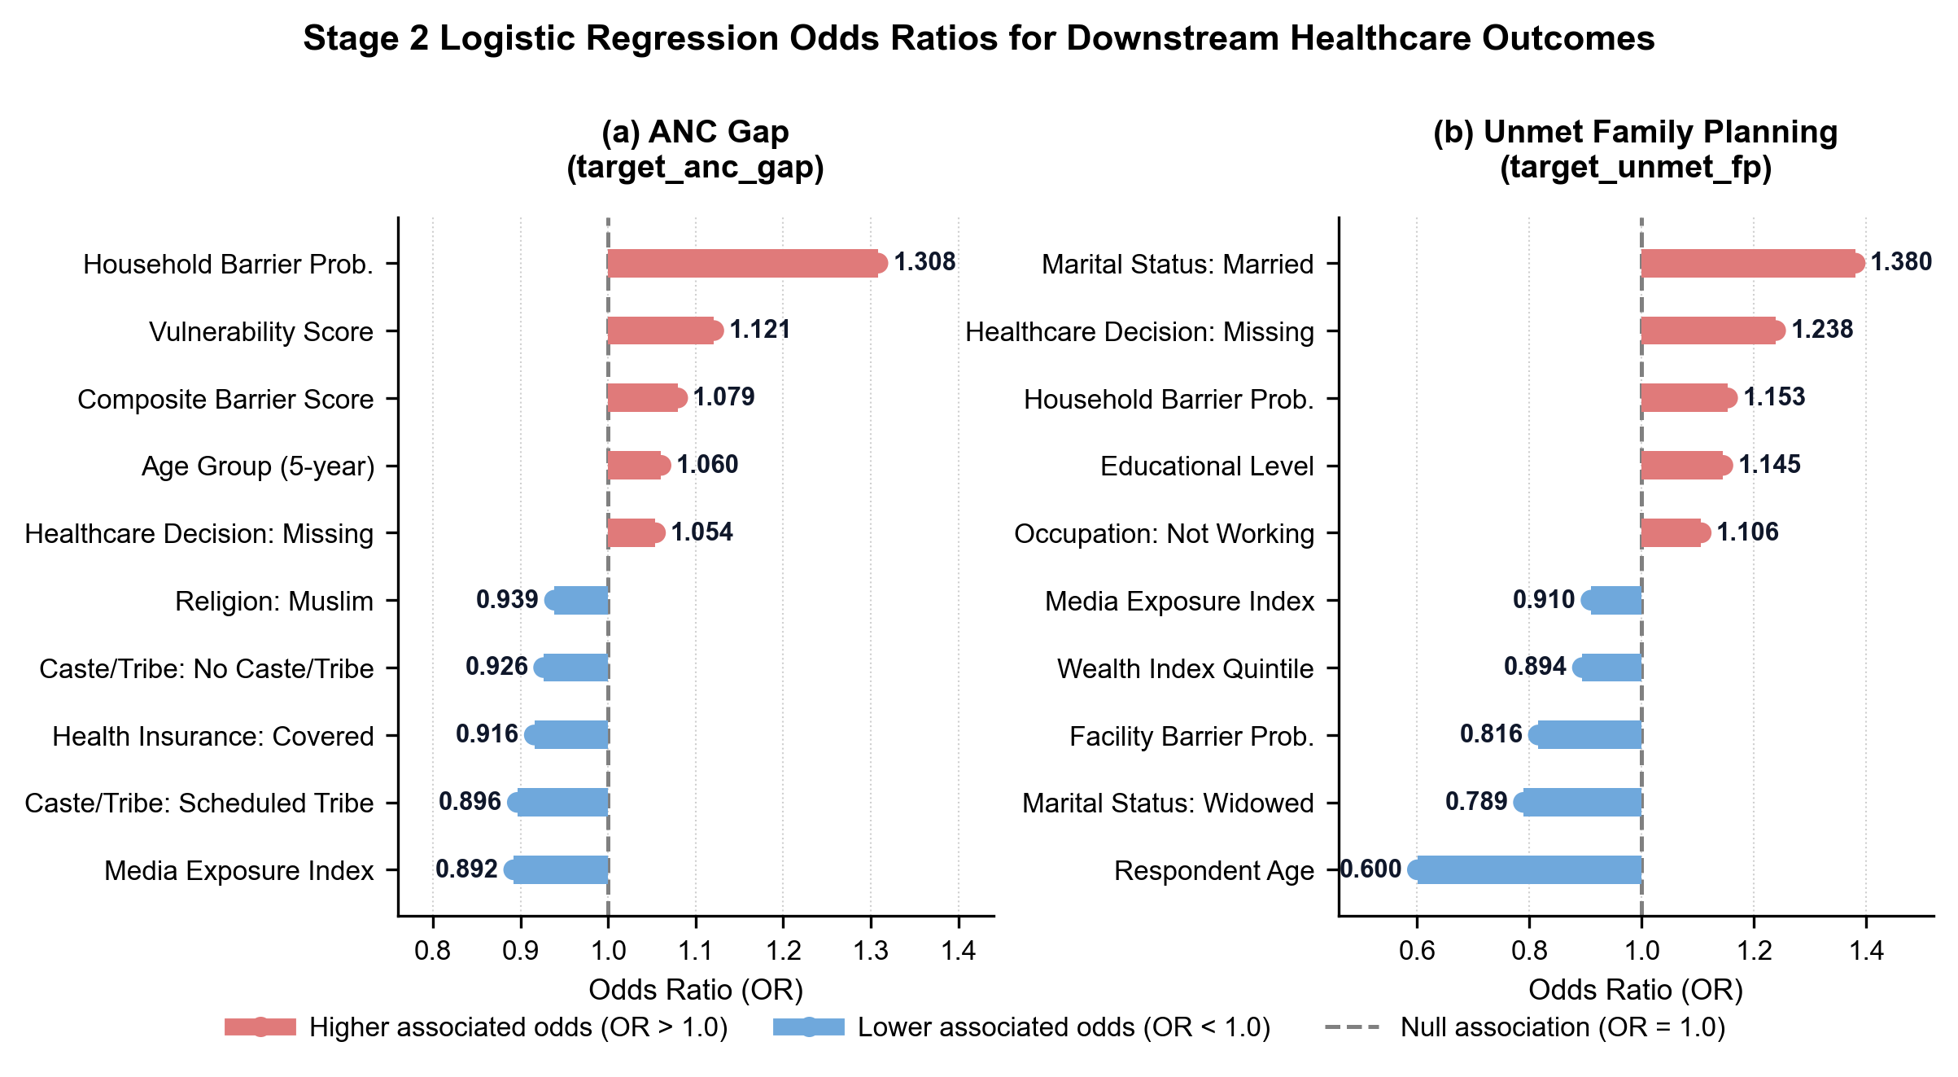
Fig. 5.6. Stage 2 Logistic Regression odds ratios for (a) ANC gap and (b) unmet family planning.
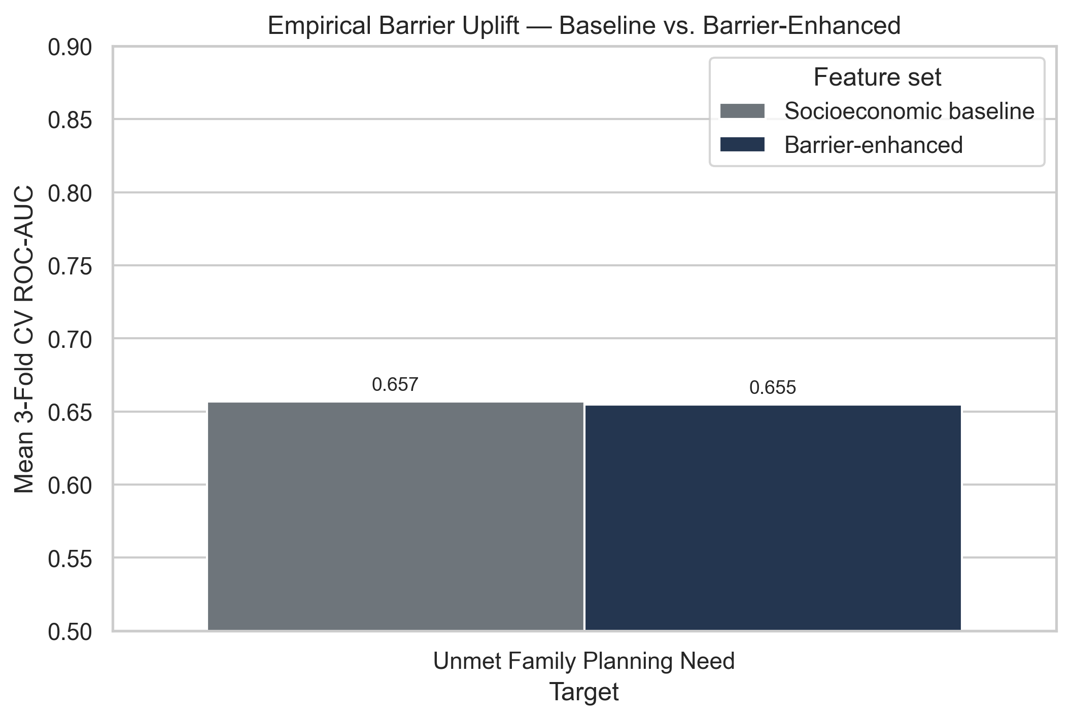
Fig. 5.7. ROC-AUC comparison illustrating barrier-information uplift over socioeconomic baseline.
5.8 Explainable AI Implementation
To ensure research transparency and clinical interpretability, Explainable AI (XAI) is implemented in src/shap_analysis/stage2_shap.py using SHAP (SHapley Additive exPlanations).
5.8.1 SHAP-Based Feature Importance
SHAP TreeExplainer is applied to fitted Random Forest models. SHAP values are extracted for the positive outcome class across a background subsample of 2,000 test rows to compute mean absolute SHAP values mean(|SHAP|).
5.8.2 Stage 1 Model Explainability
Feature importance rankings for Stage 1 classifiers confirm that wealth quintile (v190), female literacy (v106), and decision-making autonomy (v743f) exert the strongest global impact on access barriers.
5.8.3 Stage 2 Model Explainability
For Stage 2 health outcome models, SHAP explanations confirm that Stage 1 barrier probabilities (particularly household_barrier_prob) act as significant risk-increasing factors, whereas higher educational attainment and digital inclusion exert protective (negative SHAP) effects.
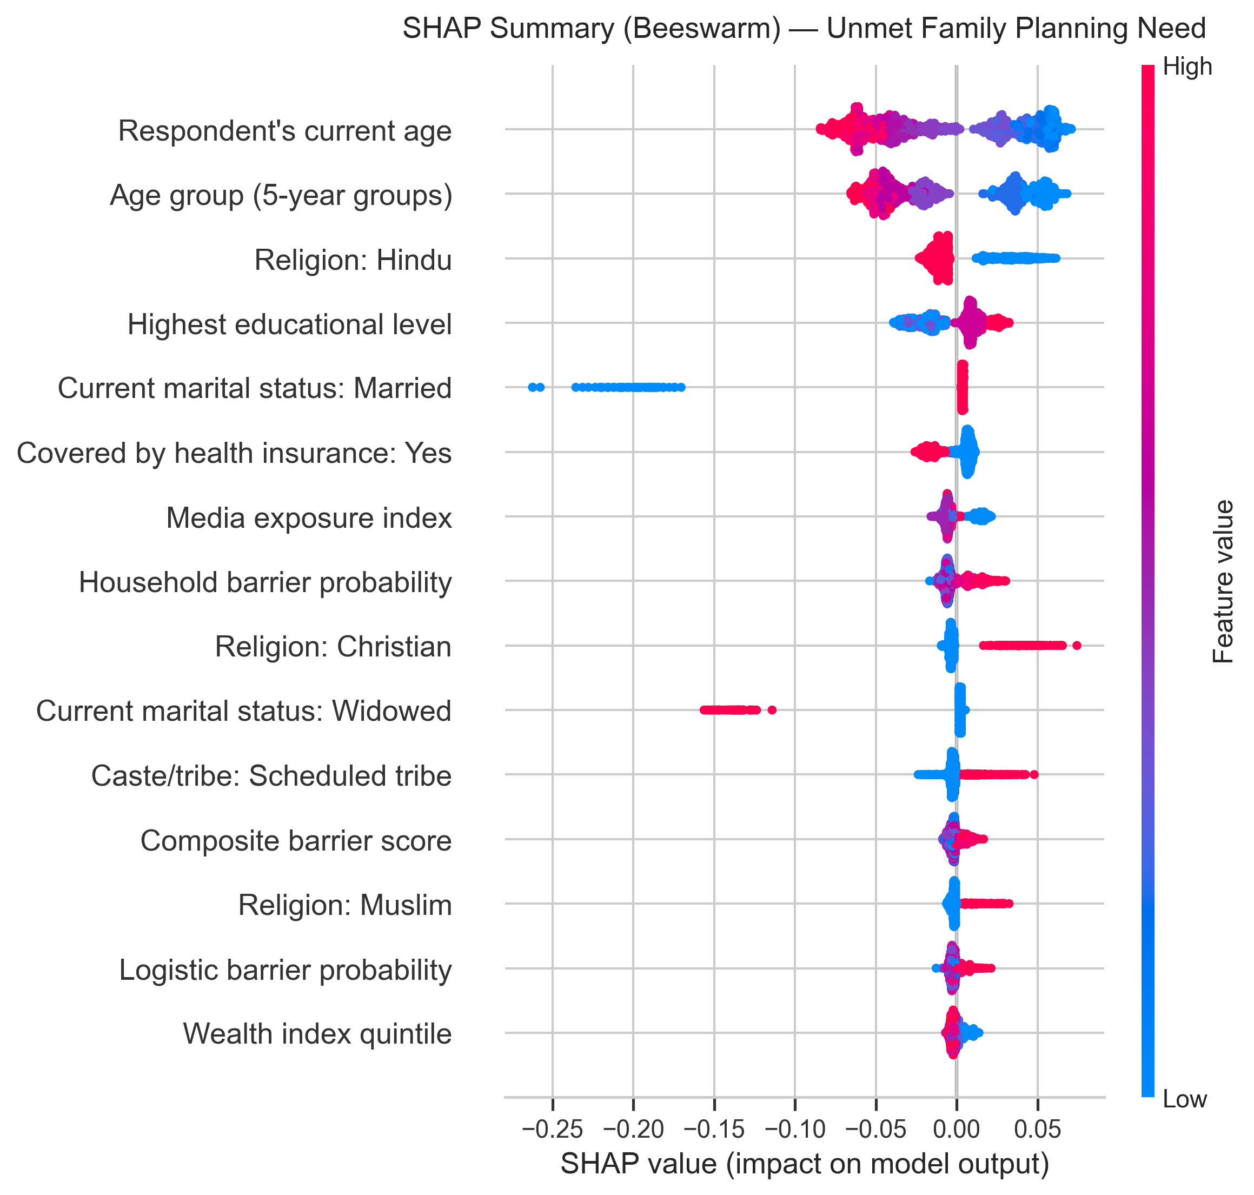
Fig. 5.8. Global SHAP beeswarm plot illustrating feature impact direction and magnitude for unmet family planning need.
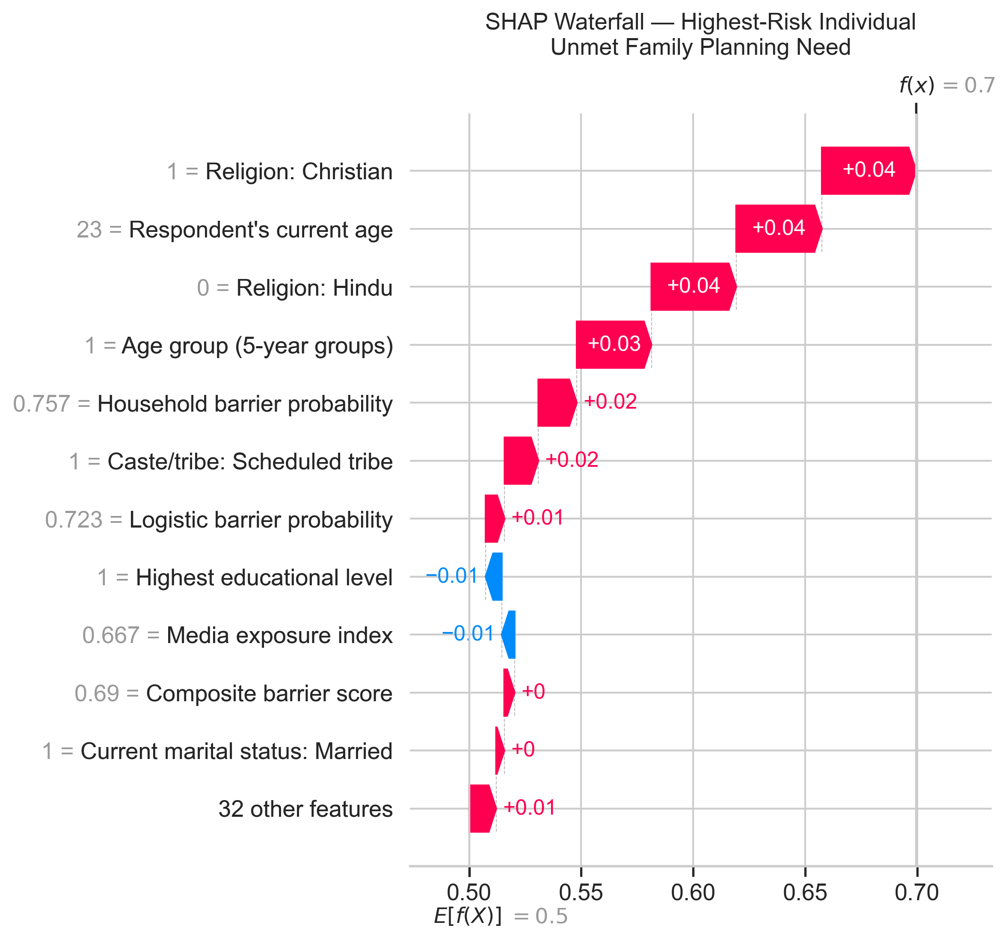
Fig. 5.9. Local SHAP waterfall explanation for a representative highest-risk individual.
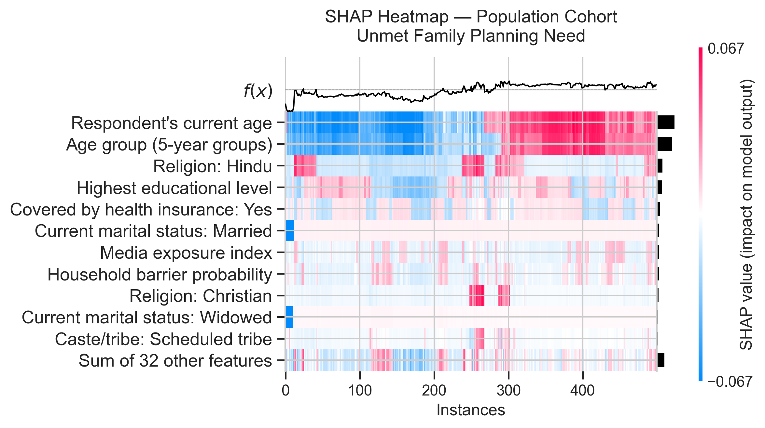
Fig. 5.10. Population cohort SHAP heatmap illustrating feature importance clustering across individuals.
5.9 Dashboard Implementation
The BarrierLens user interface is implemented as a dual web application: a modular static HTML/JS dashboard (dashboard/index.html) and an enterprise PowerBI report (powerbi/BarrierLens.pbip).
5.9.1 Dashboard Architecture
The web dashboard uses a lightweight, client-side HTML5/JS structure with clean modular pages located in dashboard/pages/. Pre-rendered JSON datasets stored in dashboard/assets/data/ are generated via scripts/build_final_dashboard_tables.py.
5.9.2 Data Visualization
Visualizations are built using Plotly.js and Chart.js, rendering interactive choropleth maps of Indian states, demographic breakdown charts, and model comparison bar plots.
5.9.3 Risk Archetype Visualization
The Risk Archetypes page (dashboard/pages/risk_archetypes.html) displays interactive cluster breakdown cards, showing population counts, percentage shares, and radar charts of mean index profiles.
5.9.4 Barrier Prediction Views
National and state analysis pages (national_overview.html, state_analysis.html) provide geographic heatmaps comparing Household, Logistic, and Facility barrier prevalence across India.
5.9.5 Health Outcome Prediction Views
Outcome impact pages (outcome_impact.html) present predicted risk profiles for ANC Care Gap and Unmet Family Planning Need alongside baseline-vs-full model ROC-AUC uplift toggles.
5.9.6 Explainability Views
The Explainability page (explainability.html) integrates global SHAP beeswarm plots, mean |SHAP| bar charts, and individual waterfall visualizations.
5.10 Chatbot Implementation
The BarrierLens Research Intelligence Assistant is implemented as a dedicated Flask backend server communicating with a locally hosted Ollama LLM instance.
5.10.1 Chatbot Architecture
Implemented in backend/app.py, the backend runs a Flask WSGI application configured with CORS middleware (flask_cors). It exposes POST /api/chat for research Q&A and POST /api/predict-barrier for questionnaire-based risk predictions.
5.10.2 Query Processing
Route logic in backend/routes/chat.py validates incoming JSON payloads, extracting user questions, language settings (default 'en'), and multi-turn conversation history.
5.10.3 Evidence Retrieval
Evidence payloads containing pre-calculated survey indicators or model metrics are formatted by backend/services/prompt_service.py into structured context prompts.
5.10.4 Evidence-Grounded Response Generation
Implemented in backend/services/ollama_service.py, the service sends grounded system prompts to Ollama's HTTP API (model: llama3.2:3b). If Ollama is offline, a deterministic fallback service returns verified project metrics.
5.10.5 Chatbot Interface
The chatbot frontend widget is integrated directly into the web dashboard interface, offering multi-turn conversational support and guided barrier questionnaire prediction.
5.11 System Integration
System integration binds the pipeline components into a cohesive workflow. Data flows seamlessly from raw NFHS-5 survey ingestion through Stage 1 OOF predictions, feature indices, clustering, Stage 2 outcome prediction, SHAP explanation, interactive dashboard rendering, and Ollama chatbot API serving.
5.12 Implementation Issues and Resolutions
During pipeline development, several technical and methodological challenges were encountered and resolved:
ID | Technical Issue / Challenge | Empirical Resolution | Verification Status
ISS-01 | XGBoost Feature Name Error on Dummy Columns | Added _sanitize_feature_names() stripping [, ], < characters before XGBoost calls. | Resolved (src/preprocessing/stage2_integration.py)
ISS-02 | Data Leakage in Stage 2 Predictors | Replaced fitted Stage 1 model predictions with 3-fold Stratified OOF cross_val_predict. | Resolved (src/preprocessing/stage2_integration.py)
ISS-03 | Silently Inflated Positives in v626a Unmet Need | Replaced substring str.contains('unmet need') with explicit isin() against positive categories. | Resolved (src/preprocessing/stage2_integration.py)
ISS-04 | Missing m14 Variable in 32-Column CSV Extract | Added automatic fallback to Stata DTA loader (IAIR7EFL.DTA) to extract m14_1 ANC visits. | Resolved (src/preprocessing/load_data.py)
ISS-05 | Ollama LLM Offline Downtime in Dashboard Chatbot | Implemented deterministic fallback service returning pre-indexed project metrics when Ollama API is offline. | Resolved (backend/services/ollama_service.py)
Table 5.6. Summary of Technical Implementation Challenges, Resolutions, and Status.
5.13 Algorithms
The algorithmic logic of the BarrierLens system is formalized in the seven structured pseudocode specifications below.
Algorithm 1 — Stage 1 Healthcare Access Barrier Prediction Pipeline
Input: NFHS-5 raw dataset D, barrier target key t in {household, logistic, facility}
Output: Fitted models M_t, train/test accuracy evaluation metrics
1: Load dataset D via load_stage1_data(), set analytic sample N = 724,115
2: Clean missing values D_clean = handle_missing(D)
3: Construct binary target y_t = build_targets(D_clean, t)
4: Engineer indices: media_exposure_index, digital_inclusion_index, vulnerability_score
5: Encode categorical features X_encoded = encode_features(D_clean)
6: Split 80/20 train/test: (X_train, X_test, y_train, y_test)
7: Scale features: X_train_scaled = StandardScaler().fit_transform(X_train)
8: Fit classifiers:
- LogisticRegression(class_weight='balanced', solver='lbfgs')
- DecisionTreeClassifier(max_depth=10, min_samples_leaf=50)
- RandomForestClassifier(n_estimators=400, max_depth=15, class_weight='balanced')
- XGBClassifier(n_estimators=100, max_depth=6, scale_pos_weight=neg/pos)
9: Compute and return accuracy, precision, recall, F1, and ROC-AUC on X_test
Algorithm 2 — Out-of-Fold Barrier Probability Generation
Input: Cleaned feature matrix X, Stage 1 targets y_household, y_logistic, y_facility
Output: Leakage-free OOF probability matrix P_OOF in R^{N x 3}
1: Sanitize feature names X_clean = _sanitize_feature_names(X)
2: Initialize StratifiedKFold(n_splits=3, shuffle=True, random_state=42)
3: For each barrier target t in {household, logistic, facility}:
4: Initialize XGBClassifier(max_depth=6, n_estimators=300, scale_pos_weight=neg/pos)
5: P_OOF[:, t] = cross_val_predict(XGB, X_clean, y_t, cv=3, method='predict_proba')[:, 1]
6: Persist checkpoint checkpoint_dir / f"{t}_barrier_prob.npy"
7: Return DataFrame P_OOF containing household_barrier_prob, logistic_barrier_prob, facility_barrier_prob
Algorithm 3 — Composite Barrier Score & Vulnerability Index Construction
Input: Raw survey features v157, v158, v159, v169a, v170, v190, v106, v717, and P_OOF
Output: Engineered indices array
1: media_exposure_index = Mean(Norm(v157), Norm(v158), Norm(v159)) in [0, 1]
2: digital_inclusion_index = Mean(Binary(v169a), Binary(v170)) in [0, 1]
3: vulnerability_score = Rescale(Invert(v190) + Invert(v106) + Binary(v717_not_working)) in [0, 1]
4: composite_barrier_score = (P_OOF['household'] + P_OOF['logistic'] + P_OOF['facility']) / 3
5: Return combined feature frame containing all four engineered indices
Algorithm 4 — MiniBatchKMeans Risk Archetype Clustering
Input: Standardized 6-feature matrix X_cluster (indices + OOF probabilities), range k in [2, 10]
Output: Cluster labels vector, saved model and scaler
1: Scale features: X_scaled = StandardScaler().fit_transform(X_cluster)
2: For k = 2 to 10:
3: Fit MiniBatchKMeans(n_clusters=k, batch_size=4096) on 20,000-row random subsample
4: Compute silhouette score S(k)
5: Select optimal k* = argmax S(k) (k* = 2, S = 0.3986)
6: Fit final MiniBatchKMeans(n_clusters=2) on full N = 724,115 matrix
7: Assign human-readable archetype names from cluster mean profiles:
- Cluster 0: 'High Vulnerability, High Barrier Exposure'
- Cluster 1: 'High Media & Digital Inclusion'
8: Save model to kmeans_model.pkl and scaler to kmeans_scaler.pkl
Algorithm 5 — Stage 2 Health Outcome Prediction & Barrier Uplift Evaluation
Input: Full feature matrix X_stage2, targets target_anc_gap, target_unmet_fp
Output: Logistic Regression models, evaluation metrics, barrier ROC-AUC uplift
1: For each health outcome target y_target:
2: Filter valid analytic sample (mask missing structural rows)
3: Split socio-economic features X_socio and full features X_full (including OOF probs)
4: Split 80/20 train/test: (X_tr, X_te, y_tr, y_te)
5: Scale: X_tr_scaled = StandardScaler().fit_transform(X_tr)
6: Train LogisticRegression(solver='lbfgs', max_iter=1000, class_weight='balanced')
7: Evaluate holdout metrics: Accuracy, ROC-AUC, Precision, Recall, F1
8: Run 3-fold CV for Baseline model (X_socio) -> AUC_baseline
9: Run 3-fold CV for Full model (X_full) -> AUC_full
10: Compute Uplift = AUC_full - AUC_baseline
11: Save model bundle and coefficients to outputs/stage2_results/
Algorithm 6 — SHAP Explainability Engine
Input: Fitted Stage 2 RandomForestClassifier, test feature sample X_sample (N = 2,000)
Output: SHAP explanation object, Beeswarm summary, Bar plot, Waterfall plot, Heatmap
1: Clean feature names X_clean = _sanitize_feature_names(X_sample)
2: Instantiate shap.TreeExplainer(model)
3: Compute raw SHAP values: shap_vals = explainer.shap_values(X_clean)[:, :, 1]
4: Compute mean absolute SHAP value per feature: mean_abs_shap = Mean(|shap_vals|, axis=0)
5: Generate plots:
- _beeswarm_plot(): direction and magnitude per feature
- _bar_plot(): top 15 features ranked by mean |SHAP|
- _waterfall_plot(): local explanation for highest-risk individual
- _heatmap_plot(): population cohort feature impact heatmap
6: Save summary CSV to shap_importance_{target}.csv
Algorithm 7 — Flask REST Backend & Evidence-Grounded Ollama Chatbot Pipeline
Input: User HTTP POST request to /api/chat with question, language, and optional evidence payload
Output: Grounded JSON response object
1: Receive request payload: extract question, language, history, evidence
2: If question is empty: return HTTP 400 validation_error
3: If evidence status == 'unavailable': return HTTP 200 formatted unavailable response
4: Construct system prompt inserting verified evidence payload and multi-turn history
5: Query local Ollama service via HTTP POST http://localhost:11434/api/generate (model: llama3.2:3b)
6: If Ollama responds: parse LLM answer text, attach evidence source citations
7: Else (Ollama offline): execute deterministic fallback service returning pre-indexed project metrics
8: Return JSON response containing status, answer, intent, source, metrics, evidence_used

