Workflow: creating lithology mask for automated litho-classification using QGIS (CAS ADS Module 6)

1) Open QGIS (V 3.14 or newer)

2) Loading polygon layer containing the defined lithology classes (mask_polygon_lithology.gpkg)

- Layer (top menu) – > Add Layer -> Add Vector Layer -> navigate source to file location and load file with defined classes.

3) Loading core picture

Layer (top menu) -> Add Layer -> Add Raster Layer -> Navigate the source to the file location and load the core picture

4) Mapping lithology with polygons

- Activate polygon layer -> activate editing mode (Fig 1a) -> add polygon (Fig 1b) -> start creating the polygons

a/d

c

b

C:\Users\Sebastian Schaller\Desktop\Capture.JPGFig 1 processing/creating polygons

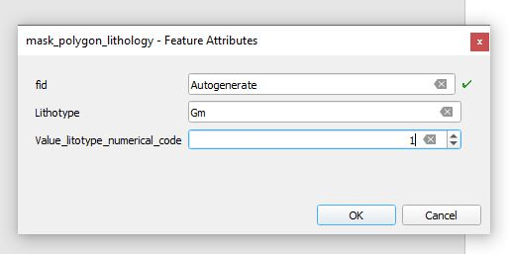- Right-click to finish creating polygon -> enter lithotype name and corresponding value (Fig 2).

Fig 2 input for polygon after creating

- Repeat till all sediments are mapped; the rest of the picture will later be marked as background

- Save edits (Fig 1c) and close editing mode (Fig 1d)

5) Creating the mask and exporting it as tiff

- Processing toolbox -> select Rasterize tool (vector to raster)

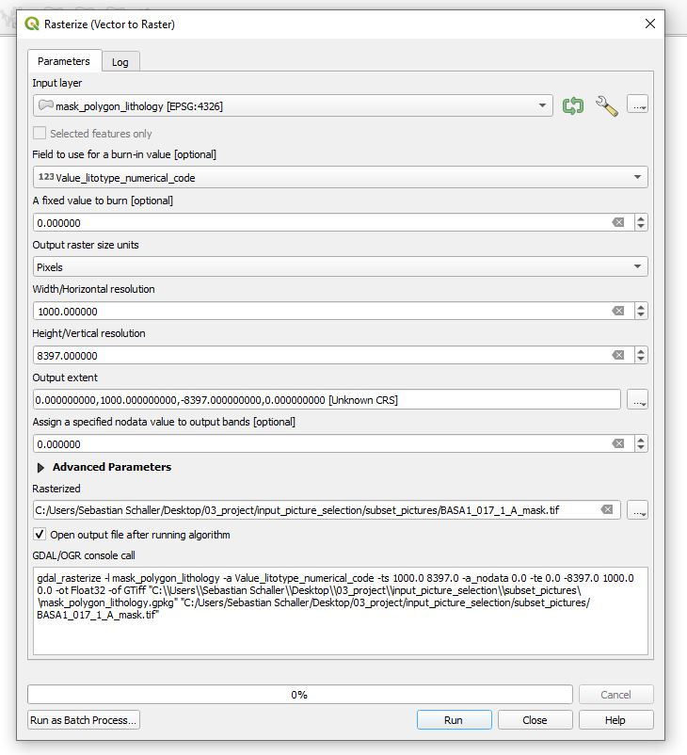 - Input: (Fig 3)

Fig 3 example of input for rasterize tool to creating and saving the polygons as mask

- Input layer -> mask_polygon_lithology

- Field to use for a burn-in value -> Value_lithotype_numerical_code

- Output raster size unit -> pixels

- With/Horizontal resolution -> with of core picture in pixels (mostly 1000)

- Height/Vertical resolution ->height of the core picture in pixels

- Output extent -> calculate from layer -> select the core picture (0, width, -height,0)

Assign a specific no data value -> 0 -> not mapped parts of the picture will get the

value 0

Save as picture name +’_mask’ and as tiff

6) Remove the mask and core picture and delete the created polygon(s) but keep the layer

7) To create the next mask, go back to step 3