# SDR JOVE RF Frontend Assembly Instructions

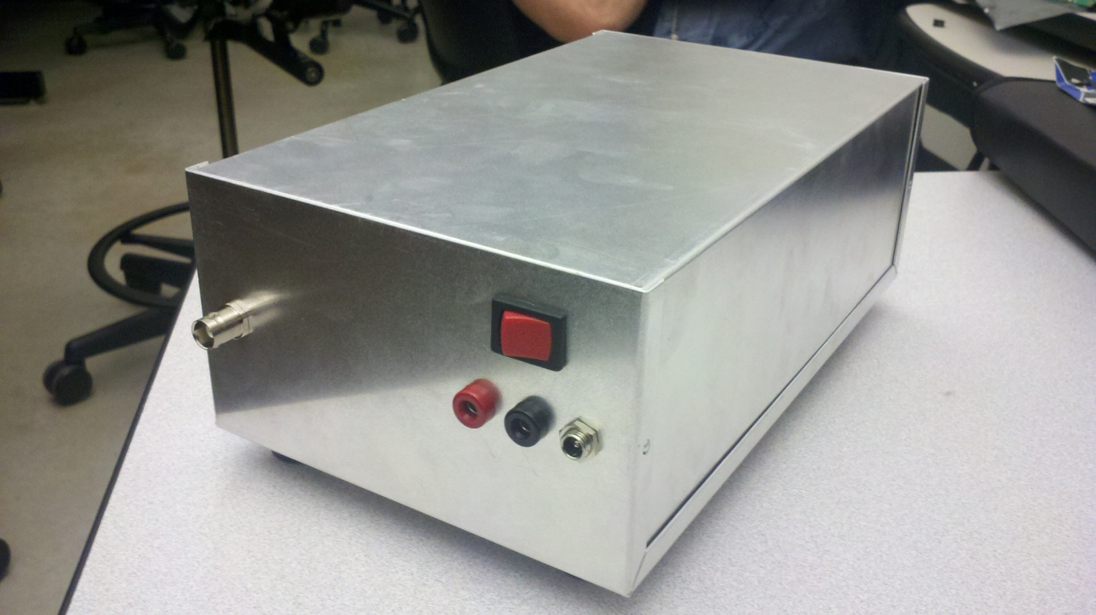

Grand Valley State University  
EGR 486 – Senior Project  
Dan Soberal  
Sean Bredeweg  
Phil Behnke

Hardware:

|  |  |  |
| --- | --- | --- |
| Image | Item | Quantity |
| 2011-08-02_02-15-36_713.jpg | #10-32, Hexagonal 1.0" Length Aluminum Standoff | 8 |
| 2011-08-02_02-14-52_580.jpg | #10-32 Aluminum Nut | 8 |
| 2011-08-02_02-10-16_236.jpg | #10-32, 0.5" Length Machine Screw | 8 |
| 2011-08-02_02-12-39_231.jpg | 0.365" x 0.219" x 0.025" Washer | 14 |
| 2011-08-02_02-16-50_212.jpg | 10" SMA Male-Male Connector | 2 |
| 2011-08-02_02-18-28_752.jpg | Board to Board Header Pins | 6 |
| 2011-08-02_02-14-01_392.jpg | #10-32, Rubber Feet | 4 |

Tools required:

* Philips Screwdriver
* Small Crescent wrench

Procedure:

1. Place a single washer on four of the aluminum standoffs. Align the standoffs with the holes in the RF frontend board with the text facing up. The board should now be supported from underneath and able to stand on its own. Place another washer over each of the four standoffs.
2. Take the remaining four standoffs and thread them on top of the first four which are supporting the RF frontend board. Refer to Figures 1 and 2. Only tighten the standoffs so that they are snug. It will make it easier to adjust and align the assembly with the mounting holes on the bottom of the box later on if these are left a little loose.

**IMPORTANT:** Do not over tighten the standoffs. The circuit board is relatively durable but it is possible to crack it if too much pressure is applied.

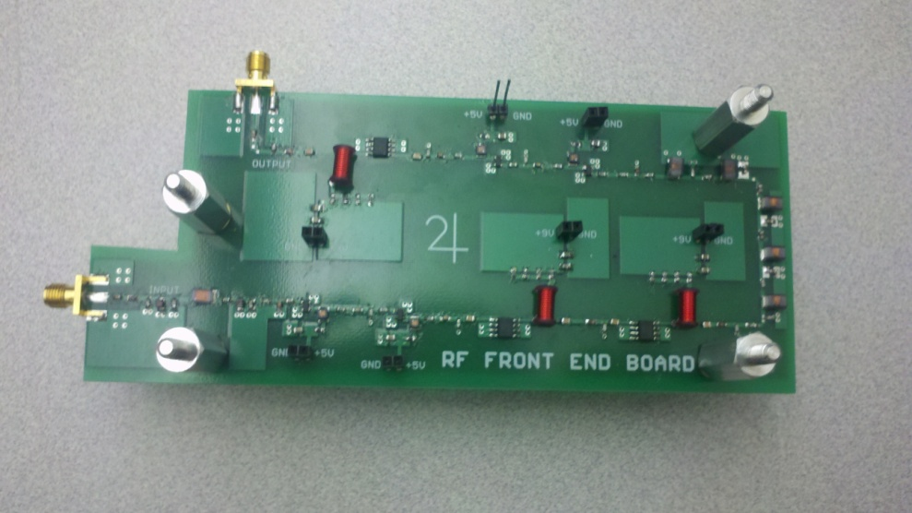  
Figure 1: Top view of the RF board with standoffs assembled

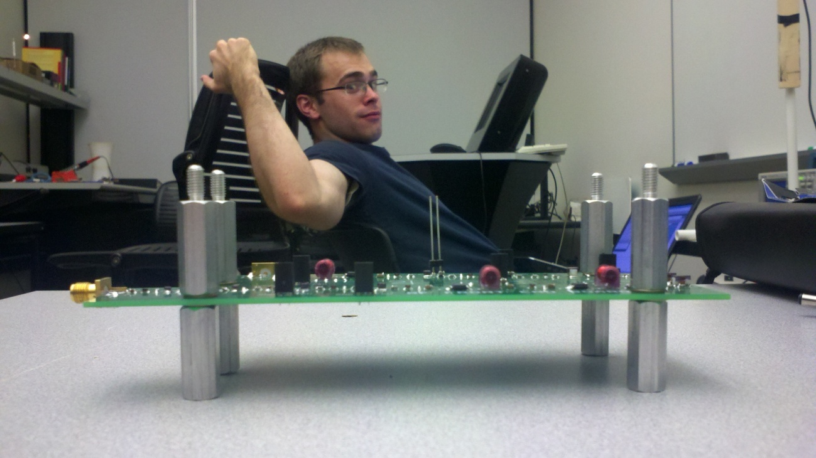

Figure 2: Side view of the RF board with standoffs assembled

1. Place four washers over top of the aluminum standoffs.
2. Take the 6 board to board header pins and placed them, with the gold plated ends down, into the header slots on the top side of the RF Board. Refer to Figures 3 and 4.

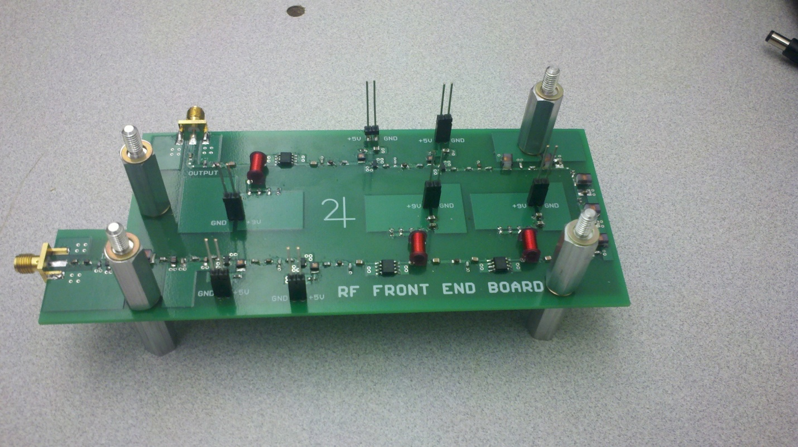  
Figure 3: Top view of RF board with board to board header pins installed

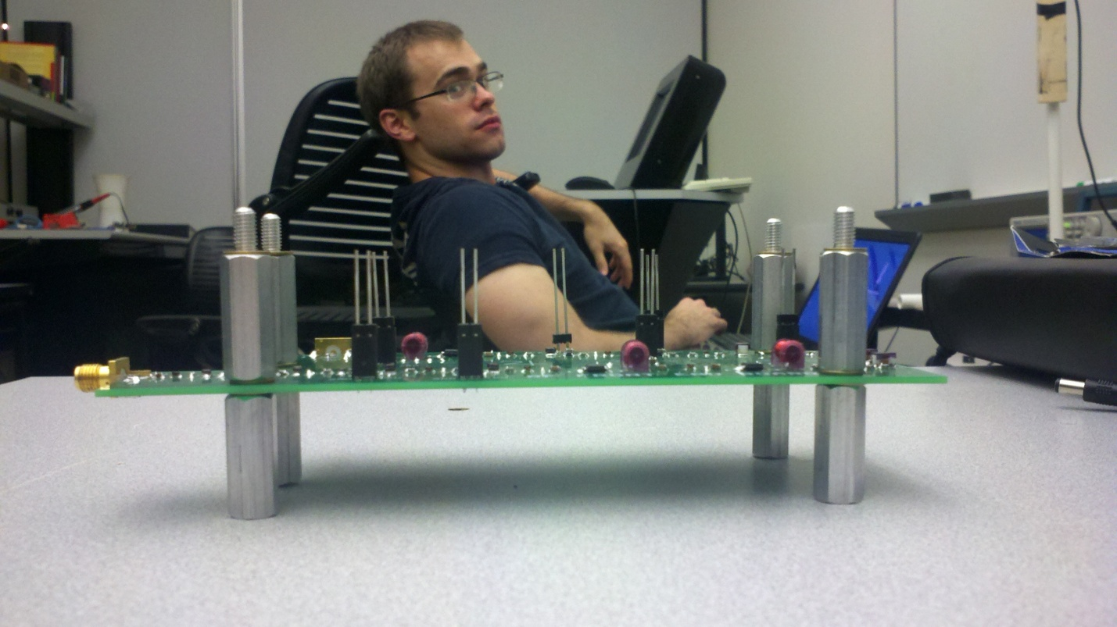  
Figure 4: Side view of RF board with board to board header pins installed

1. Take the Power board and carefully align the threaded standoffs with the holes in the power board and guide the board to board header pins to mate with those on the underside of the power board. If you are having trouble getting the standoffs to line up with the holes on the RF board, loosen them slightly. This should allow some extra movement that should allow everything to align. Refer to Figures 5 and 6.

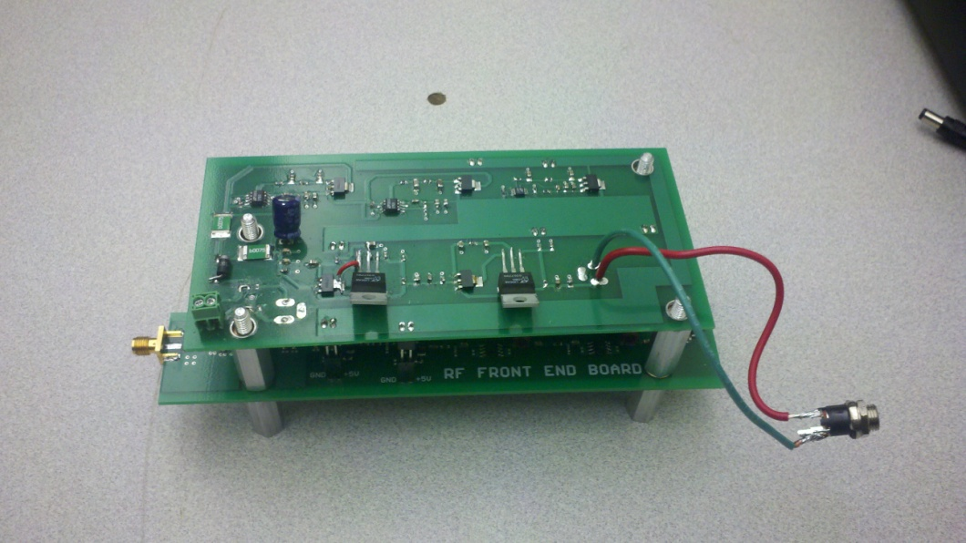  
Figure 5: Top view of Power board and RF board assembled

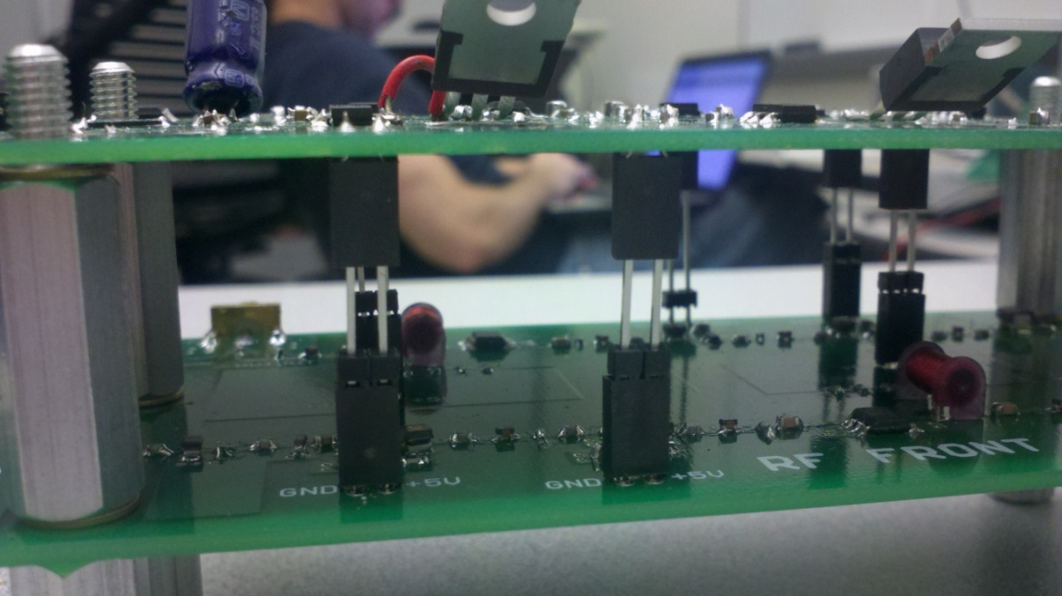  
Figure 6: Side view of Power board and RF board assembled

1. Take four of the aluminum nuts and thread them onto the standoffs, securing the Power board to the RF board. After the nuts are tightened, you may now tighten the standoffs. Refer to Figures 7, 8, and 9.

**IMPORTANT:** There is very little clearance between the two nuts near the input SMA connector. Take great care in making sure that they are not touching any exposed traces. Figures 8 and 9 highlight the two areas where there is little clearance.

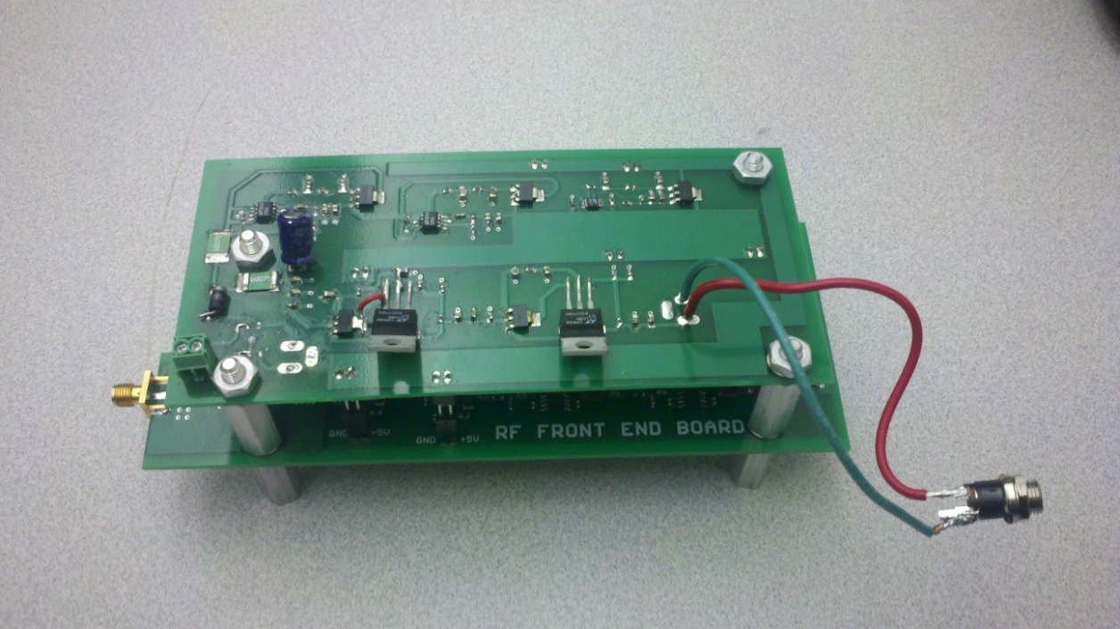  
Figure 7: Top view of board assembly

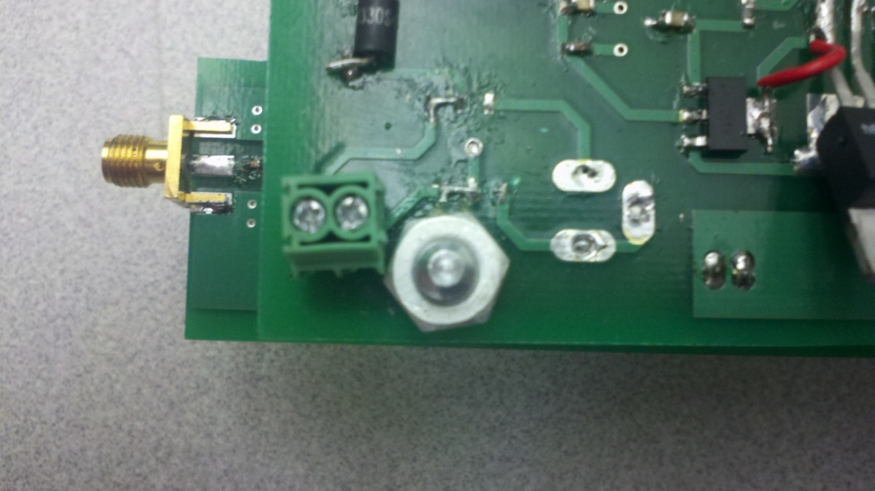  
Figure 8: Low clearance location #1

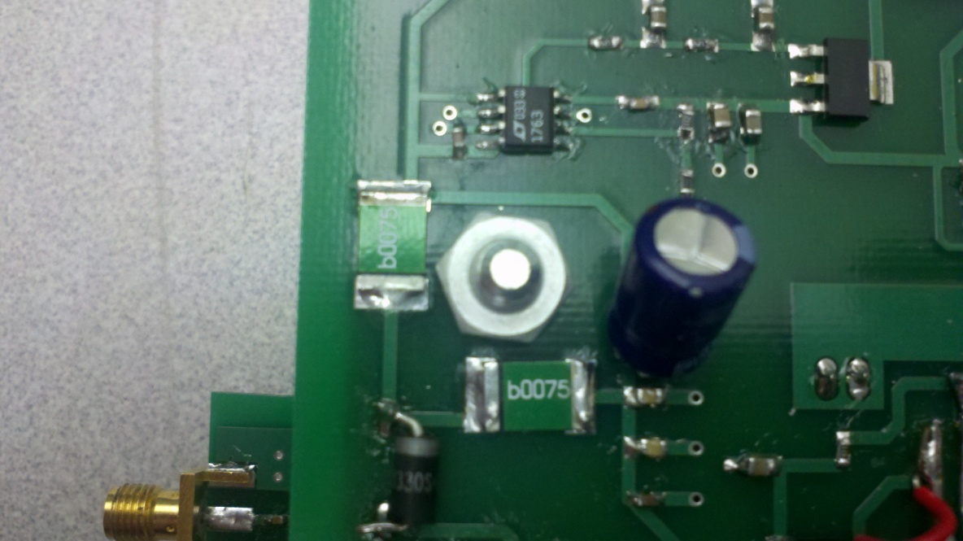  
Figure 9: Low clearance Location #2

1. Take the four rubber feet, four machine screws, and four nuts and fasten the rubber feet to the four corners of the bottom of the box.
2. Take the board assembly and box and orientate it so that the input to the RF board is facing the input from the antenna. Line up the holes on the bottom of the box with the holes on the standoffs. Again, do not tighten them down all the way immediately. Start all four screws before tightening them up. Refer to Figure 10.

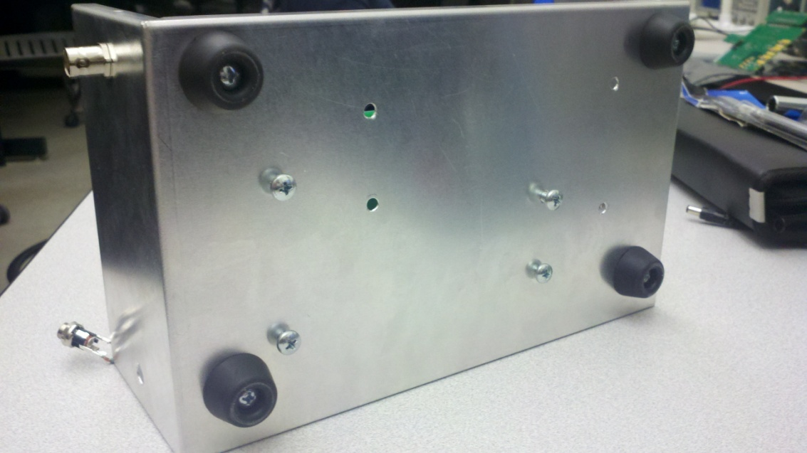  
Figure 10: Rubber feet board assembly mounted to base of enclosure

1. Connect one end of a 10” SMA cable to the input of the RF board and the other end to the antenna input SMA connector mounted to the enclosure. Take the second 10”  
    cable and connect one end to the output of the RF board and the other end to the attenuator which is connected to the enclosure mounted SMA connector opposite the input.
2. Take the panel mount barrel plug and securely mount it through the back of the enclosure. Refer to Figure 11.

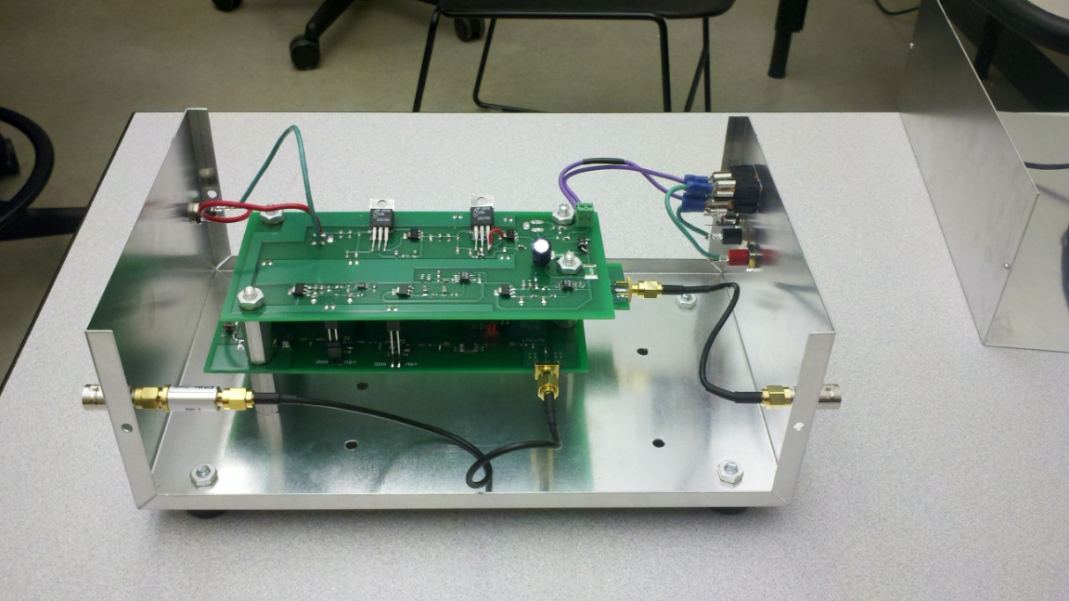  
Figure 11: Side View of Board assembly mounted in the enclosure with cables attached

1. Take the two loose wires from the power switch and slide them into the terminal block located on the top of the power board and tighten the terminal screws. For clarification, the wire attached to the top of the switch is positive, and the wire connected to the bottom is negative. Figure 12 shows the proper polarity of the wires. The wire that enters the left side of the terminal is the positive and the wire on the right is the negative.

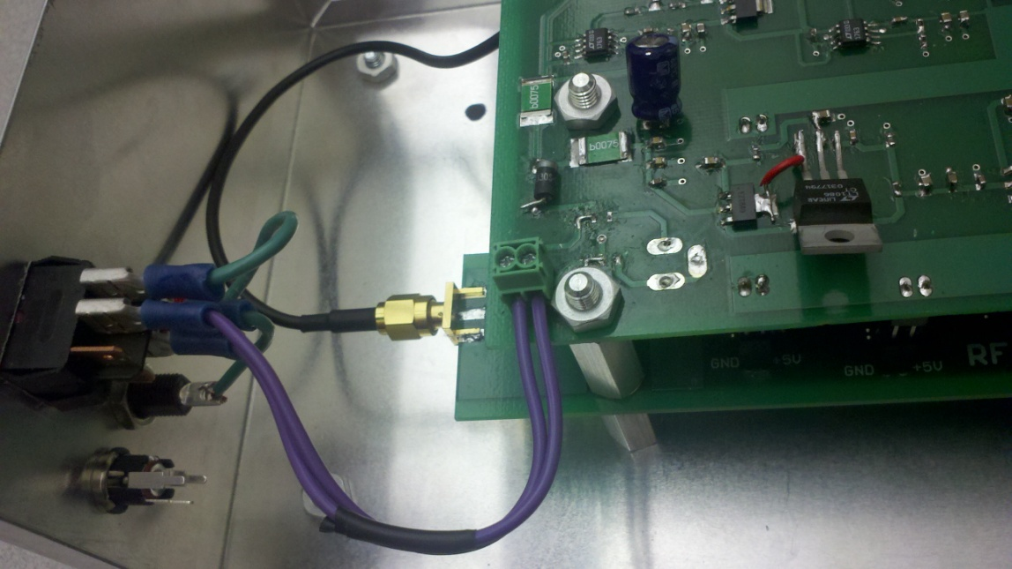  
Figure 12: Proper polarity of supply wires.

1. Slide the top half of the enclosure inside the guide rails of the lower portion. Apply pressure to the sides of the of the top half and continue sliding the top down into the base past the small holes until the rivets in the top half of the enclosure pop into place. Refer to Figure 13.

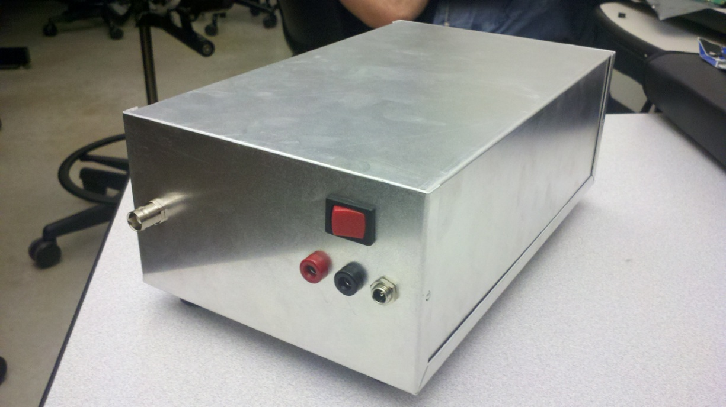  
Figure 13: Completely assembled SDR JOVE RF Frontend