Categories in Document Exchange
The categories are maintained by the document administrator. These can be indefinitely nested to better structure your companies’ resources. Categories are very powerful and provide a way to ‘matrix’ your information (i.e. to provide multiple ways to structure contents), compared to folders that only singularly structure information. The edit screen for categories is fairly straightforward and can be found under the ‘categories’ menu item on the admin menu of DMX.
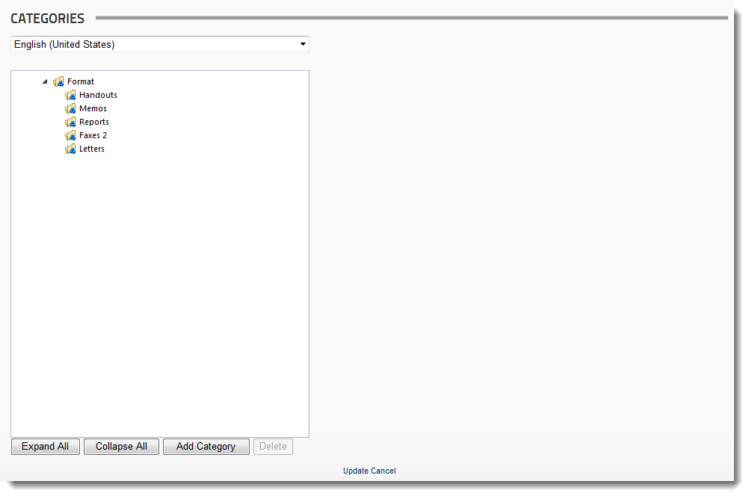

Adding a category
Click on Add Category
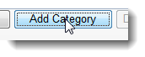
A new category will appear in the list above. Click it to select it and click it again to put it in edit mode:
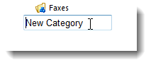
Now edit the text to what you want it to be and click anywhere next to the box to close edit (or hit enter)
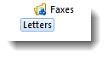
Now you can drag and drop the categories around to put them in the place you want them to be. Note you can also reorder (i.e. move them around at the same depth in the tree) them in this way.
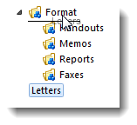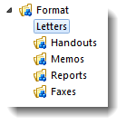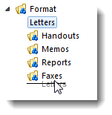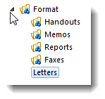
Click “Update” when you’re done editing.

Multilingual features
If you have a multilingual site, categories are multilingual as well. The language dropdown at the top of the category list is used to navigate between languages.
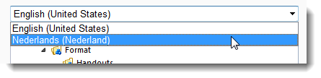
At first you won’t see any difference when you select another language as the default language text values are copied to your alternative language. But now you may edit the categories in the new language:
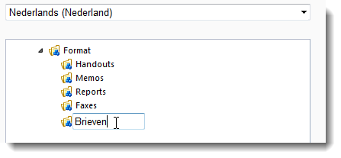

Adding items to categories
When editing items in DMX you can select any number of categories for it. Subsequently it will show up under that category in the main UI. In DMX 6 we also introduced drag and drop for categories. Now you can grab items in the list view on the right of the UI and drop them on categories in the tree on the left to add them:
