DotNetNuke Folder Provider
DMX includes the ability to register a folder in DMX as a so-called “folder provider” in DotNetNuke. What this means is that this folder becomes visible as a folder in DNN’s own internal system and you can use it to add content through the HTML editor, for instance.

How to add a DMX folder as DNN folder?
Go to DMX’s control panel and click “Add Folder to DotNetNuke”
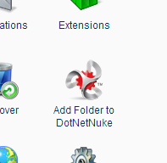
This will bring up the screen which allows you to add a folder:
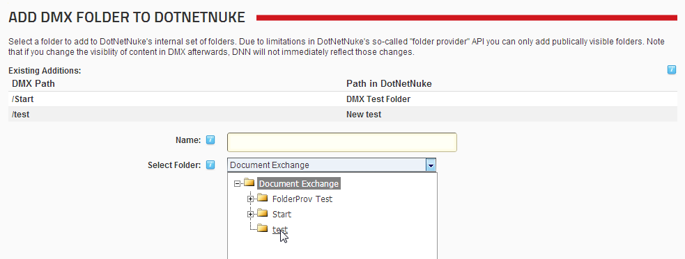
Choose the folder you wish to add and click Update. When you now go to DNN’s File Manager (Admin menu) you’ll find the folder added to DNN:
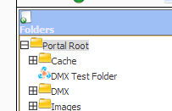
But it will be empty. That is because all we’ve done is just added the folder. Now DNN needs to synchronize the contents. Select the “recursive” checkbox and click “synchronize”. After this you should see the contents appear in DNN. Now, when using the default HTML editor in DNN we can select content from DMX:
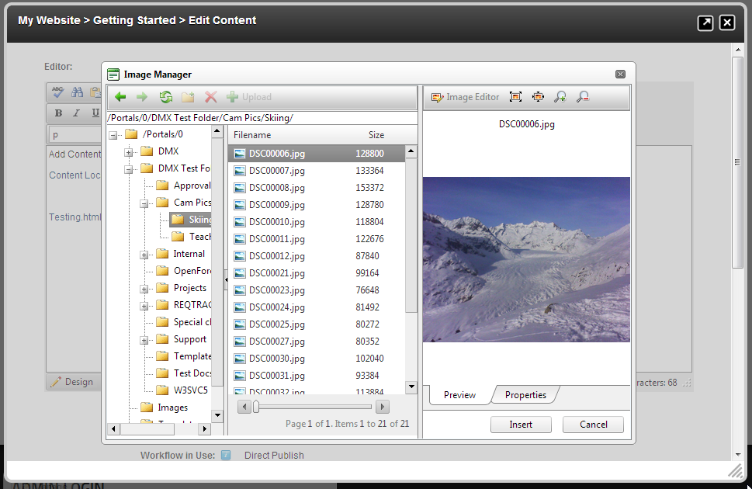

Limitations
There are some limitations you should be aware of. DNN’s “folder provider” mechanism is a kind of “contract” with the whatever component is the provider (in this case DMX). This mechanism (sometimes referred to as “extensibiility”) is how much of the flexibility of DNN is built. The upside is that DMX can now provide this hook-in out of the box. The downside is that it is limited by the aforementioned contract.
The main limitation of the contract is that DNN insists on doing its own security. It does not pass any details of security to the provider and just assumes it operates as a “vat” for storing content. This is not unlike how DMX itself has implemented its own storage provider mechanism. The consequence of this is that DMX cannot ensure that what it gives back to DNN is not displayed to unauthorized users (DNN never bothers to ask DMX about the security settings of items). So to avoid data leakage, DMX only offers content that is visible to “All Users” to DNN. In most use cases this will suffice. After all, the most heard question is how one could embed images stored in DMX onto a web page. Well, you need to make sure the image is visible to “All Users” or it won’t show up in the folder provider. Please keep this in mind.
A second limitation is related to the fact that DNN stores a copy of the document title and location in its own database when it synchronizes. This enables it to offer a folder tree in a speedy fashion. But if you’d change the permissions of a file in DMX to restrict its access, DNN would be unaware of this and still show the name of the file in the file explorer. The only leak here is the document title. Note that no one could actually download or view the document as the download logic still passes through DMX. So the risk here is limited. But you need to be aware of the fact that there is a lag between what you do in DMX and what is visible in DNN.

Removing DMX Folders
If you need to remove a folder you added to DNN, you need to do this from within DNN (not DMX). In DNN’s File Manager select “Manage Folder Types” from the module menu:
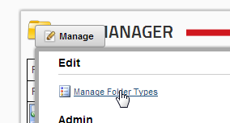
This takes you to the folder types popup where you can opt to delete any added folders.
