Mailing
Document Exchange (since version 6) includes a powerful mailing engine that you can use to distribute documents. Previously you could email documents to yourself with the MailMe function, but now you can email others as well. Because this can lead to large quantities of email being sent from the server, the Administrator has to make a few tweaks to the Main Options of the module to switch this on (see the Main Options help file for details about this).
If you have permissions to send a document you’ll see the “Mail” option become available on the Item (and context) menu of DMX:
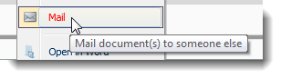
You’ll be taken to the mailing page which will allow you to specify how and to whom the email will go out.

Send Method
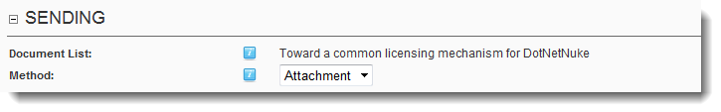
There are two ways in which you can send a document to someone: as attachment or as a link. As an attachment the document will be attached to the email so make sure it is not too big or you will upset the recipients. As a link is better suited for larger documents or if you wish to keep your email volume down to a minimum. The link option will create unique links in the emails that are sent that will directly provoke a download when clicked. Note these links bypass any security on the document. The user does not need to log in to download through the link.
NOTE: The administrator decides which one (or both) of the two options is available to you.

Recipients
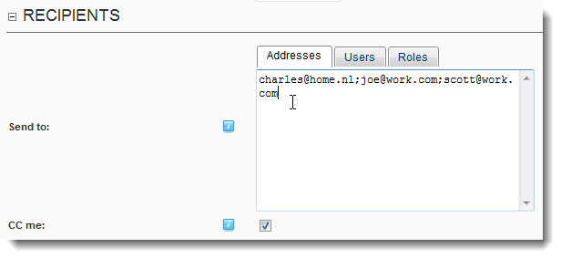
Here you specify who to send the email to. There are three ways to add recipients: by typing in a semicolon-separated list of email addresses, by selecting users from the site and by role. Note the Administrator decides which of the three options is available to you. Selecting CC me will copy the email to you. The email is sent to each addressee individually. I.e. it is not done through cc or bcc.

Selecting Users
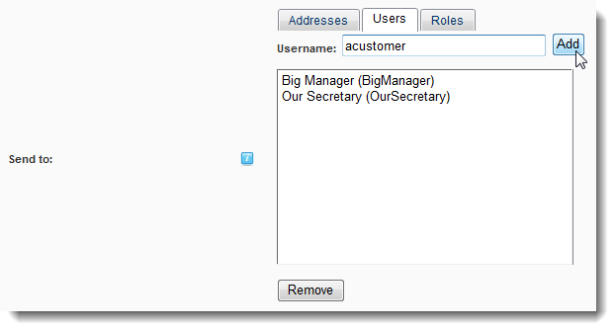
To add users from the site you need to add them by username.

Selecting Roles
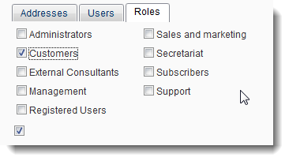
Select roles and all users belonging to that role will be added to the recipients list.

Link Options
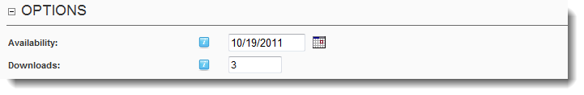
If you opted to send links AND the administrator has specified you may change these, you will see the options for the link. Set the availability after which the link will cease to function and the maximum number of downloads that are permitted through the link. Note links are strictly individual and per document. With the above setting each and every recipient will have 3 opportunities to retrieve the document.

The Email
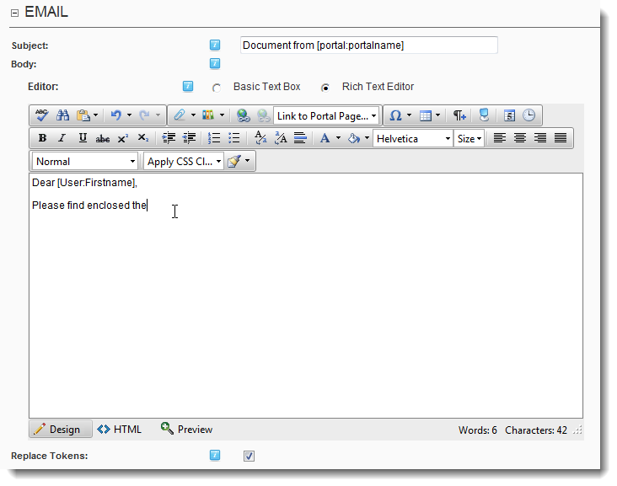
This part of the screen works just like the core newsletter function. You can write the email and use tokens which will be replaced when compiling the email. This makes it possible to personalize the email by using [user:firstname] or [user:displayname] for instance.
Note: because the free format addressees (i.e. where you just enter a bunch of email addresses) are not users in the portal this function is not advisable when using those. DMX will try to match the email addresses to existing users just in case, but if a user is not found the [user:…] tokens will be replaced with an empty string.

Sending
The emails are sent after you click “send” and you will be shown a report when done.
