Notifications
DMX has a powerful notification processor that allows you to send personalized emails upon virtually any event. It has been revised for version 04.03 and now has the ability to pool multiple notifications into one email. This has the benefit of preventing email floods when users do a lot of editing to the content of DMX while being subscribed to it.

Notification Process
The basis for the DMX notification system is the DMX event log. You can see this in SQL in the DMX_Log table. Every event records ‘who did what to which item’. The ‘what’ here is a so-called log type. This can be ‘Add’, ‘Delete’, ‘Edit’, etc.

Notification Harvesting
Every so often a scheduled event (scheduled tasks are managed on the schedule page which you find on the host menu of DotNetNuke) will check the event log for new events and compile notifications if necessary. This process is called notification harvesting. The result is a list of people to be notified tied to a particular event.
Technical note: the events in DMX_Log are checked against the notification matrix (see below, stored in DMX_LogTypes) and all events are ‘exploded’ to notifications in DMX_Notifications where the event is tied to each user to be notified.

Notification Sending
After the harvest DMX will start to compile the actual notifications. During this process DMX checks to see who should be notified of what and what kind of notification (i.e. what message should be sent) this should be. Then the message is sent using the DNN email settings (Host Settings page).
Technical note: digest emails are created from the DMX_Notifications table by pooling together all notifications to a single user.

The Notification Matrix
Under the Admin menu of your DMX you’ll find the ‘Notifications’ edit screen. If you open this you should see something similar to the following:
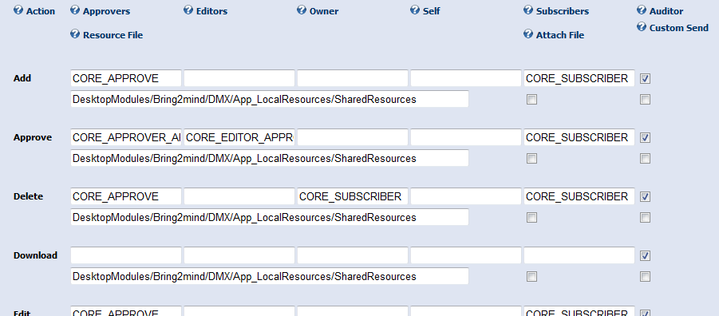
This is a matrix of event types and the notifications that should be sent. You’ll find the notification engine can send emails to Approvers, Editors, the Owner, the current user, and Subscribers. If the cell is left blank then no notification will be sent for those conditions. If it is filled in, then the text corresponds to a message template in the resource files.
There are 4 more parameters for each event type: Auditor, Resourcefile, Attach File, and Custom Send. Checking the Auditor checkbox will send an email to the auditor email address (if specified) upon this event. The resource file is the file that contains the message templates. For all default event types and messages this is set to the SharedResources.ascx.resx file of the DMX module. Extensions can have their own messages in their own resource file.
‘Attach File’ will make DMX attach the items being notified about to the email. Lastly ‘Custom Send’ signals DMX to not use this in the core notification harvesting and sending. This way extensions can bypass the notification processing but still benefit from using the logic. An example is the ‘MailMe’ function which sends an email immediately to the current user with the document attached.

Notification Templates
The (standard) notification templates are in the resource files distributed with the module (in the SharedResources.ascx.resx file). Because these are in the resource files, they can be localized and even be overridden by portal. There are 2 required entries into the resource file for every template:
- Templatename.Subject and
- Templatename.Body
The processor will look for these entries and use them to compile the subject and body of the email.
The notification processor uses a mechanism called ‘Token Replace’ which was introduced in DNN 04.06.x. With this mechanism we can add ‘tokens’ using the following format:
[object:property]
to the text and the processor will replace the token with the corresponding value. You will need the list included in the annex at the bottom of this document to determine which token/property combinations you can use.

Repeat Template
As outlined above, the current notification system can notify users of multiple events in a single email. To do this we need a system to repeat details of the document in an email. For this we use the ‘RepeatTemplate’. Use a token in the body text of the email as follows:
[templatename:RepeatTemplate]
The templatename will be read and looked up in the same resourcefile as Templatename.RepeatTemplate. This text is then used when iterating over the events to be sent in the email. The result is stuck in the place of the token in the email body.

Example
The following is an example of the above mechanism that is included in the general distribution.
CORE_APPROVE.Body | <p>Dear [Recipient:Displayname],</p>  <p>The following actions have taken place which require your approval:</p>  <p>[CORE_APPROVE_RT1:RepeatTemplate]</p>  <p>Kind regards,</p>  <p>[DNNAdmin:Displayname]</p>  <p>[DMX:Portalname]</p>
CORE_APPROVE.Subject | There are documents waiting for approval
CORE_APPROVE_RT1.RepeatTemplate | <p><strong>[Entry:Title]</strong><br />  was [LogType:Phrase] by [Editor:Displayname] on [Log:Datime:g]<br />  link: <a href="http://[DMX:DefaultPath]/Default.aspx?tabid=[DMX:DefaultDMXTabId]&amp;EntryId=[Entry:EntryId]">  http://[DMX:DefaultPath]/Default.aspx?tabid=[DMX:DefaultDMXTabId]&amp;EntryId=[Entry:EntryId]</a></p>

Annex: Available Notification Tokens
Object | Property | Details
entry | author | The Entry is the item in the document exchange. This can be a document, a folder, or a hyperlink.
 | collectionid
 | created
 | deleted
 | entry
 | entryid
 | entrytype
 | filesize
 | isapproved
 | keywords
 | lastmodified
 | lastversionid
 | lockedby
 | lockeduntil
 | lockkey
 | md5hash
 | originalfilename
 | owner
 | path
 | permissionsonlybyadmin
 | portalid
 | state
 | version
 | versionstokeep
 | workflowid
 | title
 | remarks
log | action | The log object is what recorded the event.
 | datime | The log object is what recorded the event.
 | entid | The log object is what recorded the event.
 | id | The log object is what recorded the event.
 | userid | The log object is what recorded the event.
logtype | attachfile | The logtype is the event type. This is used to determine the type of notification to send.
 | customsend
 | logtypekey
 | notifyapprovers
 | notifyaudit
 | notifyeditors
 | notifyowner
 | notifyself
 | notifysubscribers
 | portalid
 | resourcefile
editor | displayname | The 'editor', 'dnnadmin' and 'recipient' are all DNN UserInfo objects. The editor is the user who caused the event. The DNN admin is set in the portal settings.
dnnadmin | email
recipient | firstname
 | issuperuser
 | lastname
 | portalid
 | userid
 | username
dmx | portalid | The 'DMX' object holds info about the DMX installation under this portal.
 | permissionsonlybyadmin
 | defaultdmxmoduleid
 | defaultdmxtabid
 | enablewebdav
 | webdavharddelete
 | webdavpermissions
 | changefileextensions
 | searchprovider
 | remarksashtml
 | showearlyfinish
 | emailinterval
 | portalalias
 | currency
 | description
 | email
 | homedirectory
 | homedirectorymappath
 | logofile
 | portalname
 | applicationpath
 | defaultpath
 | hometabid
date | current
 | now
datetime | current
 | now
ticks | now
 | today
 | ticksperday
culture | englishname | This is the culture of the current thread.
 | lcid | This is the culture of the current thread.
 | name | This is the culture of the current thread.
 | nativename | This is the culture of the current thread.
 | twoletterisocode | This is the culture of the current thread.
 | threeletterisocode | This is the culture of the current thread.
 | displayname | This is the culture of the current thread.
portal | portalid | The 'portal' object is a DNN object with details about the portal.
 | portalname
 | homedirectory
 | homedirectorymappath
 | logofile
 | footertext
 | expirydate
 | userregistration
 | banneradvertising
 | currency
 | administratorid
 | email
 | hostfee
 | hostspace
 | pagequota
 | userquota
 | administratorroleid
 | administratorrolename
 | registeredroleid
 | registeredrolename
 | description
 | keywords
 | backgroundfile
 | siteloghistory
 | admintabid
 | supertabid
 | splashtabid
 | hometabid
 | logintabid
 | usertabid
 | defaultlanguage
 | timezoneoffset
 | version
 | users
 | pages
 | contentvisible
host | hosttitle

