Document Exchange Rss Options
DMX allows you to syndicate content to other modules or even websites. For this it offers a so-called ‘feed’ in the RSS 2.0 protocol. It extends upon this protocol so with the right processor you could extract more information from the feed than the basic RSS 2 properties.

Scope
All settings apply to the module instance. This means that content in the feed is only from content within the module folder root downward. The icon (when enabled) will only show on this module instance. In this way you can create several feeds by using multiple module instances.

Administrative settings
You’ll find ‘Rss Settings’ on the Admin menu of DMX. This will take you to the following configuration screen:
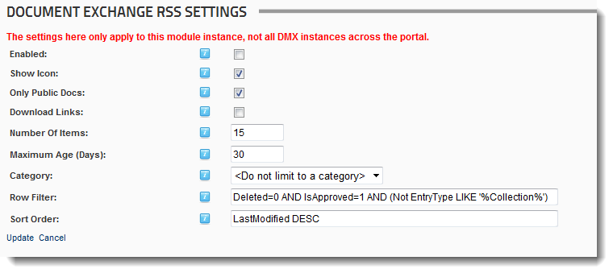

Enabling the feed
The ‘enabled’ setting allows the module to serve a feed. The ‘Show Icon’ will make the icon show up for anonymous users. If unchecked the icon is only visible to Admins. Note that if you set ‘Allow syndicate’ on the (standard DNN) module settings (under Page Settings) as well there will be two icons that show up so you’ll want to uncheck this:
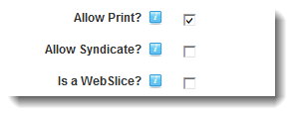
The icon will show up if included in the skin like below:
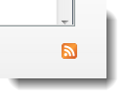

Security and caching feeds
It is important to realize that DMX will never serve out protected content to unauthorized users. As at all levels there is a WYSIWYG philosophy, DMX will not serve out metadata of protected content either. You simply do not see content that you’re not allowed to see. When a feed is requested by an external resource, that request can optionally be accompanied with authentication information. This means that to DMX it looks like a known user is requesting the RSS feed. Subsequently the metadata corresponding to that user will be served.
Most RSS consuming applications will on one way or another provide caching of the retrieved feeds. This is to help lower the total burden on internet traffic with this type of application. A feed would be retrieved every 30 minutes for instance, while the consuming site will show its contents as if it were ‘live’ in between refresh moments. Here we must issue a warning. If you use the RSS capacity of DMX with user authentication to show the contents on some other web page, and this page caches the feed, subsequent unauthorized users might see protected content reserved for the user that was browsing while the feed was retrieved.
To ensure no protected content is served, the settings page allows you to set ‘Only Public Docs’ to be served, regardless of the authentication of the retrieving request. This means documents that have ‘All Users’ in a VIEW role.

Download Links
If selected the links in the feed will provoke an immediate download of the item. If not checked then the links lead back to this module instance with the item selected.

Limiting the feed length
The feed will serve out a maximum nr of items specified and a maximum age of the items. This is a AND relationship. An item has to be within the max nr of items AND be younger than the given max age.

Filtering and sorting
Take care when adjusting these parameters. They are (SQL) expressions that use the field names as they are retrieved from the database. A spelling error will inevitably lead to a broken feed. Write down the old value before changing this. For field names examine DMX_Entries in SQL.

Using the feed
Use the link under the RSS buttons (you need to click on them to see the link in the browser) underneath the module or on the module menu to retrieve the feed url. Use this address in your software that consumes the feed. The feed will look similar to this:
<?xml version="1.0" encoding="utf-8"?>
<rss version="2.0">
<channel>
<title>Bring2mind\DMX</title>
<copyright>Copyright 2007 by My Website</copyright>
<link>http://test.bring2mind.net/tabid/0/Default.aspx</link>
<language>en-US</language>
<description>Document Exchange Feed</description>
<item>
<title>rightSelectedNormal</title>
<description />
<link>http://test.bring2mind.net/tabid/0/Default.aspx?EntryId=1889</link>
<author>SuperUser Account</author>
<guid>http://test.bring2mind.net/tabid/0/Default.aspx?EntryId=1889</guid>
<pubDate>Thu, 03 Jul 2008 20:57:02 GMT</pubDate>
<dmx:CollectionId xmlns:dmx="http://www.bring2mind.net/dmx">1878</dmx:CollectionId>
<dmx:Created xmlns:dmx="http://www.bring2mind.net/dmx">Thu, 03 Jul 2008 20:57:02 GMT</dmx:Created>
<dmx:EntryId xmlns:dmx="http://www.bring2mind.net/dmx">1889</dmx:EntryId>
<dmx:EntryType xmlns:dmx="http://www.bring2mind.net/dmx">File.Gif</dmx:EntryType>
<dmx:FileSize xmlns:dmx="http://www.bring2mind.net/dmx">632</dmx:FileSize>
<dmx:Keywords xmlns:dmx="http://www.bring2mind.net/dmx" />
<dmx:OriginalFileName xmlns:dmx="http://www.bring2mind.net/dmx">rightSelectedNormal.gif</dmx:OriginalFileName>
<dmx:Version xmlns:dmx="http://www.bring2mind.net/dmx">1</dmx:Version>
<dmx:FolderTitle xmlns:dmx="http://www.bring2mind.net/dmx">platinum</dmx:FolderTitle>
<dmx:Icon16 xmlns:dmx="http://www.bring2mind.net/dmx"> http://test.bring2mind.net/DesktopModules/Bring2mind/DMX/images/File.Gif.Gif</dmx:Icon16>
</item>
<item>
<title>rightSelected</title>
<description />
<link>http://test.bring2mind.net/tabid/0/Default.aspx?EntryId=1888</link>
<author>SuperUser Account</author>
<guid>http://test.bring2mind.net/tabid/0/Default.aspx?EntryId=1888</guid>
<pubDate>Thu, 03 Jul 2008 20:57:02 GMT</pubDate>
<dmx:CollectionId xmlns:dmx="http://www.bring2mind.net/dmx">1878</dmx:CollectionId>

The ‘title’ of the channel is taken from the module title. As you can see the items are extended with a number of DMX properties. If you’re using XSL to transform the feed to html you can use these extra fields to enhance the presentation.

