Search
A document management system is useless without a searching mechanism. DMX includes its own search engine separate from the DotNetNuke search engine. Why? Well, the DNN search engine is designed for modules with what I’d call monolithic content permissions. I.e. the permissions are set at module level and affect all content. DMX has per-item permissions. If we’d feed the contents of DMX to the DNN search engine, it would display documents that the user may not be allowed to see. This is why we had no choice but to implement our own engine.
There are two main aspects of any DMX entry to index: the metadata and the contents (in case it’s a file entry of course). The metadata is stored in the SQL database and is managed by DMX itself. The contents are in the document itself. To index the contents DMX leverages an external search engine. This is configurable. In the regular module distribution we include two providers: one based on Lucene and one based on Windows Indexing Service. To select and configure the search provider log in as Administrator and go to Search Settings:
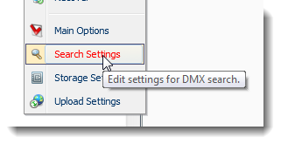

Some notes about search and security
The holy grail for any search solution is being able to index the contents of a file. For a text file this may be straightforward, but for any binary file (like MS Word) this depends on the software’s ability to read that format. The mechanism used in Windows is the employment of so-called iFilters. These are DLLs that are installed in the computer system that can open specific file types (Word, Acrobat, etc) and read their contents. Understandably these iFilters are made by the manufacturers of the software that produce the files they read. The Word iFilter is made by Microsoft (and included in just about any Windows installation) and the Pdf iFilter is made by Adobe (which you need to download and install yourself). MS Indexing Service uses iFilters and the DMX Lucene implementation also uses them to extract the contents of files.
As Microsoft enhances its security architecture in Windows, so it makes it for managed software (i.e. .NET applications like DNN/DMX) more difficult to reach other parts of the operating system. This has resulted in the DMX Lucene implementation being prone to blocking by the OS from indexing contents of files (under a so-called partial trust scenario). The reason is that DMX is not allowed to load and use the iFilter which is installed at machine level.

Selecting the Search Provider
The search settings screen is brought up from the Admin menu or the Control Panel
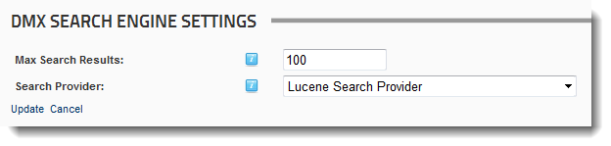

Max Search Results
When DMX retrieves results from the provider, we limit the number of documents returned to DMX which protects against a possible flood of results (e.g. searching for a very common word in a repository with 100.000 documents may well lead to a timeout in the search logic as it attempts to swallow all the results). Note though that there is an off chance that a document we’re looking for is not returned.
What is important to realize here is that the search is done in two steps. First the search engine is asked for document contents matching the criteria. This is then fed to step 2 where permissions are checked and the results are added to the results from search on the metadata. The max search results parameter concerns the first step. So theoretically the user can have 100 documents returned from contents search to which he/she does not have access so none will show up from this. Note that until now the value of 100 has always seemed to suffice.

Lucene
Lucene is an open source search engine (http://lucene.apache.org/) that is a serious competitor for big commercial solutions like Indexing Service. DMX uses the dotnet version of Lucene: Lucene.Net.

Lucene location and ‘Luke’
Lucene stores its catalogs on hard disk. In DMX the catalog is located at PortalHomeDirectory/DMX/Lucene/Index. You can use tools like Luke (http://code.google.com/p/luke/) to examine the index and test queries. If you have any trouble with search, I strongly advise you to get this simple and lightweight tool and check the contents of the index.
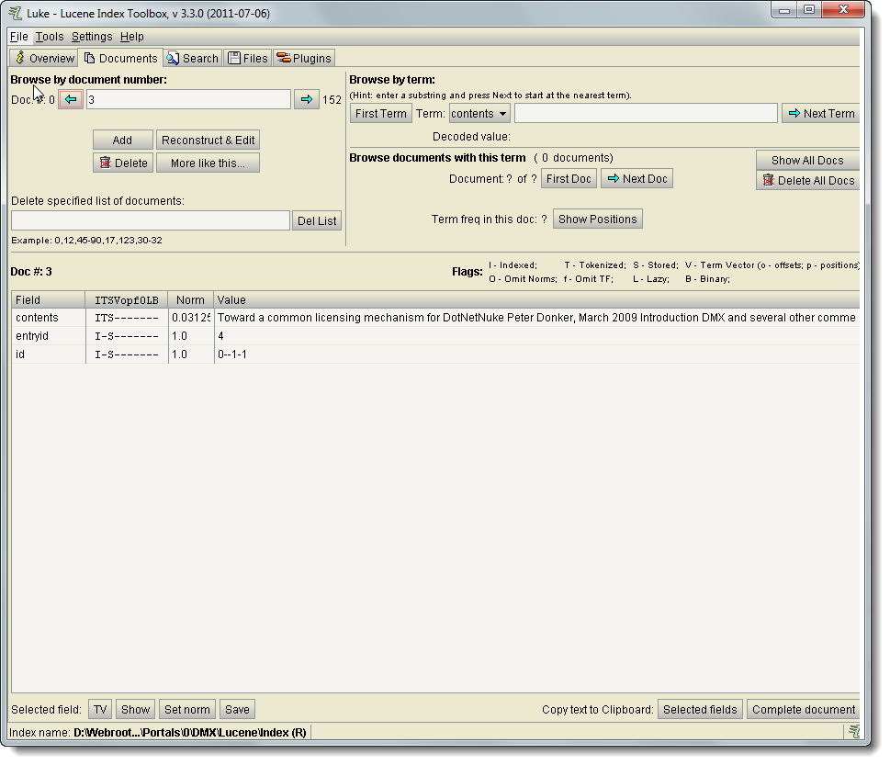

Debugging full Content Search
One of the most frequent issues in search is getting contents to be indexed by the search engine. As mentioned before iFilters are used to read the contents of files. When you have an issue indexing content (i.e. when you can’t find content you are sure was in some file) then follow the path below to debug this.

Finding out if it is an issue of the iFilter or of Lucene
The first step is to find out if the problem is in the iFilter itself, Lucene’s ability to leverage the iFilter or in Lucene itself. The first thing to do is to upload a simple text (.txt) file with a text you can search on. I usually upload a text file with the phrase “this is a sentence with a magic word”, and then I search for “magic” in contents. Does the text file get returned? No, then it’s an issue of Lucene itself. The first thing to try then is to completely delete all files of the Lucene index and reindex. Do files get created? Could it be a disk permissions issue?
If the text file with the magic word is found then we know Lucene is doing its job. So far so good. Now let’s see if it can do the same for a Word document. The Word iFilters are commonly distributed with Windows and do not need to be downloaded and installed separately. So this is a good start. Can you find the Word document in a content search? No? Then it could very well be an issue of security where Lucene (i.e. the asp.net application) is not allowed to talk to the system’s iFilters. This is not uncommon in shared hosting scenarios. Alternatively it could be because Indexing Service was not installed on the host server. The indexing service installs a dll called “query.dll” in the system which DMX uses to find the correct iFilter based on the file’s extension. If this dll is not there, DMX can’t find the iFilters.
If the Word document is found then iFilters can be leveraged and we are on the last stretch of debugging. Now we are pretty sure the real issue is the iFilter for the document you are trying to get indexed. This can be because the iFilter is simply not installed, or because it is out of date (has been known to happen with PDF ifilters). Double check with the manufacturer of the file format what the latest version of their iFilter is and make sure it’s installed properly on the server.
To properly drill down it may be necessary to use Luke (see above). With Luke you can examine a single Lucene index record and check if that record has contents indexed. Find out what the entry id of the document in question is. Then find that document in Luke and examine the ‘contents’ field. If it’s blank or absent then no contents have been found.
Final note: every time you make a change to the system you’ll need to reindex to test. This is because the Lucene index is built upon upload of every document and not as a continuous adaptive process like Indexing Service.

Indexing Service
You can use Indexing Service as an alternative to Lucene to index your DMX. There are three very important prerequisites here:
- You must use the Disk File Storage Provider for all your files (see Storage Provider documentation for details)
- Without a domain controller it is impossible to use this setup when the files stored by DMX are on a different server than the SQL Server used by DNN.
- The ‘extension renaming’ done by DMX should be switched off. Every uploaded file gets stored with a hashed name and an extension .resources. This prevents it being accessed directly by unauthorized viewers. To make Indexing Service DMX will need to leave the extension intact. This is done on the Storage Provider Settings screen: Change Extensions:
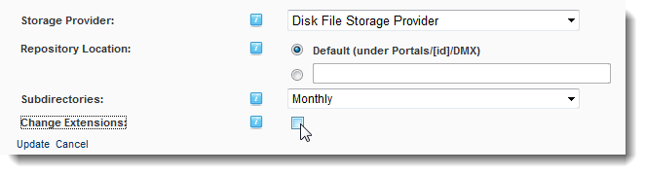

Configuring on your server (Windows 2003)
You’ll first need to create a so-called catalog on the server where the files are stored. Open the Computer Management panel and go to ‘Services and Applications > Indexing Service’. Select New Catalog:
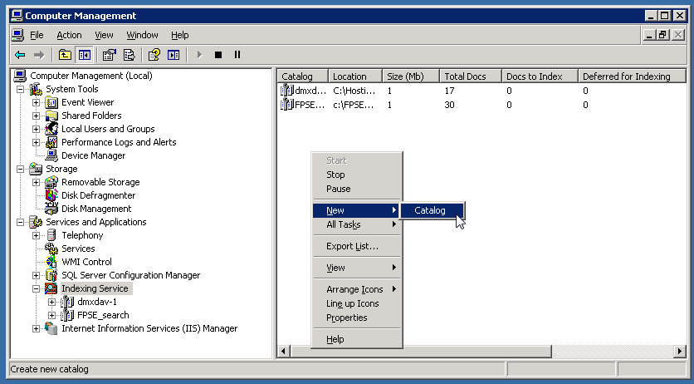
Give it some meaningful name (like DMXCAT) and specify a place where to store the catalog files (not the same place where the files are that need indexing). Once you’ve created the catalog you can specify the directories to index. Select the catalog and select ‘Directories’ and you should be able to add a new directory:
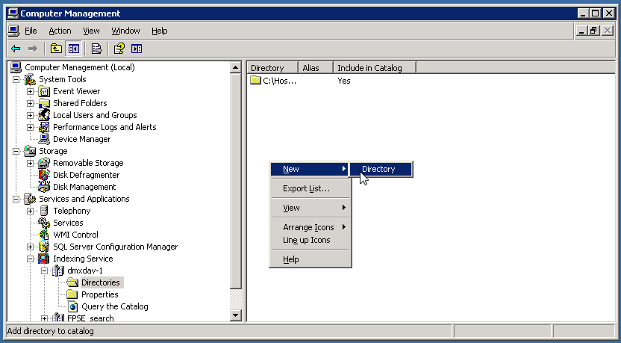
Specify the path to where the DMX stores its files. By default this is under DNNInstallation\portals\PortalId\DMX where the DNNInstallation is where your DNN is, and PortalId is the ID of the portal you want to index the DMX of. This should be enough to get you using Indexing Service on DMX. You can use the ‘Query the Catalog’ node here to directly query the index. This is helpful in determining where things go wrong if the indexing does not work as anticipated.

Configuring in DMX
As stated above you need to make sure you have extension renaming switched off. Existing content that has already been renamed can be reset by using the appropriate script (DMX menu: Admin > Run Script).
Use the SearchSettings screen and select IndexingServiceSearchProvider to bring up the following screen:
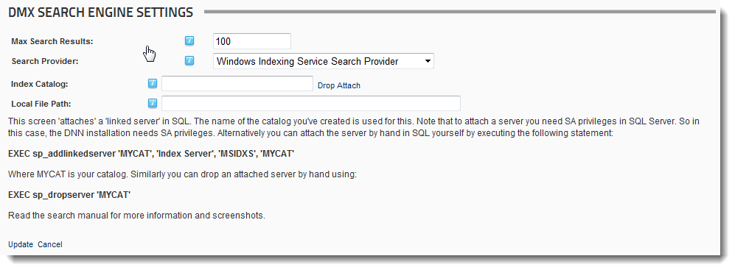
Now fill in the name of the catalog you created (e.g. DMXCAT) and click ‘Attach’. Note that the DNN installation will need sys admin privileges for this. The screen will show a red error message if this is not the case. You can attach the server directly by executing SQL in your SQL manager. The correct syntax is:
EXEC sp_addlinkedserver ‘DMXCAT’, ‘Index Server’, ‘MSIDXS’, ‘DMXCAT’ where DMXCAT is the name of your catalog. Verify the existence of the linked server in your SQL management program. In SQL Server Management Studio Express it looks like this:
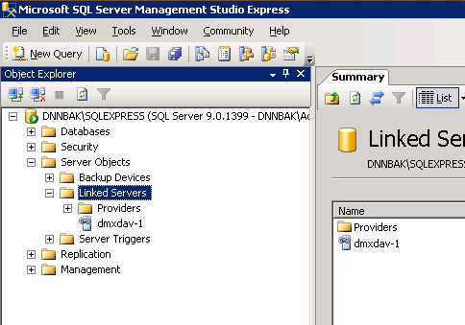

Searching DMX
Open the search window by selecting Search on the Tool menu or by pressing CONTROL-SHIFT-F on your keyboard.
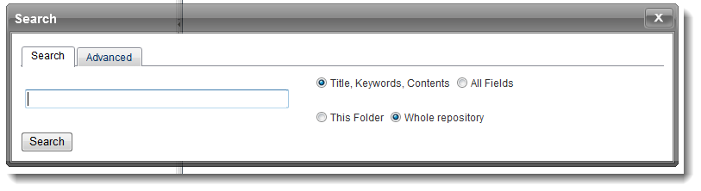
You’ll see 2 tabs on the search screen. The first tab is for a ‘quick’ search in standard fields and will be sufficient for most search queries. The second is for more advanced tuning of your query.

Scope
In the ‘quick search screen’ you can limit the scope of the search by fields and item location. ‘All Fields’ means: Title, Contents, Author, Keywords, Remarks, Original Filename and any custom attributes defined in the installation. You can also limit the search to the current folder (and subfolders) being viewed. By default this is switched on.

Advanced Search
Use advanced search to fine tune what you’re looking for.
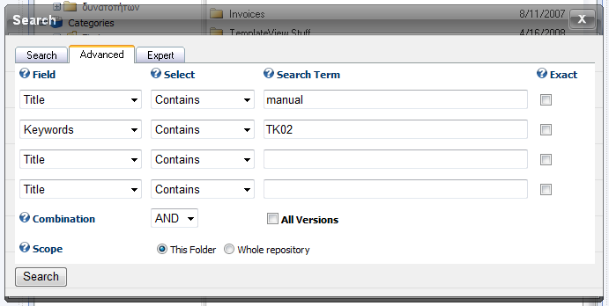
If the ‘exact’ checkbox is selected the search terms are not split into words but the whole phrase is used to match content.

Search results
Once you’ve clicked search you’ll be taken to the search results.
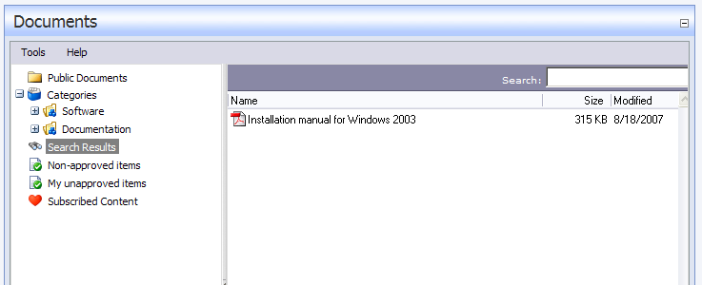
Note that the search results remain active for the current session until you search again.

Incorporating DMX Search in DNN Search
As was mentioned at the start of this document, DMX’s search is not integrated with DNN’s search engine. So is there a workaround? Well, there is the following possibility: we add something to the ‘Search Results’ page to show DMX content. Whenever a user enters a text in the DNN search box and clicks ‘Search’ the browser is redirected to the Search Results page and the search text is incorporated in the querystring. This we can leverage to search DMX and show results. DMX has a control (Search.ascx) that was designed to do this.
To use the DMX Search control on the Search Results page, you can run a script (DMX Menu: Admin > Run Script) that was designed to do this. Alternatively you can do it by hand. Add an instance of DMX to the Search Results page, open the module settings and set the default control to load to Search. That should give you the search results for DMX below the regular search results of DNN.
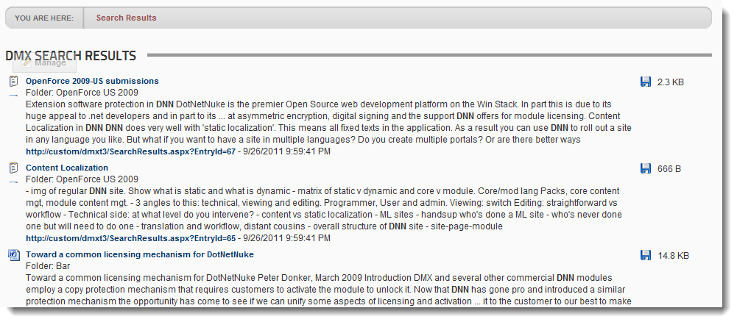
Note the Lucene search engine includes highlighting of search results which has been incorporated in the search results control of DMX.

