Synchronized Folders
Document Exchange keeps its contents in its own ‘repository’ (See also “Getting Started” manual) where files are renamed so they don’t resemble one bit the original file. The most important reasons for this are security and avoiding filename clashes. An oft heard request has been to be able to manipulate the files outside the DNN context (e.g. through FTP or a network share). The answer has always been: no. Manipulating the files ‘behind the scenes’ not only risks breaking the data integrity within the document repository, it also violates a level of security you should strive for. In DMX 5.1 we now introduce ‘Synchronized Folders’.
Synchronized folders in DMX are a special type of folder. You point them at a location on your server’s hard disk and DMX will attempt to synchronize the content there with the content in DMX. So in effect there will be two copies of your file: one in the original location and one in DMX. This allows DMX to keep full integrity of the system and also to keep versions of documents.
The challenge of any solution that opens up a back door is data integrity. In this case we need to ensure that we deal appropriately with conflicts when they arise. A conflict is when a document has been edited both on disk as well as in DMX. In the settings for the synchronized folder you specify what the synchronization engine should do in these cases.

Note: scalability
A quick note about scalability. Although the code for this part has been heavily optimized over time, we think it’s prudent to warn against overreliance on this functionality in your installation. What one needs to realize is that this runs as a scheduled task in DNN (so as a background process) and that it inevitably takes some time (especially when synchronizing with a share across a network). Setting the background task to run more often will reduce the likeliness of ‘forks’ where a document is edited on both ends. But one must not set this time to be more often than the average runtime of the complete sync task. So let’s say it takes 3 minutes to complete a check for the task, then setting it to run this task every 2 minutes is pointless. Care has been taken to make sure no 2 tasks will run at once and that an unfinished task gets completed first. But please be aware of the tradeoff and use this function wisely. You’re probably not going to be able to use this to sync Gigabytes of data over a narrow bandwidth network. We suggest you keep an eye on the task runtime (go to the history of the SyncFolderTask under Host > Schedule on your DNN menu).
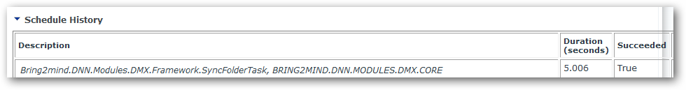

Security
Note that allowing users to browse the server’s hard disk is a security violation. For this reason the Host must decide whether he/she will allow admins to specify sync paths outside the portal home directory. The latter is the directory that is the domain of a single portal and considered owned by the portal’s admin.
In the Main Options screen the host will see the option Allow External SyncFolders. If this is set then the admin may specify folders outside the portal home directory.
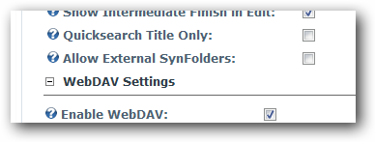
Note that as with importing content, the asp.net worker process (NETWORK SERVICE by default) must have (full) control over the content you’re going to use. So even if the admin would specify C:\Windows, it probably wouldn’t do very much as that content is normally invisible to this account.

Setting up a synchronized folder
First navigate to the folder where you want the synchronized folder to be. Select New Item:
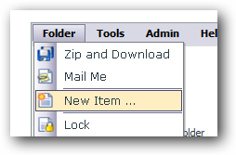
Select ‘Folder’ and click ‘Next’. Select Synchronized Folder from the dropdown menu:
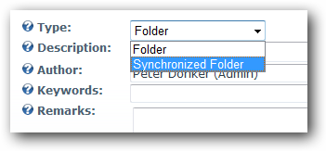
Give it a name and proceed to the next step:
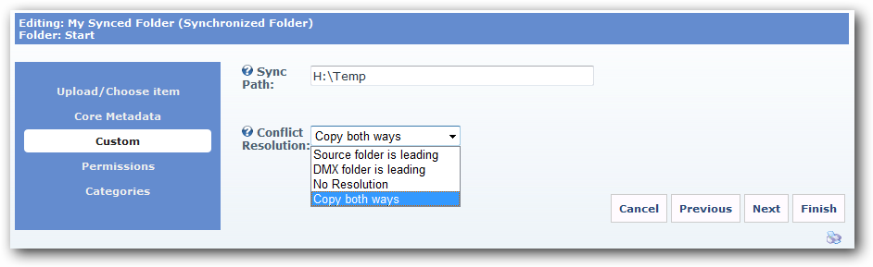
Set the path to use for synchronization and specify a conflict resolution (see above). Set permissions and click Finish. Your folder should now be set up. Right now, not much will be in it. That is because the synchronization engine runs once every so often. The host specifies this in the DNN Schedule:
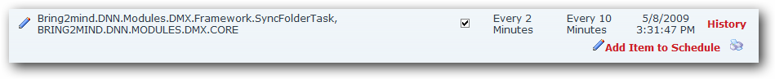
By default it is set to check every 2 minutes. But this can be changed. After it has run it should show the contents in DMX depending on the resolution chosen.

Notes about disk permissions
One of the most common issues we deal with in supporting DMX (and that is a common source of confusion in ASP.NET applications in general) is the incorrect setting of disk permissions. Any ASP.NET application works inside of a so-called Application Pool. This is a kind of container that specifies a number of boundaries like ‘how much memory is this application allowed to use’. It also includes a setting that specifies under what (user) account the ASP.NET application is running. This means that when the ASP.NET code performs a disk operation, the server sees this as so-called ‘worker process’ account. So if this account does not have permission to do what it wanted to do on the server’s hard disk, then it will be flatly refused and the ASP.NET code will be told ‘no access’.

Confusion 1: Local vs domain accounts
By default the worker process account is NETWORK SERVICE. This is a ‘local machine account’. Meaning it is like a user that was only defined on the server you’re running IIS (let’s call it the WEBSERV). As soon as it tries to perform a disk operation on another server (e.g. FILESERV) through a file share, it will present itself as ‘Hi I’m NETWORK SERVICE from WEBSERV, I’d like to access your drive D’. The FILESERV will promptly refuse this call despite the fact that it has a NETWORK SERVICE account itself. Why? Well, because it’s NETWORK SERVICE account is local, too, and is therefore not the same as the WEBSERV’s NETWORK SERVICE account. So if you want to grant access to the ASP.NET process running on WEBSERV to files on FILESERV, the worker process must run under an identity that is recognizable by FILESERV. This can be done by using a domain controller and setting up the application pool to use an identity from the domain controller. The FILESERV can now also recognize the identity of the call and check with the contents on the hard disk.

Confusion 2: Copy and move don’t do the same with permissions
In Windows, if you copy a file, it will by default inherit the permissions on the new folder. If you move a file, it will retain its old permission set. This has often led to issues in ASP.NET apps as well. If you have a folder set up with the correct permissions for synchronization (i.e. you’ve given full access to NETWORK SERVICE) you can still have surprises where content is not ‘seen’ by DNN/DMX. The reason could very well be that you moved a file into this directory and the file does not assume the NETWORK SERVICE permissions. If you experience access issues, go to the server and click on the properties of the file (and not the folder) to see if really the permissions are correctly set.

Conflict resolution
 | Source folder is leading | DMX folder is leading | No resolution | Copy both ways
Modified file found in DMX, not on source | Delete DMX file | Copy DMX file to source | Do nothing | Copy DMX file to source
Non-modified file found in DMX, not on source | Delete DMX file | Copy DMX file to source | Do nothing | Delete DMX file
Modified file found on source, not in DMX | Copy source file to DMX | Delete source file | Do nothing | Copy source file to DMX
Non-modified file found on source, not in DMX | Copy source file to DMX | Delete source file | Do nothing | Delete source file
Same file found in DMX and source | Do nothing | Do nothing | Do nothing | Do nothing
File found on source and DMX, altered on source | Create new version for DMX file using source file | Replace source file with DMX file | Do nothing | Create new version for DMX file using source file
File found on source and DMX, altered on DMX | Create new version for DMX file using source file | Replace source file with DMX file | Do nothing | Replace source file with DMX file
File found on source and DMX, altered on both | Create new version for DMX file using source file | Replace source file with DMX file | Do nothing | Split file on both sides and label DMX or SRC
Folder found on source but not in DMX | Create DMX folder | Delete source folder | Do nothing | Create DMX folder
Folder found in DMX but not on source | Delete DMX folder | Create directory on source | Do nothing | Create directory on source

