Upload Settings
Next to the ability in Document Exchange to change the edit screen, you can also change the upload component that is used by the module. ASP.NET does not have a great built in upload control.

Figure 1. Standard ASP.NET upload control
The default upload control does not provide feedback on progress and cannot handle large uploads. This is the reason that very soon third party vendors began selling custom upload controls. Bring2mind has invested in a couple of these. Because each solution has its specific advantages and disadvantages we implemented this in a way that we can keep on adding new upload controls in the future for you to choose from. DMX 6, for instance, includes a new upload control which uses Silverlight. You can access the upload settings from either the control panel or the admin menu
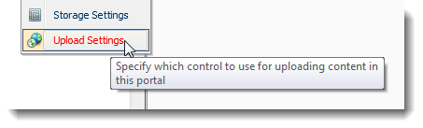
Depending on your situation you may need to switch the upload provider. We chose the Silverlight upload currently as default, but if your audience doesn’t have or want to use Silverlight there are alternatives.

Technical Backgrounder
A 101 on web uploading as this is not trivial and some customers have gotten stuck in the past. When using the default asp.net upload control the page renders with a basic HTML File input control. As you click “Next” the complete contents of the file are encoded and submitted in a request to the server. The problems start when the file is a large file. Firstly: the user does not get any feedback from the browser as the browser is unaware of the time it will take to upload the content. Secondly, and more importantly, the server will load the complete request into its memory and send it to the component that handles the request (asp.net in our case). This can cause the server to run out of memory. Finally there is a risk the server will abort the request when it thinks it is taking too long and therefore potentially blocking the server (as in a DOS attack).
The alternatives that have been programmed all rely on establishing some form of parallel communication. So instead of the web page posting back in one go, the component somehow breaks down the uploading file into chunks and uploads these one by one. These chunks upload independently of the webpage’s posting back. And these chunks all go to a specific “handler”. This is the component running on the server that knows what to do with the small chunks. After all, they are bits of single file. So the handler needs to piece these back together again and flag to the main application when the file has completed uploading where the file can be found.
The parallel communication is commonly known as Ajax calls. And, depending on the component, IIS will need to be informed where the handler can be found. This is done in the web.config. But however complex or easy this has been done, we introduce a new point of failure when we use an upload component that uses Ajax. Most issues I’ve seen when users could not get upload to work had to do with IIS not finding the upload component’s handler.

The Silverlight Upload Provider
The Silverlight Upload Provider uses Microsoft’s Silverlight to handle the upload process. There are Silverlight for all major browsers and operating systems. The advantage is the ability to program/design the UI in a very controlled fashion much like Adobe’s Flash. One thing this specific component allows, for instance, is multiple file selection and upload. The handler is a fixed path (~/DesktopModules/Bring2mind/DMX/Providers/UploadProviders/SLUploadProvider/UploadHandler.ashx) and this does not need any adjustments of the web.config.
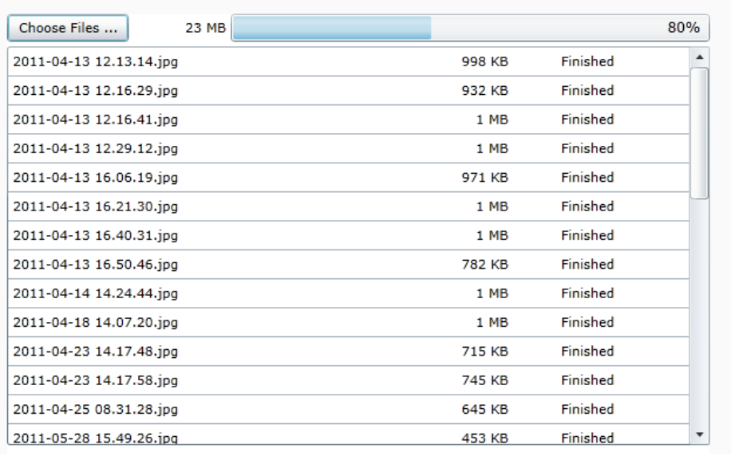
Figure 2. Silverlight Upload Control

ComponentArt (CA) Upload Provider
The CA Upload Provider is a more classic upload component relying on proprietary Javascript making Ajax callbacks to the component’s server bits. The handler needs to be registered in the web.config to make sure the Ajax calls find their way. Please go to the Web.Config Admin page of DMX to set this.
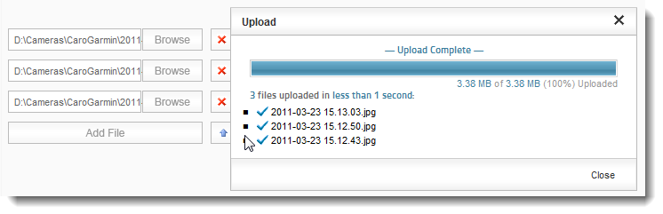
Figure 3. ComponentArt Upload control
If the handler the component needs clashes with another handler it can lead to nasty Javascript popup errors to end users when they try to upload something.
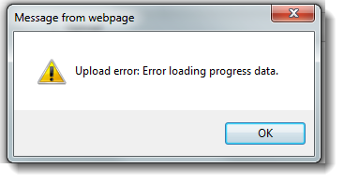
Figure 4. Javascript error indicative of missing or faulty handler

