Web.Config Configuration
Unfortunately hosting ASP.NET websites has some very technical aspects that can make or break your site. It is far more complex than hosting a bunch of html files with images. The application, as it’s called has a bunch of settings that are kept in an xml file in the root called the web.config. This configuration file governs, among others, how IIS manages the site.
Unless you are already familiar with the web.config and XML you are bound to be somewhat overwhelmed by what is inside. Although the IIS management application does its best to show the settings in a human friendly way, the sheer number of settings make it hard to work with.
DotNetNuke does not include a bit of UI to help you manage the various web.config settings. Because we have found that many customers stumble on a limited number of issues we’ve tried to abstract these settings to a configuration screen in DMX. This is the web.config configuration screen reachable through either the Admin menu or the control panel:
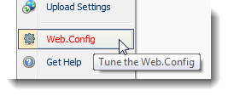
Note you need to be logged in as host to be able to see this. The screen looks like this
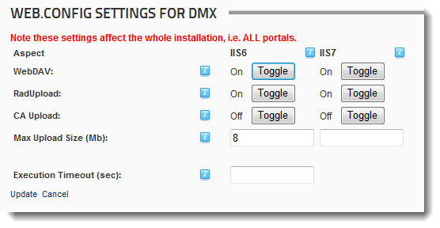
The buttons will add or remove the handlers and modules that make the 3 components (WebDAV, Telerik upload, and CA Upload) work or not. You can read more about handlers and modules here:
http://www.bring2mind.net/Company/News/tabid/155/EntryId/94/Handlers.aspx
http://www.bring2mind.net/Company/News/tabid/155/EntryId/95/-Http-Modules.aspx
Note you should use this screen prior to uninstalling and clicking the remove buttons to clean up the web.config.

IIS6
Use this column if you’re running IIS 6 (Windows 2003, XP).

IIS7
Use this column when running under IIS 7+ (Windows 2008, Vista, 7).
Note: you might still have to verify the order of the handlers in IIS. See installation manual for more details and the links above.

Max upload size
Set the maximum upload size here. Note that in IIS 7 the machine.config (to which DNN/DMX have no access) must allow the site to override this setting. Note that ALL upload components are forced to respect this parameter. So it is important you set this to reflect the maximum expected file size.
Note that by default this is 8 Mb which is not a very large amount to be able to send.

Execution Timeout
The execution timeout is important when using the Aspnet upload control. It is subjected to the amount of seconds specified here. After this the upload will be broken off. When left unaltered this is 90 seconds. This means that after a minute and a half a request is terminated by the server. During upgrades of your DNN installation and modules we suggest you increase this value to something like 300 seconds to give the server ample time to do all that is required. For daily use keep in mind that this setting is available to you. Normally 90 seconds should suffice but if you experience timeouts (recognize them by the “Server Unavailable” error message in the browser) you should increase this value.

