**CRIME AND CRIMINAL RECORD MANAGEMENT SYSTEM**

**APPLICATION DEVELOPMENT – III**

**IMPLEMENTATION PHASE**

*Submitted in partial fulfilment for the award of the degree*

*Of*

**Master of Technology**

***In***

**Information Technology**

*By*

**VIKAS**

**(15MIN0759)**



**School of Information Technology and Engineering**

March, 2019

**Table of Contents**

VIKAS 1

1. INTRODUCTION 3

1.1 PURPOSE 3

1.2 SCOPE 4

1.3 OVERVIEW 4

1.4 REFERENCES MATERIAL 5

1.5 DEFINITIONS AND ACRONYMS 6

2. OVERALL DESCRIPTION 7

2.1 DECOMPOSITION DESCRIPTION 7

2.2 DETAIL MODULE DECOMPOSITION 7

2.3 PRODUCT FUNCTIONS 9

2.4 GENERAL CONSTRAINTS 11

2.5 ASSUMPTIONS AND DEPENDENCIES 11

2.6 REQUIREMENTS MATRIX 12

ARCHITECTURAL DESIGN 12

3.1.1 User Interfaces 12

3.1.2 Hardware Interfaces 13

3.1.3 Software Interfaces 13

3.1.4 Communications Interfaces 13

3.1.5 Memory constraints 13

3.1.6 Operations 13

2.7 DATA DICTIONARY 14

3. SAMPLE CODE 16

4. SCREENSHOTS 50

4.1 OVERVIEW OF SCREENS 51

4.2 SCREEN IMAGES 51

1. Appendix 63

# INTRODUCTION

The project is aimed to develop a Crime and Criminal Record management system for maintaining computerized records of all the FIR or any type of complaints against crime or any criminal information. The system is a desktop application that can be accessed throughout the police department.

This system can be used as an application for the crime and criminal record of the police department to manage the records of different activity related to first information report. In such desktop, Crime and Criminal Record management system, we will manage all such activities (like registration of the complaint updating information, search of particulars and viewing of the respective reports of crimes) that will save time, manpower.

This system will provide better perspective for the enhancement of organization regarding to quality and transparency.

# PURPOSE

The purpose of this document is to provide the software design specifications for the Crime and Criminal Record management system.

Crime and Criminal Record management system is a system used to report crimes. This project is mainly useful for Police Departments. This system will help to manage all the activities in a police Department using computers. Currently all the works are done manually, by computerizing all the activities inside a Police Department, they can be managed easily and effectively.

The police Departments in the country are, today, virtually unconnected islands. Thanks to telephones and wireless, and especially thanks to mobile telephones, there is voice connectivity between the police Department and senior police officers, but that is about all. There is no system of data storage, data sharing and accessing data. There is no system under which one police Department can talk to another directly. There is no record of crimes or criminals that can be accessed by a Department House Officer, except the manual records relating to that police Department. The goals of the system are to facilitate collection, storage, retrieval, analysis, transfer and sharing of data and information at the police Department and between the police Department and the State Headquarters and the Central Police Organizations

# SCOPE

Software scope is the first software project management activity it describes the data and controls the processed, function, performance, constraints, interfaces and reliability. Function described in the statement of scope are evaluated and in some cases refined to provide more details prior to beginning of estimation because both cost and schedule estimates are functionally oriented, some degree of decomposition is often useful constraint identify the limit placed on the software by external hardware, available memory or other existing systems. Performance considerations in encompass processing and response time requirements.

The system ‘Crime and Criminal Record Management system’ will be a Reporting application that will be used for automating the manual process of registering different case in police department. This system will manage the details of all the crime which gets registered in police department. The system provides an interface to store the crime details of criminals or prisoners and allows the user to search and view records. The system should have a login. System should support for Data Entry module for Nominal Roll, Case register for each prisoner entering in the prison.

## **1.3 OVERVIEW**

**Section 2: General description-** This section provides a general description of the project. It includes a context diagram regarding the product perspective and an overview of the functions and features. It also describes the types of users for the project, general constraints, and all assumptions regarding the project.

**Section 3: Specification Requirement**- External Interfaces: This section provides the external interface requirements of the product. It includes the users, hardware, software, and interface specifications.

**Section 4: Design Requirement-** Design Constraints: This section specifies the specific design constraints of the product.

At its core, the system should offer the following basic functionalities:

* The system requests that the administrator to enter his/her name, password.
* The administrator enters his/her name, password.
* The system validates the entered name, password, logs the actor into the system.
* The administrator maintains the record of information of various FIR, crimes and related objects.
* If in the basic flow, the actor enters an invalid name, password, the system displays an error message. The actor can return to the beginning of the basic flow.

## **1.4 REFERENCES MATERIAL**

**Books:**

* Programming in Visual Basic 6.0: Books- By Julia Cose Bradley
* A Complete Guide to Programming in Visual Basic
* Visual Basic 6: The Complete Reference
* A Complete Visual Basic 6 Training Course: How to Program: Package
* Advanced Programming Using Visual Basic: Version 6.0
* Visual Basic 6 Programming Black Book

**Websites**

* [http://office.microsoft.com/en-us/access-help/what-s-new-in-microsoft-office-](http://office.microsoft.com/en-us/access-help/what-s-new-in-microsoft-office-%20) [access-2007-HA010024185.aspx](http://office.microsoft.com/en-us/access-help/what-s-new-in-microsoft-office-access-2007-HA010024185.aspx)
* <http://en.wikipedia.org/wiki/VB6>
* www.mahapolice.gov.in
* Google, URL: <http://www.google.co.in>
* <http://en.wikipedia.org/wiki/Database_normalization>

## **DEFINITIONS AND ACRONYMS**

* ASP.NET - is an open source server-side Web application framework designed for Web development to produce dynamic Web pages. It was developed by Microsoft to allow programmers to build dynamic web sites, web applications and web services.
* ADO.NET - is a set of computer software components that programmers can use to access data and data services from the database. It is a part of the base class library that is included with the Microsoft .NET Framework.
* Internet Information Services (IIS, formerly Internet Information Server) - is an extensible web server created by Microsoft for use with Windows NT family. IIS supports HTTP, HTTPS, FTP, FTPS, SMTP and NNTP.

|  |  |
| --- | --- |
| **Word or Acronym** | **Definition** |
| SRS | Software Requirement Specification |
| FIR | First Information Report |
| SCAMPI | Standard CMMI Appraisal Method for Process Improvement |
| CMMI | Capability Maturity Model Integration |
| ERD | Entity Relationship Diagram |
| VB | Visual Basic |
| ADODB | ActiveX Data Object - Database |
| RAM | Read Only Memory |
| STD | State Transition Diagram |
| SDLC | Software Development Life Cycle |

# 2. OVERALL DESCRIPTION

## **2.1 DECOMPOSITION DESCRIPTION**

The **CFS** can be differentiated into the following users:

* User Module.
* Admin Module.

**Constraints**

The system will be a reporting application that will be used for automating the manual process of registering different case in police department. This system will manage the details of all the crime which register themselves in police department. The system provides an interface to store the crime details of criminals or prisoners and allows the user to search and view records. The system should have a login. System should support for Data Entry module for Nominal Roll, Case register for each prisoner entering in the prison.

## **2.2 DETAIL MODULE DECOMPOSITION**

**Admin**

Administrators can monitor the whole system. Setting up the rules of the site and monitoring the people all over the site without any disputes.

|  |  |  |
| --- | --- | --- |
| **Requirement ID** | **Description** | **Priority** |
| AD-001 | The administrator should be able to authorize users with valid details | P1 |
| AD-002 | The admin should be able to see all the Users ,Criminals etc | P1 |
| AD-003 | The admin should be able to see all the user details | P1 |
| AD-004 | The admin should be able to add or remove the user | P1 |

**User**

|  |  |  |
| --- | --- | --- |
| **Requirement ID** | **Description** | **Priority** |
| CD-001 | The user should be able to register as New | P1 |
| CD-002 | The user should be able to edit his\her profile & view it. | P1 |
| CD-003 | The admin should be able to see all the user details | P1 |
| CD-004 | The admin should be able to give confirmation for user registration | P1 |

**Others**

**Authentication & Authorization**

|  |  |  |
| --- | --- | --- |
| **Requirement ID** | **Description** | **Priority** |
| AA-001 | All users logging into the system should be authenticated using a unique login-id and password (operations to be supported based on type of user) | P1 |

**Exit Handlers**

|  |  |  |
| --- | --- | --- |
| **Requirement ID** | **Description** | **Priority** |
| EX-001 | The application should handle clean exits (close all open files, descriptors, etc) | P1 |

## **2.3 PRODUCT FUNCTIONS**

The major features of Crime and Criminal Record Management System is that it has different users which has their own roles and responsibilities. One of the user roles is shown in below System flow diagram:

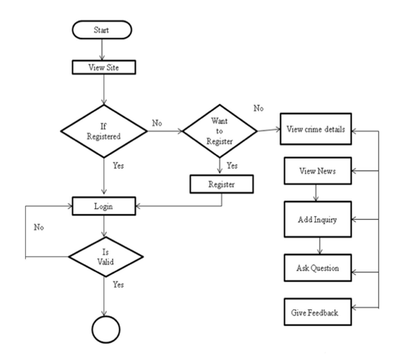

* Accepting crimes information correctly.
* Storing the correct records in the database.
* Displaying correct information on selecting view option.
* Displaying current status of FIR of all crimes.
* Accepting the updated information from user and administrator.
* Storing the updated record in database to make it consistent.
* Deletion privilege to administrator only.

**Login:**

This includes Administrator and User login. There will be a username and password to login into the system to use all the facilities.

**Complaint registration:**

This module helps to register the details about the crime. This is done by entering some details, such as incident details, Victim details, crime details etc

**View complaint status:**

This module allows us to view the status of the complaint that you have registered earlier.

**Criminal register management:**

Here we can have the facility to view the details of the criminals. The administrator can add new criminal’s details and save it in a database. This can be done by entering details such as criminal number, age, occupation, type of crime etc.

**FIR management:**

This module allows viewing the First Information Report of all the crimes that took place at recent years. The administrator can enter FIR information and save it in a database.

**Managing postmortem details:**

This module helps to view the postmortem details of a person. The details such as date of death cause of death, name of the doctor etc.

**Prisoner register management:**

This module helps the administrator as well as the user to store, view and manage the details of the past and present prisoners.

**Manage the list of most wanted criminals:**

This is an additional feature added to this Software, which helps us to make a quick search about the most wanted criminals. This helps to always keep track of and identify a person quickly, who is a most wanted criminal.

## **2.4 GENERAL CONSTRAINTS**

* The software system will run on a VB 6.0 software and Microsoft Office Access.
* All code shall be written in VB.
* Text files shall be used for all data storage and reporting.
* The system shall be developed using the methodology specified in Section3
* The documentation and code shall be in accordance with the W3C Standards.

## **2.5 ASSUMPTIONS AND DEPENDENCIES**

* User is related to certain branch of police Department
* FIR information is correct.
* User can fill the registration form.
* The System should run on all VB/Microsoft Office Access supported Browsers.
* The Clinic intranet should be up and upto speed of 128 kbps

## **2.6 REQUIREMENTS MATRIX**

|  |  |  |  |
| --- | --- | --- | --- |
| **Request Id#** | **Module Name** | **Applicable Roles** | **Description** |
| Req_01 | 1. User Maintenance  2. Role Management  3. Component Maintenance | Administrator | Administrator can perform these following tasks:   * User Maintenance * Role Management * Component Maintenance |
| Req_02 | Upload/Update details for FIR, Criminal Records. | Users | Employee can perform these following tasks:   * Add new Complain * Update existing Criminal Record. * Check maintenance activities of Records |
| Req_03 | Search FIR, Complain, Criminal | Users | User can perform these following tasks:   * Search Records as per requirement FIR |

# ARCHITECTURAL DESIGN

# 3.1.1 User Interfaces

1. Front-end software:     VB 6.0
2. Back-end software:      Microsoft Office Access 2007

# 3.1.2 Hardware Interfaces

1. Processor : Pentium Dual Core Processor with 1.7 GHz Clock speed
2. Hard Disk : 80 GB or more
3. RAM : 512 MB or more

# 3.1.3 Software Interfaces

1. Operating System : WINDOWS XP/7/8/10
2. User Interface : VB 6.0
3. Programming Language : VB 6.0
4. Web Applications : ADODB
5. Database : Microsoft Office Access

# 3.1.4 Communications Interfaces

* This project supports all types of web browsers.
* We are using simple forms for the User details viewing Complaints details and FIR details, Mortem detail entries.

# 3.1.5 Memory constraints

* At least 64 MB RAM and 2 GB space on hard disk will be required for running the application

# 3.1.6 Operations

* Viewing
* Addition (by administrator only)
* Updating (by administrator only)
* Deletion (by administrator only

## **2.7 DATA DICTIONARY**

**Table: Admin Login**

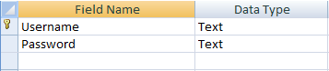

**Table: Criminal Register**

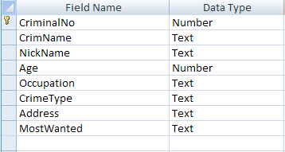

**Table: Prisoners Register**

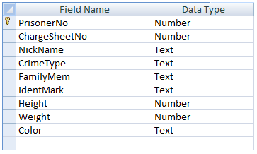

**Table: Most Wanted**

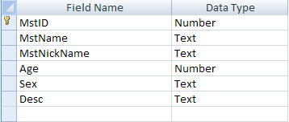

**Table: FIR**

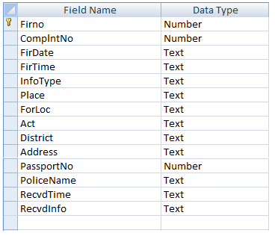

**Table: Charge Sheet**

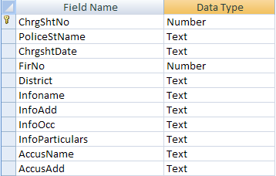

**Table: Complaint Registration**

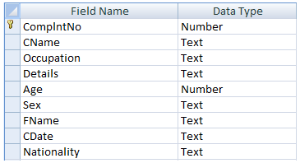

**Table: Complaint Status**

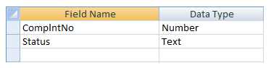

**Table: Post Mortem**

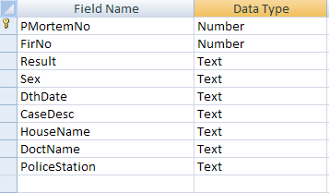

# 3. SAMPLE CODE

**Coding:Login form**

Private Sub cmdAdminLog_Click()

Set rs = con.Execute("Select * from AdminLogin where Username='" + txtUname.Text + "' and Password='" + txtPass.Text + "'")

If (Not rs.EOF) Then

MsgBox "Login Success", vbInformation, "Crime and Criminal Record Management System" frmMDI.mnuLogoff.Enabled = True frmMDI.mnuAdminAddU.Enabled = True frmMDI.mnuAdminDelU.Enabled = True frmMDI.mnuActiv.Enabled = True frmMDI.mnuLogin.Enabled = False frmMDI.mnuAdminAddComSt.Enabled = True frmMDI.mnuActivReg.Enabled = True frmMDI.mnuActivComp.Enabled = True frmMDI.mnuActivRpt.Enabled = True frmMDI.mnusearch.Enabled = True

Unload Me Else

MsgBox "Failure", vbCritical, "Crime and Criminal Record Management System"

End If 'rs.Close Unload Me End Sub

Private Sub cmdCancel_Click() Unload Me

End Sub

Private Sub cmdUserLog_Click()

Set rs = con.Execute("Select * from UserLogin where Username='" + txtUname.Text + "' and Password='" + txtPass.Text + "'")

If (Not rs.EOF) Then

MsgBox "Login Success", vbInformation, "Crime and Criminal Record Management System" frmMDI.mnuLogoff.Enabled = True frmMDI.mnuLogin.Enabled = False frmMDI.mnuActiv.Enabled = True frmMDI.mnuActivReg.Enabled = True frmMDI.mnuActivComp.Enabled = True frmMDI.mnuActivRpt.Enabled = True frmMDI.mnusearch.Enabled = True

Unload Me Else

MsgBox "Failure", vbCritical, "Crime and Criminal Record Management System"

End If 'rs.Close

End Sub

Private Sub Form_Load() connectdb

End Sub

Private Sub Form_Unload(Cancel As Integer) con.Close

End Sub

**Coding: Main form**

Private Sub MDIForm_Load() mnuLogoff.Enabled = False mnuAdminAddU.Enabled = False mnuAdminDelU.Enabled = False mnuActiv.Enabled = False mnuAdminAddComSt.Enabled = False mnuActivReg.Enabled = False mnuActivComp.Enabled = False mnuActivRpt.Enabled = False mnusearch.Enabled = False

DataEnvironment1.Connection1.ConnectionString = "Provider=Microsoft.Jet.OLEDB.4.0;Data Source=" & App.Path & "\crimefile.mdb;Persist Security Info=False"

End Sub

Private Sub mnuActivChrgSht_Click() Load frmChargeSheet frmChargeSheet.Show

End Sub

Private Sub mnuActivCompReg_Click() Load frmCompltReg frmCompltReg.Show

End Sub

Private Sub mnuActivCompStat_Click() Load frmCompStatus frmCompStatus.Show

End Sub

Private Sub mnuActivCsHist_Click() Load frmHistSheet frmHistSheet.Show

End Sub

Private Sub mnuActivFir_Click()

Load frmFIR frmFIR.Show End Sub

Private Sub mnuActivRegCrim_Click() Load frmCriminalRegister frmCriminalRegister.Show

End Sub

Private Sub mnuActivRegPost_Click() Load frmPostmortem frmPostmortem.Show

End Sub

Private Sub mnuActivRegPris_Click() Load frmPrisonerReg frmPrisonerReg.Show

End Sub

Private Sub mnuActivRptCrim_Click() Load DataReportCrimeRpt DataReportCrimeRpt.Show

End Sub

Private Sub mnuActivRptMst_Click() Load DataReportMostWanted DataReportMostWanted.Show

End Sub

Private Sub mnuActRegMst_Click() Load frmMostWanted frmMostWanted.ShowEnd Sub

Private Sub mnuAdminAddComSt_Click() Load frmAddCompltStatus frmAddCompltStatus.Show

End Sub

Private Sub mnuAdminAddU_Click()

Load frmAddUser frmAddUser.Show End Sub

Private Sub mnuAdminDelU_Click() Load frmDeleteUser frmDeleteUser.Show

End Sub

Private Sub mnucriminal_Click() Load searchCriminal searchCriminal.Show

End Sub

Private Sub mnuexit_Click() Unload Me

End Sub

Private Sub mnuLogin_Click() Load frmLogin frmLogin.Show

End Sub

Private Sub mnuLogoff_Click() mnuLogoff.Enabled = False mnuAdminAddU.Enabled = False mnuAdminDelU.Enabled = False mnuActiv.Enabled = False mnuLogin.Enabled = True mnuAdminAddComSt.Enabled = False mnuActivReg.Enabled = False mnuActivComp.Enabled = False mnuActivRpt.Enabled = False mnusearch.Enabled = False

End Sub

Private Sub mnuprisioner_Click() Load SearchPrisoner SearchPrisoner.Show

End Sub

Private Sub mnuRptFIR_Click() Load frmFIRrpt frmFIRrpt.Show

End Sub

Private Sub mnuRptMortem_Click() Load frmPMortemRpt

frmPMortemRpt.Sho

End Sub

**Add New User:**

Private Sub Form_Load() connectdb

End Sub

Private Sub cmdAdd_Click()

Set rs = con.Execute("select * from UserLogin where Username='" + txtUsername.Text + "' and Password='" + txtPassword.Text + "'")

If (Not rs.EOF) Then

MsgBox "Sorry!! User already exists. Try another username", vbCritical, "Crime and Criminal Record Management System" txtPassword.Text = ""

txtUsername.Text = "" txtUsername.SetFocus

Else

con.Execute ("insert into UserLogin values('" + txtUsername.Text + "','" + txtPassword.Text + "')")

MsgBox "User added sucessfully", vbInformation, "Crime and Criminal Record Management System" txtPassword.Text = ""

txtUsername.Text = "" txtUsername.SetFocus

End If End Sub

Private Sub cmdCancel_Click() Unload Me

End Sub

**Delete User:**

Private Sub cmdCancel_Click() Unload Me

End Sub

Private Sub cmdDelete_Click()

con.Execute ("delete from UserLogin where Username='" + cmbUsername.Text + "'") MsgBox "User deleted sucessfully!!", vbInformation, "CFS"

cmbUsername.Text = "" End Sub

Private Sub Form_Load() connectdb

Set rs = con.Execute("select * from UserLogin")

While (Not rs.EOF) cmbUsername.AddItem rs(0) rs.MoveNext

Wend End Sub

**Add** **Complaint** **Status:**

Private Sub cmdCancel_Click() Unload Me

End Sub

Private Sub cmdViewStat_Click()

Set rs = con.Execute("select * from ComplntStatus where ComplntNo=" + cmbComplntNo.Text

+ "")

If (Not rs.EOF) Then

txtDetails.Text = rs(1) End If

End Sub

Private Sub Form_Load() connectdb

Set rs = con.Execute("select distinct(ComplntNo) from ComplntStatus") While (Not rs.EOF)

cmbComplntNo.AddItem rs(0) rs.MoveNext

Wend rs.Close End Sub

**Criminal Registration:**

Private Sub cmdCancel_Click() Unload Me

End Sub

Private Sub cmdSave_Click()

If (optyes.Value = True) Then x = "Yes"

Else

x = "No" End If

If (txtAddress.Text = "" Or txtAge.Text = "" Or txtCrimeType.Text = "" Or txtName.Text = "" Or txtNickName.Text = "" Or txtOccupation.Text = "") Then

MsgBox "Missing Fields!!,Please fill up all", vbInformation, "Crime and Criminal Record Management System" ElseIf (Not IsNumeric(txtAge.Text)) Then

MsgBox "Age should be numeric"

Else

con.Execute ("insert into CriminalReg values(" + txtCriminalNo.Text + _ ",'" + txtName.Text + "','" + txtNickName.Text + "'," + txtAge.Text + _

",'" + txtOccupation.Text + "','" + txtCrimeType.Text + "','" + txtAddress.Text + _ "','" + x + "')")

MsgBox "Record Added successfully", vbInformation, "Crime and Criminal Record Management System" txtCriminalNo.Text = txtCriminalNo.Text + 1

txtAddress.Text = "" txtAge.Text = "" txtCrimeType.Text = "" txtName.Text = "" txtNickName.Text = "" txtOccupation.Text = "" txtName.SetFocus

End If End Sub

Private Sub Form_Load() connectdb

Set rs = con.Execute("select max(CriminalNo) from CriminalReg")

If (Not rs.EOF) Then cnt = rs(0)

If (cnt = 0) Then cnt = 1

Else

cnt = cnt + 1 End If

txtCriminalNo.Text = cnt End If

End Sub

**Prisoner Registration:**

Private Sub Command1_Click()

If (txtChgrNo.Text = "" Or txtColor.Text = "" Or txtCrmType.Text = "" Or txtFamMem.Text = "" Or txtHt.Text = "" Or txtIdenMark.Text = "" Or txtNikName.Text = "" Or txtPrisNo.Text = "" Or txtWt.Text = "") Then

MsgBox "Missing Fields!!, Please fill up all", vbInformation, "Crime and Criminal Record Management System" Else

If ((Not IsNumeric(txtChgrNo.Text)) Or (Not IsNumeric(txtHt.Text)) Or (Not IsNumeric(txtWt.Text))) Then

MsgBox "Some of the values entered are not matching, Please check numbers are entered correctly", vbCritical, "Crime and Criminal Record Management System"

Else

Set rs = con.Execute("select * from PrisonersReg where ChargeSheetNo=" + txtChgrNo.Text + "")

If (Not rs.EOF) Then

MsgBox "Charge Sheet Number Already Exist, Please try another number", vbCritical, "Crime and Criminal Record Management System"

txtChgrNo.Text = "" txtChgrNo.SetFocus

Else

con.Execute ("insert into PrisonersReg values(" + txtPrisNo.Text + "," + txtChgrNo.Text + ",'"

+ txtNikName.Text + _

"','" + txtCrmType.Text + "','" + txtFamMem.Text + "','" + txtIdenMark.Text + "'," + txtHt.Text + _

"," + txtWt.Text + ",'" + txtColor.Text + "')")

con.Execute ("insert into prisonersTemp values(" + txtPrisNo.Text + ",'No')") MsgBox "Record Added Sucessfully", vbInformation, "CFS"

txtPrisNo.Text = txtPrisNo.Text + 1 txtChgrNo.Text = ""txtColor.Text = "" txtCrmType.Text = "" txtFamMem.Text = "" txtHt.Text = "" txtIdenMark.Text = "" txtNikName.Text = "" txtWt.Text = "" txtChgrNo.SetFocus

End If End If

End If End Sub

Private Sub Command2_Click() Unload Me

End Sub

**Post Mortem:**

Private Sub cmdSave_Click()

If (txtDate.Text = "" Or txtDesc.Text = "" Or txtDoctName.Text = "" Or cmbFirrNo.Text = "" Or txtHouseName.Text = "" Or txtPoliceSt.Text = "" Or txtPostNo.Text = "" Or txtRslt.Text = "") Then

MsgBox "Missing Fields!! Please Fill Up all", vbInformation, "Crime and Criminal Record Management System"

Else

Set rs = con.Execute("select * from Postmortem where FirNo=" + cmbFirrNo.Text + "") If (Not rs.EOF) Then

MsgBox "Duplication is not allowded, Please try another FIR number", vbCritical, "Crime and Criminal Record Management System"

cmbFirrNo.SetFocus

Else

con.Execute ("insert into postmortem values(" + txtPostNo.Text + "," + cmbFirrNo.Text + ",'" + txtRslt.Text + _

"','" + cmbSex.Text + "','" + txtDate.Text + "','" + txtDesc.Text + _

"','" + txtHouseName.Text + "','" + txtDoctName.Text + "','" + txtPoliceSt.Text + "')") MsgBox "Record Added Sucessfully", vbInformation, "Crime and Criminal Record Management System" txtPostNo.Text = txtPostNo + 1

txtDate.Text = "" txtDesc.Text = "" txtDoctName.Text = "" txtHouseName.Text = "" txtPoliceSt.Text = "" txtRslt.Text = ""

End If End If End Sub

Private Sub Form_Load() connectdb

cmbSex.Text = "Male"

Set rs = con.Execute("select max(PMortemNo) from Postmortem")

If (Not rs.EOF) Then cnt = rs(0)

If (cnt = 0) Then cnt = 1

Else

cnt = cnt + 1 End If

txtPostNo.Text = cnt End If

rs.Close

Set rs = con.Execute("select Firno from FIR") While (Not rs.EOF)

cmbFirrNo.AddItem rs(0) rs.MoveNextWend rs.Close End Sub

**CODING**:

Dim x As Integer

Private Sub cmdShRpt_Click() x = cmbMno.Text

If (DataEnvironment1.rsCommand3.State = 1) Then

DataEnvironment1.rsCommand3.Close Else

DataEnvironment1.Command3 (x) Load DataReportmortem DataReportmortem.Show

End If

End Sub

Private Sub Command1_Click() Unload Me

End Sub

Private Sub Form_Load() connectdb

Set rs = con.Execute("select PMortemNo from Postmortem") While (Not rs.EOF)

cmbMno.AddItem rs(0) rs.MoveNext

Wend End Sub

**Mostwanted:**

Dim x As Integer

Private Sub cmdCancel_Click() Unload Me

End Sub

Private Sub cmdSave_Click()

If (txtAge.Text = "" Or txtDesc.Text = "" Or txtName.Text = "" Or txtNickName.Text = "") Then

MsgBox "Missing fields!!, Please fill up all", vbInformation, "Crime and Criminal Record Management System" Else

Set rs = con.Execute("select count(*) from MostWanted")

If (Not rs.EOF) Then x = rs(0)

If (x = 0) Then x = 1

Else

x = x + 1 End If

txthd.Text = x End If

If (Not IsNumeric(txtAge.Text)) Then

MsgBox "Age should be number", vbInformation, "Crime File Syatem" txtAge.Text = ""

txtAge.SetFocus Else

con.Execute ("insert into MostWanted values(" + txthd.Text + ",'" + txtName.Text + _

"','" + txtNickName.Text + "'," + txtAge.Text + ",'" + cmbSex.Text + "','" + txtDesc.Text + "')")

MsgBox "Record Added Successfully", vbInformation, "Crime and Criminal Record Management System" txtName.Text = ""

txtAge.Text = "" txtDesc.Text = "" txtNickName.Text =""

txtName.SetFocus

End If End If End Sub

Private Sub Form_Load() connectdb

End Sub

FIR:

Private Sub cmdCancel_Click() Unload Me

End Sub

Private Sub cmdSave_Click()

If (txtDate.Text = "" Or txtDistrict.Text = "" Or txtFirNo.Text = "" Or txtInfoAdd.Text = "" Or txtInfoRcd.Text = "" Or _

txtPassNo.Text = "" Or txtPlaceOcc.Text = "" Or txtPolice.Text = "" Or txtRcdTime.Text = ""

Or txtTime.Text = "" Or _

txtTypInfo.Text = "" Or cmbComplantno.Text = "") Then

MsgBox "Missing Fields!!", vbInformation, "Crime and Criminal Record Management System" Else

Set rs = con.Execute("select * from FIR where FirNo=" + txtFirNo.Text + " or ComplntNo="

+ cmbComplantno.Text + "") If (Not rs.EOF) Then

MsgBox "Sorry!! FIR Or Complaint Number already exists. Try another number", vbCritical, "CFS"

txtFirNo.Text = "" txtFirNo.SetFocus

Else

Dim t1, t2, t3 As String

t1 = txtTime.Text + cmbT1.Text 't2 = txtTime2.Text + cmbT2.Text

t3 = txtRcdTime.Text + cmbT3.Text

If ((Not IsNumeric(txtPassNo.Text)) Or (Not IsNumeric(txtFirNo.Text))) Then MsgBox "Please check the number fields", vbInformation, "Crime and Criminal Record Management System" 'txtPassNo.Text = ""

'txtPassNo.SetFocus Else

con.Execute ("insert into FIR values(" + txtFirNo.Text + "," + cmbComplantno.Text + _ ",'" + txtDate.Text + "','" + t1 + "','" + txtTypInfo.Text + _

"','" + txtPlaceOcc.Text + "','" + cmbForLoc.Text + "','" + cmbAct.Text + _

"','" + txtDistrict.Text + "','" + txtInfoAdd.Text + "'," + txtPassNo.Text + ",'" + txtPolice.Text + _

"','" + t3 + "','" + txtInfoRcd.Text + "')")

con.Execute ("UPDATE ComplntTemp set Status='Yes' where ComplntNo=" + cmbComplantno.Text + "")

MsgBox "Record Added", vbInformation, "Crime and Criminal Record Management System" txtDate.Text = ""

txtDistrict.Text = "" txtFirNo.Text = "" txtInfoAdd.Text = "" txtInfoRcd.Text = "" txtPassNo.Text = "" txtPlaceOcc.Text = "" txtPolice.Text = "" txtRcdTime.Text = "" txtTime.Text = "" txtTypInfo.Text = "" txtFirNo.SetFocus End If

End If End If

End Sub

Private Sub Form_Load() cmbT1.Text = "AM" cmbT3.Text = "AM" cmbAct.Text = "Murder" cmbForLoc.Text = "Foreign" connectdb

Set rs = con.Execute("Select ComplntNo from ComplntTemp where Status='No'") While (Not rs.EOF)

cmbComplantno.AddItem rs(0) rs.MoveNext

Wend End Sub

FIR Report :

Dim x As Integer

Private Sub cmdShRpt_Click() x = cmbMno.Text

If (DataEnvironment1.rsCommand4.State = 1) Then DataEnvironment1.rsCommand4.Close

Else

DataEnvironment1.Command4 (x) Load DataReportFIR DataReportFIR.Show

End If End Sub

Private Sub Command1_Click() Unload Me

End Sub

Private Sub Form_Load() connectdb

Set rs = con.Execute("select Firno from FIR") While (Not rs.EOF)

cmbMno.AddItem rs(0) rs.MoveNext

Wend End Sub

Charge Sheet:

Dim cnt As Integer Dim x As Control

Private Sub cmdBack_Click() Frame4.Visible = False Frame3.Visible = True

End Sub

Private Sub cmdBack2_Click() Frame2.Visible = False Frame1.Visible = True

End Sub

Private Sub cmdBack3_Click() Frame3.Visible = False Frame2.Visible = True

End Sub

Private Sub cmdFinish_Click()

If (txtWitnAdd.Text = "" Or txtWitnName.Text = "" Or txtWitnOcc.Text = "") Then MsgBox "Missing Fields!!, Please fill up all", vbInformation, "Crime and Criminal Record Management System"

Else

Set rs = con.Execute("select * from ChargeSheet where FirNo=" + cmbFirNo.Text + "") If (Not rs.EOF) Then

MsgBox "Dupplication is not allowed, Please try another FIR number", vbCritical, "Crime and Criminal Record Management System"

Frame4.Visible = False Frame1.Visible = True cmbFirNo.SetFocus

Else

con.Execute ("insert into ChargeSheet values(" + txtChrgNo.Text + ",'" + txtPstatName.Text + "','" + txtDate.Text + _

"'," + cmbFirNo.Text + ",'" + txtDist.Text + "','" + txtInfoName.Text + _ "','" + txtInfoAdd.Text + "','" + txtInfoOcc.Text + "','" + txtInfoPart.Text + _

"','" + txtAccuName.Text + "','" + txtAccuAdd.Text + "','" + cmbAccuSex.Text + _ "'," + txtAccuAge.Text + ",'" + txtAccuOcc.Text + "','" + cmbAccuStat.Text + _ "','" + txtAccuAct.Text + "','" + txtWitnName.Text + "','" + txtWitnAdd.Text + _ "','" + txtWitnOcc.Text + "')")

MsgBox "Record Added Successfully!!", vbInformation, "Crime and Criminal Record Management System" Frame4.Visible = False

Frame1.Visible = True txtChrgNo.Text = txtChrgNo.Text + 1

' For Each x In Me.Controls ' If (x = TextBox) Then

' x.Text = "" ' End If

'Next End If

End If End Sub

Private Sub cmdNext1_Click()

If (txtChrgNo.Text = "" Or txtPstatName.Text = "" Or txtDate.Text = "" Or cmbFirNo.Text = "" Or txtDist.Text = "") Then

MsgBox "Missing Fields!!, Please fill up all", vbInformation, "Crime and Criminal Record Management System" Else

Frame1.Visible = False Frame2.Visible = True

End If End Sub

Private Sub cmdNext2_Click()

If (txtInfoAdd.Text = "" Or txtInfoName.Text = "" Or txtInfoOcc.Text = "" Or txtInfoPart.Text = "") Then

MsgBox "Missing Fields!!, Please fill up all", vbInformation, "Crime and Criminal Record Management System" Else

Frame2.Visible = False Frame3.Visible = True

End If End Sub

Private Sub cmdNext3_Click()

If (txtAccuAct.Text = "" Or txtAccuAdd.Text = "" Or txtAccuAge.Text = "" Or txtAccuName.Text = "" Or txtAccuOcc.Text = "") Then

MsgBox "Missing Fields!!, Please fill up all", vbInformation, "Crime and Criminal Record Management System" Else

Frame3.Visible = False Frame4.Visible = True

End If End Sub

Private Sub Form_Load() Frame1.Visible = True Frame2.Visible = False Frame3.Visible = False Frame4.Visible = False connectdb

Set rs = con.Execute("select max(ChrgShtNo) from ChargeSheet")

If (Not rs.EOF) Then cnt = rs(0)

If (cnt = 0) Then cnt = 1

Else

cnt = cnt + 1 End If

txtChrgNo.Text = cnt End If

rs.Close

Set rs = con.Execute("select Firno from FIR") While (Not rs.EOF)

cmbFirNo.AddItem rs(0) rs.MoveNext

Wend

rs Close

End Sub

Complaint status:

Private Sub cmdCancel_Click() Unload Me

End Sub

Private Sub cmdViewStat_Click()

Set rs = con.Execute("select * from ComplntStatus where ComplntNo=" + cmbComplntNo.Text

+ "")

If (Not rs.EOF) Then txtDetails.Text = rs(1)

End If End Sub

Private Sub Form_Load() connectdb

Set rs = con.Execute("select distinct(ComplntNo) from ComplntStatus") While (Not rs.EOF)

cmbComplntNo.AddItem rs(0) rs.MoveNext

Wend rs.Close End Sub

Dim con As ADODB.Connection Dim rec As ADODB.Recordset

Private Sub Command1_Click() Dim strcon As String

Dim strcom As String

Strcon = "Provider=Microsoft.ACE.OLEDB.12.0;Data Source=D:\CrimeFile\CrimeFile\CrimeFile\Crime and Criminal Record Management System\crimefile.mdb;Persist Security Info=False"

Set con = New ADODB.Connection con.Open strcon

Set rec = New ADODB.Recordset

strcom = "select * from CriminalReg where CrimName='" & Text1.Text & "'" rec.Open strcom, con, adCmdText

If rec.EOF Then

MsgBox "record not present" Else: MsgBox "record is present" Text2.Text = rec.Fields(0) Text3.Text = rec.Fields(1) Text4.Text = rec.Fields(2) Text5.Text = rec.Fields(3) Text6.Text = rec.Fields(4) Text7.Text = rec.Fields(5) Text8.Text = rec.Fields(6) Text9.Text = rec.Fields(7)

End If End Sub

Private Sub exit_Click() Unload Me

End Sub

Search Prisoner:

Dim con As ADODB.Connection Dim rec As ADODB.Recordset Private Sub Command1_Click()

Dim strcon As String Dim strcom As String

Strcon ="Provider=Microsoft.ACE.OLEDB.12.0;Data Source=D:\CrimeFile\CrimeFile\CrimeFile\Crime and Criminal Record Management System\crimefile.mdb;Persist Security Info=False"

Set con = New ADODB.Connection con.Open strcon

Set rec = New ADODB.Recordset

strcom = "select * from PrisonersReg where PrisonerNo=" & Combo1.Text If Combo1.Text = "" Then

MsgBox "record not present"

Else

rec.Open strcom, con, adCmdText If rec.EOF Then

MsgBox "record not present" Else

MsgBox "record is present"

Text1.Text = rec.Fields(0) Text2.Text = rec.Fields(1) Text3.Text = rec.Fields(2) Text4.Text = rec.Fields(3) Text5.Text = rec.Fields(4) Text6.Text = rec.Fields(5) Text7.Text = rec.Fields(6) Text8.Text = rec.Fields(7) Text9.Text = rec.Fields(8)

End Sub

Private Sub exit_Click() Unload Me

End Sub

# 4. SCREENSHOTS

## **4.1 OVERVIEW OF SCREENS**

**Login Page:**

This will provide the access only to the authorized user. Hence provide the security to the application & allows only authorized user to view the contents.

**Management Page:**

This will provide platform for all management related activities

**Enquiry Page:**

This is used to ask queries to management.

## **4.2 SCREEN IMAGES**

**Progress:**

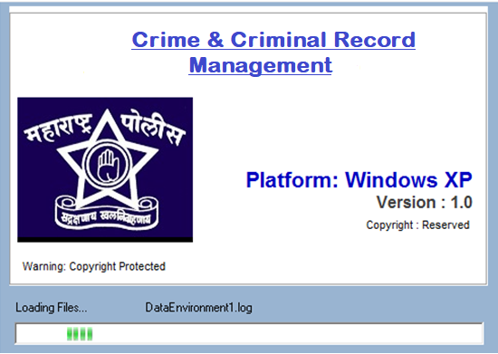

**Login Form:**

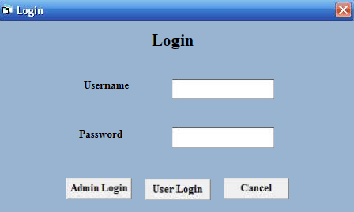

**Add New User:**

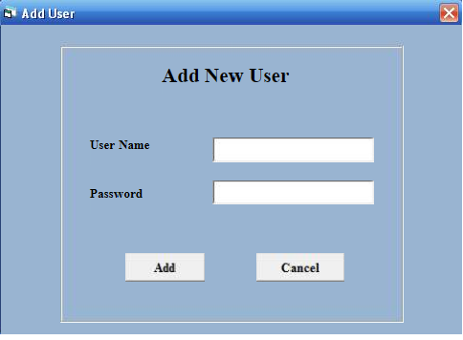

**Delete User:**

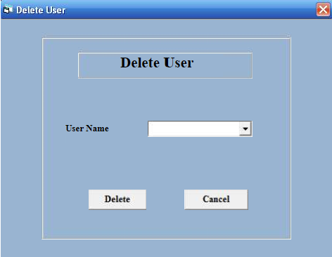

**Criminal Register:**

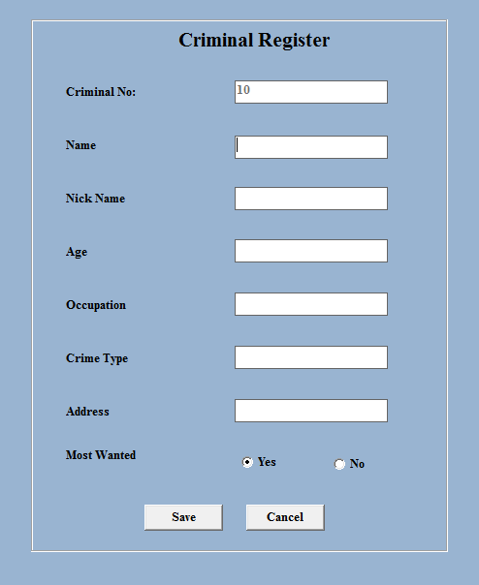

**Prisoner Register:**

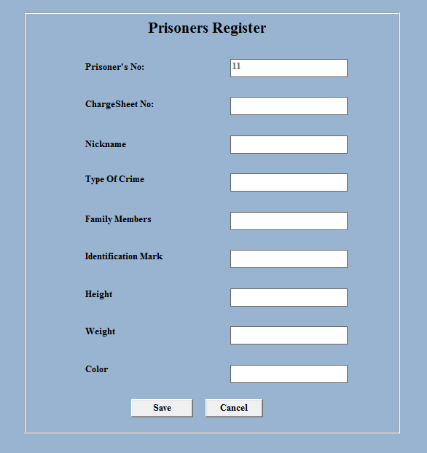

**Most Wanted:**

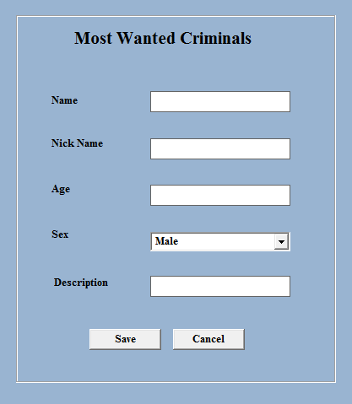

**Post Mortem:**

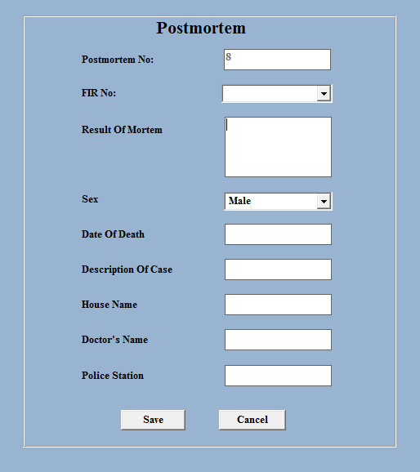

**FIR:**

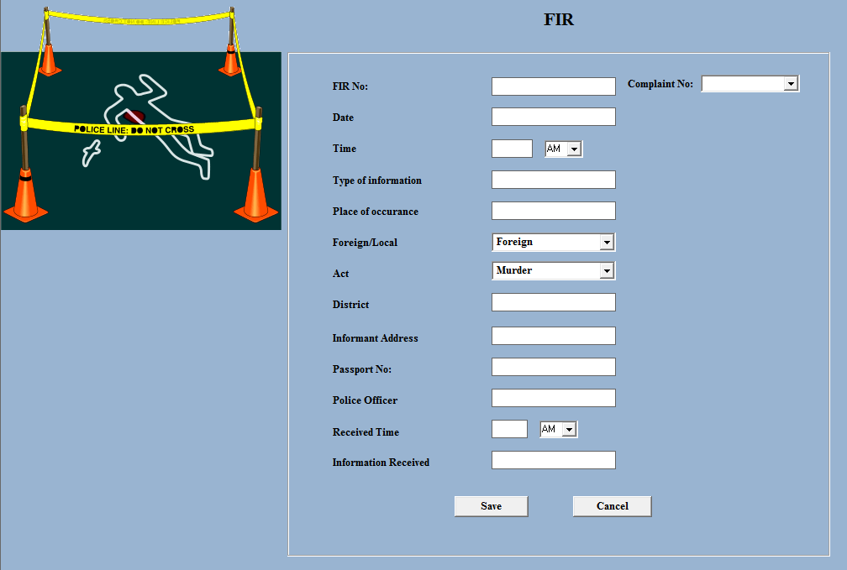

**Charge Sheet:**

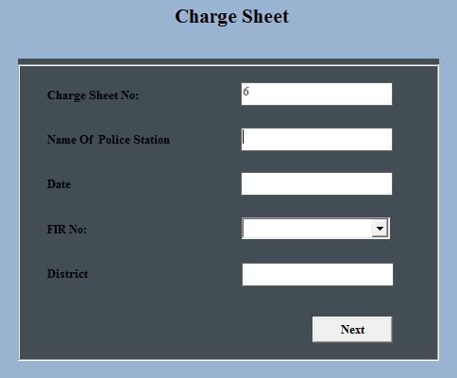

**Complaint Register:**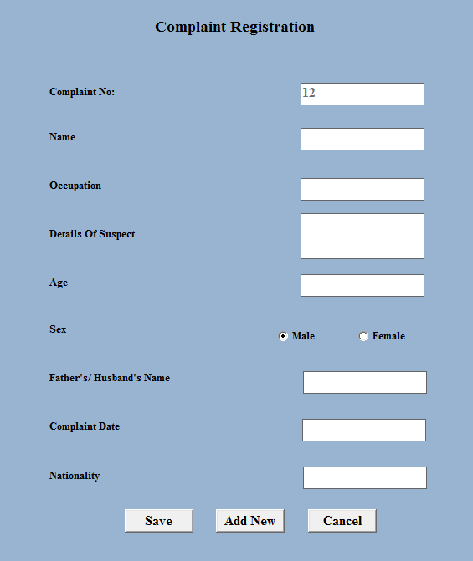

**Criminal Register Report:**

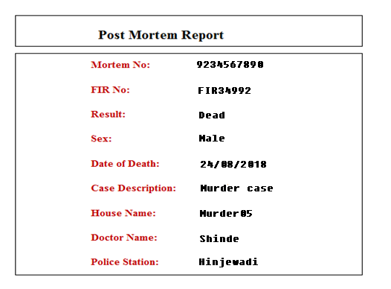

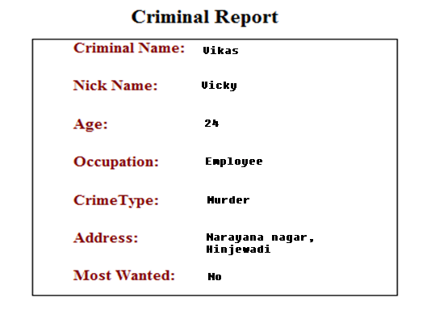

**FIR Report**

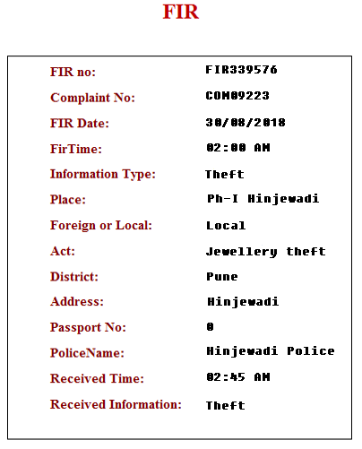

# Appendix

In my future version of this system I would like to add some following features in my project:

* 1. Synchronization of database will be made more efficient.
  2. Some more reports will be added to make administrator task easier.
  3. Database access in network will be made more efficient.
  4. Online chat window with the Police dept. will be get added to site.
  5. Online case tracking.

There are many such things that can be added in the future to enhance and better use of website. This future enhancement is mainly concerned with paying all bills online.

The other thing that is planned to add in future is advertisements on the website. These advertisements can be for cable operators or classes or paper distributors