**CRIME AND CRIMINAL RECORD MANAGEMENT SYSTEM**

**APPLICATION DEVELOPMENT – IV**

**TESTING AND DOCUMENTATION**

*Submitted in partial fulfilment for the award of the degree*

*Of*

**Master of Technology**

***in***

**Information Technology**

*By*

**VIKAS**

**(15MIN0759)**



**School of Information Technology and Engineering**

March, 2019

**Table of Contents**

VIKAS 1

1. TESTING 2

1.1 TEST PLAN 3

1.2 TEST CASES AND RESULT 10

**1.2.1 SYSTEM TEST CASES** 10

1.3 UNIT TESTING RESULT SAMPLE 13

1.4 BUG CHECKLIST 15

# 1. TESTING

## **1.1 TEST PLAN**

1. **INTRODUCTION**

This document will address the different standards that will apply to the unit, integration and system testing of the specified application. The design, development and testing of these reports will be based on clients “Crime and Criminal Record Management System” project. Throughout the testing process we will be applying the test documentation specifications described in the IEEE Standard 829-1983 for Software Test Documentation.

1. **OBJECTIVE**

Objective of Test plan is to define the various Testing strategies and testing tools used for complete Testing life cycle of this project.

1. **SCOPE**

The document mainly targets the GUI testing and validating data in report output as per Requirements Specifications provided by Client.

3.1 Functions to be tested.

1. GUI

2. Reports Output/Data

3. Report Setup/Locations

* 1. Functions not to be tested.

No other than mentioned above in section 3.1

1. **REFERENCES**

• Guidelines provided by Client and their clients.

• Refer Guideline location: \\Companyname\ProjectName\DesignGuidelines

1. **TESTING PROCESS OVERVIEW**

**5.1 TEST PROCESS**

Test process followed by QA will be categorized in to 2 ways

• Process to be followed when sufficient time is available for QA

• Process to be followed when sufficient time is not available for QA

1. Process to be followed when sufficient time is available for QA Understanding Requirements:

• Requirement specifications will be sent by client.

• Understanding of requirements will be done by QA along with

• Respective lead and developer and queries are raised if any.

• Raised queries will be sent by lead to client.

• Response to queries will be sent by client.

**Preparing Test Cases:**

QA will be preparing test cases based on the requirement specifications. This will cover all scenarios for requirements.

**Preparing Test Matrix:**

QA will be preparing test matrix which maps test cases to respective requirement. This will ensure the coverage for requirements.

**Reviewing test cases and matrix:**

• Peer review will be conducted for test cases and test matrix by senior QA member in QA team

• In certain cases, for e.g. complex requirements, lead's help will be taken for conducting review

• Any comments or suggestions on test cases and test coverage will be provided by reviewer respective Author of Test Case and Test Matrix

• Suggestions or improvements will be re-worked by author and will be send for approval

• Re-worked improvements will be reviewed and approved by reviewer

**Creating Test Data:**

Test data will be created by respective QA on client's developments/test site based on scenarios and Test cases.

**Executing Test Cases:**

• Test cases will be executed by respective QA on client's development/test site based on designed scenarios, test cases and Test data.

• Test result (Actual Result, Pass/Fail) will updated in test case document

**Defect Logging and Reporting:**

QA will be logging the defect/bugs in Bugzilla bug tracking tool found during execution of test cases and will assigned the Bug id generated by Bugzilla to respective test cases document. After this, QA will inform respective developer about the defect/bugs.

**Retesting and Regression Testing:**

Retesting for fixed bugs will be done by respective QA once it is resolved by respective developer and bug/defect status will be updated accordingly. In certain cases, regression testing will be done if required.

**Deployment/Delivery:**

• Once all bugs/defect reported after complete testing is fixed and no other bugs are found, report will be deployed to client’s test site by developer.

• Once round of testing will be done by QA on client’s test site if required

• Report will be delivered along with sample output by email to respective lead and report group.

• QA will be submitting the filled hard copy of delivery slip to respective developer

• Once lead gets the hard copy of delivery slip filled by QA and developer, he will send he report delivery email to Client.

* 1. **DATA CREATION FOR TESTING**

QA will create test data on development site for scenarios based on client’s requirements specifications.

**6. TEST STRATERGY**

**6.1 TESTING TYPES BLACK BOX TESTING:**

It is some time called behavioral testing or Partition testing. This kind of testing focuses on the functional requirements of the software. It enables one to derive sets of input conditions that that will fully exercise all functional requirements for a program.

**GUI Testing:** GUI testing will includes testing the UI part of website. It covers users Report format, look and feel, error messages, spelling mistakes, GUI guideline violations.

**Integration Testing:** Integration testing is systematic technique for constructing the program structure while conducting test to uncover errors associated with interacting. In Report, integration testing includes the testing Report from respective location(s).

**Functional Testing:** Functional testing is carried out in order to find out unexpected behavior of the report. The characteristic of functional testing is to provide correctness, reliability, testability and accuracy of the report output/data.

**System Testing:** System testing of software is testing conducted on a complete, integrated system to evaluate the system's compliance with its specified requirements.

**Performance Testing:** Performance testing will be done by Client

**Stress Testing:** Stress testing will be done by Client.

Security and Access control testing

• Not Applicable as this is already done by Client.

**User acceptance testing:** The purpose behind user acceptance testing is to conform that system is developed according to the specified user requirements and is ready for operational use. Acceptance testing is carried out at two levels – Alpha and Beta Testing. User acceptance testing (UAT) will be done at the Client.

**Alpha testing:** The alpha test is conducted at the developer's site by client.

The modules involved in this project are:

* + - Login for user and admin
    - Complaint registration
    - View complaint status
    - Criminal register management
    - FIR Management
    - Case History Details management
    - Managing Post-mortem details
    - Prisoners register management
    - Manage list about most wanted criminals

###### **LOGIN**

This includes Administrator and User login. There will be a username and password to login into the system to use all the facilities.

**COMPLAINT REGISTRATION**

This module helps to register the details about the crime. This is done by entering some details, such as incident details, Victim details, crime details etc

**VIEW COMPLAINT STATUS**

This module allows us to view the status of the complaint that you have registered earlier.

**CRIMINAL REGISTER MANAGEMENT**

Here we can have the facility to view the details of the criminals. The administrator can add new criminal’s details and save it in a database. This can be done by entering details such as criminal number, age, occupation, type of crime etc.

**FIR MANGEMENT**

This module allows viewing the First Information Report of all the crimes that took place at recent years. The administrator can enter FIR information and save it in a database.

**CASE HISTORY DETAILS MANAGEMENT**

Here we can view the details of the case, date of occurrence, the type of crime and place of occurrence etc…

**MANAGING POSTMORTEM DETAILS**

This module helps to view the post-mortem details of a person. The details such as date of death cause of death, name of the doctor etc.

**PRISONER REGISTER MANGEMENT**

This module helps the administrator as well as the user to store, view and manage the details of the past and present prisoners.

###### **MANAGE THE LIST OF MOST WANTED CRIMINALS**

This is an additional feature added to this Software, which helps us to make a quick search about the most wanted criminals. This helps to always keep track of and identify a person quickly, who is a most wanted criminal.

## **1.2 TEST CASES AND RESULT**

### **1.2.1 SYSTEM TEST CASES**

Test cases used in this project are:

###### **Test case 1:**

**Purpose**: The main purpose of this test case to inform the administrator if he did not write the correct username or password.

**Pre condition and inputs:** The precondition for this test case is if the administrator write the correct username and password, then only user will be able to access the application.

**Results**: if username and password is not correct, then an error mess will be displayed for incorrect password/ username.

###### **Test case 2:**

**Purpose**: The main purpose of this test case to inform the administrator if any exception occurs while updating information on the application. The format should be correct while entering the details for the criminal or prisoner name or fir information.

**Precondition and inputs:** The precondition of this test case is there are validations given in the form which indicates the correct format of the data .The user has to fill the all required field.

**Results**: lf data format entered is not correct or any field is blank, then no account will be generated.

|  |  |  |  |  |  |
| --- | --- | --- | --- | --- | --- |
| **Test ID** | **Test Step Name** | **Description** | **Expected results** | **Actual Result** | **Remarks** |
| TC01 | Successful User/Admin Login | User/Admin open the login page, and enter Correct user ID and Password | User/Admin Should Be able to Login | Login Successful | PASS |
| TC02 | Unsuccessful User /Admin login | User/Admin open the login page, and enter incorrect user ID and Password | User should not be able to log in successfully | Login unsuccessful | PASS |
| TC03 | Add Records successfully | Admin should be able to add Criminal details | Admin should enter Criminal details in validated form | Criminal detail added successfully | PASS |
| TC04 | Add Criminal unsuccessfully | Admin should not be able to add Criminal details | Admin should not enter Criminal detail in validated form | Criminal detail cannot be added successfully, Alert message displayed | PASS |
| TC05 | Admin able to search FIR,Criminal,Prisioner etc Records | It should have valid value for search criteria, ref table | Admin should enter search criteria | Required details are searched and displayed. | PASS |
| TC06 | Admin can add FIR details | Admin can add FIR details in database through application | FIR details has been entered | FIR details has been added successfully | PASS |
| TC07 | User can Search the status of FIR. | User can Search their FIR Status. | User should be able to view their FIR Details | User is able to View their FIR Details | PASS |
| TC08 | Search With Valid FIR No | 1. Navigate to the main page.  2. Launch the FIR Search Screen | The Data of Each FIR should appear in the Grid i.e. name, number, CNIC etc. | The Data of Each FIR appearing with details | PASS |
| TC09 | Delete Button | 1. Launch the Application.  2. Select the FIR No.  3. Click Crime Delete Button. | The Record must be deleted with proper message via dialog box. | The record not deleted. | FAIL |
| TC010 | Search With Invalid FIR No | 1. Navigate to the main page.  2. Launch the FIR Search Screen | The Data of FIR should not appear in the Grid | The Data of FIR not appearing in the Grid | PASS |

**Report:**

|  |  |  |  |  |  |
| --- | --- | --- | --- | --- | --- |
| **Test ID** | **Test Step Name** | **Description** | **Expected results** | **Actual Result** | **Remarks** |
|  | When you click Reports Menu Item | Click Reports Menu Item | The system will display the report form(view) | Successful | PASS |
|  | when you click on specific text | Click on specific text | Corresponding report will be displayed | Successful | PASS |

## **1.3 UNIT TESTING RESULT SAMPLE**

**Login Screen**

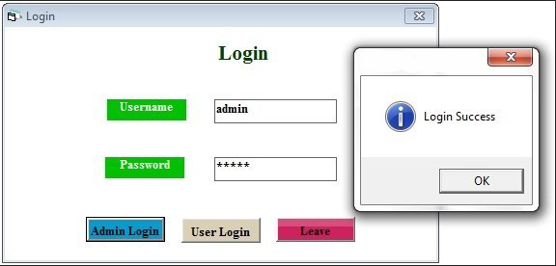

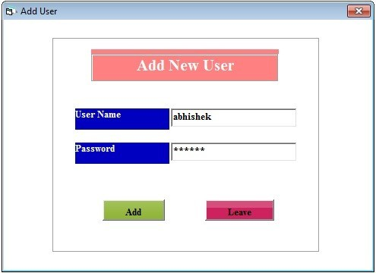**Add New User:**

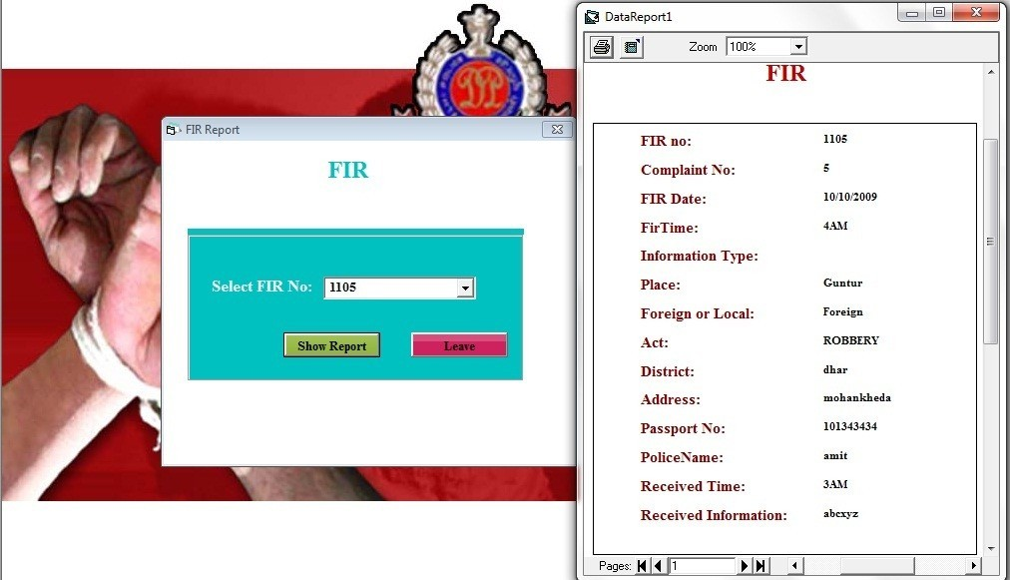**Search FIR:**

**Delete User**

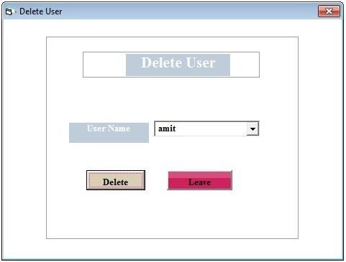

## 1.4 BUG CHECKLIST

|  |  |  |  |
| --- | --- | --- | --- |
| Bug-ID | Bug Description | Bug/Enhancement (B or E) | Status updated in Bugzilla? (Y/N) |
| 22481 | validation on modify page | B | Y |
| 22895 | implement session on all pages | E | Y |
| 22488 | validation on modify driver page | B | Y |