MY NOTES
Paul T. Bergman
11/04/21
Table of Contents
1. Data Types 3
2. Leap Seconds 4
3. Greek Alphabet 5
4. Military Phonetic Alphabet 6
5. Metric Powers 7
6. Midas Time Key Words 8
7. Midas Ephemeris Key Words 9
8. Sets 10
9. Sequence 11
10. Sampling 12
11. Mean 13
12. Standard Deviation 14
13. Root Mean Square (RMS) 15
14. Calculus Example 16
15. Partial Differential Calculus - Part One 17
16. Partial Differential Calculus - Part Two 18
17. Concerning or i 19
18. Sine, Cosine, Tangent 20
19. Angle Sum and Angle Difference 21
20. Trigonometry Behind Superheterodyne 22
21. Rotation Counter Clockwise Around X Axis 23
22. Rotation Counter Clockwise Around Y Axis 24
23. Rotation Counter Clockwise Around Z Axis 25
24. Taylor Series for e^{x} , sin(x), and cos(x) 26
25. Taylor Series and e^{ix} = cos(x) + sin(x) · i 27
26. Hyperbola 28
27. Regular Expressions 29
28. Cross Product 30
29. Golden Ratio 31
30. Polynomials 32
31. Linear Spline 33
32. Quadratic spline 34
33. Cubic Spline 36
34. Doppler for electromagnet waves 38
35. Significant Figures 39
36. Angle Sum and Angle Difference 40
37. Linear Constant Coefficient Difference Equation 41
38. Fourier and Laplace 42
39. Discrete form of Fourier and Laplace 43

Data Types

Type | Minimum Value | Maximum Value
RINT08 | -128 | +127
RINT16 | -32768 | +32767
RINT32 | -2147483648 | +2147483647
RINT64 | -9223372036854775808 | +09223372036854775807

Type, Minimum Value, Maximum Value
RXNT08, 0, +255
RXNT16, 0, +65535
RXNT32, 0, +4294967295
RXNT64, 0, +18446744073709551615

Every 10th of a nano second for the last 29 years can be accounted for using RINT64.

9223372036854775807/60/60/24/365.25/1000/1000/1000/10 =
29.22710230453132

Every 10th of a nano second for the last 58 years can be accounted for using RXNT64.

18446744073709551615/60/60/24/365.25/1000/1000/1000/10 =
58.454204609062643

Leap Seconds
Epoch 1900 (J1900)
2272060800 10 # 1 Jan 1972
2287785600 11 # 1 Jul 1972
2303683200 12 # 1 Jan 1973
2335219200 13 # 1 Jan 1974
2366755200 14 # 1 Jan 1975
2398291200 15 # 1 Jan 1976
2429913600 16 # 1 Jan 1977
2461449600 17 # 1 Jan 1978
2492985600 18 # 1 Jan 1979
2524521600 19 # 1 Jan 1980
2571782400 20 # 1 Jul 1981
2603318400 21 # 1 Jul 1982
2634854400 22 # 1 Jul 1983
2698012800 23 # 1 Jul 1985
2776982400 24 # 1 Jan 1988
2840140800 25 # 1 Jan 1990
2871676800 26 # 1 Jan 1991
2918937600 27 # 1 Jul 1992
2950473600 28 # 1 Jul 1993
2982009600 29 # 1 Jul 1994
3029443200 30 # 1 Jan 1996
3076704000 31 # 1 Jul 1997
3124137600 32 # 1 Jan 1999
3345062400 33 # 1 Jan 2006
3439756800 34 # 1 Jan 2009
3550089600 35 # 1 Jul 2012
3644697600 36 # 1 Jul 2015
3692217600 37 # 1 Jan 2017

https://www.ietf.org/timezones/data/leap-seconds.list

Greek Alphabet

Name | Lowercase | Uppercase
Alpha | α | A
Beta | β | B
Gamma | γ | Γ
Delta | δ | ∆
Epsilon | ε | E
Zeta | ζ | Z
Eta | η | H
Theta | θ | Θ
Iota | ι | I
Kappa | κ | K
Lambda | λ | Λ
Mu | μ | M
Nu | ν | N
Xi | ξ | Ξ
Omicron | o | O
Pi | π | Π
Rho | ρ | P
Sigma | σ | Σ
Tau | τ | T
Upsilon | υ | Υ
Phi | φ | Φ
Chi | χ | X
Psi | ψ | Ψ
Omega | ω | Ω

Military Phonetic Alphabet

Type | Minimum Value
A | ALPHA
B | BRAVO
C | CHARLIE
D | DELTA
E | ECHO
F | FOX TROT
G | GOLF
H | HOTEL
I | INDIA
J | JULIET
K | KILO
L | LIMA
M | MIKE
N | NOVEMBER
O | OSCAR
P | PAPA
Q | QUEBEC
R | ROMEO
S | SIERRA
T | TANGO
U | UNIFORM
V | VICTOR
W | WHISKEY
X | X-RAY
Y | YANKEE
Z | ZULU

Military.com. ”Military Phonetic Alphabet.” Military.com. Accessed February 01, 2019.
https://www.military.com/join-armed-forces/guide-to-the-military-phonetic-alphabet.html.

Metric Powers

Name | Letter | Number | Power
Yotta | Y | 1 000 000 000 000 000 000 000 000 | 10⁺²⁴
Zetta | Z | 1 000 000 000 000 000 000 000 | 10⁺²¹
Exa | E | 1 000 000 000 000 000 000 | 10⁺¹⁸
Peta | P | 1 000 000 000 000 000 | 10⁺¹⁵
Tera | T | 1 000 000 000 000 | 10⁺¹²
Giga | G | 1 000 000 000 | 10⁺⁹
Mega | M | 1 000 000 | 10⁺⁶
Kilo | k | 1 000 | 10⁺³
Hecto | h | 1 00 | 10⁺²
Deka | da | 10 | 10⁺¹
Deci | d | 0.1 | 10⁻¹
Centi | c | 0.01 | 10⁻²
Milli | m | 0.001 | 10⁻³
Micro | μ | 0.000 001 | 10⁻⁶
Nano | n | 0.000 000 001 | 10⁻⁹
Pico | p | 0.000 000 000 001 | 10⁻¹²
Fernto | f | 0.000 000 000 000 001 | 10⁻¹⁵
Atto | a | 0.000 000 000 000 000 001 | 10⁻¹⁸
Zepto | z | 0.000 000 000 000 000 000 001 | 10⁻²¹
Yocto | y | 0.000 000 000 000 000 000 000 001 | 10⁻²⁴

Midas Time Key Words

TIME DELTA
The length, in seconds, of each integer time count, used to convert all time values stored with a unit code of
counts (32) into seconds. See 1.9 for additional details. Example: “1e-10”

TIME EPOCH
The file epoch stored as an ISO-8601 ASCII string. This defines time zero for all times stored in the file. See
1.9 for additional details. Example: “2008-03-15T00:00:00”

TIMETAG.OFFSET
An array of offsets that describes the offset in elements to the start of each block in the file.

TIMETAG.TIME
An array of times that describes the time of each block in the file. The units of this keyword match the units of the other times on the file as explained in 1.9, Time.

1MHz sample rate for 86400 seconds 86 400 000 000 80 Gigabytes
1GHz sample rate for 86400 seconds 86 400 000 000 000 78 Terabytes
1THz sample rate for 86400 seconds 86 400 000 000 000 000 76 Petabytes
RINT64 maximum 09 223 372 036 854 775 807
timecode/time=n afile
Time tags the file with current time + adds TC_PREC to keywords
The 64-bit integer specifying the start time of the collect will have unit code of counts
(32) and a value of 4481946150000000000, indicating the number of 100-picosecond
clock ticks between January 1, 1994 (epoch) and 1030:15 on March 15, 2008.

3.1.1.14 time-code
The timecode field specifies the epoch time for file data, in seconds since 1 January 1950 (see 1.5 for details).
This epoch is the zero point for the first sample in the file (xstart for Type 1000, ystart for Type 2000, rstart
for Types 3000 and 6000, and tstart for Type 5000). It is stored in a single 64-bit floating point number,
representing the epoch time down to microsecond resolution. Precision time with sub-microsecond resolution
(down to the picosecond) for the first sample can be obtained by adding the appropriate xstart value to
timecode and adjusting by the value of the main header keyword TC PREC ; see section 3.4.1.5. For example,
the start time for a Type 1000 file is: start time = timecode + T C P REC + xstart. Changes to TC PREC
may be required if the value of timecode is ever changed.
6.1

Reference
Platinum BLUE Data Exchange Format Standard Volume 1. Page 30. [3]
Midas BLUE File Format. Page 20,21. [1]

Midas Ephemeris Key Words

EPH.TIME
Array of times at which each ephemeral point is valid in the standard Platinum time format implied by the TIME EPOCH and TIME DELTA keywords. The EPH.TIME keyword is an array of times used to index each of the other ephemeral keywords. The other keywords each consist of an array of values representing one component (x, y, z) of one of the derivatives (position, velocity, acceleration) of the position vector with each element in the array corresponding to the time at the same element in EPH.TIME.

EPH ACC.X X components of the collector acceleration in an ECEF coordinate system.
EPH ACC.Y Y components of the collector acceleration in an ECEF coordinate system.
EPH ACC.Z Z components of the collector acceleration in an ECEF coordinate system.
EPH POS.X X components of the collector position in an ECEF coordinate system.
EPH POS.Y Y components of the collector position in an ECEF coordinate system.
EPH POS.Z Z components of the collector position in an ECEF coordinate system.
EPH VEL.X X components of the collector velocity in an ECEF coordinate system.
EPH VEL.Y Y components of the collector velocity in an ECEF coordinate system.
EPH VEL.Z Z components of the collector velocity in an ECEF coordinate system.

Reference
Platinum BLUE Data Exchange Format Standard Volume 1 Page 30. [3]
Platinum BLUE Data Exchange Format Statement. Page 15,16. [4]

Sets

Different types of number sets.

Natural Numbers:
$$N=\{0,1,2,3,4,5,...,∞\}$$

Integer Numbers:
$$Z=\{-∞,...,-3,-2,-1,0,+1,+2,+3,...,+∞\}$$

Rational Numbers:
$Q=\{-∞,...,+∞\}$, Does not include Irrational numbers like π.

Real Numbers:
$R=\{-∞,...,+∞\}$, Does not include imaginary numbers like $\sqrt{-1}$.

Complex Numbers C = {. . . ummm, ya . . .}

Sequence
A sequence of numbers x, where n is the nth element, can be represented as:
x = {x[n]},

Where n is an element of the set of integers
ℤ = {-∞, …, -3, -2, -1, 0, +1, +2, +3, …, +∞}

Reference
Alan V. Oppenheim and Ronald W. Schafer, page 9.[2]

Sampling
For sampling some continuous analog signal x_{a}:
x[n] = x_{a}(t) = x_{a}(n·T),

Where t is some time described by element number n and sampling period T.

Reference
Alan V. Oppenheim and Ronald W. Schafer, page 10.[2]

Mean

For a sequence like $x=\{x[n]\}=\{x_{[0]},x_{[1]},x_{[2]},x_{[3]},x_{[4]},x_{[5]},x_{[6]},x_{[7]},x_{[8]},x_{[9]}\}$then
mean(x) = $\overline{x}$=$\frac{\sum_{i=0}^{i=n-1}{}x_{\left[i\right]}}{n}$and for this example
mean(x) = $\overline{x}$=$\frac{\sum_{i=0}^{i=9}{}x_{[i]}}{10}$
y = 0; n = 10; for (ii=0; ii<n; ii++) y = y + x[ii]; y = y/n;

For a sequence like $x=\{x[n]\}=\{x_{[1]},x_{[2]},x_{[3]},x_{[4]},x_{[5]},x_{[6]},x_{[7]},x_{[8]},x_{[9]},x_{[10]}\}$then
mean(x) = $\overline{x}$=$\frac{\sum_{i=1}^{i=n}{}x_{[i]}}{n}$and for this example
mean(x) = $\overline{x}$=$\frac{\sum_{i=1}^{i=10}{}x_{[i]}}{10}$
y = 0; n = 10; for ii=(1:n), y = y + x(ii); end; y = y/n;

History
Hipparchus

Python Example
import numpy as np;
seq_x = np.array([-0.48615989, -1.36166559, -0.77752425, -0.73477964, -0.90655988,
-1.44031555, -0.2444173 , -1.71278907,
print(np.mean(seq_x))
-0.553098892

MATLAB Example
x = [-0.19846 -0.24642 +1.07612 -0.36339 +1.93840 -0.66571 +1.21043 -1.50182 +1.36276 +0.53190];
printf("%f\n",mean(x));
0.314381

Standard Deviation

Root Mean Square (RMS)

For a sequence like $x=\{x[n]\}=\{x_{[0]},x_{[1]},x_{[2]},x_{[3]},x_{[4]},x_{[5]},x_{[6]},x_{[7]},x_{[8]},x_{[9]}\}$then
$RMS(x)$=$\sqrt{\frac{\sum_{i=0}^{i=n-1}{}x_{[i]}}{n}}$and for this example
$RMS(x)$=$\sqrt{\frac{\sum_{i=0}^{i=9}{}x_{[i]}}{10}}$

For a sequence like $x=\{x[n]\}=\{x_{[1]},x_{[2]},x_{[3]},x_{[4]},x_{[5]},x_{[6]},x_{[7]},x_{[8]},x_{[9]},x_{[10]}\}$then
$RMS(x)$=$\sqrt{\frac{\sum_{i=1}^{i=n}{}x_{[i]}}{n}}$and for this example
$RMS(x)$=$\sqrt{\frac{\sum_{i=1}^{i=10}{}x_{[i]}}{10}}$

Python Example
import numpy as np;
seq_x = np.array([-0.48615989, -1.36166559, -0.77752425, -0.73477964, -0.90655988,
-1.44031555, -0.2444173 , -1.71278907,
def rms(seq_x):
"""
Root-Mean-Square.
"""
seq_x_sqr = np.square(seq_x);
seq_x_sqr_mean = np.mean(seq_x_sqr);
seq_x_sqr_mean_sqrt = np.sqrt(seq_x_sqr_mean);
return(seq_x_sqr_mean_sqrt)
print(rms(seq_x))
# seq_x_sqr_mean_sqrt
# 1.1086666816802937

Calculus Example
Starting with the equation:
y = x²

Add the smallest possible amount to x and call it ’dx.’ This will cause a change in y which we will call ’dy.’
y + dy = (x + dx)²
y + dy = (x + dx) · (x + dx)
y + dy = x² + x · dx + x · dx + dx²
y + dy = x² + 2 · x · dx + dx²

Now use the first relationship:
y = x²

And then use the guideline that for all practical purposes:
dx² = 0

Then is follows that:
y + dy = y + 2 · x · dx

then
dy = 2 · x · dx

And finally that:
$\frac{dy}{dx}$= 2 · x

Reference
Silvanus Thompson,Calculus made easy. Page 51,52. [5]

Partial Differential Calculus - Part One
Starting with the equation:
w = x² + x · y + y

Add the smallest possible amount to x and call it ’dx.’
This will cause a change in w with respect to x which we will call ’dw_{x} .’
Which gives you:
w + dw_{x} = (x + dx)² + (x + dx) · y + y

and then
w + dw_{x} = x² + 2 · x · dx + dx² + x · y + y · dx + y²

Then use the guideline that for all practical purposes:
dx² = 0

And as already stated:
w = x² + x · y + y²

To convert:
w + dw x = x² + 2 · x · dx + dx² + x · y + y · dx + y²

To:
w + dw_{x} = w + 2 · x · dx + y · dx

and then
dw_{x} = 2 · x · dx + y · dx

Which is
$\frac{{dw}_{x}}{dx}$ = 2 · x + y

Or:
$\frac{∂w_{x}}{∂x}$ = 2 · x + y

Partial Differential Calculus - Part Two
Starting with the equation:
w = x² + x · y + y²

Add the smallest possible amount to y and call it ’dy.’ This will cause a change in w with respect to y which we will call ’dw_{y} .’
Which gives you:
w + dw_{y} = x² + x · (y + dy) + (y + dy) 2

and then
w + dw_{y} = x² + x · y + x · dy + y² + 2 · y · dy + dy²

Then use the guideline that for all practical purposes:
dy² = 0

And as already stated:
w = x² + x · y + y²

To convert:
w + dw_{y} = x² + x · y + x · dy + y² + 2 · y · dy + dy²

To:
w + dw_{y} = w + x · dy + 2 · y · dy

and then
dw_{y} = x · dy + 2 · y · dy

Which is
$\frac{{dw}_{y}}{dy}$= x +2 · y

Or:
$\frac{∂w}{∂y}$= x +2 · y

Concerning $\sqrt{-1}$or i

$$\begin{aligned}i=\sqrt{(-1)}=+i\end{aligned}$$
$$\begin{aligned}i^{2}={\left(\sqrt{\left(-1\right)}\right)}^{2}=-1\end{aligned}$$

$$\begin{aligned} \\ i=\sqrt{\left(-1\right)}=+i \\ \\ i^{2}={\left(\sqrt{\left(-1\right)}\right)}^{2}=-1 \\ \\ i^{3}=i^{2}⋅i={\left(\sqrt{\left(-1\right)}\right)}^{2}⋅i=\left(-1\right)⋅i=-i \\ \\ i^{4}=i^{2}⋅i^{2}={\left(\sqrt{\left(-1\right)}\right)}^{2}⋅{\left(\sqrt{\left(-1\right)}\right)}^{2}=\left(-1\right)⋅\left(-1\right)=+1 \\ \\ i^{5}=i^{2}⋅i^{2}⋅i={\left(\sqrt{\left(-1\right)}\right)}^{2}⋅{\left(\sqrt{\left(-1\right)}\right)}^{2}⋅i=\left(-1\right)⋅\left(-1\right)⋅i=+i\end{aligned}$$

The pattern repeats for higher powers; +i, −1, −i, +1, +i, −1, −i, +1, …

Concerning$\frac{1}{\sqrt{(-1)}}$or $\frac{1}{i}$
It equals −i.

Concerning$\sqrt{(-1)}⋅x$or $i⋅x$
(ix)¹ = i¹ · x¹ = +i · x
(ix)² = i² · x² = −1 · x²
(ix)³ = i³ · x³ = −i · x³
(ix)⁴ = i⁴ · x⁴ = +1 · x⁴
(ix)⁵ = i⁵ · x⁵ = +i · x⁵

The pattern repeats for higher powers; +ix, −1x² , −ix³ , +1x⁴ , +ix⁵ , −1x⁶ , −ix⁷ , +1x⁸ .

Note:
Some disciplines use j instead of i.

Sine, Cosine, Tangent
For the right triangle shown in figure 1:

Sine of α is defined as
sin(α) = $\frac{opp}{hyp}$

Cosine of α defined as
cos(α) = $\frac{adj}{hyp}$

Tangent of α defined as
tan(α) = $\frac{opp}{adj}$

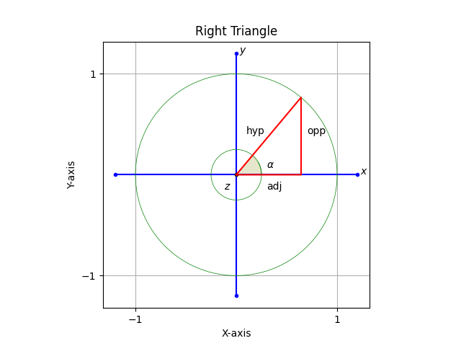

Angle Sum and Angle Difference
sin(a + b) = sin(a) · cos(b) + cos(a) · sin(b)

sin(a − b) = sin(a) · cos(b) − cos(a) · sin(b)

cos(a + b) = cos(a) · cos(b) − sin(a) · sin(b)

cos(a − b) = cos(a) · cos(b) + sin(a) · sin(b)

Trigonometry Behind Superheterodyne
From angle sum and angle difference:
sin(a + b) = sin(a) · cos(b) + cos(a) · sin(b)
sin(a − b) = sin(a) · cos(b) − cos(a) · sin(b)
cos(a + b) = cos(a) · cos(b) − sin(a) · sin(b)
cos(a − b) = cos(a) · cos(b) + sin(a) · sin(b)

sin (a + b) + sin (a − b) = sin(a) · cos(b) + cos(a) · sin(b) + sin(a) · cos(b) − cos(a) · sin(b)
sin (a + b) + sin (a − b) = sin(a) · cos(b) + cos(a) · sin(b) + sin(a) · cos(b) − cos(a) · sin(b)
sin (a + b) + sin (a − b) = sin(a) · cos(b) + sin(a) · cos(b)
sin (a + b) + sin (a − b) = 2 · sin(a) · cos(b)
sin(a) · cos(b) = ½sin(a + b) + ½sin(a − b)

cos(a + b) + cos(a − b) = cos(a) · cos(b) − sin(a) · sin(b) + cos(a) · cos(b) + sin(a) · sin(b)
cos(a + b) + cos(a − b) = cos(a) · cos(b) − sin(a) · sin(b) + cos(a) · cos(b) + sin(a) · sin(b)
cos(a + b) + cos(a − b) = cos(a) · cos(b) + cos(a) · cos(b)
cos(a + b) + cos(a − b) = 2 · cos(a) · cos(b)
cos(a) · cos(b) = ½cos (a + b) + ½cos(a-b)

Rotation Counterclockwise Around X Axis

A point (y₀,z₀) on the unit circle described by:
r̄ = (cos(α), sin(α))
y₀ = |r̄| · cos(α)
z₀ = |r̄| · sin(α)

Can be rotated by angle φ to point (y₁,z₁ ) on the unit circle described by:
r̄ = (cos(α + φ), sin(α + φ))
y₁ = |r̄| · cos(α + φ)
z₁ = |r̄| · sin(α + φ)

Using angle sum identity for cos and sin and the fact that |r̄| = 1.0 on the unit circle:
y₁ = |r̄| · cos(α + φ)
= |r̄| · cos(α) · cos(φ) − |r̄| · sin(α) · sin(φ)
= cos(α) · cos(φ) − sin(α) · sin(φ)

and
z₁ = |r̄| · sin(α + φ)
= |r̄| · sin(α) · cos(φ) + |r̄| · cos(α) · sin(φ)
= sin(α) · cos(φ) + cos(α) · sin(φ)

Now use the beginning identities for y₀ and z₀ and that |r̄| = 1.0:
y₀ = cos(α)
z₀ = sin(α)
Then:
y₁ = cos(α) · cos(φ) − sin(α) · sin(φ)
= y₀ · cos(φ) − z₀ · sin(φ)
and:
z₁ = sin(α) · cos(φ) + cos(α) · sin(φ)
= z₀ · cos(φ) + y₀ · sin(φ)

Bringing the x component into the picture:

x₁ = x₀

So the final transformation for three dimensions is then:

x₁ = 1.0 · x₀ + 0.0 · y₀ + 0.0 · z₀
y₁ = 0.0 · x₀ + cos(phi) · y₀ − sin(phi) · z₀
z₁ = 0.0 · x₀ + sin(phi) · y₀ + cos(phi) · z₀

In linear algebra notation:

$$\left.\left[\begin{matrix}1 & 0 & 0 \\ 0 & +cos(ϕ) & -sin(ϕ) \\ 0 & +sin(ϕ) & +cos(ϕ)\end{matrix}\right]*\left[\begin{aligned}x_{0} \\ y_{0} \\ z_{0}\end{aligned}\right]\right.=\left[\begin{matrix}x_{1} \\ y_{1} \\ z_{1}\end{matrix}\right]$$

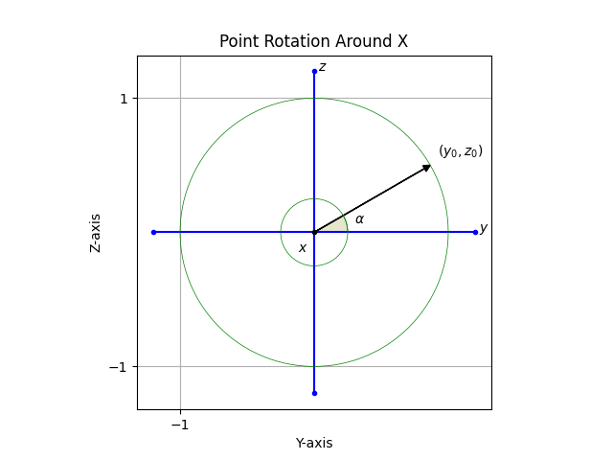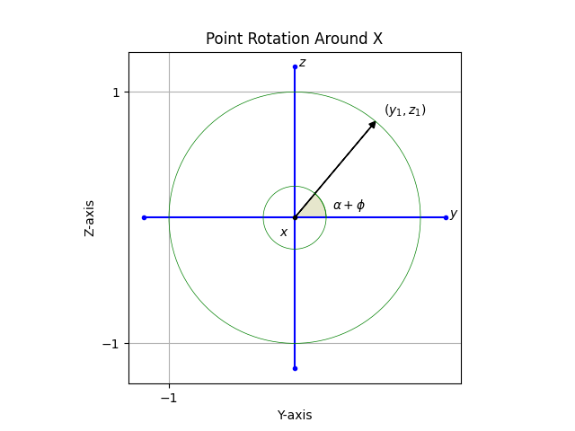

Rotation Counterclockwise Around Y Axis

A point (x₀ , z₀ ) on the unit circle described by:
r̄ = (cos(β), sin(β))
x₀ = |r̄| · cos(β)
z₀ = |r̄| · sin(β)

Can be rotated by angle ε to point (x₁,z₁ ) on the unit circle described by:
r̄ = (cos(β + ε), sin(β + ε))
x₁ = |r̄| · cos(β + ε)
z₁ = |r̄| · sin(β + ε)

Using angle sum identity for cos and sin and the fact that |r̄| = 1.0 on the unit circle:
x₁ = |r̄| · cos(β + ε)
= |r̄| · cos(β) · cos(ε) − |r̄| · sin(β) · sin(ε)
= cos(β) · cos(ε) − sin(β) · sin(ε)

and
z₁ = |r̄| · sin(β + ε)
= |r̄| · sin(β) · cos(ε) + |r̄| · cos(β) · sin(ε)
= sin(β) · cos(ε) + cos(β) · sin(ε)

Now use the beginning identities for x₀ and z₀ and that |r̄| = 1.0:
x₀ = cos(β)
z₀ = sin(β)
Then:
x₁ = cos(β) · cos(ε) − sin(β) · sin(ε)
= x₀ · cos(ε) − z₀ · sin(ε)
and:
z₁ = sin(β) · cos(ε) + cos(β) · sin(ε)
= z₀ · cos(ε) + x₀ · sin(ε)

Bringing the y component into the picture:

y₁ = y₀

So the final transformation for three dimensions is then:

x₁ = cos(ε) · x₀ + 0.0 · y₀ − sin(ε) · z₀
y₁ = 0.0 · x₀ + 1.0 · y₀ − 0.0 · z₀
z₀ = sin(ε) · x₀ + 0.0 · y₀ + cos(ε) · z₀

In linear algebra notation:

$$[\begin{matrix}+cos(ϵ) & 0 & -sin(ϵ) \\ 0 & 1 & 0 \\ +sin(ϵ) & 0 & +cos(ϵ)\end{matrix}]*[\begin{aligned}x_{0} \\ y_{0} \\ z_{0}\end{aligned}]=[\begin{aligned}x_{1} \\ y_{1} \\ z_{1}\end{aligned}]$$

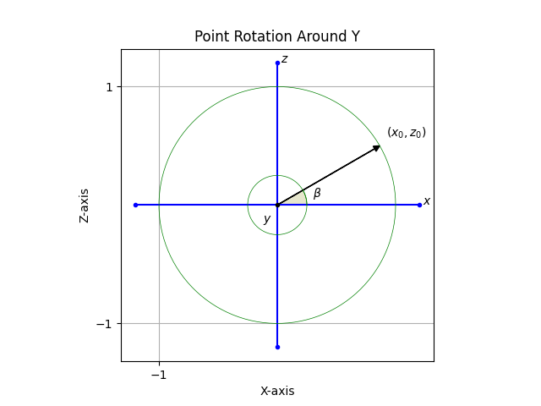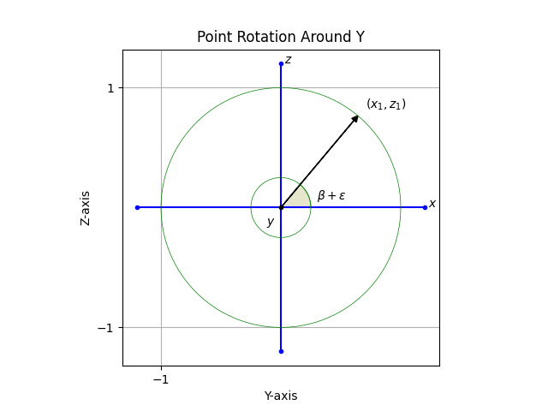

Rotation Counterclockwise Around Z Axis

A point (x₀ , y₀ ) on the unit circle described by:
r̄ = (cos(γ), sin(γ))
x₀ = |r̄| · cos(γ)
y₀ = |r̄| · sin(γ)

Can be rotated by angle δ to point (x₁,y₁) on the unit circle described by:
r̄ = (cos(γ + δ), sin(γ + δ))
x₁ = |r̄| · cos(γ + δ)
y₁ = |r̄| · sin(γ + δ)

Using angle sum identity for cos and sin and the fact that |r̄| = 1.0 on the unit circle:
x₁ = |r̄| · cos(γ + δ)
= |r̄| · cos(γ) · cos(δ) − |r̄| · sin(γ) · sin(δ)
= cos(γ) · cos(δ) − sin(γ) · sin(δ)

and
y₁ = |r̄| · sin(γ + δ)
= |r̄| · sin(γ) · cos(δ) + |r̄| · cos(γ) · sin(δ)
= sin(γ) · cos(δ) + cos(γ) · sin(δ)

Now use the beginning identities for x₀ and y₀ and that |r̄| = 1.0:
x₀ = cos(γ)
y₀ = sin(γ)

Then:
x₁ = cos(γ) · cos(δ) − sin(γ) · sin(δ)
= x₀ · cos(δ) − y₀ · sin(δ)

and:
y₁ = sin(γ) · cos(δ) + cos(γ) · sin(δ)
= y₀ · cos(δ) + x₀ · sin(δ)

Bringing the z component into the picture:
z₁ = z₀

So the final transformation for three dimensions is then:
x₁ = cos(δ) · x₀ − sin(δ) · y₀ + 0.0 · z₀
y₁ = sin(δ) · x₀ + cos(δ) · y₀ + 0.0 · z₀
z₁ = 0.0 · x₀ + 0.0 · y₀ + 1.0 · z₀

In linear algebra notation:
$$[\begin{matrix}+cos(δ) & -sin(δ) & 0 \\ +sin(δ) & +cos(δ) & 0 \\ 0 & 0 & 1\end{matrix}]*[\begin{aligned}x_{0} \\ y_{0} \\ z_{0}\end{aligned}]=[\begin{aligned}x_{1} \\ y_{1} \\ z_{1}\end{aligned}]$$

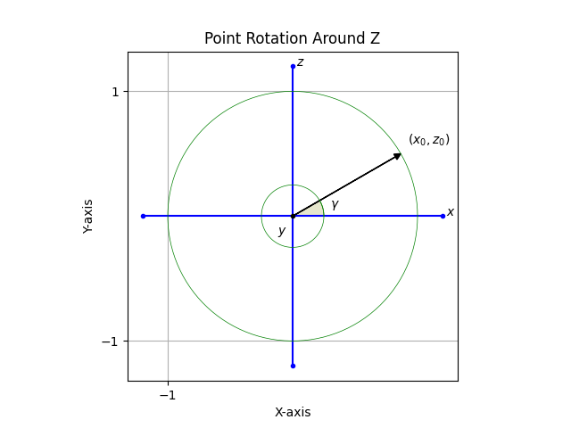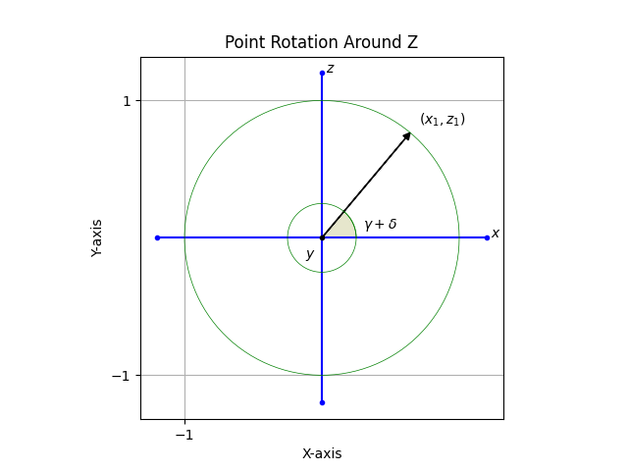

Taylor Series for e^{x} , sin(x), and cos(x)
$$\begin{aligned}e^{x}=1+\frac{x^{1}}{1!}+\frac{x^{2}}{2!}+\frac{x^{3}}{3!}+\frac{x^{4}}{4!}… \\ \\ \sin\left(x\right)=x-\frac{x^{3}}{3!}+\frac{x^{5}}{5!}-\frac{x^{7}}{7!}… \\ \\ \cos\left(x\right)=1-\frac{x^{2}}{2!}+\frac{x^{4}}{4!}-\frac{x^{6}}{6!}…\end{aligned}$$

Taylor Series and e^{ix} = cos(x) + sin(x) · i
If:
$$e^{x}=1+\frac{x^{1}}{1!}+\frac{x^{2}}{2!}+\frac{x^{3}}{3!}+\frac{x^{4}}{4!}+\frac{x^{5}}{5!}+\frac{x^{6}}{6!}+\frac{x^{7}}{7!}+\frac{x^{8}}{8!}+\frac{x^{9}}{9!}+...$$

Then:
$$e^{ix}=1+\frac{{(ix)}^{1}}{1!}+\frac{{(ix)}^{2}}{2!}+\frac{{(ix)}^{3}}{3!}+\frac{{(ix)}^{4}}{4!}+\frac{{(ix)}^{5}}{5!}+\frac{{(ix)}^{6}}{6!}+\frac{{(ix)}^{7}}{7!}+\frac{{(ix)}^{8}}{8!}+\frac{{(ix)}^{9}}{9!}+...$$
$$e^{ix}=1+ix+\frac{{(ix)}^{2}}{2!}+\frac{{(ix)}^{3}}{3!}+\frac{{(ix)}^{4}}{4!}+\frac{{(ix)}^{5}}{5!}+\frac{{(ix)}^{6}}{6!}+\frac{{(ix)}^{7}}{7!}+\frac{{(ix)}^{8}}{8!}+\frac{{(ix)}^{9}}{9!}+...$$
$$e^{ix}=1+ix+\frac{i^{2}x^{2}}{2!}+\frac{i^{3}x^{3}}{3!}+\frac{i^{4}x^{4}}{4!}+\frac{i^{5}x^{5}}{5!}+\frac{i^{6}x^{6}}{6!}+\frac{i^{7}x^{7}}{7!}+\frac{i^{8}x^{8}}{8!}+\frac{i^{9}x^{9}}{9!}+...$$

Using the pattern for the powers of i: +i, −1, −i, +1, +i, −1, −i, +1, …
Gives:$e^{ix}=1+ix-1\frac{x^{2}}{2!}-i\frac{x^{3}}{3!}+1\frac{x^{4}}{4!}+i\frac{x^{5}}{5!}-1\frac{x^{6}}{6!}-i\frac{x^{7}}{7!}+1\frac{x^{8}}{8!}+i\frac{x^{9}}{9!}+...$
$e^{ix}=1+ix-\frac{x^{2}}{2!}-i\frac{x^{3}}{3!}+\frac{x^{4}}{4!}+i\frac{x^{5}}{5!}-\frac{x^{6}}{6!}-i\frac{x^{7}}{7!}+\frac{x^{8}}{8!}+i\frac{x^{9}}{9!}+...$
Shift:$e^{ix}=(1-\frac{x^{2}}{2!}+\frac{x^{4}}{4!}-\frac{x^{6}}{6!}+\frac{x^{8}}{8!}+...)+(ix-i\frac{x^{3}}{3!}+i\frac{x^{5}}{5!}-i\frac{x^{7}}{7!}+i\frac{x^{9}}{9!}+...)$
$e^{ix}=(1-\frac{x^{2}}{2!}+\frac{x^{4}}{4!}-\frac{x^{6}}{6!}+\frac{x^{8}}{8!}+...)+i⋅(x-\frac{x^{3}}{3!}+\frac{x^{5}}{5!}-\frac{x^{7}}{7!}+\frac{x^{9}}{9!}+...)$

Then use the Taylor series identity for cos(x) and sin(x):
$$cos(x)=(1-\frac{x^{2}}{2!}+\frac{x^{4}}{4!}-\frac{x^{6}}{6!}+\frac{x^{8}}{8!}+...)$$
$$sin(x)=(x-\frac{x^{3}}{3!}+\frac{x^{5}}{5!}-\frac{x^{7}}{7!}+\frac{x^{9}}{9!}+...)$$

We finally get:
$$e^{ix}=cos(x)+sin(x)⋅i$$

Hyperbola
Event location using satellites and the time difference of arrival (TDOA) inevitably leads to analysis of the
hyperbola. A key characteristic of the hyperbola is the ability to describe a line of equal time difference
between two points, also know as an isochrone. When an event occurs and is detected by two different
satellites, commonly the only information available is the time difference of arrival (TDOA.) The hyperbola can
be used as a tool to find the location at which the event occurred.
Some of the parametric forms of the hyperbola equation are given here.
y 2
x 2
a 2 − b 2 = 1
Using tangent and secant and angle t.
x(t) = b · tan(t)
y(t) = a · sec(t)
Using hyperbolic sine (sinh) and hyperbolic cosine (cosh) and angle t.
x(t) = a · cosh(t)
y(t) = b · sinh(t)
The hyperbola has an eccentricity, e, that is > 1.0 as compared with the other conics like circles (e = 0.0), ellipses
(e < 1.0), and parabolas (e = 1.0). The hyperbola’s eccentricity can be described relative to a and b as:
√
e =
a 2 +b 2
a
The equation for the hyperbola’s asymptotes are give as:
b
y asun 1 = + a · x asun 1
b
y asun 2 = − a · x asun 2

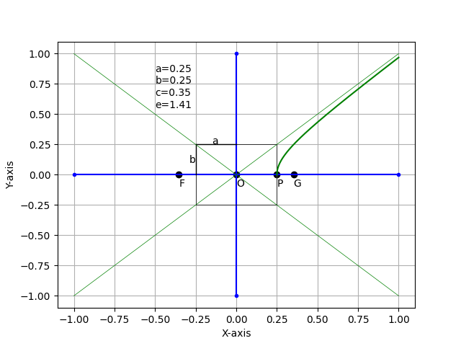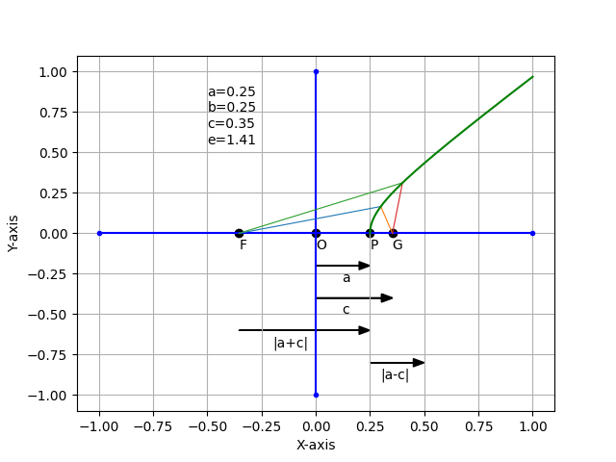

Regular Expressions
Regular Expression | Description
. | Matches any single Character.
^xyz | Matches characters “xyz” at the beginning of a line.
Xyx$ | Matches characters “xyx” at the end of a line.
[abc] | Matches character “a” or “b” or “c”.
[123] | Matches number “1” or “2” or “3”.
[xyz][456] | Matches character “x” or “y” or “z” and number “4” or “5” or “6”.
[^abc] | Matches any character other than “a” or “b” or “c”.
[a-z] | Matches any character “a” through “z”.
[0-9] | Matches any number “0” through “9”.
[A-Z] | Matches any character “A” through “Z”.
[r-w][2-8] | Matches any character “r” through “w” and any number “2” through “8”.
xyz|abc | Matches “xyz” or “abc”.

Meta-characters
Meta-character | Description
\d | Short for [0-9].
\D | Short for [^0-9].
\s | Short for [\t\nx00\f\r]. (White spaces).
\S | Short for [^\t\nx00\f\r].
\w | Short for [a-zA-Z0-9].
\W | Short for [^a-zA-Z0-9].
\b | A word boundary where character is [a-zA-Z0-9].
\B | A non word boundary.

Quantifiers
Quantifiers | Description
X? | X occurs once or not at all.
X* | X occurs zero or more times.
X+ | X occurs one or more times.
X{n} | X occurs “n” times.
X{n,} | X occurs “n” or more times.
X{n,M} | X occurs at least “n” times but no more than “m” times.
*? | “?” after Quantifier makes it a reluctant Quantifier.

Groupings

Group regular expressions with “()”. Move everything but ISO images: mv !(*.iso) ../scripts/.

Cross Product
$$\begin{aligned}\overline{A}×\overline{B}\text{=} \\ \\ (a_{1}\hat{i}+a_{2}\hat{j}+a_{3}\hat{k})×(b_{1}\hat{i}+b_{2}\hat{j}+b_{3}\hat{k})\text{=} \\ \\ a_{1}b_{1}(\hat{i}×\hat{i})+a_{1}b_{2}(\hat{i}×\hat{j})+a_{1}b_{3}(\hat{i}×\hat{k})\text{+} \\ a_{2}b_{1}(\hat{j}×\hat{i})+a_{2}b_{2}(\hat{j}×\hat{j})+a_{2}b_{3}(\hat{j}×\hat{k})\text{+} \\ a_{3}b_{1}(\hat{k}×\hat{i})+a_{3}b_{2}(\hat{k}×\hat{j})+a_{3}b_{3}(\hat{k}×\hat{k}) \\ \\ \text{i to j is positive} \\ \text{j to k is positive} \\ \text{k to i is positive} \\ \text{i to k is negative} \\ \text{k to j is negative} \\ \text{j to i is negative} \\ \text{i to i is zero} \\ \text{j to j is zero} \\ \text{k to k is zero} \\ \text{i}×\text{j}=\text{+k} \\ \text{j}×\text{k}=\text{+i} \\ \text{k}×\text{i}=\text{+j} \\ \text{i}×\text{k}=\text{-j} \\ \text{k}×\text{j}=\text{-i} \\ \text{j}×\text{i}=\text{-k} \\ \\ a_{1}b_{1}(0)+a_{1}b_{2}(\hat{i}×\hat{j})+a_{1}b_{3}(\hat{i}×\hat{k})\text{+} \\ a_{2}b_{1}(\hat{j}×\hat{i})+a_{2}b_{2}(\hat{j}×\hat{j})+a_{2}b_{3}(\hat{j}×\hat{k})\text{+} \\ a_{3}b_{1}(\hat{k}×\hat{i})+a_{3}b_{2}(\hat{k}×\hat{j})+a_{3}b_{3}(\hat{k}×\hat{k})\text{=} \\ \\ a_{1}b_{1}(0)+a_{1}b_{2}(\hat{k})+a_{1}b_{3}(-\hat{j})\text{+} \\ a_{2}b_{1}(-\hat{k})+a_{2}b_{2}(0)+a_{2}b_{3}(\hat{i})\text{+} \\ a_{3}b_{1}(\hat{j})+a_{3}b_{2}(-\hat{i})+a_{3}b_{3}(0) \\ \\ (a_{2}b_{3}-a_{3}b_{2})\hat{i}+(a_{3}b_{1}-a_{1}b_{3})\hat{j}+(a_{1}b_{2}-a_{2}b_{1})\hat{k}\end{aligned}$$

Golden Ratio
The Golden Ratio is the following relationship:
$$\frac{(a+b)}{a}=\frac{a}{b}=ϕ$$
To find the value of $ϕ$ First expand the left hand term:
$$\frac{a}{a}+\frac{b}{a}=\frac{a}{b}=ϕ$$

Use the fact that:
$$\frac{1}{ϕ}=\frac{b}{a}$$

To get:
$$1+\frac{1}{ϕ}=\frac{a}{b}=ϕ$$
Ignore the a/b portion and multiply both sides of equation by $ϕ$
$$ϕ+1=ϕ^{2}$$
Get all the terms on one side:
$$0=ϕ^{2}-ϕ-1$$
Use the Quadratic Equation:
$$x=\frac{-b±\sqrt{b^{2}-4⋅a⋅c}}{2⋅a}$$
And use, a=1, and b=-1, and c=-1:
$$\begin{aligned}ϕ=\frac{-(-1)+\sqrt{{(-1)}^{2}-4⋅1⋅(-1)}}{2⋅1} \\ ϕ=\frac{1+\sqrt{5}}{2}=1.61803398874989\end{aligned}$$

Polynomials
$$\begin{aligned} \\ {(x+y)}^{2}=x^{2}+2⋅x⋅y+y^{2} \\ \\ {(x-y)}^{2}=x^{2}-2⋅x⋅y+y^{2} \\ \\ x^{2}-y^{2}=(x+y)⋅(x-y) \\ \\ (x+a)⋅(x+b)=x^{2}+(a+b)⋅x+a⋅b \\ \\ {(x+y+z)}^{2}=x^{2}+y^{2}+z^{2}+2⋅x⋅y+2⋅y⋅z+2⋅z⋅x \\ \\ {(x+y)}^{3}=x^{3}+3⋅x^{2}⋅y+3⋅x⋅y^{3}+y^{3} \\ \\ {(x-y)}^{3}=x^{3}-3⋅x^{2}⋅y+3⋅x⋅y^{3}-y^{3} \\ \\ x^{3}+y^{3}=(x+y)⋅(x^{2}-x⋅y+y^{2}) \\ \\ x^{3}+y^{3}+z^{3}-3⋅x⋅y⋅z=(x+y+z)⋅(x^{2}+y^{2}+z^{2}-x⋅y-y⋅z-z⋅x)\end{aligned}$$

Linear Spline

$$\begin{aligned}y=y_{0}⋅\frac{x-x_{1}}{x_{0}-x_{1}}+y_{1}⋅\frac{x-x_{0}}{x_{1}-x_{0}} \\ \\ y=y_{1}⋅\frac{x-x_{2}}{x_{1}-x_{2}}+y_{2}⋅\frac{x-x_{1}}{x_{2}-x_{1}} \\ \\ y=y_{2}⋅\frac{x-x_{3}}{x_{2}-x_{3}}+y_{3}⋅\frac{x-x_{2}}{x_{3}-x_{2}} \\ \\ y=y_{3}⋅\frac{x-x_{4}}{x_{3}-x_{4}}+y_{4}⋅\frac{x-x_{3}}{x_{4}-x_{3}}\end{aligned}$$

Quadratic spline
$\begin{aligned}Forequation:a+b⋅x+c⋅x^{2} \\ \\ a_{1}+b_{1}⋅x_{0}+c_{1}⋅x_{0}^{2}=y_{0} \\ \\ a_{1}+b_{1}⋅x_{1}+c_{1}⋅x_{1}^{2}=y_{1} \\ \\ a_{2}+b_{2}⋅x_{1}+c_{2}⋅x_{1}^{2}=y_{1} \\ \\ a_{2}+b_{2}⋅x_{2}+c_{2}⋅x_{2}^{2}=y_{2} \\ \\ a_{3}+b_{3}⋅x_{2}+c_{3}⋅x_{2}^{2}=y_{2} \\ \\ a_{3}+b_{3}⋅x_{3}+c_{3}⋅x_{3}^{2}=y_{3} \\ \\ Forderivative:b+2⋅c⋅x \\ \\ b_{1}+2⋅c_{1}⋅x_{1}=b_{2}+2⋅c_{2}⋅x_{1} \\ b_{2}+2⋅c_{2}⋅x_{2}=b_{3}+2⋅c_{3}⋅x_{2} \\ \\ \text{Or:} \\ \\ b_{1}+2⋅c_{1}⋅x_{1}-b_{2}-2⋅c_{2}⋅x_{1}=0 \\ b_{2}+2⋅c_{2}⋅x_{2}-b_{3}-2⋅c_{3}⋅x_{2}=0 \\ \\ \\ b_{2}-b_{3}+2⋅c_{2}⋅x_{1}-2⋅c_{3}=0 \\ \\ Then:c_{1}=0\end{aligned}$

(x₀,y₀)
(x₁,y₁)
(x₂,y₂)
(x₃,y₃)

$$[\begin{matrix}a_{1} & b_{1} & c_{1} & a_{2} & b_{2} & c_{2} & a_{3} & b_{3} & c_{3}\end{matrix}]*[{}_{1}]=[{}_{1}]$$
$$[\begin{matrix}1 & x_{0} & x_{0}^{2} & 0 & 0 & 0 & 0 & 0 & 0 \\ 1 & x_{1} & x_{1}^{2} & 0 & 0 & 0 & 0 & 0 & 0 \\ 0 & 0 & 0 & 1 & x_{1} & x_{1}^{2} & 0 & 0 & 0 \\ 0 & 0 & 0 & 1 & x_{2} & x_{2}^{2} & 0 & 0 & 0 \\ 0 & 0 & 0 & 0 & 0 & 0 & 1 & x_{2} & x_{2}^{2} \\ 0 & 0 & 0 & 0 & 0 & 0 & 1 & x_{3} & x_{3}^{2} \\ 0 & 1 & 2x_{1} & 0 & -1 & -2x_{1} & 0 & 0 & 0 \\ 0 & 0 & 0 & 0 & 1 & 2x_{2} & 0 & -1 & -2x_{2} \\ 0 & 0 & 1 & 0 & 0 & 0 & 0 & 0 & 0\end{matrix}]*[\begin{aligned}a_{1} \\ b_{1} \\ c_{1} \\ a_{2} \\ b_{2} \\ c_{2} \\ a_{3} \\ b_{3} \\ c_{3}\end{aligned}]=[\begin{aligned}y_{0} \\ y_{1} \\ y_{1} \\ y_{2} \\ y_{2} \\ y_{3} \\ 0 \\ 0 \\ 0\end{aligned}]$$

Cubic Spline

$\begin{aligned}Forequation:a+b⋅x+c⋅x^{2}+d⋅x^{3} \\ \\ a_{1}+b_{1}⋅x_{0}+c_{1}⋅x_{0}^{2}+d_{1}⋅x_{0}^{3}=y_{0} \\ \\ a_{1}+b_{1}⋅x_{1}+c_{1}⋅x_{1}^{2}+d_{1}⋅x_{1}^{3}=y_{1} \\ \\ a_{2}+b_{2}⋅x_{1}+c_{2}⋅x_{1}^{2}+d_{2}⋅x_{1}^{3}=y_{1} \\ \\ a_{2}+b_{2}⋅x_{2}+c_{2}⋅x_{2}^{2}+d_{2}⋅x_{2}^{3}=y_{2} \\ \\ a_{3}+b_{3}⋅x_{2}+c_{3}⋅x_{2}^{2}+d_{1}⋅x_{2}^{2}=y_{2} \\ \\ a_{3}+b_{3}⋅x_{3}+c_{3}⋅x_{3}^{2}+d_{1}⋅x_{3}^{2}=y_{3} \\ \\ Forfirstderivative:b+2⋅c⋅x+3⋅d⋅x^{2} \\ \\ b_{1}+2⋅c_{1}⋅x_{1}+3⋅d_{1}⋅x_{1}^{2}=b_{2}+2⋅c_{2}⋅x_{1}+3⋅d_{2}⋅x_{1}^{2} \\ b_{2}+2⋅c_{2}⋅x_{2}+3⋅d_{2}⋅x_{2}^{2}=b_{3}+2⋅c_{3}⋅x_{2}+3⋅d_{3}⋅x_{2}^{2} \\ \\ \text{Or:} \\ b_{1}+2⋅c_{1}⋅x_{1}+3⋅d_{1}⋅x_{1}^{2}-b_{2}-2⋅c_{2}⋅x_{1}-3⋅d_{2}⋅x_{1}^{2}=0 \\ b_{2}+2⋅c_{2}⋅x_{2}+3⋅d_{2}⋅x_{2}^{2}-b_{3}-2⋅c_{3}⋅x_{2}-3⋅d_{3}⋅x_{2}^{2}=0 \\ \\ ForSecondderivative:2⋅c+6⋅d⋅x \\ \\ 2⋅c_{1}+6⋅d_{1}⋅x_{1}=2⋅c_{2}+6⋅d_{2}⋅x_{1} \\ 2⋅c_{2}+6⋅d_{2}⋅x_{2}=2⋅c_{3}+6⋅d_{3}⋅x_{2} \\ \\ \text{Or:} \\ 2⋅c_{1}+6⋅d_{1}⋅x_{1}-2⋅c_{2}-6⋅d_{2}⋅x_{1}=0 \\ 2⋅c_{2}+6⋅d_{2}⋅x_{2}-2⋅c_{3}-6⋅d_{3}⋅x_{2}=0 \\ \\ Alsosecondderivatiesarezeroatendpoints: \\ 2⋅c_{1}+6⋅d_{1}⋅x_{0}=0 \\ 2⋅c_{3}+6⋅d_{3}⋅x_{3}=0\end{aligned}$

(x₀,y₀)

(x₁,y₁)
(x₂,y₂)
(x₃,y₃)

$$\begin{matrix}a_{1} & b_{1} & c_{1} & d_{1} & a_{2} & b_{2} & c_{2} & d_{2} & a_{3} & b_{3} & c_{3} & d_{3} \\ 1 & x_{0} & x_{0}^{2} & x_{0}^{3} & 0 & 0 & 0 & 0 & 0 & 0 & 0 & 0 \\ 1 & x_{1} & x_{1}^{2} & x_{0}^{2} & 0 & 0 & 0 & 0 & 0 & 0 & 0 & 0 \\ 0 & 0 & 0 & 0 & 1 & x_{1} & x_{1}^{2} & x_{1}^{3} & 0 & 0 & 0 & 0 \\ 0 & 0 & 0 & 0 & 1 & x_{2} & x_{2}^{2} & x_{2}^{2} & 0 & 0 & 0 & 0 \\ 0 & 0 & 0 & 0 & 0 & 0 & 0 & 0 & 1 & x_{2} & x_{2}^{2} & x_{2}^{3} \\ 0 & 0 & 0 & 0 & 0 & 0 & 0 & 0 & 1 & x_{3} & x_{3}^{2} & x_{3}^{2}\end{matrix}$$

Doppler for electromagnet waves
$$f_{0}=\frac{c+v_{0}}{c+v_{s}}⋅f_{s}$$

Where:
c is the speed of light.
f₀ is the frequency observed.
f_{s} is the frequency of the source.
v₀ is the velocity of observer.
v_{s} is the velocity of the source.

Wave number is the number of cycles in one meter.
$$\tilde{ν}=\frac{1}{λ}$$

Wave length is the inverse of frequency times the speed of light.
$$λ=\frac{1}{f}⋅c$$

Frequency is the inverse of wave length times the speed of light.
$$f=\frac{1}{λ}⋅c$$

Significant Figures
The use of significant figures is helpful in error analysis. The number of significant figures is defined as the number of digits that can be assumed to be correct, starting at the left with the first nonzero digit, and proceeding to the right. By this definition,
10.62,
0.05713,
4.600
all have four significant figures. A number such as
4300
is ambiguous. This ambiguity may be resolved by using scientific notation, since we may write the number as
4.3x10³,
4.30x10³,
4.300x10³
according to whether the number has two, three or four significant figures, respectively.

Space Mathematics- Math problems based on space science. Bernice Kastner . Dover Publications, Inc. Mineola, New York.

Angle Sum and Angle Difference
Given the angle relationship:
γ = β − α

Then:
cos(γ) = cos(β − α)

and because:
cos(a − b) = cos(a) · cos(b) + sin(a) · sin(b)

Then:
cos(γ) = cos(β) · cos(α) + sin(β) · sin(α)

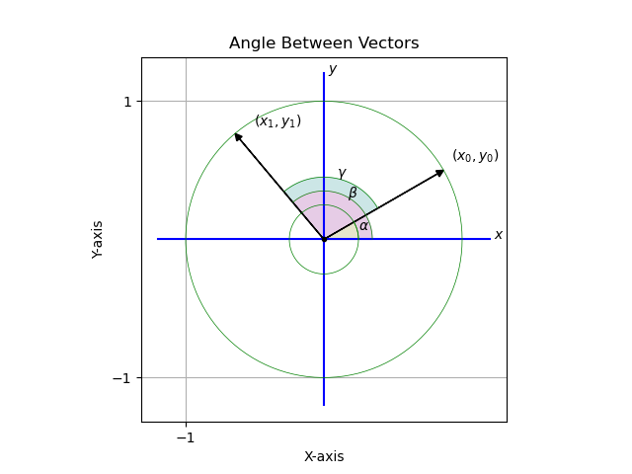

Linear Constant Coefficient Difference Equation

The linear constant coefficient difference equation can be expressed as the following:

$$\sum_{k=0}^{k=N}{}a_{k}⋅y[n-k]=\sum_{k=0}^{k=M}{}b_{k}⋅x[n-k]$$

If N = 3, and M = 3 then:

a0·y[n] + a1·y[n-1] + a2·y[n-2] + a3·y[n-2] =
b0·x[n] + b1·x[n-1] + b2·x[n-2] + b3·x[n-2]

The coefficient a0 is set to one (because … )

If y[n] is isolated on the left on the left hand side of equation you get the following:

y[n] =
b0·x[n] + b1·x[n-1] + b2·x[n-2] + b3·x[n-2] - a1·y[n-1] - a2·y[n-2] – a3·y[n-2]

This equation is what is used in MATALB’s filter function.

The following call to MATLAB’s butter function gives you the values for the coefficients {a0, a1, a2} and {b0, b1, b2}:

[b, a] = butter (2, .25);

Where the value 2 is the ----- and the value .25 is the ------ and the computed values of a and b are:

a =

+1.000000 -0.942800 +0.333333

b =

+0.097631 +0.195262 +0.097631

This is what is used for the low pass filter in this version of the Dual Mixer time difference.

Infinite Impulse Response Filter
Structures in Xilinx FPGAs
By: Michael Francis

Indicates the IIR filter can be realized in an FPGA.

Fourier and Laplace
Fourier transform for a value of ω and Laplace transform for a value of ω and ⍺.
$\begin{aligned} \\ F(ω)=\int_{-∞}^{+∞}{}f(t)⋅e^{-i⋅ω⋅t}⋅dt\end{aligned}$ $\begin{aligned} \\ F(ω,α)=\int_{-∞}^{+∞}{}f(t)⋅e^{-i⋅ω⋅t}⋅e^{-α⋅t}⋅dt\end{aligned}$

Euler’s equation.
$\begin{aligned} \\ e^{i⋅ω⋅t}=cos(-ω⋅t)+i⋅sin(-ω⋅t)\end{aligned}$

Because cos(-ω) = cos(ω) and sin(-ω) = -sin(ω).
$\begin{aligned} \\ e^{i⋅ω⋅t}=cos(ω⋅t)-i⋅sin(ω⋅t)\end{aligned}$

Substitute for Fourier.
$\begin{aligned} \\ F(ω)=\int_{-∞}^{+∞}{}f(t)⋅(cos(ω⋅t)-i⋅sin(ω⋅t))⋅dt\end{aligned}$

Substitute for Laplace.
$\begin{aligned} \\ F(ω,α)=\int_{-∞}^{+∞}{}f(t)⋅(cos(ω⋅t)-i⋅sin(ω⋅t))⋅e^{-α⋅t}⋅dt\end{aligned}$

Distribute f(x) and split for Fourier.
$\begin{aligned} \\ F(ω)=\int_{-∞}^{+∞}{}f(t)⋅(cos(ω⋅t)⋅dt-i⋅\int_{-∞}^{+∞}{}f(t)⋅sin(ω⋅t))⋅dt\end{aligned}$

Distribute f(x) and split for Laplace.
$\begin{aligned} \\ F(ω,α)=\int_{-∞}^{+∞}{}f(t)⋅(cos(ω⋅t)⋅e^{-α⋅t}⋅dt-i⋅\int_{-∞}^{+∞}{}f(t)⋅sin(ω⋅t))⋅e^{-α⋅t}⋅dt\end{aligned}$

Discrete form of Fourier and Laplace
Discrete form Fourier.
$\begin{aligned} \\ \sum_{n=0}^{n=127}{}f(n⋅Δ_{T})⋅cos(n⋅Δ_{T}⋅ω)-i⋅\sum_{n=0}^{n=127}{}f(n⋅Δ_{T})⋅sin(n⋅Δ_{T}⋅ω) \\ \\ \text{Where:} \\ Δ_{T}=\frac{1}{\text{sample rate}} \\ \\ t=n⋅Δ_{T}\end{aligned}$

Discrete form Laplace.
$\begin{aligned} \\ \sum_{n=0}^{n=127}{}f(n⋅Δ_{T})⋅cos(n⋅Δ_{T}⋅ω)⋅e^{-α⋅n⋅Δ_{T}}-i⋅\sum_{n=0}^{n=127}{}f(n⋅Δ_{T})⋅sin(n⋅Δ_{T}⋅ω)⋅e^{-α⋅n⋅Δ_{T}} \\ \\ \text{Where:} \\ Δ_{T}=\frac{1}{\text{sample rate}} \\ \\ t=n⋅Δ_{T}\end{aligned}$

