The X-Midas Software Technical Manual

by Derek Jones and Scott Schoen

August 1996

Table of Contents

0 Introduction 1
1 The Shared Memory Structures 1
1.1 The Midas Common Structure (Mc) 1
1.2 The Midas Tables Structure (Mt) 5
1.2.1 The Macro Buffer 7
1.2.2 The Result Table 7
1.2.3 The X-Midas Dictionary 11
1.2.4 The History Buffer 13
2 The BLUE Header Definition 13
3 Execution Control 21
3.1 Macros 25
3.1.1 Macro Execution 25
3.1.2 The Macro Preprocessor 29
3.1.3 Piping 32
3.2 Intrinsics 40
3.3 Operating System Commands 41
3.4 Stand-Alone Primitives 44
3.5 Executing Commands in the Background 47
3.6 Oneshot Commands 51
3.7 Datastream Commands 54
3.7.1 The Cray Interface 54
3.8 Exception Handling 59
3.8.1 ERRORs and WARNINGs 60
3.8.2 CTRL-Cs (Aborting) 61
4 Graphics 61
4.1 The C/FORTRAN Interface 62
4.2 The Midas X-Graphics Structure (Mx) 64
4.3 Color 79

Table of Figures

Figure 1 M$RASSIGN, M$RCAST, M$RGOOD and their Interaction 10
Figure 2 The M$xRSLT Routines as an Interface to M$RCAST and M$RASSIGN 11
Figure 3 Layout of the BLUE Header Structure 14
Figure 4 Piped System Data Flow 36
Figure 5 Execution of a VMS Operating System Command from within X-Midas 42
Figure 6 Execution of a UNIX Operating System Command from within X-Midas 43
Figure 7 Execution of Host Primitives under VMS X-Midas 45
Figure 8 Execution of Host Primitives under UNIX X-Midas 46
Figure 9 Backgrounded Commands under VMS X-Midas 48
Figure 10 Backgrounded Commands under UNIX X-Midas 50
Figure 11 Execution of Oneshot Commands under VMS X-Midas 52
Figure 12 Execution of Oneshot Commands under UNIX X-Midas 54
Figure 13 Structure of the Cray Interface 59
Figure 14 Color Resource Allocation 83

Table of Tables

Table 1 Midas Common Structure 1
Table 2 Midas Tables Structure 5
Table 3 Checks for Explicit Typing of Command-Line Parameters 30
Table 4 Mt.npipe and Mc.mode Value Definitions 33
Table 5 outmask Bits Definitions 37
Table 6 Widget Memory Cost 39
Table 7 X-Graphics Field Definitions 65

Introduction
Intended Audience
This manual is written for someone who has a working knowledge of X-Midas, who has read the X-Midas User’s Guide and probably the Primitive Programmer’s Guide. This manual gives an in-depth view of the architecture of X-Midas and how X-Midas operations are performed, not how to invoke them or use them. It is a behind-the-scenes look at X-Midas; some users who will not be writing primitives or altering the libraries may still want to read parts of this manual just to get an idea of what is going on “underneath”, to give themselves a better understanding of X-Midas.

The Software Technical Manual is not complete at this time, but the most requested sections are present.

The Shared Memory Structures
X-Midas uses a great deal of shared memory both for interprocess communication and for retaining the context of an X-Midas session between image exits. Almost all of the X-Midas environment is stored in shared memory. This section describes the structures that make up the X-Midas environment and how they are used. Share d memory is used for other operations, such as piping, real-time controls and datastreams, but this memory is released upon completion of the operation. The two structures that define the X-Midas environment are called Mc (Midas Common) and Mt (Midas Tables) and are defined below.

The Midas Common Structure (Mc)
Table 1 Midas Common Structure
Field Name | Meaning | See also
command_string | contains the command, its switches, and its arguments | Section 3, “Execution Control”
global_switch_string | contains all global switches and values
command_length | number of characters in Mc.command_string
switch_length | position of last character of last local switch in Mc.command_string | HELP  M$GET_SWITCH  M$GET_USWITCH
global_switch_length | number of characters in the global switch string
number_parameters | number of command-line parameters required for the command
command_name | the string name of the command; contains “;option” information, and, if a macro, “$##.EXT” information as well
command_support | single character indicating which support to use for the command
command_option | (unused)
ds_engine | the number of the datastream engine selected for the command
ds_def_engine | the number of the default datastream engine
verify | bit vector containing one control bit for each VERIFY function | HELP M$VERIFY  HELP M$SHELL  EXPLAIN VERIFY
debug | bit vector containing one control bit for each DEBUG function | EXPLAIN DEBUG
break | .TRUE. if the user hit CTRL-C; also set to shut down a piped system | Section 3.8, “Exception Handling”
beep | whether or not to beep upon command termination | EXPLAIN BEEP
status | 0 = a command is preparing to run; in its preamble stage  1 = M$SYNC encountered—command can be safely spawned  2 = successful command completion  < 0 = ERROR encountered
count | the current number of active primitives in a piped system
mode | 0 = normal operation; no pipe system present  any other value—pipe system operational | Section 3.1.3, “Piping”
datastream | for handshaking between shell and datastream manager (DSMCLIENT) | Section 3.7, “Datastreams”
OS_type | name of operating system
machine_type | indicates internal numeric machine data representation
pipeable | list of pipeable supports
login_path | user’s login directory ($HOME in UNIX, SYS$LOGIN in VMS)
home_path | directory for user macros (those beginning with “%”); where aux 98 points | EXPLAIN HOMEPATH  Section 3.1, “Macro Execution”
plot_node | X-Windows screen designator | EXPLAIN XWINDOW
plot_node2 | secondary screen designator
left | default X-Windows left | Section 4, “Graphics”
top | default X-Windows top
width | default X-Windows width
height | default X-Windows height
window_id | X-Windows window ID
window_w | X-Windows actual width in pixels
window_h | X-Windows actual height in pixels
colormap(4) | Four RGB 7 element colormaps | Section 4, “Graphics”  HELP MX$COLORMAP
aux_list | string containing list of auxiliary storage devices | EXPLAIN AUX
write_id | write path | EXPLAIN WRITEID
read_id | read path | EXPLAIN READID
user_id | username of account to read and write from | EXPLAIN USERID
write_aux | current write aux number | EXPLAIN AUX
read_auxs | the number of currently active read auxes | EXPLAIN AUX
aux_offset | array of integers (> L_auxs) which indicate the positions in Mc.aux_list where each auxiliary device name begins | Section S?, “File Handling”
read_aux | array of L_auxs integers, listing the active read auxes
masterslave | master/slave control mode. Used for handshaking between the SLAVE primitive and M$GET_COMMAND. | Section 3, “Execution Control”
detached | default detached mode: .TRUE. if files are to be created detached; .FALSE. if not | EXPLAIN DETACH. These fields correspond exactly to its first three arguments.
detach_aux | which aux to create the detached data portion on
detach_start | byte offset in detached file to begin writing data.
next_file_lu | Used on VMS only. Contains the number of the next available logical unit
pipesize | default pipe size in bytes
propmask | header keyword propagation mask
macro | indicates the next command to execute in the macro buffer | Section 1.2.1, “The Macro Buffer”  Section 3.1, “Macro Execution”
macro_level | the current depth of macro nesting, must be  ≤ L_macros
macro_top | the location of the top of each nested macro
macro_return | the location of the next executable command of each nested macro
loop_level | the current depth of loop nesting, must be ≤ L_loops
loop_top | an array of L_loops integers; holds the values of the top of each of the loops in terms of Mc.macro
loop_count | an array of L_loops integers; holds the number of the current iteration for each of the counting loops (LOOP)
timer | Continuous primitive timer | EXPLAIN TIMER
elapse | Elapsed timer
pause | Wait time for polling loops
seed | Random number seed | EXPLAIN RANDOM  EXPLAIN ENVIRONMENT
scratch | System scratch variable.
sec_sz | An array of L_sections integers; contains the sizes of each of the shared memory sections (pipe headers, pipe_buffers, cntrl_widgets, messages, ds_structs). There is one “LS_” parameter for each section, to be used when referencing this table.
userscr | User scratch area. L_userscr four-byte integers for general interprocess communication.

The remaining fields in the Mc structure are there strictly for compatibility with GOLD routines. They are not used by X-Midas.

The Midas Tables Structure (Mt)
Table 2 Midas Tables Structure
Field Name | Meaning | See also
ncommand | number of commands in configure table | Section 1.2.3, “The X-Midas Dictionary”
c_alpha | indices to alphabetized command list
c_index | starting positions of each command in Mt.c_string
c_namel | Length of each command name. Includes the semicolon and option name, if the command is not in the SYS option.
c_minl | minimum abbreviation length of each command
c_key | category key for each command
c_string | Holds entire contents of memory-resident dictionary. All commands, their options, defaults, supports, categories and I/O behavior concatenated one after the other.
nmacro | number of macro commands in the buffer | Section 1.2.1, “The Macro Buffer”
m_index | contains indices to commands in Mt.m_index
m_string | holds contents of macro buffer
n_result | current number of result parameters | Section 1.2.2, “The Result Table”
r_index | contains indices to stored results in Mt.r_string
r_namel | contains lengths of each result name
r_indez | contains end position in Mt.r_string of entire stored result name+data
r_string | holds contents of result table
historyb | indicates which history buffer is in use | Section 1.2.4, “The History Buffer”
nhistory(0:1) | number of commands in each history buffer | HELP M$PUT_HISTORY
h_index(0:1, L_historys) | contains indices to commands in history buffer | HELP M$SAVE_HISTORY
h_string(0:1) | holds contents of history buffers; each buffer must be ≤ L_history_chars
dmess_in | next message in | See section 3.7, “Datastreams”
dsmess_out | next message out
dsmess | The message buffer, an array of L_dsmess MESSAGESTRUCTs.
nmessage | queue length
qmess_top | first valid message
qmess_bottom | location for next new message
qmess_lock | global writer lock
npipe | number of pipes | See section 3.1.3, “Piping”
mpipe | maximum number of pipes
phead_off | offset, in bytes, to where the pipe headers actually start, in the pipe headers section
nwidget | number of control widgets
wparm_off | offset, in bytes,, to where the widget parameters start in the widget shared memory section
wparm_used | number of bytes actually used in the widget shared memory section
wbank | an array of L_wbanks integers
ds_alloc |  | See section 3.7, “Datastreams”
ds_used
ds_ptr
ds_flag
engine | an array of L_engines+1 ENGINESTRUCTs, starting at 0 for the local engine

The following sections are more detailed explanations of certain sections of the Mt structure.

The Macro Buffer
The macro buffer is defined by the following:

Mt.m_string a string, L_macro_chars in length, which holds all the commands in the macro buffer concatenated together sequentially.
Mt.m_index an array of L_macrolines elements, which contains the ending positions of each command embedded in Mt.m_string. Thus, if Mt.m_index(1) = 14, it means that the first command is Mt.m_string(1:14). If Mt.m_index(9) = 6, it means that the ninth command is Mt.m_string(Mt.m_index(8)+1:Mt_m_index(9)).
Mt.nmacro the total number of commands in the macro buffer; Mt.m_index(Mt.nmacro) will be the position of the very last character of the very last command in the buffer.
Mc.macro the macro “pointer”; it indicates the number of the next command to execute in the macro buffer; 4 for the fourth command, 9 for the ninth command, etc.
Any command that needs to search through the macro buffer for a specific command (e.g. GOTO) needs to keep track of two indices so that it knows, for the current macro pointer, the beginning and ending character positions of the command within Mt.m_string. The function M$LOAD_MCR, located in xmint:macro.for, will pass back these two indices based on the value of Mc.macro. It will also reload the macro buffer from a previous or subsequent .MCR file, if possible and if necessary.

The Result Table
Implementation of the Result Table
The result table in which result parameters are stored is large string called Mt.r_string which is L_result_chars in length and capable of holding L_results result names and their associated values. Mt.nresult holds the current number of results.

Each result is stored as a string of characters. The first part of the string is the name of the result. The next character indicates its type. The rest of the characters hold the value of the result. This does not mean that the result value is stored as an ASCII representation. Rather, the actual bit configuration of (for example) an 8-byte numeric value is stored unchanged as an 8-byte character string. When the value is retrieved, it is simply interpreted as a numeric value again. This is done through the use of FORTRAN equivalence statements, where variables of different types may reference the same location in memory as long as they all require the same amount of storage.
Since the result names and their values are concatenated without delimiters into one string, the positions of each result and its value are stored in other members of the Mt structure, which are arrays of L_results elements that have the following meanings:

Mt.r_namel() holds the length of the result name
Mt.r_index() points to the beginning of the result name in Mt.r_string
Mt.r_indez() holds the end position of each name//type//value string in Mt.r_string.
In summary: for the jth result in the table:

the name is Mt.r_string(Mt.r_index(j):Mt.r_index(j)+Mt.r_namel(j)-1)

the type//value is Mt.r_string(Mt.r_index(j)+Mt.r_namel(j):Mt.r_indez(j))

Using the Result Table
The routines that handle the interface to the results table are:

M$RGET: Called primarily by M$RFIND. Given a result name, passes back the associated type//value string. Returns -1 if the result was not found; returns the length of the string if it was.
M$RPUT: The inverse of M$RGET. Stores a given name and type//value string as a name//type//value string in the results table.
M$RDEL: Removes the result parameter with the given name from the results table. If the name ends with “*”, all results whose names begin with the given name are deleted. If the name begins with “<type>:”, removes only the results of that type. Returns the number of deleted results.
More detailed explanations of any of these routines can be given by typing “HELP <routine>” at the X-Midas prompt.

However, these functions are generally internal to the intrinsic routines. The routines that the writers of primitives should use are:

M$RFIND: The most common interface between routines that need a value from the result table and the result table itself. Note that in the case of numeric results, no matter what numeric type is returned, the number passed back will always be double precision. Note also that the length of an ASCII value is returned in RFIND’s “dval” argument.
M$ARSLT, M$DRSLT, M$FRSLT, M$LRSLT, M$IRSLT and M$BRSLT: There is one routine for each of the types that can be stored in the results table (ASCII, Double precision, Floating point, Long integer, Integer and Byte). They take the name of a results parameter and a value of their specific type and store it in the results table.
Explicit typing entered on the command line can, of course, override the type with which the primitive would otherwise store the value. The writer of a primitive does not need to concern himself with this; as long as the result name contains a type and a colon at the beginning, the value will be cast appropriately. For example, the call

M$DRSLT('I:VAL1', 56.500)

will end up storing VAL1 as the integer value 57.

The routines that actually handle explicit type casting are M$RASSIGN, M$RCAST, and M$RGOOD. (See HELP for descriptions of these functions.) The interaction between these routines is shown in Figure 1. Figure 2 illustrates the interface between the M$xRSLT routines and M$RASSIGN and M$RCAST. M$RASSIGN is used when the ASCII representation of the value is available; M$RCAST for the numeric representation.

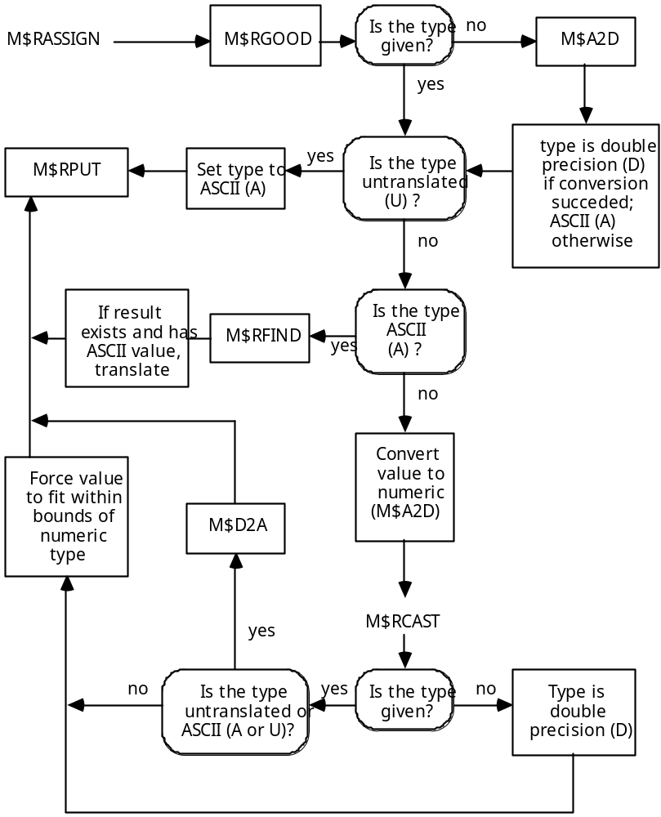

Figure 1 M$RASSIGN, M$RCAST, M$RGOOD and their Interaction

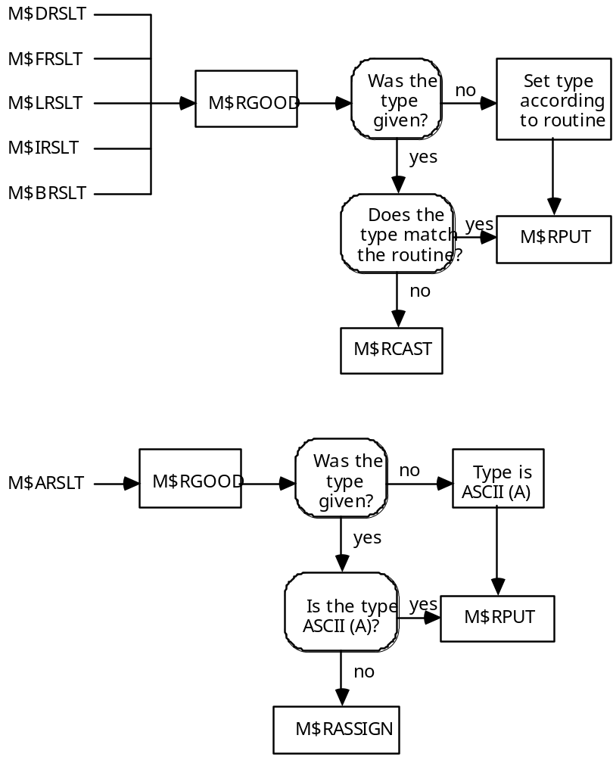

Figure 2 The M$xRSLT Routines as an Interface to M$RCAST and M$RASSIGN

The X-Midas Dictionary
The Midas external dictionary is the heart of X-Midas command parsing; it indicates, for every valid Midas command: its name, abbreviation, category, support, number of arguments, default argument values, and input/output or parameter behavior for each argument. The dictionary is always named commands.cfg and resides in the CFG area of the option containing the code for the commands that it defines. The system dictionary is also accompanied by a commands.tab file, which is a binary representation of this dictionary and is loaded during an xmstart. A user can also save a binary snapshot of their in-memory dictionary to a commands.tab that resides in their login area; if this file exists upon an xmstart, it is loaded instead of the system file.
The working dictionary remains in shared memory for fast lookup and does not change unless reconfigured with a configure command. The following fields in the Mt global structure define the memory-resident dictionary:

Mt.c_string - a string, L_command_chars in length, which contains the names, number of parameters, default parameter values, supports, and categories of all the commands, concatenated together sequentially. The name of the command will contain a semicolon and an option name if it is not a baseline command, as in “MARRAY;USER”.
NOTE: L_command_chars is very different from L_cmd_chars, which is the maximum length of a Midas command entered from the prompt.
Mt.ncommand - number of commands in the table; must be less than or equal to L_commands
Mt.c_alpha() - an array of 32 elements which comprise an alphabetical index to the list of commands. The array really only uses elements 1..26; it is sized to 32 for purposes of memory alignment within the structure. Each element corresponds to that letter of the alphabet (1=A, 2=B, etc.). Since the commands in Mt.c_string are already alphabetized, each number in Mt.c_alpha indicates the position in Mt.c_string where a new block of commands beginning with that letter begins. For example, Mt.c_alpha(3) will be the position in Mt.c_string where all the “C” commands begin. It is therefore possible for M$PARSE_COMMAND to find a group of commands with O(1) search time, leaving only a short O(N) search through that block.
The following are all arrays of L_commands elements; they contain information for each of the commands in the command table.

Mt.c_index() - the starting position in Mt.c_string of each command
Mt.c_namel() - the length of each command name
Mt.c_minl() - minimum abbreviation length of each command
Mt.c_key() - contains the category key for each command. See HELP CATEGORY for an explanation of the keys.
The dictionary is usually accessed through a call to M$PARSE_COMMAND or M$FIND_COMMAND, which is invoked to discover all the applicable information for a command, given just its unique abbreviation.

The History Buffer
All commands typed at the X-Midas prompt, including operating system commands and comments, are stored in the history buffer so that they can be either viewed using the HISTORY command or recalled using the RECALL command (or the up and down arrows). The history buffer is a pair of strings stored in Mt.h_string(0:1); it is therefore actually two history buffers, one for subscript 0, one for subscript 1. The buffer currently in use is indicated by the variable Mt.historyb, equal to either 0 or 1. When one history buffer fills up (i.e. the number of commands exceeds L_historys or the total number of characters exceeds L_history_chars), it is written to disk and the other history buffer is used for accepting new commands. Commands available for recall are only taken from the history still in memory; this “ping-pong” approach ensures that there will always be at least one full history buffer of the most recent commands in memory. There are two other “pair” arrays that can be indexed by Mt.historyb:

Mt.nhistory - the number of commands in that particular buffer. Must be
≤ L_historys.
Mt.h_index - an array of L_historys integers for that particular buffer; indicates where each command begins in Mt.h_string. The end of each command in the history is indicated by an ampersand (&).

The BLUE Header Definition
One of the most important structures in X-Midas is the BLUE header structure. All X-Midas files and pipes use one of these headers to define all the important properties of that particular file or pipe, and to keep track of certain “housekeeping” variables specific to that file or pipe, while it is in use. The purpose of this section is to discuss first the structure of, and then the purpose and meaning of every field in the X-Midas BLUE header.

Header structure
The X-Midas BLUE header is a 512-byte header on disk; it can also be accompanied by an extended header which, if the header is attached, appears at the end of the data in the file, and if detached, appears immediately after the 512-byte main header.

When a variable is declared to be of type /HEADER/, however, 1536 bytes are actually reserved, not 512. This is because the /HEADER/ structure actually has three distinct 512-byte members:

main an alias for all the fields that are written to disk. This field can be used to perform an optimized memory-to-memory copy, as in HCB1.main = HCB2.main, or for easy file input and output.
internals an alias for all the internal housekeeping fields.
buffer a 512-byte data buffer for general use. In VMS, this buffer is used in the low-level I/O routines to avoid repeated disk I/O. On the Sun, this behavior is left up to the operating-system cache.

The main and internals fields occupy the same memory as all the BLUE header fields and all the internal housekeeping fields, respectively (Figure 3).

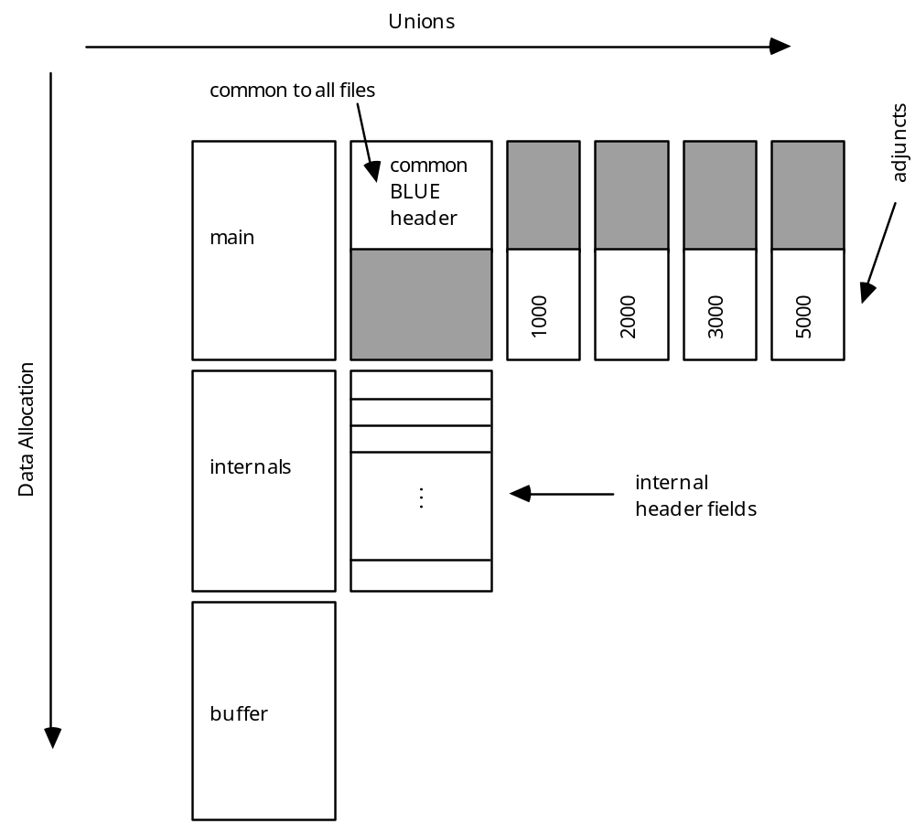
Figure 3 Layout of the BLUE Header Structure

The individual fields have the following meanings and significance:

The Main Header

version Either the letters ‘BLUE’ or ‘GOLD’.
head_rep Machine representation of the header , e.g. ‘VAX’, ‘IEEE’
data_rep Machine representation of the data
detached 1 if the header is detached from the data, 0 if not
protected 1 if the file is write-protected, 0 if not
pipe See section 3.1.3, “Piping”.
ext_start The offset of the extended header, expressed in units of 512-byte blocks.
ext_size If zero, no extended header; otherwise, the size of extended header in bytes.
data_start Where the file data begins, expressed in bytes from the beginning of the file, where 0 is the first byte of the file. Typically 512.
data_size Size of the data portion of the file in bytes.
type File type code, e.g. 1000, 2000, 3000, 5000
format The two-character format digraph e.g. ‘SF’, ‘SD’, ‘CF’, ‘8A’
flagmask For digitized data; not used at present. The idea is that the GRAB routines will zero out bit positions in the data wherever this field has a bit turned on.
timecode Absolute time of data acquisition expressed in seconds since midnight, January 1st, 1950 A.D. Serves as a reference point for the xstart, tstart, and rstart fields.
inlet See section 3.1.3, “Piping”, for a detailed explanation of this and the next seven fields.
outlets
outmask
pipeloc
pipesize
in_byte
out_byte
out_bytes

keylength Length of the keyword string in bytes
keywords 92-character keyword string { format to be described } This is the internal keyword table mentioned in the KEYWORD explain file.

The 1000, 2000, 3000, and 5000 type files have all the fields above in common. Each type, however, has it own adjunct that begins in the lower half of the 512-byte header:

Type 1000 and 2000 adjunct
xstart Where the file abscissa axis begins.
xdelta The file’s abscissa delta.
xunits The code specifying the abscissa units. See HELP UNITS_NAME for a complete list of units codes.
subsize Unused in a type 1000 file. In a type 2000 file, this is the frame size in terms of atoms. This and the following three fields do not have meaning in a type 1000 file. If a type 2000 file is HEADERMOD’ed to a type 1000, this field is unchanged, so that if the file is HEADERMOD’ed back to its original type 2000 format, its frame size will still be valid.
ystart Frame start.
ydelta Frame delta.
yunits Units for the frame.

Type 3000 adjunct
rstart Abscissa start.
rdelta Abscissa delta.
runits Units of abscissa; see HELP UNITS_NAME.
subrecords The number of subrecords per type 3000 record.
r2start This and the next two fields are not presently used in type 3000 files but are there to map on top of the similar fields in the type 5000 adjunct.
r2delta
r2units
record_length Length of a single record in bytes.
subr An array of L_subrecords subrecord structures. L_subrecords is presently 26. You cannot have more subrecords per record than L_subrecords.

Type 5000 adjunct
tstart Abscissa start.
tdelta Abscissa delta.
tunits Units of abscissa; see HELP UNITS_NAME.
components The number of components per record.
t2start Secondary abscissa start.
t2delta Secondary abscissa delta.
t2units Secondary abscissa units. See HELP UNITS_NAME.
record_len Length of each type 5000 record in bytes.
comp An array of L_components component structures. L_components is presently 14. You cannot have more components per record than L_components.
quadwords An array of L_quadwords double precision numbers. Used for systems modeling. The first quadword element is an ASCII string (e.g., ‘TOPOCENT’, ‘ECI’) which determines how the rest of the quadwords should be interpreted. Note that this first element is the frame_of_ref field in the type 5001 specifics, below—frame_of_ref is overlaid on the top of quadword’s first element.

There are also some fields specifically for type 5001 files:

Type 5001 specifics
frame_of_ref An eight-character string which indicates how the remaining fields should be interpreted. The first element of quadwords, above.
altitude Altitude, in meters, for TOPOCENT
latitude Latitude, in degrees, for TOPOCENT
longitude longitude, in degrees, for TOPOCENT
epoch_year The year of epoch for ECI
epoch_seconds Seconds of epoch for ECI
hour_angle GW angle, in radians, at epoch f ECI

Many of the fields in the internals header are used to communicate with the I/O routines; their complete behavior and expected values are covered in the Primitive Programmer’s Guide.

The Internals Header
file_name The full pathname of the file for the HCB. This and the following six fields are used to communicate with the various file I/O routines such as M$INOK, M$EXISTENCE, M$ALLOCATE, etc.
detach_name Full pathname of .DET file (the data) for a file with a detached header. The header is the one with the .TMP or .PRM extension.
type_allow A comma-separated list of allowed types that the file can have; used when opening files.
format_allow A comma-separated list of allowed or disallowed format codes that the file can have; used when opening.
qualifier The qualifiers used on the file.
label The name of a result that contains the name of the file. Used by SOURCEFILE and others like it for cases in which the file’s name may become changed mid-stream by changing the result parameter; the primitive may need to do an M$RFIND on this label again. MD$NEWFILE uses this field to change the file that is being read mid-stream; datastream DSESs need to use this function since they cannot expressly close and re-open files themselves.
switch A string of file switches to alter the ways in which files might be opened or processed. See the Primitive Programmer’s Manual for complete information.
extension Holds the file name’s extension.
qualifierlen Length of the string in the qualifier field.
file_lu Logical unit pointing to the open data file.
head_lu Logical unit pointing to the open header file. Will be the same as file_lu if the header is not detached.
exist .TRUE. if the file exists, .FALSE. if it does not.
open .TRUE. if the file is open, .FALSE. if not.
output .TRUE. if the file is open for output, .FALSE. if open for input.
dbpe Double precision bytes per element. Used primarily for certain type 2000 files and bit data where there may actually be a fractional number of bytes per element. This information is used frequently and is stored in the header to avoid constantly recalculating it. NOTE that this is the ONLY field used by the GRAB routines. Setting .bpe without also setting this field is futile. M$INOK and M$ALLOCATE normally set .dbpe for you.
size File size in units of logical elements.
offset File read offset in units of logical elements. It starts at zero and is used by M$FILAD and M$GRABX.
save_offset Used by M$GRABX; it is expressed in the same units that M$FWRITE and M$FREAD use: bytes from the beginning of the file. It is separated in the structure from the other save-buffer fields (described below) to ensure natural alignment (8-byte in this case).

If any of the five fields below have a negative value, it means that they are in units of bits, not bytes.

bps Bytes (or bits) per scalar.
spa Scalars per atom.
bpa Bytes (or bits) per atom
bpe Bytes (or bits) per element
ape Atoms per element.

The three fields below are all used by M$GRABX.

save_size Number of elements in the save buffer, in units of logical elements.
savebuf_loc Address of the save buffer. This is a direct memory address to a dynamically allocated buffer.
savebuf_len Length of the save buffer in bytes.

buffer_block The block number of the data in the header buffer, expressed in units of 512-block buffers. buffer_block is the number of the block currently residing in hcb.buffer; it is used by M$FREAD and M$FWRITE on the VAX.
xfer_len Transfer length, in logical elements.
cons_len Consume length, in logical elements.

scr_format Unused, available for filler
buf_mode Buffer format mode. Currently unused.
buf_type Buffer format type (LDFB).

readonly .TRUE. if open for read-only; .FALSE. if for read/write.
overwrite .TRUE. if the file can be overwritten; .FALSE. if not.

outlet If this header references a pipe and is used by a reader, this field contains the reader’s outlet number on the pipe.

ext_loc Direct memory address pointing to the extended header in memory.
ext_alloc Size of the memory used for the extended header, in bytes.

rtype File record type (VAX only). Either STREAM_LF or FIXED.

last_bits Bits in the save_bits byte.
save_bits Holds the last byte of packed bits in the event that a packed bit format file was last accessed on a non-byte boundary.
fill_bits Filler.
lph Location of piped header.

first_byte For file trimming. Where to start reading in the file.
last_byte For file trimming. Where to stop reading in the file.

The six fields below are all used by datastreams, and are explained in section 3.7, “Datastreams”.
first_buffer
status
mode
engine
active
blk
lu

Execution Control
This section describes how X-Midas parses a given command line and executes it, based on its support.

When X-Midas is started with the xmstart command, or re-entered with xm, execution begins with the subroutine M$SHELL. This subroutine, located in xmlib:shell.for, decides where to take commands from and how to execute them.

Getting the Command
If a macro is being executed, Mc.command_string is loaded from the macro buffer. The command will not need to be run through M$CLEAN to uppercase and delimit it, since everything in a macro has been M$CLEANed by the macro preprocessor. A macro is considered to be undergoing execution if Mc.macro_level is greater than Mu.spawn_level. A more straightforward check is to see if Mc.macro_level is simply greater than zero, but this kind of check could fool commands that have been spawned from within a macro. There should never be two processes trying to read the macro buffer at once. Mu.spawn_level is set equal to Mc.macro_level whenever a command is spawned, so if the macro level is greater that the spawn level, the shell knows that the executing macro belongs it its process.

This check also allows the STEP command to work from within suspend mode, where Mc.macro_level would be negative. Mu.spawn_level is set to -99 by the STEP command, causing this check to succeed and the command to be retrieved from the macro buffer. Immediately after this test, Mu.spawn_level is set to zero if it is less than zero, since Mu.spawn_level is always supposed to be positive. This means that when the STEP command executes, one command will be retrieved from the macro buffer, but the next time through the loop, the test will fail and the user will be prompted for the next command.

If the macro level is not greater than the spawn level, indicating that this shell is not executing a macro (this includes being in suspend mode), a call to M$GET_COMMAND is made. Normally this prompts the user for Mc.command_string, as well as handling the up- and down-arrows (for history substitutions), the final “?” for argument prompting, and the final “&” as a continuation character.

However, M$GET_COMMAND is also the routine from which X-Midas can be externally controlled. If Mc.masterslave is greater than or equal to 1, the session is assumed to be in the “slave” mode, meaning that the SLAVE primitive is running in the background, listening to a socket over which the corresponding “master” session (an X-Midas session running the MASTER primitive) sends command lines. The shell and the SLAVE primitive communicate only through shared memory, so they use Mc.masterslave as a handshaking mechanism to indicate when the shell wants Mc.command_string to be filled and when the SLAVE primitive has filled it.

Parsing the Command
To determine the support for the command, M$SHELL calls M$PARSE_COMMAND. This routine puts the correct values into:

Mc.command_support: one of the following:
I intrinsic
M macro (system or user)
O operating system command
! comment to be placed in history file
? blank entry line

H host primitive
G Gold command
F FPS processor command
S SSP-160 command
C Cray-MIDAS command
D Datastream primitive

Mc.command_name: a string containing only the name of the command. If this is not a command from the SYS option, this variable will also contain the semicolon and option name, as in “SINCOSINE;USER”. For macros and control sections, this will contain, when chaining, the complete name of the macro file, as in “MYMACRO;USER$03.CTL”. For this reason, macros that get split into segments cannot have names as long as macros that do not; and commands that are under a non-system option cannot have names as long as those that are baseline.
Mu.command_name: a process-local copy of Mc.command_name. This string is tacked onto an ERROR or WARNING message if the command encounters them from within a macro. M$PARSE_COMMAND sets it to “Parsing <Mc.command_name>...” while it is substituting defaults and caret (^) substitutions; afterward, it sets it to Mc.command_name. This is done so that errors that occur as part of parsing appear as such when a macro writer is trying to debug their macro.
Mc.number_parameters: the number of arguments (parameters) required for the command named in Mc.command_name; retrieved from the entry in the Midas dictionary for that command.
Mc.global_switch_string: contains all of the global switch strings concatenated together. When outside of a macro, it is only a single slash (/). Switches added onto a command at the X-Midas prompt are concatenated to it. If there are any switches on the macro definition line, they are added following a vertical bar. No matter whether there are macro definition switches or not, an extra slash is always appended to the switch string to indicate that the macro is down another level. You can find the switches that a macro was invoked with and the switches that were on its definition line according to the following pattern:
//<at macro invocation>/|/<on definition line>/
In other words, if the macro had the switches /DEF1 and /DEF2 on its definition line, and was invoked with the switches /ABC and /GHI, the global switch string would look like this: //ABC/GHI/|/DEF1/DEF2/ Therefore, when the string is searched left to right, the switches added closest to the interactive prompt have the highest precedence.
When a macro terminates, it removes the switches it had on its definition line and with which it was invoked. It does this by searching backward for a double slash (//) which indicates the last time a new macro level was entered, and deletes everything from there to the end.
Mc.global_switch_length: the number of characters in Mc.global_switch_string.
Mc.switch_length: Local switches are stored along with the command name and arguments, immediately after the command name but just before the first argument. Mc.switch_length indicates the position of the last character of the last switch in Mc.command_string. If there are no switches, Mc.switch_length will be 0. The functions M$GET_SWITCH and M$GET_USWITCH both call M$FIND_SWITCH, which searches first Mc.global_switch_string for switches on the command line, then Mc.command_string(1:Mc.switch_length), then Mc.global_switch_string again for switches on the macro definition line to find the given switch. All searches take place left-to-right. This search order gives switches the proper precedence:
1. command-line invocation switches
2. switches on a command within a macro
3. switches on a macro definition line
Mc.ds_engine: The number of the datastream engine being used. -1 if the command is not a datastream command; 0 if it is the local engine. If the command support does not follow the “D” with a number or the name of some specific engine, this field will be set to Mc.ds_def_engine, the default datastream engine.
Mc.command_string: The command, its switches, and its arguments. It will have any applicable defaults substituted in from the dictionary and will have any results names which are preceded by a caret (^) replaced by the ASCII representation of their value. It will also be properly uppercased and delimited by M$CLEAN if the command was found in the Midas dictionary; otherwise, it will have been assumed to be an operating system command and left unchanged.
If a macro is being executed, it will also find all instances of “P_00” and substitute in the current macro level for the “00”.
Mc.command_length: the number of characters in Mc.command_string.
Mc.number_parameters: the number of command-line arguments listed for this command in the dictionary. If that number was -1, meaning an indefinite number of arguments, Mc.number_parameters will be the number of parameters actually entered by the user.
Mc.verbose: .FALSE. if the /QUIET switch was asserted; .TRUE. if it was not.

M$SHELL then uses the character in Mc.command_support to decide where to pass execution control. Since the Mc structure is global, M$SHELL usually needs only to decide which routine should be executed next, and let that routine take what it needs from the Mc structure. The routines that handle the various supports are described below.

Macros
The routine M$RUN_MACRO, called if the command support is “M”, is located in xmlib:shell.for along with M$SHELL. This subroutine does not run a macro to completion; rather, it loads the macro buffer and assigns the values of command-line arguments to temporary result parameters. As described above under “Getting the Command”, a macro gets executed a line at a time by putting the entire shell into a “macro execution” mode. This “macro mode”, indicated by Mc.macro_level being nonzero (a negative value indicates suspend mode—the macro remains loaded), is terminated by the ENDMODE command, which calls M$ENDMODE. Therefore, the macro buffer “cooperates” by always ending with an ENDMODE command. This condition is ensured by the macro preprocessor. (See section 3.1.2, “The Macro Preprocessor”, for details.

The name of the macro to be loaded is stored in Mc.command_name. If the name begins with “%”, M$RUN_MACRO opens the .MCR file located in the user’s HOMEPATH directory; if not, it is opened in the MCR area of the command’s option as listed in the dictionary. See section 3.1.1, “Macro Execution”, for a more detailed description of this process.

Just after loading the macro buffer, the shell checks for the /XPIPE or the /PIPE switch. If either of these exist, the shell runs XPIPE or PIPE respectively through the M$RUN_PRIMITIVE command. These primitives are shells of their own; they take over the macro buffer and run it themselves. See section 3.1.3, “Piping”, for a detailed explanation of this process.

Without the /PIPE or /XPIPE switch, the macro is considered a sequential macro, meaning that commands are executed, to completion, one after another, until the macro ends. The following section describes how such macros are executed, although many of the issues apply to piped macros as well.

Macro Execution
When the shell determines that the name and arguments typed at the prompt belong to a macro, the shell calls M$RUN_MACRO, which takes the string in Mc.command_name, opens the appropriate .MCR file, and loads the macro buffer with its contents.

There is no special “execution shell” for macros; the same shell is used to execute macro commands as is used to execute commands from the prompt. (See section 3, “Execution Control” for further information.)

Getting It Started
Before the macro buffer can be used, however, a number of housekeeping chores have to be performed:

• Mc.macro_level is incremented so as to avoid local variable collisions. This variable is then decremented when the macro terminates; it is therefore an indicator of how many macros are in progress—how deeply they are nested. If its value is negative, it indicates that the macro is in suspend mode.
• If this is a macro being called from another macro, M$RUN_MACRO attempts to let them share the macro buffer. If they can, it is important to know both where the calling macro began and where it was executing. This is done through two arrays of L_macros integers:
Mc.macro_top() holds a pointer to the beginning of each nested macro in Mt.m_string (see section 1.2.1, “The Macro Buffer”). The pointer is not an indicator of the character position in the string but of the number of the first executable command in the buffer—the same way Mc.macro (see section 1.2.1, “The Macro Buffer”) is interpreted.
Mc.macro_return() holds a pointer to the next executable statement of each nested macro in Mt.m_string; it is interpreted the same way as Mc.macro_top(). In addition, its value will be negative if the macro was in suspend mode; positive if executing normally. Thus, if the user is in suspend mode with one macro and invokes another macro at the S-Midas prompt, the second macro will not “inherit” the suspended nature of the first one.
However, if the newly invoked macro will not fit in the existing buffer, the buffer is swapped out to the X-Midas temporary directory, under the name MACROTEMP<Mc.macro_level>_<parent process>.MCR . The temporary directory’s name is held in the operating system symbol XM_TEMP; it is the /tmp directory under UNIX and XMAREA:[TEMP] under VMS. Because there is not a separate temporary directory for each user, the parent process ID (held in the operating system symbol XM_PPID) must also be part of the name, to prevent collisions with other sessions. Note that the values in Mc.macro_top() and Mc.macro_return() are not changed if this swapping occurs; when the MACROTEMP file is swapped back in later, the previously stored top and return values will be correct for that file since they were correct at the time of swapping.

• The macro pointer (Mc.macro) is positioned at the first executable statement of the new macro. If the new macro has been added into the same macro buffer as the previous one, Mc.macro will be moved past the end of the old macro.
Macro Command-Line Parameters and Defaults
The values that the user entered on the command line when the macro was called are assigned to the names of the result parameters listed on the first line of the .MCR file by calls to M$RASSIGN. For example, if the user entered:

X-Midas>%mymacro 7 the_file
and the first line of the MYMACRO.MCR file in your HOMEPATH directory was

MYMACRO,N:P_00FIRST[1],A:P_00SECOND,N:P_00THIRD[50],
then assuming Mc.macro_level is 1, the following calls to M$RASSIGN are made:

call M$RASSIGN('N:P_01FIRST', '7')
call M$RASSIGN('A:P_01SECOND', 'THE_FILE')
call M$RASSIGN('N:P_01THIRD', '50')

M$RUN_MACRO handles the substitution of user-defined defaults, M$PARSE_COMMAND handles the insertion of “01” into the result names for the command-line parameters, and M$RASSIGN handles the casting of the ASCII representations of the values into their correct type.

The above example dealt with user macros stored in the user’s HOMEPATH directory. The procedure with system macros is identical, with the exception that defaults are taken from the Midas dictionary. (See section 1.2.3, “The X-Midas Dictionary”, for further information on this topic.) M$PARSE_COMMAND actually inserts the default arguments from the commands.tab dictionary entry into Mc.command_string, so that by the time it arrives at M$RUN_MACRO, it is as though the values were supplied at the command line. The defaults in the commands.cfg dictionary therefore “override” defaults listed in brackets in the macro itself. Generally, installed macros (those with entries in a commands.cfg) are not coded to have bracketed defaults.

Loop Execution
Every macro command goes through the Midas shell, which is a command interpreter. This means that a macro executes its control constructs (e.g., WHILE, LOOP, GOTO and BREAK) somewhat differently than compiled programming languages.

Mc.loop_top and Mc.loop_level are both arrays of L_loops integers and keep track of the nested loops in progress. When a WHILE or LOOP command is encountered, Mc.loop_level is incremented and Mc.loop_top(Mc.loop_level) gets the “line number” (the value of Mc.macro) of the WHILE or LOOP command. If the command is LOOP, Mc.loop_count(Mc.loop_level) gets the number of iterations requested.

When an ENDWHILE or ENDLOOP command is encountered, Mc.macro is set to Mc.loop_top(Mc.loop_level) and execution continues. If the command was ENDLOOP, Mc.loop_count(Mc.loop_level) is decremented and its value assigned to the associated results parameters, if it was given. (See EXPLAIN LOOP.)
When a loop terminates, Mc.loop_level is decremented. The primary consequence of this kind of housekeeping is that it is somewhat dangerous to simply point Mc.macro somewhere else and keep executing (e.g. with a SKIP command from suspend mode), because the loop context is updated only when encountering the first and last statements of the loop. Note, in fact, that when a macro is called from another macro, it continues to increment the same Mc.loop_level, meaning that the first loop encountered in a nested macro might have a level > 1. This has no effect on the proper execution of the loop, but it does mean that it is somewhat easier to exceed L_loops than the macro writer might expect.

The BREAK and GOTO commands must therefore take this into account. A BREAK command advances Mc.macro one step at a time, looking for the first ENDLOOP or ENDWHILE; when it finds it, Mc.loop_level is decremented and control returns to the macro.

The GOTO command must be able to move both backward and forward, and searches not for the end of a loop but for its associated LABEL statement. It must decrement Mc.loop_level when it finds ENDLOOP, ENDWHILE, LOOP, or WHILE commands since jumping back past the beginning of a loop also terminates it.

Furthermore, the GOTO command must be given an initial direction in which to begin moving, since it moves in a relative and not an absolute manner. This direction is usually supplied by the preprocessor but can be overridden by giving it explicitly in the macro source code. (See Section 3.1.2, “The Macro Preprocessor” and EXPLAIN GOTO.)

Large Macros
Macro .TXT files that are unusually large may have been split up into multiple .MCR files by the preprocessor (see Section 3.1.2, “The Macro Preprocessor”). If the name of the macro source file was MYMACRO.TXT, and it was split up into three .MCR files, they will have the names MYMACRO.MCR, MYMACRO$01.MCR, and MYMACRO$02.MCR. The last line of MYMACRO.MCR will be ENDMODE,MYMACRO$01. This performs another call to M$RUN_MACRO, which loads the file MYMACRO$01.MCR into the macro buffer, but does not increment the macro level or destroy local variables or command-line parameters. The next part of the macro continues executing without interruption, transparent to the user.

This is a consequence of the ENDMODE command itself: if it has no arguments, it terminates the macro entirely, destroying local variables (result parameters that begin with P_<macro level>) and command line parameters and decrementing the macro level. With an argument, it chains to the named macro—passing execution control to that macro without expecting to return, leaving the results table intact. This is done with a call to M$CHAIN_MACRO. This differs from simply invoking a macro from within a macro; in that case, the normal execution process causes the called macro to have separate local variables and command-line values, and returns to the calling macro when it terminates.

What this means is that the ENDMODE command can be used to chain to any macro, not just the next .MCR file in a series. This is a rather esoteric usage of the ENDMODE command, but the capability exists.

Some commands, such as WHILE and LOOP, must execute in their entirety within one macro buffer. Others, such as GOTO, IF, and SKIP, can step across the “boundaries” between .MCR files belonging to the same macro. They do this by use of the M$LOAD_MCR function, located in xmint:macro.for. This command passes back the indices in the macro buffer (see section 1.2.1, “The Macro Buffer”) to the next command to execute from the macro. Its most important function is to determine if the macro pointer is at the top or bottom of the macro buffer, and to reload the macro buffer from a previous or subsequent .MCR file, if necessary and if possible. Any commands which use this function to step through the macro buffer will not be limited by the size of the macro buffer.

The Macro Preprocessor
Before macros can be executed, they must be preprocessed with the MTRANSLATE command. If you used the MEDIT command to edit a macro, this is done automatically. The preprocessor performs the following functions:

• Adds the placeholder “P_00” to the front of command-line parameter names. Command-line parameters are like local result parameters; they should not “collide” with the parameters of other macros which they may call (or which may have called them). In order to do this, Mc.macro_level is written over the two zeros whenever they are referenced from within a running macro. The “P_<level>” ensures that the results parameters which hold the command-line values will be destroyed when that macro level terminates.
• Changes the “P_” heading for local variables to “P_00”, as a placeholder for the macro level. Thus they are given the same form as command-line parameters and will act the same way, not colliding with local variables in other macros and being deleted upon completion of the macro.
When MTRANSLATE sees the LOCAL keyword, it puts all the names following it into the same array as the command-line arguments, causing them to get the “P_00” placeholder in front of their names as well. They are not implemented in some special way; it is only a preprocessing step to save the macro writer some typing and make the macro more readable.
• Checks for explicit typing of command-line parameters. When assigning values at the X-Midas prompt with RESULTS or ASK, type information is optional; if the type is omitted, it is assigned based on whether the value can be converted to a number or not. In a macro, however, the type must be given explicitly on the command line. This is done to ensure that a macro will run correctly in an unpredictable results environment. For example, a user might pass the argument “A” to the macro during a time when there exists both a numeric results parameter named “A” and a file named “A”. Each type emulates some PICK routine (see section 3, “Command Line Parsing”):
Table 3 Checks for Explicit Typing of Command-Line Parameters
Type | Description | PICK routine
A | ASCII | M$APICK
U | Untranslated ASCII | M$UPICK
D | Double | M$DPICK
N | Numeric | (same as Double)
L | Long integer | M$LPICK
I | short Integer | M$IPICK
B | Byte | M$BPICK
_  (underscore) | assumed | M$_PICK

NOTE: there is no type “S” to correspond to M$SPICK, since logical (state) values cannot be stored in the results table as such.

At run-time, the label (with type information attached) and the ASCII representation of the value that was entered on the macro's command line are passed directly to M$RASSIGN. (See section 3.1, “Macro Execution”.)

• Adds the explicit direction arguments to GOTO commands based on their position with respect to the LABEL command that they reference. A GOTO command can be executed interactively from the S-Midas prompt; it moves the macro pointer through the macro to the correct LABEL command. It must therefore know which direction to begin searching in—either backward or forward. The writer of a macro should not have to worry about this, so the preprocessor keeps a table of the LABELs encountered and adds the direction argument to each GOTO command if it has not been added already. The functions LABEL_INIT and LABEL_INS, which are local to the macro preprocessor, perform this function.
• Processes continuation characters and takes out comments. This is actually done by calls to M$NEXTLINE, which returns the next relevant line of the macro file; any continuation characters ending a line cause it to be concatenated to the next line until either there are no more continuation characters or the maximum characters allowed are exceeded.
• Converts one-line IF statements into equivalent block IF structures. The block IF structure is the only executable form; the one-line IF statement is simply a source-code shortcut. The command which composes the THEN-action of the one-line IF can be any valid X-Midas command; it cannot be an operating system command or part of some other structure (e.g. IF, ELSE, ELSEIF, ENDIF, WHILE, ENDWHILE, LOOP, ENDLOOP). The preprocessor does not specifically watch for these cases; they may indirectly cause other errors such as improper loop structures, or bizarre run-time behavior. In addition, the preprocessor will not notice or complain if you attempt to put an operating system command or illegal command in the THEN-action of a one-line IF.
All other preprocessing, such as local variable and command-line parameter substitution, and the addition of a direction argument to the GOTO statement, are performed explicitly on the THEN-action.
• Splits large .TXT files into a series of .MCR files in order to make each executable portion of the macro small enough to fit into the macro buffer. The size of the macro buffer is determined by the parameters L_macrolines and L_macro_chars, both defined in xminc:tables.inc. (See section 1.2.1, “The Macro Buffer”.)
The “macro splitting limits”—the number of lines or characters after which a new .MCR file is written—are determined by the /DIV switch for the preprocessor. The value of this switch is the percentage of the macro buffer at which the split should occur. If the switch is omitted, its value defaults to 75 (i.e. three-fourths of the macro buffer). Therefore, the preprocessor normally writes a new .MCR file as soon as the number of processed lines exceeds L_macrolines * .75, or the number of processed characters exceeds L_macro_chars * .75. (See section 3.1, “Macro Execution”, for a description of how the series of .MCR files is executed as one macro.)
X-Midas requires that WHILE and LOOP structures fit entirely within one macro buffer. This is so that they will execute with maximum speed, not having to go to the disk to retrieve intermediate sections. The preprocessor is intelligent enough to put a loop in its own separate section if necessary; the only constraint with which the writer of a macro need be concerned is the number of commands that comprise the entire structure. If larger loops are required, a combination of IFs and GOTOs (neither of which are limited by the size of the macro buffer) can be used to perform a loop.
• Creates a .CTL section for the macro if it contains a CONTROLS section. If this control section is large and must be split into multiple .CTL sections, it is done the same way that .MCR sections are done.
• Transforms the keyword ENDMACRO into an ENDMODE command at the end of the macro buffer. In this way ENDMACRO and ENDMODE are functionally the same. However, the last line of the macro body must be ENDMACRO or another ENDMODE will be added automatically.

Piping
This section will describe the meaning of the X-Midas common variables and the header block fields with respect to piping, and how the library routines interact to make a piping system work. It does not discuss the way you should think about a dataflow pipe, nor does it discuss how pipes are used at a user level (that is covered in Notes on Piping and the X-Midas User’s Guide).

Definitions
pipe system A macro executing with the /PIPE or /XPIPE switch. All primitives without the /NOPIPE switch in the macro will be executing concurrently and can pass data to one another via pipes. User interaction occurs through controls.
pipes Circular buffers in shared memory. To the low level I/O routines, they look like infinitely extending files, but they are actually implemented as circular buffers.
widgets Located in shared memory, controls are simply real-time result parameters that can be altered interactively through the XPIPE menu or CONTROLS section of the macro.
controls Widgets which are polled frequently by their associated primitives. Altering the control’s value interactively has no effect unless the primitive asks for and uses the value.

Piped Macro Execution
When a macro is executed, as soon as it is loaded into the macro buffer, the shell checks for the /PIPE or /XPIPE switches. If found, either PIPE or XPIPE is executed; these primitives take control of execution and do the following:

1. Check the macro buffer for references to pipes; that is, filenames beginning with an underscore. If the /NP switch is found, its value is taken to be the number of pipes, not the number encountered during this check. This initial check is not very reliable since it is not actually executing commands in the macro and therefore cannot know if some pipes are skipped over by an IF command and so forth. It only checks the first buffer; if the piped macro has been split into multiple buffers by MTRANSLATE, the /NP switch will become necessary.
2. Start executing commands from the top of the macro. Intrinsics, non-pipeable primitives, operating system commands, and primitives with the /NOPIPE switch are executed to completion. (Note that even with the /NOPIPE switch, if the command is pipeable, it will be executed in its own process; however, the XPIPE primitive will wait until it has finished completely before proceeding.) Other primitives are executed as far as their M$SYNC call, which will block the calling primitive until an ENDMODE command is encountered.
3. When the ENDMODE command is encountered (remember ENDMACRO is translated to ENDMODE by the macro preprocessor), all the M$SYNC calls return and the primitives begin executing concurrently.

The various library routines involved with piping communicate via the variables Mt.npipe, Mc.status, and Mc.mode. Mc.status is described in section 1.1, “The Midas Common Structure”. Mt.npipe and Mc.mode have the following meanings:
Table 4 Mt.npipe and Mc.mode Value Definitions
Variable | Values | Meaning
Mt.npipe | -1 | Pipe system is off. M$EXISTENCE uses this variable to determine whether to configure an HCB with an underscore on the front of its name as a pipe or not. This information is then stored in HCB.pipe, where it is used by other routines to know how to treat the pipe.
 | 0 | Pipe system is up; no pipes in place. This condition may mean either that someone is running a piped macro without actually using pipes or that not all the pipes have been allocated yet.
 | > 0 | Pipe system is up, with Mt.npipe pipes in place
Mc.mode | 0 | No piping enabled—standard file-to-file operation
 | 1 | Pipe system up; in pause mode
 | 2 | Pipe system up without controls
 | 3 | Pipe system up with controls
 | -1 | Preamble stage execution of a non-piped command
 | -2 | Preamble stage without controls
 | -3 | Preamble stage with controls

Note that when Mc.mode is greater than zero it means that the piped system is in a running mode. This is the condition on which M$SYNC waits.

In summary, then, when XPIPE or PIPE takes control and begins executing the macro, Mt.npipe is set to zero. The macro buffer is checked (or the /NP switch is found) and Mt.npipe is set accordingly. Remember, this initial check is not taking into account which parts of the macro might actually be executed. For this reason the scan might think the number of pipes is larger than it is. This is fine; the macro will be unable to execute only if too little space is reserved beforehand. For this reason, when the /NP switch is used, its value should be an overestimate. Mc.mode is set to some negative value and each command in the piped part of the macro is executed as far as it is allowed. For normal primitives without /NOPIPE this means as far as the M$SYNC call, which blocks until Mc.mode is positive. When all the primitives in the piped part of the macro have finished their preambles, Mc.mode is set positive, all the M$SYNC calls return and the piped primitives begin running concurrently.

The other importance of the M$SYNC call is that it indicates when the primitive is done reading shared memory that is used for parsing (such as doing any kind of PICKing of its arguments). For this reason, when a primitive is invoked with the /BG switch, the shell waits after the M$SPAWN call (which actually creates the process) until Mc.status becomes not equal to zero, indicating that M$SYNC has been called, or that the primitive has completed one way or the other.

How Data Flows Through a Piped System
Neither the XPIPE nor the PIPE primitive actually supervise the moving of data through the pipes or do any data movement. All data movement is done via library routines that are called indirectly by the primitives. M$FILAD, for example, decides whether or not to do an M$FWRITE or M$PWRITE based on the .pipe field of the HCB (Header Control Block).

In fact, the entire definition of the pipe is carried around in its own HCB and is not intrinsically part of the XPIPE or PIPE primitives. The following fields make a pipe different from a regular file:

integer*4 pipe

integer*2 inlet
integer*2 outlets
integer*4 outmask

integer*4 pipeloc
integer*4 pipesize

real*8 in_byte
real*8 out_byte
real*8 out_bytes(L_outlets)

The pipe field is equal to zero if the HCB refers to a normal disk file. If nonzero, it refers to the pipe’s ID number, which is the number of the pipe in the order it was encountered as the pipe macro was executed.

A pipe, in theory, is a piece of shared memory through which data flows. You visualize data entering from one end and leaving from another. In reality, a pipe is a circular buffer of data. The inlet and outlets chase each other around the pipe, wrapping back to the top of the buffer after running off the bottom.

The inlet field indicates the number of the datastream engine that owns (writes to) the pipe. If it’s located on the host, inlet is 0. If the pipe is closed, i.e. does not have a writer anymore, inlet is -1.

The outlets field indicates the number of readers that are currently connected to the pipe. A pipe without any outlets is a “bit bucket”; the writer will never be blocked.

The pipeloc field is simply the address of the pipe’s data buffer in memory; pipesize is the buffer’s size in bytes.

A pipe can have multiple readers (up to 8 at one time) but only one writer. Pipe readers can be synchronous (the usual mode) or asynchronous. Synchronous readers do not wish to lose any data that comes through the pipe; asynchronous readers only want to see the present data in the pipe, even if that involves missing the data between their last read and the present position. This “present position” is actually the last (nearest out_byte) chunk of data that is aligned properly with dbpe, so that even an asynchronous reader will never get some nonsensical piece of data resulting from crossing logical element boundaries.

Presently only XRTPLOT and XRTRASTER read asynchronously; this is done by first setting the HCB’s cons_len field to -2, to indicate asynchronous reading, and then doing an M$CLOSE on the HCB, to remove that reader from the outmask field. The negative consume length causes M$PREAD to be invoked with a negative offset argument, telling it to advance by multiples of dbpe until it gets into the pipe.

To ensure data integrity for synchronous readers, the data in one part of a pipe must have been read by all the synchronous readers before that part of the pipe can have new data in it. If one of these readers is failing to read its data, this can result in the entire pipe becoming “clogged” and the macro “hangs”. This is a direct result of the implementation of the pipes as circular buffers: part of the pipe that has data to be read will be needed eventually by the writer to continue writing.

Though the pipes are circular, they are not treated as such by the fields of the HCB. The in_byte, out_byte, and out_bytes fields are all in the units of “absolute” or cumulative bytes. Zero is the beginning of the pipe and they grow toward infinity (or the maximum number that can be represented by a double precision number). The values of these fields therefore represent the number of bytes of data that have passed through this pipe since the beginning of the macro. These are the numbers that appear in a PipeDump or a Pipe Monitor (debugging options that can be chosen from the X-Pipe menus). However you can still imagine a pipe of finite size moving along this stream (Figure 4). The leading edge of this pipe is in_byte; the trailing edge can advance no farther than .out_byte.

out_bytes is an array of cumulative byte values, one element for each reader. When the writer of the pipe prepares to write, it takes the smallest value in this array and stores it into the out_byte field. If the writer needs to overwrite part of the pipe, it can overwrite up to this point but not there or beyond. NOTE that only the elements of out_bytes belonging to synchronous readers are checked.

in_byte is expressed in the same cumulative byte units; it indicates the location of the last piece of valid data. If a reader reads up to this point, it must wait until more is written. If out_byte is equal to in_byte, the pipe is considered “empty”.

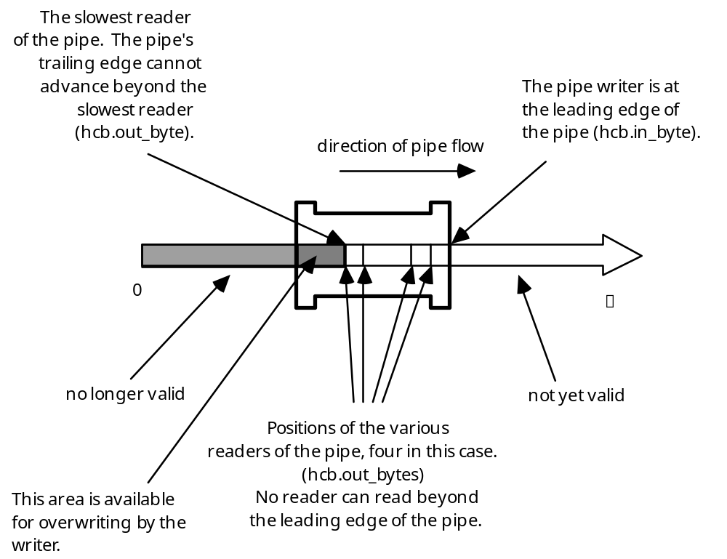
Figure 4 Piped System Data Flow
Within the X-Midas library routines, everything is kept in terms of cumulative bytes, which suggests the model of an infinite pipe in which no “clogging” or “hanging” should occur. However, this model meets the real world in the subroutines M$PWRITE and M$PREAD. These routines take the same arguments as M$FWRITE and M$FREAD but convert the cumulative offset argument, via MODs, into the actual offset into the circular buffer. If incrementing in_byte by one more will cause it to map onto a place in the pipe where it will be beyond the place where out_byte maps to, the pipe is full and no more writing can take place. In other words, there are pipesize unread bytes in the pipe.

However there is more than one way to hang a pipe. If a reader asks for data that is “ahead of” in_byte, that reader will be blocked until enough is written so that in_byte reaches that point. And of course, if a reader asks for more data than is actually present in the pipe, they will be blocked until the pipe fills up that far.

M$PWRITE is the routine that does low-level writes to a pipe. It performs the polling of all the offsets in out_bytes, the checking against outmask, and the setting of out_byte. Also advances in_byte after it has finished writing.

M$PREAD does low-level reading of a pipe. It will hang if either the given offset indicates a position beyond in_byte (i.e. it is “ahead” of the pipe) or there is not enough data in the pipe to satisfy the read. It polls in_byte, Mc.break, and the inlet field. As described above, if the inlet field becomes -1, it means the pipe has closed and M$PREAD can return with whatever it has.

The bits of outmask, from bit 0 (least significant) to bit 31 (most significant) have the following meanings (bit ON means TRUE, bit OFF means FALSE):
Table 5 outmask Bits Definitions
0-7 | whether or not the reader with the number of that bit is synchronous
8 | host involved. Host is NOT involved ONLY IF all the readers and writers of the pipe are on a single foreign datastream engine (because the host doesn’t have to shuffle bytes around on it)
9 | FOREIGN datastream engine involved
10 | LOCAL datastream engine involved
11 | datastream algorithm used to determine pipe size
12 | pipe size qualifier specified explicitly
13 | feed through: if TRUE, means that data is going FROM one foreign engine TO another foreign engine and this probably means that the pipe is duplicated on the host, at least at present
14 | (not used)
15 | (not used)
16-31 | whether or not each of the 16 possible foreign datastream engines are involved

Further Elements of a X-Piped System
There’s more plumbing in an XPIPEd macro than just pipes. There is direct access to the control widgets of the pipe’s primitives and a user-defined controls section.

Whenever a piped system is brought up, five separate sections of shared memory are allocated:

pipe headers The headers of all the pipes in the macro.
pipe buffers The data buffers of all the pipes in the macro.
control widgets Memory for every menu and numeric widget initialized by the total of all the primitives in the macro.
message queue Memory for the message queue.
datastream structures
{ to be described }

All of these sections are allocated by the M$MAP_BUFFER function. Although only the first such call actually creates the shared memory, and all subsequent calls map onto the same section, each process does allocate virtual memory for that section in its own process.

M$MAP_BUFFER is called with one of the following flags: LS_pipe_headers, LS_pipe_buffers, LS_cntrl_widgets, LS_messages, or LS_ds_structs. These five flags are actually integers; calling M$MAP_BUFFER with a negated flag unmaps the buffer. The last caller to unmap the buffer causes the section to be destroyed.

In the section above, we have already discussed the mechanisms and significance of the pipe header and pipe buffer sections. We will now discuss the remaining sections one at a time.

Control Widgets
The words “widget” and “controls” are used almost synonymously throughout X-Midas, because the primary use of a widget is to effect control over some aspect of a piped primitive, to be able to adjust one of its input parameters in an interactive, real-time fashion. Actually, a widget is simply a real-time numeric result parameter. The menus or HP-instrument style boxes that the user interacts with are referred to as X-widgets; interactions with X-widgets immediately change the value stored in the widget itself.

You can also change the value of a widget by assigning a value to its associated result name. Such names might be “W_3”, if you use the absolute widget index (the number of the widget counting from the top of the macro), “W_2001” if using widget banks, which allow a widget to be named by a primitive number followed by a relative widget index, or an arbitrary result name bound to the widget with a /CTAG switch. Though the interface changes, assignments to such result-like names cause change which is as immediate as the interaction with an X-widget.

Since widgets are no more than storage locations, the only way they can control a primitive is if the primitive is coded to be controlled by a widget, polling its value every time it makes another iteration through its data processing loop and using that value in its calculations.

Widgets are created by an M$xWINIT call such as M$MWINIT (menu widget), M$LWININT (long integer widget), M$FWINIT (floating point widget), or M$DWINIT (double precision widget). This assigns the widget a number, which starts at 1 with the first widget encountered and increments with each successive WINIT call.

The memory cost for widgets is as follows:
Table 6 Widget Memory Cost
Long integer | 32 bytes
Floating point | 32 bytes
Double precision | 48 bytes
Menu | 27 bytes plus the length of the string, rounded up to the next multiple of 4

There is no way for the XPIPE primitive to determine beforehand just how many widgets will be created by the primitives in its macros; that is, how many M$xWINIT calls will be made. The amount of memory also varies with the type of widget, and with the menu widget, is dependent on the length of the menu string. XPIPE is generous and assumes 48 widgets at 64 bytes apiece. If the /NW switch is present, its value, multiplied by 64, is used to determine how much space is reserved in the control widgets section.

Control Section Execution
Only XPIPEd macros can have control sections because it is the XPIPE primitive that executes them. When the macro preprocessor sees the keyword “STARTCONTROLS” in the macro .TXT file, it begins generating .CTL files instead of .MCR files. When the user chooses the “Controls” item on the XPIPE menu, XPIPE brings up the all the X-Widgets associated with the XCONTROL statements in the macro.

{ more to be described }

When the code associated with a particular control is executed, it is executed sequentially, much like a standard macro. However, this part of the macro is not free to go into suspend mode, and cannot perform an image exit in the case of an ERROR—to do so would bring down the entire pipe system.

Furthermore, even normal execution of the primitives via M$RUN_PRIMITIVE cannot be done on a VAX since even successful image execution requires an image exit of the calling process.

Primitives
Therefore, all primitives are spawned with a flag to M$SPAWN of 1, causing XPIPE (the parent) to sleep until the primitive finishes, whether it finishes successfully or not. The XPIPE primitive is therefore insulated from errors in primitive commands.

Intrinsics
Intrinsics, however, are executed within the XPIPE image, since they are only subroutines and do not cause image rundown in the case of success. (See section 3.2, “Intrinsics”.) However, if an intrinsic encounters an ERROR, the XPIPE image will exit and the user will be left in P-Midas> mode.

Macros
If a control section executes a macro, that macro is run, in a sense, in the XPIPE process. Since there is only one shared global macro buffer, it is the only one that can be used. But within the nested macro, the same rules apply as to commands executing in the original control section itself: pipeable commands are spawned synchronously (i.e., the parent waits on the child), and intrinsics are executed in the XPIPE image. Therefore, the danger from stopping the macro because of an error in an intrinsic applies not only to intrinsics coded directly in the control section itself but to any intrinsic in any nested macros at any level.

Piped Macros
Piped macros cannot be executed from within a control section. All of the memory and fields dealing with the state of a piped macro and the pipes themselves are all stored in global shared memory; since the XPIPE primitive is using them, no other piped macro can run until it is finished.

Intrinsics
The routine M$RUN_INTRINSIC, called if the command support is “I”, is located in the file xmint:run.for. Based on the first four characters of Mc.command_name, it makes a call to the appropriate MI$ subroutine, which will be part of the xmlib:MIDASLIB executable image. It is important to realize that intrinsics are executed in the same image as the caller, both under UNIX and VMS, since they are coded and executed in both places as subroutines. They do not make a call to M$RETURN when they complete; they simply return from their call.

In the controls section of a piped macro, this means that an error encountered in an intrinsic will shut the entire piped macro down.

Under VMS, the intrinsics are all copied into one large file called intrinsics.for, which is compiled into the XMIDASLIB image. Under UNIX, each intrinsic is compiled to its own .o file; these files are linked into a single shared library, intrinsics.so, which the MIDASLIB image links to itself as soon as the user executes an intrinsic command. The image remains linked until the MIDASLIB image itself exits. This is done so that under piped mode, when each part of the pipe will have a separate instance of MIDASLIB, processes not using intrinsics will not be linked to them and therefore be “charged” for the space of their local variables.

Operating System Commands
The routine M$RUN_OS, called if the command support is “O”, is located in the xmlib:commolink file (commolink.vms for VMS, commolink.unx for UNIX). M$SHELL sends it Mc.command_string. What M$RUN_OS does depends on the operating system:

• In VMS, a symbol named XMCOMM is assigned the given string with a call to LIB$SET_SYMBOL, and then xmlib:MIDASLIB is terminated. This is done with the call LIB$DO_COMMAND(' ') because it turns out that such a call is one of the only ways in VMS to stop a FORTRAN program without printing a message on the terminal. The XM.COM script then executes the contents of XMCOMM and begins xmlib:MIDASLIB (the program containing intrinsics, library functions and the interactive prompt).
• In UNIX, a file named .XOS### (where ### is the process ID of the shell running X-Midas) is created in the XM_TEMP area which contains the given string. The name of this file is retrieved from the environment variable OSFILE with a call to getenv(); the variable OSFILE is set appropriately during xmstart. M$RUN_OS then exits X-Midas with status 92, indicating to the xm script that it should source the file named in OSFILE and start MIDASLIB again (the program containing intrinsics, library functions and the interactive prompt) . It is necessary to use the UNIX source command so that any directory, variable or other shell environment changes will affect the shell that ran xmstart.
If the XM_SHELL environment variable is set to “B” or “Bourne”, however, a system() call is made to execute the command. This is faster, but environment changes such as a change of directory will not be copied back to the shell running X-Midas.
This process is detailed in Figure 5, for VMS, and Figure 6, for UNIX.

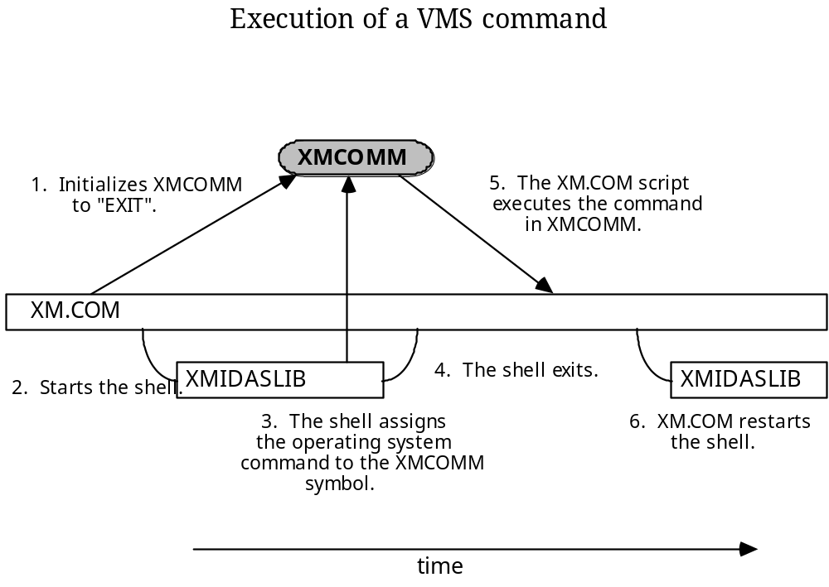
Figure 5 Execution of a VMS Operating System Command from within X-Midas
The gray oblong represents a DCL symbol; the white rectangles indicate processes. Process invocation goes from top to bottom. NOTE that because XMCOMM is initialized to “EXIT”, the XM.COM script will exit to DCL unless XMIDASLIB assigns something into it. This does not pose a problem because intrinsics are executed within XMIDASLIB entirely, and primitives, when executed, destroy the XMIDASLIB image that started them, and, when they finish, call M$SHELL themselves via M$RETURN. Therefore it is not until a user types “EXIT” at the command line that the XM.COM script will actually terminate. In fact, the XMIDASLIB image, when encountering an error, immediately spawns a new XMIDASLIB image as it dies, so that control still does not fall back down to the XM.COM script until it is time for a normal exit.

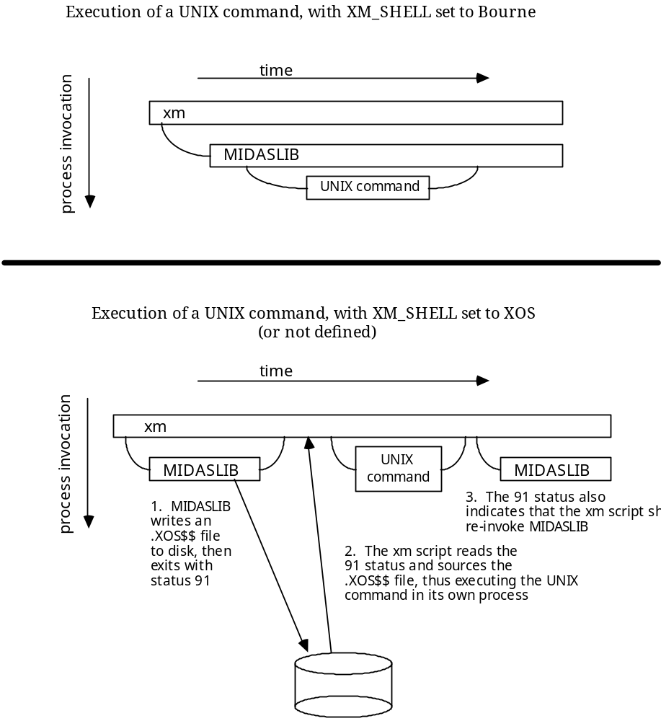
Figure 6 Execution of a UNIX Operating System Command from within X-Midas
There are two ways to do this: the first way, shown on the top, executes the command in a subshell, in a faster and more UNIX-like manner. However, users of VMS X-Midas are used to their operating system commands affecting their parent environment, and so the second way, shown on the bottom, uses the C shell source command to execute the desired command at the same level as the xm script. Since the xm script has itself been sourced from the user’s login shell, those commands that affect the environment (e.g., setenv, cd) will indeed affect the parent shell of X-Midas, and the newly spawned MIDASLIB will inherit the changes.

Stand-Alone Primitives
By “stand-alone primitives” in this section we mean not just those with host support, but any command that is executed by M$RUN_PRIMITIVE. This routine takes a support and a command name. M$RUN_PRIMITIVE is located in the xmlib:commolink file (commolink.vms for VMS, commolink.unx for UNIX). What M$RUN_PRIMITIVE does depends on the operating system.

On the VAX, these primitives are actually separate executable images, all linked to a common shared library named MIDASLIB in order to save disk space and improve startup speed. The primitives are invoked as separate images, and continuity is preserved between commands through the shared memory, which each primitive connects to with its M$CHECKIN call. When a primitive finishes executing, its M$RETURN call actually runs the shell and command-line prompt, prompting for the next command, which it chains to when the command is given. This “baton passing” is started off by the XMIDASLIB program, run by the XM.COM script. This program is an executable version of the MIDASLIB shared library which is linked with all of the primitives. Every primitive, therefore, has access to every shell routine, and is therefore capable of taking over shell execution after its computation is finished. See Figure 7 below.
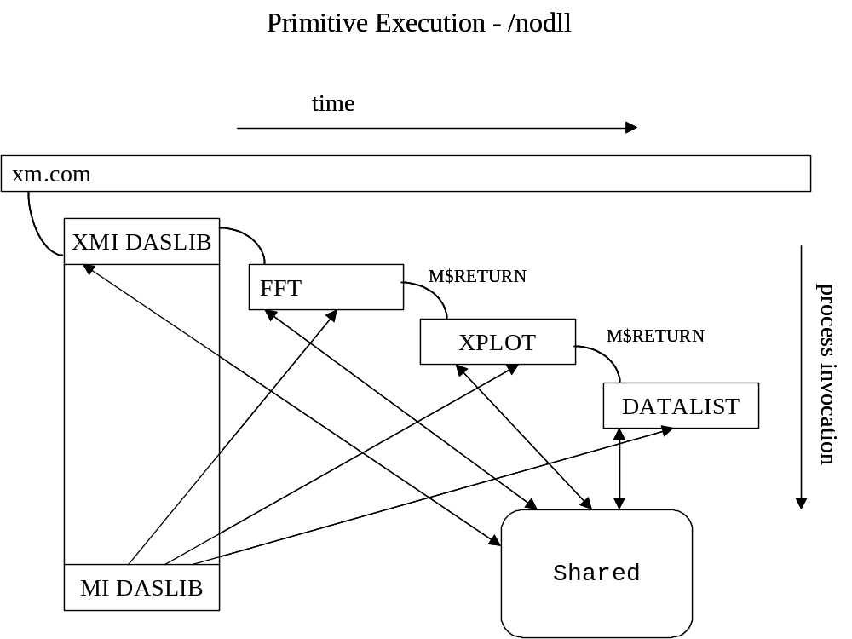
Figure 7 Execution of Host Primitives under VMS X-Midas
The solid black arrows indicate the communication that takes place through the shared memory. The light gray arrows indicate the linkage of each primitive to the shared library MIDASLIB. The dashed lines indicate that XMIDASLIB is identical, in terms of code, with MIDASLIB. The process is not ended until the user types “EXIT” in response to the shell prompt, causing the image of the last executed primitive to run all the way down instead of transforming into a new primitive.

On a UNIX machine, the primitive source code that looks like a stand-alone FORTRAN program is preprocessed by $XMAREA/util/xpp into source code for a subroutine that begins with MH$. This is then compiled into position-independent code and written to a dynamic library. This library has the can be pulled off of disk and linked onto another image while that image is running; the primitive is run as a subroutine from the MIDASLIB image. The MIDASLIB program is the only stand-alone executable; it runs the shell and remains util the user types “EXIT” at the prompt. The M$RETURN call in UNIX does not run another shell but simply does some cleanup and returns. The preprocessor ensures that every M$RETURN is followed by a subroutine return, so the primitive subroutine returns back to MIDASLIB after the cleanup is finished. Once the shell has finished running the primitive, it is unlinked from the image, allowing MIDASLIB to reclaim the memory taken by its local variables. UNIX X-Midas only infrequently spawns new processes in the course of normal execution, in contrast to VMS X-Midas. In an iterative macro, where a series of primitives might be invoked again and again, this implementation difference can cause UNIX X-Midas to run more than an order of magnitude faster than VMS X-Midas. See Figure 8 below.
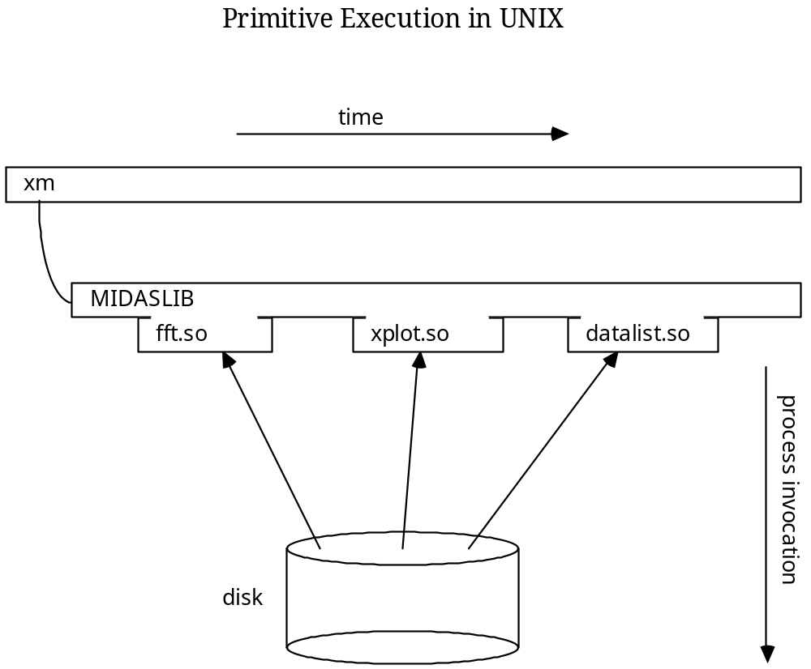

Figure 8 Execution of Host Primitives under UNIX X-Midas
Dynamic libraries have the extension “.so” (shared object) and are linked into the MIDASLIB executive only long enough to run them; they are unlinked afterwards. No process is invoked to execute them.

The Importance of M$RETURN
All primitives must end with a call to M$RETURN, located in commolink, which among other things, determines how control is passed back to the shell. In VMS, since MIDASLIB terminated in order to run the primitive, the M$RETURN call starts up the next shell; therefore, it is actually the primitive’s image that prompts for the next command. Because of this, it is very important that each primitive call M$CHECKIN in order to map to the correct shared memory. If a primitive is compiled without a call to M$CHECKIN, a user running this primitive will suddenly discover that their entire command dictionary, result parameter table, and environment is gone, and their session will remain in this limbo until they happen to exit the image with an ERROR, causing the XM.COM script to restart a correct version of MIDASLIB.

Executing Commands in the Background
To run a command in the “background” means that it is run in a separate process, spawned asynchronously. A user can specify this from the command line or from within a macro with the /BG switch. As a rule, only pipeable commands can be backgrounded.

Putting a command in the background involves:

• Starting a separate process for the command.
• Preventing the parent and child from stepping on each other through global memory.
• Causing the command to exit its process when it is done. This is done by causing the child’s Mu.oneshot variable to be true, so that after finishing, as soon as the child tries to read another command from the user, it exits (see M$SHELL); and when exiting, does not try to restart the shell as usual (see M$EXIT).

The first and last steps are handled differently according to the operating system, as shown below in Figure 9 and Figure 10. Preventing the parent and child from interfering with each other through global memory is done the same on both systems: through the M$SYNC call.

In a pipe system (see section 3.1.3, “Piping”), a primitive’s preamble is separated from its computational loop by the M$SYNC call. All primitives are blocked at the M$SYNC call until all primitives are ready to compute. A primitive’s preamble consists of retrieving command-line parameters and switches as well as opening files and initializing widgets. Command-line parameters and switches are part of global memory; the shell routines set them up based on user or macro input and the primitive then reads them. If the shell begins resetting them before the primitive has finished reading them, chaos results. Therefore, after spawning a process for the primitive to be backgrounded, the shell waits until the primitive hits the M$SYNC call to begin executing the next command.

This communication happens through the Mc.status variable, which is part of shared global memory. Before executing a command, this variable is set to 0, meaning that the command is executing its preamble. The shell polls this variable, waiting for it to be non-zero before continuing. A non-zero status means that the primitive is no longer reading command-line global memory: either it is -1, meaning an error, 2, meaning total completion, or 1, meaning that M$SYNC has been called and the primitive can begin running asynchronously.

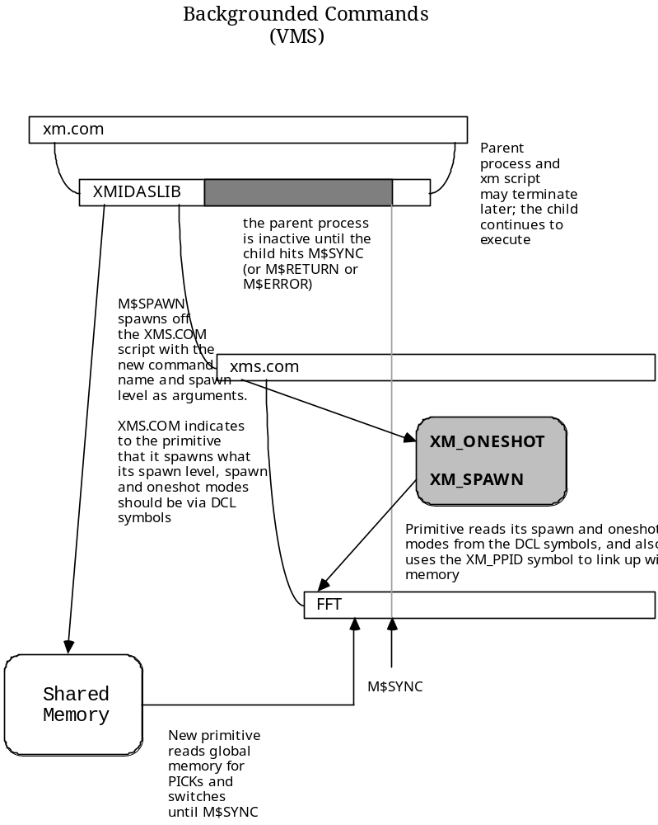
Figure 9 Backgrounded Commands under VMS X-Midas
The XMIDASLIB process (or, the last primitive to be run sequentially—see section 3.4, “Execution of Host Primitives”) parses the command and writes its full command name, switches, arguments, and defaults into shared memory. The M$SPAWN routine uses the VMS call LIB$SPAWN to spawn off the XMS.COM script, which sets the DCL symbols XM_ONESHOT and XM_SPAWN, and prepares to run a single primitive, then exit. The new primitive sets Mu.oneshot and Mu.spawn according to the XM_ONESHOT and XM_SPAWN symbols, and re-maps to shared memory via a call to M$CHECKIN. Once it calls M$SYNC, the parent process can continue executing. If it exits before the child, the child is not affected. When the child finishes, because of the setting of Mu.oneshot, it does not try to read another command or restart the shell; its exiting will therefore have no effect on the parent.

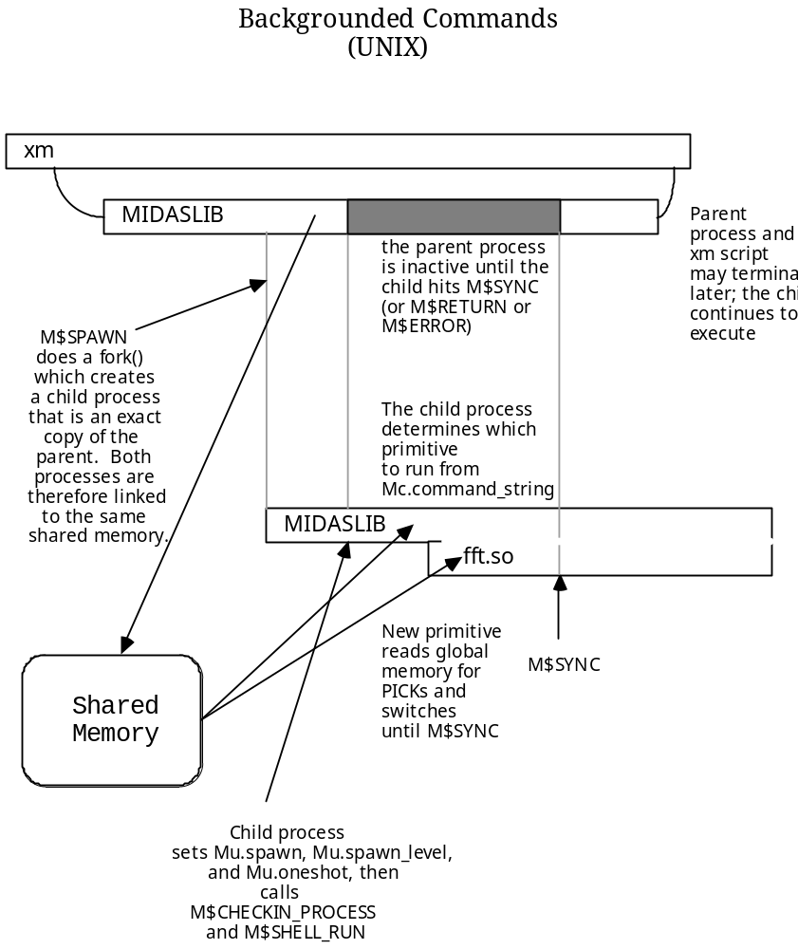
Figure 10 Backgrounded Commands under UNIX X-Midas
The MIDASLIB process parses the command and writes its full command name, switches, arguments, and defaults into shared memory. The M$SPAWN routine uses the UNIX fork() system call to create the new child process; this creates an identical copy of MIDASLIB, executing the same code as its parent. M$SPAWN therefore has two paths, one for the parent and one for the child. The parent returns; the child explicitly sets the Mu.spawn, Mu.spawn_level, and Mu.oneshot variables, then calls M$CHECKIN_PROCESS followed by M$SHELL_RUN. Because the new process is an exact copy of the parent, it does not need to re-map to the global sections; it is already pointing there. (On a UNIX machine, M$CHECKIN does not map to global memory; only M$CHECKIN_SHELL, called when the shell is invoked “cold”.) The new process then loads the command as described in the shared memory and executes it; the parent waits until M$SYNC has been called. The child process will end when the command finishes, because of the setting of Mu.oneshot.

Oneshot Commands
The purpose of a oneshot command is the ability to invoke an X-Midas command from some context where you cannot, for one reason or another, be in the X-Midas shell. A oneshot command must therefore be able to bring the command and its arguments in from the operating system, start the shell at some point beyond where it asks for a command, and exit after executing the single command.

In VMS X-Midas, oneshot commands are done through DCL symbols. DCL symbols can be abbreviated, and so only one symbol per X-Midas command need be generated. The CONFIGURE O command creates a script called XMONESHOT.COM, which, when executed, sets up these symbols. Under VMS the symbols are always of the form

COM*MAND :== @xmvms:xm %<support> <command>

The support, name of the command, and its arguments are passed directly to the XM.COM script, which sets the XM_ONESHOT symbol. If the command is a macro or intrinsic, XM_ONESHOT is set to “TRUED”; the “D” means that this will be a “Direct” call; the primitive will be executed directly. If a macro or intrinsic, the XM_ONESHOT symbol is set to “TRUE”, meaning that XMIDASLIB will be invoked to run the command. XM.COM then does the following:

• If the command is a macro or intrinsic, the XMIDASLIB executive is invoked with the command name and its arguments as arguments to XMIDASLIB. In its M$CHECKIN_SHELL call (which is an entry point in M$CHECKIN), it maps to shared memory and reads the XM_ONESHOT symbol, setting Mu.oneshot to agree. When the shell finds that it is in oneshot mode, it reads its arguments and assigns them to Mc.command_string, then parses then and calls M$SHELL_RUN. Note that both macros and intrinsics take this path because both are executed in the XMIDASLIB image.
• If the support is a primitive support, it invokes the primitive’s image directly, passing it both its own name and its arguments as arguments to the primitive. Passing the command its own name is necessary because the primitive’s M$CHECKIN call executes the same code as XMIDASLIB uses when it is invoked. When the primitive discovers that it is in oneshot mode, it parses the command line and returns, letting the primitive go on to read its command-line arguments and switches.

The process is shown below in Figure 11.
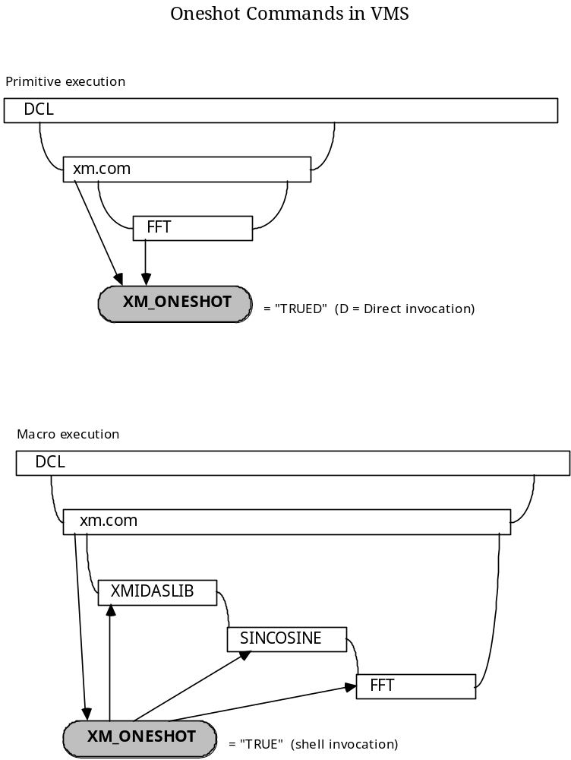
Figure 11 Execution of Oneshot Commands under VMS X-Midas
Note that when a macro is executed, even though all the primitives that make it up check XM_ONESHOT, they do not try to read their own command lines but instead assume that their command has already been parsed by the shell. This is because command line arguments are only read if Mu.oneshot is TRUE and either (1) it was a direct call, as in the first picture, or (2) the shell is executing AND a macro is not in progress.

Under UNIX X-Midas, the process is similar with the exception that no commands are executed directly. The shell must always be invoked with the command name and its arguments in order to run any command. Furthermore, there is no script to run which sets up operating system symbols as aliases to the X-Midas commands. Neither UNIX environment variables nor UNIX aliases may be abbreviated, so to preserve the ability to abbreviate commands, an X-Midas command and its arguments need to be given as arguments to the xmx command:

example% xmx sincos s1 ,, 3 ,,, 16k

The xm “script” that runs the X-Midas shell is actually an alias that sources the $XMAREA/unx/xm file. This is only done so that operating system commands from within X-Midas can indeed affect the parent process, since a process is never spawned to execute them—it’s just one source after another. However, the source command cannot pass arguments to what it sources. Therefore, the xmx command is a command alias which sets XM_ONESHOT to TRUE, assigns its arguments to a shell variable named xm_args and then sources the xm file.

If the xm_args variable has been set, the xm script passes the arguments on to MIDASLIB. MIDASLIB’s MAIN procedure calls M$CHECKIN_SHELL, which maps to global memory, reads the XM_ONESHOT variable, and sets Mu.oneshot. When M$CHECKIN_SHELL returns, if Mu.oneshot has been set, MIDASLIB reads its command-line arguments into Mc.command_string and calls M$PARSE_COMMAND followed by M$SHELL_RUN. The process is shown below in Figure 12.

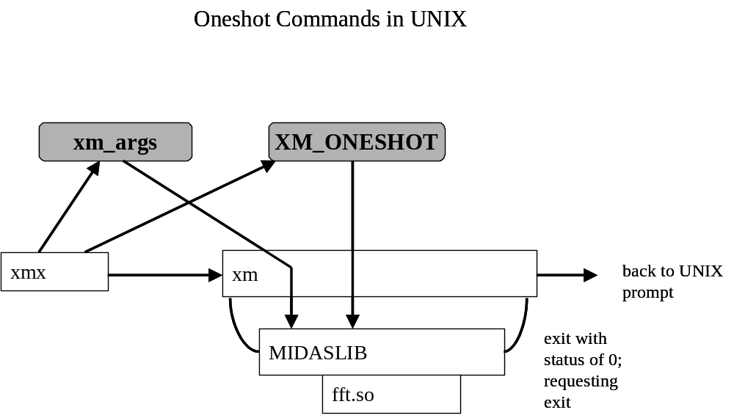
Figure 12 Execution of Oneshot Commands under UNIX X-Midas
The horizontal arrow between xmx and xm indicates that no process invocation occurs at this point. The light gray arrow indicates that the xm script passes the contents of xm_args as arguments to MIDASLIB. Note that the xmx command sets XM_ONESHOT for MIDASLIB to read directly; xm does not test for it; it takes the existence of xm_args as its only indicator.

Datastream Commands
{ to be described }

The Cray Interface
X-Midas supports an interface to Cray-MIDAS, allowing a user on a machine running X-Midas to use all the features of the X-Midas shell and all the computational power of the Cray. Results created on the Cray get shipped back to the X-Midas session, as well as any text output that the Cray command produces (such as that from the STATUS command).

The Cray interface support is a special case of the datastream support. The name of the “operating system” is ‘CRIF’ in dsmengines.cfg, and the name of the remote datastream engine is a program named crayserver, which behaves like a stripped down UNIX shell. Its only purpose is to execute Cray-MIDAS commands which are sent to it over its sockets, and send back the status and results parameters over the same. Since Cray-MIDAS commands are all either binary executables or scripts, the crayserver program can execute them just as a UNIX shell would—by using fork() to copy itself and then execvp() to execute the desired image.

When the shell discovers that a command is to be executed on a remote Cray, it calls M$RUN_CRAY. It may call this routine from:
- M$SHELL, if the command support is determined to be ‘C’;
- M$RUN_OS, if the command string starts with “#”;
- MI$RESULTS, if the /CRAY switch is used on the RESULTS command.

The M$RUN_CRAY routine is a quick wrapper which calls M$CRAY_FORMAT and then uses Mc.datastream for handshaking with the backgrounded DSMCLIENT primitive. All the parsing and formatting is done in the shell so that any M$ERRORs encountered during this process will cause only the shell’s image to die and restart. If the errors occurred in the DSMCLIENT image, all of its socket connections to the datastream engines on remote machines, including crayserver, would be broken messily, and would have to be re-established painfully—all because of an error which might have resulted from something as simple as a typo on the command line.

It is important that DSMCLIENT be insulated from M$ERRORs before, during, and after execution of a Cray command.

M$CRAY_FORMAT only performs its formatting if Mc.command_support is ‘C’; anything else is left alone. The formatting is performed directly on Mc.command_string and Mc.command_length. Many of the desirable features of X-Midas, including in-line calculations, are a result of using the X-Midas PICK routines. Because of this, it turns out that a good deal of the X-Midas command-line parsing is done from within a primitive’s own code. But the remote Cray primitives are not linked to, and therefore cannot use, these routines. The crayserver program has to receive a completely preformatted string; therefore, the appropriate PICKs must be done beforehand in the shell. To know what kind of PICK to do for each argument, the shell uses the I/O behavior encoded in the X-Midas dictionary for that command to determine the kind of argument. The UPDATE command requires that the I/O behavior be given for each command, in terms of whether a given argument represents an input file, an output file, an ASCII parameter, an Untranslated parameter, a Numeric result parameter, or a Result parameter to be established (such as for STATUS or MAXMIN). The PICKs are done, in order, according to the characters in the I/O behavior string as follows:

A, I, or O M$APICK
R or U M$UPICK
N M$DPICK
_ M$_PICK

(Note that the shell does not have to use the I/O behavior from the dictionary for host primitives; the primitive calls the PICK of the appropriate type from within its own code.) Any numeric values received from these PICKs are converted to ASCII and concatenated with the rest of the arguments onto Mc.command_string. If the /BG switch has been asserted, an ampersand (&) is appended to the command string as well, so that it will execute in the background.

M$RUN_CRAY initializes Mc.status to 0 to indicate that the command is in progress. It then sets Mc.datastream to 12, indicating that a CRIF command is ready in Mc.command_string. While Mc.datastream is greater than or equal to 12, the shell sleeps, waiting for the command to finish. When it does, Mc.status will reflect whether the command was successful or not. If not, the shell issues an M$ERROR.

The DSMCLIENT image is therefore protected from any image exits due to an error. M$ERRORs during parsing are issued by the shell; M$ERRORs that occur because of an exception during processing are also handled by the shell. Remember, too, that the DSMCLIENT image is protected from any other kind of crash on the Cray since it is the Cray, not the host computer running DSMCLIENT, that is executing the image.

DSMCLIENT executes a Cray command as a special case. As soon at it detects Mc.datastream equal to 12, it sets it equal to 13, indicating that the command has been received, and calls a local subroutine, RUN_CRAY. When the command is complete, DSMCLIENT sets Mc.datastream to 1 to let the shell know.

RUN_CRAY checks Mc.command_support and does one of the following:
- If it is ‘C’, this indicates a normal Cray-MIDAS command; it is lowercased and sent to MC$SUBMIT.
- If it is a lowercase ‘r’, this indicates that the RESULTS/CRAY command has been given and that the X-Midas session should ship all of its local results over to the Cray. This is done by sending over 8 results at a time via Cray-MIDAS RESULT commands. Numeric results have to be converted to ASCII and concatenated onto the growing RESULTS command line. ASCII values are truncated to 8 characters since that is all Cray-MIDAS can handle.
- If it begins with the word “setenv”, the word “setenv” is replaced with the characters “##”, indicating a change to the crayserver’s own environment symbol table (and therefore to the tables of any processes spawned beneath it); the string is then shipped to MC$SUBMIT.
- If it is anything else, the string is shipped directly to MC$SUBMIT without any further changes. This case includes Cray operating system commands such as ls or ps that the user wishes to execute on the Cray and not on the host machine.

The MC$SUBMIT routine calls the local routine SOCKET_SEND to ship the command over to the Cray and then handles the three different possible outcomes. Note that RUN_CRAY sets Mc.status to the return value of MC$SUBMIT.

- The command executes successfully. SOCKET_SEND has returned a zero status. MC$SUBMIT returns a 1. MC$SUBMIT expects the successful command to be followed by zero or more result name-value pairs, in ASCII format. It calls the local routine GET_CRAY_RESULT to retrieve them all off of the receiving socket.
- The command fails. SOCKET_SEND has returned a nonzero status. No results are expected and there should be none remaining on the receiving socket. MC$SUBMIT returns -1.
- The command was directed to the server itself, to modify its environment variables. No Cray primitive or operating system command was executed at all. No status message or results parameters are expected. MC$SUBMIT returns 1.

The local routine SOCKET_SEND actually writes the command string into the sending socket to the crayserver program as a datastream message of type MS_COMM and then waits for the status to come back over the receiving socket as a datastream message of type MS_DONE containing a short status integer. SOCKET_SEND also handles the exception that may occur if the user hits CTRL-C while the Cray command is executing, described in detail below, under “Handling User Interrupts”.

The crayserver Program
The crayserver datastream engine is a stand-alone program, written in C, intended to execute in the background, on the Cray. It has to be able to handle the messages MS_PING and MS_PONG (for initially establishing input/output sockets), MS_DIE (to terminate the server at the end of a session), and MS_COMM, meaning that a new command is coming through. If it receives the MS_COMM message (the normal behavior), it calls its local routine sockshell() with the sending and receiving sockets and the command to execute.

The sockshell() procedure does the following:
- Spawns a separate process to run the command with the fork() system call. It should be noted that in order to handle the expansion of metacharacters and substitution of environment variables, the child process that the sockshell() procedure spawns is actually a Bourne shell using the “-c <command>” option to run the requested command.
- Sends back the result parameters created by the command over the sending socket. Cray-MIDAS stores its result parameters in ASCII form, in a text file, appending a string of the form “NAME=VALUE” every time an assignment to a result is made. The number of results added during the execution of the command can therefore be determined by noting the number of lines in the results file at the time of the last results parameter transfer and subtracting that from the number of lines present before this transfer; all of the newly added lines are sent, verbatim, over the socket to the waiting DSMCLIENT, which parses the line.
- Determines whether the command is a backgrounded command. If it is not, the parent process waits for the child to finish, determines its status and sends it back over the sockets, and, if successful, performs a results parameter transfer as in (2) above. If the command is backgrounded, the child process does not execute any differently; in fact, the final ampersand (&) is removed. The parent, however, immediately returns a status of 0 (success) and continues. Any results parameters created by the asynchronously executing command will be picked up on the next results parameter transfer; they are not lost but may be delayed.

Handling User Interrupts
This is a very delicate business. The problem is that if the user hits a CTRL-C on the X-Midas machine while a Cray command is underway, the DSMCLIENT process needs to signal the crayserver that an abort has been requested, after which the crayserver needs to stop its child process. Furthermore, an M$ERROR needs to be generated in the shell so that it will stop any macro which is running and will also re-arm its CTRL-C handler. Three separate processes on two different machines therefore need to handle this exception gracefully all at the same time; in particular, the DSMCLIENT image must not exit. Otherwise there are broken socket connections and prematurely terminated processes requiring a full reset of the X-Midas session.

The SEND_SOCKET routine, located in the DSMCLIENT process, is the routine that send the command to the Cray and the one on which the rest of the process is waiting while the Cray command is executing. SOCKET_SEND therefore needs to be waiting for either the user to hit a CTRL-C or for the status to arrive from the Cray socket, whichever comes first.

SOCKET_SEND accomplishes this by first unblocking its receiving socket and then, 10 times a second, checking it for a message and also checking Mc.break. If Mc.break becomes .TRUE., it reblocks the socket, sends an MS_ABORT message, and returns an error status. This error status causes Mc.status to be set negative by RUN_CRAY; and this will cause M$RUN_CRAY, in the shell image, to execute an M$ERROR.

The crayserver process, for its part, needs to be waiting for its child process to finish or for an MS_ABORT message from the DSMCLIENT process, whichever comes first. The crayserver process also unblocks it receiving socket, so that it can check it periodically for the MS_ABORT message from DSMCLIENT. Its other problem is waiting for its child process to finish. It has to periodically check this condition as well, with a non-blocking wait() call. If it gets the MS_ABORT message, it has to kill its child and then wait() on it in order to clean up the process space. There is a problem with killing only its child process, however; the child may have been a script, itself spawning many other processes. All processes descending from the child must also be terminated. This is done by making the child process a leader of its own process group; the parent process then uses the kill() system call to kill all the processes of that particular process group. After doing so, the crayserver process returns an error status over the socket to the DSMCLIENT process.

The net effect is that when the user, sitting at their remote X-Midas host computer, hits a CTRL-C while the process is executing, the process will stop, an ERROR will be generated, and the session remains intact: neither the DSMCLIENT process nor the crayserver process are terminated and therefore the connections remain undisturbed.
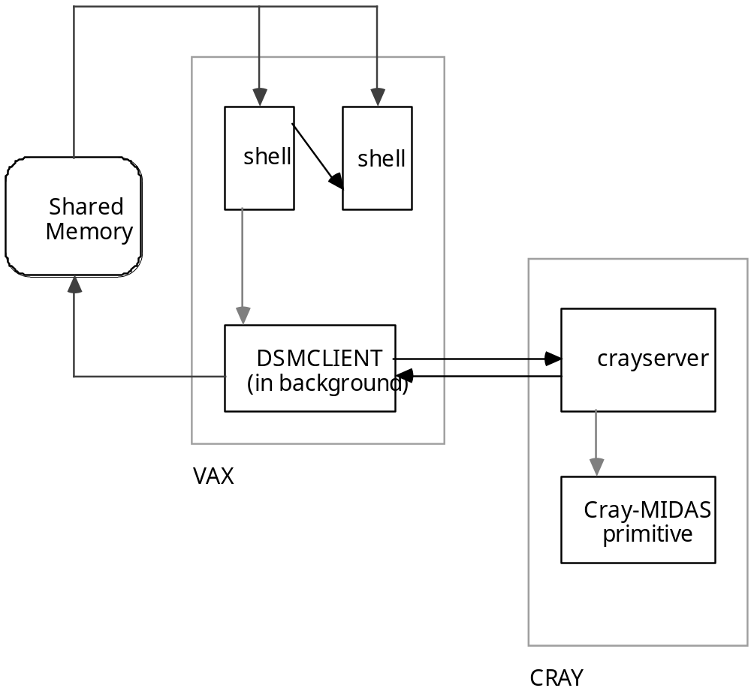

Figure 13 Structure of the Cray Interface
The striped arrows indicate the spawning of a process. The gray arrows indicate access to shared memory. Note on the VAX that the first shell process spawned the DSMCLIENT process, and later ran down as it spawned another shell process, because of an M$ERROR. The DSMCLIENT process and the crayserver process are connected via two sockets, one for sending, one for receiving.

Exception Handling
There are two ways that an X-Midas command can indicate than an exception—an unusual or unexpected condition—has taken place: make a call to M$ERROR or to M$WARNING. Both of these subroutines are located in utilities.for and are therefore operating-system independent. M$WARNING simply alerts the user of the condition; control returns to the point at which it was called. M$ERROR stops the computation and does not return.

Both routines call M$MESSAGE to print out the message that was passed to them. This routine turns any runs of white space in the message into a single space and puts the string into the history of the session that called it. More importantly, however, if Mu.spawn is TRUE or a macro is executing (Mc.macro_level nonzero), it prints out Mu.command_name in brackets after the message to help a macro writer see where the error or warning occurred. (This is especially helpful in a piped macro where the primitives are executing concurrently.) If the ERROR or WARNING was called from within the command itself, Mu.command_name will contain the routine’s name; if the error occurred while parsing the command, Mu.command_name will contain the message “Parsing ... ” followed by the first part of the command line.

ERRORs and WARNINGs
The effect of an error on a running process depends on the process running. A call to M$ERROR always causes an image exit, and must do so, in order to halt the execution of that primitive or library code.

If primitives are being executed in a control section, each primitive is being spawned in its own process, so the death of that process does not affect the parent, which is running XPIPE. The Mc.status field will be negative; if the next command in the control section is an ENVIRONMENT GET STATUS, the XPIPEd macro can branch off of this status, to behave differently if the primitive fails.

However, a primitive executing as part of a sequential macro is not part of its own process; the macro control is embodied in the Mt structure. If this primitive encounters an M$ERROR, the image will shut down and the xm script must restart a new image that will pick up where the other left off.

All image exiting is handled by M$EXIT. When a macro encounters an error, the shell is normally put into suspend mode just before exiting with a status of 91, indicating that the shell should be restarted. As soon as the new process starts up, it stops in suspend mode. A macro writer can use the TRAP ERROR command to prevent the macro from coming to a stop like this. This intrinsic simply sets an ASCII result parameter named “P_<level>on_error” containing the name of a label to jump to in case of an error. The “P_<level>” ensures that the result will be deleted when the macro completes; the fact that “on_error” is lowercase prevents a user from accidentally overwriting or deleting it.

The M$ERROR function checks to see if this result parameter is set. If so, it performs an M$GOTO on the label name, to move the macro pointer to the new label, and then calls M$EXIT(1). If not, it calls M$EXIT(0).

The 1 argument to M$EXIT indicates a trapped error; it should not alter the macro level or mode before starting the shell. The 0 argument indicates a normal exit, putting the macro into suspend mode.

TRAPping WARNINGs works with much the same mechanism, except that instead of calling M$EXIT, the routine simply returns.

CTRL-Cs (Aborting)
Mc.break etc.

{ to be discussed }

Graphics
X-Midas graphics are layered directly on top of Xlib calls. No other libraries or include files are necessary to build X-Midas graphics primitives. There are a great deal of functions all beginning with MX$, which are shortcuts and FORTRAN-callable wrappers to the Xlib calls, which are written in C. Section 4.1 describes the interface between C and FORTRAN; section 4.2 describes the field of the process-specific Mx structure, used to pass information between the graphics primitive and the graphics library.

Under VMS, all of the graphics routines are linked together into a single shareable library called XGRAPHICLIB. Non-graphic primitives are not linked with these libraries, in order to avoid incurring unnecessary memory expense for routines that they do not use. NOTE that the way the XBHOST.COM script decides whether or not to link in this library is if the primitive’s name begins with an “X”. Therefore, under VMS it is very important that if you use any MX$ routine, that you begin your primitive name with “X”.

For a host primitive, the MIDASXPRM.OPT link option file is used. This option links in the standard X-Midas library, the XGRAPHICLIB library, and another file, the mxsetup.obj object file. This file is kept separate from XGRAPHICLIB because datastream graphics primitives must use the mdxsetup.obj object file as well as the XGRAPHICLIB library.

Under UNIX, all of the graphics libraries, system Xlib libraries, and normal routines are all linked together into the MIDASLIB executable. The primitives cannot be any smaller because they are never actually linked with any library; it is MIDASLIB that links to them. (See section 3.4, “Stand-Alone Primitive Execution”.) Since it is unknown which primitive the user might choose to execute next, MIDASLIB must contain all necessary code. NOTE that this is not the expense that it would be on a VMS machine, since when processes are spawned via a fork() system call (see section 3.5, “Executing Commands in the Background”), the code segment is shared between the multiple processes. Only the static and global variable space is copied.

The C/FORTRAN Interface
Most systems that have both C and FORTRAN compilers which produce object code that will be linked together have some kind of coding standard so that you can call the routines written in one language from the routines written in another. This standard often varies from machine to machine, yet it is necessary for maintenance purposes that the C code for the X-Midas graphics library be the identical on any machine.

The solution is the gjackets.c file, which defines machine-specific wrappers to routines whose code does not change. There are several issues when a FORTRAN routine calls a C routine and vice versa:

• FORTRAN passes all variables by reference, passing a pointer to the memory location; C receives arguments by value, assuming that the value on the stack is the value itself.
• The name of the C routine as seen from FORTRAN and vice versa are not identical. On the VAX, a lowercase name in C code can be called as upper- or lowercase from FORTRAN. Likewise, C code can call FORTRAN routines as their lowercase names. On the Sun, however, the FORTRAN compiler turns its routine names into all lowercase and appends an underscore. What this means is that in order to call C routines from FORTRAN, the C routine names must have an underscore appended to them. The FORTRAN code needs to reference the C routine without the underscore. C routines can call FORTRAN routines by using a lowercase name followed by an underscore.
• Character string arguments are passed differently. Not only do FORTRAN and C model character strings differently, the interface between them is different from machine to machine. This is discussed at length below.

FORTRAN strings have a constant length, which is their size in memory, determined by the LEN() function. This information is carried along with the string; any recipient can determine the storage available. There is no FORTRAN standard for determining the valid length of a string (how many characters are significant); the X-Midas function M$LENGTH is used constantly to determine the valid characters. M$LENGTH does this simply by starting at the end of the memory allocation for that string and moving backwards until it finds a non-blank character. Clearly, even if the string was supposed to have some trailing space, M$LENGTH will trim it off. For this reason, as many macro writers may have discovered, ASCII results parameters will never retain trailing space, even if it is explicitly concatenated.

The memory size of a C string is known only to the routine that first allocates it; other routines receive only a pointer to an array of indeterminate length; the valid length of the string is indicated by a null character (‘\0’) immediately following the last valid character. Therefore, a C routine needs to know the memory size of a FORTRAN string, since the string will contain no internal information as to its size.

On the Sun, this is handled by passing (by value) the string’s length on the end of the argument list. If there are multiple string arguments, their lengths are all passed at the end, in the order that the strings were passed.
Example: A Sun FORTRAN routine calls a Sun C routine as follows:
CALL CROUTINE (N, S1, M, S2, X, Y)
where N, M, X, and Y are numbers and S1 and S2 are strings. The declaration of the C routine would look as follows:
void croutine_ (n, s1, m, s2, x, y, Ls1, Ls2)
int *n, *m;
char *s1, *s2;
double *x, *y;
{ ...
where Ls1 and Ls2 are the lengths of s1 and s2 respectively.

On the VAX, FORTRAN strings are stored in string “descriptors”, which are structures containing, from the top, a two-byte integer describing the length, another two bytes, and a four-byte pointer to the character array. When a VAX FORTRAN routine passes a string to a VAX C routine, it passes a pointer to this descriptor.
Example: A VAX FORTRAN routine calls a VAX C routine as follows:
CALL CROUTINE (N, S1, M, S2, X, Y)
where N, M, X, and Y are numbers and S1 and S2 are strings. The declaration of the C routine would look as follows:
typedef struct {
unsigned short length;
unsigned short junk;
char *c;
} VAXstring;
void croutine (n, s1, m, s2, x, y)
int *n, *m;
VAXstring *s1, *s2;
double *x, *y;

Clearly, the C code written to handle these strings will look quite different depending on the machine. To improve maintenance, it is desirable to code all the X-Midas C routines according to a single standard.

How C Code Should Look
C code is most readable when arguments that are not used as “out” parameters are passed by value, names do not end in underscores, and strings are handled as simple pointers to characters. In addition, although both the VAX and Sun C compilers can handle identifier names containing dollar signs ($), it is not standard and is less portable.

Therefore, all the C routines coded in glibc1.c and glibc2.c define their functions using pass-by-value when appropriate, with identifiers that do not end in an underscore, and string arguments as characters, with their original FORTRAN lengths appended to the end of the argument list. Underscores are used instead of dollar signs to separate a function prefix from the rest of its name, even when calling other X-Midas functions; e.g., M$A2D is called as m_a2d from the X-Midas C code.

The interface between the X-Midas C coding standard and the machine-specific C/FORTRAN interface coding standards is handled by the gjackets.c file. This file has machine-specific code, separated by compiler directives, to create different jackets to the routines in the glibc files based on the machine. The C preprocessor symbols currently supported are sunc for the Sun C compiler and vaxc for the VAX C compiler.

For both machines, the code in the glibc files receives arguments by value. These routines begin with mx_, and when they call X-Midas routines (such as M$A2D), call them by names beginning with m_, and arguments passed by value. This is done by coding two kinds of jackets in the gjackets file: one kind, beginning with mx$, which receive arguments by reference and then pass their dereferenced values to the corresponding mx_ routines in the glibc files; the other kind, beginning with m_, receive arguments by value and pass on their addresses to the FORTRAN M$ routines in the X-Midas main library.

For the Sun, all routine names which are called across “language barriers” are #defined as ending with an underscore.

For the VAX, all routines which pass strings have a different kind of jacket. If the routine is written in C, called by FORTRAN, the jacket expects a VAXstring pointer and passes on the character pointer and length elements of the structure to the routine in the glibc files. If the routine is written in FORTRAN and called by C, the jacket expects pointer and length arguments, constructs a VAXstring structure containing the pointer and length and passes its reference on to the FORTRAN routine.

In this way, the only operating-system dependent code is collected into one file, and the C routines are written in good C style.

The Midas X-Graphics Structure (Mx)
The X-Midas graphics primitives and the X-Midas graphics library communicate with each other through an MX structure. This structure is defined in xstructures.inc, which in turn is included by xprimitive.inc where the Mx structure is declared as part of a common block; therefore every subroutine or program including xprimitive.inc will be connected to that structure. Please note however that this is not a global shared structure, like Mc and Mt; it is global only over a single process or primitive. The xprim.inc file declares an Mx structure that is not part of a common block. The xdsprim.inc file contains an alternate definition of the MX structure for datastreams graphics primitives that contains less fields (the last section as noted below). It also declares an Mx structure that is not part of a common block. Hence, each time you include xdsprim.inc or xprim.inc you are receiving a unique Mx structure. The fields in the Midas X-Graphics structure are defined and explained below.
Table 7 X-Graphics Field Definitions
Field Name | Meaning | See also
name | contains the command name used to invoke the primitive, used for menu help. | HELP MX$SETUP  HELP MX$MHELP
title | contains a title to put in the window title bar. | HELP MX$OPEN
node | name of the display node | HELP MX$DISPLAY
left | number of pixels the left of edge of the window is from the left edge of the screen. | HELP MX$SETUP
top | number of pixels the top of edge of the window is from the top edge of the screen.
width | width of the window in pixels  excluding window borders.
height | height of the window in pixels, excluding borders and the window title bar.
screen_width | width of the entire screen in pixels. | HELP MX$SETUP  HELP MX$DISPLAY
screen_height | height of the entire screen in pixels.
text_size_lock | if the absolute value of this field is greater than 1 then all text displayed (excluding Annotate) is locked to one width. | HELP SWITCHES /XTS
text_w | the exact pixel width of one letter of the Courier text used by MX$TEXT. | HELP MX$SETFONT
text_h | the pixel height of the current Courier text including ascent and descent.
black | pixel value of the background color, if the screen is inverted, this actually points to white. | HELP MX$DISPLAY  HELP SWITCHES /XI
white | pixel value of the foreground color, if the screen is inverted, this actually points to black.
icon | 1 = primitive is to come up in icon state  0 = primitive is to come up as a full window | HELP SWITCHES /ICON
cmode | field used by primitive programmer to store current mode of data display (e.g. 1=Mag, 2=Phase, 3=Real, 4=Imag, etc.)
shrcmap | if greater than 0, the current shared colormap id the primitive is attached to. | HELP SWITCHES /XCSHR
clast | used by the graphics library to keep track of the last color set into the foreground for MX$DRAW_LINES, etc.
rmode | 1 = double rubber banding mode on. Draw all rubber lines double thick with 2 XOR masks to improve visibility.  0 = normal single thick XOR lines. | HELP MX$DRAW_MODE  HELP MX$RUBBERLINE  HELP MX$RUBBERDOT  HELP MX$RUBBERBOX  HELP MX$DRAGBOX
noevent | 1 = only events sent by other primitives are processed by the primitive, user created events are ignored.  0 = all events are processed | HELP MX$WAKEUP
The following fields pertain to real time controls.
xtag | name of results parameter to update with the current X abscissa value | HELP MX$SETUP  HELP SWITCHES /MTAG
ytag | name of results parameter to update with the current Y abscissa value
ztag | name of results parameter to update with the current Z abscissa value
xytag | name of results parameter to update with the current X + Y abscissa value
The following fields are reset to 0 each time MX$EVENT is called and a new event is received. Those fields pertaining to the new event are filled in with the appropriate information.
exposure | 1 = expose event received | HELP MX$EVENT  HELP MX$IFEVENT
resize | 1 = window resized, Mx.left, Mx.top, Mx.width and Mx.height are updated internally to reflect new window size and location.
motion_notify | 1 = mouse motion detected
xpos | number of pixels from the left edge of the window that the event occurred
ypos | number of pixels from the top edge of the window that the event occurred
button_press | 1,2,3 = mouse button press detected (1=L, 2=M, 3=R)
button_release | 1,2,3 = mouse button release detected (1=L, 2=M, 3=R)
key_press | if non-zero, the ASCII or X integer value of a keyboard key press detected
key_char | ASCII character version of key_press
key_upchar | same as key_char, but all lower case alphabetic characters are converted to upper case.
The following three fields are set by the graphics library and should not be altered by primitive code. The zoom array keeps track of stored pixmaps, MX$ZOOM and MX$UNZOOM provide all of the interfaces necessary. The GLOBALS array contains information very important to the graphics library including the display server id, the window id, and pointers to the various graphics contexts used for drawing.
pixel(64) | a byte array containing the pixel values (color locations) associated to extra colors allocated to a primitive through MX$COLORMAP or MX$COLORLAB | HELP MX$COLORMAP  HELP MX$COLORTAB  HELP MX$COLORLAB
zoom(*) | an index into, and an array of structures used by the graphics library to keep track of pixmap structures
GLOBALS(*) | special section containing globals important to the graphics libraries.
level | indicates the FORTRAN array index (1-10 not 0-9) of the stk structure that reflects the current plotting field. Needed by several graphics library routines | See below
stk(10) | array of structures containing the real world and pixel coordinate values that define a plotting field | See below
These last fields are currently part of the MX structure available in XSTRUCTURES.INC (included by XPRIMITIVE.INC and XPRIM.INC) but will be eliminated in future releases. They are not part of the MX structure available in XDSPRIM.INC used by datastreams primitives.
layers | current number of valid LAYER structures | See below
layer(16) | array of LAYER structures used primarily by XPLOT, XRTPLOT and XGEOPLOT. These contain information regarding file overlays.
npix | current number of valid elements in the pix structure array
pix(32768) | array of XPIX structures available to the primitive programmer. This is the form many graphics library drawing routines expect data to be sent in. | HELP XSTRUCTURES  HELP MX$DRAW_LINES  HELP MX$DRAW_DOTS  HELP MX$FILL_POLY
xpix(32768) | these next two arrays of real*4 values are made available as a convenience to the primitive programmer | HELP XSTRUCTURES
ypix(32768)

name, title and node

Mx.name contains the full command name of the graphics primitive. This is set by MX$SETUP and is taken directly from the parsed command line. This field is used by MX$MHELP to locate the explain file for the primitive when menu help is accessed.

Mx.title contains an optional title string that will appear in the window title bar provided by your window manager. This name is usually derived from the /XN=“Window Title” switch. If this switch is not present, the argument to MX$OPEN is used as the title. The window title bar may be altered temporarily, as is done by MX$POINTS (and most X-Widgets) by calling MX$SETBAR with the desired title. This does not change the string in Mx.title, it simply sets the new string into the window title bar. When MX$UNSETBAR is called, the window title bar is refreshed with the string in Mx.title.

The Mx.node field is set in MX$SETUP and indicates the name of the display server you wish to make a connection to. The node string is obtained from the Midas Common structure: either the Mc.plot_node field or the Mc.plot_node2 field. The latter is taken if the /XD2 switch is present. These fields are set by the XWINDOW and SETNODE primitives.

left, top, width, height, screen_width and screen_height

When MX$SETUP is called several fields associated with the Mx structure are calculated. Among these are the fields associated with the size and location of the window, and the screen that window is displayed on. First of all, MX$DISPLAY is called to open the display server and the Mx.screen_width and Mx.screen_height fields are determined. These fields are then used to determine the window’s size and location using the following sets of equations.

First of all the command line switches permitting the user to specify size and location are extracted from the command line. If the switches are not present (signified by a return value of -1 by M$GET_SWITCH), the defaults are extracted from the Midas Common structure for left and top and from the arguments to MX$SETUP for width and height. Width and height are not taken directly from the Midas Common structure to allow the graphics primitive to specify its dimensions. Many graphics primitives prefer a distinct size and shape. Primitives such as X-Plot and X-Raster do not and thus simply send Mc.width and Mc.height as arguments to MX$SETUP.

c
c get desired window sizes from command line and/or environment
xl = M$GET_SWITCH ('XL')
if (xl .eq. -1) xl = Mc.left
xt = M$GET_SWITCH ('XT')
if (xt .eq. -1) xt = Mc.top
xw = M$GET_SWITCH ('XW')
if (xw .eq. -1) xw = width
xh = M$GET_SWITCH ('XH')
if (xh .eq. -1) xh = height

In the next set of equations, positive values are interpreted as thousandths of screen width and height and negative values are interpreted as exact pixel specifications. The final values left in the Mx structure are in pixels.

c
c convert to pixel measurements
if (xl .ge. 0) Mx.left = NINT(float(Mx.screen_width*xl)*.001)
if (xl .lt. 0) Mx.left = -xl
if (xt .ge. 0) Mx.top = NINT(float(Mx.screen_height*xt)*.001)
if (xt .lt. 0) Mx.top = -xt
if (xw .ge. 0) Mx.width = NINT(float(Mx.screen_width*xw)*.001)
if (xw .lt. 0) Mx.width = -xw
if (xh .ge. 0) Mx.height = NINT(float(Mx.screen_height*xh)*.001)
if (xh .lt. 0) Mx.height = -xh

Finally, the dimensions and location of the window are limited so that the window fits on the screen in its entirety. This means reducing the width and height if they are larger than the screen, and moving left and top if they would cause a portion of the window to come up off the screen.

c
c limit desired window to screen size
Mx.width = min ( Mx.width, Mx.screen_width - 10 )
Mx.height = min ( Mx.height, Mx.screen_height - 10 )
Mx.left = min ( Mx.left, Mx.screen_width - Mx.width - 5)
Mx.top = min ( Mx.top, Mx.screen_height- Mx.height - 5)

Once these values have been calculated, the window itself is not created until the call to MX$OPEN. After the window has been created, you may move and resize it however you please, including off the screen if your window manager permits. When the window is moved or resized, the four Mx fields are updated to reflect the current size and location of the window at any given time.

text_size_lock, text_w and text_h

All drawing to the window that incorporates text (except for Annotate text) is done in a non-proportional Courier font. This includes axis labels, all X-Widgets (Menu, Prompt, DVal, etc.) and anything else requiring text. A Courier font was chosen due to its non-proportional font metrics. Thus the text width can be used as a basic building block to determine the dimensions and layout of the plotting window. A string 100 characters long, will always be 100 * Mx.text_w pixels long.

Courier fonts of different sizes are available on most systems. Thus we may wish to choose a larger or smaller font, depending on the size of the window, in order to efficiently use our real estate.

Resizing the common font is done through the MX$SETFONT graphics routine. The argument to it is a desired font width. This argument is returned with the actual font width of the closest font size available. The new font is loaded and its dimensions are stored in Mx.text_w and Mx.text_h. Mx.text_w is the exact pixel width of one character in the current font size. Thus, as stated previously, the dimensions of a string that is 10 characters long is exactly 10 * Mx.text_w pixels long. Mx.text_h incorporates character ascent and descent and gives a comfortable value for text height so that when writing text to the window you may write one string Mx.text_h pixels below another and they are nicely separated.

In most graphics primitives when the window is resized, the common font is also resized so that all of the information in the window is still visible. It may be desirable to disallow such resizing if the person manipulating the primitive wants only one size font to be used. The person may also desire a Bold Courier font as opposed to the default Normal Courier.

The Mx.text_size_lock field is set in MX$SETUP by getting the /XTS switch from the command line. If the /XTS switch is not present it gets the value -1. This is the default value. A negative value in the Mx.text_size_lock field specifies that a Normal Courier font will be used, a positive value indicates a Bold Courier font. Furthermore, if the absolute value of Mx.text_size_lock is greater than one, then one initial call to MX$SETFONT is made using the absolute value as the desired width. During this call, the width of the closest available font is set into the Mx.text_size_lock with the appropriate sign (negative for Normal, positive for Bold). Henceforth, when any call is made to MX$SETFONT, the argument to MX$SETFONT is ignored and the font specified by Mx.text_size_lock is reloaded. A primitive may choose to override the lock by setting Mx.text_size_lock directly itself. If the value is 1 or 0, MX$SETFONT changes the font size as expected, loading in a Bold Courier font. If the value is -1 a Normal Courier font is used that can be resized.

black, white, pixel, rmode, shrcmap and clast

For a more in depth discussion of colors and definitions of a few of the terms below, see the discussion on color in the next section.

Mx.black and Mx.white contain the indices into the server color table of the background and foreground color cells. Mx.pixel is an array of the indices of color cells that have been allocated to the primitive. See the discussion on colors in the next section for more detail.

The Mx.rmode field is set by calling MX$DRAW_MODE with the correct flag value. It is used to enhance visibility of rubber banded lines in primitives that use many colors that differ only slightly in hue. All rubber banded lines (for example those drawn by MX$RUBBERBOX) are drawn double thick in two different graphics contexts with different XOR (exclusive OR) mask values in the hopes that one of the colors obtained contrasts with the surrounding area. It is necessary to set this flag through MX$DRAW_MODE so that the appropriate graphics context alters its XOR mask.

The Mx.shrcmap field indicates whether a primitive wishes to share his read/write colormap with other primitives. When a non-negative value is picked up for the /XCSHR=id switch that colormap can be picked up by any other primitive with the same switch value. Currently shared colormaps are only implemented in datastreams graphics primitives.

The Mx.clast field is a field used by the graphics libraries to keep track of which color (either the index into the pixel array, or 0 for background, -1 for foreground) was last used in the drawing routines MX$DRAW_LINE, MX$DRAW_LINES, MX$DRAW_DOTS, MX$COLORTEXT or MX$FILL_POLY. Each time one of these routines is called the foreground color for the Gcg graphics contexts has to be set with the color that is desired. (This should not be confused with the overall foreground color which is always the same.) Mx.clast indicates which color was last set into the graphics context so that if it hasn’t changed since the last drawing routine was called it doesn’t bother resetting the foreground with an extraneous X-Windows call.

icon and cmode

The Mx.icon field contains the switch value of the /icon switch as picked up in MX$SETUP (1 if the switch is present, -1 if it is not.) If it is greater than 0 then just after the window is mapped to the screen it is iconified. This field is only used when the window is first mapped.

The Mx.cmode is a field that is unused by the graphics libraries, it is simply made available as a convenience to the primitive programmer. In most primitives this field reflects the current plotting mode of the data (e.g. Real, Imaginary, Phase, etc.)

xtag, ytag, ztag and xytag

These fields contain the names of results parameters that are set with the abscissa value of the x, y, z or x+y values when controls are turned on in a graphics primitive. Their values are picked up by MX$SETUP from the command line by searching for the /MTAG switch. This switch is followed by a parenthetical expression containing a tag indicator and a results parameter name. Once the primitive is up a menu item allows you to select the mode in which you wish to run controls. LM Click will set the results parameter with the abscissa values of the mouse when the left mouse button is clicked. If the Continuous mode is set then each time the mouse moves within the window, each of the tags with results parameter names will write the pertinent abscissa value to them.

The Event Fields: exposure, resize, motion_notify, xpos, ypos, button_press, button_release key_press, key_char and key_upchar

This event fields are set when MX$EVENT or MX$IFEVENT are called. MX$IFEVENT sets all of the event fields to 0 and then checks to see if there are any events on the queue for the primitive calling it. If an event is ready it is processed setting the proper fields in the Mx structure and MX$IFEVENT returns with a value of 1. If no event is on the queue, MX$IFEVENT returns a value of 0. MX$EVENT continually calls MX$IFEVENT until it returns with a value of 1 (an event was received.) Between calls to MX$IFEVENT it calls M$PAUSE. MX$EVENT is simply MX$IFEVENT with blocking. The X-Widget routines and all other graphics library routines that do their own event handling DO NOT call MX$EVENT or MX$IFEVENT and therefore do not set the fields in the Mx structure (except in a few special case as noted, see the discussion below noevent.)

Mx.exposure
An X-Windows Expose event is generated for a window any time the window, or any part thereof that was previously hidden is exposed. When this occurs the Mx.exposure field is set to 1. Many times numerous Expose events will be created by one action, such as bringing a window to the top of the stacking order. Each independent area of the window that was obscured by another window will cause a separate Expose event to be generated when that area becomes visible. Thus, it is customary when we receive a group of Expose events to remove all of them from the queue and treat it as a single exposure event. Many primitives will redraw their entire screen as the result of an exposure event. It would be wasteful to give them more than one exposure event when no other changes have occurred between them.

Furthermore, when a window is brought up from iconified state to window state a special X-Windows event called a MapNotify event is generated followed by an Expose event. A MapNotify event is also interpreted as an exposure event, the Mx.exposure field is set and all Expose events following it are peeled off of the event queue.

Mx.resize
The Mx.resize field is set to 1 when the window dimensions are changed. When a window is resized or moved an X-Windows ConfigureNotify event is generated and the Mx.left, Mx.top, Mx.width and Mx.height fields need to be updated. If the new dimensions of the window differ from the previous dimensions then the Mx.resize field is set to 1. If the window is simply moved without changing its size Mx.resize is not set to 1.

Mx.motion_notify
Each time the mouse moves inside the window an X-Windows MotionNotify event is generated. When such an event is received the Mx.motion_notify field is set to 1 and the Mx.xpos and Mx.ypos fields reflect the new mouse position in terms of the pixel offset from the upper left hand corner. For example, if Mx.xpos = 100 and Mx.ypos = 50, the mouse was moved to the location 100 pixels from the left edge of the window and 50 pixels from the top edge of the window.

Mx.button_press and Mx.button_release
When a mouse button is pressed or released an X-Windows ButtonPress or ButtonRelease event is generated, the proper field is set, and the location of the press or release is reflected in Mx.xpos and Mx.ypos. The mouse button pressed or released can be one of three: the left, middle or right. These buttons are interpreted as the values 1 (left), 2 (middle) and 3 (right.) Thus if the middle mouse button is pressed in the window the Mx.button_press field will be set to 2. When that button is released, another event will be generated that will set the Mx.button_release field to 2. Of course in most graphics primitives a middle mouse button press brings up a menu so by the time the button is released the Menu X-Widget actually receives the event rather than MX$EVENT or MX$IFEVENT. This will be discussed in more detail later.

Mx.key_press, Mx.key_char and Mx.key_upchar
When a key is pressed on the keyboard an X-Windows KeyPress event is generated containing a special keycode field. This keycode is some value that must be translated before we can interpret it. This translated value is a special X-Windows value called a KeySym. X-Windows provides a massive set of KeySym identifiers to easily identify which key the KeySym represents. If you look in the code those constants all begin with the prefix “XK_”. Some examples are XK_Return, XK_A, XK_backspace, etc. Along with this KeySym it is also handy to have an ASCII equivalent of the key press if one exists. Note that many keyboards have a Help key which translates to the KeySym “XK_Help” but has no ASCII representation. The ASCII representation is what gets set into the Mx.key_press, Mx.key_char and Mx.key_upchar fields. The first field contains the integer value of the character, the second is the character, the third field contains the uppercase version of the character. If the character is not a lowercase letter then the last two fields are identical.

When a KeyPress event is detected in MX$IFEVENT, first a special routine called mx_pointer is called, this is a C routine in the glibc1.c file that is used to move the mouse pointer. This routine calls mx_lookupstring who translates the keycode to a KeySym value and an ASCII representation. We can then determine whether the key pressed was an arrow key. If so, we call an Xlib routine called XWarpPointer that will cause the mouse pointer to move in the specified direction we specify. When the mouse moves a MotionNotify event is generated that can later be picked up by MX$IFEVENT. Upon returning from mx_pointer, if we did not move the mouse then the ASCII representation of the key pressed is set into the proper fields and the location of the mouse a the time the key was pressed is set into the Mx.xpos and Mx.ypos fields. If we did move the mouse then no fields are set in the Mx structure but a Mx.motion_notify event will be received shortly.

noevent

The Mx.noevent field is a special field normally set to 0, if it is any other value then only events that are created and sent by some other primitive (normally through MX$WAKEUP) are processed. A good example of this is in X-Tutor. Many times a graphics primitive will appear along side the X-Tutor window and the user is not allowed to bring up menus, or zoom in it during certain messages. This is done through an interface to the Mx.noevent field given in MX$WAKEUP. The mode values of 5 and -5 set the Mx.noevent field to 1 or 0. XCALL SEND events are created by MX$WAKEUP and sent off to other primitives. These events can still be received when the Mx.noevent flag is on.

There are two different ways that events are received by the graphics library. MX$EVENT and MX$IFEVENT receive events directly, filling in the Mx structure with the pertinent information and returning them directly to the graphics primitive. The various X-Widgets (Menu, DVal, Scrollbox, etc.) receive and process events independently of the Mx structure and this can lead to trouble as you will see.

Problems With Event Handling
Let’s say, for example, that we resize our window generating a ConfigureNotify event in MX$IFEVENT. No problem. The proper fields in the Mx structure are filled in, the Mx.resize flag is set, the graphics primitive can pick up the flag and redraw itself.

Now suppose there is a Menu X-Widget up on the screen and we resize the window, again generating a ConfigureNotify event. MX$MENU does its own event handling, thus at best it may redraw itself, but it does not know to set the fields in the Mx structure to let the graphics primitive know about the new window size. Furthermore, once we’ve exited the menu, the primitive doesn’t know that a resize even took place, so it doesn’t know to redraw itself.

Now let’s complicate the issue even further. Let’s say we bring up a menu and then press the “Help” key which brings up a help message by calling MX$MESSAGE. Again, MX$MESSAGE does its own event handling so that it can detect a button or key press to exit the message. Now we resize the window. Again we receive a ConfigureNotify event. We may know to redraw the message, but not only can we not tell the graphics primitive a resize occurred, we also can’t tell the menu that just brought us up that it might have to redraw itself when we get rid of the message.

Resize is not the only event that can cause these problems. Expose events may also need to be passed from X-Widget to X-Widget to primitive to let them know to redraw. Also, there are certain ClientMessage events that must be dealt with properly no matter when they occur (be it during an X-Widget or in MX$IFEVENT.) The Learn option from the X-Pipe MACRO OPTIONS menu, for example, sends out special client messages to each of the graphics primitives so that they can pass back their current size and location. If this event is not processed properly, X-Pipe hangs indefinitely waiting for a response.

This poses quite a problem, not only for the sake of properly redrawing the screen and updating the Mx structure, but also in the way it pertains to how the Mx.noevent flag is interpreted. The Mx.noevent flag was established primarily for preventing users from directly changing the state of a graphics primitive by clicking the mouse to bring up menus and make selections, zooming, etc., in other words, by any means that they normally interactively control a graphics primitive. Although they can be prevented from zooming by ignoring the mouse events and not passing them on through MX$IFEVENT, we cannot prevent them from resizing the window since this is a function of the window manager. We would also at least like to know if an Expose event was received and let that pass through to the graphics primitive of X-Widget so it can at least redraw itself (this should not change the current state at all.)

The Solution
First of all, when the Mx.noevent flag is set and where MX$IFEVENT is concerned, direct events (i.e. events that were not created and sent by other primitives through MX$WAKEUP) are only ignored if they are MotionNotify, ButtonPress, ButtonRelease or KeyPress events (KeyRelease events are not picked up by MX$IFEVENT, one of the reasons X-Widgets do not use MX$IFEVENT for their event processing.) Expose, ConfigureNotify, ClientMessage, etc. events are processed no matter where they came from.

Furthermore, in all event handling in X-Widget routines a special getevent() routine is called who handles Expose, ConfigureNotify and ClientMessage in the exact same way as MX$IFEVENT does (they both call the same routine) including setting the Mx.resize and Mx.exposure fields if necessary. The return value for getevent indicates whether an event is present or not. This value is returned as 0 (false) if the Mx.noevent flag is set and the event was not sent by another primitive. Thus the X-Widget does not process that event and it is ignored.

This setting of the Mx.resize and Mx.exposure fields gives us a handy tool to help solve our other redraw problems. As you’ll recall, MX$IFEVENT resets all of the Mx event fields each time it is called. Setting these fields directly from getevent() while we are in the X-Widgets code means that they will retain their current value until we call MX$IFEVENT again, but MX$IFEVENT won’t be called again until we return to the graphics primitive code. Thus, these fields provide the handshaking method used to tell other X-Widgets and the graphics primitive that a resize or exposure event occurred that they did not know about.

Let’s use our second example concerning resizing the window while a menu is up. The Menu X-Widget code traps the ConfigureNotify event in getevent() and updates the fields in the Mx structure, including setting the Mx.resize flag. The Menu X-Widget then redraws itself and continues to process events. (Actually, the Menu X-Widget knows not only to redraw itself, but also not to worry about drawing back the area that was formerly behind him since a resize always clears the entire graphics screen.) Now when the menu is exited the graphics primitive can check the Mx.resize flag. If it is set the primitive can redraw and has the correct values in the Mx structure to do so.

Checking the Mx.resize flag can also be extended to our third example. If the Menu X-Widget code checks the flag after calling the MX$MHELP (the routine that actually calls MX$MESSAGE) then it knows whether a resize occurred while the help message was up and can redraw the menu if necessary.

The same holds true for the Mx.exposure flag. Once it is set in getevent(), it is not reset to 0 until MX$IFEVENT is called which is not done until the graphics primitive regains control. Thus X-Widgets that call X-Widgets can pass information back to one another through this field, letting them know if they should redraw.

zoom

This area of memory in the Mx structure is not intended for direct access by the primitive programmer. It is set and maintained by the graphics libraries directly and no other interface except MX$ZOOM and MX$UNZOOM is needed. In the C coded version of the Mx structure this area appears as a 4 byte integer indicating the current zoom level, and an array of 10 zoom structures each 12 bytes in size. Each structure consists of 4 short integer values specifying the x, y, width and height pixel coordinate values of the zoom, and a 4 byte pointer to a pixmap. When a zoom is created by MX$ZOOM, a pixmap of the area behind the zoom is created and its size and location are stored in a zoom structure. The zoom level indicator is then incremented. A pixmap is a representation of an area of the graphics screen that is allocated on the server side. We do not need to allocate space for it ourselves and simply receive a pointer which is stored in the zoom structure. When MX$UNZOOM occurs, the top valid zoom structure’s pixmap is written back to the screen at the proper location, the pixmap is freed (on the server side) and the zoom level indicator is decremented.

GLOBALS

This area contains values and pointers extremely important to the graphics libraries. Again, like the zoom area, they are not for the explicit use of the primitive programmer. The fields stored here are:

A pointer to the display server used in almost every Xlib call.
The window id number used in all drawing and event handling.
The screen id number and a pointer to the screen.
A pointer to a visual structure and the screen depth.
Pointers to the 6 graphics contexts used for all drawing routines.
The flag indicating whether the terminal is a black & white or a color terminal.
A pointer to an Image structure used to pass images to the server.

These values were placed in the Mx structure so that datastreams could quickly and easily do context switching by sending a different Mx structure. This GLOBALS structure could then be copied from the Mx structure into a local global structure in the graphics library

level and stk

These two fields contain information about the current plotting field that are used by MX$POINTS, MX$BOXES and other graphics library routines that need to know the real world coordinate values of the plotting screen. These fields and all of the ones following it are not needed in the C portion of the graphics library code and are thus not present in the glibc.h conversion of the Mx structure. They are, however, used in the FORTRAN graphics library code (GLIBF.FOR) Mx.level is an index into the stk array (using FORTRAN indexing 1...n rather than C indexing 0...n-1,) which indicates which stk structure reflects the current plotting screen. stk is defined as an array of /STKSTRUCT/ structures as found in XSTRUCTURES.INC as:

STRUCTURE /STKSTRUCT/
real*8 xmin ! real world minimum x value
real*8 xmax ! real world maximum x value
real*8 ymin ! real world minimum y value
real*8 ymax ! real world maximum y value
real*8 xscl ! (xmax-xmin) / (x2-x1)
real*8 yscl ! (ymax-ymin) / (y2-y1)
integer*4 x1 ! pixel offset of left edge
integer*4 y1 ! pixel offset of top edge
integer*4 x2 ! pixel offset of right edge
integer*4 y2 ! pixel offset of bottom edge
END STRUCTURE

Currently the stack structure is interpreted in two different ways by MX$POINTS and MX$BOXES in order to properly plot items in the plotting field. In primitives that reflect time on the X axis and value on the Y axis such as X-Plot and X-Geoplot ymin is the real world ordinal value at the bottom of the plotting field (y2) and ymax is the ordinal value at the top (y1). In primitives that reflect time on the X axis, like X-Raster, ymin occurs at the top of the plotting field and ymax at the bottom. In either case the xmin and xmax values reflect the left and right edges of the plotting field.

layers and layer

These fields provide a convenient set of structures to store information pertaining to an overlay file. They are used in X-Plot and X-Geoplot to keep track of what data is presently buffered from the various overlay files. Mx.layers refers to how many of the layers are currently valid. These structures are not referenced by graphics library routines at all and thus are important only to those primitives that are currently using them. Eventually the layer structures will be removed from the Mx structure and will be declared independently in those routines who need it. The /XLAYER/ struct is defined in the XSTRUCTURES.INC file. These fields are not available in the datastreams version of the Mx structure (XDSPRIM.INC.)

npix, pix, xpix and ypix

Like the layer structures, these fields were simply made available to the primitive programmer as a convenience. They are never directly accessed by the graphics library routines. The Mx.pix array is an array of 32768 /XPIX/ structures as defined in XSTRUCTURES.INC:

STRUCTURE /XPIX/
integer*2 x ! pixel offset from left edge
integer*2 y ! pixel offset from top edge
END STRUCTURE

These short integer coordinates define points in terms drawing routines can understand. This is the format the MX$DRAW_LINES and MX$DRAW_DOTS routines expect, hence the programmer can simply fill in this array of structures and send them off to these routines. Mx.npix is normally used to indicate how many structures in the pix array are valid. xpix and ypix are simply 32768 element arrays of float (real*4) values that can be used to store real world values before they are converted to their pixel equivalents in the pix array. These fields have already been removed from the datastreams versions of the Mx structure and will eventually also be eliminated from all other versions.

Color
Many machines that provide unlimited color capabilities still limit the number of different colors that may be used at one time. A finite number of color cells are made available, which in turn may be loaded with the colors you wish to use. A color cell is a structure containing the red, green and blue intensity values necessary to create some color on the screen. Each pixel on the screen has a value associated with it that associates it to a particular color cell and thus defines its color. When we draw to the screen we are simply changing the values of pixels so that they refer to different color cells. As mentioned above, servers limit the number of color cells made available at one time. The array of color cells available is called a colormap. To avoid confusion with the X-Midas colormap structure ( a 4 by 7 array of short integers used to define the RGB values of a series of colors ) we will refer to this array as the server colortable. Once you have used all of the color cells available in the server colortable no other new colors can be used until color cell slots in the table are freed up again.

You may specify a color in one of two ways: by name or by red, green and blue intensity values. Xlib provides a color definition structure which we can use to set a color cell. The structure looks like this:

typedef struct {
unsigned long pixel; /* index into server color table */
unsigned short red; /* red intensity of color */
unsigned short green; /* green intensity of color */
unsigned short blue; /* blue intensity of color */
char flags; /* flag used in setting colors */
char pad; /* keeps struct on 8 byte bounds */
} XColor;

When we request color cells by a color name we are returned a color definition structure containing the color cell index and the actual red, green and blue values used. Colors allocated by name (as is done by MX$COLORLAB) are called read-only color cells. Since many applications will use the same colors, they will allocate colors in this way so that they can share colors with other applications. When a named color is allocated, the server color table is first searched to see if anyone else has allocated that color. If so, the index of that color cell is returned and no new color cell is allocated. Once you have the index of this color cell you CANNOT change its red, green and blue values directly as it may have other applications pointing to it. To change a color you must tell the server you no longer need the one you are currently using, and request another one. If the color cell is still being used by another application, you are given a different color cell for your new color.

Many applications need to change color cells dynamically so that the color changes are reflected instantaneously on the window. This would require keeping the same set of color cells but changing the colors in those cells. The second way we may request color cells from the server is by simply requesting a set of read-write color cells. The server returns to us one or more pixel values (indices into the color table.) Once we have been given one of these pixel values we can set it into a color definition structure, set the red, green and blue values, and store that color into the server colortable. The graphics library code allocates an array of these color definition structures to be used for this purpose called G.color(). G.color() is our way of communicating to the server. The addresses of the color cells we currently have allocated to us are stored in this array, and in the Mx.pixel array so that they are available to graphics primitives. This allows them to create a structure containing an array of the proper pixel values which can be drawn to the screen through the MX$PUT_IMAGE routine.

Special black and white color cells are made globally available to all graphics primitives. These cells are read-only color cells and Mx.black and Mx.white contain their indices into the server color table. Mx.black does not necessarily point to the color cell containing the color black , though. In terms of X-Midas graphics primitives Mx.black refers to the background color, and Mx.white to the foreground color. Thus if the /XI switch is present, Mx.black actually points to the color cell containing white since white is the background color in an inverted screen.

In MX$SETUP if the /XI switch is present Mx.black is flagged to a negative value. Mx.black and Mx.white are then set in MX$DISPLAY after the display has been opened. When MX$DISPLAY is called we know whether to give Mx.black the index of the color cell containing black and Mx.white the index of the color cell containing white, or in the case of an inverted screen, the opposite.

These values for background and foreground colors are then set into the various graphics contexts that are used to draw text and other graphics. They are especially important for the graphics contexts that are used to draw rubber band type lines and text. Most graphics are drawn by resetting pixels on the screen with the color cell addresses that contain the colors you wish to use. “Rubber band” type graphics are drawn by simply taking the XOR (exclusive bitwise OR) of each pixel’s bit value against some predefined mask. This method of drawing is extremely useful in quickly drawing temporary graphics that are non-destructive. It is based on the principal that if you take the XOR of a pixel’s value with some mask value, you will receive a different value. This different value maps to the address of a different color cell, and hence (hopefully) a different color. If you then take that new value and XOR it again with the same mask, you will get the original pixel value back again. Thus, to erase a line that is drawn by XORing pixel values on the screen, simply draw it again over the exact same pixels. This eliminates the need to save all of the pixel values that you might have written over by drawing the line and just resetting the pixel values to new values.

The only problem that might arise from using XOR to draw graphics is choosing a good value for your mask. When you XOR a pixel value the first time, it might be changed to a value that is not even currently defined (among the color cells that are not yet allocated). It is extremely difficult to determine what, if any color, the new color will be, much less if it will create a good contrast with the colors around it. A pretty safe bet, and a utility that is frequently needed, is to convert black to white and vice versa. This is frequently used when highlighting menu boxes and lines of text in X-Widgets, and also in creating a reverse video rectangle that follows the mouse in zooming. A way we can be guaranteed of always converting black to white is by setting the mask to the bitwise OR of Mx.black and Mx.white. When the address for black is XORed with this value it becomes the address for white and vice versa.

In certain cases it is not enough to set the mask so that black becomes white and vice versa. In X-Raster, for example, many times you are dealing with an array of colors that are very similar. Thus when you XOR the pixel values they may map to near identical colors making visibility difficult. In these special cases a utility has been provided to double up all rubber banded lines drawing them double thick in two different graphics contexts with two different XOR masks. This will give you two different colors of lines and hopefully one of the two will be adequately visible. This is done by call MX$DRAW_MODE with the appropriate flag, who resets one of the graphics contexts with a new XOR mask and then sets the Mx.rmode flag. Henceforth, the graphics routines that draw lines in XOR mode (MX$RUBBERDOT, MX$RUBBERLINE, MX$RUBBERBOX, MX$DRAGBOX, MX$RUBBERWARPBOX) check this flag. If it is set, they draw all lines double thick in the two different XOR graphics contexts.

This is how black and white are allocated and used, other colors may be allocated in one of two ways. You may either allocate a series of colors through MX$COLORMAP, or one color at a time through MX$COLORLAB. Color cells allocated through the latter method are designated by sending a string with the color name and an array index into the pixel array. The Xlib color data base is searched for the color requested. If the color is found, a new color cell is requested and it is loaded with that color. The color cell’s address is set into the Mx.pixel array at the location specified. If the color is not found one of two things will happen, if no color has been set into that location yet it is set with the foreground color, otherwise the previous color remains. Colors allocated in this way are read-only colors like black and white. This means if another application requests the same color, he will receive the address of the same color cell. It also means that you cannot dynamically change the value of the color in that location. In order to change a color you must free up the color cell and allocate a new one. If some other primitive is pointing to that color you cannot get that color cell back again.

Colors allocated by MX$COLORMAP are read-write color cells. These color cells can be changed by simply resetting the values in them (you need not free them up and request them again). These colors are specified by their red, green and blue intensities directly, rather than by a color name (Xlib’s color data base also translates color names to red, green and blue intensities.) If other applications request read-only colors, they cannot receive the colors allocated by MX$COLORMAP, therefore we need not worry about accidentally changing anyone else’s colors. Another advantageous feature of allocating colors in this way is that when we request multiple color cells we are frequently given a series of contiguous color cells. This simplifies the process of converting image data from a buffer containing color cell addresses, to a buffer containing the index value of the color in the Mx.pixel array, which is often more useful to the primitive programmer.

The Colormap X-Widget and the Colortab X-Widget both depend on colors that have been allocated as read-write color cells.

Datastreams primitives can currently share read-write color cells as well through use of the /XCSHR=id switch. The value of this switch is stored in Mx.shrcmap. The first time a primitive is encountered with a unique Mx.shrcmap id it is allocated an array of color definition structures. The indices of the colors cells it requests, or as many as can be allocated, are placed into this array. All subsequent primitives with the same /XSCHR id are simply given a pointer to this array so that they all point to the same array of structures. Henceforth when one of the primitives changes the shared colormap, the colors change in all of the primitives sharing those colors simultaneously. Keep in mind, each pixel value is simply the index of a color cell, if that color changes, the pixel color changes instantaneously.

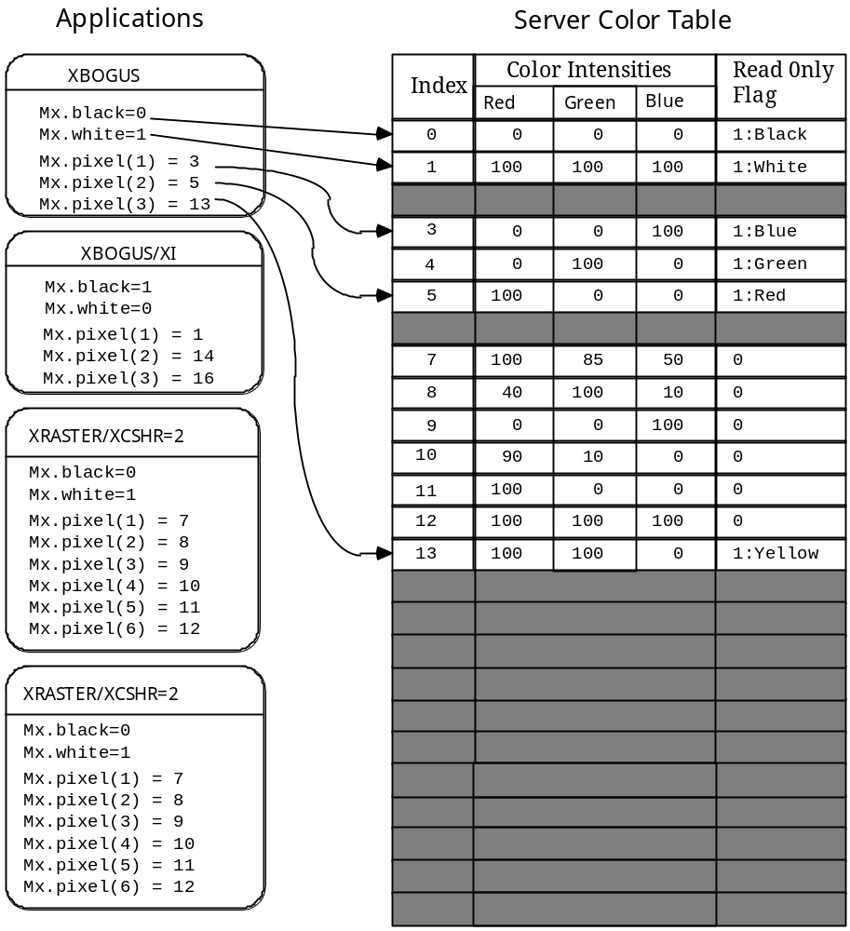
Figure 14 Color Resource Allocation
The figure above shows 4 primitives and the way in which they have been allocated color resources. The XBOGUS primitive is assigned the normal background and foreground colors of black and white, and when given the /XI switch it points at white and black. It then allocates 3 extra colors of blue, green and red by using MX$COLORLAB. At first both instances of XBOGUS are using these same three colors and are pointing to the same three color cells. Then each makes other MX$COLORLAB choices to replace these colors. You’ll notice that when one makes a request for white, it is given the same color cell as those requesting white for their foreground or background color.

The XRASTER applications also are given the same background and foreground color cells as the XBOGUS applications. The rest of their colors are allocated through MX$COLORMAP as read-write color cells. Normally such cells are exclusive to the application who allocates them, but in this instance we assume we are using the /XCSHR switch which allows us to share read-write color cells (currently available in datastreams only.)

