
Raf latest.jpg
Value
Experience
Service

Value
Experience
Service

Rafael E. Huber
Organisational Development Consultant

+41 (0)76 364 5612
6 bis rue du pont neuf • 1227 Carouge • Switzerland

rafael_huber@yahoo.com
www.rafaelhuber.com







Raf latest.jpg
“Master of Business Administration (MBA) with 22 + years of Humans Resources, Learning & Development, Talent Management and Change Management Experience…”
Industries and companies worked for…

Rafael E. Huber
Organisational Development Consultant
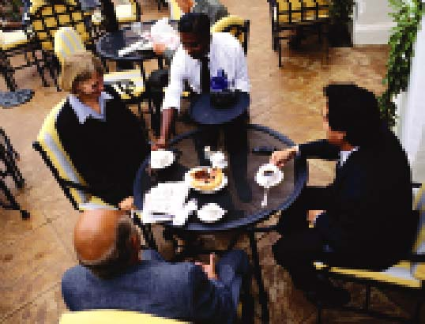
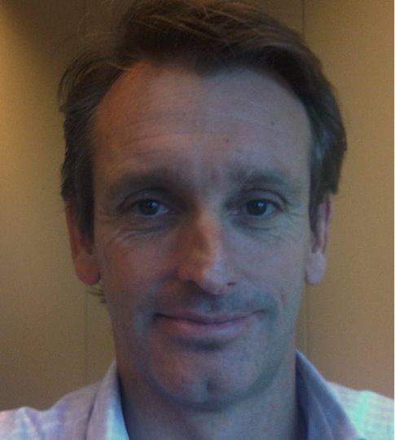
I am a skilled and experienced Human Resources professional with significant strategic and international HR experience in Talent Management, Strategy and Change Leadership, Strategic Workforce Planning and Organizational Development.

I currently serve on the Board of Directors of Totai Citrus S.A. as Vice President Human Resources and is responsible for setting and driving the Human Resources and Organisational Development strategy. Prior to this I worked at Cargill International for nearly a decade where he held various senior leadership roles in Human Resources, Talent Management and Learning and Development. Before this he worked at UBP - Union Bancaire Privée, Reuters, and Embassy Suites. Working in the Banking and Finance, the Financial Information Services and the Hospitality Industries has given me valued experiences in developing and adapting strategies, processes and tools to the unique needs of the respective businesses.
I hold an MBA from the HEC, Université de Genève and B.A. from the University of California Berkeley. He speaks English, French and Spanish fluently and has a working understanding of Italian. aspirations.

My experience…

Helping Leaders Lead Themselves
I have over 10 years of experience coaching and helping senior leaders in the areas of Strategy, Talent Management, Change Management and Human Resources. am trained on the Co-active Coaching* method as well as the GROW ( Goal, Reality, Options, What Next) methodology. If relevant I also use self-awareness tools such as DISC, MBTI, Talent Explorer, OPQ.

My aim is the help Leaders lead themselves so they can lead others more effectively.

* In the process of being certified
Value
Experience
Service

“A passion for helping business & professionals develop based on their talents ”

- Coaching
- Strategy
- Leadership
- Change Management
- Talent Management
- HR Learning and Development

- Business Skills Training

