Test Case Id: 002 |  | Test Purpose: To determine whether the category can be selected
Environment: Windows CMD
Preconditions: There must be questions which already have a category assigned
Test Case Steps:
Step No | Procedure |  |  | Response | Pass/Fail
01 | Start the program |  |  | Displays the config page  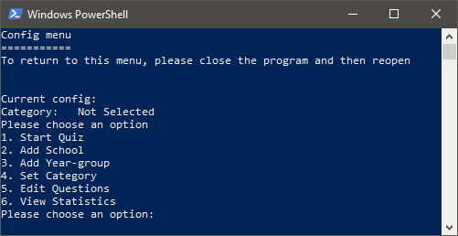 | PASS
02 | Choose the option to set the category |  |  | Displays a list of categories  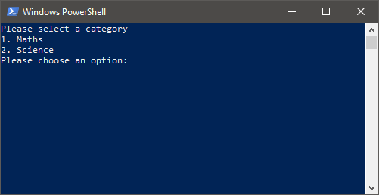 | PASS
03 | Choose a category from the list presented |  |  | The main menu displays again with the category displayed at the top  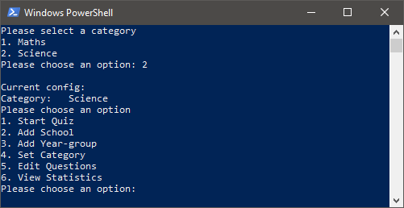 | PASS
04 | Start the quiz |  |  | The quiz begins and the questions are of the chosen category  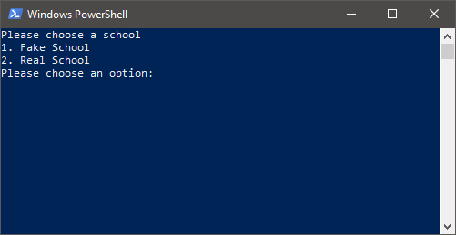 | PASS
Comments: Everything works
Related Tests: The user is able to complete the quiz
Author: Miles Budden |  |  | Checker: Angus Smith

