Documentation

**Content:**

***Map***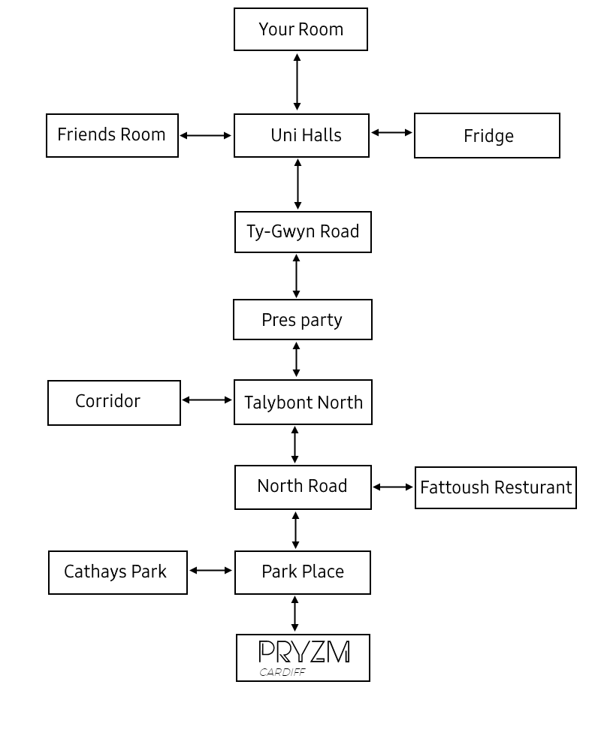

**How to play**:

Locate the game.py file and run it. Your retro windows command prompt will launch, or, if you’re using Linux/ Mac the terminal window will open.

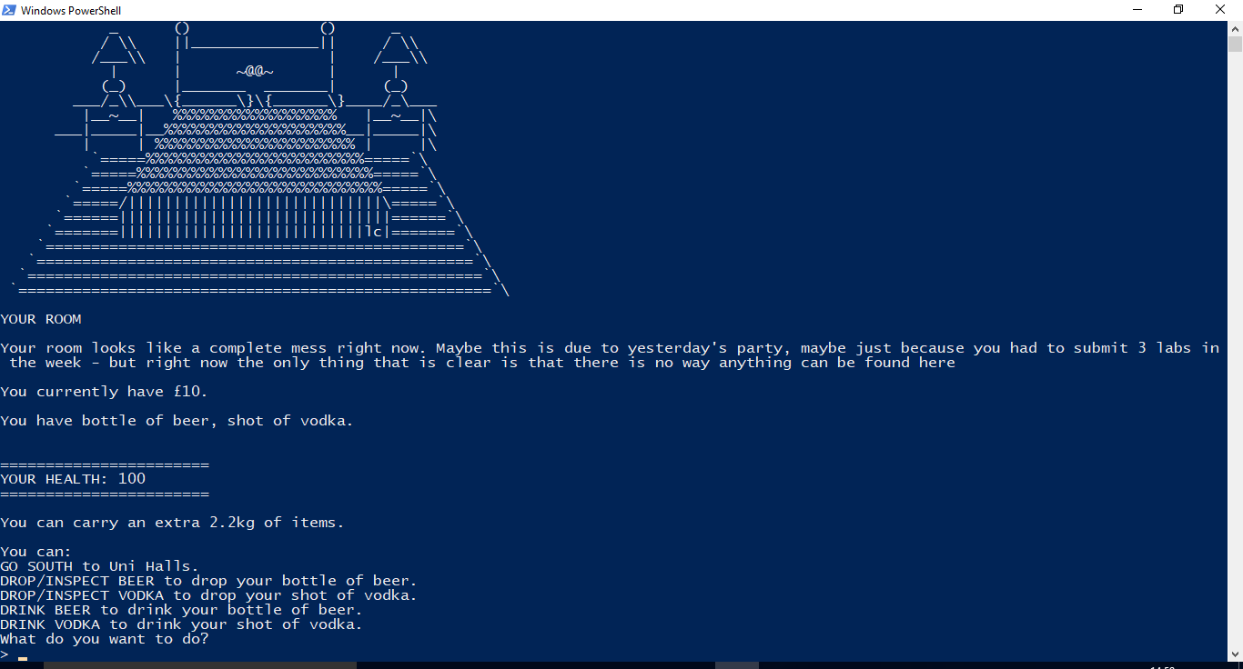

You initial location will be your room. Your player stats will be displayed here. From here you can do different things, by entering commands, like consume food/drink from your inventory and go to different rooms. The list of possible commands will be displayed to you. Based on which room you’re in the list of commands will change. If you not sure what to do type in ‘help’ when it asks you, ‘what you want to do?’.

You will notice that as you make your way through the game you will encounter some wild characters that you have to battle. Make sure you choose the right attack! The characters have some valuable items that you will acquire once they are defeated. You will need some of them to get to certain parts of the map. Your objective is to get pryzm in one piece, this is where the showdown is, so make sure that you have acquire as much abilities as possible by consuming alcohol as this will better your chance of winning against the bouncer.

When you’re in a battle you can select the attack vector by inputting the number next to the attack when prompted. Each player takes turn to attack, so make sure you don’t die first, otherwise you will have to start all over again. If your health is at a critical stage you can revive it by consuming food. I hope you found this helpful.

Enjoy the game!

**Support**: If you find any bugs you can report them to nonexistent@email.com