

USER INTERFACE DESIGN

23CSE113 LAB
MANUAL

SUBMITTED BY
NAME | P. Bharath Chand
ROLL NO | AV.SC.U4CSE25225
YEAR/SEM/SECTION | 1ST YEAR/SEM-2/CSE-C
CREDITS | 03

SUBMITTED TO | DR. RAJ KUMAR BATCHU
DESIGNATION | ASST. PROFFESSOR (SI. Grade)
DEPARTMENT | SCHOOL OF COMPUTING

INDEX

S.NO | TITLE | PAGE.NO | REMARK
1. | WEEK 1: 1. Installation of VS Code tool.  2. Understanding basic of html  Structure  3. Understanding basic html tags | 4-12
2. | WEEK 2: 1. Design a basic web page with the  heading and paragraph with table by  heading styles | 13-16
3. | WEEK 3: 1. Create a class timetable using HTML  Elements  2. Create a HTML webpage that could  Display syllabus of all the subjects as  An image format also the time table | 17-26
4. | WEEK 4:1. Design a registration form using  Html tags  2. Design a two different form in  Webpage using iframe | 27-35
5. | WEEK 5:1. Create a card layout using <div>  tag. Consider three cards and a  button for each card, using HTML  and CSS  2. Navigation using iframe (Mini  website ). Create three basic pages  like  Index.html  Home.html  About.html  Constact.html  3. Design amrita login page by  showing different campuses on  home page. Open clicking on each  campuse should be displayed on  the same page use html and css to  design stylist web page | 36-52
6. | WEEK 6:1. Design a responsive e-commerce  application using the grid layout. This  application  should contain different categories of  products such as electronics, clothing,  home-appliances, books  2. Design a responsive e-commerce  application using the grid layout. This  application should contain different  categories of products such as  electronics, clothing, home-  appliances, books. Based on the  category we select corresponding  products should be displayed on the  sidebar. | 52-63
7. | WEEK:7. create a GitHub account and create a  repository in it and push all the week 6  code files in it. | 64-65
8. | WEEK 8:1. create a web page that displays  a square that continuously rotates 360  using css animation  2. create a ball that moves up and down  continuously using css animation  3. create a circle that moves horizontally  and rotates At the same time | 66-74
9. | Week 9: create a web page using html, CSS and  JavaScript based on the  given condition  a) create a button for each program based on the button clicked the corresponding to be executed and should display the output  b) the logic for each button includes finding an even or odd number, prime or not, factorial of a number and Armstrong  c) use appropriate design to display the output
10. | Week 10:1) Write a java script conditional  statement to find the largest of five  numbers using and onclick event.  Display alert box to show the result  2)Write a java script conditional  statement to sort three numbers  using functions. Display an alert to  show the result  3)Write a java script conditional  statement to find the largest of three  numbers using functions and onclick  event. Display an alert to show the  result
11. | Week 11:1) A website requires users to enter a  username. The system should  display a message while typing if the  username is less than 5 characters.  2) A registration form should validate  email format before submission. If  invalid, the form should not be  submitted.  3) A form should validate a mobile  number when the user leaves the  input field. The number must be  exactly 10 digits.  4) :- A form should validate a mobile  number when the user leaves the  input field. The number must be  exactly 10 digits.  5):- . Design an HTML page, such  that the registration form must  validate:
12. | Week 12: To install and setup the Electron  Framework application.

WEEK -1

1.AIM: Steps to install VS CODE

PROCEDURE:
STEP-1
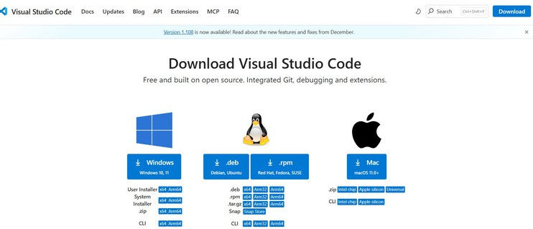

STEP-2
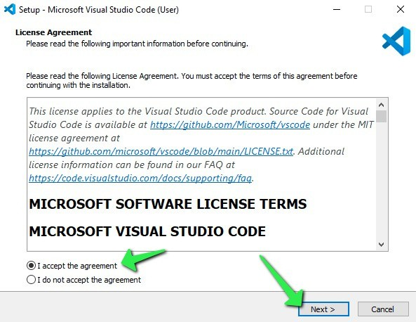

STEP-3
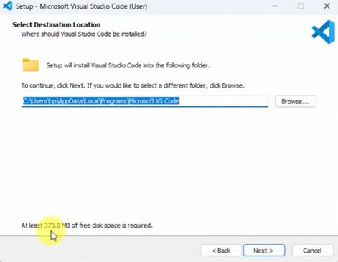

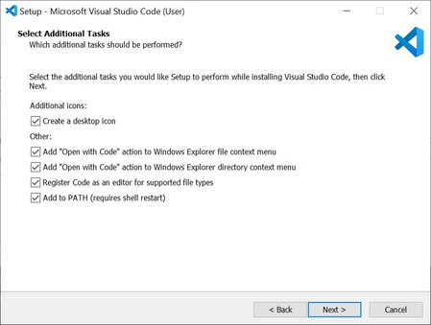
STEP-4
STEP-5
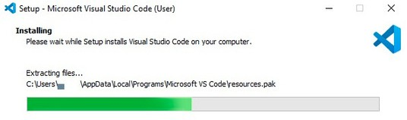

STEP-6
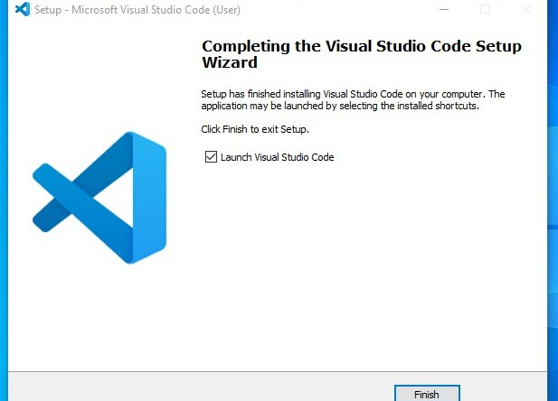

STEP-7
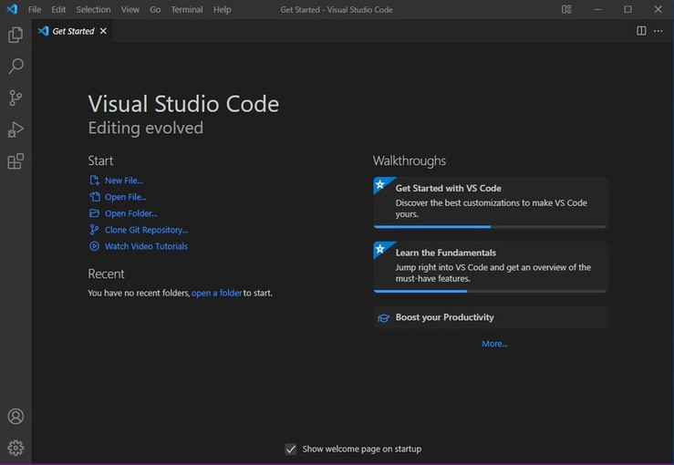

- Aim : To learn the basics of html( basics.html)
Program:
UID25225-P. Bharath Chand-CSE-C

<!DOCTYPE html>
<html>
<head>
<title>FirstWeb Page</title>
<p> P. Bharath Chand</p>
<p> AV.SC.U4CSE25225</p>
<p> CSE-C</p>

</head>
<body>
<h1>Happy to learn HTML</h1>
<p>This is my first sample code</p>
</body>

</html>

Output:

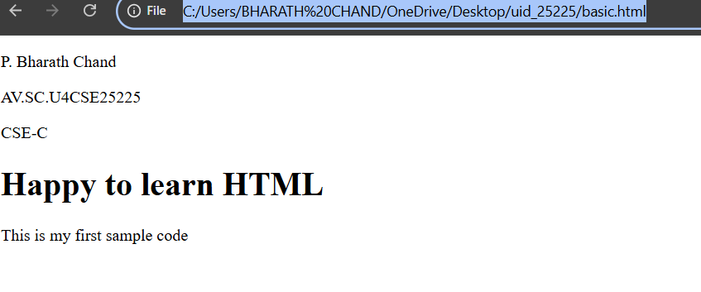

Explanation of the tags:

HTML stands for Hyper Text Markup Language. HTML is used to create and structure web pages.
It tells the web browser what to display and how to display it.
<DOCTYPE HTML> : The <DOCTYPE html>element tells the browser , this is an HTML5 document
<html>: The <html> element is the root element of an HTML page.
<head>: The <head> element contains meta information about the HTML page.
<title>: The <title> element specifies a title for the HTML page.
<body>: The <body>element contains all visible content like text
,images ,links ,tables ,etc.
<h3>: The <h3> element defines a large heading.
<p>: The <p> element defines a paragraph.

2. Aim : understanding basic html tags. Tags - <p>; <h1>; <img>;<color>
Program:
UID251225-P. Bharath Chand
<!DOCTYPE html>
<html>
<head>
<title>LINK HTML Page</title>
<p> P. Bharath Chand</p>
<p> AV.SC.U4CSE25225</p>
<p> CSE-C</p>

</head>
<body>
<h1 style="color:orange":>link for amrita</h1>
<p style="color:red">amrita vishwa vidyapetam <br> school of engiennering and computing </p>
<a href="https://www.amrita.edu/">Amrita </a>
<img src="https://etimg.etb2bimg.com/photo/121182615.cms" alt="logo of Amrita" width="200" height="100">
<h1 style="color:violet":>link for srm</h1>
<p style="color:blue">SRM <br> institute of science and technology </p>
<a href="https://www.srmist.edu.in/">SRM</a>
<img src="https://images.seeklogo.com/logo-png/38/2/srm-institute-of-science-and-technology-logo-png_seeklogo-381994.png" alt="logo of SRM" width="200" height="100">
<h1 style="color:yellow"> link for vit </h1>
<p style="color:green">VIT <br> school of engiennering and computing </p>
<a href="https://www.vit.edu/">VIT</a>
<img src="https://encrypted-tbn0.gstatic.com/images?q=tbn:ANd9GcRmsNoOgftuzicjJIz5RZ4_7t91R_c45n-isA&s" alt="logo of VIT" width="200" height="100">
</body>
</html>

Output
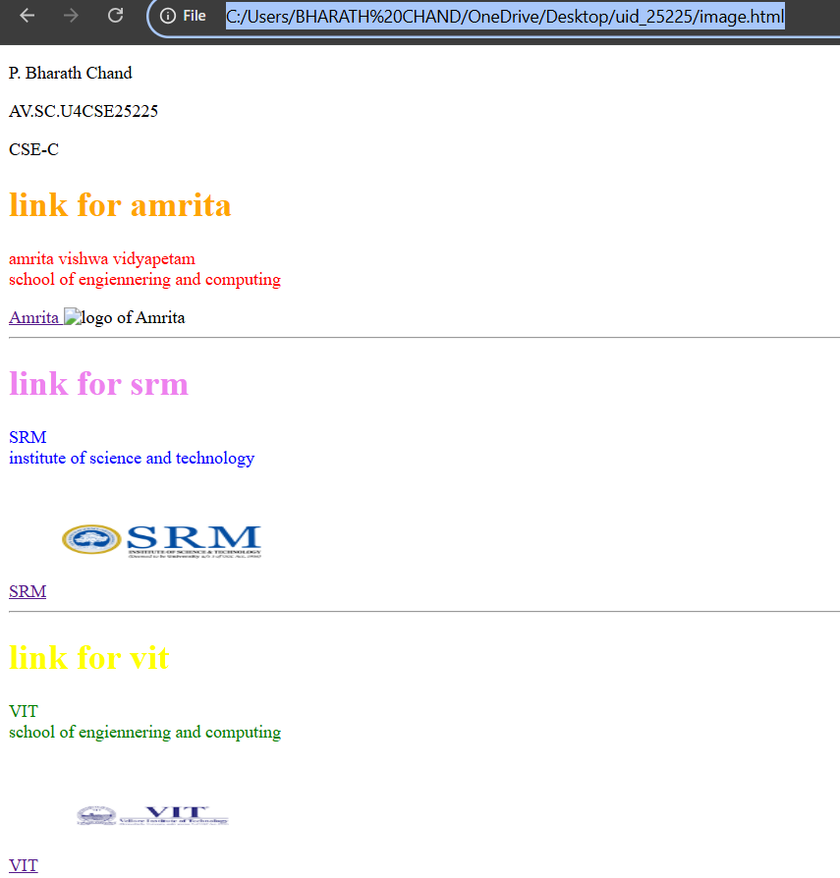

Explanation of the tags:

- <br>: The HTML <br> elements defines a line break. It is an empty tag with no end tag
- Style: The HTML style attributes is used to add styles to an elements such as clolor, front, size and more
- <img>: The <img> tag is a fundamental HTML element used to embed an image into a web page
- <a>: The HTML <a>tag, which stands for ”anchor”, is used to define a hyperlink

WEEK-2

- AIM: Design a basis web page with the heading and paragraph with table by adding styles
Program
UID25225-P. Bharath Chand
<!DOCTYPE html>
<html>
<body style="background-image: url(nbElb5oz-amrita-amaravati-campus-banner-2022.jpg); background-repeat: no-repeat; background-size: cover;">
<hr>
<h1 style="color:aqua;font-family: verdana;text-align:center;">Amrita Vishwavidyapeetham</h1>
<hr>
<p style="color:blue;font:italic;text-align:center;">Mata Amritanandamayi Devi (born Sudhamani Idamammel on September 27, 1953)<br>known fondly as Amma ("Mother") or the "hugging saint,' is a world-renowed<br> indian spiritual leader and hummanitarian from Kerala. She is globally recognized <br> for embracing millions as a profounf act of compassion, offering unconditional<br>love to alleviate physical and emotional suffering.</p>
<table style="text-align:center; margin: auto;" width="50%" border="1" cellpadding="25" cellspacing="10" ;>
<tr style="text-align: center;background-color:cyan;">
<th colspan="6">AMRITA VISHWAVIDYAPEETHAM BRANCHES</th>
</tr>
<tr style="text-align: center;background-color:white; color:greenyellow">
<th>S.No</th>
<th>Campus</th>
<th>Location</th>
<th>Contact No</th>
<th colspan="2">Contact person</th>
</tr>
<tr style="text-align: center; color:greenyellow">
<th style="background-color:darkcyan;">1</th>
<th style="background-color:darkcyan;">Amaravati Campus</th>
<th style="background-color:darkcyan;">Kuragallu</th>
<th rowspan="2">91-9865784585</th>
<th>Rajkumar</th>
<th>Batchu</th>
</tr>
<tr style="text-align: center; color:greenyellow">
<th style="background-color:darkcyan;">2</th>
<th style="background-color:darkcyan;">Amritapuri Campus</th>
<th style="background-color:darkcyan;">Amrita Nagar</th>
<th colspan="2">Adithya Ram</th>
</tr>
<tr style="text-align: center; color:greenyellow">
<th style="background-color:darkcyan;">3</th>
<th style="background-color:darkcyan;">Coimbathoor Campus</th>
<th style="background-color:darkcyan;">Ettimadai</th>
<th>91-9231184586</th>
<th>AAshish</th>
<th>B</th>
</tr>

</table>
</body>
</html>

Output
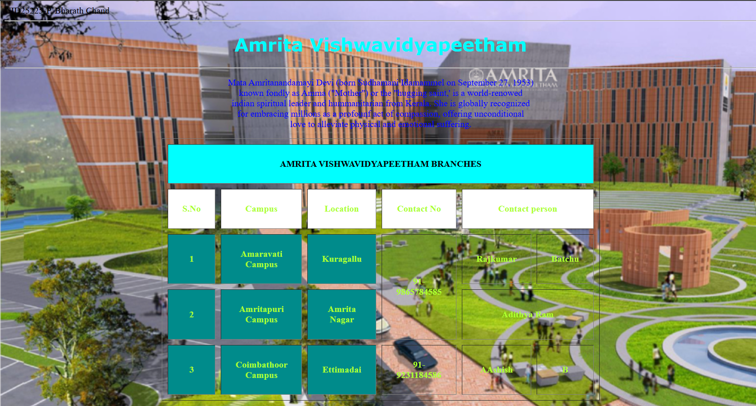

Explanation of the Tags

. <DOCTYPE html> : the <!DOCTYPE html> element tells the web browser that this an HTML document
or this is the latest version of HTML
. <html> : the <html> element is the root element of an HTML web page
. <head> : the <head> element will contain meta data about the HTML web page
. <title> : the <title> element specifies a title for the HTML Page
. <body> : the <body> element contains all visible content all visible content like text , image , links ,
tables , etc
. <table>: the element <table> is used to create a table
. <tr>: the element <tr> creates a new row in the table
. <th>: the element <th> create a new heading inside the table
. <td>: the element <td> fill the columns in the row
. <button>: the element <button> is used for button .

WEEK-3

- AIM: Create a class timetable using HTML elements
Program:
UID25225-P. Bharath Chand-CSE-C
<!DOCTYPE html>
<html>
<head>
<p>P. Bharath Chand</p>
<p>AV.SC.U4CSE25225</p>
<p>CSE-C</p>
</head>

<body>
<table width="10" border="2" cellpadding="15" cellspacing="0">
<tr style="text-align:center">
<th colspan="12" style="background-color:yellow;">Master Time Table CSE-2 Semester C Section</th>
</tr>
<tr>
<th> Dept: CSE</th>
<th rowspan="3" colspan="11"> Class Room Venue:512 </th>
</tr>
<tr>
<th> Class: B.Tech. CSE-C</th>
</tr>
<tr>
<th> Semester-2</th>
</tr>
<tr>
<th rowspan="2">Time/Day</th>
<th> slot 1 </th>
<th> slot 2 </th>
<th> break </th>
<th> slot 3 </th>
<th> slot 4 </th>
<th> slot 5 </th>
<th> lunch </th>
<th> slot 6 </th>
<th> breack</th>
<th> slot 7 </th>
<th> slot 8</th>
</tr>
<tr>
<th>8:55-9:45</th>
<th>9:45-10:35</th>
<th>10:35-10:45</th>
<th>10:45-11:35</th>

<th>11:35-12:25</th>
<th>12:25-1:15</th>
<th>1:15-2:10</th>
<th>2:10-3:00</th>

<th>3:10-3:10</th>
<th>3:10-4:00</th>
<th>4:00-4:50</th>
</tr>
<tr>
<th>Monday</th>
<th colspan="2"> 23MAT116 Discrete Mathematics_lab2 </th>
<th rowspan="5"; style="background-color:yellow"> break</th>
<th> 23PHY115 Modern Physics</th>
<th>23CSE111Object Oriented Programming</th>
<th>22ADM111Glimpses of Glorious India</th>
<th rowspan="5"; style="background-color:yellow"> lunch break</th>
<th>22ADM111Glimpses of Glorious India </th>
<th rowspan="5"; style="background-color:yellow"> breack</th>
<th colspan="2"> sports</th>
</tr>
<tr>
<th>Tuesday</th>
<th colspan="2"> 23CSE113 User Interface Design LAB(BYOD) </th>
<th> 23MAT117 Linear Algebra</th>
<th>23MAT116 Discrete Mathematics</th>
<th>22ADM111Glimpses of Glorious India</th>
<th>23MEE115 Manufacturing Practice LAB</th>
<th>23MEE115 Manufacturing Practice LAB</th>
<th>23MEE115 Manufacturing Practice LAB</th>
</tr>
<tr>
<th>Wednesday</th>
<th>23PHY115 Modern Physics</th>
<th>23CSE113 User Interface Design LAB(BYOD)</th>
<th colspan="2">23MAT117 Linear Algebra</th>
<th>22ADM111Glimpses of Glorious India</th>
<th>library</th>
<th>22ADM111Glimpses of Glorious India</th>
<th>library</th>
</tr>
<tr>
<th>Thursday</th>
<th>23CSE111Object Oriented Programming</th>
<th>23MAT116 Discrete Mathematics</th>
<th colspan="2">23CSE111Object Oriented Programming</th>
<th>23MAT117 Linear Algebra</th>
<th>library</th>
<th colspan="2">sports</th>
</tr>
<tr>
<th>Friday</th>
<th>23CSE111Object Oriented Programming</th>
<th>23MAT116 Discrete Mathematics</th>
<th>23PHY115 Modern Physics</th>
<th>23CSE113 User Interface Design LAB(BYOD)</th>
<th>23MAT117 Linear Algebra</th>
<th>library</th>
<th colspan="2">sports</th>
</table>
<table width="10" cellpadding="25" cellspacing="0" border="1" >
<tr>
<th>Course Code</th>
<th>Course Name</th>
<th><pre>L-T-P</pre></th>
<th>Credits</th>
<th>Faculty Name</th>
<th>Assisting Faculty</th>
</tr>
<tr>
<td>23MAT116</td>
<td>Discrete Mathematics</td>
<td>3-0-2</td>
<td>4</td>
<td>Dr.Srivivasa Rao Thota</td>
<td>-</td>
</tr>
<tr>
<td>23MAT117</td>
<td>Linear Algebra</td>
<td>3-0-2</td>
<td>4</td>
<td>Mr.Sapavat Bixapathi</td>
<td>-</td>
</tr>
<tr>
<td>23CSE111</td>
<td>Object Oriented Programming</td>
<td>3-0-2</td>
<td>4</td>
<td>Dr.Satya Rajendra Singh</td>
<td>Dr Balaji TK</td>
</tr>
<tr>
<td>23PHY115</td>
<td>Modern Physics</td>
<td>2-1-0</td>
<td>3</td>
<td>Dr.Soumya</td>
<td>-</td>
</tr>
<tr>
<td>23CSE113</td>
<td>User Interface Design</td>
<td>2-0-2</td>
<td>3</td>
<td>Dr.Rajkumar Batchu</td>
<td>Mr.Barge Bhardwaj</td>
</tr>
<tr>
<td>23MEE115</td>
<td>Manufacturing Practice</td>
<td><p>0-0-3</p></td>
<td>1</td>
<td>Dr.Sathies S</td>
<td>-</td>
</tr>
<tr>
<td>23ADM111</td>
<td>Glimpses of Glorius India</td>
<td>2-0-1</td>
<td>2</td>
<td>Dr.Siva Panuganti</td>
<td>-</td>
</tr>
<tr>
<td> </td>
<td>Total(15L+1T+12P=28hrs)</td>
<td>15-1-12</td>
<td>21</td>
<td> </td>
<td> </td>
</tr>
</table>
<h4>Discrete Mathematics</h4>
<img src="Screenshot 2026-02-09 190238.png" alt=" Discrete Mathematics " >
<h4>Linear Algebra</h4>
<img src="Screenshot 2026-02-09 190323.png" alt=" Linear Algebra " width="200" >
<h4>Object Oriented Programming</h4>
<img src="Screenshot 2026-02-09 190359.png" alt=" Object Oriented Programming " >
<h4>Modern Physics</h4>
<img src="Screenshot 2026-02-09 190543.png" alt=" Modern Physics " >
<h4>User Interface Design LAB</h4>
<img src="Screenshot 2026-02-09 190638.png" alt=" User Interface Design LAB " >
<h4> User Interface Design </h4>
<img src="Screenshot 2026-02-09 190735.png" alt=" User Interface Design " >
<h4>Manufacturing Practice</h4>
<img src="Screenshot 2026-02-09 190818.png" alt=" Manufacturing Practice " >

</body>
</html>

Output

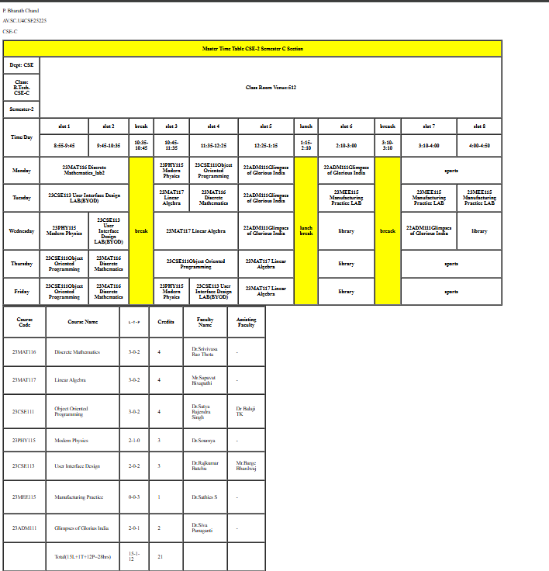

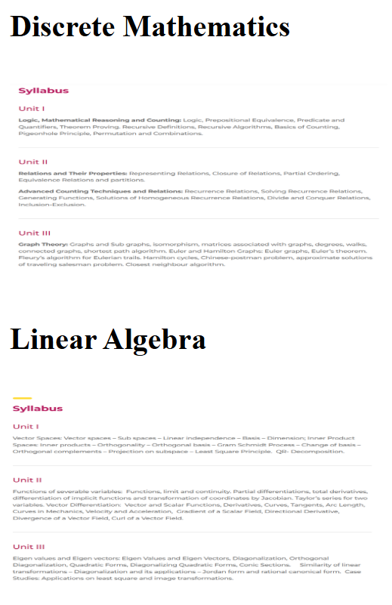

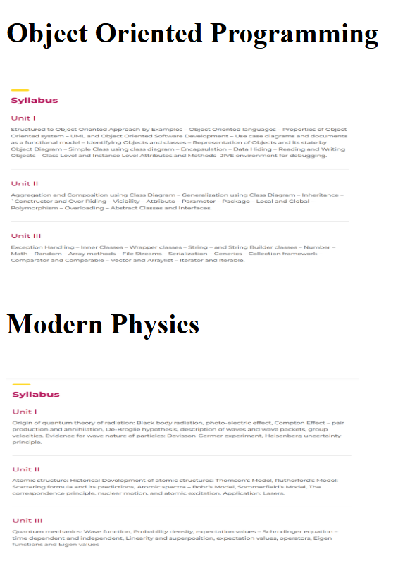




Explanation of the tags:
- <table>: Defines a table structure used to display data in rows and columns.
- <tr>: Defines a table row that contains table cells (<th> or <td>).
- <th>: Defines a table header cell that displays bold, centered text by default.
- <td>: Defines a standard table data cell that holds the actual content of a table.
- <colspan>: it is used to merge multiple colomns horizontally
- <rowspan>: used to merge multiple rows vertically

WEEK-4

Aim: a) Design a registration form using html tags
UID25225-P. Bharath Chand-CSE-C
Program:
UID25225-P. Bharath Chand-CSE-C
<!DOCTYPE html>
<html>
<head>
<title>HTML Forms</title>
<style>
table{
border:1px solid black;
border-collapse: collapse;
width:50%;
margin:auto;
}
td{
border:1px solid black;
padding:8px;
}
h2{
text-align:center;
}
</style>
</head>

<body>

<h2>HTML Forms</h2>

<form>
<table>

<tr>
<td>Full Name</td>
<td><input type="text" name="fname" required></td>
</tr>

<tr>
<td>Email</td>
<td><input type="email" name="email" required></td>
</tr>

<tr>
<td>Phone Number</td>
<td><input type="text" name="phone" required></td>
</tr>

<tr>
<td>Gender</td>
<td>
<input type="radio" name="gender"> Male
<input type="radio" name="gender"> Female
<input type="radio" name="gender"> Other
</td>
</tr>

<tr>
<td>Course Applying for?</td>
<td>
<select name="course">
<option>B.Tech</option>
<option>B.E</option>
<option>B.Arch</option>
<option>BCA</option>
<option>B.Sc</option>
</select>
</td>
</tr>

<tr>
<td>Hobbies</td>
<td>
<input type="checkbox"> Sports
<input type="checkbox"> Music
<input type="checkbox"> Reading
</td>
</tr>

<tr>
<td>Date of Birth</td>
<td><input type="date" name="dob"></td>
</tr>

<tr>
<td>Upload Certificate</td>
<td><input type="file"></td>
</tr>

<tr>
<td>Address</td>
<td><textarea rows="4" cols="30"></textarea></td>
</tr>

<tr>
<td colspan="2" style="text-align:center;">
<input type="submit" value="Submit">
<input type="reset" value="Reset">
</td>
</tr>

</table>
</form>

</body>
</html>

OUTPUT:
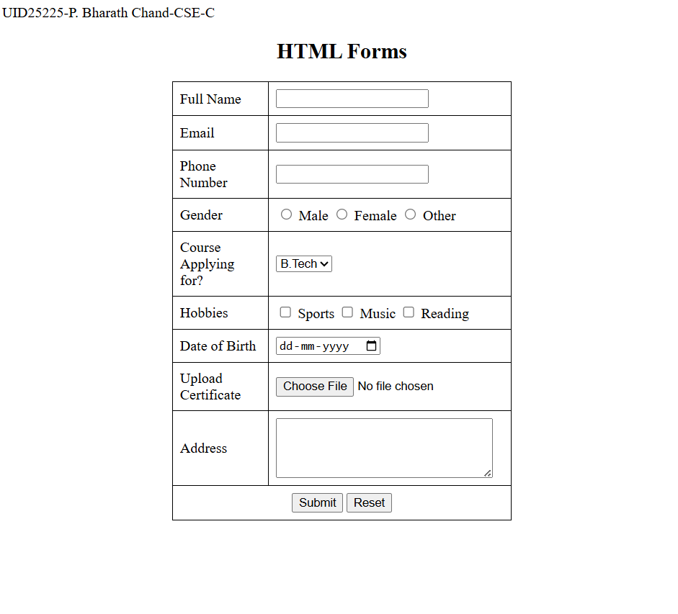

EXPLANATION OF THE TAGS:-

1)<form>: Creates a form.
2)<label>: It defines a label for many form elements.
3)<input type="radio">: It defines a radio button .Radio buttons are used to select only one of a limited number of choices.
4)<input type="checkbox"> : Checkboxes are used to select one or more options of a limited number of choices.
5)<input type=”text”>: It defines a single-line text field.
6) <input type=”date”>: It defines a date picker.
7)<input type=”file”>: It defines a file-select field and a "Browse" button for file uploads.
8)<input type=”submit”>: It defines a submit button which submits all form values to a form-handler..
9)<input type=”reset”>: It defines a reset button which resets all form values to its initial values.
10)<textarea>: It defines a multi-line text input control.
11)<select>: It is used to create a drop-down list.
12)<option>: It defines options inside a dropdown list.

AIM: b) Design a two different form in webpage using iframes.
Program:
UID25225-P.Bharath Chand-CSE-C
<!DOCTYPE html>
<html>
<body style="background-color: rgb(90, 230, 181);">
<center>
<h1 style="text-align: center;">Two Forms Displayed Using Iframe</h1>
<table cellspacing="40">
<tr>
<td>
<iframe src="username.html"width="600"height="400" align="center"width="500"height="100"style="align-self: unset;border-color:purple;background-color:white;"></iframe></td>
<td><iframe src="password.html"width="600"height="400" align="center"width="500"height="100"style="align-self: unset;border-color:purple;background-color:white;"></iframe>
</td>
</tr>
</table>
</center>
</body>
</html>

Password.html
<!DOCTYPE html>
<html>
<body>
<h2 style="text-align: center;">User Registration</h2>
<table width="300"border="2"align="center"height="300">
<tr>
<th><label for="fname">Full Name:</label></th>
<th><input type="text" id="fname" name="fname" required></th>
</tr>
<tr>
<th><label for="fname">Email:</label></th>
<th><input type="text" id="fname" name="fname" required></th>
</tr>
<tr>
<th><label for="fname">Phone:</label></th>
<th><input type="text" id="fname" name="fname" required></th>

</tr>
</tr>
<tr>
<th><label for="fname">Password:</label></th>
<th><input type="text" id="fname" name="fname" required></th>
</tr>
<tr>
<th colspan="2"align="center"><input type="submit"value="Register"><input type="reset"value="Reset">
</th>
</tr>
</table>
</body>
</html>

Username.html

<!DOCTYPE html>
<html>
<body>
<h2 style="text-align: center;">User Login</h2>
<table align="center"width="350" border="2"height="250"background-color:white;>
<tr>
<th><label for="fname">Username:</label></th>
<th><input type="text" id="fname" name="fname"required></th>
</tr>
<tr>
<th><label for="fname">Password:</label></th>
<th><input type="text" id="fname" name="fname"required></th>
</tr>
<tr>
<th colspan="2"align="center"><input type="submit"value="Login"></th>
</tr>
</table>
</body>
</html>

OUTPUT:
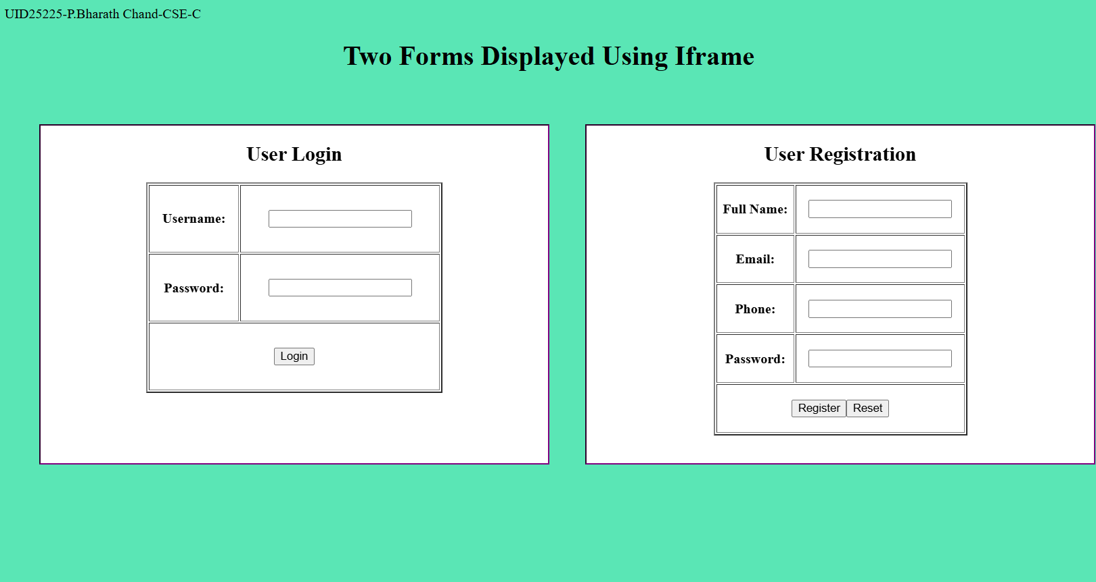

Explanation of the Tags

1)<iframe>:An HTML iframe is used to display a web page within a web page.
2)src attribute: It specifies the address of the document to embed in an iframe.
3)width attribute: It specifies the width of iframe.
4)height attribute: It specifies the height of iframe.

WEEK 5

- Aim:- Create a card layout using <div> tag. Consider three cards and a button for each card, using HTML and CSS
Program:-

UID25225-P.Bharath Chand-CSE-C
<!DOCTYPE html>
<html>
<head>
<title style="color: #e70f0f;">Card Layout</title>
<style>
body {
font-family: Arial, sans-serif;
background-color: #d0d4d6;
display: flex;
justify-content: center;
align-items: center;
height: 100vh;
}
.container {
display: flex;
gap: 100px;
}
.card {
background-color: white;
width: 300px;
height: 350px;
padding: 20px;
border-radius: 1px;
box-shadow: 0 4px 10px rgba(0,0,0,0.1);
text-align: center;
}
.card h3 {
margin-bottom: 10px;
}

.card p {
font-size: 14px;
color: #555;
}
.btn {
display: inline-block;
margin-top: 15px;
padding: 8px 15px;
background-color: #de0e0e;
color: white;
text-decoration: none;
border-radius: 5px;
cursor: pointer;
}
.btn:hover {
background-color: #0056b3;
}
</style>
</head>
<body>
<div class="container">
<div class="card">
<img src="c:\Users\BHARATH CHAND\OneDrive\Pictures\Saved Pictures\80cf6556264925.59a7c6e1c4f8e.jpg" width="50%" height="50%">
<h3>Full Stack Developement</h3>
<p>Best course is avalable in META</p>
<div class="btn">Click Me</div>
</div>
<div class="card">
<img src="c:\Users\BHARATH CHAND\OneDrive\Pictures\Saved Pictures\210880.jpg" width="50%" height="50%">
<h3>Cloud Computing</h3>
<p>Best course is avalable in Google</p>
<div class="btn">Click Me</div>
</div>
<div class="card">
<img src="c:\Users\BHARATH CHAND\OneDrive\Pictures\Saved Pictures\pngtree-gaming-neon-light-esport-sci-fi-futuristic-image_2589658.jpg" width="50%" height="50%">
<h3>DSA</h3>
<p>Best course is avalable in GeeksforGeeks</p>
<div class="btn">Click Me</div>
</div>
</div>
</body>
</html>

OUTPUT:-



EXPLANATION OF TAGS:-
•<div> : It is used as a container for other HTML elements and comes with line breaks before and after.
•<button>: It creates a clickable button.
•.container: It is a CSS class selector used to apply styles to any HTML element that has class=”container”.
•.card: It is a CSS class selector used to style each individual card element.
•.card button: It is a CSS selector that styles the button inside the card.
•.card button-hover: It is a CSS pseudo-class that changes the button style when the mouse pointer moves over it.
•Display-flex: It uses flexbox layout.
•Flex-direction: It sets the display-direction of flex items.
•Flex-wrap: It specifies whether the flex items should wrap or not.
•Justify-content: It aligns the flex items when they do not use all available space on the main-axis (horizontally).
•Align-items: It aligns the flex items when they do not use all available space on the cross-axis (vertically).
•box-shadow: It adds shadow effect.

2)AIM:- Navigation using iframe (Mini website ). Create three basic pages like
Index.html
Home.html
About.html
Constact.html
Program:-
Index.html
UID25225-P. Bharath Chand-CSE-Chand
<!DOCTYPE html>
<html>
<head>
<title>Mini Website</title>
<style : #d0d4d6>
body {
font-family: Arial ;
margin: 0;
background-image: url(nbElb5oz-amrita-amaravati-campus-banner-2022.jpg);
background-size: cover;
background-repeat: no-repeat;
}

nav {
background-color: #333;
padding: 15px;
text-align: center;
}

nav a {
color: white;
text-decoration: none;
margin: 0 20px;
font-size: 18px;
}

nav a:hover {
color: yellow;
}

iframe {
width: 100%;
height: 500px;
border: none;
}
</style>
</head>
<body>

<nav>
<a href="home.html" target="content">Home</a>
<a href="about.html" target="content">About</a>
<a href="contact.html" target="content">Contact</a>
</nav>

<iframe name="content" src="home.html"></iframe>

</body>
</html>

Home.html
<!DOCTYPE html>
<html>
<head>
<title>Home</title>
</head>
<body>
<h1>Welcome to Home Page</h1>
<p>Welcome to Amrita Vishwavidyapetum</p>
</body>
</html>

About.html
<!DOCTYPE html>
<html>
<head>
<title>About</title>
</head>
<body>
<h1>About Us</h1>
<p>Corcess avalable <br> CSE <br> AID <br> AIE <br> CCE </p>
</body>
</html>

Contact.html
<!DOCTYPE html>
<html>
<head>
<title>Contact</title>
</head>
<body>
<h1>Contact Us</h1>
<p>Email: amrita@gmail.com</p>
</body>
</html>

OUTPUT:-

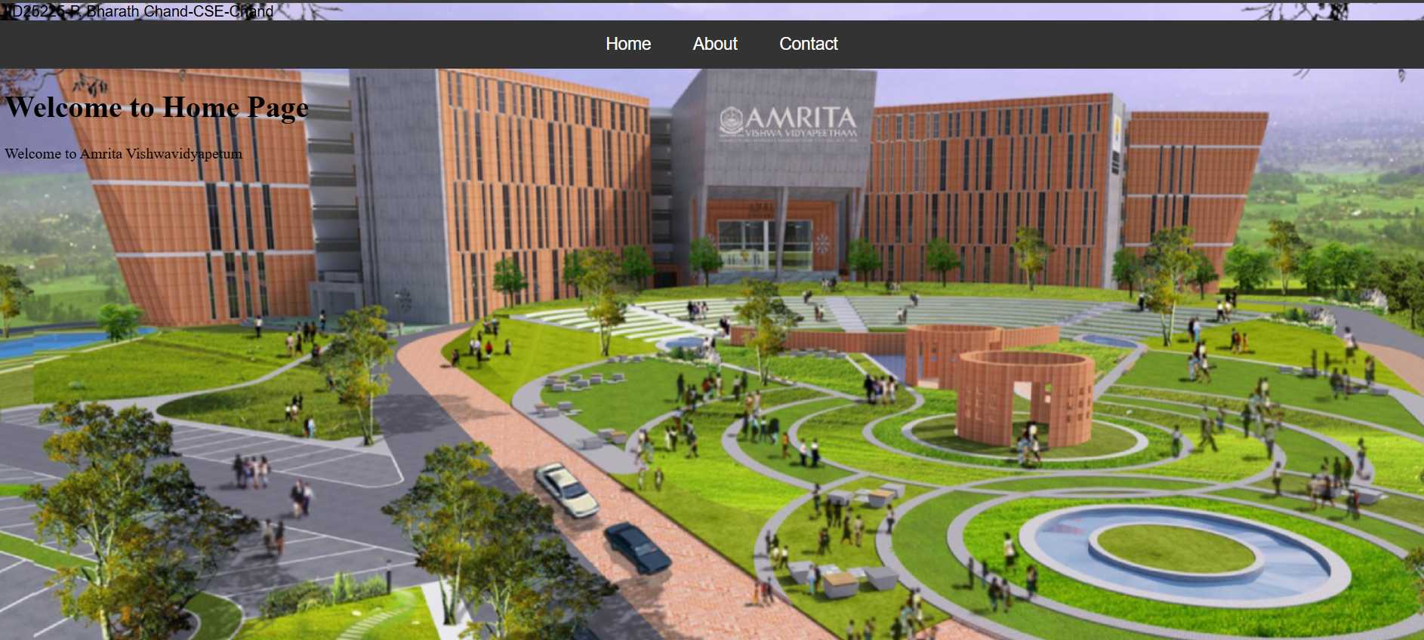

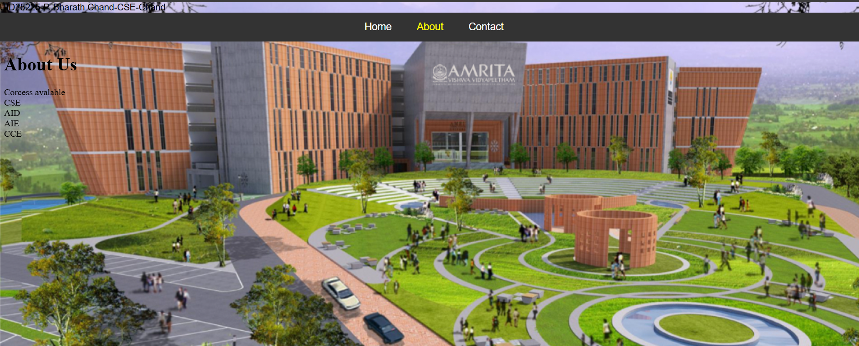

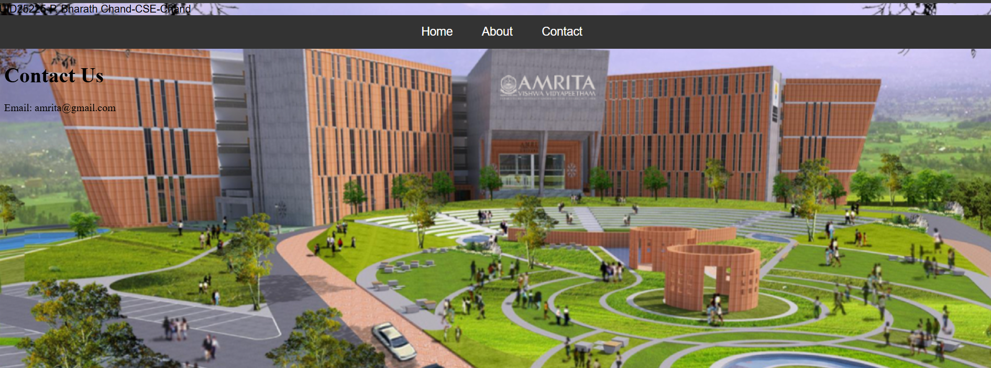

EXPLANATION OF THE TAGS:-
1)<a>: It creates links (navigation buttons).
2)href: It creates page links.
3)Target attribute: It specifies where to open the linked document.
4)<div> : It is used as a container for other HTML elements and comes with line breaks before and after.
5)<iframe>:An HTML iframe is used to display a web page within a web page.

- Aim:- Design amrita login page by showing different campuses on home page. Open clicking on each campuse should be displayed on the same page use html and css to design stylist web page
Sol:- UID25225-P. Bharath Chand-CSE-Chand
<!DOCTYPE html>
<html>
<head>
<title>Amrita Campuses</title>

<style>

body{
font-family:Arial;
margin:0;
background:#f4f4f4;
}

h1{
background:#8b0000;
color:white;
padding:15px;
text-align:center;
}

.menu{
text-align:center;
margin:20px;
}

.menu a{
text-decoration:none;
background:#8b0000;
color:white;
padding:10px 20px;
margin:10px;
border-radius:5px;
}

.menu a:hover{
background:#cc0000;
}

.container{
display:flex;
width:100%;
height:500px;
}

.login{
width:25%;
padding:20px;
background:white;
border-right:2px solid #ccc;
}

.login input{
width:100%;
margin:5px 0;
padding:6px;
}

.content{
width:75%;
padding:20px;
}

iframe{
width:100%;
height:450px;
border:1px solid #ccc;
}

</style>
</head>

<body>

<h1>Amrita University Campuses</h1>

<div class="menu">

<a href="amritapuri.html" target="campus">Amritapuri</a>
<a href="coimbatore.html" target="campus">Coimbatore</a>
<a href="bengaluru.html" target="campus">Bangalore</a>
<a href="amaravati.html" target="campus">Amaravati</a>
<a href="chennai.html" target="campus">Chennai</a>
<a href="kochi.html" target="campus">Kochi</a>
<a href="nagercil.html" target="campus">Nagercoil</a>
</div>

<div class="container">

<div class="login">
<h2>Login</h2>

Email
<input type="email">

Password
<input type="password">

<input type="button" value="Login">

<br><br>

<a href="#">Forgot Password?</a>

</div>

<div class="content">

<iframe name="campus" src="amritapuri.html"></iframe>

</div>

</div>

</body>
</html>

Amritapuri.html
<html>
<head>
<title>Amritapuri Campus</title>
</head>
<body style="font-family:Arial;text-align:center;padding:30px;">
<h1 style="color:#ff4444;">Amritapuri Campus</h1>
<p>
The Amrita Vishwa Vidyapeetham Amritapuri Campus is located in Amritapuri, Kerala,<br> near the Arabian Sea and the Kerala backwaters. <br>It is the headquarters campus of the university and offers programs in engineering, computing, and<br> other disciplines in a peaceful environment known for research and innovation.
</p>
<img src="c:\Users\BHARATH CHAND\OneDrive\Pictures\Saved Pictures\amritapuri.JPEG" width="450" alt="Amritapuri Campus">
</body>
</html>

coimbatore.html

<html>
<head>
<title> Coimbatore Campus</title>
</head>
<body style="font-family:Arial;text-align:center;padding:30px;">
<h1 style="color:#ff4444;">Coimbatore Campus</h1>
<p>
The Amrita Vishwa Vidyapeetham Coimbatore Campus is located in Coimbatore, Tamil Nadu,<br> at the foothills of the Western Ghats.<br> It is the largest campus of the university and is well known for its strong engineering, technology, and<br> research programs with modern laboratories and academic facilities.
</p>
<img src="c:\Users\BHARATH CHAND\OneDrive\Pictures\Saved Pictures\coimbatore.JPEG" width="450" alt="Coimbatore Campus">
</body>
</html>

bengaluru.html

<html>
<head>
<title> Bengaluru Campus</title>
</head>
<body style="font-family:Arial;text-align:center;padding:30px;">
<h1 style="color:#ff4444;">Bengaluru Campus</h1>
<p>
The Amrita Vishwa Vidyapeetham Bengaluru Campus is located in Bengaluru, Karnataka,<br> one of India’s major technology hubs.<br> The campus focuses mainly on computing and technology education and<br> provides students with strong industry exposure due to its proximity to many tech companies.
</p>
<img src="c:\Users\BHARATH CHAND\OneDrive\Pictures\Saved Pictures\bengaluru.JPEG" width="450" alt="Bengaluru Campus">
</body>
</html>

amaravati.html

<html>
<head>
<title>Amaravati Campus</title>
</head>
<body style="font-family:Arial;text-align:center;padding:30px;">
<h1 style="color:#ff4444;">Amaravati Campus</h1>
<p>
The Amrita Vishwa Vidyapeetham Amaravati Campus is located in Amaravati, Andhra Pradesh,<br> near the state’s developing capital region.<br> The campus focuses on modern engineering education, advanced research, and <br>industry-oriented learning in a growing academic environment.
</p>
<img src="c:\Users\BHARATH CHAND\OneDrive\Pictures\Saved Pictures\amaravati.JPEG" width="450" alt="Amaravati Campus">
</body>
</html>

chennai.html

<html>
<head>
<title> Chennai Campus</title>
</head>
<body style="font-family:Arial;text-align:center;padding:30px;">
<h1 style="color:#ff4444;">Chennai Campus</h1>
<p>
The Amrita Vishwa Vidyapeetham Chennai Campus is located in Chennai, Tamil Nadu, <br>one of India’s major educational and technological centers.<br> The campus focuses on engineering education, research, and <br>industry-oriented learning with modern infrastructure and academic facilities.
</p>
<img src="c:\Users\BHARATH CHAND\OneDrive\Pictures\Saved Pictures\chennai.JPEG" width="450" alt="Chennai Campus">
</body>
</html>

kochi.html

<html>
<head>
<title> Kochi Campus</title>
</head>
<body style="font-family:Arial;text-align:center;padding:30px;">
<h1 style="color:#ff4444;">Kochi Campus</h1>
<p>
The Amrita Vishwa Vidyapeetham Kochi Campus is located in Kochi, Kerala,<br> and is well known for its medical education and healthcare facilities.<br> The campus includes the Amrita Institute of Medical Sciences,<br> one of the leading hospitals and medical colleges in India.
</p>
<img src="c:\Users\BHARATH CHAND\OneDrive\Pictures\Saved Pictures\kochi.JPEG" width="450" alt="Kochi Campus">
</body>
</html>

nagercil.html

<html>
<head>
<title> Nagercoil Campus</title>
</head>
<body style="font-family:Arial;text-align:center;padding:30px;">
<h1 style="color:#ff4444;">Nagercoil Campus</h1>
<p>
The Amrita Vishwa Vidyapeetham Nagercoil Campus is located in Nagercoil, Tamil Nadu,<br> near the southern tip of India.<br> The campus focuses on engineering education and<br> technical training while promoting research and innovation in emerging technologies.
</p>
<img src="c:\Users\BHARATH CHAND\OneDrive\Pictures\Saved Pictures\nagercoil.JPEG" width="450" alt="Nagercoil Campus">
</body>
</html>

OUTPUT

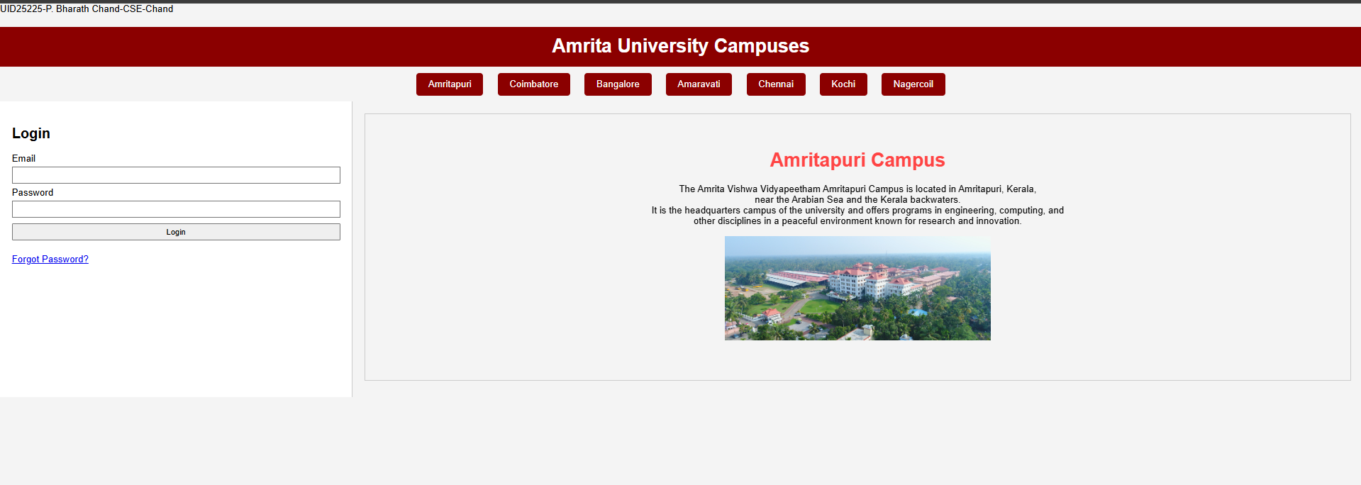

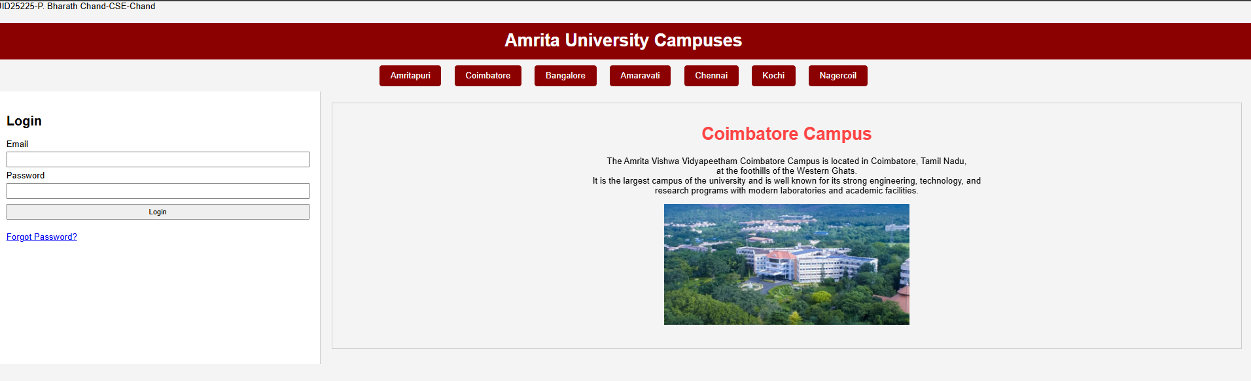

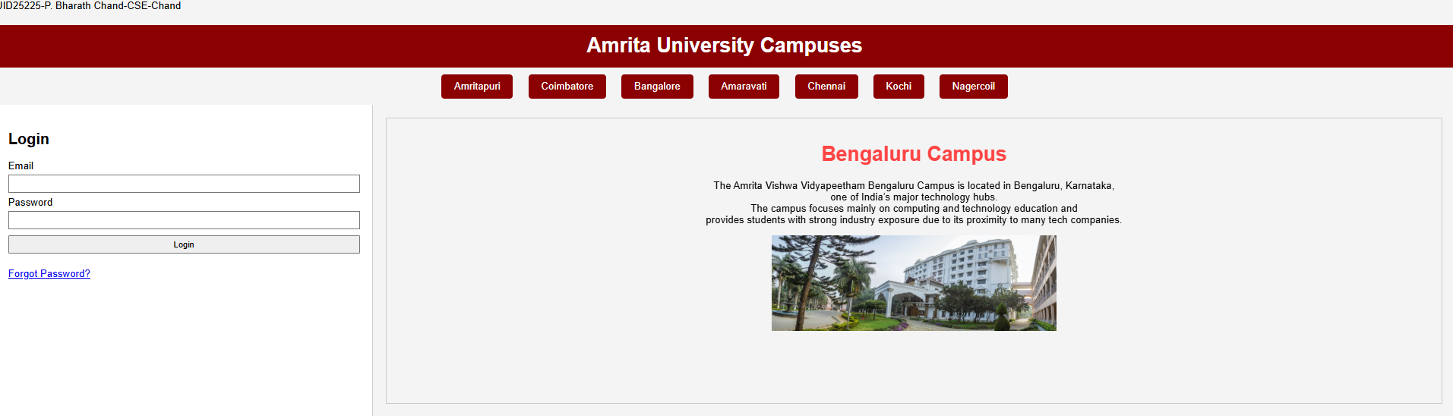

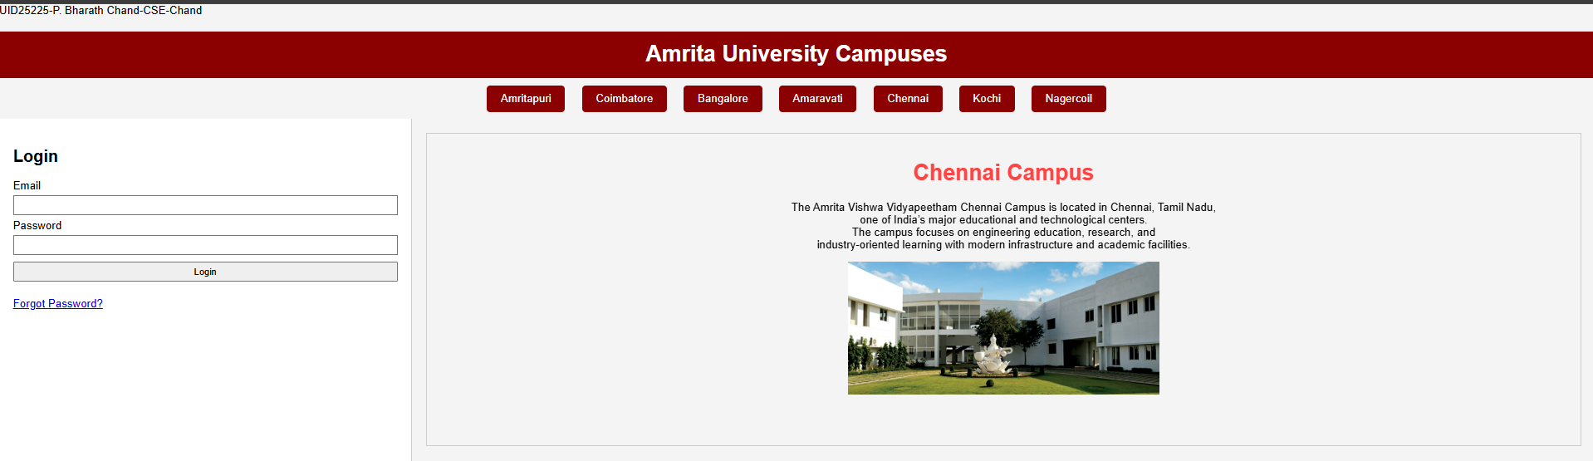

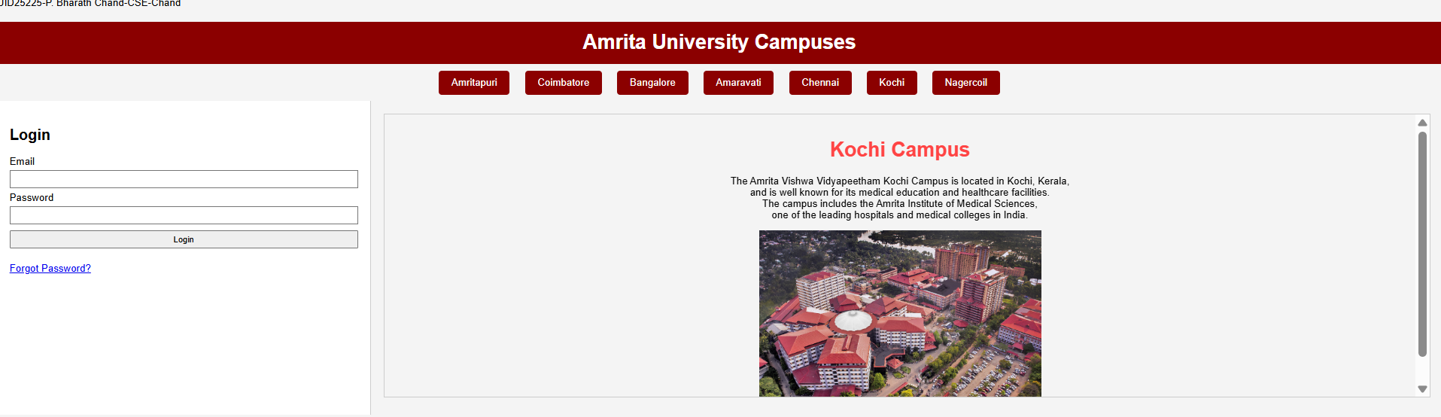

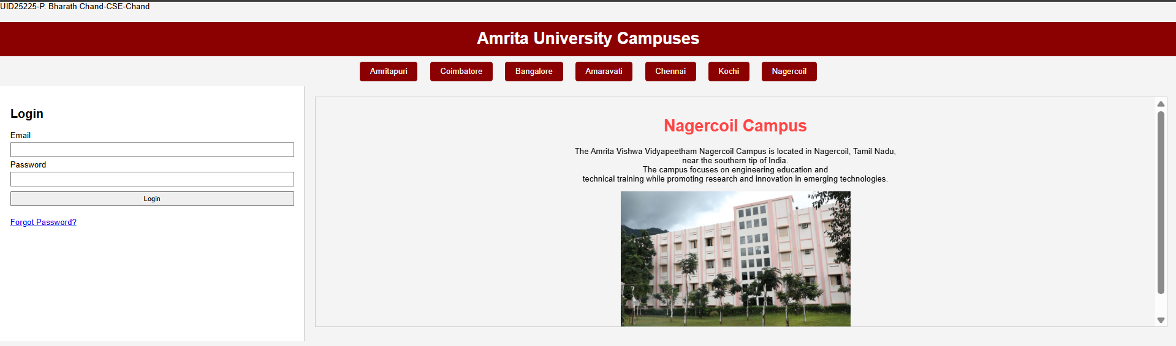

Explanation of the Tags
1)<style>: It is used to write CSS styles for designing the webpage.
2)<a>: It creates links (navigation buttons).
2)href: It creates page links.
3)Target attribute: It specifies where to open the linked document.
4)<input type="checkbox"> : Checkboxes are used to select one or more options of a limited number of choices.
5)<input type=”submit”>: It defines a submit button which submits all form values to a form-handler..
6) <div> : It is used as a container for other HTML elements and comes with line breaks before and after.
7)<label>: It displays text describing an input field.
8)<iframe>:An HTML iframe is used to display a web page within a web page.
9)CSS Flexbox Layout: It is a layout model for arranging items (horizontally or vertically) within a container, in a flexible and responsive way.

Week-6

Aim: Design a responsive e-commerce application using the grid layout. This application
should contain different categories of products such as electronics, clothing, home-appliances,
books.
Program:-
<!DOCTYPE html>
<html>
<head>
<title>E-Commerce store</title>
<style>
body{
font-family: Arial, sans-serif;
margin: 0;
padding: 0;
background-color: grey;
}
.container{
display: grid;
grid-template-columns:200px 1fr;
grid-template-rows:auto auto 1fr auto;
gap:20px;
padding:20px;
min-height:100vh;
grid-template-areas:
"header header"
"sale sale"
"sidebar products"
"footer footer";
}
.header{
grid-area: header;
background-color: red;
color: white;
padding: 20px;
text-align: center;
}
.sale{
grid-area: sale;
background-color:black;
color: white;
padding: 20px;
text-align: center;
}
.sidebar{
grid-area: sidebar;
background-color: lightgray;
padding: 20px;
}
.sidebar ul{
list-style:none;padding:0;
}
.sidebar li{
margin:15px 0;
}
.sidebar a{
color:#fff;
text-decoration:none;
font-size:18px;
transition:.3s;
}
.sidebar a:hover{
color:#00ffd5;padding-left:8px;
}
.main{
grid-area:products;
}
iframe{
width:100%;
height:100%;
border:0;
}
.products{
grid-area: products;
background-color: white;
padding: 0;
}
.card{
background-color:red;
color: white;
padding: 20px;
border-radius: 5px;
text-align:center;
}
.button{
display: inline-block;
padding: 10px 20px;
background-color: palevioletred;
color: white;
text-decoration: none;
border-radius: 5px;
margin-top: 10px;
}
.button:hover{
background-color: plum;
}
.footer{
grid-area: footer;
background-color: lightgray;
color: black;
padding: 20px;
text-align: center;
}

</style>
</head>
<body>
<div class="container">

<div class="header">
<h1>Welcome to Our E-Commerce Store</h1>
</div>

<div class="sale">
<h2>Big Sale! Up to 50% Off!</h2>
</div>

<div class="sidebar">
<h3>Categories</h3>
<ul>
<li><a href="electronics.html" target="contentFrame">Electronics</a></li>
<li><a href="clothings.html" target="contentFrame">Clothing</a></li>
<li><a href="home-kitchen.html" target="contentFrame">Home & Kitchen</a></li>
<li><a href="books.html" target="contentFrame">Books</a></li>
</ul>
</div>

<div class="products">
<iframe name="contentFrame"></iframe>
</div>

<div class="footer">
<p>© 2026 My Store</p>
</div>

</div>
</div>
</div>
</body>
</html>

Electronics.html
<!DOCTYPE html>
<html>
<head>
<style>
body{
font-family: Arial, sans-serif;
margin: 0;
padding: 0;
background-color: grey;
}
.products{
grid-area: products;
background-color: white;
padding: 20px;
display: grid;
grid-template-columns: repeat(2, 1fr);
gap: 20px;
}
.card{
background-color:red;
color: white;
padding: 20px;
border-radius: 5px;
text-align:center;
}
.button{
display: inline-block;
padding: 10px 20px;
background-color: palevioletred;
color: white;
text-decoration: none;
border-radius: 5px;
margin-top: 10px;
}
.button:hover{
background-color: plum;
}
</style>
<body>
</div>
<div class="products">
<div class="card">
<img src="c:\Users\BHARATH CHAND\OneDrive\Pictures\Saved Pictures\10PRO5G.JPEG" width="450" alt="product 1">
<h3>Product 1</h3>
<p>$19.99</p>
<a href="#" class="button">Buy Now</a>
</div>
<div class="card">
<img src="c:\Users\BHARATH CHAND\OneDrive\Pictures\Saved Pictures\17PROMAX.JPEG" width="450" alt="product 2">
<h3>Product 2</h3>
<p>$29.99</p>
<a href="#" class="button">Buy Now</a>
</div>
<div class="card">
<img src="c:\Users\BHARATH CHAND\OneDrive\Pictures\Saved Pictures\1PLUS15.PNG" width="450" alt="product 3">
<h3>Product 3</h3>
<p>$39.99</p>
<a href="#" class="button">Buy Now</a>
</div>
<div class="card">
<img src="c:\Users\BHARATH CHAND\OneDrive\Pictures\Saved Pictures\samsung-galaxy.WEBP" width="450" alt="product 4">
<h3>Product 4</h3>
<p>$49.99</p>
<a href="#" class="button">Buy Now</a>
</div>
</div>
</body>
</html>

Clothings.html
<!DOCTYPE html>
<html>
<head>
<style>
body{
font-family: Arial, sans-serif;
margin: 0;
padding: 0;
background-color: grey;
}
.products{
grid-area: products;
background-color: white;
padding: 20px;
display: grid;
grid-template-columns: repeat(2, 1fr);
gap: 20px;
}
.card{
background-color:red;
color: white;
padding: 20px;
border-radius: 5px;
text-align:center;
}
.button{
display: inline-block;
padding: 10px 20px;
background-color: palevioletred;
color: white;
text-decoration: none;
border-radius: 5px;
margin-top: 10px;
}
.button:hover{
background-color: plum;
}
</style>
<body>
</div>
<div class="products">
<div class="card">
<img src="c:\Users\BHARATH CHAND\OneDrive\Pictures\Saved Pictures\hoodie.JPEG" width="450" alt="product 1">
<h3>Product 1</h3>
<p>$19.99</p>
<a href="#" class="button">Buy Now</a>
</div>
<div class="card">
<img src="c:\Users\BHARATH CHAND\OneDrive\Pictures\Saved Pictures\jacket.JPEG" width="450" alt="product 2">
<h3>Product 2</h3>
<p>$29.99</p>
<a href="#" class="button">Buy Now</a>
</div>
<div class="card">
<img src="c:\Users\BHARATH CHAND\OneDrive\Pictures\Saved Pictures\shirt.JPEG" width="450" alt="product 3">
<h3>Product 3</h3>
<p>$39.99</p>
<a href="#" class="button">Buy Now</a>
</div>
<div class="card">
<img src="c:\Users\BHARATH CHAND\OneDrive\Pictures\Saved Pictures\tshirt.JPEG" width="450" alt="product 4">
<h3>Product 4</h3>
<p>$49.99</p>
<a href="#" class="button">Buy Now</a>
</div>
</div>
</body>
</html>

Home-kitchen.html
<!DOCTYPE html>
<html>
<head>
<style>
body{
font-family: Arial, sans-serif;
margin: 0;
padding: 0;
background-color: grey;
}
.products{
grid-area: products;
background-color: white;
padding: 20px;
display: grid;
grid-template-columns: repeat(2, 1fr);
gap: 20px;
}
.card{
background-color:red;
color: white;
padding: 20px;
border-radius: 5px;
text-align:center;
}
.button{
display: inline-block;
padding: 10px 20px;
background-color: palevioletred;
color: white;
text-decoration: none;
border-radius: 5px;
margin-top: 10px;
}
.button:hover{
background-color: plum;
}
</style>
<body>
</div>
<div class="products">
<div class="card">
<img src="c:\Users\BHARATH CHAND\OneDrive\Pictures\Saved Pictures\ac.JPEG" width="450" alt="product 1">
<h3>Product 1</h3>
<p>$19.99</p>
<a href="#" class="button">Buy Now</a>
</div>
<div class="card">
<img src="c:\Users\BHARATH CHAND\OneDrive\Pictures\Saved Pictures\washing.JPEG" width="450" alt="product 2">
<h3>Product 2</h3>
<p>$29.99</p>
<a href="#" class="button">Buy Now</a>
</div>
<div class="card">
<img src="c:\Users\BHARATH CHAND\OneDrive\Pictures\Saved Pictures\harrypotter.JPEG" width="450" alt="product 3">
<h3>Product 3</h3>
<p>$39.99</p>
<a href="#" class="button">Buy Now</a>
</div>
<div class="card">
<img src="c:\Users\BHARATH CHAND\OneDrive\Pictures\Saved Pictures\summeriturnedpretty.JPEG" width="450" alt="product 4">
<h3>Product 4</h3>
<p>$49.99</p>
<a href="#" class="button">Buy Now</a>
</div>
</div>
</body>
</html>

Books.html
<!DOCTYPE html>
<html>
<head>
<style>
body{
font-family: Arial, sans-serif;
margin: 0;
padding: 0;
background-color: grey;
}
.products{
grid-area: products;
background-color: white;
padding: 20px;
display: grid;
grid-template-columns: repeat(2, 1fr);
gap: 20px;
}
.card{
background-color:red;
color: white;
padding: 20px;
border-radius: 5px;
text-align:center;
}
.button{
display: inline-block;
padding: 10px 20px;
background-color: palevioletred;
color: white;
text-decoration: none;
border-radius: 5px;
margin-top: 10px;
}
.button:hover{
background-color: plum;
}
</style>
<body>
</div>
<div class="products">
<div class="card">
<img src="c:\Users\BHARATH CHAND\OneDrive\Pictures\Saved Pictures\percyjackson.JPEG" width="450" alt="product 1">
<h3>Product 1</h3>
<p>$19.99</p>
<a href="#" class="button">Buy Now</a>
</div>
<div class="card">
<img src="c:\Users\BHARATH CHAND\OneDrive\Pictures\Saved Pictures\gameofthrones.JPEG" width="450" alt="product 2">
<h3>Product 2</h3>
<p>$29.99</p>
<a href="#" class="button">Buy Now</a>
</div>
<div class="card">
<img src="c:\Users\BHARATH CHAND\OneDrive\Pictures\Saved Pictures\harrypotter.JPEG" width="450" alt="product 3">
<h3>Product 3</h3>
<p>$39.99</p>
<a href="#" class="button">Buy Now</a>
</div>
<div class="card">
<img src="c:\Users\BHARATH CHAND\OneDrive\Pictures\Saved Pictures\summeriturnedpretty.JPEG" width="450" alt="product 4">
<h3>Product 4</h3>
<p>$49.99</p>
<a href="#" class="button">Buy Now</a>
</div>
</div>
</body>
</html>

Output:-

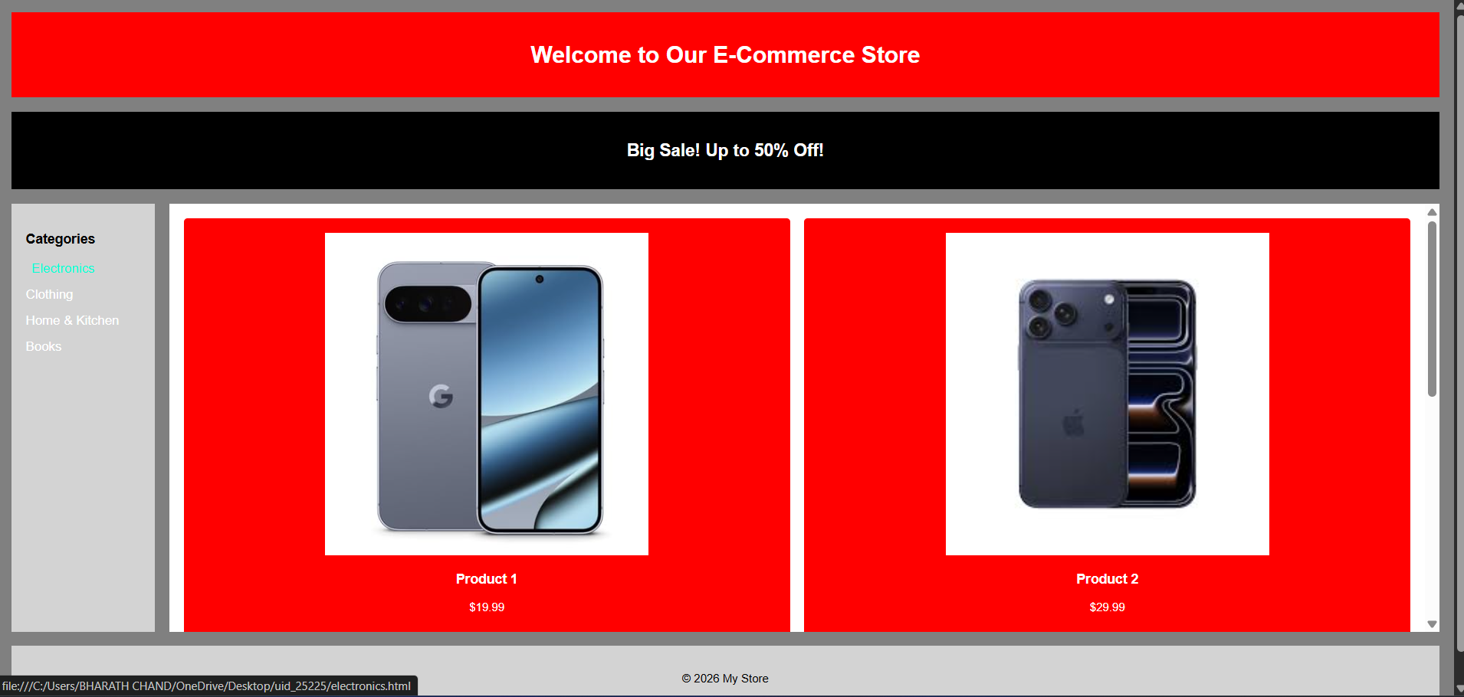

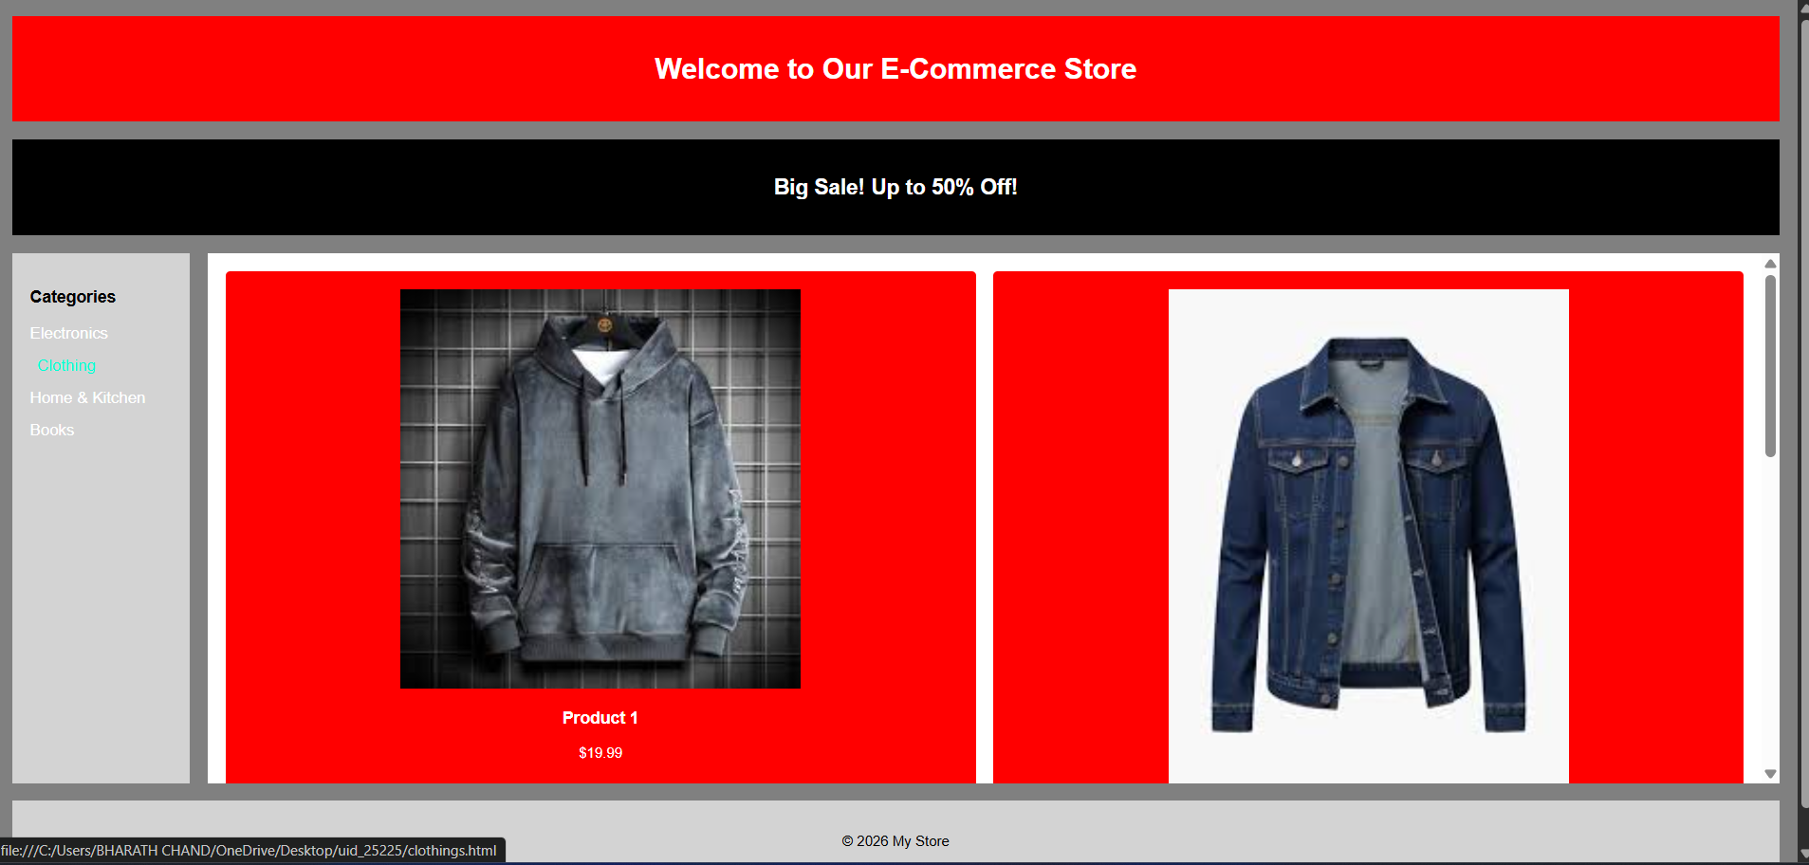

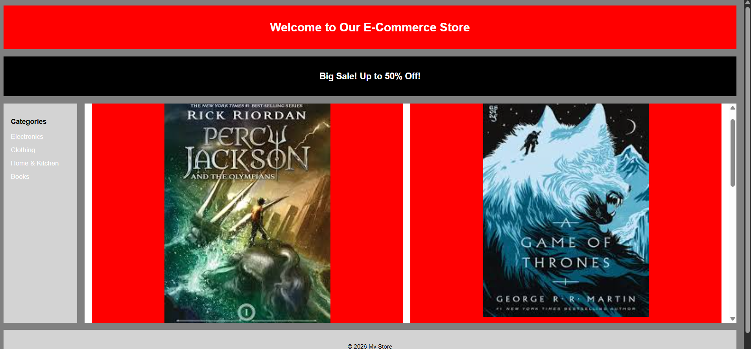

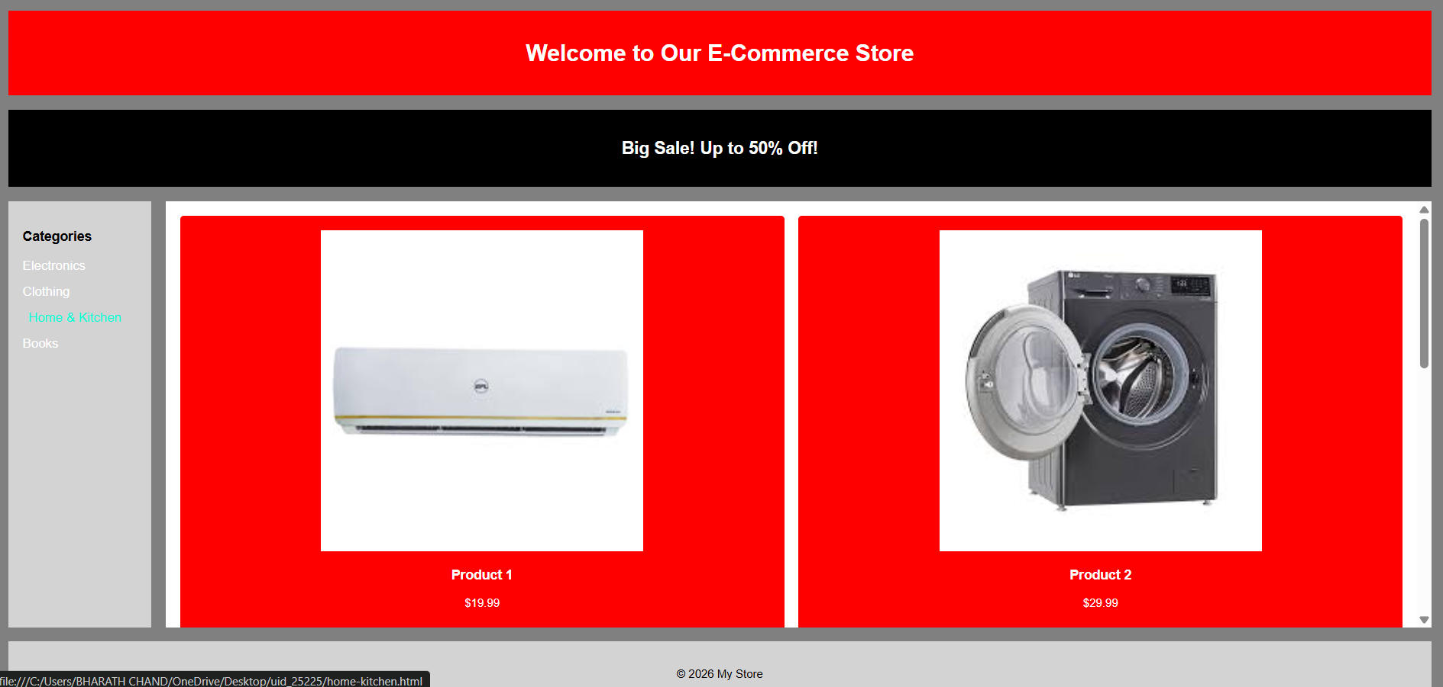

Explanation:
<DOCTYPE html> : the <!DOCTYPE html> element tells the web browser that this an
HTML document or this is the latest version of HTML
<html> : the <html> element is the root element of an HTML web page
<head> : the <head> element will contain meta data about the HTML web page
<title> : the <title> element specifies a title for the HTML Page
<body> : the <body> element contains all visible content all visible content like text ,
image , links , tables , etc
<h> : we used <h> element for heading
<p> : we used <p> element for the paragraph
<div>:we use <div> element for encapsulating the the divisions and easy to modify and
<button>: we use <button> element for button
<img>: we use <img> tag for displaying the image
<I frame>:we <iframe> tag to create link other webpages into it.

Week-7

Aim:- create a GitHub account and create a repository in it and push all the week 6 code files
in it.
Procedure:-
Step 1: browse for GitHub and enter it.

Step 2: login to GitHub account.

Step 3: create a repository after login by clicking new.

Step 4: specify the repository specifications.

Step 5: download GitHub desktop and Lauch it.

Step 6: add the repository to it.

Step 7: add the vs code file to the GitHub desktop.

Step 8: add commit to it and the files to repository and sync the changes. it automatically
pushes the files.

Step 9: now go to browser and check it . it will show all the new added files in the repository.

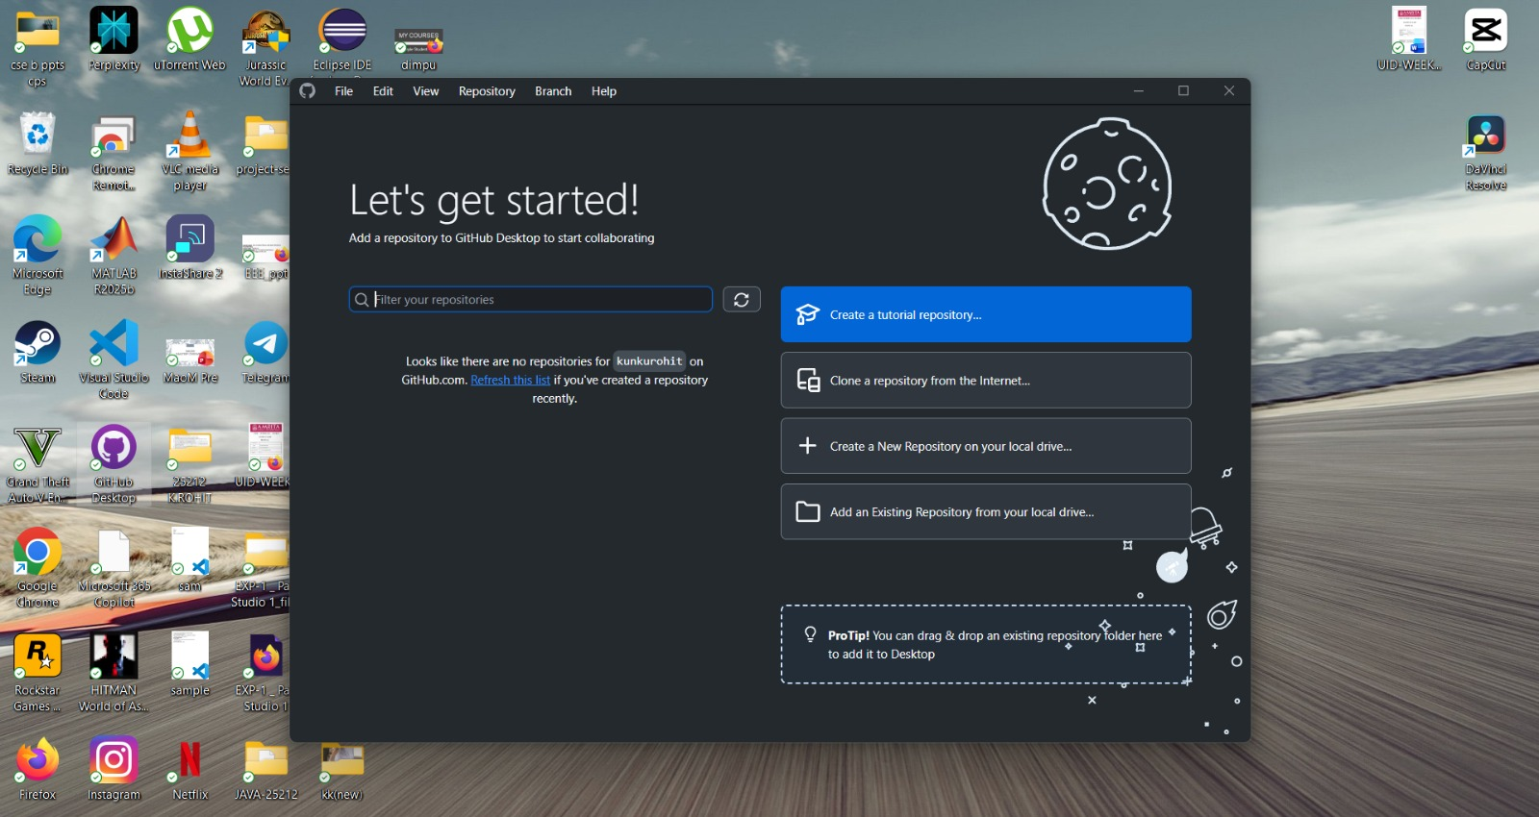

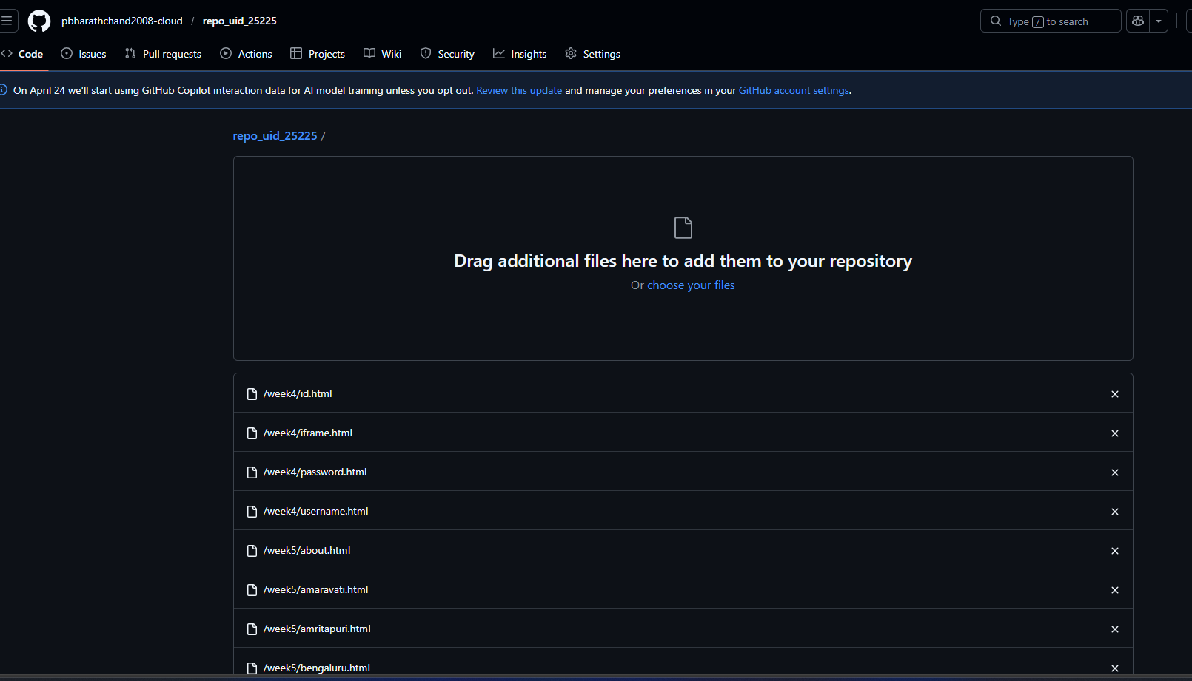

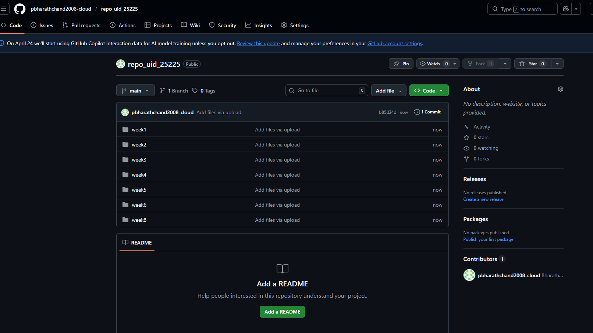

https://github.com/pbharathchand2008-cloud/repo_uid_25225.git

WEEK-8

Aim:- 8.A) Aim: create a web page that displays a square that continuously rotates 360 using
css animation
Program:-
<!DOCTYPE html>
<html>
<head>
<title>Rotating Square</title>
<style>
body {
margin: 0;
height: 100vh;
display: flex;
flex-direction: column;
justify-content: flex-start;
align-items: center;
background-color: #2f3e46;
font-family: Arial, sans-serif;
padding-top: 50px;
}
.square {
width: 120px;
height: 120px;
background: #ffffffcc;
border-radius: 12px;
box-shadow: 0 8px 25px rgba(0, 0, 0, 0.2);
animation: rotate 3s linear infinite;
}
@keyframes rotate {
from {
transform: rotate(0deg);
}
to {
transform: rotate(360deg);
}
}
</style>
</head>
<body>
<h1 style="color: #fff;">Rotating Square</h1>
<div class="square"></div>
</body>
</html>

Output:-


EXPLINATION:-
<DOCTYPE html> : the <!DOCTYPE html> element tells the web browser that this an HTML document
or this is the latest version of HTML
<html> : the <html> element is the root element of an HTML web page
<head> : the <head> element will contain meta data about the HTML web page
<title> : the <title> element specifies a title for the HTML Page
<body> : the <body> element contains all visible content all visible content like text , image , links ,
tables , etc
<h> : we used <h> element for heading
<div>:we use <div> element for encapsulating the the divisions and easy to modify and
@keyframes:we use @keyframes for animation from starting to end transformation.
We used animation shorthand property for these things to mention the animations preferences and
use keyframes for mentioning the positions of the animation and used style attribute and some value
properties for look and we used internal css in it .

8.B)Aim :create a ball that moves up and down continuously using css animation
Problem:-
<!DOCTYPE html>
<html>
<head>
<title>Bouncing Ball</title>
<style>
body {
margin: 0;
height: 100vh;
display: flex;
flex-direction: column;
align-items: center;
justify-content: flex-start;
background: #2f3e46;
}
h1 {
margin-top: 20px;
color: #ffffff;
}
.ball {
width: 80px;

height: 80px;
background: #ffffff;
border-radius: 50%;
margin-top: 120px;
animation: bounce 1.5s ease-in-out infinite;
}
@keyframes bounce {
0% {
transform: translateY(0);
}
50% {
transform: translateY(-120px);
}
100% {
transform: translateY(0);
}
}
</style>
</head>
<body>
<h1>Bouncing Ball</h1>
<div class="ball"></div>
</body>
</html>

OUTPUT:-



EXPLANATION:-

<DOCTYPE html> : the <!DOCTYPE html> element tells the web browser that this an HTML document
or this is the latest version of HTML
<html> : the <html> element is the root element of an HTML web page
<head> : the <head> element will contain meta data about the HTML web page
<title> : the <title> element specifies a title for the HTML Page
<body> : the <body> element contains all visible content all visible content like text , image , links ,
tables , etc
<h> : we used <h> element for heading
<div>:we use <div> element for encapsulating the the divisions and easy to modify and
@keyframes:we use @keyframes for animation from starting to end transformation.
We used animation shorthand property for these things to mention the animations preferences and
use keyframes for mentioning the positions of the animation and used style attribute and some value
properties for look and we used internal css in it .

8.C)Aim :create a circle that moves horizontally and rotates At the same time
Program:
<!DOCTYPE html>
<html lang="en">
<head>
<title>Moving Rotating Circle</title>
<style>
body {
margin: 0;
height: 100vh;
display: flex;
flex-direction: column;
align-items: center;
justify-content: flex-start;
background: #2f3e46;
overflow: hidden;
}
h1 {
margin-top: 20px;
color: #ffffff;
}
.circle {
width: 80px;
height: 80px;
background: #ffffff;
border-radius: 50%;
margin-top: 120px;
animation: moveRotate 3s linear infinite;
}

@keyframes moveRotate {
0% {
transform: translateX(-150px) rotate(0deg);
}
50% {
transform: translateX(150px) rotate(180deg);
}
100% {
transform: translateX(-150px) rotate(360deg);
}
}
</style>
</head>
<body>
<h1>Moving Rotating Circle</h1>

<div class="circle"></div>
</body>
</html>

Output:-
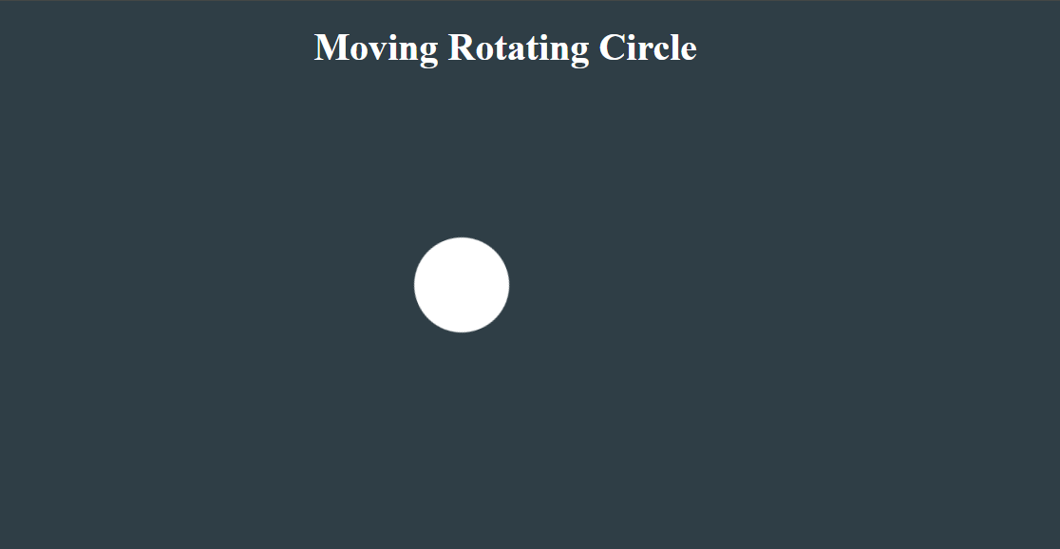

EXPLANATION:-

<DOCTYPE html> : the <!DOCTYPE html> element tells the web browser that this an HTML document
or this is the latest version of HTML
<html> : the <html> element is the root element of an HTML web page
<head> : the <head> element will contain meta data about the HTML web page
<title> : the <title> element specifies a title for the HTML Page
<body> : the <body> element contains all visible content all visible content like text , image , links ,
tables , etc
<h> : we used <h> element for heading
<div>:we use <div> element for encapsulating the the divisions and easy to modify and
@keyframes:we use @keyframes for animation from starting to end transformation.
We used animation shorthand property for these things to mention the animations preferences and
use keyframes for mentioning the positions of the animation and used style attribute and some value
properties for look and we used internal css in it .

WEEK-9

Aim:- create a web page using html, CSS and JavaScript based on the
given condition
a) create a button for each program based on the button clicked the corresponding to be executed and should display the output
b) the logic for each button includes finding an even or odd number, prime or not, factorial of a number and Armstrong
c) use appropriate design to display the output
Program:-
AV.SC.U4CSE25225
<!DOCTYPE html>
<html>
<head>
<title>Number Programs</title>

<style>
body {
font-family: Arial, sans-serif;
background: linear-gradient(to right, #667eea, #764ba2);
text-align: center;
color: white;
margin: 0;
padding: 0;
}

h1 {
margin-top: 40px;
}

.container {
margin-top: 50px;
}

a {
display: block;
width: 250px;
margin: 15px auto;
padding: 15px;
font-size: 16px;
text-decoration: none;
border-radius: 10px;
background-color: #ffffff;
color: #333;
transition: 0.3s;
}

a:hover {
background-color: #ffd369;
transform: scale(1.05);
}
</style>
</head>

<body>

<h1>Number Checker Programs</h1>

<div class="container">
<a href="evenorodd.html">Even / Odd Checker</a>
<a href="primeornot.html">Prime Number Checker</a>
<a href="factorial.html">Factorial Calculator</a>
<a href="amstrongnumber.html">Armstrong Number Checker</a>
</div>

</body>
</html>

Evenorodd.html:-
<!DOCTYPE html>
<html>
<head>
</head>
<body>
<script>
let a = prompt("Enter a number:");

if(a%2==0)
{
document.write("a is even");
}
else
{
document.write("a is odd");
}
</script>
</body>
</html>

Primeornot:-
<!DOCTYPE html>
<html>
<body>
<script>
let a = prompt("Enter a number:");
let isPrime = true;

if (a <= 1) {
isPrime = false;
} else {
for (let i = 2; i < a; i++) {
if (a % i == 0) {
isPrime = false;
break;
}
}
}

if (isPrime) {
document.write("Number is Prime");
} else {
document.write("Number is Not Prime");
}
</script>
</body>
</html>

Factorial.html:-
<!DOCTYPE html>
<html>
<body>
<script>
function factorial(n) {
if (n === 0 || n === 1) {
return 1;
} else {
return n * factorial(n - 1);
}
}

let a = prompt("Enter a number:");
let result = factorial(a);
document.write("Factorial of " + a + " is: " + result);
</script>
</body>
</html>

Armstrongnumber.html:-
<!DOCTYPE html>
<html>
<body>
<script>
let num = parseInt(prompt("Enter a number:"));
let temp = num;
let sum = 0;
let digits = num.toString().length;
while (temp > 0) {
let digit = temp % 10;
sum += Math.pow(digit, digits);
temp = Math.floor(temp / 10);
}
if (sum === num) {
document.write("Armstrong Number");
} else {
document.write("Not an Armstrong Number");
}
</script>
</body>
</html>

Output:-


Explanation :-
- background: linear-gradient(to right, #667eea, #764ba2): Creates a smooth color transition across the background instead of a flat, single color.
- transition: 0.3s: Controls the speed of the hover effect, making the buttons animate smoothly rather than changing instantly.
- transform: scale(1.05): Makes the button grow 5% larger when a user hovers over it to create an interactive, pop-out effect. a:hover: A special CSS selector that triggers specific styles only when the user's mouse cursor is resting on top of a link.
- Math.pow(digit, digits): A JavaScript function that calculates exponents by raising the single digit to the power of the total number of digits.
- Math.floor(temp / 10): Divides the number by 10 and chops off the decimals to successfully remove the last digit during a loop.
- num.toString().length: Converts the number into a piece of text so it can automatically count how many digits it contains.

WEEK-10

Aim:- Write a java script conditional statement to find the largest of five numbers using and onclick event. Display alert box to show the result
Program:-
<!DOCTYPE html>
<html>
<head>
<title>Sign of Product</title>
<style>
body {
font-family: Arial;
text-align: center;
background-color: #f0f8ff;
}

h2 {
color: #333;
}

input {
padding: 10px;
width: 200px;
margin: 5px;
border: 2px solid #555;
border-radius: 5px;
}

button {
padding: 10px 20px;
background-color: #4CAF50;
color: white;
border: none;
border-radius: 5px;
cursor: pointer;
}

button:hover {
background-color: #45a049;
}
</style>
</head>
<body>

<h2>Enter Three Numbers</h2>

<input type="number" id="num1" placeholder="First number"><br><br>
<input type="number" id="num2" placeholder="Second number"><br><br>
<input type="number" id="num3" placeholder="Third number"><br><br>

<button onclick="findSign()">Check Sign</button>

<script>
function findSign()
{
let a = Number(document.getElementById("num1").value);
let b = Number(document.getElementById("num2").value);
let c = Number(document.getElementById("num3").value);

let product = a * b * c;

if(product > 0)
{
alert("The sign is + (Positive)");
}
else if(product < 0)
{
alert("The sign is - (Negative)");
}
else
{
alert("The sign is 0 (Zero)");
}
}
</script>

</body>
</html>
Output:-
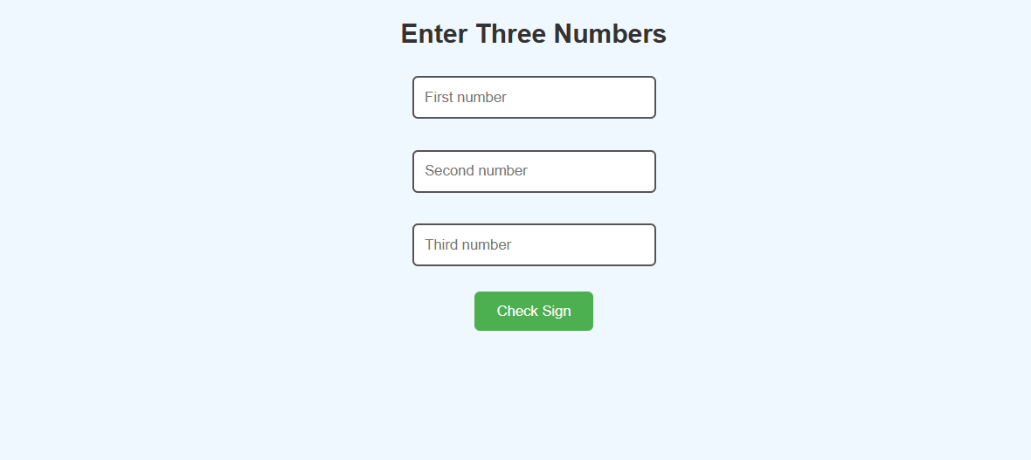

Explanation of the tags:-
- <input type="number">: Limits user input specifically to numerical values and automatically provides up/down arrow steppers in the browser.
- placeholder="First number": Displays a faint, temporary hint inside the input box that vanishes as soon as the user starts typing.
- <br>: Creates a simple line break to push elements to the next line without adding extra paragraph spacing.
- onclick="findSign()": An event attribute that monitors for user clicks and instantly triggers the specified JavaScript function when clicked.
- Number(document.getElementById().value): Targets a specific element by its unique ID, grabs its text value, and instantly forces it into an actual mathematical number.
- alert(): Pops open a native browser dialog box at the top of the screen to display a quick notification message to the user.

Aim:- Write a java script conditional statement to sort three numbers using functions. Display
an alert to show the result
Program:-
<!DOCTYPE html>
<html>
<head>
<title>Sort Numbers</title>

<style>
body {
font-family: Arial;
text-align: center;
background-color: #f0f8ff;
}

h2 {
color: #333;
}

input {
padding: 10px;
width: 200px;
margin: 5px;
border: 2px solid #555;
border-radius: 5px;
}

button {
padding: 10px 20px;
background-color: #2196F3;
color: white;
border: none;
border-radius: 5px;
cursor: pointer;
}

button:hover {
background-color: #1976D2;
}
</style>
</head>

<body>

<h2>Sort Three Numbers (Highest to Lowest)</h2>

<input type="number" id="num1" placeholder="First number"><br>
<input type="number" id="num2" placeholder="Second number"><br>
<input type="number" id="num3" placeholder="Third number"><br><br>

<button onclick="sortNumbers()">Sort</button>

<script>
function sortNumbers()
{
let a = Number(document.getElementById("num1").value);
let b = Number(document.getElementById("num2").value);
let c = Number(document.getElementById("num3").value);

let numbers = [a, b, c];

numbers.sort(function(x, y) {
return y - x; // descending order
});

alert("Sorted order (Highest to Lowest): " + numbers.join(", "));
}
</script>

</body>
</html>

Output:-
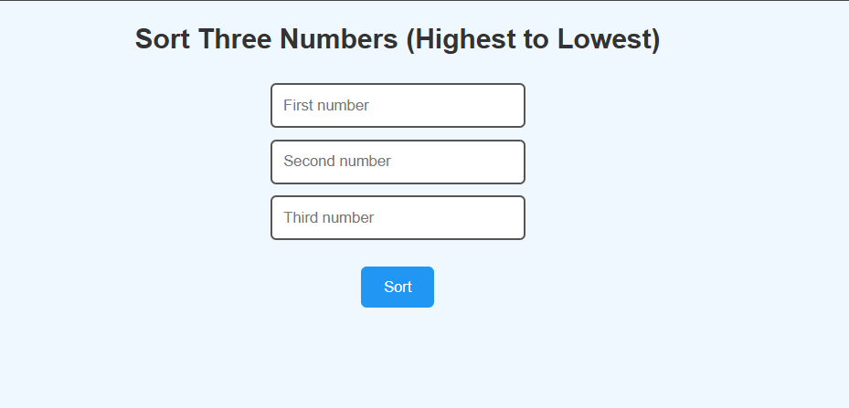

Explanation of the tags:-
- let numbers = [a, b, c];: Creates an array container to group your three separate numerical variables into a single, organized list.
- numbers.sort(function(x, y) { return y - x; });: An array method that runs a custom comparison function to sort your list of numbers mathematically from highest to lowest.
- numbers.join(", "): Converts the sorted array elements into a single text string, gluing them together with a comma and a space in between.
- cursor: pointer;: A CSS property that forces the user's mouse cursor to transform into a clickable hand icon whenever it passes over the button.
- button:hover: A CSS pseudo-class used to automatically shift the button's background color to a darker blue the instant a user's mouse rests on it.

Aim:- Write a java script conditional statement to find the largest of three numbers using functions and onclick event. Display an alert to show the result

Program:-
<!DOCTYPE html>
<html>
<head>
<title>Find Largest Number</title>

<style>
body {
font-family: Arial;
text-align: center;
background-color: #f0f8ff;
}

h2 {
color: #333;
}

input {
padding: 10px;
width: 200px;
margin: 5px;
border: 2px solid #555;
border-radius: 5px;
}

button {
padding: 10px 20px;
background-color: #2196F3;
color: white;
border: none;
border-radius: 5px;
cursor: pointer;
}

button:hover {
background-color: #1976D2;
}
</style>
<body>

<h2>Find Largest of Five Numbers</h2>

<input type="number" id="num1" placeholder="Enter number 1"><br><br>
<input type="number" id="num2" placeholder="Enter number 2"><br><br>
<input type="number" id="num3" placeholder="Enter number 3"><br><br>
<input type="number" id="num4" placeholder="Enter number 4"><br><br>
<input type="number" id="num5" placeholder="Enter number 5"><br><br>

<button onclick="findLargest()">Find Largest</button>

<script>
function findLargest()
{
let a = Number(document.getElementById("num1").value);
let b = Number(document.getElementById("num2").value);
let c = Number(document.getElementById("num3").value);
let d = Number(document.getElementById("num4").value);
let e = Number(document.getElementById("num5").value);

let largest;

if(a >= b && a >= c && a >= d && a >= e)
{
largest = a;
}
else if(b >= a && b >= c && b >= d && b >= e)
{
largest = b;
}
else if(c >= a && c >= b && c >= d && c >= e)
{
largest = c;
}
else if(d >= a && d >= b && d >= c && d >= e)
{
largest = d;
}
else
{
largest = e;
}

alert("The largest number is: " + largest);
}
</script>

</body>
</html>

Output:-
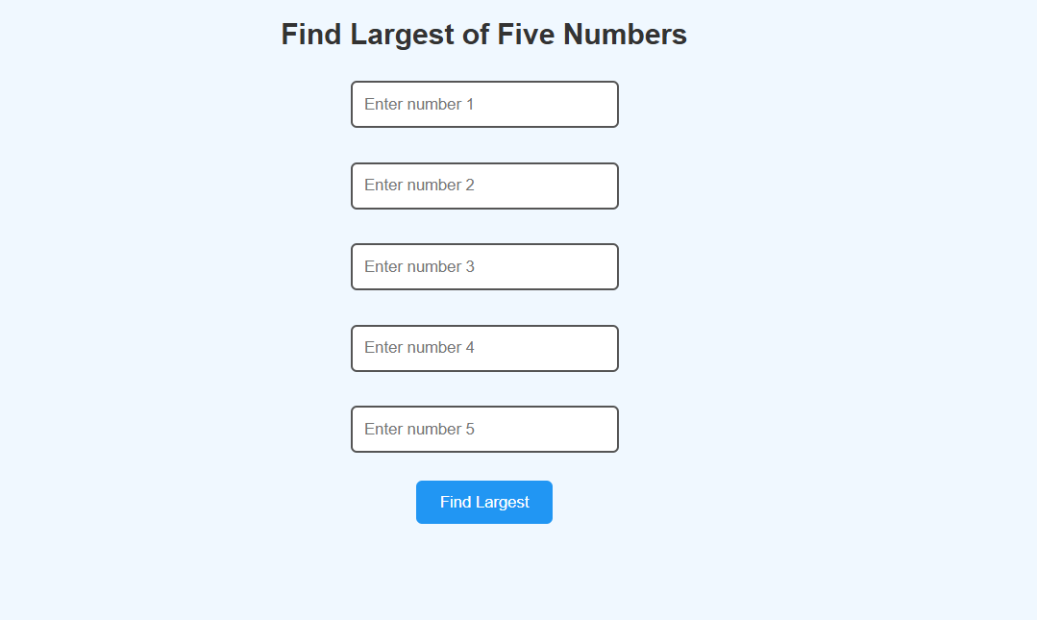
Explanation of the tags:-
- && (Logical AND): A comparison operator that checks if multiple conditions are all true at the exact same time before executing the code block.
- if / else if / else: A conditional logic structure used to systematically test your numbers one by one until it finds the maximum value.
- let largest;: Declares a block-scoped variable without assigning an initial value, serving as a blank storage container to hold the winning number later.
- border: 2px solid #555;: A CSS property that draws a solid, dark gray outline around your numeric input boxes to define their boundaries.
- border-radius: 5px;: A CSS styling rule that rounds off the sharp corners of your input boxes and buttons to give them a softer look.

Aim:- write a java script program which iterates the integer from 1 to 100
but for multiple of three prints "LOL" instead of the number and for the
multiple of five print "OK" for number which are multiple of both three
and five print "LOL OK"
program:-
<!DOCTYPE html>
<html>
<head>
<style>
body {
font-family: Arial;
text-align: center;
background-color: #f0f8ff;
}

input, button {
padding: 10px;
margin: 5px;
}

#result {
margin-top: 20px;
font-size: 20px;
font-weight: bold;
}
</style>
</head>

<body>

<h2>LOL / OK Checker</h2>
<input type="number" id="num1" placeholder="Enter a number">
<button onclick="checkLOL()">Check</button>

<p id="result"></p>

<script>
function checkLOL() {
var num = parseInt(document.getElementById("num1").value);

if (isNaN(num)) {
document.getElementById("result").innerHTML = "Please enter a valid number.";
return;
}

var result = "";

if (num % 3 === 0 && num % 5 === 0) {
result = "LOL OK";
}
else if (num % 3 === 0) {
result = "LOL";
}
else if (num % 5 === 0) {
result = "OK";
}
else {
result = num;
}

document.getElementById("result").innerHTML = result;
}
</script>

</body>
</html>

Output:-
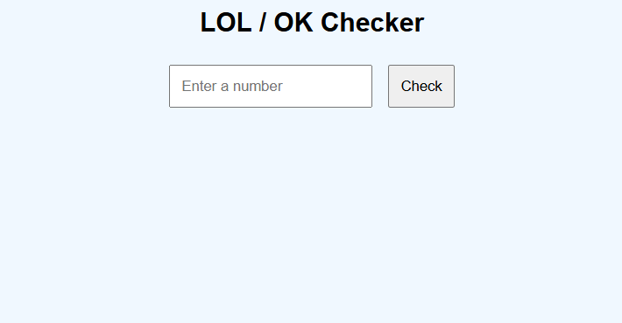

Explanation of the tags:-
- input, button: A grouped CSS selector that applies identical padding and margin styles to both elements simultaneously to keep your code clean.
- font-weight: bold;: A typography styling rule that thickens the text inside your result paragraph to make the final answer stand out.
- <p id="result"></p>: An empty HTML paragraph tag acting as a dynamic placeholder waiting to be filled with text by your JavaScript code.
- isNaN(num): A built-in JavaScript function ("Is Not a Number") that checks if the user left the input blank or typed something invalid.
- return;: A control statement that immediately stops the function execution, preventing the rest of the code from running if an error is caught.
- .innerHTML: A powerful JavaScript property used to change or insert brand new content right inside a specific HTML tag dynamically.
- === (Strict Equality): A comparison operator that checks if two values are perfectly identical in both their actual value and their data type.

Aim:- write a java script program to read 6 subjects marks from the
student then compute the average marks of the student then the average
is used to determine the corresponding grade
Program:-
<!DOCTYPE html>
<html>
<head>
<style>
body {
font-family: Arial;
text-align: center;
background-color: #f0f8ff;
}

h2 {
color: #333;
}

input {
padding: 8px;
width: 150px;
margin: 5px;
border: 2px solid #555;
border-radius: 5px;
}

button {
padding: 10px 20px;
background-color: #2196F3;
color: white;
border: none;
border-radius: 5px;
cursor: pointer;
}

button:hover {
background-color: #1976D2;
}

#result {
margin-top: 20px;
font-size: 18px;
}
</style>
</head>

<body>

<h2>Student Grade Calculator</h2>

<input type="number" id="m1" placeholder="Subject 1"><br>
<input type="number" id="m2" placeholder="Subject 2"><br>
<input type="number" id="m3" placeholder="Subject 3"><br>
<input type="number" id="m4" placeholder="Subject 4"><br>
<input type="number" id="m5" placeholder="Subject 5"><br>
<input type="number" id="m6" placeholder="Subject 6"><br>

<button onclick="calculateGrade()">Calculate</button>

<p id="result"></p>

<script>
function calculateGrade() {
var m1 = parseFloat(document.getElementById("m1").value);
var m2 = parseFloat(document.getElementById("m2").value);
var m3 = parseFloat(document.getElementById("m3").value);
var m4 = parseFloat(document.getElementById("m4").value);
var m5 = parseFloat(document.getElementById("m5").value);
var m6 = parseFloat(document.getElementById("m6").value);

if (isNaN(m1) || isNaN(m2) || isNaN(m3) || isNaN(m4) || isNaN(m5) || isNaN(m6)) {
document.getElementById("result").innerHTML = "Please enter all marks.";
return;
}

var avg = (m1 + m2 + m3 + m4 + m5 + m6) / 6;
var grade = "";

if (avg < 60) {
grade = "F";
}
else if (avg < 70) {
grade = "D";
}
else if (avg < 80) {
grade = "C";
}
else if (avg < 90) {
grade = "B";
}
else if (avg <= 100) {
grade = "A";
}
else {
grade = "Invalid Marks";
}

document.getElementById("result").innerHTML =
"Average: " + avg.toFixed(2) + "<br>Grade: " + grade;
}
</script>

</body>
</html>

Output:-
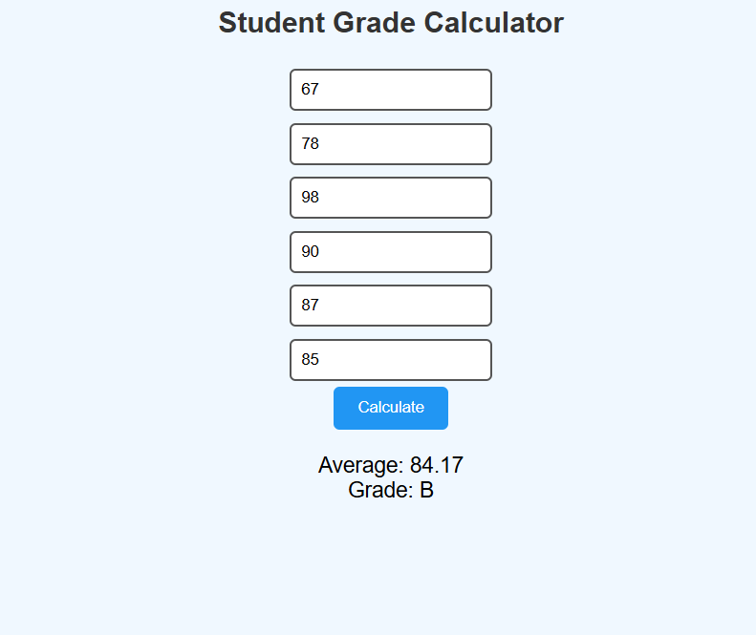

Explanation of the tags:-
- parseFloat(): Converts the entered text string into a floating-point number, allowing the code to calculate precise averages with decimal values.
- || (Logical OR): A comparison operator that checks if any of the input fields are blank or invalid, triggering the error message if even one condition matches.
- avg.toFixed(2): A JavaScript method that rounds down the calculated average number to exactly two decimal places for a cleaner presentation.
- var grade = "";: Initializes a string variable with an empty text value, setting up a container to safely store the final letter grade later.
- border: none;: A CSS styling rule that strips away the browser's default 3D shaded outline from the button element.

Week-11

Aim:- A website requires users to enter a username. The system should
display a message while typing if the username is less than 5 characters.
Program:-
<html>
<head>
<title>Username Validation</title>
<style>
body {
font-family: Arial;
text-align: center;
background-color: #f0f8ff;
}

h2 {
color: #333;
}

input {
padding: 10px;
width: 200px;
margin: 5px;
border: 2px solid #555;
border-radius: 5px;
}

button {
padding: 10px 20px;
background-color: #2196F3;
color: white;
border: none;
border-radius: 5px;
cursor: pointer;
}

button:hover {
background-color: #1976D2;
}
</style>

</head>
<body>
<h1>Enter your credentials</h1>

<input type="text" id="username" placeholder="Username">
<button onclick="validateUsername()">Submit</button>

<div id="result"></div>

<script>
function username(name) {
if (name.length < 5) {
document.getElementById("result").innerHTML =
"Your username is less than 5 characters";
} else {
document.getElementById("result").innerHTML =
"Your username is " + name;
}
}

function validateUsername() {
let name = document.getElementById("username").value;
username(name);
}
</script>
</body>

Output:-
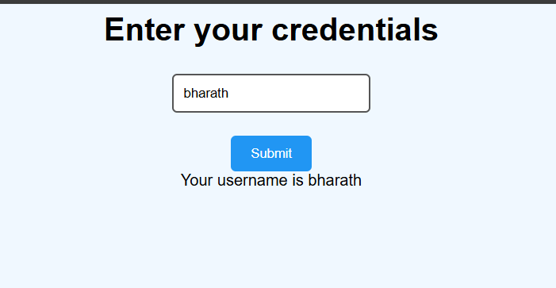

Explanation of the tags:-
- <input type="text">: Creates a standard text entry field allowing users to type any combination of letters, numbers, and symbols.
- placeholder="Username": Provides a non-clickable text hint inside the input field that disappears as soon as the user focuses or types into it.
- onclick="validateUsername()": An event handler that watches for a mouse click on the button to instantly run the JavaScript validation function.
- <div id="result"></div>: An empty structural block container that acts as a targeted anchor point for JavaScript to display output messages.
- name.length: A built-in JavaScript property that automatically counts and returns the total number of individual characters inside the text string.
- username(name);: A functional execution statement that passes the collected input value directly into a secondary, specialized helper function for processing.

Aim:- A registration form should validate email format before
submission. If invalid, the form should not be submitted.
Program:-
<html>
<head>
<title>Email Validation</title>
<style>
body {
font-family: Arial;
text-align: center;
background-color: #f0f8ff;
}

h2 {
color: #333;
}

input {
padding: 10px;
width: 200px;
margin: 5px;
border: 2px solid #555;
border-radius: 5px;
}

button {
padding: 10px 20px;
background-color: #2196F3;
color: white;
border: none;
border-radius: 5px;
cursor: pointer;
}

button:hover {
background-color: #1976D2;
}
</style>
</head>
<body>
<h2>Enter your email</h2>

<input type="text" id="email" placeholder="Enter Email"><br><br>
<button onclick="checkEmail()">Submit</button>

<div id="result"></div>

<script>
function checkEmail() {
var input = document.getElementById("email").value;
var mailformat = /[a-zA-Z0-9._-]+@[a-zA-Z0-9.-]+\.[a-zA-Z]{2,4}/;

if (input.match(mailformat)) {
document.getElementById("result").innerHTML = "Valid email address!";
} else {
document.getElementById("result").innerHTML = "Invalid email address!";
}
}
</script>

</body>

</html>

Output:-
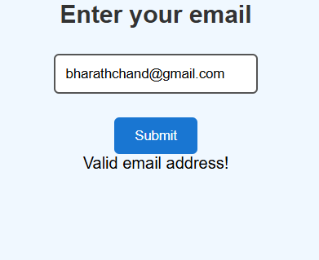

Explanation of the tags:-
- /[a-zA-Z0-9._-]+@[a-zA-Z0-9.-]+\.[a-zA-Z]{2,4}/: A Regular Expression (RegEx) pattern used to systematically validate if the text follows a standard email format layout.
- input.match(mailformat): A JavaScript string method that checks your text input against the RegEx pattern, returning true if they match perfectly.
- <input type="text">: Creates a basic text entry field where users can type out their complete email address string.
- document.getElementById("email").value: Reaches into the document to extract the exact text the user typed inside the input box at that moment.
- #result: A CSS ID selector inside the <style> block that applies specific layout designs exclusively to the element marked with id="result".
- <div id="result"></div>: An empty container block that serves as the targeted canvas where JavaScript prints out the "Valid" or "Invalid" status message.

Aim:- A system should check password strength while typing and display
it is weak or strong.
Program:-
<html>
<head>
<title>Strength of a password</title>
<style>
body {
font-family: Arial;
text-align: center;
background-color: #f0f8ff;
}

h2 {
color: #333;
}

input {
padding: 10px;
width: 200px;
margin: 5px;
border: 2px solid #555;
border-radius: 5px;
}

button {
padding: 10px 20px;
background-color: #2196F3;
color: white;
border: none;
border-radius: 5px;
cursor: pointer;
}

button:hover {
background-color: #1976D2;
}
</style>

</head>
<body>
<h1>Enter your credentials</h1>

<input type="text" id="password" placeholder="Password"><br><br>
<button onclick="validatePassword()">Submit</button>

<div id="result"></div>

<script>
function validatePassword() {
var password = document.getElementById("password").value;
var passwordformat = /[a-zA-Z0-9._%+-]/;
if (password.match(passwordformat)) {
document.getElementById("result").innerHTML = "Password is valid.";
} else {
document.getElementById("result").innerHTML = "Password is not valid.";
}
}
</script>
</body>
</html>

Output:-
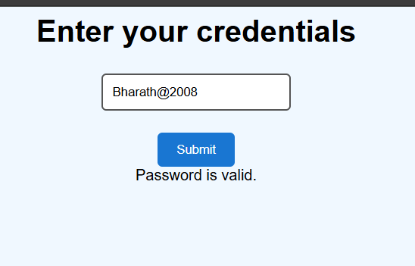

Explanation of the tags:-
- <input type="text" id="password">: Creates a standard text input field, though security-wise it displays characters in plain text rather than masking them with dots.
- /[a-zA-Z0-9._%+-]/: A Regular Expression (RegEx) character class that defines which individual characters (letters, numbers, or specific symbols) are allowed in the password.
- password.match(passwordformat): A JavaScript method that scans the password string to confirm it contains at least one character matching your defined RegEx rules.
- document.getElementById("password").value: Grabs the actual sequence of characters typed by the user inside the password field at the moment the button is clicked.
- document.getElementById("result").innerHTML: Injects the validation result string ("Password is valid." or "not valid.") dynamically into the blank results section.
- <div id="result"></div>: Creates an empty structural container that functions as a placeholder on the screen where the JavaScript output will be displayed.

Aim:- A form should validate a mobile number when the user leaves the
input field. The number must be exactly 10 digits.
Program:-
<html>
<head>
<title>Phone number Validation</title>
<style>
body {
font-family: Arial;
text-align: center;
background-color: #f0f8ff;
}

h2 {
color: #333;
}

input {
padding: 10px;
width: 200px;
margin: 5px;
border: 2px solid #555;
border-radius: 5px;
}

button {
padding: 10px 20px;
background-color: #2196F3;
color: white;
border: none;
border-radius: 5px;
cursor: pointer;
}

button:hover {
background-color: #1976D2;
}
</style>

</head>
<body>
<h1>Enter your credentials</h1>

<input type="text" id="phonenumber" placeholder="Phone Number"><br><br>
<button onclick="validatePhoneNumber()">Submit</button>

<div id="result"></div>

<script>
function validatePhoneNumber() {
var phone = document.getElementById("phonenumber").value;
var phoneformat = /^\(?([0-9]{3})\)?[-. ]?([0-9]{3})[-. ]?([0-9]{4})$/;

if (phone.match(phoneformat)) {
document.getElementById("result").innerHTML = "Valid phone number!";
} else {
document.getElementById("result").innerHTML = "Invalid phone number!";
}
}
</script>
</body>
</html>

Output:-
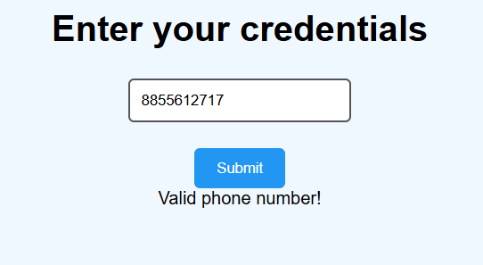

Explanation of the tags:-
- /^\(?([0-9]{3})\)?[-. ]?([0-9]{3})[-. ]?([0-9]{4})$/: A complex Regular Expression (RegEx) designed to validate North American 10-digit phone number layouts with optional area code parentheses, dashes, dots, or spaces.
- [0-9]{3}: A RegEx token that specifically demands a sequence of exactly three numeric digits between 0 and 9.
- ^\(? and \)?: Matches optional opening and closing parentheses around the area code while using backslashes to treat them as literal text instead of code groupings.
- [-. ]?: Tells the validation script that a single optional dash, period, or blank space is permitted as a separator between number blocks.
- phone.match(phoneformat): Evaluates whether the user's input string perfectly complies with every structural rule defined inside the phone format expression.
- <input type="text" id="phonenumber">: Creates a generic text input element that accepts any keyboard input, allowing users to type formatting symbols like hyphens or parentheses.

Aim:- 5. Design an HTML page, such that the registration form must
validate:
Name (not empty)
Email (valid format)
Password (minimum 6 characters)
Program:-
<!DOCTYPE html>
<html>
<head>
<title>Registration Form</title>
<style>
body {
font-family: Arial;
text-align: center;
background-color: #f0f8ff;
}

h2 {
color: #333;
}

input {
padding: 10px;
width: 200px;
margin: 5px;
border: 2px solid #555;
border-radius: 5px;
}

button {
padding: 10px 20px;
background-color: #2196F3;
color: white;
border: none;
border-radius: 5px;
cursor: pointer;
}

button:hover {
background-color: #1976D2;
}
</style>

</head>

<body>

<h2>Registration Form</h2>

<!-- Name -->
<input type="text" id="name" placeholder="Enter Name"><br><br>

<!-- Email -->
<input type="text" id="email" placeholder="Enter Email"><br><br>

<!-- Password -->
<input type="password" id="password" placeholder="Enter Password"><br><br>

<button onclick="validateForm()">Register</button>

<div id="result"></div>

<script>
function validateForm() {

var name = document.getElementById("name").value;
var email = document.getElementById("email").value;
var password = document.getElementById("password").value;

var mailformat = /[a-zA-Z0-9._-]+@[a-zA-Z0-9.-]+\.[a-zA-Z]{2,4}/;

// Name validation
if (name === "") {
document.getElementById("result").innerHTML = "Name cannot be empty";
return;
}

// Email validation
if (!email.match(mailformat)) {
document.getElementById("result").innerHTML = "Invalid email format";
return;
}

// Password validation
if (password.length < 6) {
document.getElementById("result").innerHTML = "Password must be at least 6 characters";
return;
}

// If all valid
document.getElementById("result").innerHTML = "Registration Successful!";
}
</script>

</body>
</html>
Output:-
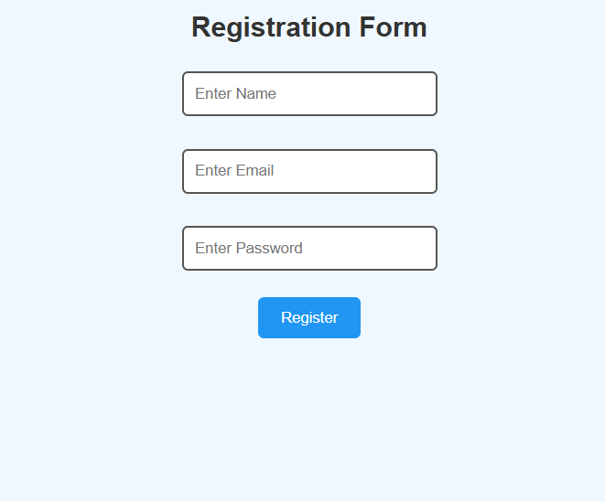

Explanation of the tags:-
- ``: An HTML comment tag used to leave notes or labels in the source code that are completely ignored by the web browser.
- <input type="password">: A specialized input element that masks typed characters with dots or asterisks to keep passwords hidden from onlookers.
- if (name === ""): A conditional statement that checks if the string is completely empty to prevent the user from submitting a blank field.
- !email.match(mailformat): Uses the logical NOT operator (!) to invert the result, triggering the error code block only if the email does not match the regular expression format.
- password.length < 6: Evaluates the character count of the password string to enforce a minimum security rule of at least 6 characters.
- return;: Placed inside each validation check to immediately stop the function from running further once an error is discovered.

Week 12:-

Aim: To install and setup the Electron Framework application.
Procedure:
Step 1: Go to the web browser and download node.js.

Step 2: After installing the Node.js, complete the setup process.

Step 3: After installing node.js, Open the command prompt and navigate to the folder where
your project is located.

Step 4: And give the prompt “node –v” and also "npm –v".

Step 5: If you get the versions then it is successfully installed.

Step 6: Now open PowerShell as Administrator and give the prompt "Set-ExecutionPolicy
RemoteSigned". 138

This command allows local PowerShell scripts to run securely.

And press Y.

Create Project Folder :

Step 7: Create a new folder for the Electron project using mkdir.

Step 8: Move into the project folder using cd.
- This helps keep all project files organized.

Step 9:

Initialize Node Project:

- The above command creates the package.json file.
- This file stores:

1.Project name
2.Version
3. Main entry file
4. Scripts
5. Dependencies
- Without package.json file, npm cannot manage project properly.

Step 10:
Install Electron:

- Downloads Electron package
- Saves it in node_modules
- Adds it to devDependencies
- --save-dev→Because Electron is needed during development.

Step 11:
Configure package.json:

Main→Tells Electron which file starts the application.

Start→Defines command used when we run:

Electron → This command runs Electron in the current project folder.

Create Main Application Files:

Step 12: main.js→Controls app lifecycle and creates windows

Step 13: index.html→User interface

Step 14: style.css→Design and layout

Step 15: renderer.js→Handles user interaction

Write main.js
- Imports Electron modules
- Creates application window
- Loads UI

Run Application:

