Airborne Infection Risk Prediction in Hospital Environments Using IoT and Environmental Sensing

Abstract
Infection risk prediction in indoor healthcare environments has become increasingly important due to rising concerns about airborne diseases and poor air quality conditions. Effective infection control is crucial for minimizing healthcare-associated infections (HAIs), improving patient safety, and reducing healthcare costs. Existing monitoring methods often depend on manual inspections or isolated sensor readings, which lack scalability, accuracy, and real-time responsiveness. To address these limitations, this project proposes a smart infection risk detection system using the ESP32 Wroom-32 microcontroller integrated with environmental sensors—BME280, CCS811, and GP2Y1010AU0F. These sensors monitor key parameters such as temperature, humidity, pressure, CO₂, VOCs, and dust concentration. The collected multi-dimensional data is analysed using the K-Means clustering algorithm to classify indoor spaces based on infection risk levels. This system offers continuous, autonomous monitoring, enabling early warnings and better management of infection-prone zones without human intervention.
Key words: Infection risk prediction, Health care, Airborne diseases, Environmental sensors.
- Introduction
The increasing concern over airborne infection transmission in healthcare environments has underscored the need for proactive, automated monitoring systems. Hospital-acquired infections (HAIs), especially in densely occupied wards or areas with poor ventilation, remain a persistent challenge for patient safety and healthcare quality [1]. Environmental conditions such as high humidity, elevated VOCs, CO₂ levels, and particulate matter have a direct correlation with infection-prone zones [2]. The integration of IoT-based systems facilitates continuous monitoring of such parameters through embedded sensor nodes. Utilizing low-cost sensors like BME280 for temperature and humidity, CCS811 for VOCs and eCO₂, and GP2Y1010AU0F for dust particles, combined with real-time edge analytics, it is possible to detect environmental factors contributing to infection risk [3]. Microcontrollers such as ESP32-WROOM-32 provide sufficient processing power and wireless communication support, enabling the deployment of real-time, connected healthcare solutions [4].
- Motivation
Globally, healthcare-associated infections (HAIs) account for increased morbidity, prolonged hospital stays, and significant economic burden [1]. According to WHO reports, over 15% of hospitalized patients in low-income settings acquire at least one HAI during their stay [2]. Conventional infection control techniques involve manual air quality testing or visual audits, which are not only time-consuming but also reactive. With advancements in IoT and sensor technology, it's now possible to automatically and continuously monitor air quality, thereby enabling early warning systems for high-risk areas [2]. Furthermore, KMeans clustering, a lightweight and unsupervised algorithm, is suitable for deployment on edge devices where labelled training data may be unavailable [5]. This makes it feasible to identify abnormal conditions even in dynamic environments like hospitals.
- Problem statement
Design and development of an IoT-based infection risk prediction system that continuously monitors environmental parameters within indoor healthcare spaces using embedded sensors and an ESP32-WROOM-32 microcontroller. The system uses unsupervised KMeans clustering on the sensor data to identify infection-prone zones. The objective is to deliver a real-time, low-cost, and scalable solution for hospital infection prevention and early risk detection without manual inspection.
- Scope and novelty
The proposed system integrates three environment-monitoring sensors—BME280, CCS811, and GP2Y1010AU0F—with an ESP32-WROOM-32 microcontroller to detect temperature, humidity, VOCs, CO₂, and dust levels. Unlike conventional systems that only log data or require centralized analysis, this system performs on-device clustering using KMeans to dynamically segment safe and risky zones. The novelty lies in its low-cost hardware, real-time edge processing, and unsupervised ML-based decision making, making it an ideal solution for infection risk prediction in hospitals, clinics, and crowded indoor environments. Moreover, this approach eliminates the need for expensive AI models or large medical datasets while maintaining reasonable accuracy [6].
- Work contributions
The proposed work contributions are as follows
- To identify the limitations of existing solutions and analyse the impact of airborne infections in hospital environments.
- To design a smart IoT-based device for real-time air quality monitoring using a microcontroller and environmental sensors.
- To implement the proposed IoT device capable of sending alert notifications based on measured air quality parameters.
- To train a KMeans clustering model on collected or existing datasets to predict infection risk levels in healthcare settings.
- To evaluate the performance and applicability of the developed smart IoT device for infection risk monitoring in real-world scenarios.
- Outline of the paper
The remaining part of the paper consists of a Literature survey in section 2, followed by the proposed Methodology with a detailed explanation of the working of the device and model in section 3, Results and Analysis of the proposed device including performance analysis in section 4, Conclusion and Futures scope in section 5, followed by references.
- Literature survey
Abubeker KM et.al.,[7] developed a low-cost air quality monitoring system for hospital rooms using Arduino and Bluetooth. It measures temperature, humidity, and CO₂ levels, alerting staff via a smartphone app when values exceed safe limits. The limitation here is that it doesn’t detect fine particles and volatile organic compounds (VOCs)
A Parkavi et.al.,[8] proposed an IoT-based system for monitoring air quality, dust, temperature, and humidity in hospitals using MQ135, GP2Y1010AU0F, and DHT11 sensors. The system integrates cloud storage and a mobile app for real-time alerts and visualization. Alerts are triggered when thresholds are exceeded to improve hygiene and patient safety. The limitation here is the sensor accuracy, frequent calibration needs, and delayed response due to 120-second update intervals.
F D Andrei et.al.,[9] developed an affordable air quality monitoring and control system for hospital rooms using Arduino-based hardware and Bluetooth connectivity. The system tracks temperature and humidity, and carbon dioxide levels in the room. It alerts staff via a smartphone app if thresholds are exceeded. The limitations are that it doesn’t measure fine particles like particulate matter (PM2.5) and volatile organic compounds (VOCs)
C Ahmadi et.al.,[10] developed an IoT-based hospital air quality monitoring system using the ESP32 microcontroller integrated with fog and cloud computing. The system tracks PM2.5, humidity, temperature, and oxygen levels in real time. Alerts are sent via Telegram, and buzzer notifications are sent when thresholds are exceeded. Data is stored through fog and cloud computing for better responsiveness. The limitation is that it relies on network connectivity, shorter lifespan.
V Kumar S et.al., [11] developed an indoor air quality monitoring system for healthcare using Arduino UNO and MQ135 to measure gases like CO₂ and VOCs. The system provides real-time readings on a TFT display and alerts users via LED and buzzer when thresholds are crossed. The system aims to improve indoor health conditions and reduce infection risks. Its limitation is the absence of PM2.5 sensing.
Keskin S et al.,[12] developed an IoT-based indoor air quality monitoring system using Arduino UNO, ESP8266 Wi-Fi module, and MQ135 gas sensor to measure pollutants like ammonia and carbon dioxide. The data is sent to ThingSpeak for real-time monitoring and analysis. This system helps ensure safe air conditioning in indoor healthcare settings. The limitation is that it focuses only on gaseous pollutants and lacks sensing of particulate matter (PM2.5/PM10).
Table 1. Related works summary
Author | Microcontrollers | Sensors | Measurements | Limitations
Abubeker KM et.al.,[7] | ESP8266 | IR, MQ135, HC-SR04, and Moisture sensor. | Temperature, Humidity, and CO2 levels. | It doesn’t detect fine particles and VOCs.
A Parkavi et.al.,[8] | Arduino UNO | MQ135, GP2Y1010AU0F and DHT11 sensors. | Air quality, dust concentration, Temperature, and Humidity. | Sensor accuracy, frequent calibration needs, and delayed response.
F D Andrei et.al.,[9] | Arduino UNO | DHT11 | Temperature, Humidity, and CO2 levels. | It doesn’t measure fine particles like PM2.5 and VOCs
C Ahmadi et.al.,[10] | ESP32 | Humidity, PM2.5 and MQ135 sensors | PM2.5, Temperature, Humidity, and Oxygen levels. | It relies on connectivity, and it doesn’t measure VOC, CO.
V Kumar et.al.,[11] | Arduino UNO | MQ135 | CO2 and VOCs. | It doesn’t monitor PM2.5 gases.
Jayashree D et.al.,[12] | Arduino UNO and ESP8266 Wi-Fi module | MQ135 | Ammonia and CO2. | It doesn’t monitor PM2.5 and PM10 gases.

- Proposed methodology
The proposed system uses IoT technology to monitor and improve hospital hygiene. The ESP32 microcontroller, BME280, CCS811, and GP2Y1010AU0F sensors are included in the proposed device to provide real-time monitoring of infection risk via air in any hospital room. The BME280 sensor measures temperature, humidity, and pressure to detect conditions that promote pathogen survival. The CCS811 sensor monitors indoor air quality by detecting VOCs (Volatile Organic Compounds) and estimating CO₂ levels, similar to [13], helping identify poor ventilation or infection-prone zones. And the GP2Y1010AU0F sensor detects particulate matter (dust) levels in the air, which is crucial for monitoring airborne particles that may carry pathogens or irritants. The data will be stored on the ThingSpeak cloud platform. ThingSpeak will generate a notification when the risk is medium or high. Fig 1 displays the proposed system architecture. The main modules of the proposed work are
- Air quality monitoring in a hospital using IOT.
- Training a model to predict infection risk.
- Voice-over, notification alert using ThingSpeak.

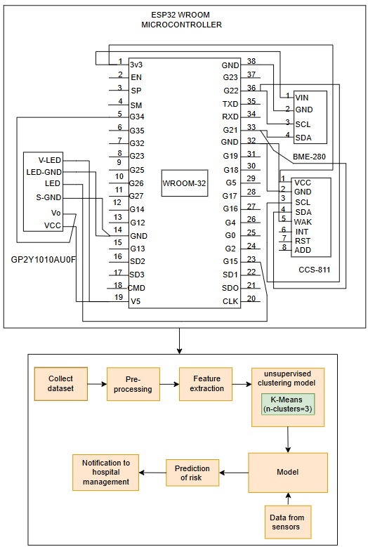
Fig.1. The proposed system circuit architecture.

- Air quality monitoring in a hospital using IOT.
The proposed device is equipped with an ESP32 microcontroller. This module continuously collects air quality parameters using a set of sensors connected to the ESP32 microcontroller. The data is then sent to ThingSpeak for cloud-based monitoring and processing.
- Temperature, Humidity, Pressure (BME280)
Temperature T, relative humidity RH, and pressure P are measured as
$T=T_{raw}× S_{T} + O_{T}$ (1)
$RH={RH}_{raw}{×S}_{RH}+O_{RH}$ (2)
$P=P_{raw}×S_{P}+O_{P}$ (3)
Where S is the sensor-specific scaling factor and O is the offset (Sensor calibration Constant)
- VOC and CO2 equivalent (CCS811)
VOCs are represented in parts per billion (ppb), and estimated ${CO}_{2}$ $(e{CO}_{2})$It is in ppm. The CCS811 sensor measures the resistance change $R_{s}$in its metal-oxide surface as a response to VOCs. The VOC concentration (TVOC) is estimated using a power-law relationship. The equivalent ${CO}_{2}$ ($e{CO}_{2})$, is then calculated using a linear regression model based on TVOC, relative humidity, and temperature.
$TVOC=A×{(R_{o}÷R_{s})}^{α}$ (4)
$eCO2=k_{1}×TVOC+k_{2}×RH+k_{3}$ (5)
Here, A is the Calibration constant, $R_{o}$Baseline resistance in clean air, $α$ is the Empirical exponent, $k_{1}$, $k_{2}$, and $k_{3}$are empirically derived constants, and RH is Relative Humidity (from BME280)
- Dust concentration (GP2Y1010AU0F)
The output voltage $V_{o}$​ of the dust sensor is converted to dust density $D_{d}$in $mg/m^{3}$
$D_{d}=(V_{o}-V_{baseline})/K$ (6)
where$V_{baseline}$ is the clean-air voltage, and K is the sensor sensitivity.

- Training a model to predict infection risk.
After environmental data is collected from the sensors, it undergoes a structured data processing pipeline that transforms raw measurements into meaningful risk classifications. The core stages of this pipeline include data preprocessing, feature extraction, unsupervised clustering using K-Means based on [14], and real-time inference and alert generation.
- Data preprocessing:
It includes handling null values. The raw data is normalized to remove scale bias among features. This will help improve the performance of the model.
- Feature extraction
The selected features include temperature T, relative humidity RH, pressure P, equivalent ${CO}_{2}$concentration $e{CO}_{2}$, Total volatile organic compounds TVOC, and dust concentration${ D}_{d}$.
These features form the input vector for each observation
$x_{i}=[T,RH,P,e{CO}_{2},TVOC,{ D}_{d}]$ (7)
- Unsupervised clustering
To classify the infection risk levels, the normalized data is passed through the K-Means clustering algorithm with k=3, representing three risk categories: Low, Medium, and High [15] [16]. The algorithm iteratively partitions the data into clusters by minimizing intra-cluster variance, as defined by:
$${Arg}_{min}\sum_{i=1}^{k}{\sum{{|\left|x_{j}-μ_{i}\right||}^{2}}}$$
Where $x_{j}$ belongs to $C_{i}$ , $C_{i}$is the centroid of a cluster
- Risk Prediction:
Each cluster is mapped to an infection risk level – {Low, Medium, or High} based on average values of $e{CO}_{2}$, TVOC and dust levels in each cluster.
Algorithm 1: Working of the proposed IOT device
Input: Microcontroller, BME280, CCS811, GP2Y1010AU0F sensors, pre-trained model components (scaler, PCA, clustering model), email credentials, and hospital environment.
Output: Updated ThingSpeak channel data, alert email notification if risk is Medium or High
Step 1: Load scaler, PCA transformer, and clustering model from saved files.
Step 2: Fetch the latest sensor data feeds from ThingSpeak API into a data matrix X
Step 3: Apply preprocessing
$X_{scaled}=scaler.transform(X)$
$X_{pca}=pca.transform(X_{scaled})$
Step 4: Predict risk cluster labels using a clustering model and map cluster labels to risk categories.
$Predictions=model.predict(X_{pca})$
$$0→Low risk, 1→High risk,2→medium risk$$
Step 5: Send alert messages to the user if the risk is high or medium. Mail is sent using a Python script.
Step 6: Schedule this script for GitHub actions to run this every 5 minutes.
- Voice-over, notification alert using ThingSpeak.
The proposed device utilizes the ThingSpeak IoT platform to monitor infection risk by analyzing indoor air quality parameters. An ESP32 Wroom-32 microcontroller collects real-time data from BME280, CCS811, and GP2Y1010AU0F sensors, including temperature, humidity, air pressure, CO₂, VOC, and dust levels. This data is then uploaded to the ThingSpeak cloud via Wi-Fi. A K-Means clustering model is used to retrieve the latest sensor readings from the cloud and predict the current infection risk level each time new data is updated. Based on the predicted risk, the system automatically sends alert emails to hospital management to prompt timely intervention. This automated system enhances indoor health safety by enabling real-time detection and response to potentially infection-prone conditions.
- Results and analysis
The proposed device is designed to monitor hospital indoor air quality using an IoT microcontroller and environmental sensors. The system integrates an ESP32 microcontroller with BME280, CCS811, and GP2Y1010AU0F sensors to track temperature, humidity, pressure TVOC, $e{CO}_{2}$ and dust levels. The device uses the ThingSpeak IoT platform for sending notification alerts, uses a K-Means clustering model, implemented using MATLAB analysis on ThingSpeak as similarly demonstrated in [17].
Fig. 2 illustrates the operation flow of the infection risk detection system. At start, the ESP32 initializes the BME280, CCS811, and GP2Y1010AU0F sensors to collect temperature, humidity, gas, and dust data. This data is processed by a machine learning model on the ESP32 to predict infection risk. If a risk is detected, an alert is sent via ThingSpeak; otherwise, the system continues monitoring.
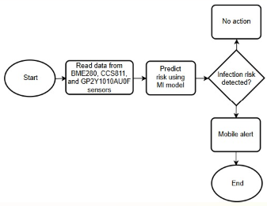
Fig. 2. The flow of proposed system activities.
Fig. 3 provides an overview of the components and equipment 3(a-h). The components consist of (a) ESP32 microcontroller, (b) BME280, (c) GP2Y1010AU0F, (d) CCS811 Sensors, (e) Breadboard, (f) Jumper wires, (g) Soldering equipment, (h) Battery. Table 2 illustrates the components and equipment used to design the proposed device, which are displayed in Fig. 3 with their configuration and functionality.
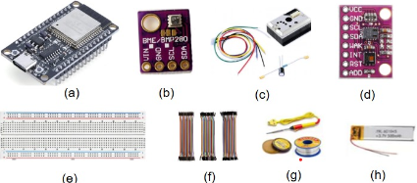
Fig. 3. Components and equipment used in the proposed device.
Table 2. System components specifications
Component | Configuration | Functionality
ESP32  Microcontroller | Wi-Fi Connectivity  Bluetooth Connectivity  Dual-core Architecture  3.3V Operating Voltage | Controls the device, processes sensor data and manages Wi-Fi/Bluetooth communication, generates notification alerts.
BME280 Sensor | Measures Temperature, Humidity, and Pressure; $I²C$/SPI interface; 3.3V | Monitors environmental temperature, humidity, and barometric pressure.
GP2Y1010AU0F  Optical Dust  Sensor Module | Analog Output; 3.3V/5V operation | Measures particulate matter (PM) in the air to detect dust concentration.
CCS811 Sensor | Measures ${CO}_{2}$ (400–8192 ppm) and TVOC (0–1187 ppb), $I²C$ interface (SDA/SCL), Operating voltage: 1.8V to 3.6V (typically 3.3V) | Monitors air quality by sensing estimated CO₂ and total volatile organic compounds (TVOC).
Breadboard | Standard solderless breadboard | Facilitates easy prototyping and circuit testing.
Jumper Wires | Female-to-Female,  Male-to-Female,  Male-to-Male varieties. | Connects components in the device.
Soldering Equipment | Soldering Iron  Soldering Wire Flux | Used for making permanent connections between components.
Battery | 3.7V Li-Ion Battery Capacity: 500mAh | Powers the device, providing portability.
Fig. 4 illustrates the experimental setup for the proposed device, which uses components listed in Table 2 and Fig. 3. ESP32 processes the data collected from the sensors as shown in Fig.5(a) and sends it to the ThingSpeak IoT platform over Wi-Fi. A K-Means clustering model, implemented using MATLAB Analysis on ThingSpeak, classifies the infection risk level into three categories: Low, Medium, and High. The TimeControl application triggers this analysis every 60 seconds, ensuring near real-time evaluation. Whenever a medium or high-risk level is detected, it sends real-time alerts as a notification, as shown in Fig. 5(a) and 5(b).
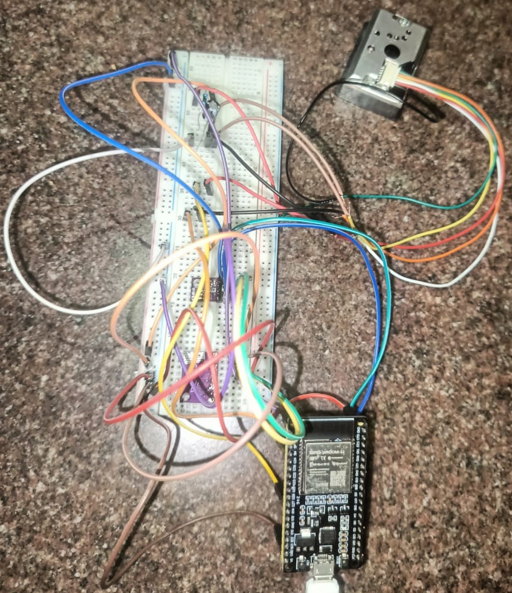
Fig.4. Proposed system experimental setup
Fig. 5 shows the graphical visualization of clusters; The clusters graph is a scatter plot of two PCA components, which represent simplified versions of the original sensor data. Each point shows one set of air quality readings, grouped into low, medium, or high infection risk. The different colors make it easy to see how the model separates these risk levels. This helps to visualize patterns in the data and understand the conditions linked to higher infection risks.
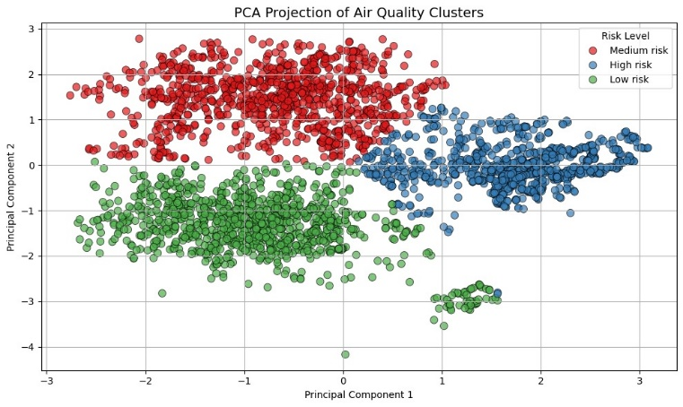
Fig.5. Prediction of Risk Levels

- Performance analysis
The performance evaluation of the proposed infection risk prediction system highlights its effectiveness in real-time environmental monitoring and automated health risk assessment. By integrating an ESP32 microcontroller with a suite of environmental sensors (BME280, CCS811, PMSA003), the system captures critical indoor air quality parameters such as temperature, humidity, ${CO}_{2}$, PM2.5, and TVOC levels. These readings are processed through a trained machine learning pipeline consisting of feature scaling, PCA, and clustering models to classify the environment into risk levels (Low, Medium, High). The integration with the ThingSpeak IoT platform enables seamless real-time visualization and data logging. At the same time, automated email alerts are triggered via GitHub Actions, ensuring timely notifications when the infection risk is Medium or High. This end-to-end system provides a low-cost, scalable, and proactive solution for infection-prone zone detection, particularly in healthcare and public environments. The integration of machine learning algorithms with real-time backend platforms has proven effective in enabling secure, efficient, and intelligent decision-making in health-related data systems. [18]. Fig. 6 (a) and (b) are the screenshots of alert messages.

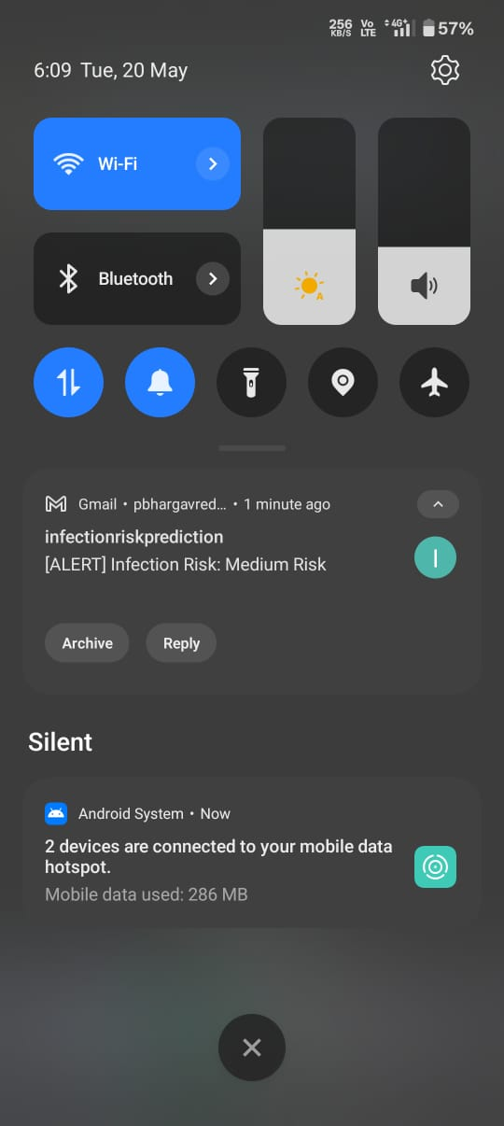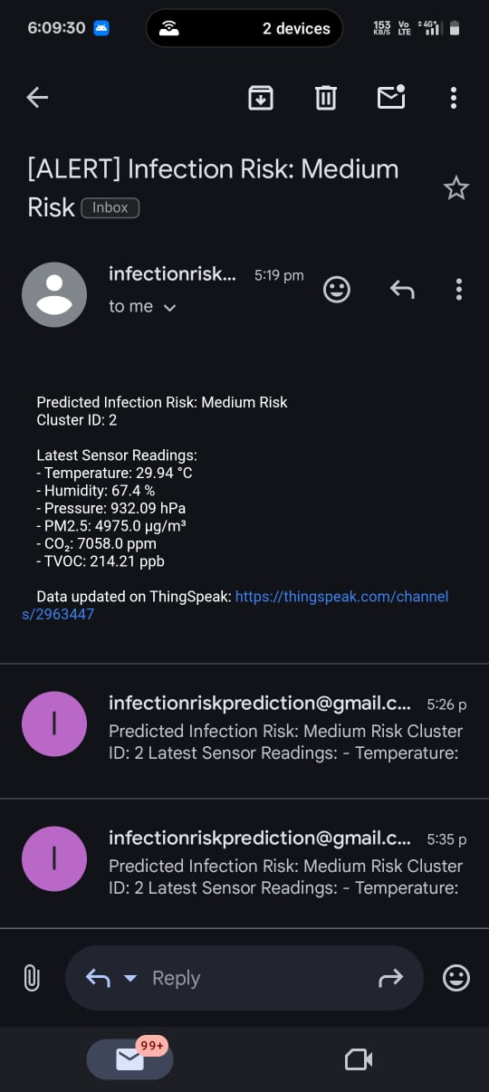
Fig.6. (a) Fig. 6. (b)
Fig. 6. (a), (b) Notification alert sent to mobile using the Python script if alert risk is medium or high.

The sensor readings are uploaded to the Thingspeak cloud every 15 seconds. The Python script runs every 5 minutes and fetches 20 values from the cloud. The pre-trained model predicts the risk, if the risk predicted is medium or high alert message will be triggered. The action time of reading Values from the cloud is 1498 milliseconds, and the action time of sending mail if the risk is medium or high is 2 milliseconds.

- Conclusion
The proposed infection risk prediction system provides a smart and efficient solution for monitoring environmental factors in hospital settings using an ESP32-based IoT setup. By collecting real-time data from sensors (BME280, CCS811, GP2Y1010AU0F) and applying a trained machine learning model similar to [19], [20], the system accurately predicts infection-prone conditions. This prediction is visualized via ThingSpeak, and automated email alerts are triggered through a scheduled Python script using GitHub actions, ensuring timely warnings. The system is lightweight, modular, and adaptable for low-resource environments. In the future, this work can be extended by integrating advanced deep learning models and deploying the solution across multiple rooms or public areas to generate a comprehensive infection risk heatmap. A notable feature worth exploring is the development of a centralized web dashboard that combines real-time monitoring, historical trends, and automated decision support, making the system not just reactive but also preventive and insightful for healthcare facilities.
References
- [1] E. M. N. Sharmila, K. Rama Krishna, G. N. R. Prasad, Byram Anand, Chetna Vaid Kwatra, Dhiraj Kapila. Internet of Medical Things for Smart Healthcare: Concepts, Technologies, and Applications, Book Chapter, In: Satya Prakash Yadav, Sudesh Yadav, Pethuru Raj Chelliah, Victor Hugo C. de Albuquerque (Eds.), 2024.
- [2] L. Dietz, P. F. Horve, D. A. Coil, M. Fretz, J. A. Eisen, and K. V. D. Wymelenberg, “2019 Novel Coronavirus (COVID-19) Pandemic: Built Environment Considerations To Reduce Transmission,” mSystems, vol. 5, no. 2, 2020. https://doi.org/10.1128/mSystems.00245-20
- [3] A. De Paola, M. Ortolani, S. Gaglio, and G. Lo Re, “A Smart Framework for Indoor Air Quality Monitoring and Automated Ventilation Control,” Journal of Ambient Intelligence and Humanized Computing, vol. 12, no. 6, pp. 6737–6749, 2021. https://doi.org/10.1007/s12652-020-02611-6
- [4] M.J. Espinosa-Gavira, Agustín Agüera-Pérez, J.C. Palomares-Salas, Jose Maria Sierra-Fernandez, Paula Remigio-Carmona, Juan José González de-la-Rosa, “Characterization and Performance Evaluation of ESP32 for Real-time Synchronized Sensor Networks,” Procedia Computer Science, vol. 237, pp. 261-268, 2024. https://doi.org/10.1016/j.procs.2024.05.104
- [5] M. Salehi, M. H. Anisi, H. Rashid, and A. Dehghantanha, “Clustering Methods for Healthcare Applications: A Review,” Computer Methods and Programs in Biomedicine, vol. 205, 106032, 2021. https://doi.org/10.1016/j.cmpb.2021.106032
- [6] A. Kouadri, A. Bouabdellah, and Y. Challal, “Fog-Based Machine Learning for Real-Time Environmental Monitoring in Smart Hospitals,” IEEE Access, vol. 10, pp. 16077–16087, 2022. https://doi.org/10.1109/ACCESS.2022.3149638
- Abubeker KM and Baskar S (2022) Wireless sensor and wireless body area network assisted biosensor network for effective monitoring and prevention of non-ventilator hospital-acquired pneumonia. Front. Sustain. Cities 4:1063067. doi: 10.3389/frsc.2022.1063067
- Parkavi, A., Sowmya, B.J., Alex, S.A. et al. Air quality and dust level monitoring systems in hospitals using IoT. Discov Internet Things 5, 23 (2025). https://doi.org/10.1007/s43926-025-00120-w
- F. D. Andrei, G. Seritan, B. Enache, F. C. Argatu and F. . -. C. Adochiei, "Air Quality Monitoring and Control System for a Hospital Room," 2021 International Conference on e-Health and Bioengineering (EHB), Iasi, Romania, 2021, pp. 1-4, doi: 10.1109/EHB52898.2021.9657663.
- C. Ahmadi, J. Constantine, D. Syuhada, N. K. Qumari and J. L. Chen, "Air Quality Monitor In Hospital Based On Fog And Cloud Computing," 2022 4th International Conference on Cybernetics and Intelligent System (ICORIS), Prapat, Indonesia, 2022, pp. 1-3, doi: 10.1109/ICORIS56080.2022.10031516.
- V. Kumar S, P. Samanvitha S, V. Kumar K, S. S, Y. N and S. C. A, "Indoor Air Quality Monitoring System for Healthcare," 2024 Ninth International Conference on Science Technology Engineering and Mathematics (ICONSTEM), Chennai, India, 2024, pp. 1-5, doi: 10.1109/ICONSTEM60960.2024.10568669.
- Keskin S, Emecen AN, Ergör A. Infection Risk Prediction in Healthcare Settings: Lessons from COVID-19 Contact Tracing. Infect Dis Clin Microbiol. 2024 Mar 8;6(1):44-54. doi: 10.36519/idcm.2024.315. PMID: 38633443;
- S. Chauhan, M. R. Ansari, Y. Kumar and H. Parashar, "Environmental Health Monitoring System," 2024 1st International Conference on Advances in Computing, Communication and Networking (ICAC2N), Greater Noida, India, 2024, pp. 560-563, doi: 10.1109/ICAC2N63387.2024.10895514.
- F. Nie, Z. Li, R. Wang and X. Li, "An Effective and Efficient Algorithm for K-Means Clustering With New Formulation," in IEEE Transactions on Knowledge and Data Engineering, vol. 35, no. 4, pp. 3433-3443, 1 April 2023, doi: 10.1109/TKDE.2022.3155450.
- R. Ahuja, A. Solanki and A. Nayyar, "Movie Recommender System Using K-Means Clustering AND K-Nearest Neighbor," 2019 9th International Conference on Cloud Computing, Data Science & Engineering (Confluence), Noida, India, 2019, pp. 263-268, doi: 10.1109/CONFLUENCE.2019.8776969.
- M. F. Alam, R. Singh and S. Katiyar, "Customer Segmentation Using K-Means Clustering in Unsupervised Machine Learning," 2021 3rd International Conference on Advances in Computing, Communication Control and Networking (ICAC3N), Greater Noida, India, 2021, pp. 94-98, doi: 10.1109/ICAC3N53548.2021.9725644.
- B. V. Praneeth, C. Rupa, D. P. Kumar and C. N. Manikanta, "Virtual Circuit based Real Time Wearable Device for Alerting Erroneous Neck Posture," 2024 First International Conference on Software, Systems and Information Technology (SSITCON), Tumkur, India, 2024, pp. 1-7, doi: 10.1109/SSITCON62437.2024.10797160.
- G. Sai Varshitha, R. Ch and D. Divya, "Real Time Blood Bank Communication Integrating Access Control Using XGBoost and Supabase," 2024 Second International Conference on Data Science and Information System (ICDSIS), Hassan, India, 2024, pp. 1-6, doi: 10.1109/ICDSIS61070.2024.10594708.
- R. Chiramdasu, G. Srivastava, S. Bhattacharya, P. K. Reddy and T. Reddy Gadekallu, "Malicious URL Detection using Logistic Regression," 2021 IEEE International Conference on Omni-Layer Intelligent Systems (COINS), Barcelona, Spain, 2021, pp. 1-6, doi: 10.1109/COINS51742.2021.9524269.
- Guddanti, Devi & Rupa, Ch & Uppuluri, Mahalakshmi. (2025). A multi-algorithm approach for phishing uniform resource locator’s detection. IAES International Journal of Artificial Intelligence (IJ-AI). 14. 358. 10.11591/ijai.v14.i1.pp358-367.

