***RESUME***

|  |
| --- |
| **Name : Sneha Rani**  **E-mail :** ranisneha30@gmail.com  **Mob :** 7558536223 |

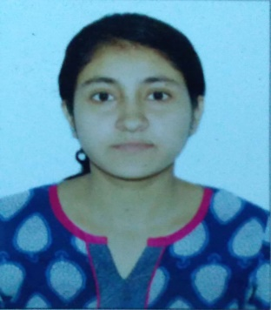

|  |
| --- |
| **CAREER OBJECTIVE** |

To obtain a position of responsibility that utilizes my skill and experience and keen to work in an environment where I can enrich my knowledge.

|  |
| --- |
| **BASIC ACADEMIC CREDENTIALS** |

|  |  |  |  |  |
| --- | --- | --- | --- | --- |
| **Qualification** | **College / Institutes** | **Board / University** | **Year** | **Aggregate** |
| B.E.(Sem VII & VIII) | Dr. D.Y.PATIL Institute of Technology,Pimpri | SPPU | 2017-2018 | 71% |
| T.E. (Sem V & VI ) | Dr. D.Y.PATIL Institute of Technology,Pimpri | SPPU | 2016-2017 | 60.0% |
| S.E. ( Sem III & IV ) | Dr. D.Y.PATIL Institute of Technology,Pimpri | SPPU | 2015-2016 | 56.93% |
| F.E. ( Sem I & II ) | Dr. D.Y.PATIL Institute of Technology,Pimpri | SPPU | 2014-2015 | 60.42% |
| H.S.C | Ekalavya Educational Complex | CBSE | 2012-2013 | 62.0% |
| S.S.C | Ekalavya Educational Complex | CBSE | 2010-2011 | 85.5% |

**Aggregate :** 63%

**Branch** : Computer Science

|  |
| --- |
| **SKILL SET** |

Operating Systems known : Windows XP, 7,8, Red Hat, Fedora, Ubuntu

Programming Languages : C, Java Basics, SQL

Application Software : MS Office

|  |
| --- |
| **ACADEMIC PROJECT** |

**BE Final Year Project:** “Twitter User Circle Detection using Multi-View Network Structure”

Automatic social circle detection in ego-networks. The main goal of our system is finding out a multiple view clustering Information by using a multi view clustering and Selective Co-trained Spectral Clustering which gives us appropriate information and correct information rather than the single view clustering information.

**Duration:** 1 Year.

**TE Seminar: “**GREEN COMPUTING”

|  |
| --- |
| **EXTRA CURRICULAR** |

* Participated in ORACLE in ZION.
* Participated in campaigning for R-EVOLUTION 6.0 and ZION 2016.

|  |
| --- |
| **CERTIFICATIONS** |

* Core JAVA

|  |
| --- |
| **PERSONAL PROFILE** |

**NAME** : Sneha Rani   
**DATE OF BIRTH** : 31/12/1996

**GENDER**  : Female

**LANGUAGES KNOWN** : English, Hindi

**PERMANENT ADDRESS** : D/O Brajesh Kumar Singh, Vill- Geeta Deodha,

Via Mangalgadh, Post- Hasanpur, Samastipur,

Bihar – 848208.

|  |
| --- |
| **DECLARATION** |

I do hereby declare that the above information is true to the best of my knowledge**.**

Place: Pimpri, PUNE **Sneha Rani**

Date : (Signature)